Report: Cluster Analysis of Mushroom Dataset

1. Introduction
The objective of this project was to perform unsupervised cluster analysis on the UCI Mushroom dataset. The dataset contains 8124 mushrooms with 22 categorical attributes, where the target classification is edible (e) or poisonous (p).
The analysis followed the following techniques, including:
- Principal Component Analysis (PCA) for dimensionality reduction and visualization.
- K-means clustering, Hierarchical clustering, and Gaussian Mixture Models (GMMs) for grouping mushrooms.
- Silhouette evaluation and confusion matrices for cluster quality assessment.
- Visualization through parallel coordinates and dendrograms.

2. Data Preprocessing
- The dataset was loaded from agaricus-lepiota.data.
- All 22 categorical attributes were converted into numeric codes.
- One constant column was removed due to zero variance.
Removed 1 constant columns.
This ensured that the clustering algorithms could work on valid features without singular covariance issues.

3. Principal Component Analysis (PCA)
PCA was applied to reduce dimensionality and visualize clusters in two dimensions.
- The first two principal components captured a significant proportion of the variance.
- Edible and poisonous mushrooms showed partial separation in PCA space.
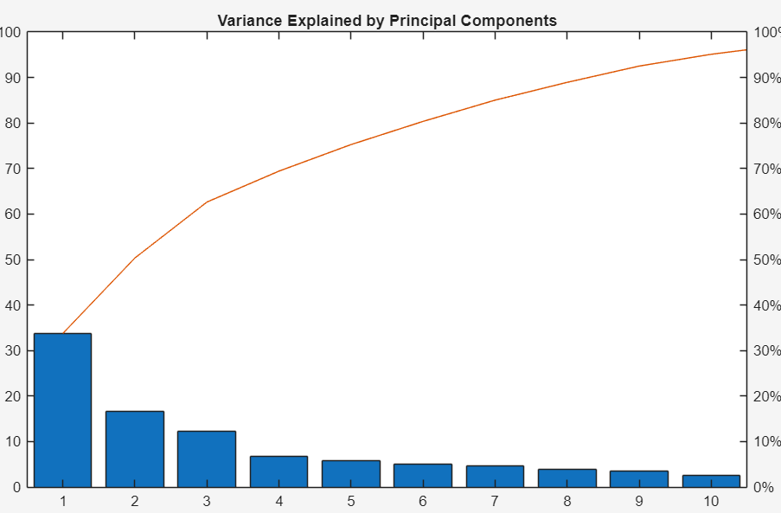
Figure 1: variance explained plot
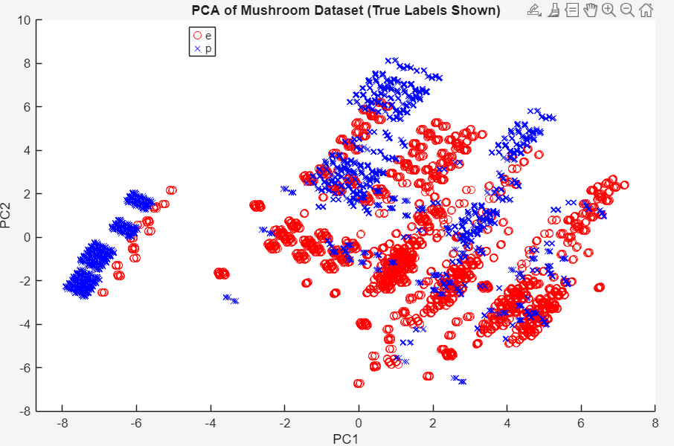
Figure 2: PCA Scattor plot

4. K-means Clustering
K-means clustering was applied with k = 2 clusters.
- Silhouette analysis confirmed that 2 clusters was the optimal choice.
- Average silhouette value: ~0.435 (moderate separation).
- Accuracy compared to true labels: 70.91%.
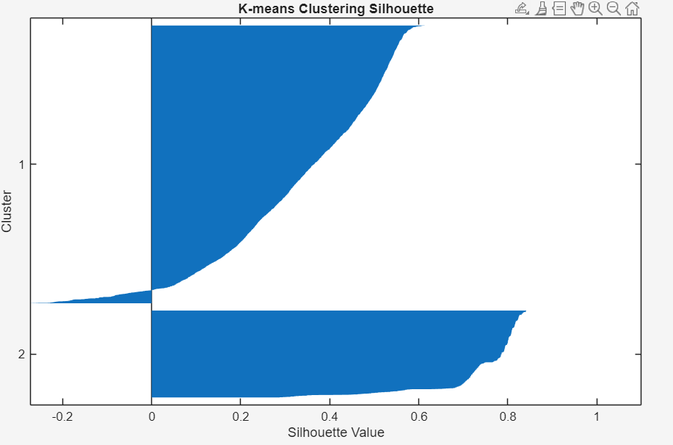
Figure 3: silhouette plot
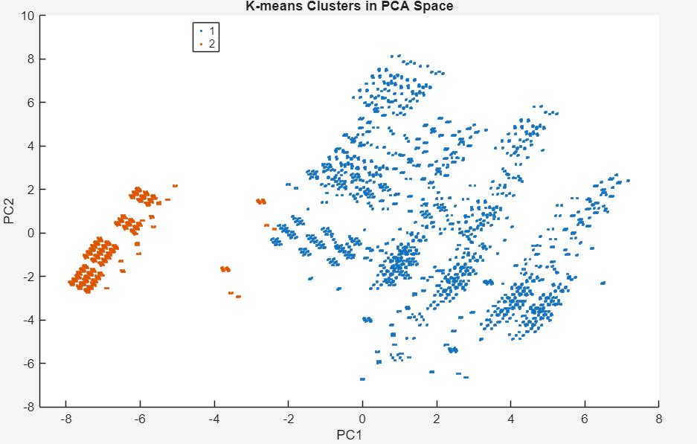
Figure 4: PCA scatter plot of K-means clusters

5. Parallel Coordinates Visualization
Parallel coordinates were used to explore feature patterns across clusters.
- Differences between clusters were observed in specific features such as odor and spore-print-color.
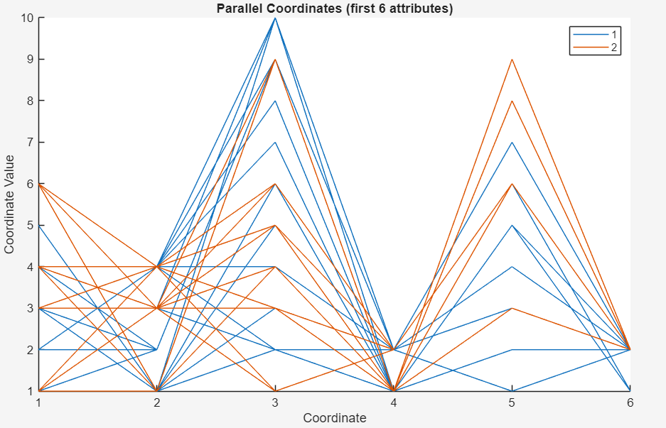
Figure 5: parallel coordinates figure

6. Hierarchical Clustering
Hierarchical clustering using Ward’s linkage and Euclidean distance was performed.
- The dendrogram revealed two dominant clusters.
- Accuracy compared to ground truth: 70.61%.
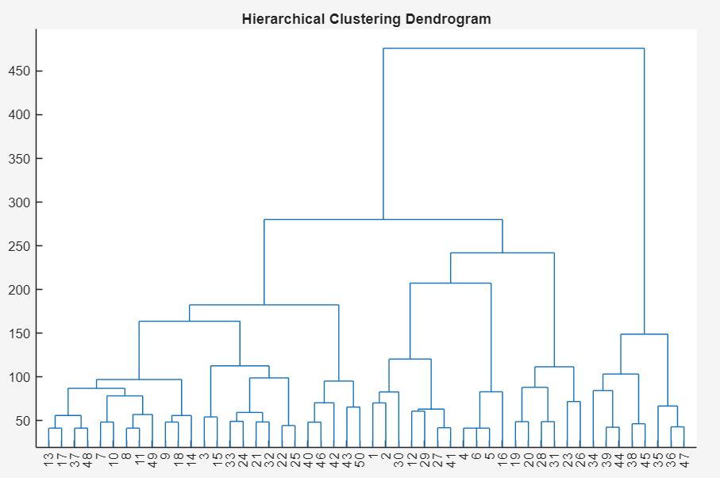
Figure 6: dendrogram for hierarchical clustering
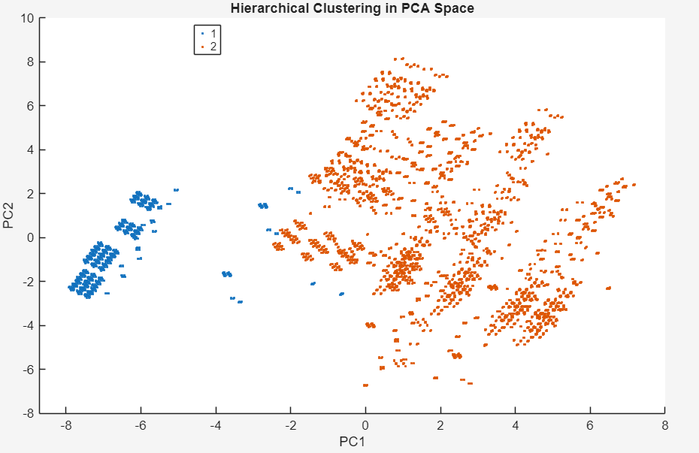
Figure 7:PCA scatter for hierarchical clustering

7. Gaussian Mixture Models (GMM)
A Gaussian Mixture Model with two components was fitted (regularization applied to handle collinear features).
- GMM produced soft cluster assignments but less alignment with true labels than K-means or Hierarchical.
- Accuracy: 69.33%.
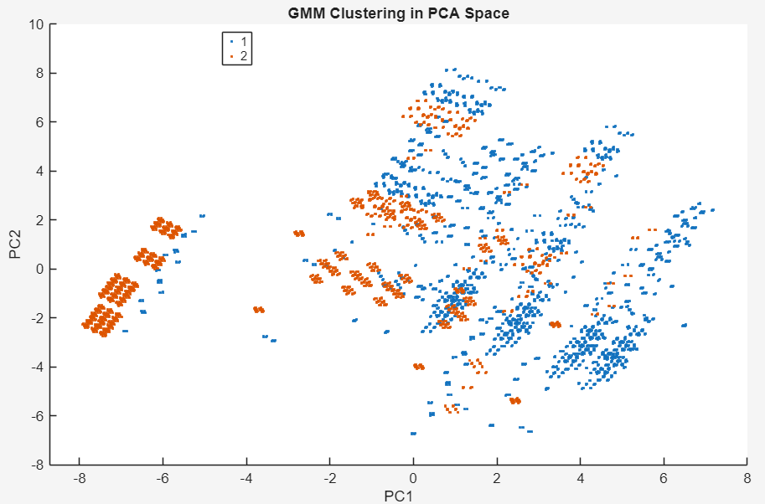
Figure 8: PCA scatter plot for GMM clusters

8. Cluster Evaluation
Silhouette analysis across k = 2, 3, 4, 5 clusters showed that k = 2 was optimal.
SilhouetteEvaluation with properties:
NumObservations: 8123
InspectedK: [2 3 4 5]
CriterionValues: [0.4350 0.3937 0.4084 0.4082]
OptimalK: 2
This result matches the true number of classes in the dataset (edible vs poisonous).

9. Conclusion
- K-means achieved the best accuracy at 70.91%, closely followed by Hierarchical clustering (70.61%), while GMM performed slightly lower at 69.33%.
- All methods consistently indicated that the dataset naturally forms two clusters, aligning with the edible vs poisonous categories.
- PCA visualizations showed partial but not complete separation, explaining why accuracy did not exceed ~71%.
- Strong attributes such as odor and spore-print-color drove much of the separation, while weaker attributes introduced noise.
- Future improvements could involve feature selection or weighting to emphasize the most discriminative attributes, which may improve clustering accuracy beyond 71%.

