A) FEATURE SELECTION
In order to forecast the electricity consumption in a city I would propose the following four features:
- Temperature and Weather Conditions
- Time of Day and Seasonality
- Population Density and Demographics
- Industrial and Commercial Activity Levels

TEMPERATURE SENSOR AND WEATHER CONDITIONS
Data can be collected through weather stations, IoT temperature sensors and satellite-based meteorological data, also data can be acquired from national weather agencies or private weather data providers.
Temperature and weather data are readily available from sources like local meteorological departments or private services like AccuWeather. They data may require smoothing or aggregation for accuracy.
- Justification: The electricity demand is highly sensitive to the variations of the temperature because of the heating or cooling needs, increasing the air conditioning with high temperature and increasing the heating demands when the temperatures are cold.

TIME OF DAY AND SEASONALITY:
Data can be collected from smart meters, grid sensors and historical consumption records, also from utility companies and smart grid monitoring systems.
These data might need cleaning and seasonal decomposition techniques.
- Justification: The electricity usage follows predictable daily and seasonal patterns, with peaks in the morning and evening and also during the summer and winter months due to the climate control needs.

POPULATION DESNSITY AND DEMOGRAPHICS:
Data can be collected from census, mobile network data or GIS-based population heatmaps, social surveys or government databases.
These data are available from National Statistics agencies but they would require spatial analysis and integration with grid demand.
- Justification: Is known that areas with high population density consume more electricity due to residential and commercial activities and also other demographic factors like age and income levels might have influence in consumption behaviour.

INDUSTRIAL AND COMMERCIAL ACTIVITY LEVELS:
Data can be collected from smart meters in industrial and commercial zones and business operational data, also from economics reports and energy consumption data from industries.
In order to obtain these data, we would require collaboration from industries and government databases.
- Justification: We know that industrial and commercial sectors are major electricity consumers, and fluctuations in their activity significantly impact in the overall demand. During the peak hours in the business industry the grid experiences big variations on the load.

B) DATASET CREATION
The data has been obtained from weather agencies like NOAA National census Bureau and Platforms like WorldPop, economics activity reports and information from Energy providers like National Grid. The dataset has been split in 20 samples for testing and last 10 samples for training.
- Temperature (°C): Higher cooling demands are needed with higher temperatures and higher heating demands while the temperatures are lower.
- Time of the day: The energy consumption van varies along the day, showing consumption peaks during the morning and afternoon.
- Population density: Areas with higher density of population have higher electricity consumption
- Industry Activity Level: The intensity of the industrial operations have an impact in the electricity consumption.
- Electricity Consumption (MW): representation of the electricity consumption in megawatts.

Sample | Temperature (°C) | Time of the Day | Population Density (people/Km²) | Industrial Activity Level | Electricity Consumption (MW)
1 | 15 | 6 | 5000 | 3 | 230
2 | 20 | 12 | 8000 | 5 | 340
3 | 30 | 15 | 7000 | 6 | 420
4 | 25 | 19 | 6000 | 4 | 310
5 | 18 | 7 | 5500 | 3 | 250
6 | 22 | 14 | 7200 | 5 | 360
7 | 28 | 16 | 6800 | 7 | 410
8 | 24 | 18 | 6500 | 6 | 350
9 | 17 | 8 | 5300 | 2 | 240
10 | 21 | 13 | 7500 | 6 | 380
11 | 27 | 17 | 6900 | 8 | 430
12 | 29 | 20 | 6600 | 7 | 390
13 | 16 | 5 | 5100 | 2 | 220
14 | 23 | 11 | 7800 | 5 | 350
15 | 26 | 21 | 7000 | 9 | 450
16 | 19 | 9 | 5700 | 4 | 270
17 | 31 | 22 | 7300 | 8 | 470
18 | 20 | 10 | 5900 | 3 | 290
19 | 25 | 12 | 7700 | 6 | 370
20 | 32 | 23 | 7400 | 9 | 490
21 | 18 | 8 | 5400 | 2 | 230
22 | 22 | 14 | 7000 | 6 | 360
23 | 29 | 18 | 6500 | 7 | 400
24 | 27 | 19 | 6600 | 6 | 390
25 | 15 | 6 | 5000 | 3 | 210
26 | 24 | 16 | 6800 | 7 | 370
27 | 30 | 20 | 7200 | 8 | 450
28 | 21 | 11 | 7600 | 5 | 340
29 | 26 | 21 | 7100 | 9 | 460
30 | 31 | 22 | 7400 | 10 | 500

- Training Set: Samples 1-20
- Testing Set: Samples 21-30

C) DATA VISUALIZATION
Data visualization will help us to support forecasting electricity consumption in a city.
I’m providing a Scatter Plot for “Temperature- Electricity Consumptions” and Histogram Plot for “Time of the day-Electricity consumption”.
We can observe a clear upward trend in electricity consumption as temperatures increases, particularly after 25°C. This supports the hypothesis that higher temperatures drive-up air-conditioning usage, increasing electricity demand.
We observe lower demand between 5-9am and late evening (after 22pm), showing significant higher electricity consumption late afternoon to evening 15:00-21:00 as expected usage pattern in cities.
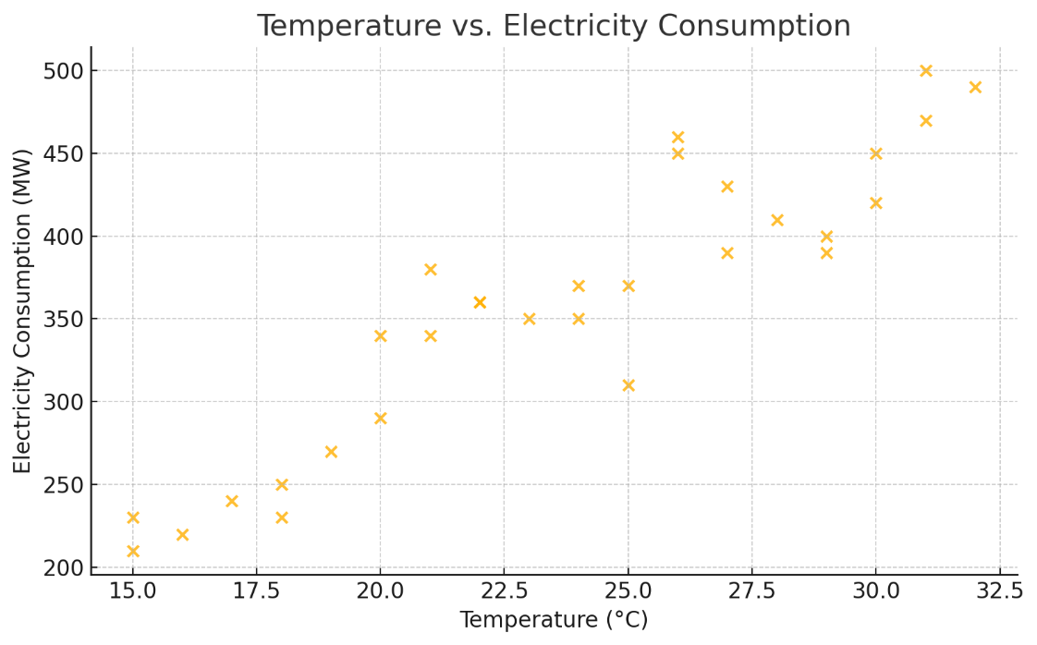

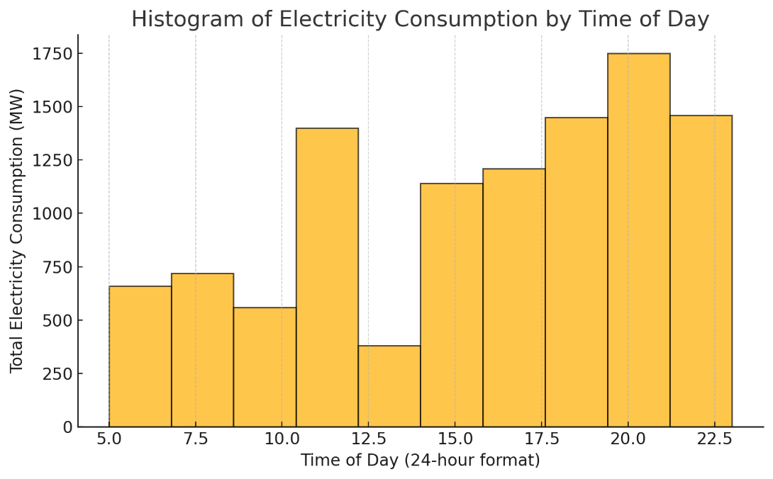

D) STATISTICAL ANALYSIS

1. Descriptive Statistics
The following table summarizes the key statistical measures for each feature in the dataset:
Feature | Mean | Standard Deviation | Minimum | Maximum
Temperature (°C) | 23.7 | 5.0 | 15 | 32
Time of the Day (hours) | 14.4 | 5.4 | 5 | 23
Population Density (people/km²) | 6626.7 | 879.0 | 5000 | 8000
Industrial Activity Level | 5.7 | 2.3 | 2 | 10
Electricity Consumption (MW) | 357.7 | 83.4 | 210 | 500

2. Interpretation & Trends

a) Temperature (°C)
  - Range: 15°C (min) to 32°C (max)
  - Mean: 23.7°C
  - Standard Deviation: 5.0 (moderate variability)
  - Insights:
Higher temperatures (e.g., 30-32°C) likely correlate with increased electricity consumption due to air conditioning usage.
Lower temperatures (e.g., 15-18°C) may still show high consumption if heating is required.

b) Time of the Day (hours)
  - Range: 5 (early morning) to 23 (late night)
  - Mean: 14.4 (around mid-afternoon)
  - Standard Deviation: 5.4 (high variability, as expected for time-based data)
  - Insights:
Peak consumption likely occurs during daytime (12-18 hours) when industrial and commercial activity is highest.
Late-night (21-23 hours) may still show high consumption if industrial shifts are active.

c) Population Density (people/km²)
  - Range: 5000 (low density) to 8000 (high density)
  - Mean: 6626.7
  - Standard Deviation: 879.0 (high variability)
  - Insights:
Higher population density (7000-8000) correlates strongly with increased electricity demand due to residential and commercial usage.
Lower density areas (5000-6000) may still have high consumption if industrial activity is present.

d) Industrial Activity Level (1-10 scale)
  - Range: 2 (low) to 10 (very high)
  - Mean: 5.7 (moderate industrial activity)
  - Standard Deviation: 2.3 (high variability)
  - Insights:
Strongest predictor of electricity consumption—higher industrial activity (≥7) leads to significantly higher demand (400-500 MW).
Lower industrial activity (≤4) corresponds to lower consumption (210-300 MW).

e) Electricity Consumption (MW)
  - Range: 210 MW (min) to 500 MW (max)
  - Mean: 357.7 MW
  - Standard Deviation: 83.4 (high variability, indicating fluctuating demand)
  - Insights:
Highest consumption (450-500 MW) occurs when:
Temperature is very high (≥30°C)
Industrial activity is high (≥8)
Population density is high (≥7000)
Lowest consumption (210-250 MW) occurs when:
Temperature is mild (~15-20°C)
Industrial activity is low (≤3)
Population density is low (~5000)

3. Key Trends & Anomalies

Strong Correlations:
Industrial activity has the strongest impact—when industrial levels exceed 7, electricity demand consistently rises above 400 MW.
Population density amplifies demand, especially when combined with high temperatures or industrial activity.
Time of day matters—consumption peaks in the afternoon (12-18 hours) and remains high in the evening if industries operate late.

E) Model Training and testing
Code had been Provided for this part

F) Evaluation Metrics Interpretation

The model was evaluated using four key metrics:
  - MAE (Mean Absolute Error): 16.7013
  - On average, the model's predictions are about 16.7 units away from the actual electricity consumption values.
  - This gives us an absolute measure of error magnitude in the original units.
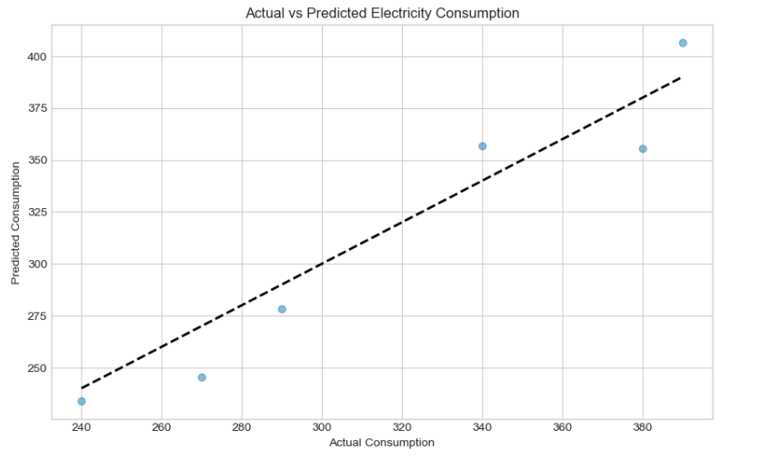
  - MSE (Mean Squared Error): 321.7530
  - The squared error metric penalizes larger errors more heavily.
  - This higher value (compared to MAE) indicates there are some larger errors in the predictions.
  - RMSE (Root Mean Squared Error): 17.9375
  - This is in the same units as the original data (like MAE).
  - The RMSE being slightly higher than MAE suggests some predictions have larger errors.
  - R² Score (Coefficient of Determination): 0.8967
  - This is a very strong result, indicating that about 89.67% of the variance in electricity consumption is explained by the model.
  - An R² score this close to 1 suggests the model fits the data very well.
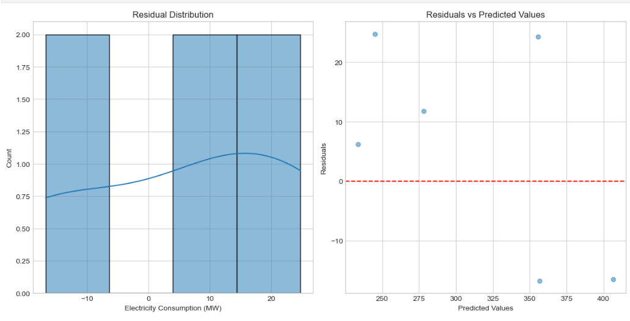

Strengths of the Developed System
High Predictive Power: With an R² score of 0.8967, the model explains nearly 90% of the variance in electricity consumption, indicating excellent predictive performance.
Reasonable Error Margins: The MAE and RMSE values, while needing to be interpreted in context of the actual consumption values, suggest the model makes predictions with reasonable accuracy.
Comprehensive Evaluation: The use of multiple metrics (MAE, MSE, RMSE, R²) provides a well-rounded view of model performance from different perspectives.
Potential for Practical Use: The accuracy level suggests this model could be deployed in real-world scenarios for electricity consumption forecasting.

Weaknesses and Limitations
Absolute Error Values: Without knowing the scale of the actual electricity consumption values, it's difficult to assess whether an MAE of 16.7 is acceptable. If consumption values are in the thousands, this would be excellent; if they're in the hundreds, less so.
Possible Overfitting: The very high R² score could indicate potential overfitting, because the dataset is small.
Limited Dataset: Based on the task requirements, the model was trained on only 20 samples which is quite small for robust machine learning.
Feature Limitations: We don't know if all relevant features were included or if some important predictors were missing from the model.

