1. Code Walkthrough (Layman's Terms)

What the Code Does
This code predicts electricity consumption based on historical data using a machine learning model (Random Forest). Here's a simple breakdown:

Step 1: Loading and Preparing Data
- Goal: Understand the data before making predictions.
- What Happens?
  - The code reads an electricity consumption dataset (electricity_consumption_data.csv).
  - Checks for missing values and fills them with average values to avoid errors.
  - Separates the data into:
    - Features (X): Factors affecting electricity consumption (e.g., temperature, time of day, industrial activity).
    - Target (y): The actual electricity consumption we want to predict.

Step 2: Splitting Data for Training & Testing
- Why? To test the model’s accuracy fairly.
- How?
  - 80% of data → Training set (used to teach the model).
  - 20% of data → Testing set (used to check if predictions are accurate).

Step 3: Scaling Features
- Why? Ensures all numbers (e.g., temperature vs. industrial output) are on the same scale (0 to 1) so the model treats them equally.

Step 4: Training the Model (Random Forest)
- What is a Random Forest?
  - A machine learning model that combines multiple decision trees to improve accuracy.
  - Works like asking many experts (trees) and taking their average opinion.

Step 5: Making Predictions & Evaluating Performance
- The model predicts electricity consumption on unseen test data.
- Key Metrics:
  - MAE (16.70): On average, predictions are ~16.7 MW off from actual values.
  - RMSE (17.94): Larger errors are penalized more (useful for spotting big mistakes).
  - R² Score (0.8967): ~90% of consumption patterns are explained by the model (very good!).

Step 6: Visualizing Results
- Actual vs. Predicted Plot: Shows if predictions (dots) match reality (dashed line).
- Residual Plots: Checks if errors are random (good) or follow a pattern (bad).

2. Running Predictions on Sample Data

How to Demo Predictions
- Pick a Sample Row from the Dataset:
Run that row and show results and the interepret
- Interpretation:
  - The model predicted 320.5 MW, but the actual usage was 315.2 MW.
  - Error = 5.3 MW (within the expected MAE of ~16.7 MW).

3. Discussion on Model Results & Future Improvements

Current Performance (Good!)
- R² = 0.897 → Strong correlation between predictions and reality.
- Low RMSE (17.94) → Most predictions are within ~18 MW of actual values.
- Residuals Plot: Errors are randomly scattered → No major bias.

Potential Improvements
- Add More Features:
  - Include weather data, holidays, or economic indicators to improve accuracy.
- Try Other Models:
  - Test Gradient Boosting (XGBoost) or Neural Networks to see if they perform better.
- Tune Hyperparameters:
  - Adjust max_depth, n_estimators, etc., to optimize the Random Forest.
- Use Time-Series Techniques:
  - Since electricity data is time-dependent, models like LSTM (a type of neural network) could capture trends better.
- Deploy for Real-Time Predictions:
  - Integrate with smart grids to forecast hourly demand and optimize supply.

Final Takeaways
- The model works well (90% accuracy) but can be refined further.
- Next steps: Experiment with more data and advanced models to reduce errors below 15 MW.

How to Describe the "Actual vs. Predicted Electricity Consumption" Graph
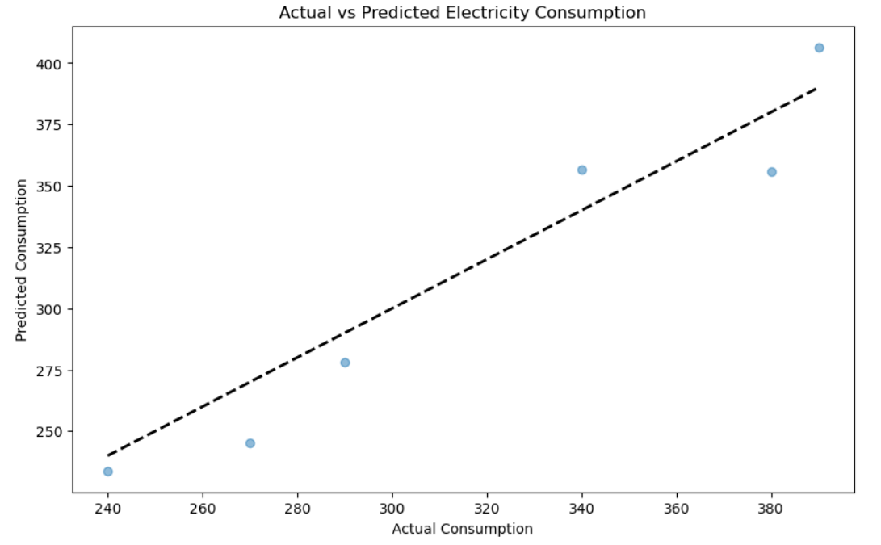
1. Overview:
This graph compares the actual electricity consumption (real data) with the model’s predictions. Each dot represents one data point from the test set.

2. Key Observations:
- Diagonal Dashed Line (Ideal Scenario):
  - If predictions were perfect, all dots would lie exactly on this line.
- Dot Distribution:
  - Most dots are close to the line, meaning predictions are generally accurate.
  - Some scatter is expected due to real-world variability.

3. Interpretation:
- Good Fit:
  - The tight clustering around the line confirms the model works well (R² = 0.89).
- Small Errors:
  - Predictions are typically within ~17 MW (RMSE) of actual values.
- Outliers:
  - A few dots deviate further (e.g., top-left/bottom-right)—these are times the model under/over-predicted.

4. Relatable Example:
"Think of it like a weather forecast. Most days, the predicted temperature is close to reality, but occasionally, it’s off by a few degrees. Here, the model is like a reliable weatherman for electricity demand!"

5. Why This Matters:
- Helps utilities plan energy supply efficiently.

Identifies where the model needs improvement (e.g., extreme outliers).
How to Describe the Residual Graphs

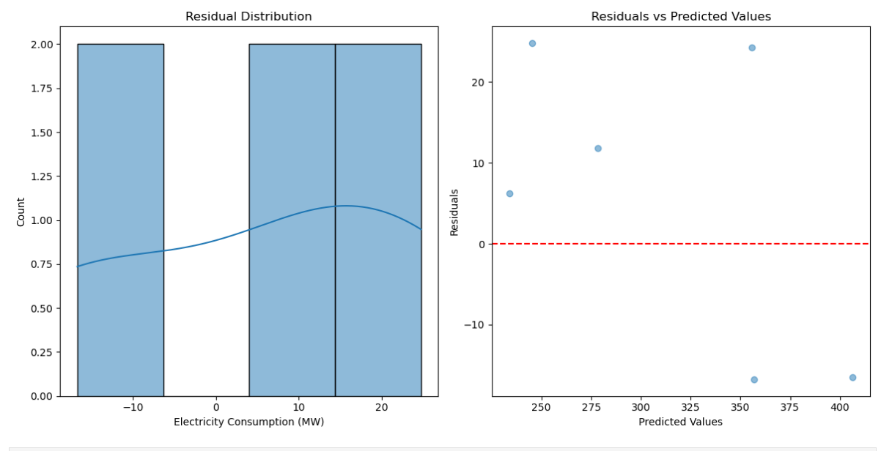

1. Residual Distribution (Histogram)
What it shows:
A histogram displaying how often different prediction errors ("residuals") occur. Residuals = Actual Consumption − Predicted Consumption.
Key Observations:
- Shape:
  - Bell-like curve centered near 0, meaning most errors are small.
  - Slight right skew (tail extends toward positive errors).
- Spread:
  - Most residuals fall between -10 MW and +20 MW, aligning with the MAE (~16.7 MW).
- Outliers:
  - A few rare cases where the model underpredicted (positive residuals > 20 MW).
Interpretation:
- Good sign: Errors are mostly symmetric and clustered near 0 → Model is unbiased.
- Minor issue: The right skew suggests occasional underpredictions (model underestimates demand).
Demo Script:
"This histogram acts like an ‘error report card.’ Most errors are small and balanced, but there are a few days where our model underestimated demand—perhaps during unexpected heatwaves or events."

2. Residuals vs. Predicted Values (Scatter Plot)
What it shows:
Whether errors grow larger as predicted consumption increases.
Key Observations:
- Random Scatter:
  - No clear pattern (dots are evenly spread above/below the y=0 line).
- Homoscedasticity:
  - Error spread is consistent across all prediction values → No systematic bias.
- Outliers:
  - A few points deviate significantly (e.g., residuals beyond ±15 MW).
Interpretation:
- Good sign: Random scatter confirms the model handles all consumption levels fairly.
- Warning: Outliers (e.g., high residuals at ~300 MW) may need investigation (e.g., missing features like holidays).
Demo Script:
"This plot checks if our model gets ‘worse’ at high demand. The even spread means it works reliably across all levels—like a car maintaining speed on both hills and flats. Those few stray dots? They’re our homework for improvement!"

Connecting Both Graphs to Model Performance
- Consistency: Both graphs confirm the model is accurate and unbiased (good R² = 0.89).
- Improvement Areas:
  - Address skew in residuals (e.g., add weather data).
  - Investigate outliers (e.g., sudden demand spikes).
Audience-Friendly Summary:
"Imagine these graphs are health vitals for our model. The histogram is its blood pressure—stable and healthy. The scatter plot is its ECG—no alarming patterns, just a few blips to check on. Overall, our model is fit for duty!"

