Willow Services Application

Table of Contents
1. Overview 3
2. Design 4
2.1Issues with the current system 4
2.2Design Considerations 5
2.3Replication conversation 6
2.3.1Operation 6
3. APIs 8
3.1Common API 8
3.2Binary API 8
3.3Reference Data API 9
3.4Contact API 9
3.5Course API 9
3.6Enrolment API 10
3.7Payment API 10
3.8System API 10

Overview
Willow Services is responsible for the Willow side of replication and enrolment communication with onCourse system.
Willow Services will utilise SOAP XML as the transport technology.

Design

Issues with the current system
The following are known issues with the current (WebObjects) replication system and should be addressed within the scope of this project:
- data does not get replicated if the maximum number of retries is reached (currently set at 3)
- replication has dictated that the database schema in Willow does not enforce FK constraints – this has resulted in missing relationship
- replication mechanism is generic and singular Entities are sent using the same methods. This makes for a very confusing API with little chance of reliably validating data on either side. It is proposed to abandon the concept of a generci API in favour of a more succinct and explicit API
- it is possible to start a copy of the Angel database which will replicate with Willow introducing erroneous data and or dequeing Willow data – this effectively results in data corruption at a business level
- in addition to the above, it is not possible for an Angel administrator to invalidate the current set of credentials to stop a “clone” of the database from replicating

Design Considerations
- all communication is always initiated by Angel
- all communication requires authentication which serves a dual purpose
  - web services security code identifies the College
  - communication key ensures continuation of conversation
- Willow tracks the conversation by starting and maintaing a server side HTTP Session
- Willow may also store a state within the persistent object store that indicates the status of replication with respect to a college
- Entities may be sent as Aggregates whenever the Entity contains relationship constraints that must be satisfied. From a queueing perspective, an Entity Aggregate is no different to an Entity
- all effort must be made to keep the Willow HTTP Session as lightweight as possible to allow flexibility in deployment of the application
- introduction of the concept of replication conversation which means that any exchange of data is wrapped in authentication exchange
- at the end of the replication conversation both systems exchange and store a new communication key that is used as the basis of validating the next replication conversation
- it is proposed that the communication key be given the value of System.nanoTime() by Willow – this means that we can have some idea of the age of the Angel database however, no other value is attached to the key – i.e. we don't try to use the temporal information for any other purpose and we simply perform a straightforward equals() comparison on the value
- it will be necessary to provide means of resetting both the web services security code and the communication key by ish administrators – preferably through the means of a Web Services Administration Portal

Replication conversation

Operation
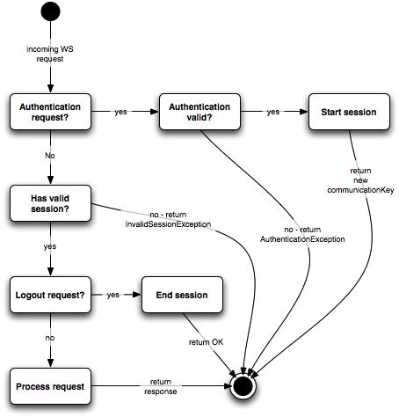
The web services security code ensures that a database is uniquely identifiable. The key is generated by Angel when the database is created however, any copy of the database or a backup will still contain the same code. Therefore, nothing prevents a copy from attempting replication.
The communication key attempts to stop the situation where multiple copies of the same database `are started and all attempt to replicate. At present there is no mechanism to stop this from happening. As a result, erroneous data is sent to Willow (from the clones) and Willow may send new and updated data to the incorrect database.
The communication key attempts to mitigate this by assuming that the communication key will change by the time a copy attempts to replicate. This can fail in the following ways:
- The master or real database fails to exchange new keys in the time that the clone is copied and started – there is then a chance that the clone will successfully resume replication
- The master database is in fact restored from backup – there are issues with allowing replication at this point anyway so, for the time being this is of no concern
To eliminate the possibility of the first problem, I propose that as soon as Willow receives an invalid communication key, the College is put in a HALT state. From that point, any replication attempts fail.
What should happen if replication is halted?
It is proposed that ish would at this point be responsible for carrying out whatever is necessary to reset the replication mechanism.
One procedure could be to reset the communication key to null and set the replication status to OK.
It is also proposed that the communication key is sent by Angel in the authentication request. It is then compared by Willow with previously generated communication keys and if it matches the last key sent a new communication key is then generated and returned to Angel.
It has also been proposed that the key could simply be the System.nanoTime() value on Willow. This value would have no impact on the business logic of authentication but it would allow ish to determine how old the Angel database is.
The processing of the communication key on the Angel side would be as follows:
- Angel starts a replication conversation and sends the communication key received during last communication from Willow
- Angel receives the new communication key in response to the authentication request and stores this key immediately in database
- Angel sends the new communication key on logout() for verification
The processing of the communication key on the Willow side would be as follows:
- Willow receives a communication key as part of the authentication request from Angel. It compares the key against the all communication keys mark “VALID”
- If keys match, a new communication key is generated (System.nanoTime()) and stored against the College as “VALID”, an HTTP Session is started and the key is returned to Angel
- On logout(), any communication key not matching the one sent, is set to “INVALID” state.
The step 3 attempts to mitigate the situation where Angel might have been stopped after sending a valid authentication attempt. It is entirely possible that Willow would generate and store a new communication key effectively locking up replication.
This extension to the authentication scheme would allow Angel to still resume replication even if it did not have a chance to update its database with the new communication key.

APIs

Common API
- Methods
  - authenticate(String webServicesSecurityCode, Long lastCommKey) : Long
  - logout(Long newCommKey) : Status

Binary API

- Entities
  - BinaryData – (aggregate – parent) contains the binary BLOB
  - BinaryInfo – (aggregated with BinaryData) contains BinaryData's metadata
  - BinaryInfoRelation – (aggregated with BinaryData) defines relation to other Entities in the model
- Methods

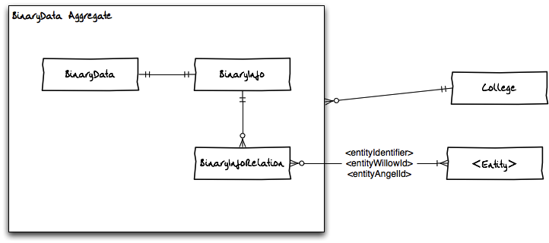

Reference Data API
- Stubs
  - Country_Stub (single)
  - Language_Stub (single)
  - Module_Stub (single)
  - Qualification_Stub (single)
  - TrainingPackage_Stub (single)
- Methods
  - checkVersions() → Map
  - getCountries(angelVersion) → Collection<Country_Stub>

Contact API
- Entities
  - Attendance (single)
  - Contact (aggregate – parent)
  - SessionTutor (single)
  - Student (aggregated with Contact)
  - StudentConcession (single)
  - Tutor (aggregated with Contact)
  - TutorRole (single)
  - WaitingList (aggregate – parent)
  - WaitingListSite (aggregated with WaitingList)
- Methods

Course API
- Entities:
  - Course (can be either single or aggregated with CourseClass)
  - CourseClass (aggregate – parent)
  - CourseModule (aggregated with CourseClass)
  - Room (can be either single or aggregated with Site)
  - Session (aggregated with CourseClass)
  - Site (aggregate – parent)
- Methods:

Enrolment API
- Entities:
  - Certificate (single)
  - CertificateOutcome (single)
  - ContactAggregate <Contact/Student/Tutor> (aggregated with Invoice)
  - Enrolment (aggregated with Invoice)
  - Invoice (aggregate – parent)
  - InvoiceLine (aggregated with Invoice)
  - InvoiceLine_Discount (aggregated with Invoice)
  - Outcome (single)
- Methods:

Payment API
- Entities:
  - PaymentIn (aggregate – parent)
  - PaymentInLine (aggregated with PaymentIn)
  - PaymentOut (aggregate – parent)
  - PaymentOutTransaction (aggregated with PaymentOut)
  - PaymentTransaction (aggregated with PaymentIn)
- Methods:

System API
- Entities:
  - Message (single)
  - MessagePerson (single)
  - MessageTemplate (single)
  - Preference (single)
  - Tag (aggregate - parent)
  - TagGroupRequirement (aggregated with Tag)
  - Taggable (aggregated with Tag)
  - TaggableTag (aggregated with Tag)
- Methods:

