onCourse Resource Management
Document revisions
Who | Revision | Comment
Marek Wawrzyczny | 02/06/10 | Initial version

Table of Contents
1 DB Schema 4
2 Site Resources 5
2.1 Database schema 5
2.2 Resource directory structure 5
2.3 Defaults directories 7
3 Resource discovery 8

DB Schema

Site Resources
Resources are files found at a special location on the application/web server.
There are three types of files:
- Configuration files
- Static web resources
- Web Application templates

Database schema
The following database schema is involved in resource management.
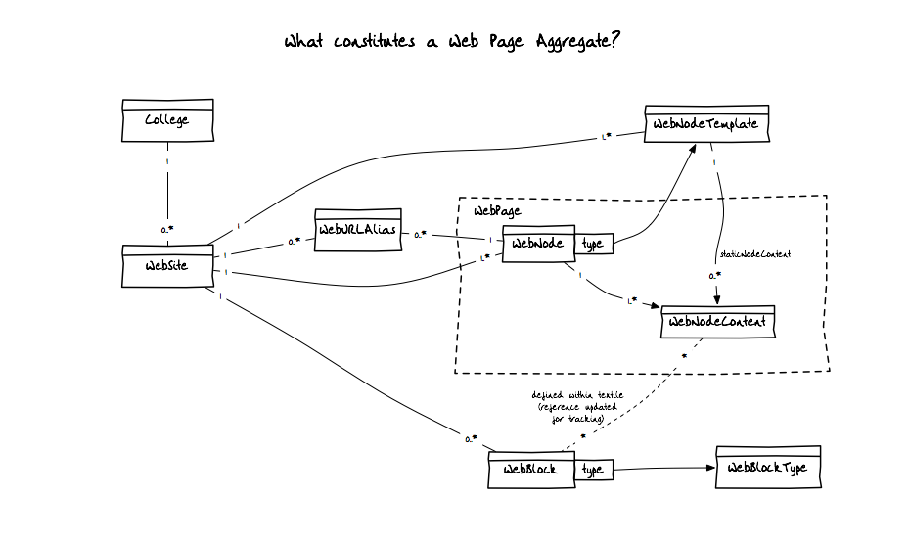
Of particular interest are the College, WebSite and WebNodeTemplate tables. The College records contain the collegeKey property, WebSite records contain the siteKey property and the WebNodeTemplate records contain the templateKey property.
The “key” properties are used to identify the location of resources on disk.

Resource directory structure
The resources should be located in a directory available to both the application server (e.g. Tomcat) and web server (e.g. Apache). Within this location, the directories will be structured as follows:

- willow/active/custom/
    - defaults/
      - config/
      - s/
        - css/
        - img/
        - js/
      - layouts/
        - defaults/
        - <templateKey>/
        - <templateKey>/
        - ...
    - <collegeKey>/
      - config/
      - s/
        - css/
        - img/
        - js/
      - layouts/
        - defaults/
        - <templateKey>/
        - <templateKey>/
        - .../
    - <collegeKey>_<siteKey>/
      - …/

The example above shows directories named by convention in italic, these directories are to be assumed to exist.
Directories shown in bold are referred to in the database. The collegeKey for example is used to find directories relevant to a particular college. In cases where “sub-sites” are defined for the college, the corresponding folder will be assumed to take the form of collegeKey_siteKey.
The templateKey is used to identify particular templates within the assumed layouts directory. These will denote particular templates, such as an email template, or a 1 column layout template.
Each of these directories will then contain one of the 3 types of files:
- config – configuration files such as resource combining
- s – static resources such as CSS, JavaScript and image files
- layouts – will contain Tapestry template within the templateKey directories

Defaults directories
The defaults directories define the default implementations of resources and are used as defaults in the resource discovery process. Refer to Resource discovery.

Resource discovery
The resource discovery process should be as follows.
- Obtain the collegeKey and siteKey from the request (lookup requested domain in CollegeDomain and follow related College and WebSite records). We'll use scc for collegeKey and english for siteKey.
- Construct the resource folder location:
  - Case of CollegeKey but no SiteKey defined:
/.../willow/active/custom/scc/
  - Case of CollegeK and SiteKey defined:
/.../willow/active/custom/scc_english/
- For template resolution, determine the WebNode requested and lookup the related WebNodeTemplate. We'll use email as the templateKey and Promotions as the webNode name:
/.../willow/active/custom/scc_english/layouts/email/WebNode.tmp
Note that WebNode content is stored in the WebPage Aggregate – a collection of WebNode and WebNodeContent records.
- If WebNode.tmp is not found in the email template directory of scc college/site, or the email is not present, lookup the template in the defaults directory of scc college/site:
/.../willow/active/custom/scc_english/layouts/defaults/WebNode.tmp
- If WebNode.tmp is not found in the defaults template directory of scc college/site, lookup the template in email template directory of defaults college/site:
/.../willow/active/custom/scc_english/layouts/defaults/WebNode.tmp
- If WebNode.tmp is not found in the email template directory of defaults college/site, lookup the template in defaults template directory of defaults college/site:
/.../willow/active/custom/scc_english/layouts/defaults/WebNode.tmp

