EXPENSE-TRACKER

* This application is made using Django web framework, uses python as server side scripting language and xampp web server is used which makes our application able to stand on the computer’s local host/server.
* This is how Django File Structure looks like:

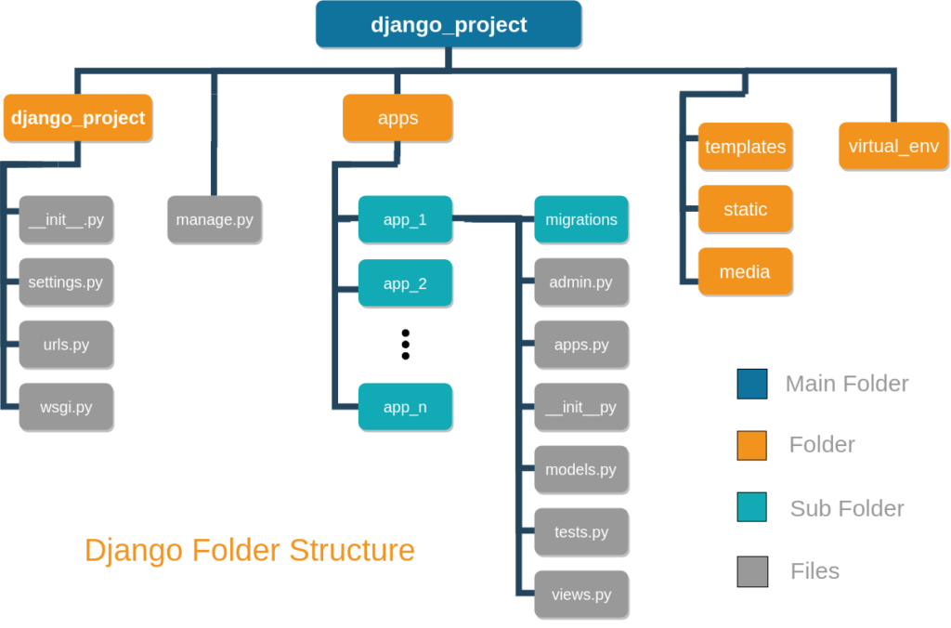

* The very first step is that we need to start a project with Django admin using the following syntax :

Django-admin startproject ExpenseTracker

* After this we will get into project and start a app using the following syntax:

Python manage.py startapp TrackingApp

* The other thing is to follow is create functions in views.py and connect it with URL using url.py , create models in model.py and doing the appropriate settings.
* To run the application in your local host we need run the command prompt in the project folder(python manage.py runserver) and start the Apache, MySQL from xampp.

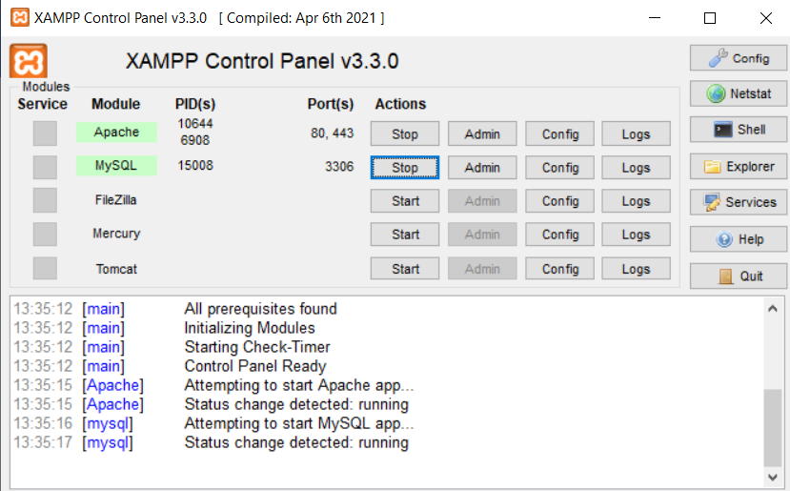

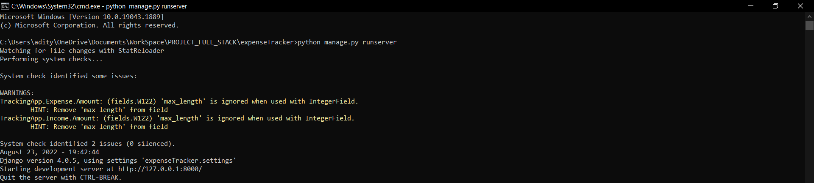

* Now copy the http server link [**http://127.0.0.1:8000/**](http://127.0.0.1:8000/)and paste in your browser.
* There you will find the URLs of your application that you have created.

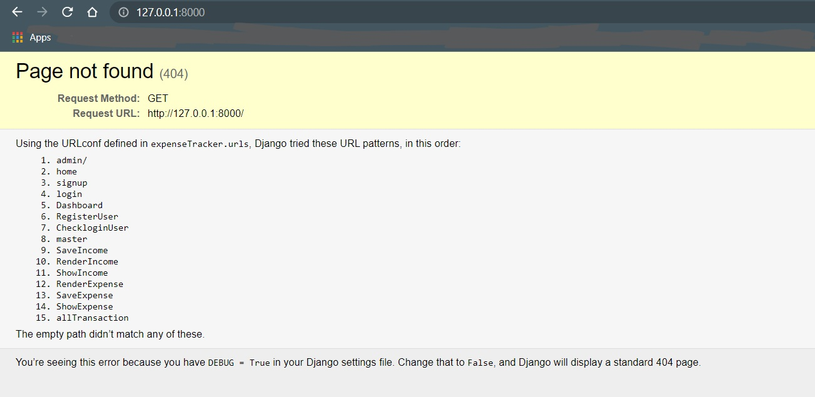

* We can go on any URL of the application by using [**http://127.0.0.1:8000/**nameofURL](http://127.0.0.1:8000/nameofURL).
* Let’s go to signup page

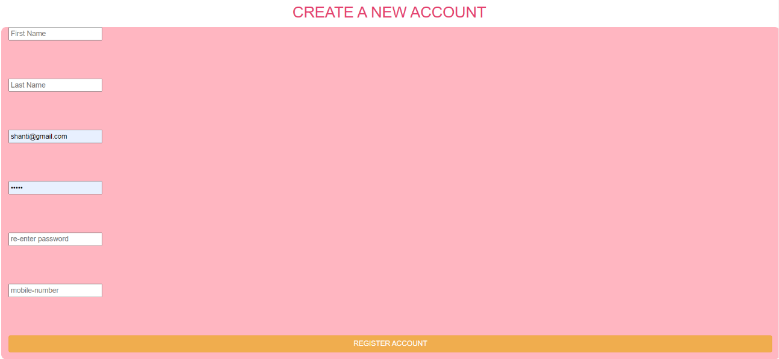

* Login Page of ExpenseTracker:

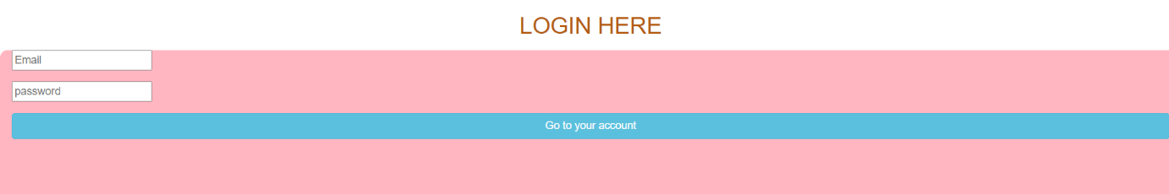

* Just after login with registered account the page will be directed to master page from where we can choose to go to any options.

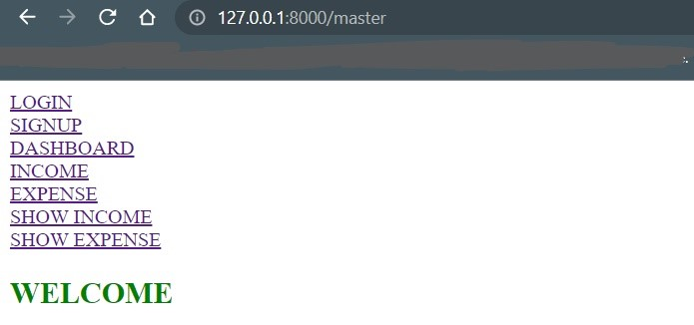

* To save your new income go to INCOME.

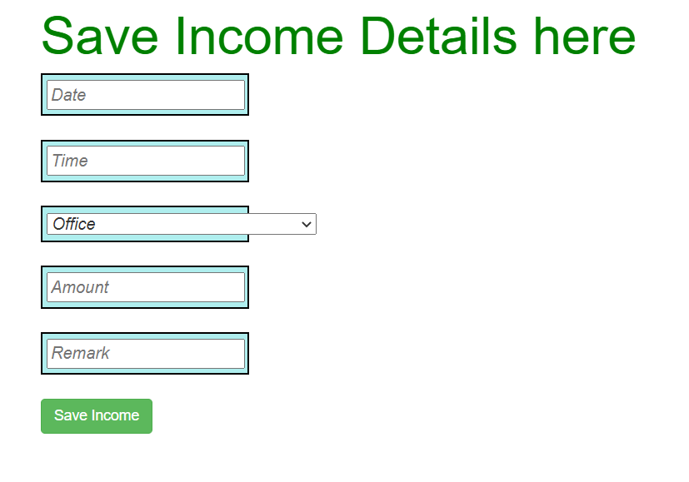

* To save your new Expense go to EXPENSE.

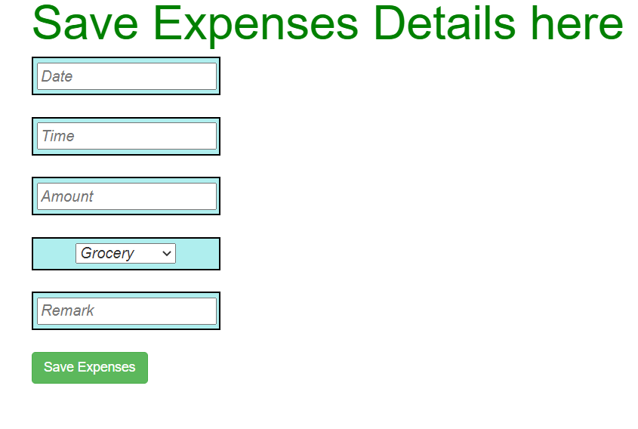

* To see all your recent expenses go to SHOW EXPENSE.

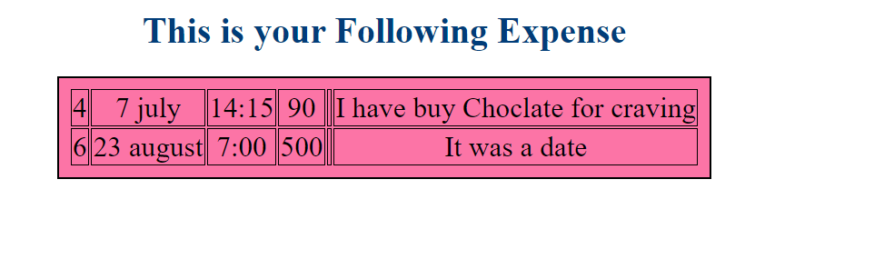

* To see all your recent Incomes go to SHOW INCOME.

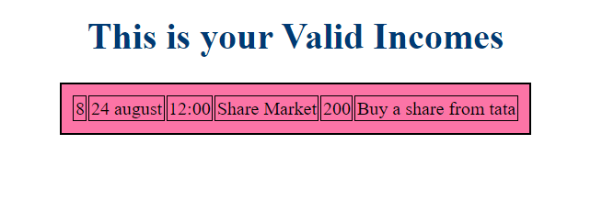

* To see All of the transaction and money inflow and outflow go to DASHBOARD.

