Lab Assignment No. 01
RSA Encryption & Homomorphic Property

1- Paython code :
# RSA Homomorphic Property Demonstration
# E(m1) * E(m2) mod n = E(m1 * m2 mod n)

# Import math module for gcd
import math

# --- Step 1: Generate RSA key pair ---
# Choose two small prime numbers
p = 11
q = 13

# Compute modulus n and Euler's totient φ(n)
n = p * q
phi = (p - 1) * (q - 1)

# Choose a public exponent e (must be coprime with φ)
e = 7
while math.gcd(e, phi) != 1:
e += 2 # increase until gcd(e, phi) = 1

# Compute private key d (modular inverse of e mod φ)
d = pow(e, -1, phi)

# Display key generation results
print("=== RSA Key Generation ===")
print(f"p = {p}, q = {q}")
print(f"n = {n}, φ(n) = {phi}")
print(f"Public key (e, n) = ({e}, {n})")
print(f"Private key (d, n) = ({d}, {n})\n")

# --- Step 2: Implement encryption and decryption functions ---

def encrypt(m, e, n):
"""Encrypt message m using public key (e, n)"""
return pow(m, e, n)

def decrypt(c, d, n):
"""Decrypt ciphertext c using private key (d, n)"""
return pow(c, d, n)

# --- Step 3: Select two plaintext messages ---
m1 = 4
m2 = 6
print("=== Messages ===")
print(f"m1 = {m1}, m2 = {m2}\n")

# --- Step 4: Encrypt both messages ---
c1 = encrypt(m1, e, n)
c2 = encrypt(m2, e, n)
print("=== Encryption ===")
print(f"E(m1) = {c1}")
print(f"E(m2) = {c2}\n")

# --- Step 5: Multiply ciphertexts modulo n ---
product_cipher = (c1 * c2) % n
print("=== Homomorphic Multiplication ===")
print(f"E(m1) * E(m2) mod n = {product_cipher}\n")

# --- Step 6: Decrypt the result ---
decrypted_result = decrypt(product_cipher, d, n)
expected_result = (m1 * m2) % n
print("=== Decryption of Product ===")
print(f"Decrypted result = {decrypted_result}")
print(f"Expected (m1 * m2 mod n) = {expected_result}\n")

# --- Step 7: Verify homomorphic property ---
print("=== Verification ===")
if decrypted_result == expected_result:
print("Homomorphic property verified ✅: E(m1)E(m2) ≡ E(m1*m2) mod n")
else:
print("Homomorphic property failed ❌")

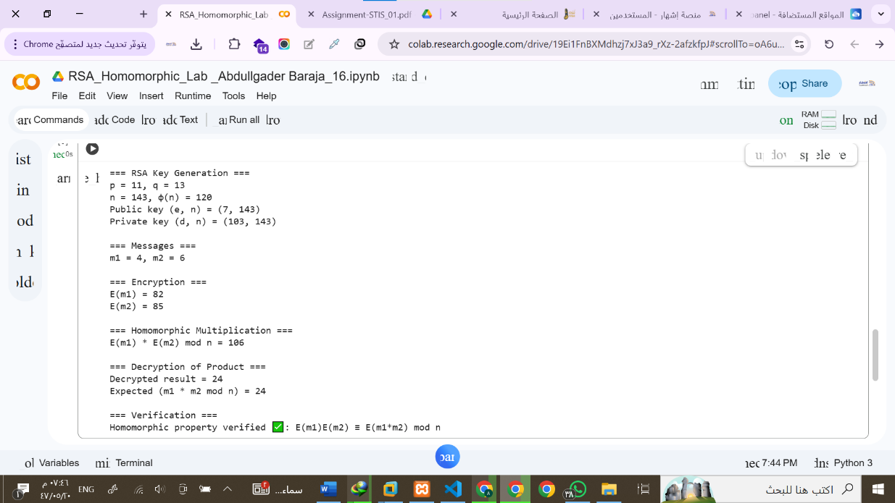
2- Output screenshot :

3- Lab Questions:

