**Reading 1**

I never learned hate at home, or shame. I had to go to school for that. I was about seven years old when I got my first big lesson. I was in love with a little girl named Helene Tucker, a light-complexioned little girl with pigtails and nice manners.

Everybody’s got a Helene Tucker, a symbol of everything you want. I loved her for her goodness, her cleanness, her popularity.

If I knew my place and didn’t come too close, she’d wink at me and say hello.

These passions, like great winds, have blown me hither and thither, in a wayward course, over a deep ocean of anguish, reaching to the very verge of despair.

I have sought it, next, because it relieves loneliness—that terrible loneliness in which one shivering consciousness looks over the rim of the world into the cold unfathomable lifeless abyss.

I have sought it, finally, because in the union of love I have seen, in a mystic miniature, the prefiguring vision of the heaven that saints and poets have imagined. This is what I sought, and though it might seem too good for human life, this is what—at last—I have found.

**Reading 2**

I knew then they were bigoted, but the culture spoke to me more powerfully than my mind and I felt ashamed for being different- a nonstandard person.

Whereas my other teachers approached the problem of easing in their new black pupil by ignoring him for the first few weeks, Miss Bean went right at me.

They weren’t brilliant answers, but they did establish the facts that I had read the assignment and that I could speak English.

Thus, the teacher began to give me human dimensions, though not perfect ones for an eighth-grader. It was somewhat better to be an incipient teacher’s pet than merely a dark presence in the back of the room onto whose silent form my classmates could fit all the stereotypes they carried in their heads.

I was for Roosevelt because my parents were, and I was for the Yankees because my older buddy from Harlem was a Yankee fan. Besides, we didn’t have opinions about historical figures like Jefferson. Like our high school building or old Mayor Welch, he just was.

**Reading 3**

Originally, the term self-made man referred to an individual who arises from a poor or otherwise disadvantaged background to eminence in financial, political or other areas by nurturing qualities, such as perseverance and hard work , as opposed to achieving these goals through inherited fortune, family connections, or other privileges.

“They are the men who, in a world of schools, academies, colleges and other institutions of learning, are often compelled by unfriendly circumstances to acquire their education elsewhere and, amidst unfavorable conditions, to hew out for themselves a way to success, and thus to become the architects of their own good fortunes. ... From the depths of poverty such as these have often come. ... From **hunger, rags and destitution**, they have come ...”

**Reading 4**

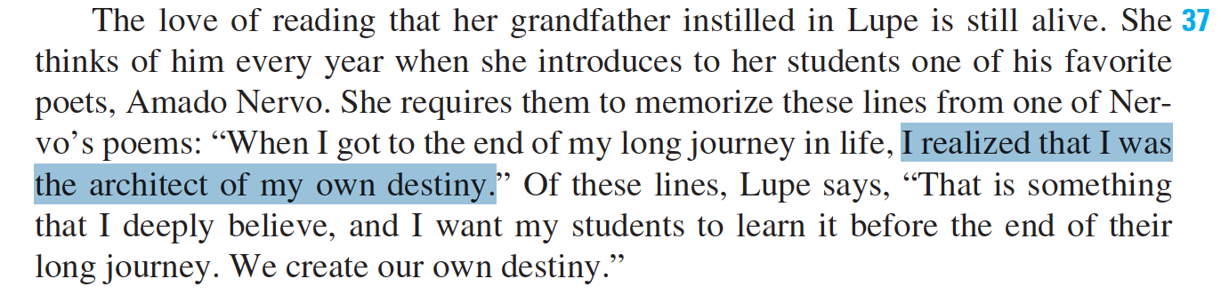

**Reading 5**

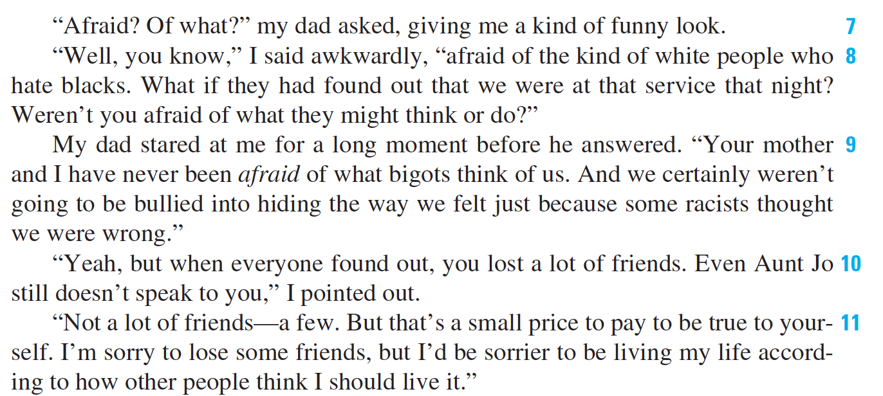

**Reading 6**

She found a way out and confided: “I considered my options: Confess openly to the teacher, copy someone else’s sheet, or make up an excuse.” Glanz chose the third option—the one most widely used—and told the teacher that the pages needed to complete the assignment had been ripped from the book. The teacher accepted the story, never checking the book. In class, nobody else did the homework; and student after student mumbled responses when called on.

“Finally,” Glanz said, “the teacher, thinking that the assignment must have been difficult, went over each question at the board while students copied the problems at their seats. The teacher had ‘covered’ the material and the students had listened to the explanation. But had anything been learned? I don’t think so.”

**Reading 7**

“The system encourages incredible passivity,” Glanz said. “In most classes one sits and listens. A teacher, whose role is activity, simply cannot understand the passivity of the student’s role,” she said. “When I taught,” Glanz recalled, “my mind was going constantly—figuring out how to best present an idea, thinking

about whom to call on, whom to draw out, whom to shut up; how to get students involved, how to make my point clearer, how to respond; when to be funny, when serious. As a student, I experienced little of this. Everything was done to me.”

**Reading 8**

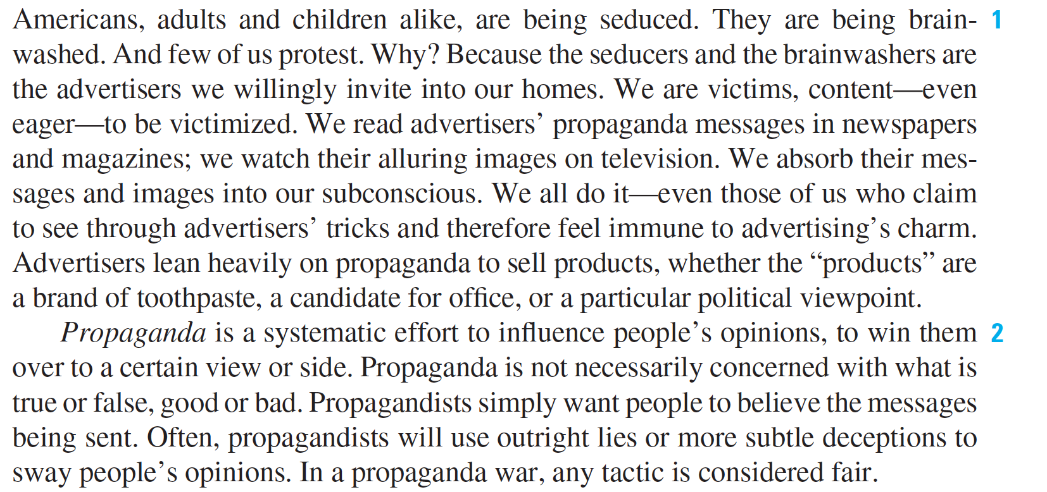

**Reading9**



**Reading 10**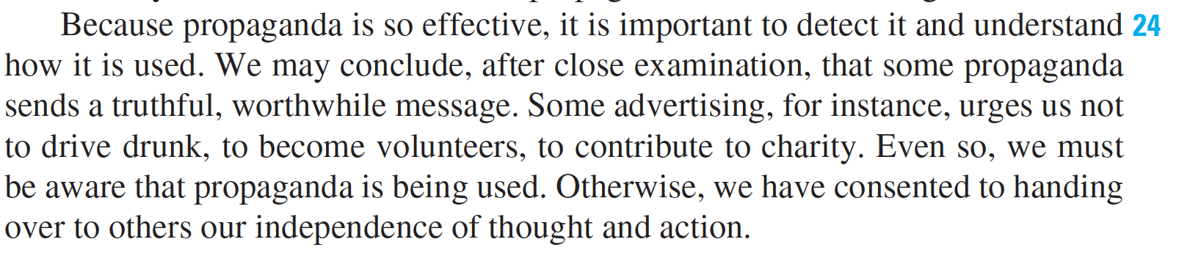

**Reading 11**

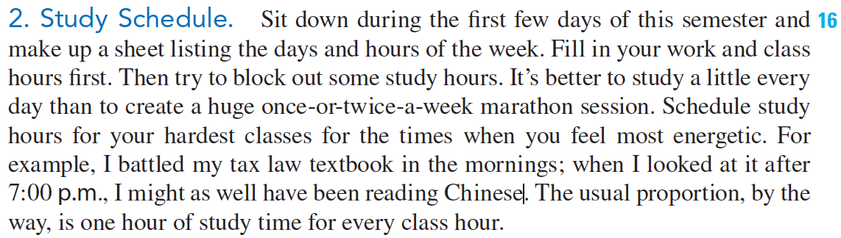

**Reading 12**

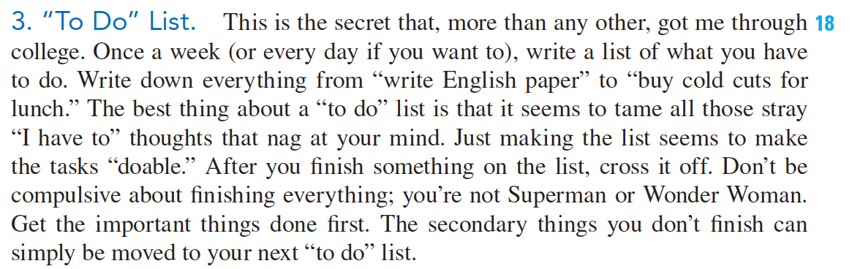

**Reading 13**

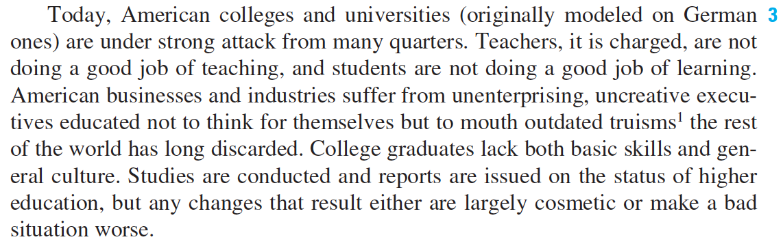

**Reading 14**

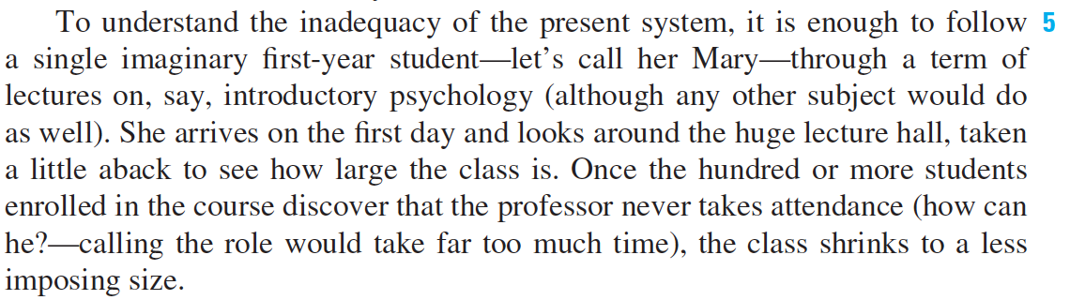

**Reading 15**

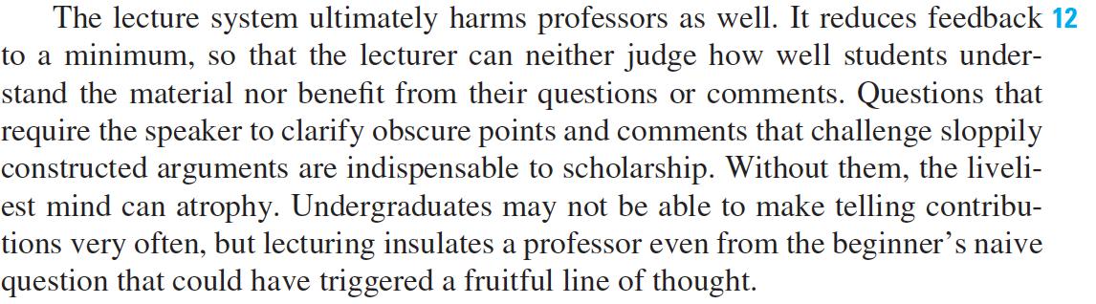

**Reading 16**

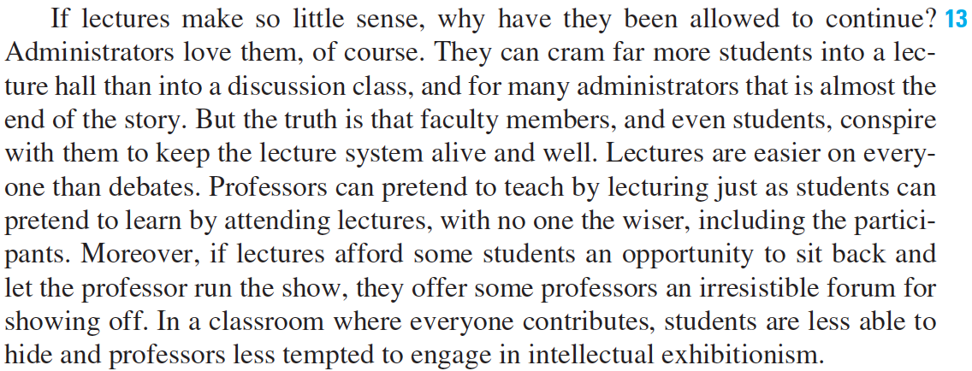

**Reading 17**

