1. **package** array_list;

**import** java.util.ArrayList;

**import** java.util.List;

**public** **class** colors {

**public** **static** **void** main(String[] args) {

List<String> str_list = **new** ArrayList<String>();

str_list.add("Red");

str_list.add("Green");

str_list.add("Orange");

str_list.add("Peach");

str_list.add("Olive");

System.***out***.println(str_list);

}

}

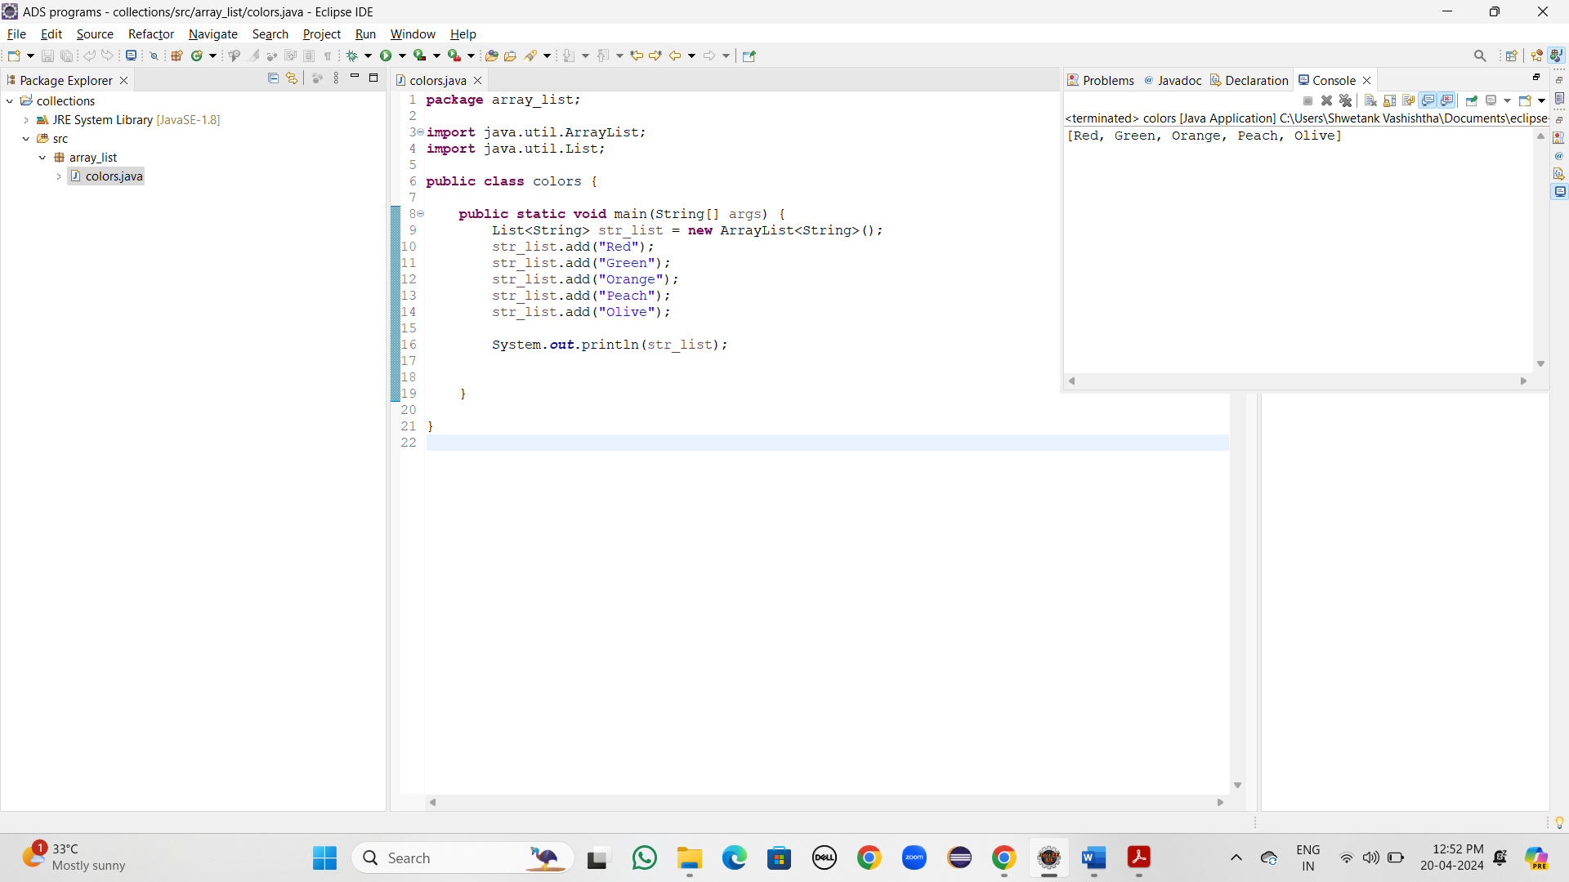

1. **package** array_list;

**import** java.util.ArrayList;

**import** java.util.List;

**public** **class** colors {

**public** **static** **void** main(String[] args) {

List<String> str_list = **new** ArrayList<String>();

str_list.add("Red");

str_list.add("Green");

str_list.add("Orange");

str_list.add("Yellow");

str_list.add("Olive");

System.***out***.println("List is: " + str_list);

str_list.add(0, "Peach");

System.***out***.println("Updated list is: " +str_list);

}

}

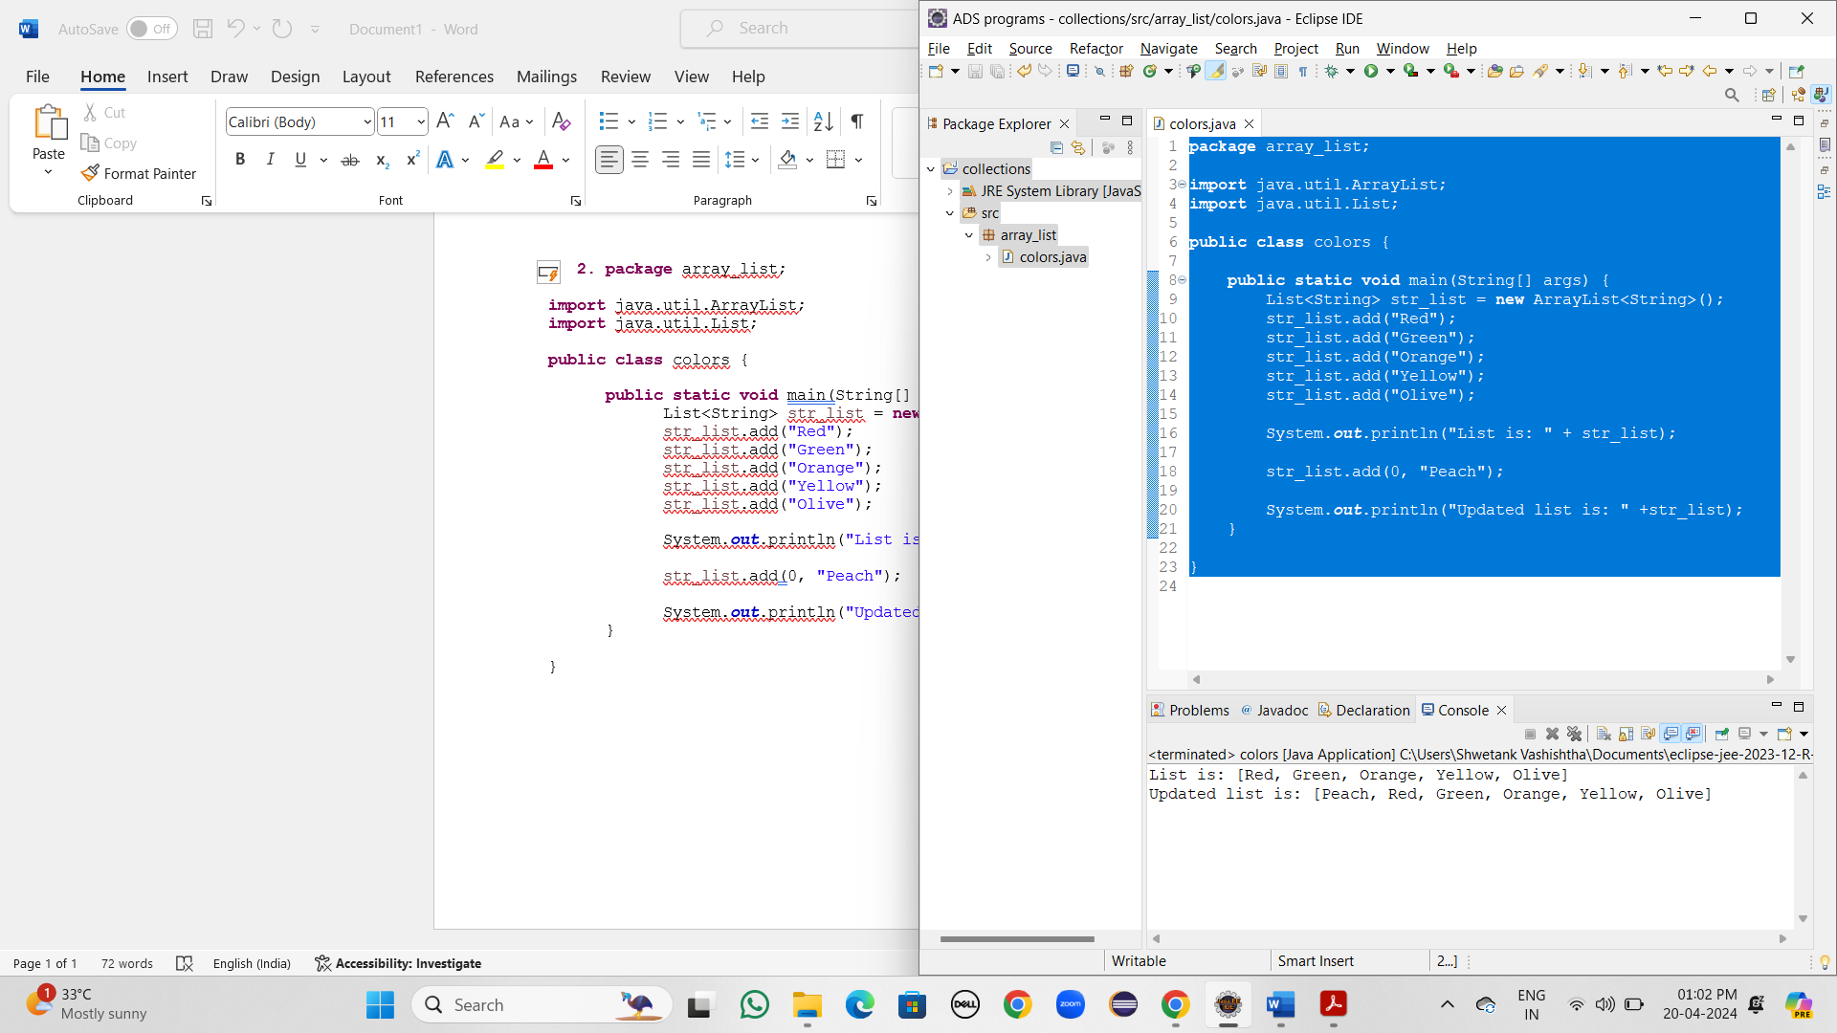

1. **package** array_list;

**import** java.util.ArrayList;

**import** java.util.List;

**public** **class** colors {

**public** **static** **void** main(String[] args) {

List<String> str_list = **new** ArrayList<String>();

str_list.add("Red");

str_list.add("Green");

str_list.add("Orange");

str_list.add("Yellow");

str_list.add("Olive");

System.***out***.println("List is: " + str_list);

System.***out***.println(str_list.get(4));

}

}

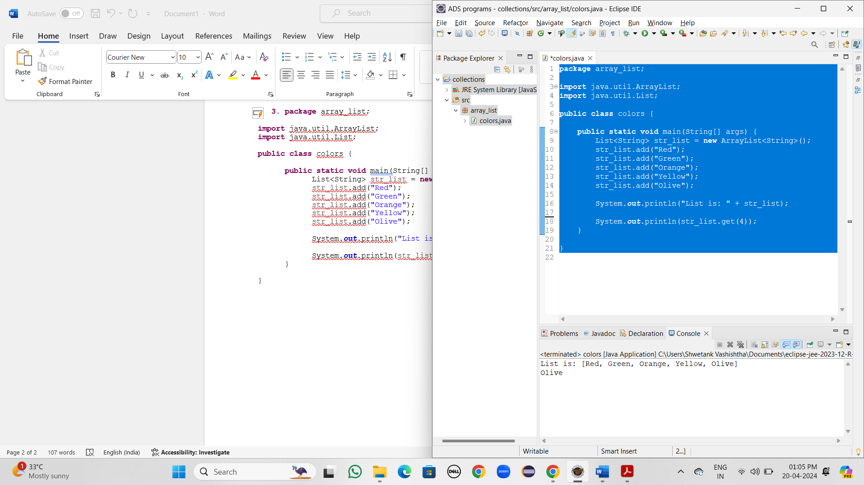

1. **package** array_list;

**import** java.util.ArrayList;

**import** java.util.Collections;

**import** java.util.List;

**public** **class** sortArrayList {

**public** **static** **void** main(String[] args) {

List<Integer> list = **new** ArrayList<Integer>();

list.add(5);

list.add(2);

list.add(44);

list.add(22);

list.add(66);

System.***out***.println("List is: " + list);

Collections.*sort*(list);

System.***out***.println("Sorted list is: " + list);

}

}

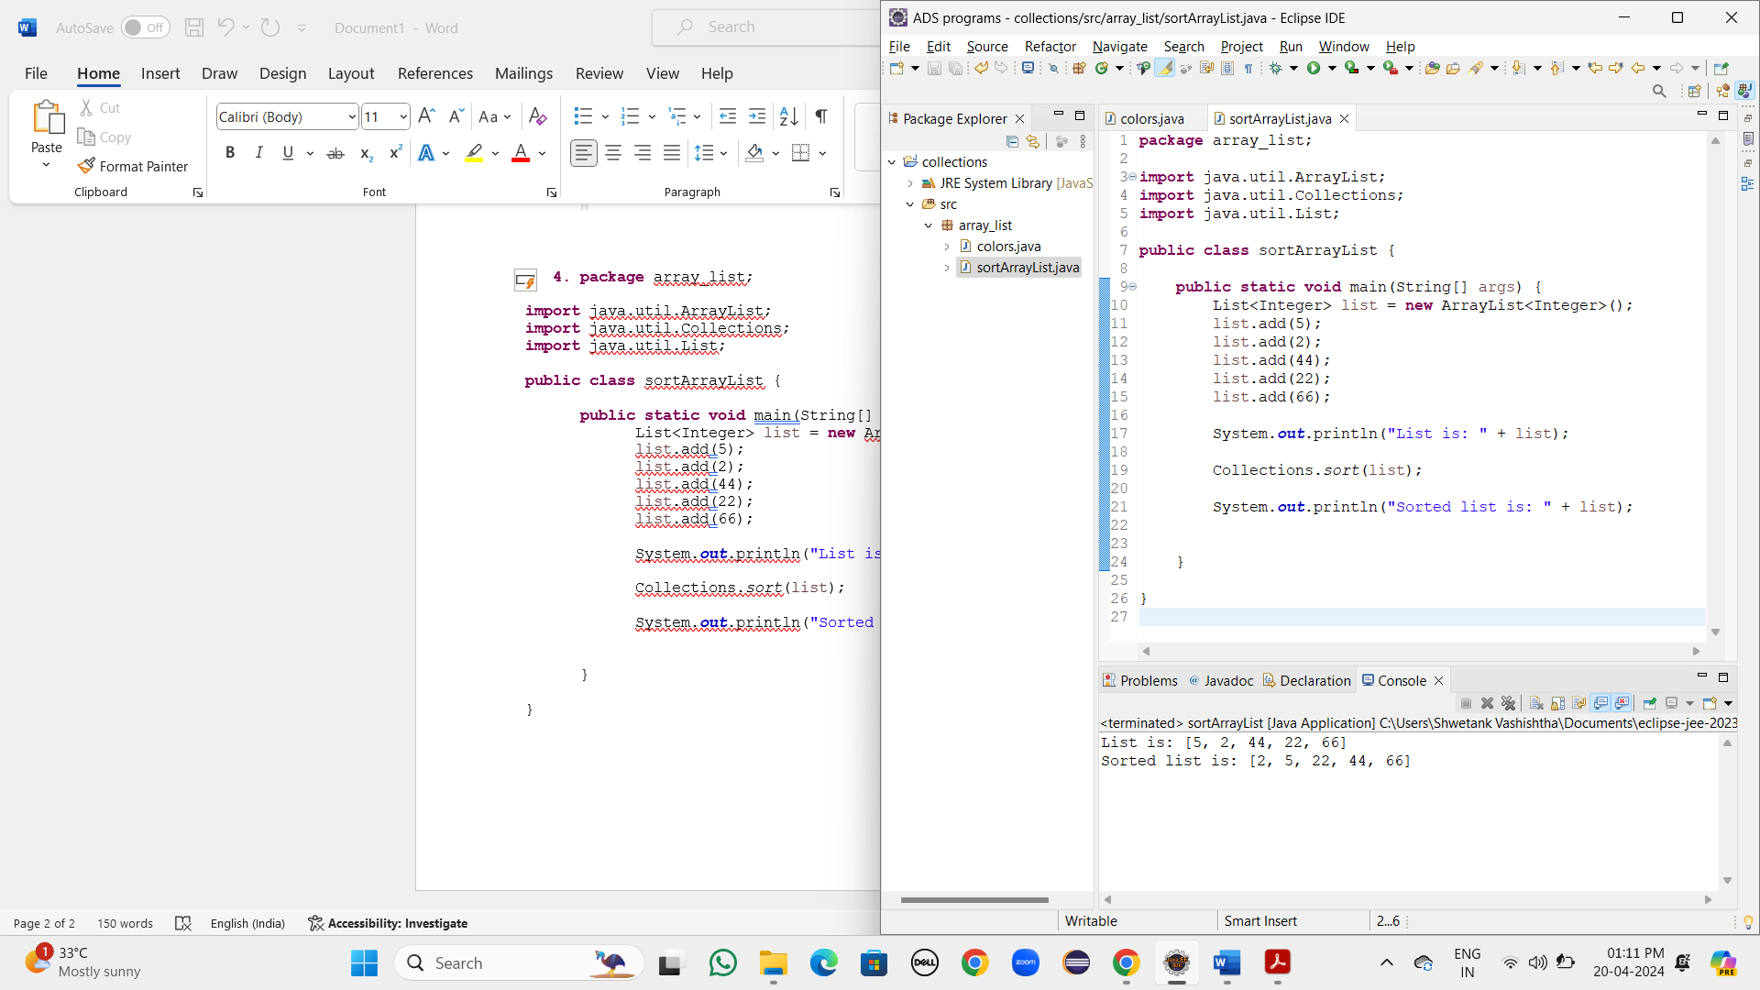

1. **package** array_list;

**import** java.util.ArrayList;

**import** java.util.Collections;

**import** java.util.List;

**public** **class** sortArrayList {

**public** **static** **void** main(String[] args) {

List<Integer> list = **new** ArrayList<Integer>();

list.add(5);

list.add(2);

list.add(44);

list.add(22);

list.add(66);

System.***out***.println("List is: " + list);

Collections.*sort*(list);

System.***out***.println("Sorted list is: " + list);

Collections.*reverse*(list);

System.***out***.println("Reversed list is: " + list);

}

}

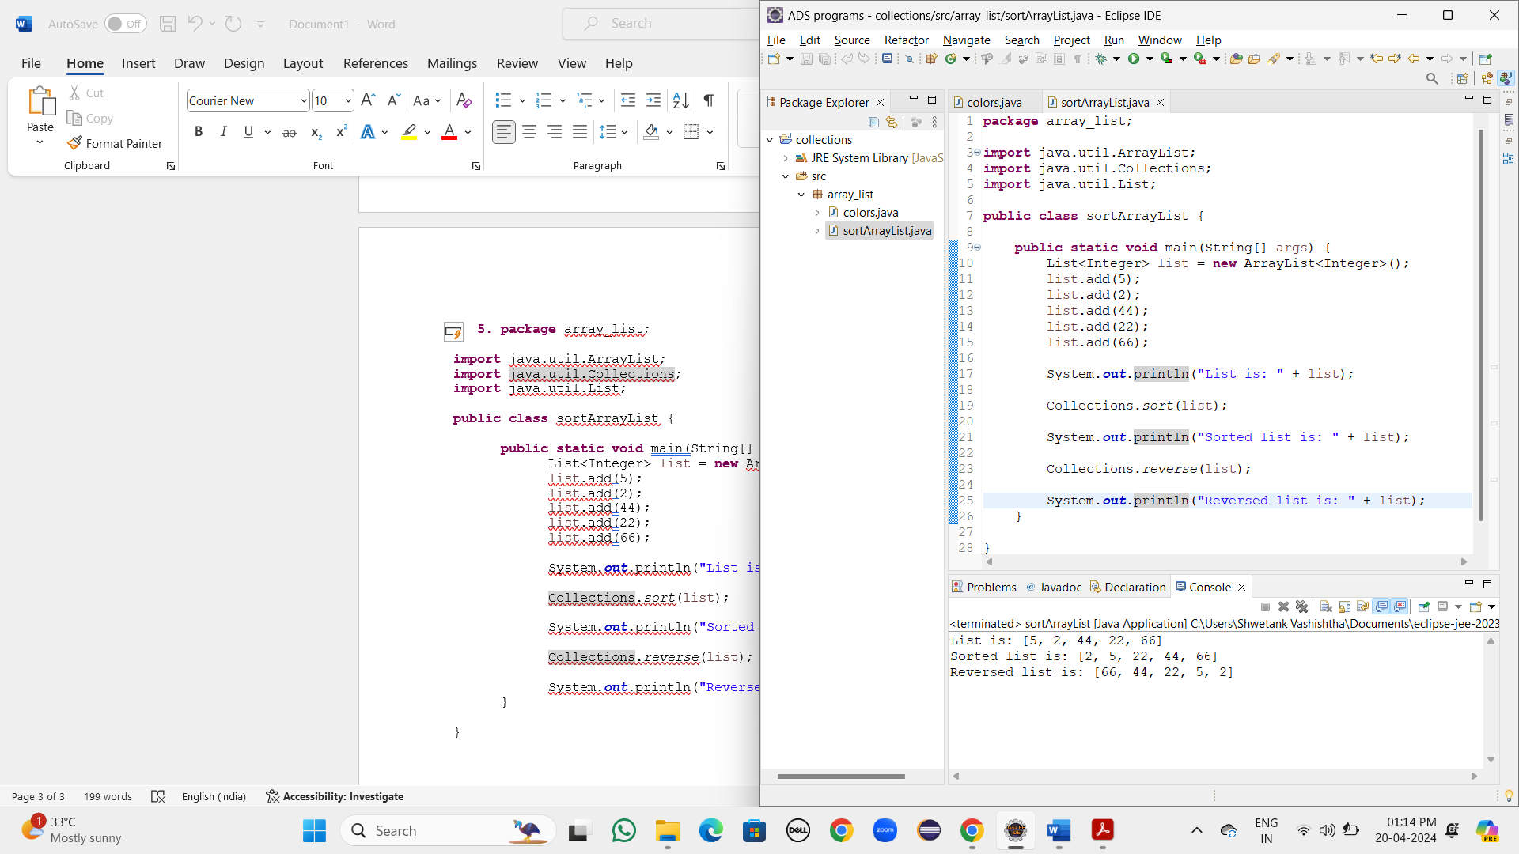

1. **package** array_list;

**import** java.util.ArrayList;

**import** java.util.Collections;

**import** java.util.List;

**public** **class** colors {

**public** **static** **void** main(String[] args) {

List<String> str_list = **new** ArrayList<String>();

str_list.add("Red");

str_list.add("Green");

str_list.add("Orange");

str_list.add("Yellow");

str_list.add("Olive");

System.***out***.println("List is: " + str_list);

str_list.add(0, "Peach");

System.***out***.println("Updated list is: " +str_list);

Collections.*swap*(str_list, 1, 5);

System.***out***.println("After swapping: " +str_list);

}

}

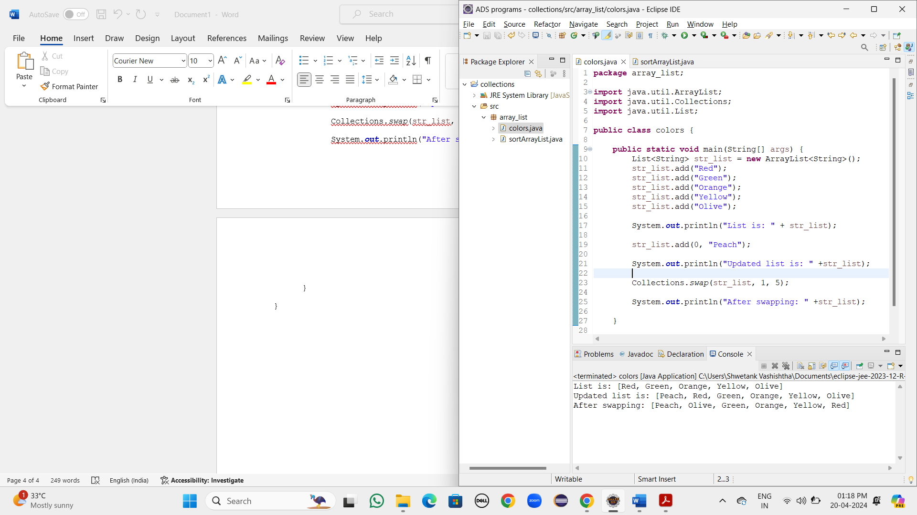

1. **package** array_list;

**import** java.util.ArrayList;

**import** java.util.Collections;

**import** java.util.List;

**public** **class** colors {

**public** **static** **void** main(String[] args) {

List<String> str_list = **new** ArrayList<String>();

str_list.add("Red");

str_list.add("Green");

str_list.add("Orange");

str_list.add("Yellow");

str_list.add("Olive");

System.***out***.println("List is: " + str_list);

str_list.add(0, "Peach");

System.***out***.println("Updated list is: " +str_list);

Collections.*swap*(str_list, 1, 5);

System.***out***.println("After swapping: " +str_list);

System.***out***.println("Element with their position: ");

**for**(**int** i = 0; i<str_list.size(); i++) {

System.***out***.println("Position " +i+ ": " + str_list.get(i));

}

}

}

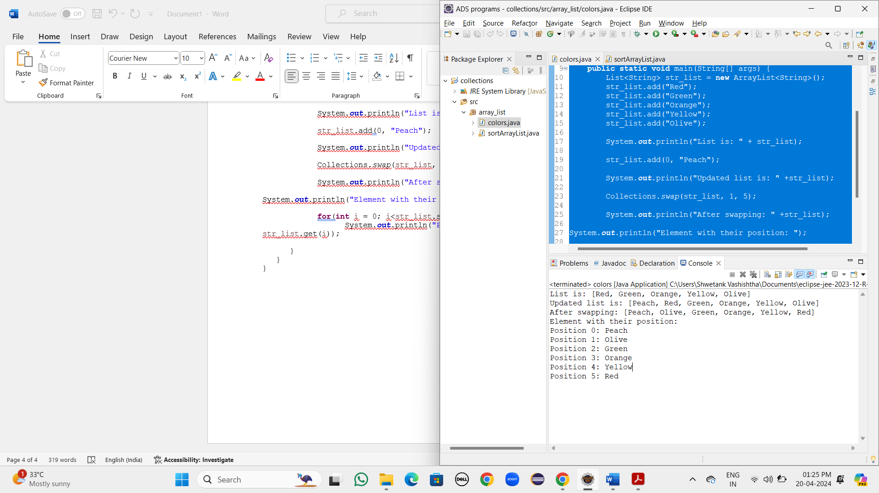

1. **package** array_list;

**import** java.util.ArrayList;

**import** java.util.Collections;

**import** java.util.List;

**public** **class** colors {

**public** **static** **void** main(String[] args) {

List<String> str_list = **new** ArrayList<String>();

str_list.add("Red");

str_list.add("Green");

str_list.add("Orange");

str_list.add("Yellow");

str_list.add("Olive");

System.***out***.println("List is: " + str_list);

str_list.add(0, "Peach");

System.***out***.println("Updated list is: " +str_list);

Collections.*swap*(str_list, 1, 5);

System.***out***.println("After swapping: " +str_list);

**int** position = 3;

String element = "Blue";

str_list.add(position, element);

System.***out***.println("Element at specified position: " +str_list);

}

}

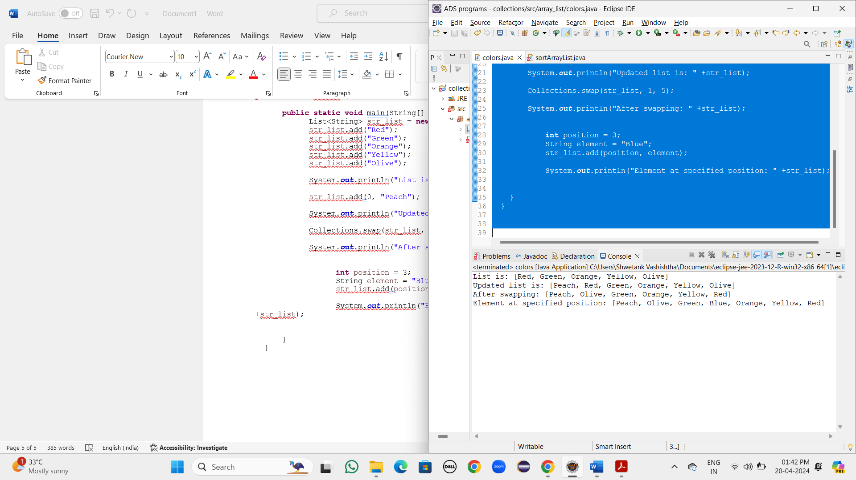

PATTERN

1. **package** logical_coding_questions;

**public** **class** pattern {

**public** **static** **void** main(String[] args) {

**for**(**int** i = 1; i<=5; i++) {

**for**(**int** j = i; j>=1; j--) {

System.***out***.print(j+ " ");

}

System.***out***.println();

}

}

}

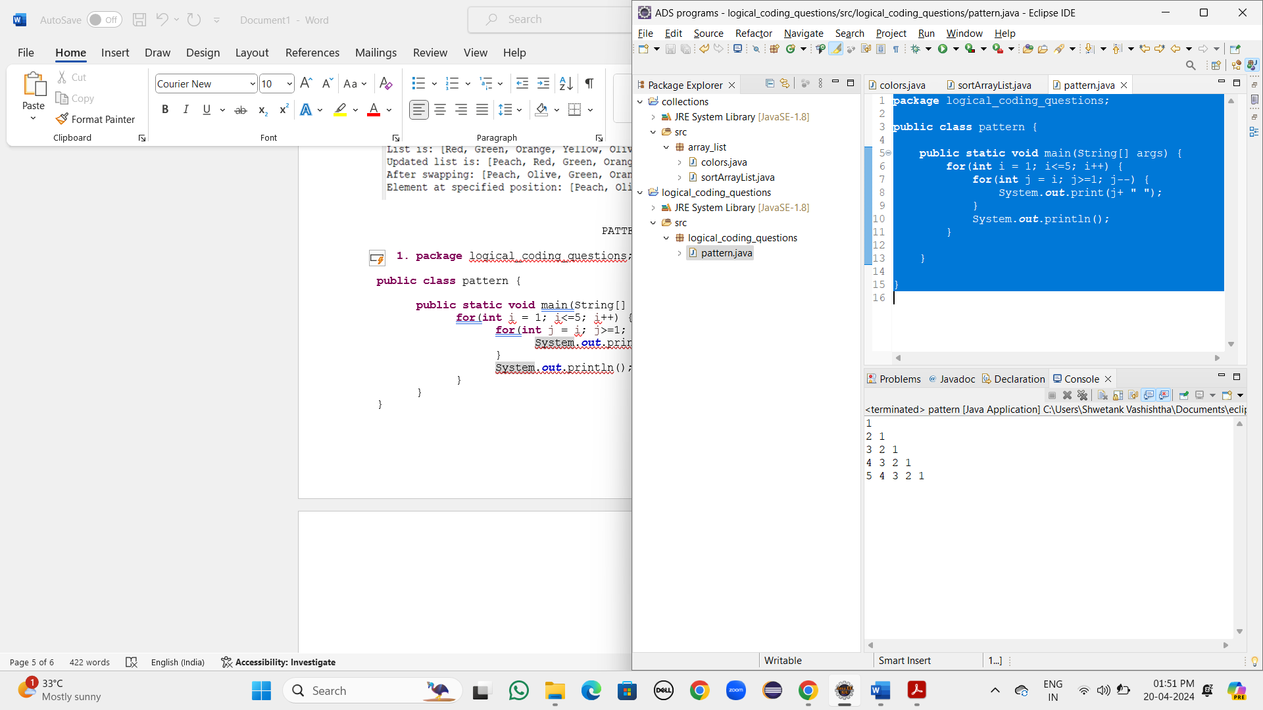

1. **package** logical_coding_questions;

**public** **class** pattern {

**public** **static** **void** main(String[] args) {

**for**(**int** i = 1; i<=5; i++) {

**for**(**int** j = 1; j<=i; j++) {

**if**(j%2==1) {

System.***out***.print("1 ");

}

**else** {

System.***out***.print("0 ");

}

}

System.***out***.println();

}

}

}

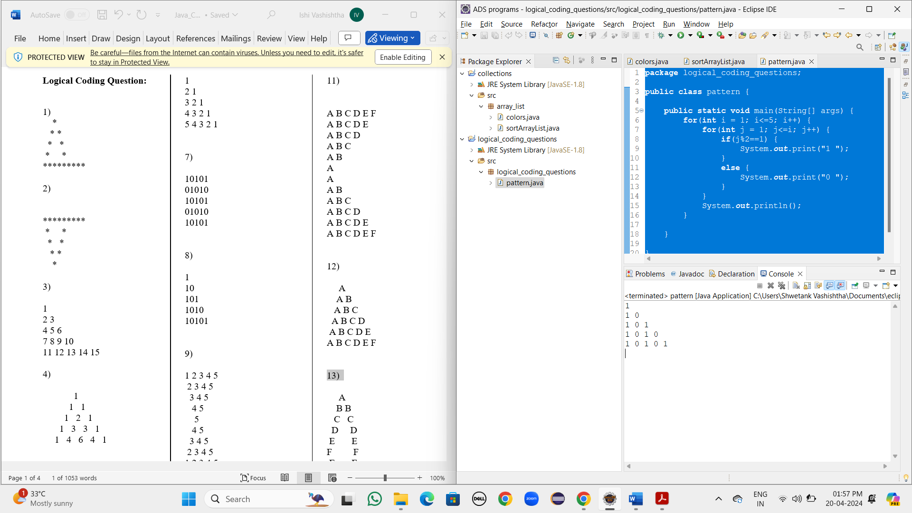

1. **package** logical_coding_questions;

**public** **class** pattern {

**public** **static** **void** main(String[] args) {

**int** cnt = 1;

**for**(**int** i = 1; i<=5; i++) {

**for**(**int** j = 1; j<=i; j++) {

System.***out***.print(cnt+ " ");

cnt++;

}

System.***out***.println();

}

}

}

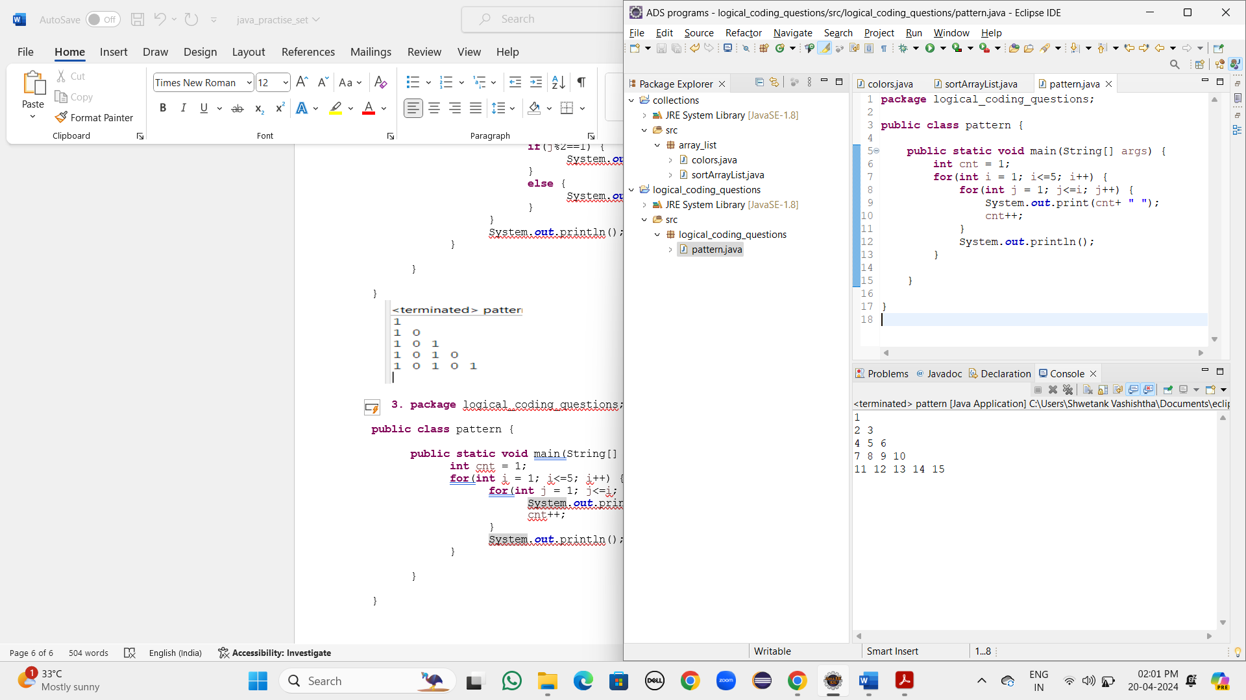

1. **package** logical_coding_questions;

**public** **class** pattern {

**public** **static** **void** main(String[] args) {

**for**(**int** i = 1; i<=5; i++) {

**for**(**int** j = 1; j<=5; j++) {

**if**((i+j)%2==0) {

System.***out***.print("1 ");

}

**else** {

System.***out***.print("0 ");

}

}

System.***out***.println();

}

}

}

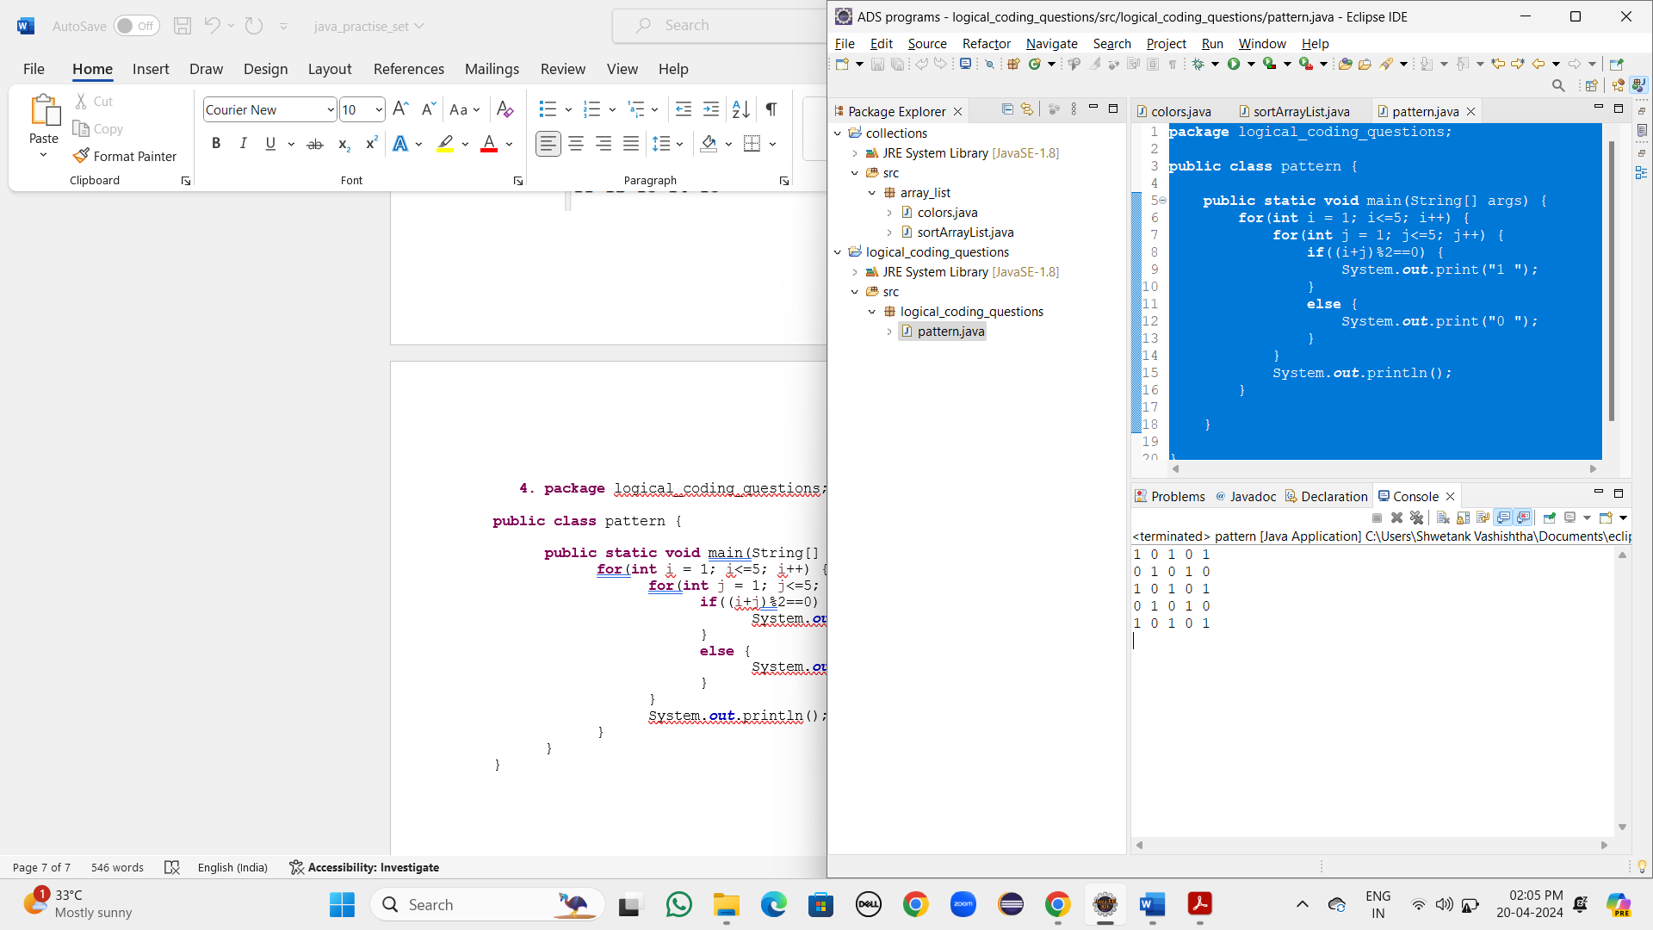

1. **package** logical_coding_questions;

**public** **class** pattern {

**public** **static** **void** main(String[] args) {

**for**(**int** i = 1; i<=5; i++) {

**for**(**int** j = i; j>=1; j--) {

System.***out***.print("* ");

}

System.***out***.println();

}

**for**(**int** i = 4; i>=1;i--) {

**for**(**int** j = 1; j<=i; j++) {

System.***out***.print("* ");

}

System.***out***.println();

}

}

}

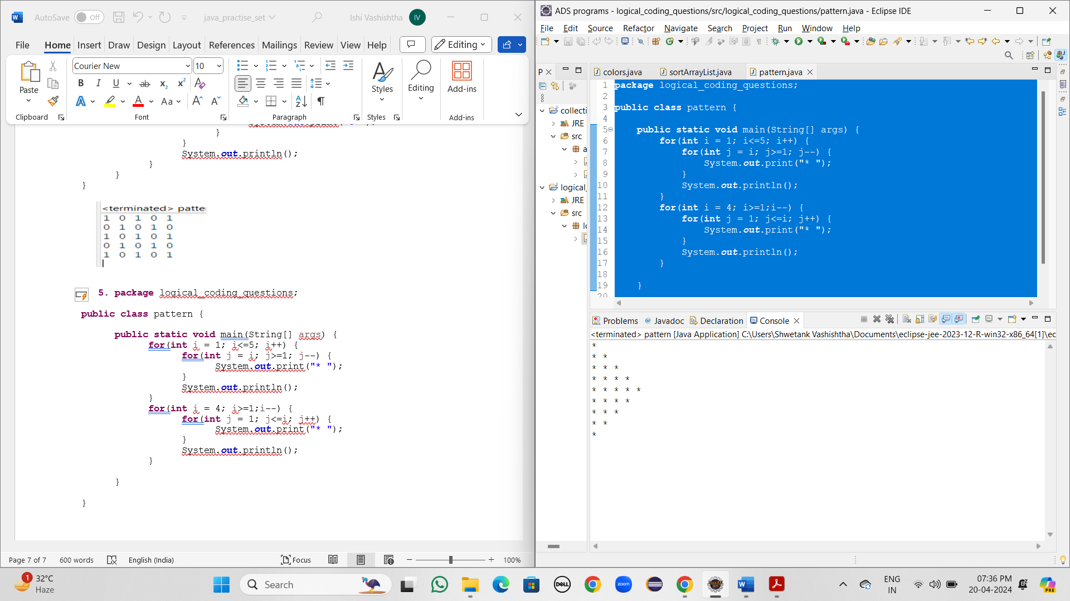

1. **package** logical_coding_questions;

**public** **class** pattern {

**public** **static** **void** main(String[] args) {

**for**(**int** i = 1; i<=7; i++) {

**for**(**int** j = 7; j>=7-i+1; j--) {

System.***out***.print(j+ " ");

}

System.***out***.println();

}

}

}

