# E and ID proteins regulate cell chirality and left-right asymmetric development in *Drosophila*

Tomoki Ishibashi1, Ryo Hatori1, Reo Maeda2, Mitsutoshi Nakamura1, Tomohiro Taguchi2, Yoko Matsuyama1, and Kenji Matsuno1*  
1 Department of Biological Sciences, Osaka University, 1-1 Machikaneyama-cho, Toyonaka, Osaka 560-0043, Japan; 2 Department of Biological Science and Technology, Tokyo University of Science, Noda, Chiba, Japan  
* Corresponding author. Tel.: +81-6-6850-5805; Fax: +81-6-6850-5805  
E-mail addresses: Kenji Matsuno: kmatsuno@bio.sci.osaka-u.ac.jp  
Short title: E and ID regulate left-right asymmetry  
Keywords: E protein, Id protein, Left-right asymmetry, Myosin ID, Cell chirality.

## Abstruct

How left-right (LR) asymmetry forms in the animal body is a fundamental problem in Developmental Biology. While the mechanisms for LR asymmetry are well studied in some species, they are still poorly understood in invertebrates. We previously showed that the intrinsic LR asymmetry of cells (designated as cell chirality) drives LR asymmetric development in the *Drosophila* embryonic hindgut, although the machinery of the cell chirality formation remains elusive. Here, we found that the *Drosophila* homolog of the *Id* gene, *extra macrochaetae* (*emc*), is required for the normal LR asymmetric morphogenesis of this organ. Id proteins, including Emc, are known to interact with and inhibit E-box-binding proteins (E proteins), such as *Drosophila* Daughterless (Da). We found that the suppression of da by wild-type *emc* was essential for cell chirality formation and for normal LR asymmetric development of the embryonic hindgut. *MyosinID* (*MyoID*), which encodes the *Drosophila* Myosin ID protein, is known to regulate cell chirality. We further showed that Emc-Da regulates cell chirality formation, in which Emc functions upstream of or parallel to MyoID. Abnormal Id-E protein regulation is involved in various human diseases. Our results suggest that defects in cell shape may contribute to the pathogenesis of such diseases.

## Introduction

### Left-right asymmetry in animals

Many animals show the directional LR asymmetry in their body structures and functions. Mechanisms of LR asymmetric development have been the one of central question in Developmental Biology (Levin, 2005). The molecular mechanisms of the LR asymmetric development have been well studied, although mostly in vertebrates (Blum & Ott, 2018; Kimelman & Martin, 2012; Riechmann & Ephrussi, 2001). For example, in some vertebrates, the LR symmetry is first broken by an LR directional flow of extra-embryonic fluid, which is induced by ciliary rotation in the node or its equivalent tissue in early embryos (Yoshiba & Hamada, 2014). In contrast, in invertebrates the mechanisms of LR-asymmetry formation remain unclear, although a few excellent studies have unveiled basic concepts behind the directional LR asymmetry formation in nematodes, snails, and *Drosophila* (Blum & Ott, 2018; R. Kuroda, Endo, Abe, & Shimizu, 2009; Okumura et al., 2008; Spéder & Noselli, 2007). Some invertebrate species develop LR asymmetric body structures using mechanisms arising from the intrinsic chirality of blastomeres or cells in tissues, which is distinct from the mechanism used in vertebrates, indicating that the processes for directional LR symmetric development diverged in evolution (Blum & Ott, 2018; Inaki et al., 2018; Okumura et al., 2008).

Several organs in *Drosophila* also show a directional LR asymmetric morphology (Hayashi & Murakami, 2001; S. Hozumi et al., 2006; Ligoxygakis, Strigini, & Averof, 2001; Pascual, Huang, Neveu, & Préat, 2004; Spéder, Ádám, & Noselli, 2006). Among these organs, the embryonic gut is the first to exhibit an LR asymmetric shape during development (Campos-Ortega, 2015; Hayashi & Murakami, 2001; Ligoxygakis et al., 2001). The embryonic hindgut shows the simple morphology exhibiting the stereotypic LR asymmetry, in which a monolayer epithelial tube bends like a hook at its most anterior part (Fig. 1A). At an early stage of embryonic development (stage 12), the hindgut is LR symmetric and bends toward the ventral side of the embryo (Fig. 1A). At the next stage of development (stage 12-13), the hindgut rotates anticlockwise 90°, which causes the hindgut to curve rightward and to be LR asymmetric (Fig. 1A) (Hayashi & Murakami, 2001; S. Hozumi et al., 2006). Neither cell division nor apoptosis is involved in this rotation (Campos-Ortega, 2015). Moreover, the embryonic hindgut epithelial tube, but not the surrounding visceral muscles, is sufficient for this rotation (S. Hozumi et al., 2006; M. Nakamura et al., 2013). Thus, LR asymmetric cell deformation of the hindgut epithelial cells themselves may contribute to the hindgut rotation.

### Cell chirality

In agreement with this idea, we previously reported that the epithelial cells of the embryonic hindgut exhibit an LR-asymmetric shape in their apical surface before hindgut rotation (R. Hatori et al., 2014; Inaki et al., 2018; Inaki, Liu, & Matsuno, 2016; Inaki, Sasamura, & Matsuno, 2018; Taniguchi et al., 2011). Lorem ipsum dolor sit amet, consectetur adipiscing elit, sed do eiusmod tempor incididunt ut labore et dolore magna aliqua. Ut enim ad minim veniam, quis nostrud exercitation ullamco laboris nisi ut aliquip ex ea commodo consequat. Duis aute irure dolor in reprehenderit in voluptate velit esse cillum dolore eu fugiat nulla pariatur. Excepteur sint occaecat cupidatat non proident, sunt in culpa qui officia deserunt mollit anim id est laborum.

## Experimental Procedures

### *Drosophila* strains and genetic crosses

*Canton-S* was used as the wild-type (WT) strain. The following mutants were used: *emctink*, a null allele induced by ethyl methanesulfonate in this study; *emcAP6*, an amorphic allele (Bloomington #36544; Ellis, 1994); *emc2*, a hypomorphic allele (Kyoto DGRC #101588; Ellis, Spann, & Posakony, 1990).

Mutations on the first and second chromosome were balanced with *FM7c, P{ftz/lacC}YH1* and *CyO, P{en1}wgen11*, respectively. Mutations on the third chromosome were balanced with *TM3, P{ftz-lacZ.ry+}TM3, Sb1 ry\**, *TM6B, P{iab-2(1.7)lacZ}6B, Tb1*, or *TM3, P{GAL4-twi.G}2.3, P{UAS-2xEGFP}AH2.3, Sb1 Ser1*. All genetic crosses were performed at 25 °C on a standard *Drosophila* culture medium.

### Staining of embryos

Lorem ipsum dolor sit amet, consectetur adipiscing elit, sed do eiusmod tempor incididunt ut labore et dolore magna aliqua. Ut enim ad minim veniam, quis nostrud exercitation ullamco laboris nisi ut aliquip ex ea commodo consequat. Duis aute irure dolor in reprehenderit in voluptate velit esse cillum dolore eu fugiat nulla pariatur. Excepteur sint occaecat cupidatat non proident, sunt in culpa qui officia deserunt mollit anim id est laborum.

Lorem ipsum dolor sit amet, consectetur adipiscing elit, sed do eiusmod tempor incididunt ut labore et dolore magna aliqua. Ut enim ad minim veniam, quis nostrud exercitation ullamco laboris nisi ut aliquip ex ea commodo consequat. Duis aute irure dolor in reprehenderit in voluptate velit esse cillum dolore eu fugiat nulla pariatur. Excepteur sint occaecat cupidatat non proident, sunt in culpa qui officia deserunt mollit anim id est laborum.

## Results

### *emc* is required for LR-asymmetric development of the embryonic hindgut

Sample equation . You can write block-style equation.

Lorem ipsum dolor sit amet, consectetur adipiscing elit, sed do eiusmod tempor incididunt ut labore et dolore magna aliqua. Ut enim ad minim veniam, quis nostrud exercitation ullamco laboris nisi ut aliquip ex ea commodo consequat. Duis aute irure dolor in reprehenderit in voluptate velit esse cillum dolore eu fugiat nulla pariatur. Excepteur sint occaecat cupidatat non proident, sunt in culpa qui officia deserunt mollit anim id est laborum.

Lorem ipsum dolor sit amet, consectetur adipiscing elit, sed do eiusmod tempor incididunt ut labore et dolore magna aliqua. Ut enim ad minim veniam, quis nostrud exercitation ullamco laboris nisi ut aliquip ex ea commodo consequat. Duis aute irure dolor in reprehenderit in voluptate velit esse cillum dolore eu fugiat nulla pariatur. Excepteur sint occaecat cupidatat non proident, sunt in culpa qui officia deserunt mollit anim id est laborum.

### Result 2

Lorem ipsum dolor sit amet, consectetur adipiscing elit, sed do eiusmod tempor incididunt ut labore et dolore magna aliqua. Ut enim ad minim veniam, quis nostrud exercitation ullamco laboris nisi ut aliquip ex ea commodo consequat. Duis aute irure dolor in reprehenderit in voluptate velit esse cillum dolore eu fugiat nulla pariatur. Excepteur sint occaecat cupidatat non proident, sunt in culpa qui officia deserunt mollit anim id est laborum.

Lorem ipsum dolor sit amet, consectetur adipiscing elit, sed do eiusmod tempor incididunt ut labore et dolore magna aliqua. Ut enim ad minim veniam, quis nostrud exercitation ullamco laboris nisi ut aliquip ex ea commodo consequat. Duis aute irure dolor in reprehenderit in voluptate velit esse cillum dolore eu fugiat nulla pariatur. Excepteur sint occaecat cupidatat non proident, sunt in culpa qui officia deserunt mollit anim id est laborum.

## Discussion

### Discussion 1

Lorem ipsum dolor sit amet, consectetur adipiscing elit, sed do eiusmod tempor incididunt ut labore et dolore magna aliqua. Ut enim ad minim veniam, quis nostrud exercitation ullamco laboris nisi ut aliquip ex ea commodo consequat. Duis aute irure dolor in reprehenderit in voluptate velit esse cillum dolore eu fugiat nulla pariatur. Excepteur sint occaecat cupidatat non proident, sunt in culpa qui officia deserunt mollit anim id est laborum.

Lorem ipsum dolor sit amet, consectetur adipiscing elit, sed do eiusmod tempor incididunt ut labore et dolore magna aliqua. Ut enim ad minim veniam, quis nostrud exercitation ullamco laboris nisi ut aliquip ex ea commodo consequat. Duis aute irure dolor in reprehenderit in voluptate velit esse cillum dolore eu fugiat nulla pariatur. Excepteur sint occaecat cupidatat non proident, sunt in culpa qui officia deserunt mollit anim id est laborum.

### Discussion 2

Lorem ipsum dolor sit amet, consectetur adipiscing elit, sed do eiusmod tempor incididunt ut labore et dolore magna aliqua. Ut enim ad minim veniam, quis nostrud exercitation ullamco laboris nisi ut aliquip ex ea commodo consequat. Duis aute irure dolor in reprehenderit in voluptate velit esse cillum dolore eu fugiat nulla pariatur. Excepteur sint occaecat cupidatat non proident, sunt in culpa qui officia deserunt mollit anim id est laborum.

Lorem ipsum dolor sit amet, consectetur adipiscing elit, sed do eiusmod tempor incididunt ut labore et dolore magna aliqua. Ut enim ad minim veniam, quis nostrud exercitation ullamco laboris nisi ut aliquip ex ea commodo consequat. Duis aute irure dolor in reprehenderit in voluptate velit esse cillum dolore eu fugiat nulla pariatur. Excepteur sint occaecat cupidatat non proident, sunt in culpa qui officia deserunt mollit anim id est laborum.

## Figures and Tables

### Figure 1

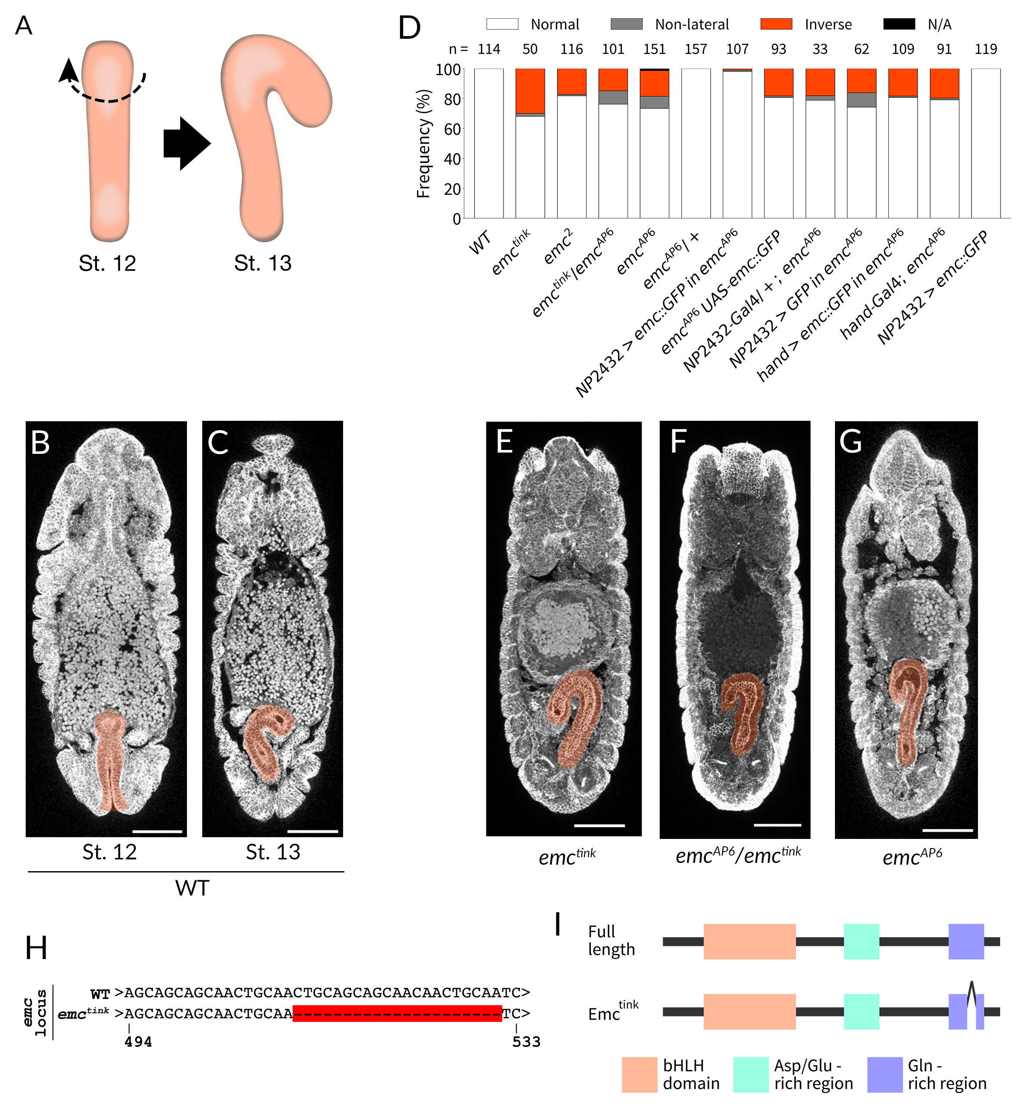  
**Fig. 1.** ***emc*** **mutant embryos show defects in LR asymmetric development of the embryonic hindgut.**  
(A) Schematic showing the LR asymmetric development of the *Drosophila* embryonic hindgut as viewed from the dorsal side. The hindgut has an LR symmetric shape bending dorsally (left) at stage 12, and then undergoes a counterclockwise (broken arrow) rotation from late stage 12, consequently bending to the right at stage 13 (right). (B-C) The hindgut (orange) of wild-type embryos at stage 12 (B) and stage 13 (C). (D-I) Lorem ipsum dolor sit amet, consectetur adipiscing elit, sed do eiusmod tempor incididunt ut labore et dolore magna aliqua. Ut enim ad minim veniam, quis nostrud exercitation ullamco laboris nisi ut aliquip ex ea commodo consequat. Duis aute irure dolor in reprehenderit in voluptate velit esse cillum dolore eu fugiat nulla pariatur. Excepteur sint occaecat cupidatat non proident, sunt in culpa qui officia deserunt mollit anim id est laborum.

### Figure 2

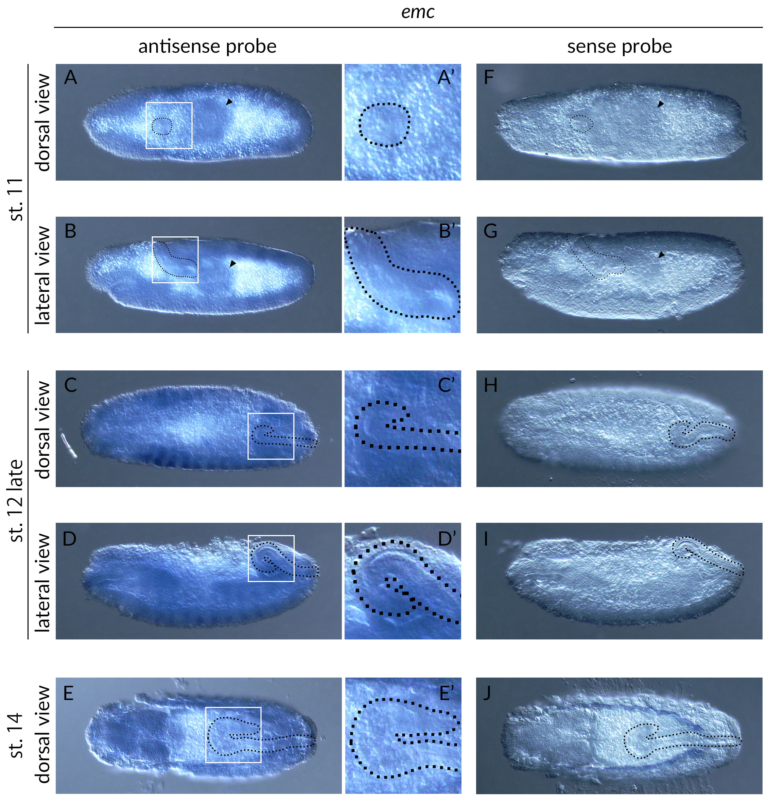  
**FIg. 2. Figure Title.**  
(A) Lorem ipsum dolor sit amet, consectetur adipiscing elit, sed do eiusmod tempor incididunt ut labore et dolore magna aliqua. Ut enim ad minim veniam, quis nostrud exercitation ullamco laboris nisi ut aliquip ex ea commodo consequat. Duis aute irure dolor in reprehenderit in voluptate velit esse cillum dolore eu fugiat nulla pariatur. Excepteur sint occaecat cupidatat non proident, sunt in culpa qui officia deserunt mollit anim id est laborum. (B) Lorem ipsum dolor sit amet, consectetur adipiscing elit, sed do eiusmod tempor incididunt ut labore et dolore magna aliqua. Ut enim ad minim veniam, quis nostrud exercitation ullamco laboris nisi ut aliquip ex ea commodo consequat. Duis aute irure dolor in reprehenderit in voluptate velit esse cillum dolore eu fugiat nulla pariatur. Excepteur sint occaecat cupidatat non proident, sunt in culpa qui officia deserunt mollit anim id est laborum.

### Table S1

|  |  |  |  |
| --- | --- | --- | --- |
| *emc* expressionin the hindgut | stage 11 | stage 12 | stage 14 |
| + | 11 | 4 | 0 |
| +/- | 1 | 13 | 7 |
| - | 0 | 0 | 14 |
| **TOTAL** | **12** | **17** | **21** |

**Table S1** The expression of *emc* was detected by *in situ* hybridization using an antisense probe for *emc* (see Figure 2). The numbers of embryos showing *emc* signals in the hindgut primordium and hindgut are shown. +, strong signal; +/-, weak signal; -, no signal.

## References

Blum, M., & Ott, T. (2018). Animal left–right asymmetry. <https://doi.org/10.1016/j.cub.2018.02.073>

Campos-Ortega, J. A. (2015). *[Book] The Embryonic Development of Drosophila Melanogaster* (Vol. 1). <https://doi.org/10.1007/978-3-662-02454-6>

Ellis, H. M. (1994). Embryonic expression and function of the Drosophila helix-loop-helix gene, extramacrochaetae. *Mech. Dev.*, *47*(1), 65–72. <https://doi.org/10.1016/0925-4773(94)90096-5>

Ellis, H. M., Spann, D. R., & Posakony, J. W. (1990). extramacrochaetae, a negative regulator of sensory organ development in Drosophila, defines a new class of helix-loop-helix proteins. *Cell*, *61*(1), 27–38. <https://doi.org/10.1016/0092-8674(90)90212-W>

Hatori, R., Ando, T., Sasamura, T., Nakazawa, N., Nakamura, M., Taniguchi, K., … Matsuno, K. (2014). Left-right asymmetry is formed in individual cells by intrinsic cell chirality. *Mech. Dev.*, *133*, 146–162. <https://doi.org/10.1016/j.mod.2014.04.002>

Hayashi, T., & Murakami, R. (2001). Left-right asymmetry in Drosophila melanogaster gut development. *Dev. Growth Differ.*, *43*(3), 239–246. <https://doi.org/10.1046/j.1440-169X.2001.00574.x>

Hozumi, S., Maeda, R., Taniguchi, K., Kanai, M., Shirakabe, S., Sasamura, T., … Matsuno, K. (2006). An unconventional myosin in Drosophila reverses the default handedness in visceral organs. *Nature*, *440*(7085), 798–802. <https://doi.org/10.1038/nature04625>

Inaki, M., Hatori, R., Nakazawa, N., Okumura, T., Ishibashi, T., Kikuta, J., … Honda, H. (2018). Chiral cell sliding drives left-right asymmetric organ twisting. *Elife*, *7*. <https://doi.org/10.7554/eLife.32506>

Inaki, M., Liu, J., & Matsuno, K. (2016). Cell chirality: Its origin and roles in left-right asymmetric development. <https://doi.org/10.1098/rstb.2015.0403>

Inaki, M., Sasamura, T., & Matsuno, K. (2018). Cell Chirality Drives Left-Right Asymmetric Morphogenesis. *Front. Cell Dev. Biol.*, *6*. <https://doi.org/10.3389/fcell.2018.00034>

Kimelman, D., & Martin, B. L. (2012). Anterior-posterior patterning in early development: Three strategies. *Wiley Interdiscip. Rev. Dev. Biol.*, *1*(2), 253–266. <https://doi.org/10.1002/wdev.25>

Kuroda, R., Endo, B., Abe, M., & Shimizu, M. (2009). Chiral blastomere arrangement dictates zygotic left-right asymmetry pathway in snails. *Nature*, *462*(7274), 790–794. <https://doi.org/10.1038/nature08597>

Levin, M. (2005). Left-right asymmetry in embryonic development: A comprehensive review. <https://doi.org/10.1016/j.mod.2004.08.006>

Ligoxygakis, P., Strigini, M., & Averof, M. (2001). Specification of left-right asymmetry in the embryonic gut of Drosophila. *Development*, *128*(7), 1171–1174. Retrieved from <http://www.ncbi.nlm.nih.gov/pubmed/11245582>

Nakamura, M., Matsumoto, K., Iwamoto, Y., Muguruma, T., Nakazawa, N., Hatori, R., … Matsuno, K. (2013). Reduced cell number in the hindgut epithelium disrupts hindgut left-right asymmetry in a mutant of pebble, encoding a RhoGEF, in Drosophila embryos. *Mech. Dev.*, *130*(2-3), 169–180. <https://doi.org/10.1016/j.mod.2012.09.007>

Okumura, T., Utsuno, H., Kuroda, J., Gittenberger, E., Asami, T., & Matsuno, K. (2008). The development and evolution of left-right asymmetry in invertebrates: Lessons from Drosophila and snails. <https://doi.org/10.1002/dvdy.21788>

Pascual, A., Huang, K. L., Neveu, J., & Préat, T. (2004). Brain asymmetry and long-term memory: Fruitflies that have structurally similar brain hemispheres forget within a matter of hours. *Nature*, *427*(6975), 605–606. <https://doi.org/10.1038/427605a>

Riechmann, V., & Ephrussi, A. (2001). Axis formation during Drosophila oogenesis. *Curr. Opin. Genet. Dev.*, *11*(4), 374–383. <https://doi.org/10.1016/S0959-437X(00)00207-0>

Spéder, P., & Noselli, S. (2007). Left-right asymmetry: class I myosins show the direction. <https://doi.org/10.1016/j.ceb.2006.12.006>

Spéder, P., Ádám, G., & Noselli, S. (2006). Type ID unconventional myosin controls left-right asymmetry in Drosophila. *Nature*, *440*(7085), 803–807. <https://doi.org/10.1038/nature04623>

Taniguchi, K., Maeda, R., Ando, T., Okumura, T., Nakazawa, N., Hatori, R., … Matsuno, K. (2011). Chirality in planar cell shape contributes to left-right asymmetric epithelial morphogenesis. *Science (80-. ).*, *333*(6040), 339–341. <https://doi.org/10.1126/science.1200940>

Yoshiba, S., & Hamada, H. (2014). Roles of cilia, fluid flow, and Ca2+signaling in breaking of left-right symmetry. <https://doi.org/10.1016/j.tig.2013.09.001>