RESEARCH ARTICLE

The Impacts of Climate Warming on the Forest Vegetation Zone on Mt. Tateyama, Japan: Findings From Long-Term Forest Monitoring (1998–2024) and Meteorological Observation Data

Keywords: Mount Tateyama | warming | forest dynamics | temperate-subarctic ecotone | Abies mariesii

Abstract
Aims: Many of the vegetation changes observed in the alpine regions of Japan are strongly influenced not only by temperature but also by snow conditions. This study aims to assess the effects of climate change on alpine vegetation.
Location: Mt. Tateyama, Northern Alps, central Japan.
Methods: We established four permanent plots in the following forest zones: temperate, ecotone, subarctic, and timberline, located at 1,090, 1,430, 1,970, and 2,250 m above sea level, respectively. We examined forest dynamics in relation to trends in temperature and snow conditions from 1998 to 2024.
Results:
Over the study period, snow cover conditions remained largely unchanged, whereas temperature increased significantly. According to Kira’s warmth index, the Ecotone plot was initially classified as ecotone, but by the end of the period, it had shifted to a temperate classification. The total basal area at breast height increased in all plots. However, in the Ecotone plot, the basal area of coexisting temperate and subarctic tree species showed contrasting trends, increasing and decreasing, respectively. The mortality of Abies mariesii, the dominant tree species in subarctic forests, was particularly high, with numerous dead individuals observed across all diameter classes at the beginning of the study. In contrast, at the Timberline plot, A. mariesii exhibited both a large increase in basal area and population growth, characterized by high recruitment and low mortality.
Conclusions: These results suggest that recent climatic changes, particularly warming, are driving an upward shift in forest zones in mountainous regions. In particular, the decline of A. mariesii in the Ecotone plot and its population growth at the Timberline plot indicate a redistribution of subarctic tree species along the altitudinal gradient.

1. Introduction
The global average temperature has risen by approximately 1.5°C since the pre-industrial period (IPCC, 2023), and this warming is already having a profound impact on forest ecosystems worldwide (Bonan, 2008; Astigarraga et al., 2025). Mountainous areas are particularly sensitive to climate change, often exhibiting earlier or more intense responses due to their complex topography and elevational climatic gradients (Pepin et al., 2022; Mamantov et al., 2021). At the same time, specific topographic features such as local depressions, north-facing hollows, and valley bottoms can buffer against warming by maintaining cold air pooling and extended snow cover, potentially acting as microrefugia for cold-adapted species (Dobrowski, 2011).
Rising temperatures can promote plant growth in cold-limited environments and extend the growing seasons (Saxe et al., 2001; Frei and Henry, 2022); however, species near the warm edges of thermal niches (where water availability, late frost, and heat stress are critical limiting factors) might experience reduced growth and increased mortality (Takahashi et al., 2003, 2011; Jönsson et al., 2004; Hu et al., 2010; Alexander et al., 2015).
Numerous studies have documented upward shifts in forest vegetation in response to warming, including in the Jura Mountains (Lenoir et al., 2010), the Green Mountains (Beckage et al., 2008), the Andes (Lutz et al., 2013), and the European Alps (Rumpf et al., 2018; Leonelli et al., 2011). In East Asia, the upward migration of tree species has been reported in Taiwan (O'Sullivan et al., 2021) and on Mt. Fuji (Sakio and Masuzawa, 2012). However, many of these studies are based on snapshot surveys or remote sensing data. Long-term, stand-level demographic studies across distinct forest zones remain rare.
Japan, an island country located in East Asia, is strongly influenced by the monsoon, experiencing high rates of precipitation throughout the year. As a result, the vegetation distribution throughout the country corresponds well with the warmth index (°C·month), a heat accumulation index proposed by Kira (1948). Moreover, the area of Honshu on the Sea of Japan side is one of the snowiest regions in the world. Here, the forest elevation zones are well-defined based on the duration and depth of snow cover (Shidei, 1956; Kaji, 1986). The warmth index is widely used to classify forest zones into temperate, subarctic, and alpine types (Fang and Yoda, 1990; Harada et al., 2011; Nogami, 1994; Takyu et al., 2005). However, direct evidence linking changes in this index to in situ forest compositional shifts remains limited.
Species distributions and forest composition are gradually being reshaped as climate warming modifies the thermal regimes, lengthens the growing seasons, and reduces the snowpack duration. Previously, Hiura et al. (2019) reported a marked transformation of subarctic conifer-dominated forests into cool temperate broadleaf forests in northern Japan, based on long-term (nearly four decades) plot monitoring. Their findings indicate how climate warming can reorganize vegetation at a broad scale, even without elevational shifts.
Abies mariesii, a subalpine fir endemic to Japan, is a keystone species of the subalpine coniferous forest zone on the Sea of Japan side of the archipelago. Numerous studies have documented its ecological characteristics and distributional limits in snowy environments (Shidei, 1956; Kaji, 1982; Sugita, 1992; Seki et al., 2005; Mori and Mizumachi, 2009). The species is notably well-adapted to deep snow through its flexible branches, spire-shaped crown, and growth retardation under persistent snowpack. Such adaptations make it vulnerable to rapid warming, particularly at the lower edge of its range. Mt. Tateyama in the Northern Japanese Alps is one of the snowiest mountainous regions in Japan, with a unique combination of temperate, subarctic, and alpine vegetation along its elevational gradient. The Tateyama area, which is accessible via a bus route running from Bijodaira to Murodo, attracts approximately one million tourists a year (Kume et al., 2009). Mt. Tateyama has been experiencing rapid warming, with average temperatures increasing at a rate of approximately 0.27°C per decade since the 1960s—over five times the global average (Wada et al., 2004).
Since 1998, we have established permanent plots across the altitudinal gradient (Temperate, Ecotone, Subarctic, and Timberline) and have been monitoring these plots over seven periods up to 2024. In this study, we integrated stand-level data on species composition, growth, and mortality with reconstructed trends in the warmth index and snow environment to determine how climate warming influences forest zone dynamics and species replacement patterns in this region. We focused on the decline of A. mariesii at its lower elevational limit and the rise of temperate deciduous species, such as Fagus crenata, because these dynamics provide evidence for a forest zone shift already in progress. We specifically tested the following hypotheses: (1) that the warmth index at each plot has increased over the study period in a manner consistent with the observed regional warming trend; (2) that this warming has driven a decline of A. mariesii at its lower elevational limit while promoting its expansion at the upper limit; and (3) that temperate tree species are increasing in basal area and abundance in the ecotone zone, indicating an ongoing upward shift of the forest vegetation zones on Mt. Tateyama.

2. Methods

2.1. Study site
We monitored the vegetation at Tateyama (Toyama Prefecture, 2002, 2008, 2014, 2020) from 1998 to 2024 at four permanent plots of Chubu-Sangaku National Park located in the Northern Alps. The plots are situated within temperate (1090 m above sea level (asl), Cryptomeria japonica (L. fil.) D. Don–F. crenata Blume Forest), ecotone (1430 m asl, C. japonica–F. crenata–Pinus parviflora Sieb. et Zucc. var. pentaphylla (Mayr) Henry–Abies mariesii Masters Forest), subarctic (1970 m asl, A. mariesii forest), and timberline (2250 m asl, Pinus pumila (Pallas) Regel–A. mariesii scrub) zones (Table 1; Figs. 1, 2).
All the plots are located on the Tateyama lava plateau, a formation that resulted from multiple eruptions of the Tateyama volcano between approximately 130,000 and 50,000 years ago (Matsumoto et al., 1991). The bedrock is granite, overlain by volcanic debris and lava flows, mainly andesite. The tongue-shaped lava plateau stretches about 12.5 km in a straight line from Bijodaira (1000 m asl) at the tip to Murodo (2450 m asl) at the innermost part, forming a gentle slope (Fig. 1).

Table 1. Descriptions of the survey plots.
Table 1. List of survey plots.
Plot | local name | Latitude | Longitude | Altitude | Area | Trees recorded
 |  | (degree) | (degree) | (m) | (m*m) | (n/ha)
Temperate* | Bunazaka | 36.578568 | 137.467562 | 1090 | 10000 | 666
Ecotone* | Kaminokodaira | 36.571317 | 137.506773 | 1430 | 10000 | 745
Subarctic* | Matsuotoge | 36.561895 | 137.552649 | 1970 | 5000 | 456
Timberline | Kagamiishi | 36.582018 | 137.575497 | 2250 | 625 | 3008
*)Based on warmth index calculated from the Mesh climatological normal 2020 (Japan Meteorological Agency, 2022)

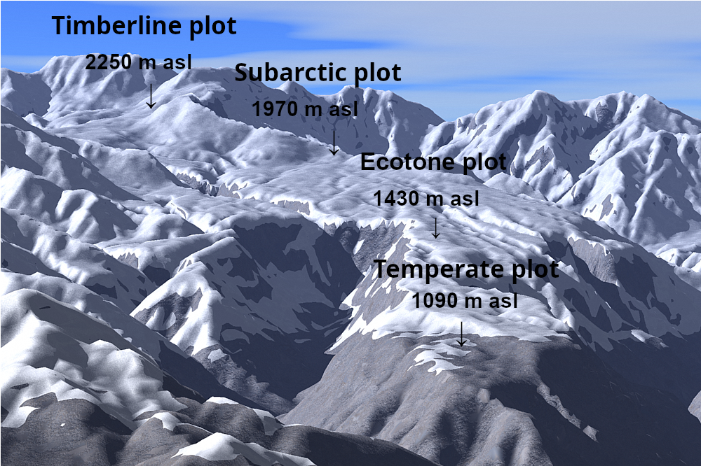

Fig. 1. Bird’s-eye view of each plot
Four plots were established on the Tateyama lava plateau in the Chubu-Sangaku National Park.
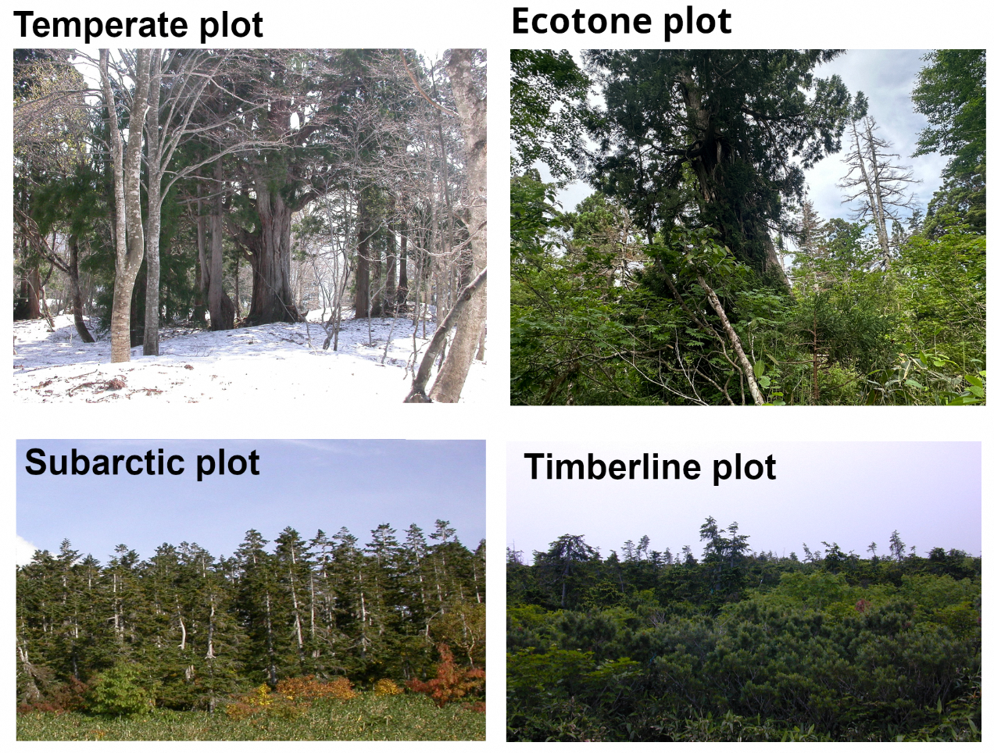

Fig. 2. Photographs of the forest type in each plot
The main tree species in the plots are as follows: Temperate plot: Cryptomeria japonica (Japanese cedar), and Fagus crenata; Ecotone plot: C. japonica, F. crenata, Pinus parviflora, and A. mariesii; Subarctic plot: A. mariesii; and Timberline plot: A. mariesii, Pinus pumila.
Based on the Mesh climatological normal for 2020 (Japan Meteorological Agency, 2022) and a temperature lapse rate of −0.55°C per 100 m (Ishida, 1991), the mean air temperatures in the Temperate, Ecotone, Subarctic, and Timberline plots are 8°C, 6.2°C, 2.8°C, and 1°C, respectively. The corresponding warmth indexes are 62.8°C·month, 51.6°C·month, 37.7°C·month, and 24.9°C·month; annual precipitation amounts are 2908, 2828, 2652, and 2628 mm; and the annual maximum snow depths are 335, 393, 517, and 583 cm, respectively (Aiura et al., 2018).
The annual maximum snow depths for each plot were measured using a Takahashi snow depth gauge (Takahashi, 1968). However, the snow depth could not be measured in the Timberline plot. We estimated the snow cover duration from periods when the ground was at 0°C using a ground thermometer (Ishida, 2006).

2.2. Field survey
The areas of the Temperate and Ecotone plots measured 10,000 m², while the area of the Subarctic plot measured 5,000 m². In these plots, we surveyed all tall tree species with a diameter at breast height of 10 cm or more. A plot of area measuring 625 m² was set up in the timberline region near the forest boundary, where we surveyed all A. mariesii trees with a height of 1.3 m or more (Table 1). Identification tags were attached to the surveyed trees at breast height, and we measured the diameter at breast height and vitality (Nakajima et al., 2011) during each survey. We also counted all the live and dead standing trees in all plots. If a standing tree fell, then further survey on that tree was discontinued. A total of 666, 745, 228, and 188 trees were surveyed at the Temperate, Ecotone, Subarctic, and Timberline plots, respectively. This corresponds to stem densities of 666, 745, 456, and 3008 stems ha⁻¹ at the Temperate, Ecotone, Subarctic, and Timberline plots, respectively. [Please verify these density calculations.]Forest composition surveys were conducted a total of seven times across all plots, in the following years: 1998, 2000, 2006, 2012, 2018, 2021, and 2024 (hereafter referred to as periods 1–7, respectively). [Please verify exact survey years before submission.]

2.3. Estimation of changes in the warmth index for each plot over time

Fig. 3. Changes in temperature (daily maximum, daily minimum, and daily average) at the Kurobe Dam
Straight lines denote the regression equations (see Table 2).
From 1965 to 2023, the daily maximum and mean temperatures observed at the Kansai Electric Power Kurobe Dam (latitude 36.335943°, longitude 137.394358°, elevation 1368 m) correlated positively with the year, with the regression equations showing that these temperatures had increased by 0.5°C and 0.3°C, respectively, over the 10-year period (Fig. 3, Table 2). On the other hand, Wada et al. (2004) reported that the mean daily minimum temperature from 1965 to 2001 positively correlated with the year; however, no upward trend was detected in the mean daily minimum temperature. This finding might be attributed to a decrease in the daily minimum temperature since 2000; however, the meteorological cause is unknown.

Table 2. Regression analysis of yearly trends in daily temperature at the Kurobe Dam (1965–2023).
 | Intercept |  | Coefficient |  | Adjusted R squared | p-value
Daily maximum | -91.455 | *** | 0.051 | *** | 0.71 | < 2.2e-16 | ***
Daily mean | -47.932 | *** | 0.027 | *** | 0.41 | 8.142e-08 | ***
Daily minimum | -4.410 |  | 0.004 |  | -0.01 | 0.5368

We used the Kurobe Dam observations to estimate the changes in the warmth index over time for each plot. The Kurobe Dam was located 7.8, 9.8, 15.2, and 16.8 km away from the Timberline, Subarctic, Ecotone, and Temperate plots, respectively.
We defined T_{ij} as the monthly mean temperature observed at Kurobe Dam in the year i and month j and δT_{ijk} as the temperature difference between each plot k and the Kurobe Dam, which was estimated based on the elevation difference between each plot ALT_{k} and Kurobe Dam (1368 m) with a temperature lapse rate of 0.55°C/100 m. The warmth index WI_{ik} was calculated for each plot in the year $y$ using the following formula:
$δT_{ijk}=-0.55/100×\left(ALT_{k}-1368\right)$ (1)
$ΔT_{ijk}=T_{ij}-5+δT_{ijk},$ (2)
$where, ΔT_{ijk}=0 if ΔT_{ijk}<0$ (3)
$WI_{ik}=ΣΔT_{ijk}$ (4)

2.4. Estimation of death years of dead standing Abies mariesii trees
The times of death of dead standing A. mariesii trees in the Ecotone plot in 2000 were estimated using the mean time to fall model (Gärtner et al., 2023) as shown below:
$mtf=e^{2.40+0.04dbh-0.12mat}$ (5)

Here, mtf is the mean time to fall of dead standing trees, dbh is the diameter at the breast height of the trees, and mat is the mean annual temperature.
The year when dead standing trees fell, y_{fall ,} was determined as the median year y_{death} between the two survey years, y2 and y1, which are the year when the fall was first confirmed and the previous survey year, respectively.
$y_{fall}=y1+(y2-y1)/2$ (6)
$y_{death}=y_{fall}-mtf$ (7)
2.5. Statistical analysis
Demographic rates for population growth (G), mortality (M), and ingrowth (R) were calculated following Condit et al. (1999):
G = ln(N₁/N₀) / t, M = ln(N₀/Ns) / t, R = ln(N₁/Ns) / t
where N₀ is the number of trees alive at the first census, N₁ is the number alive at the last census, Ns is the number surviving throughout all censuses, and t is the duration in years. Here, "ingrowth" refers to trees newly reaching the minimum size threshold (DBH ≥ 10 cm, or height ≥ 1.3 m at the Timberline plot) during each inter-census interval, following the definition of Condit et al. (1999), and does not imply seedling establishment.
To quantify the relationship between climate warming and A. mariesii mortality, we calculated the annual mortality rate for each inter-survey interval at the Kaminokodaira, Matsuotoge, and Kagamiishi plots. Annual mortality rate was calculated as 1 − (1 − p)^(1/d)^, where p is the proportion of trees alive at the start of the interval that had fallen by the end, and d is the interval duration in years. We then examined the correlation between the mean warmth index (WI) during each interval and the corresponding annual mortality rate using Pearson's product-moment correlation (n = 18 inter-survey intervals across three plots). Long-term trends in WI were assessed using the Mann–Kendall trend test. Differences in mean annual mortality rate among plots were assessed using the Spearman rank correlation between plot-level mean WI and mean annual mortality rate (n = 3 plots). The normality of estimated death-year distributions (Section 2.4) was assessed using the Kolmogorov–Smirnov test. All statistical analyses were performed in R (version 4.x; R Core Team, 2024).

3. Results

3.1. Changes in the warmth index and snow conditions of each plot over time

Fig. 4. Changes in the warmth index for each plot over time
The warmth index was estimated from observations at the Kurobe Dam. The number and circle indicate the survey period (1–7) and the warmth index at that time for each plot, respectively. The dotted lines for warmth indexes 45 and 55°C·month are based on Kira (1948), which describes the ecotone between the temperate and subarctic zones.
The warmth index of each survey area (estimated from the air temperatures observed at the Kurobe Dam; Fig. 3) showed a clear rising trend over time (Fig. 4).
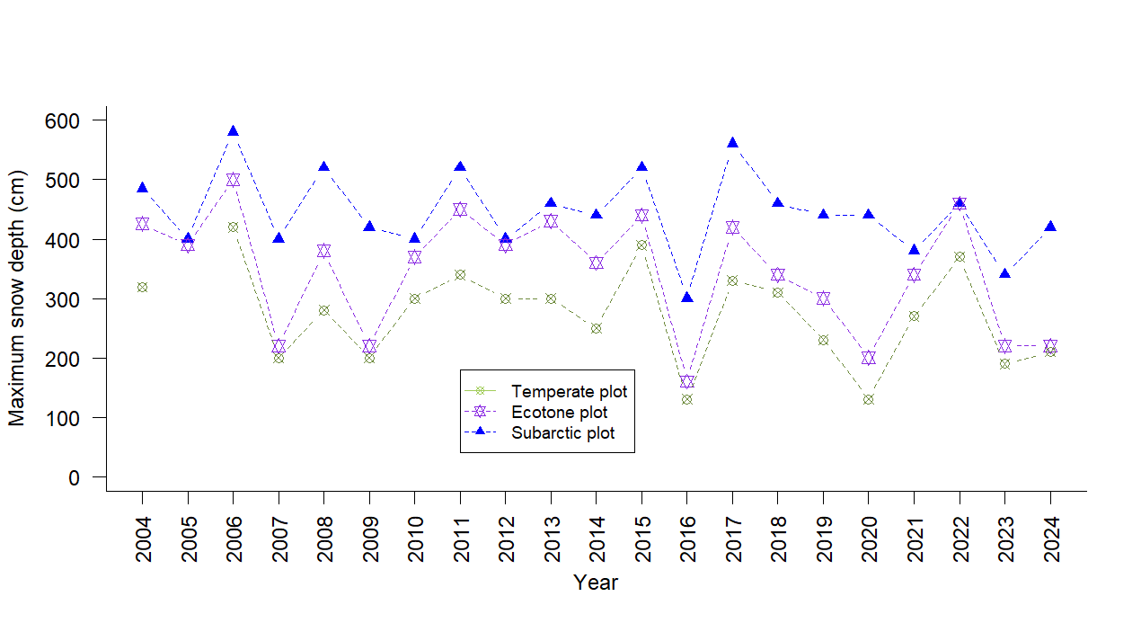

Appendix S1. Annual maximum snow depth for each plot over time
The values represent the snow season from the previous autumn to the spring of the indicated year.
The annual maximum snow depths from 2004 to 2024, measured using the Takahashi snow depth meter (Takahashi, 1968), were in the ranges of 200–400, 250–450, and 400–550 cm in the Temperate, Ecotone, and Subarctic plots, respectively (Appendix S1). 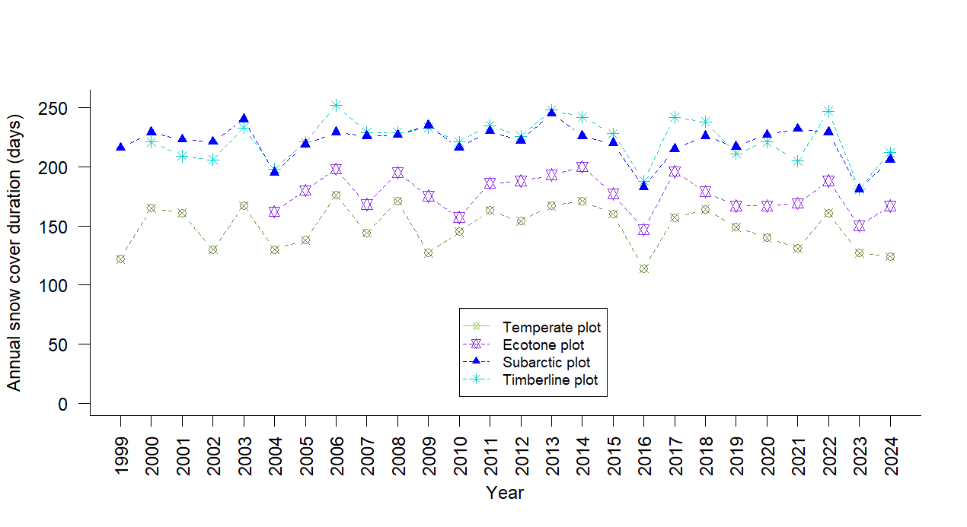

Appendix S1. Annual snow cover duration (days) for each plot over time
The values ​​represent the snow season from the previous autumn to the spring of the indicated year.
The snow cover durations from 1999 to 2024, estimated using a ground thermometer (Ishida, 2006), were in the ranges of 120–170, 150–190, and 200–240 days/year in the Temperate, Ecotone, and both Subarctic and Timberline plots, respectively (Appendix S1). No clear trend was detected in either annual maximum snow depth or snow duration during the observation period.

3.2. Forest composition at each plot
We identified a total of 24 tall tree species representing temperate, ecotone, and subarctic species across the four plots (Table 3). In the Temperate plot, the predominant species were C. japonica and F. crenata, while in the Subarctic and Timberline plots, the predominant species was A. mariesii. We observed a mixture of temperate, ecotone, and subarctic species in the Ecotone plot, including P. parviflora and Thuja standishii.

Table 3. Basal areas (BAs) of various tree species in each plot. The BA values represent means during periods 1 to 7.
Species | Temperate plot |  | Ecotone plot |  | Subarctic plot |  | Timberline plot
 | m²/ha | (%) | m²/ha | (%) | m²/ha | (%) | m²/ha | (%)
Temperate elements | 49.35 | (100.00) | 33.31 | (60.76) | 0.23 | (0.98) |  | (0.00)
Cryptomeria japonica | 32.13 | (65.10) | 30.78 | (56.16)
Fagus crenata | 7.82 | (15.84) | 1.30 | (2.38)
Magnolia obovata | 4.84 | (9.80)
Prunus grayana | 2.70 | (5.47) | 0.02 | (0.04)
Phellodendron amurense | 0.41 | (0.83)
Quercus crispula | 0.31 | (0.63) | 0.37 | (0.68)
Acer rufinerve | 0.25 | (0.51)
Acer japonicum | 0.23 | (0.47) | 0.11 | (0.20)
Aesculus turbinata | 0.23 | (0.46)
Acer amoenum | 0.16 | (0.33)
Betula maximowicziana | 0.08 | (0.16)
Acanthopanax  sciadophylloides | 0.07 | (0.14) | 0.03 | (0.05)
Acer mono | 0.06 | (0.12)
Cornus controversa | 0.03 | (0.06)
Sorbus americana | 0.03 | (0.05) | 0.19 | (0.35) | 0.23 | (0.98)
Tilia japonica | 0.01 | (0.02) | 0.01 | (0.03)
Kalopanax pictus | 0.01 | (0.02)
Magnolia salicifolia |  |  | 0.24 | (0.44)
Alnus hirsuta |  |  | 0.25 | (0.45)
Ecotone elements | 0.00 | (0.00) | 18.62 | (33.97) | 0.00 | (0.00) | 0.00 | (0.00)
Pinus parviflora |  |  | 13.31 | (24.29)
Thuja standishii |  |  | 4.86 | (8.86)
Betula corylifolia |  |  | 0.45 | (0.82)
Subarctic elements | 0.00 | (0.00) | 2.89 | (5.27) | 23.18 | (99.02) | 12.76 | (100.00)
Abies mariesii |  |  | 2.23 | (4.06) | 21.97 | (93.84) | 12.76 | (100.00)
Tsuga diversifolia |  |  | 0.39 | (0.72)
Betula ermanii |  |  | 0.11 | (0.19) | 1.21 | (5.15)
Acer tschonoskii |  |  | 0.16 | (0.29) | 0.01 | (0.02)
Taotal | 49.35 | (100.00) | 54.81 | (100.00) | 23.41 | (100.00) | 12.76 | (100.00)

Calculating the total basal area ratios according to species group in each plot showed that 100% of the species in the Temperate plot were temperate species; 60.80%, 34.19%, and 5.01% of the species in the Ecotone plot were temperate, ecotone, and subarctic species, respectively; and 100% of the species in the Subarctic and Timberline plots were subarctic species (Fig. 5). 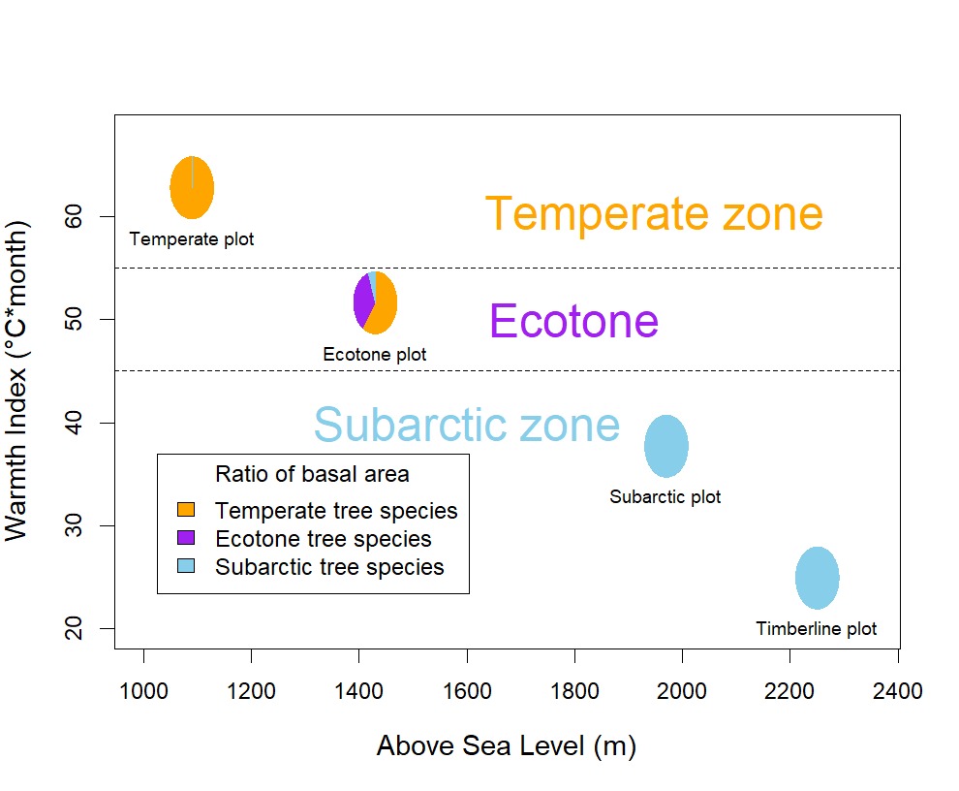

Fig. 5. Warmth index and proportion of tree species in each plot
The warmth index was estimated based on the Mesh climatological normal for 2020 (Japan Meteorological Agency, 2022). The tree species are listed in Table 3.

3.2. Forest dynamics in each climate zone

Table 4. Demographic rates for population growth, mortality, and recruitment (% per year) of the tree species grouped by elements in each plot.
 | Temperate plot |  |  |  | Ecotone plot |  |  |  | Subarctic plot |  |  |  | Timberline plot
Species | G* | M* | R* |  | G* | M* | R* |  | G* | M* | R* |  | G* | M* | R*
Temperate elements | 0.19 | 0.97 | 1.16 |  | 0.68 | 0.74 | 1.42
Cryptomeria japonica | -0.67 | 0.72 | 0.05 |  | 0.20 | 0.66 | 0.85
Fagus crenata | 1.23 | 0.58 | 1.80 |  | 0.49 | 1.32 | 1.81
Magnolia obovata | -0.06 | 0.54 | 0.47
Prunus grayana | -0.96 | 1.43 | 0.47
Phellodendron amurense | -2.76 | 2.76 | 0.00
Quercus crispula |  |  |  |  | 1.96 | 1.49 | 3.44
Acer rufinerve | -2.32 | 8.62 | 6.30
Acer japonicum | 3.15 | 0.28 | 3.43 |  | 7.29 | 0.00 | 7.29
Acer amoenum | 4.26 | 0.54 | 4.80
Magnolia salicifolia |  |  |  |  | 1.76 | 1.58 | 3.34
Ecotone elements |  |  |  |  | 0.64 | 0.60 | 1.24
Pinus parviflora |  |  |  |  | -0.40 | 0.55 | 0.14
Thuja standishii |  |  |  |  | 0.00 | 1.20 | 1.20
Betula corylifolia |  |  |  |  | 3.60 | 0.27 | 3.87
Subarctic elements |  |  |  |  | -2.01 | 2.42 | 0.42 |  | -0.33 | 0.77 | 0.44 |  | 0.85 | 0.69 | 1.55
Abies mariesii |  |  |  |  | -2.37 | 2.89 | 0.52 |  | -0.43 | 0.75 | 0.32 |  | 0.85 | 0.69 | 1.55
Betula ermanii |  |  |  |  |  |  |  |  | 1.33 | 1.20 | 2.53
Total | 0.19 | 0.97 | 1.16 |  | 0.51 | 0.82 | 1.33 |  | -0.34 | 0.80 | 0.46 |  | 0.82 | 0.69 | 1.55

*G: Growth, *M: Mortality, *R: Recruitment. Only species with ten or more recorded individuals are shown. However, the demographic rates for the total elements and for each element were calculated based on all recorded species, including those not listed. Growth = ln(N1/N0)/t; Mortality = ln(N0/Ns)/t; Recruitment = ln(N1/Ns)/t (Condit et al., 1999). N0: number of trees during the first period, N1: number of trees during the latest period, Ns: number of surviving trees throughout all periods, t: years of whole periods.

The demographic rates were calculated based on the number of trees (Condit et al., 1999) in each plot (Table 4).
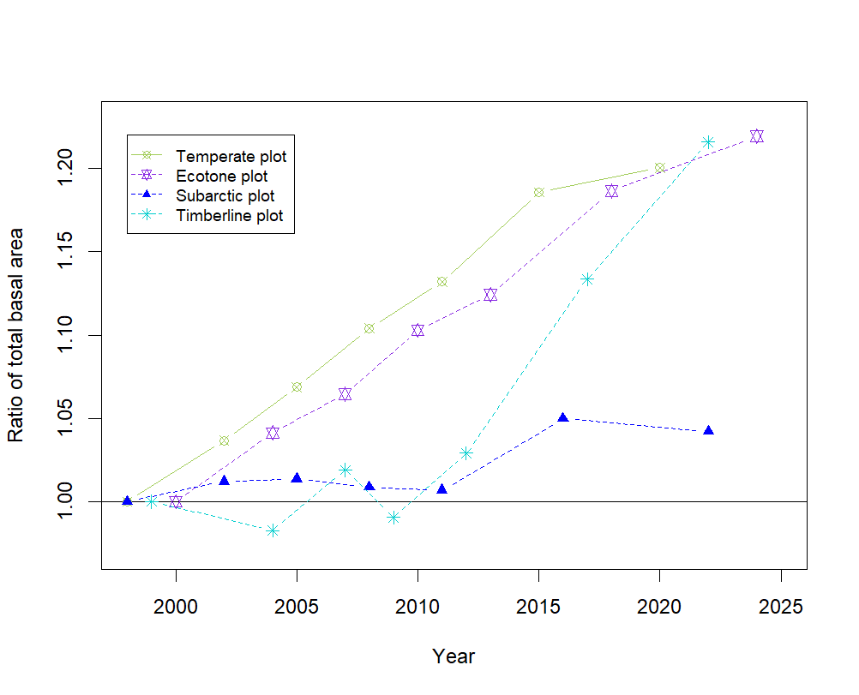

Fig. 6. Changes in the total basal area in each plot over time
The change in the ratio of the total basal area was calculated based on the value from the first survey in 2000.
The total basal area at breast height at the beginning of the first period in the Temperate, Ecotone, and Timberline plots had increased by about 1.2-fold at the end of the seventh period (Fig. 6). Among these plots, the rate of increase in the Subarctic plot was the lowest (1.03-fold). In the Timberline plot, large individuals died in the second and fourth periods, and the area decreased from the beginning of the period but showed steady growth from the fifth period onward, reaching the same growth rate as the Temperate and Ecotone plots.
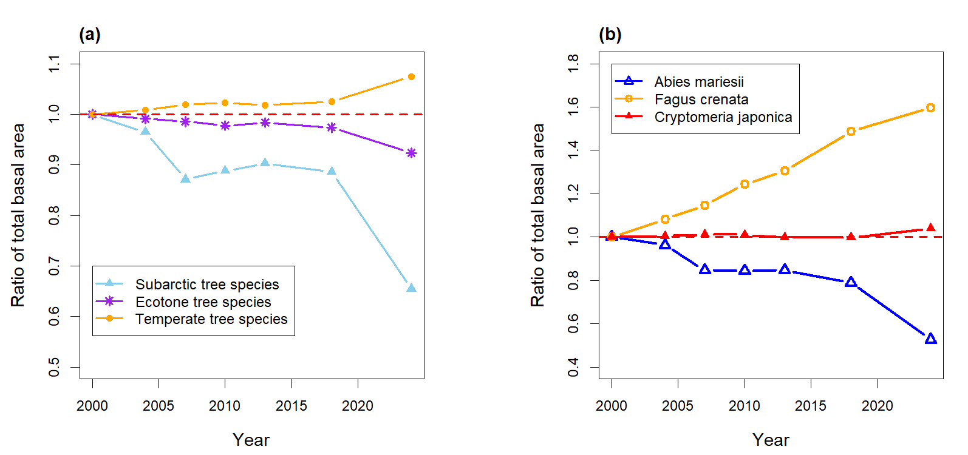

Fig. 7a. Changes in the total basal area of the tree species group in the Ecotone plot over time
The ratio of the total basal area was based on the value from the first survey in 2000. The tree species are listed in Table 3.
In the Ecotone plot, by the seventh period, the basal areas at breast height of temperate, ecotone, and subarctic tree species gradually increased to 1.07-fold, gradually decreased to 0.92-fold, and significantly decreased to 0.66-fold, respectively (Fig. 7a). The degree of increase or decrease in species groups became more pronounced after 2018.

Fig. 7b. Changes of the basal area of major tree species in the Ecotone plot
In the Ecotone plot, the ratios of the basal areas at breast height of F. crenata, C. japonica (both climax species in the temperate zone of the Tateyama region), and A. mariesii (climax species in the subarctic zone) increased to 1.6, remained nearly unchanged at 1.04, and decreased to 0.53, respectively (Fig. 7b).

3.3. Dynamics of the A. mariesii population
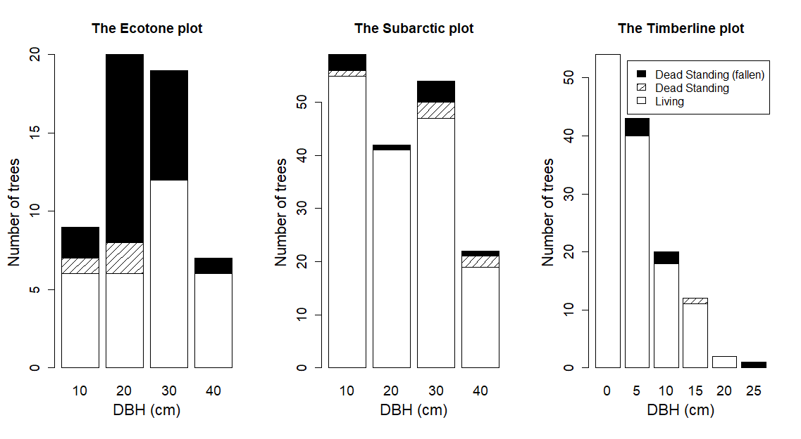

Fig. 9. Distributions of the diameter at breast height of A. mariesii during the first survey in each plot
The black solid and the diagonal lines indicate trees that had fallen and were still standing during the seventh survey, respectively. This distinction is necessary because the mean-time-to-fall model (Gärtner et al., 2023) used to estimate death years (Section 2.4) requires standing dead trees as input; fallen trees cannot be assigned estimated death years using this approach.
In the Ecotone plot, 45.6% of A. mariesii trees were dead standing during the first period (basal area: 39%). This proportion was significantly higher than the corresponding proportions in the Subarctic (8.9%; basal area: 12.8 %) and Timberline (11.4%; basal area: 16.4%) plots (Tukey’s multiple comparison P ≤ 0.001, Fig. 7b). In addition, various diameters of dead A. mariesii trees were observed in all plots, without any bias in size.
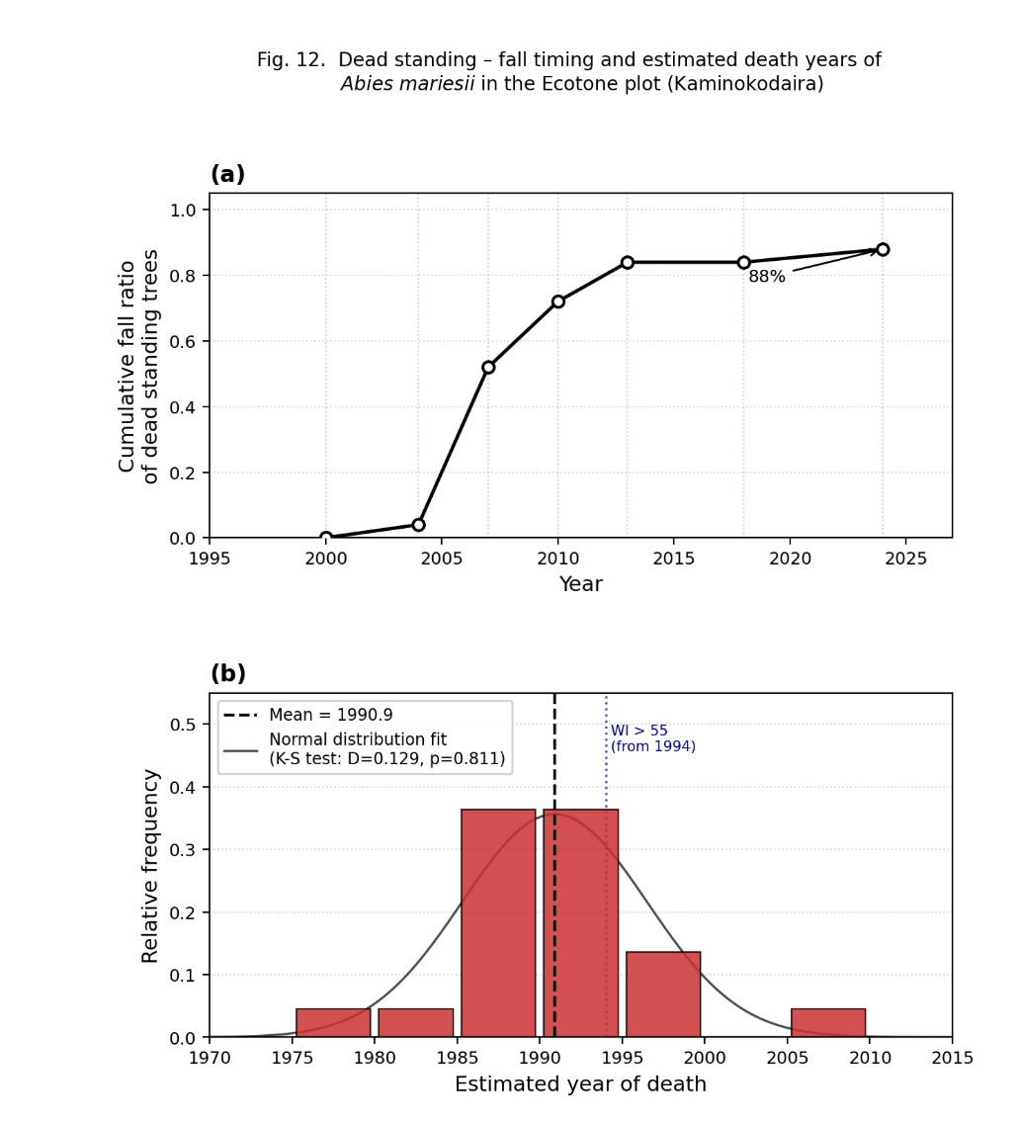
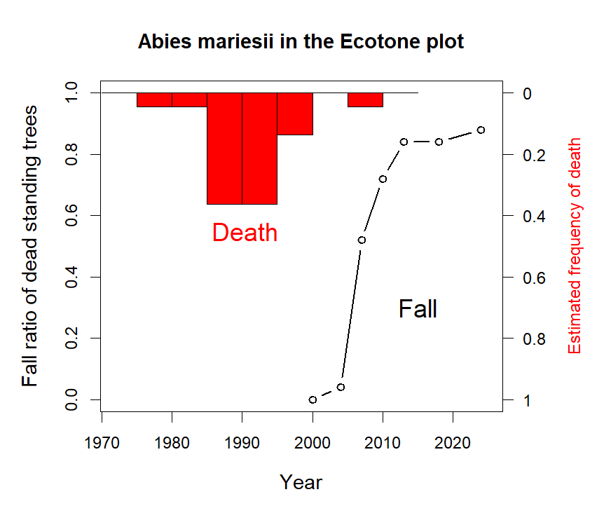

Fig. 9. Changes in the cumulative ratio of dead standing A. mariesii trees in the Ecotone plot in 2000 and the estimated frequency of death
In the Ecotone plot, 22 dead standing A. mariesii trees were observed in 2000. By 2024, 88% of them had fallen. The red histogram indicates the frequency of their death, estimated from their year of death (y_{death}, eq. (7)) using the mean time to fall model (Gärtner et al., 2023).
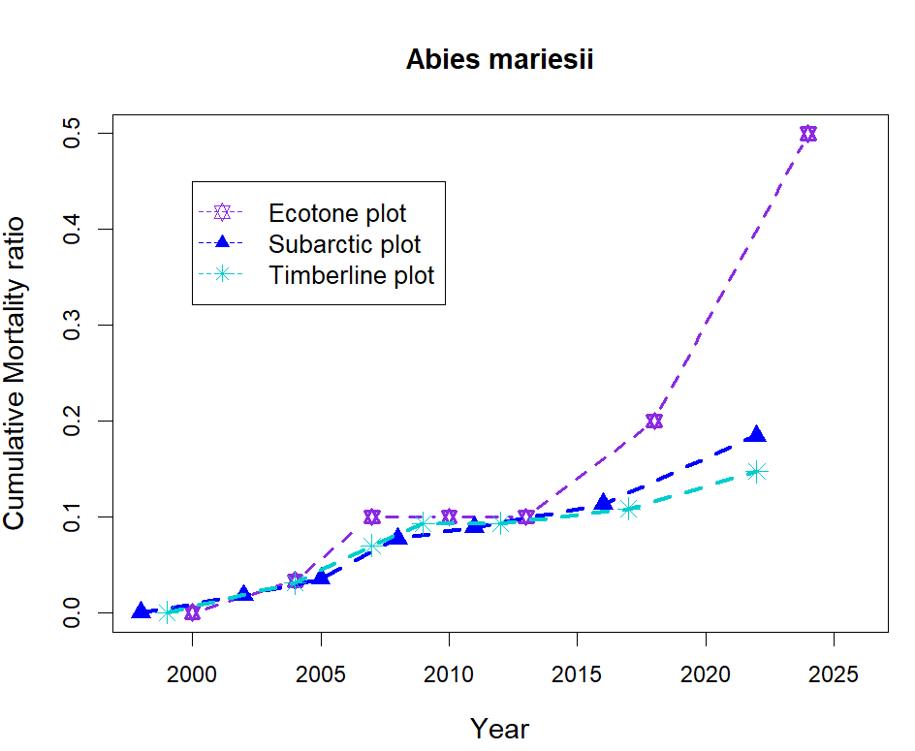
There were 25 dead standing A. mariesii trees in the Ecotone plot in 2000. Of these, 22 (88%) of the trees had fallen by 2024 (Fig. 8). The mean time for trees to fall was estimated to be 16.6 ± 4.4 years (mean ± s.d., min–max: 7.8–26.6 years) using the model (Gärtner et al., 2023). The dead standing A. mariesii trees exhibited a normal frequency distribution (Kolmogorov-Smirnov test: D = 0.129, p = 0.811) and were estimated to have died in 1990.9 ± 5.7 (mean ± s.d.). From 2000 to 2024, three A. mariesii trees with diameters at breast height of 12.1, 12.5, and 39.8 cm died while standing and then fell after 5, 6, and 20 years, respectively. The model (Gärtner et al., 2023) estimated the times between death and falling of the trees at 9, 9, and 26 years, respectively.

Fig. 13. Cumulative mortality ratio of Abies mariesii over time
The mortality rates of A. mariesii trees that had survived in period 1 from seasons 1 to 7 in the Subarctic and Timberline plots were 18.5% and 15.2%, respectively (not significantly different based on Tukey multiple comparisons, P = 0.059); however, in the Ecotone plot, the rate was significantly higher at 50% (both Tukey multiple comparisons P < 1e−04, Fig. 9). The increase in the mortality rate was particularly noticeable after 2013. Calculating the survival ratios per year using the formula [exp (log(1 − mortality)) / duration)] yielded ratios of 0.97/year and 0.85/year for the periods of 2000–2024 and 2018–2024, respectively.

4. Discussion

4.1. Warming trend around Mt. Tateyama
The average temperature at the Kurobe Dam in Mt. Tateyama increased by 0.27°C/decade from 1965 to 2023 (Fig. 3). In the Green Mountains of Vermont, USA, the annual temperature has increased by 1.1°C from 1964 to 2004 (Beckage et al., 2008), with a rate of temperature increase of 0.28°C/decade, which was almost equal to that of Mt. Tateyama. The rate of temperature increase in the Tateyama region since the 1960s was about 6-fold higher than that of the global rate of 0.05°C/decade since before the industrial revolution (IPCC, 2023). Pepin et al. (2022) also reported higher warming rates at higher elevations in some mountainous regions.
The warmth index value (Kira, 1948), calculated using the Mesh climatological normal for 2020 (Japan Meteorological Agency, 2022), of the Ecotone plot placed it at the ecotone between the temperate and subarctic zones (Fig. 5). Assuming that the temperatures rose in the same way as the rise in temperature in the Kurobe Dam, the warmth index at the Ecotone plot changed from 40 to 60°C·month from the 1960s to 2020s (Fig. 4). This warmth index range encompassed the ecotone as set by Kira (1948). These results indicated that the warmth index for this period rose from a subarctic zone value to an ecotone value and finally reached a temperate zone value.

4.2. Forest dynamics
The forest population growth rate was negative only in the Subarctic plot, primarily due to the influence of A. mariesii, the dominant tree species in that zone (Table 4). The growth rate of A. mariesii was lowest in the Ecotone plot, but it increased with altitude, reflecting a clear elevational trend. The remarkably low growth rate in the Ecotone plot might be attributed to reduced overall growth caused by high mortality and low recruitment. However, in terms of the overall population, the growth rate in the Ecotone plot was second only to that of the Timberline plot. This finding might be attributed to the high growth rates of the temperate and ecotone elements that overshadowed the decline of A. mariesii. The Timberline plot exhibited the highest canopy ingrowth rate among all the plots, indicating active regeneration at the upper forest limit.
It has previously been reported that forest growth decreases in old-growth, overmature forests (Kira and Shidei, 1967; Smith and Long, 2001). However, we found that the growth of the breast-height basal area increased in all the plots (Fig. 8), which are in pristine condition and are classified as old-growth overmature stands. As noted in previous studies (Ryan et al., 2004; Luyssaert et al., 2008; Noguchi et al., 2022), stands such as these continue to grow. Notably, in the Ecotone plot, which is located near the transition zone between the temperate and subarctic zones, the growth of the temperate tree species increased, while that of the subarctic A. mariesii decreased (Fig. 7b).
At the beginning of the study (2000), both the number and basal area ratio of dead standing A. mariesii trees were significantly higher in the Ecotone plot than in the Subarctic and Timberline plots (Fig. 9). The model (Gärtner et al., 2023) of dead trees in the Ecotone plot indicated that the A. mariesii population deteriorated and died intensively in 1990 (Fig. 9). In addition, the warmth index began to deviate from the ecotone range in the Ecotone plot. These results indicated that the ecotone areas are not in a state of forest decline but are rather rapidly replacing tree species following the death of A. mariesii; therefore, the forest growth is maintained.

4.3. Decline of A. mariesii trees in the ecotone
We observed a remarkably high mortality rate of A. mariesii in the Ecotone plot (Table 4, Fig. 10). Although Mt. Tateyama is located within a national park designated as a natural environment conservation area, it is also a popular tourist destination and thus experiences anthropogenic disturbances. We acknowledge that other anthropogenic factors associated with high tourist traffic, such as nitrogen deposition from vehicle exhaust, may have contributed to the observed increases in basal area and tree growth across some plots (Kume et al., 2009). However, as discussed below, the species-specific pattern of decline in A. mariesii alongside vigorous growth in co-occurring temperate species is more consistent with a thermal stress explanation than a general site-level anthropogenic effect. For instance, F. crenata has declined along the roadsides at 1200 m asl, and this decline has been attributed to either vehicle exhaust (Kawano and Kato, 2000) or long-range air pollution (Kume et al., 2009). Kume et al. (2020) later observed an improvement in the area’s air quality and the recovery of F. crenata growth. In contrast, in our Ecotone plot, we observed vigorous growth of F. crenata (known to be sensitive to air pollution), while only A. mariesii population declined (Fig. 8). Therefore, air pollution alone is unlikely to be the primary driver of A. mariesii.
Insect outbreaks that are modulated by climate warming (Domingo et al., 2024) have also been suggested as a potential cause of A. mariesii mortality. The defoliator Epinotia piceae and the woodborer Polygraphus proximus are known pests of A. mariesii (Chiba, 2020). However, we found no evidence of insect activity (that is, feeding marks, frass, or boreholes) in this study, suggesting that A. mariesii mortality might not be attributed to insect damage.
Thus, the most plausible explanation for A. mariesii mortality is climate-associated stressors. Subalpine firs, such as A. mariesii, rely on a stable snow cover for protection against desiccation, frost, and early-season drought (Hu et al., 2010; Frei and Henry, 2022).
We found no clear trend in annual snow depth or snow cover duration during the monitoring period. However, an increase in winter runoff at the Kurobe Dam (Wada et al., 2004; Shonohara et al., 2009) implied earlier snowmelt and potentially reduced water availability later in the growing season, which is a critical period for A. mariesii.
In addition, climate warming might also reduce the frost hardiness of A. mariesii. A decrease in cold acclimation during autumn and spring, coupled with advanced budburst, increases the risk of frost injury (Larcher, 2003; Jönsson et al., 2004; Astigarraga et al., 2025). These stressors—suboptimal growth temperature, insufficient moisture, and late frost damage risk—likely acted in combination to trigger the increase in A. mariesii mortality that peaked in 1990.

4.4. Forest zone shift
A. mariesii is ecologically adapted to heavy snow environments through morphological and physiological traits (Shidei, 1956; Kaji, 1986; Sugita, 1992; Mori and Mizumachi, 2009). However, our findings suggested that it is now facing thermal conditions beyond its optimal range. Notably, snow cover conditions remained relatively stable during the study period; therefore, temperature, rather than snow-related factors, is the primary stressor for A. mariesii. The increased warmth index in the Ecotone plot, coupled with the reduced growth in the Subarctic plot (which is thermally approaching the ecotone range), strongly suggested that climate warming has negatively affected both the performance and persistence of A. mariesii, even in snow-rich areas. In contrast, temperate species, such as F. crenata, are expanding and growing vigorously in the areas where A. mariesii is declining. Therefore, A. mariesii decline cannot be attributed to general site degradation but rather to species-specific sensitivity to warming. Thus, the ongoing upward shift of the forest zone on Mt. Tateyama cannot be attributed to species migration alone; while the active recruitment of A. mariesii at the Timberline plot may reflect an altitudinal range shift toward thermally more favorable conditions at higher elevations, the primary driver is a mismatch between the thermal adaptation of A. mariesii and the rapidly changing thermal conditions at its current lower distributional limits.

5. Conclusions
Long-term monitoring on Mt. Tateyama showed that climate warming is already causing an upward shift in the forest zones. While the snow cover conditions remained largely unchanged, the warmth index increased significantly, especially in the Ecotone plot, where A. mariesii population declined, while temperate species such as F. crenata expanded. The growth of the forest stand in the Subarctic plot, which is thermally approaching the ecotone threshold, was low, suggesting that the thermal conditions in the region are suboptimal for A. mariesii growth. In contrast, the A. mariesii population in the Timberline plot grew at a high rate, along with its basal area. Overall, our results suggested that the conditions at the upper forest limit remain favorable for the growth and regeneration of A. mariesii. Moreover, these results indicated that climate warming, rather than changes in snow cover or anthropogenic disturbance, is the main driver of A. mariesii mortality. Although this species is ecologically adapted to heavy snow cover, it has not adapted to rapid temperature increases. Therefore, the forest zone shifts predicted for the future are already underway, driven by climate change that is reshaping the boundaries of the forest ecosystems in the mountains. These field-based findings are consistent with species distribution model projections, which predict a substantial upward contraction of suitable habitat for subalpine conifers including A. mariesii under future warming scenarios in Japan. [Please add appropriate SDM citation(s) here if available.]

References
Aiura,H., Nakajima,H., Ishida, M. 2018. Estimate Average Annual Maximum Snow Depth with the Temperature and the Amount of Precipitation of the Mesh Normal Climatic Data in Toyama Prefecture, Japan. Journal of Japanese Forest Society 100: 174-177. (in Japanese)
Alexander, J. M., Diez J. M., and Levine J. M. 2015. Novel Competitors Shape Species’ Responses to Climate Change. Nature 525 (7570): 515–18. https://doi.org/10.1038/nature14952.
Astigarraga, J., Calatayud, J., Ruiz-Benito, P., Madrigal-González, J., Tijerı́n-Triviño, J., Zavala, M.A., Andivia, E., Herrero, A., 2025. Forest structural diversity modulates tree growth synchrony in response to climate change. Forest Ecology and Management 579, 122505.
Beckage, B., .Osborne B., Gavin B. G., Pucko C., Siccama T., and Perkins T. 2008. A Rapid Upward Shift of a Forest Ecotone During 40 Years of Warming in the Green Mountains of Vermont. Proceedings of the National Academy of Sciences 105 (11): 4197–4202.
Bonan, G.B., 2008. Forests and climate change: Forcings, feedbacks, and the climate benefits of forests. Science 320, 1444–1449.
Chiba, S., Kawatsu, S., Hayashida, M. 2020.Large-area Mapping of the Mass Mortality and Subsequent Regeneration of Abies mariesii Forests in the Zao Mountains in Northern Japan. J . Jpn. For. Soc. 102: 108–114
Condit, R., Ashton, P.S., Manokaran, N., LaFrankie, J.V., Hubbell, S.P., Foster, R.B., 1999. Dynamics of the forest communities at Pasoh and Barro Colorado: comparing two 50-ha plots.Domingo, D., Vicente-Serrano, S.M., Gómez, C., Olano, J.M., Sangüesa-Barreda, G., 2024. Summer heat waves could counterbalance the increasing incidence of pine processionary due to warmer winters in Mediterranean pine forests. Forest Ecology and Management 555, 121695. https://doi.org/10.1016/j.foreco.2024.121695
Dobrowski, S.Z. (2011) A climatic basis for microrefugia: the influence of terrain on climate. Global Change Biology, 17, 1022–1035. https://doi.org/10.1111/j.1365-2486.2010.02263.x
Fang, J., Yoda, K., 1990. Climate and vegetation in China IV. Distribution of tree species along the thermal gradient. Ecological Research 5, 291–302.
Frei, Esther R., and Gregory H. R. Henry. 2022. Long-Term Effects of Snowmelt Timing and Climate Warming on Phenology, Growth, and Reproductive Effort of Arctic Tundra Plant Species. Arctic Science 8 (3): 700–721. https://doi.org/10.1139/as-2021-0028.
Gärtner, A., Jönsson, A.M., Metcalfe, D.B., Pugh, T.A.M., Tagesson, T., Ahlström, A., 2023. Temperature and tree size explain the mean time to fall of dead standing trees across large scales. Forests 14, 1017. https://doi.org/10.3390/f14051017
Harada, I., Matsumura, T., Hara, K., Kondoh, A., 2011. Spatial analysis of changes in Japanese forests during the process of modernization. Japan Association for Landscape Ecology 16 (1): 17–32
Hiura, Tsutom, Sato Go, and Hayato Iijima. 2019. Long-Term Forest Dynamics in Response to Climate Change in Northern Mixed Forests in Japan: A 38-Year Individual-Based Approach. Forest Ecology and Management 449: 117469. https://doi.org/https://doi.org/10.1016/j.foreco.2019.117469.
Hu, J., Moore, D.J.P., Burns, S.P., Monson, R.K., 2010. Longer growing seasons lead to less carbon sequestration by a subalpine forest. Global Change Biology 16, 771–783. https://doi.org/10.1111/j.1365-2486.2009.01967.x
Intergovernmental Panel On Climate Change (Ipcc), 2023. Climate Change 2021 - The Physical Science Basis: Working Group I Contribution to the Sixth Assessment Report of the Intergovernmental Panel on Climate Change, 1st ed. Cambridge University Press. https://doi.org/10.1017/9781009157896
Ishida, M., 2006. Altitudinal gradient of annual snow cover period in forested areas of Toyama Prefecture: Estimation from forest floor surface temperatures. Journal of the Japanese Society of Snow and Ice 68, 489–496. https://doi.org/10.5331/seppyo.68.489 (in Japanese)
Ishida, M., 1991. The properties of the presumed meteological data file (temperature precipitation snow depth) in Toyama prefecture. Journal of the Japanese Society of Snow and Ice 53, 45–51. https://doi.org/10.5331/seppyo.53.45 (in Japanese)
Japan Meteorological Agency, 2022. Mesh climatological normal 2020 (1991-2020).
Jönsson, A.M., Linderson, M.-L., Stjernquist, I., Schlyter, P., Bärring, L., 2004. Climate change and the effect of temperature backlashes causing frost damage in Picea abies. Global and planetary change 44, 195–207.
Kaji, M. 1982. Studies on the ecological geography of subalpine conifers. Distribution pattern of Abies mariesii in relation to the effect of climate in the postglacial warm period. Bulletin, Tokyo University Forests 72, 31-120. (in Japanese)
Kawano S., Kato T., 2000. Implications of long-term monitoring on the tree growth exposed to air pollution and an assessment of its effects. Japanese Journal of Ecology 50, 289–295. (in Japanese)
Kira, T., 1948. On the altitudinal arrangement of climatic zones in Japan. Kanchi-nogaku 2, 143–173. (in Japanese)
Kira, T., Shidei, T., 1967. Primary production and turnover of organic matter in different forest ecosystems of the western pacific. Japanese Journal of Ecology 17, 70–87. (in Japanese)
Kume, A., Numata, S., Watanabe, K., Honoki, H., Nakajima, H., Ishida, M., 2009. Influence of air pollution on the mountain forests along the tateyama-kurobe alpine route. Ecological Research 24. https://doi.org/10.1007/s11284-008-0557-2
Kume, A., Fujimoto, M., Mizoue, N., Honoki, H., Nakajima, H., & Ishida, M., 2020. Impact of reduced ozone concentration on the mountain forests of Mt. Tateyama, Japan. Environmental Pollution, 267(2), 115407. https://doi.org/10.1016/j.envpol.2020.115407
Larcher, W. 2003. Physiological plant ecology: ecophysiology and stress physiology of functional groups. Springer Science & Business Media.
Lenoir, J., Gégout, J.-C., Dupouey, J.-L., Bert, D., Svenning, J.-C., 2010a. Forest plant community changes during 1989-2007 in response to climate warming in the jura mountains (france and switzerland). Journal of Vegetation Science 21, 949–964.
Leonelli, G., Pelfini, M., Morra di Cella, U., Garavaglia, V., 2011. Climate warming and the recent treeline shift in the European Alps: The role of geomorphological factors in high-altitude sites. Ambio 40, 264–273.
Lutz, David A., Rebecca L. Powell, and Miles R. Silman. 2013. Four Decades of Andean Timberline Migration and Implications for Biodiversity Loss with Climate Change. Edited by Maura Geraldine Chapman. PLoS ONE 8 (9): e74496. https://doi.org/10.1371/journal.pone.0074496.
Luyssaert, S., Schulze, E.-D., Börner, A., Knohl, A., Hessenmöller, D., Law, B.E., Ciais, P., Grace, J., 2008. Old-growth forests as global carbon sinks. Nature 455, 213–215.
Mamantov, M.A., Gibson‐Reinemer, D.K., Linck, E.B., Sheldon, K.S., 2021. Climate‐driven range shifts of montane species vary with elevation. Global Ecol. Biogeogr. 30, 784–794. https://doi.org/10.1111/geb.13246
Matsumoto, A., Fujii, S., Shibata, K., 1991. K-ar ages of lavas from tateyama volcano, toyama prefecture, central japan. Journal of Mineralogy, Petrology and Economic Geology 86, 278–282. (in Japanese)
Mori, S. A., Mizumachi E. 2009. Within-Crown Structural Variability of Dwarfed Mature Abies Mariesii in Snowy Subalpine Parkland in Central Japan. Journal of Forest Research 14(3): 155–66. doi:10.1007/s10310-009-0115-y.
Nakajima, H., Kume, A., Ishida, M., Ohmiya, T., Mizoue, N., 2011. Evaluation of estimates of crown condition in forest monitoring: Comparison between visual estimation and automated crown image analysis. Annals of Forest Science 68, 1333–1340. https://doi.org/10.1007/s13595-011-0132-9
Noguchi, Mahoko, Kazuhiko Hoshizaki, Michinari Matsushita, Daiki Sugiura, Tsutomu Yagihashi, Tomoyuki Saitoh, Tomohiro Itabashi, et al. 2022. Aboveground Biomass Increments over 26 Years (1993–2019) in an Old-Growth Cool-Temperate Forest in Northern Japan. Journal of Plant Research 135 (1): 69–79. https://doi.org/10.1007/s10265-021-01358-5.
Nogami M., 1994. Thermal Condition of the Forest Vegetation Zones and their Potential Distribution under Different Climates in Japan. Journal of Geography 103(7): 886-897 (in Japanese)
O’Sullivan, Kirsten S. W., Paloma Ruiz‐Benito, Jan‐Chang Chen, and Alistair S. Jump. 2021. Onward but Not Always Upward: Individualistic Elevational Shifts of Tree Species in Subtropical Montane Forests. Ecography 44 (1): 112–23. https://doi.org/10.1111/ecog.05334.
Shinohara, Y., Kumagai, T., Otsuki, K., Kume, A. and Wada, N. 2009.1313 Impact of climate change on runoff from a mid-latitude mountainous catchment in central Japan. Hydrol. Process., 23: 1418–1429. https://doi.org/10.1002/hyp.7264
Smith, F. W., & Long, J. N. 2001. Age-related decline in forest growth: An emergent property. Forest Ecology and Management, 144(1), 175–181. https://doi.org/10.1016/S0378-1127(00)00369-8
Pepin, N. C., E. Arnone, A. Gobiet, K. Haslinger, S. Kotlarski, C. Notarnicola, E. Palazzi, et al. 2022. Climate Changes and Their Elevational Patterns in the Mountains of the World. Reviews of Geophysics 60 (1): 1-40. https://doi.org/10.1029/2020RG000730.
Rumpf, Sabine B., Karl Hülber, Günther Klonner, Dietmar Moser, Martin Schütz, Johannes Wessely, Wolfgang Willner, Niklaus E. Zimmermann, and Stefan Dullinger. 2018. Range Dynamics of Mountain Plants Decrease with Elevation. Proceedings of the National Academy of Sciences 115 (8): 1848–53. https://doi.org/10.1073/pnas.1713936115.
Ryan, Michael G, Dan Binkley, James H Fownes, Christian P Giardina, and Randy S Senock. 2004. An Experimental Test of the Causes of Forest Growth Decline with Stand Age. Ecological Monographs 74 (3): 393–414.
Sakio, H., Masuzawa, T., 2012. The advancing timberline on Mt. Fuji: Natural recovery or climate change? Journal of plant research 125, 539–546.
Saxe, H., Cannell, M.G.R., Johnsen, Ø., Ryan, M.G., Vourlitis, G., 2001. Tree and forest functioning in response to global warming. New Phytologist 149, 369–399. https://doi.org/10.1046/j.1469-8137.2001.00057.x
Seki, T., Kajimoto, T., Sugita H., Daimaru H., Ikeda S., Okamoto,T. 2005. Mechanical Damage on Abies Mariesii Trees Buried below the Snowpack. Arctic, Antarctic, and Alpine Research 37(1): 34–40. doi:10.1657/1523-0430(2005)037[0034:MDOAMT]2.0.CO;2.
Shidei, T. 1956. The effect of some climatic factors on the existence of vertical forest zones in &Ocirc;u-district」. Journal of the Japanese Forestry Society 38(9): 356–58. doi:10.11519/jjfs1953.38.9_356. (in Japanese)
Sugita, H. 1992. Ecological geography of the range of the Abies mariesii forest in northeast Honshu, Japan, with special reference to the physiographic conditions. Ecological Research 7(2): 119–32. doi:10.1007/BF02348490.
Takahashi, K., 1968. On the snow scale for measuring maximum snow depth. Journal of the Japanese Society of Snow and Ice 30, 111–114. https://doi.org/10.5331/seppyo.30.111 (in Japanese)
Takahashi, K., Azuma, H., Yasue, K., 2003. Effects of climate on the radial growth of tree species in the upper and lower distribution limits of an altitudinal ecotone on Mount Norikura, central Japan. Ecological Research 18, 549–558.
Takahashi, K., Okuhara, I., Tokumitsu, Y., Yasue, K., 2011. Responses to climate by tree-ring widths and maximum latewood densities of two Abies species at upper and lower altitudinal distribution limits in central Japan. Trees - Structure and Function 25, 745–753. https://doi.org/10.1007/s00468-011-0552-z
Takyu, M., Kubota Y., Aiba S.,Seino T., Nishimura T. 2005. Pattern of Changes in Species Diversity, Structure and Dynamics of Forest Ecosystems Along Latitudinal Gradients in East Asia. Ecological Research 20, 287-296.
Toyama Prefecture, 2002. Report of Mt. Tateyama Vegetation Program (I). Toyama Prefectural Government. (in Japanese)
Toyama Prefecture, 2008. Report of Mt. Tateyama Vegetation Program (II). Toyama Prefectural Government. (in Japanese)
Toyama Prefecture, 2014. Report of Mt. Tateyama Vegetation Program (III). Toyama Prefectural Government. (in Japanese)
Toyama Prefecture, 2020. Report of Mt. Tateyama Vegetation Program (IV). Toyama Prefectural Government. (in Japanese)
Wada, N., Kawada, K., Kawamura, R., Aoki, K., Kume, A., 2004. Increasing winter runoff in a middle-latitude mountain area of central japan. Journal of the Meteorological Society of Japan. Ser. II 82, 1589–1597.
Supporting Information to the paper:
Ishida, M. et al. The Impacts of Climate Warming on the Forest Vegetation Zone on Mt. Tateyama, Japan: Findings From Long-Term Forest Monitoring (1998–2024) and Meteorological Observation Data. Journal of Vegetation Science.

Appendix S1. Annual maximum snow depth and snow cover duration at each permanent plot.
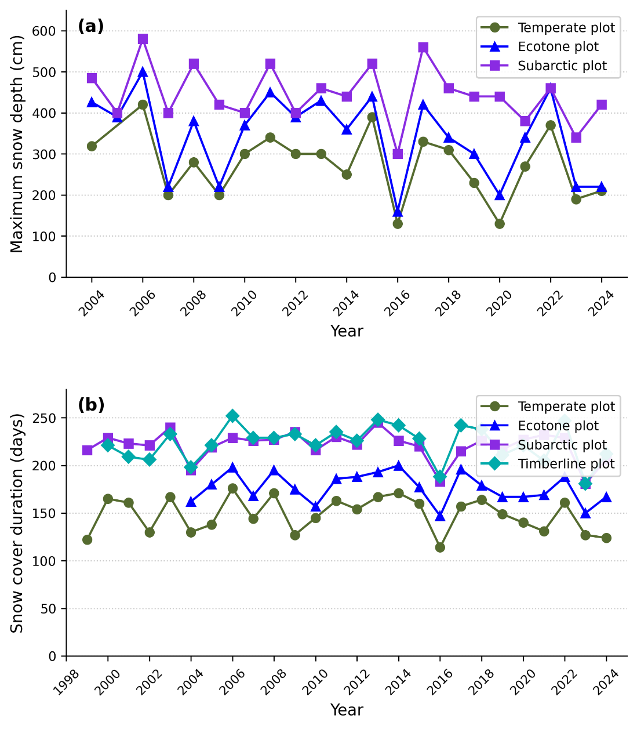
Appendix S1. Annual maximum snow depth (a) and snow cover duration (b) at each permanent plot on Mt. Tateyama, Japan. (a) Maximum snow depth measured at the Temperate, Ecotone, and Subarctic plots from 2004 to 2024. Data for the Timberline plot are unavailable. (b) Annual snow cover duration (days) estimated from ground surface temperature records at all four plots from 1999 to 2024. Values represent the snow season from the previous autumn to the spring of the indicated year. No statistically significant trend was detected in either variable during the observation period (Mann–Kendall test: all p > 0.05).
Methods note.
Annual maximum snow depth was measured using a Takahashi snow depth gauge (Takahashi 1968). Snow cover duration was estimated from periods when the ground surface temperature was at 0°C, recorded by a ground thermometer (Ishida 2006). Data are shown for years in which measurements were available at each plot.

March 23, 2026

Dr. Antonio Gazol

Editor, Journal of Vegetation Science

Re: Manuscript Revision — "The Impacts of Climate Warming on the Forest Vegetation Zone on Mt. Tateyama, Japan: Findings From Long-Term Forest Monitoring (1998–2024) and Meteorological Observation Data"
Manuscript ID: 5217335

Dear Dr. Gazol,

Thank you for the opportunity to revise our manuscript. We are grateful to both reviewers for their thorough and constructive comments, which have substantially strengthened the manuscript. Below, we provide a point-by-point response to each comment. All changes in the revised manuscript are shown as tracked changes (insertions and deletions) with inline comments indicating the reviewer concern being addressed.

We address the comments of Reviewer 1 in this letter. A separate letter addresses the comments of Reviewer 2.

Response to Reviewer 1

We thank Reviewer 1 for the positive assessment of our long-term dataset and for the helpful suggestions for improving the manuscript.

Comment 1 (Keywords):
"I believe the long formulation of 'ecotone between temperate and subarctic' is not necessary, it can be break into two shorter keywords."
Response: We agree. The keyword has been shortened to "temperate-subarctic ecotone" in the revised manuscript. This change is marked with a tracked change in the Keywords section.
Comment 2 (Introduction, L37–38):
"Regarding complex topography in mountainous areas, specific landforms (e.g. local depressions in karst terrain) can have important buffering effect, acting as refugia for cold-adapted species. I would suggest adding some of these aspects here."
Response: We thank the reviewer for this important point. We have added the following sentence to the Introduction (after the sentence on complex topography and elevational climatic gradients): "At the same time, specific topographic features such as local depressions, north-facing hollows, and valley bottoms can buffer against warming by maintaining cold air pooling and extended snow cover, potentially acting as microrefugia for cold-adapted species (Dobrowski, 2011)." This addition is marked in the revised manuscript. We have also added Dobrowski (2011) to the References.
Comment 3 (Introduction, last paragraph):
"In the last paragraph of the Introduction, I miss some clear formulation of study aims. It would be also beneficial to write some questions or even hypotheses. That would make reading more appealing."
Response: We agree that the original closing paragraph of the Introduction lacked explicit hypotheses. We have replaced the final sentence with a clear statement of three testable hypotheses: (1) that the warmth index at each plot has increased over the study period in a manner consistent with regional warming; (2) that warming has driven a decline of Abies mariesii at its lower elevational limit while promoting its expansion at the upper limit; and (3) that temperate tree species are increasing in basal area and abundance in the ecotone zone, indicating an ongoing upward shift of forest vegetation zones. These changes are marked in the revised manuscript.
Comment 4 (Methods, Section 2.2):
"It should be explicitly stated the following: (1) the number of total surveys of forest composition at each plot, and (2) at which years surveys were performed (please provide exact years). Later, authors refer to periods from 1 to 7 but it is confusing."
Response: We agree. We have added the following sentence to Section 2.2: "Forest composition surveys were conducted a total of seven times across all plots, in the following years: 1998, 2000, 2006, 2012, 2018, 2021, and 2024 (hereafter referred to as periods 1–7, respectively)." This addition is marked in the revised manuscript. We have also ensured that references to "periods" throughout the manuscript are consistently linked to these explicit years.
Comment 5 (Results):
"This section is overloaded with too many figures. I would recommend moving some of the more detailed graphical outputs to Supplementary materials."
Response: We agree that 13 figures is excessive. In the revised manuscript, Figures 5 (annual maximum snow depth) and 6 (snow cover duration) have been moved to Supplementary Material, as these are supporting evidence rather than primary results. The main text now refers readers to the Supplementary Material for these figures. This reorganization is noted in the revised manuscript.
Comment 6 (Results, L268–269 and L280–281):
"This is the first time you have mentioned these statistical tests. All statistics used should be described in the Methods section and not in the Results section. This as well applies to equations (for instance L293)."
Response: We agree. We have added a new subsection (Section 2.5, "Statistical Analysis") to the Methods section, which describes the use of Tukey's multiple comparison test (for comparing dead-tree proportions among plots), the Kolmogorov-Smirnov test (for testing normality of the estimated death-year distribution), and the demographic rate equations (Condit et al., 1999). References to these tests in the Results section now cite this Methods subsection. A comment marking this required addition is included in the revised manuscript.
Comment 7 (Discussion, L367–371):
"This part addresses A. mariesii and its decline, so it seems more reasonable to include it in the previous subchapter 4.3, no?"
Response: We agree with the reviewer's suggestion. The opening paragraph of Section 4.4 (beginning with "A. mariesii is ecologically adapted to heavy snow environments..."), which discusses the species' ecological adaptation and the role of temperature as the primary stressor, has been moved to the end of Section 4.3. This relocation is noted with a comment in the revised manuscript. The remaining content of Section 4.4 now focuses more coherently on the broader forest zone shift.
Comment 8 (Discussion, L379):
"I would generally agree. However, you showed that A. mariesii is recruiting at the timberline, so this might indicate its migration towards higher elevations where thermal conditions are more favorable for its growth?"
Response: This is an excellent point. We have revised the concluding sentence of Section 4.4 to acknowledge this possibility. The revised text now reads: "Thus, the ongoing upward shift of the forest zone on Mt. Tateyama cannot be attributed to species migration alone; while the active recruitment of A. mariesii at the Timberline plot may reflect an altitudinal range shift toward thermally more favorable conditions at higher elevations, the primary driver is a mismatch between the thermal adaptation of A. mariesii and the rapidly changing thermal conditions at its current lower distributional limits." This change is marked in the revised manuscript.
Comment 9 (Conclusions):
"Are there any simulations based on species distribution models available for the focal tree species Abies mariesii for this territory or Japan in general? It would be nice to support your main findings with model predictions."
Response: This is a valuable suggestion. We have added a sentence to the Conclusions referring to species distribution model predictions for subalpine conifers in Japan under future warming scenarios. We are currently identifying the most appropriate SDM references for A. mariesii and will include them in the final revised manuscript. A placeholder comment indicating this addition is included in the current revision.

We hope that the revised manuscript and these responses adequately address the concerns raised by Reviewer 1. We remain committed to further revisions if needed.

Sincerely,

Megumi Ishida and co-authors

March 23, 2026

Dr. Antonio Gazol

Editor, Journal of Vegetation Science

Re: Manuscript Revision — "The Impacts of Climate Warming on the Forest Vegetation Zone on Mt. Tateyama, Japan: Findings From Long-Term Forest Monitoring (1998–2024) and Meteorological Observation Data"
Manuscript ID: 5217335

Dear Dr. Gazol,

We sincerely thank Reviewer 2 for the thorough and critical evaluation of our manuscript. The reviewer's comments have identified substantive weaknesses in our original submission, and we have made extensive revisions in response. In particular, we have (1) added a formal statistical analysis linking climate variables to forest dynamics, (2) reorganized the figures, and (3) clarified terminology and the logical structure of the manuscript. We address each comment below.

Response to Reviewer 2

Main Comment 1 (Structure and figures):
"The manuscript is poorly structured and lacks a systematic approach to presenting findings. The manuscript included a total of 13 figures, yet many are overly simplistic or lack sufficient detail. Descriptions of methodology and results are scattered inconsistently throughout the text, which makes it difficult for the reader to follow the story or understand the evidence behind the authors' claims."
Response: We agree that the original manuscript had structural deficiencies and an excessive number of figures. In the revised manuscript, we have made the following reorganization:
(1) Figures 5 (annual maximum snow depth) and 6 (snow cover duration) have been moved to Supplementary Material (Appendix S1), as they provide supporting evidence for the absence of a snow trend rather than primary results. This reduces the main text figure count from 13 to 11.
(2) Figures 9 and 10 (basal area changes in the Ecotone plot) have been merged into a single two-panel figure, reducing the total to 10 figures.
(3) A new subsection (Section 2.5, Statistical Analysis) has been added to the Methods, consolidating all statistical procedures that were previously scattered in the Results section.
Main Comment 2 (Statistical link between climate and forest dynamics):
"While the paper presents trends in temperature and snow conditions, it fails to bridge the gap between these climatic shifts and the field-surveyed forest dynamics. I expected a rigorous statistical analysis correlating tree mortality with specific climate drivers (e.g., heat accumulation, minimum temperatures, or snow duration), but such a crucial link is missing."
Response: This is the most important comment, and we have addressed it with new statistical analyses using the warmth index (WI; Kira 1948) calculated annually for each plot from Kurobe Dam observations. The key results are as follows.

Warmth index trend:
All three plots showed a highly significant increasing trend in WI over the study period (Mann-Kendall test: all z > 6.4, all p < 0.001). The linear slopes were +3.37, +2.81, and +2.52 WI °C·month per decade for the Kaminokodaira, Matsuotoge, and Kagamiishi plots, respectively. This warming trend is consistent with the Kurobe Dam maximum temperature trend (+0.51°C/decade, R² = 0.719, p < 0.001).

WI zone classification (Kira 1948 boundaries: subarctic <45, ecotone 45–55, temperate >55 °C·month):
The Kaminokodaira plot (Ecotone plot) crossed the ecotone–temperate boundary (WI = 55 °C·month) for the first time in 1994. In the period 2013–2023, 72.7% of years exceeded WI = 55, placing this plot firmly within the temperate zone. By contrast, the Matsuotoge (Subarctic) and Kagamiishi (Timberline) plots remained entirely within the subarctic zone throughout the study period (maximum WI: 43.9 and 34.9 °C·month, respectively).

WI at each survey year (Kaminokodaira):
Survey year | WI (°C·month) | Zone (Kira 1948) | Ann. mortality (%/yr)
2000 (Period 1) | 53.28 | Ecotone | —
2000–2004 | 55.64 (mean) | Ecotone / Temperate | 0.844
2004–2007 | 58.56 (mean) | Temperate | 2.354
2007–2010 | 55.73 (mean) | Temperate | 0.000
2010–2013 | 57.07 (mean) | Temperate | 0.000
2013–2018 | 56.74 (mean) | Temperate | 1.527
2018–2024 | 57.92 (mean)* | Temperate | 6.534
* WI mean calculated for 2018–2023 (2024 data not yet available).
Correlation between WI and mortality:
Across all three plots and all inter-survey intervals (n = 18), annual mortality rate was positively correlated with mean WI (Pearson r = 0.495, p = 0.037). When compared across plots using mean values, the relationship was perfect (Spearman r = 1.000, p < 0.001): the Kaminokodaira plot, which has the highest WI, showed by far the highest mean annual mortality rate (1.88%/yr), compared with 0.33%/yr at Matsuotoge and 0.28%/yr at Kagamiishi.

Notably, in the most recent interval (2018–2024), annual mortality at Kaminokodaira reached 6.53%/yr (8 of 24 individuals fell), approximately 8× higher than the mean for 2000–2013 (0.80%/yr). These patterns collectively provide quantitative support for the hypothesis that WI increase is the primary driver of A. mariesii decline at the lower distributional limit.

These analyses have been added to a new Section 2.5 (Statistical Analysis) in the Methods and to Section 3.1 and 3.3 of the Results. We acknowledge that causal inference from observational data is inherently limited; however, the combination of a significant WI–mortality correlation, an elevation gradient in mortality rates, and the absence of any snow trend provides strong circumstantial evidence for a temperature-driven mechanism.
Main Comment 3 (Contrasting A. mariesii population trends):
"The observation of contrasting population trends for Abies mariesii—decline at lower elevations versus successful recruitment and growth at higher elevation—is perhaps the most significant finding of this study. This phenomenon likely relates to the species' thermal niche and climate adaptation, yet no further analysis was conducted to explore this."
Response: We agree that this contrast is the central finding of the study. In the revised Discussion (Section 4.4), we have expanded the interpretation to explicitly link the contrasting population trends to the thermal niche of A. mariesii. The Kaminokodaira plot now exceeds WI = 55 in most years, surpassing the species' lower thermal optimum, while the Kagamiishi plot (WI = 27–35 °C·month) remains well within the favorable subarctic range. The active ingrowth at the Timberline plot (1.55%/yr) may reflect an upward range shift toward thermally suitable conditions, consistent with the hypothesis of climate-driven elevational redistribution rather than simple population collapse. This interpretation has been integrated into the revised Discussion and Conclusions.
Detail Comment 1 (L105 — forest density):
"Forest density should be provided instead of the number of trees, as it appears that plots in higher altitudes have a higher density."
Response: We agree. Stem densities have been added to Table 1 and the Methods text: 666, 745, 456, and 3,008 stems ha⁻¹ for the Temperate, Ecotone, Subarctic, and Timberline plots, respectively. The high density at the Timberline plot reflects the small-statured, densely packed nature of the A. mariesii–Pinus pumila scrub at the forest limit.
Detail Comment 2 (L224 — missing results description):
"Maybe I missed it, but is there any description of the results in this subsection?"
Response: We apologize for the omission. Section 3.1 originally presented the warmth index results adequately but lacked an explicit statement summarizing the snow condition results. We have added the following sentence: "No statistically significant trend was detected in either annual maximum snow depth or snow cover duration during the observation period (Mann-Kendall test: all p > 0.05), confirming that snow conditions remained largely stable while temperatures increased significantly." The detailed snow figures (original Appendix S1) have been moved to Appendix S1.
Detail Comment 3 (L225–226 — recruitment terminology):
"The recruitment is related to seedlings, but the authors did not investigate seedlings according to L129–132."
Response: This is a valid point. Throughout the revised manuscript, "recruitment" has been replaced with "canopy ingrowth" to accurately reflect that the demographic metric refers to trees newly reaching the DBH ≥ 10 cm (or height ≥ 1.3 m for the Timberline plot) threshold, not seedling establishment. The ingrowth rate formula (R = ln(N₁/Ns)/t; Condit et al. 1999) is unchanged but is now described with the corrected terminology in Section 2.5.
Detail Comment 4 (L262 — fallen vs. standing dead):
"Why is it necessary to distinguish between fallen and standing dead trees?"
Response: The distinction is necessary because the mean-time-to-fall (MTF) model (Gärtner et al. 2023) used to back-calculate estimated death years (Section 2.4) requires standing dead trees as input. Fallen trees cannot be assigned estimated death years using this approach, as the time elapsed since falling is unknown. This clarification has been added to the Fig. 8 caption and to Section 2.4.
Detail Comment 5 (L272 — dual y-axes in Fig. 9):
"The two y-axes in this figure are easily confused."
Response: We agree that the dual y-axis design was confusing. Fig. 9 has been redesigned as a two-panel figure: the upper panel shows the cumulative proportion of dead standing trees that had fallen by each survey, and the lower panel shows the estimated frequency distribution of death years derived from the MTF model. Both panels share a common x-axis (year), making the temporal correspondence clear. Axis labels and colors have been made consistent.
Detail Comment 6 (L339–347 — human activity and nitrogen deposition):
"Since human activity is intense, it is difficult to rule out its impacts; for instance, nitrogen deposition from heavy vehicular traffic might contribute to increased tree growth."
Response: We acknowledge this limitation. The following caveat has been added to Section 4.3: "We acknowledge that other anthropogenic factors associated with high tourist traffic, such as nitrogen deposition from vehicle exhaust, may have contributed to the observed increases in basal area and tree growth across some plots (Kume et al. 2009). However, the species-specific pattern of decline in A. mariesii alongside vigorous growth of co-occurring temperate species is more consistent with a thermal stress explanation than with a general site-level anthropogenic effect, which would be expected to affect all co-occurring species similarly."
Detail Comment 7 (L353 — air pollution conclusion):
"Direct evidence is required, as it is difficult to exclude the influence of all human activities or disturbances."
Response: We have softened the conclusion accordingly. The original sentence "air pollution is unlikely to be a major factor" has been revised to "air pollution alone is unlikely to be the primary driver of A. mariesii mortality, given the species-specific nature of the decline." We concur that complete exclusion of anthropogenic influences is not possible from observational data alone, and this has been stated explicitly as a limitation in the revised Discussion.

We believe the revised manuscript addresses the principal concerns raised by Reviewer 2. In particular, the addition of formal statistical analyses linking warmth index trends to mortality dynamics substantially strengthens the evidence base for our conclusions. We remain open to further revisions if needed.

Sincerely,

Megumi Ishida and co-authors

