RESEARCH ARTICLE

The Impacts of Climate Warming on the Forest Vegetation Zone on Mt. Tateyama, Japan: Findings From Long-Term Forest Monitoring (1998–2024) and Meteorological Observation Data

Keywords: Abies mariesii | forest dynamics | temperate-subarctic ecotone |Warmth index

Abstract
Aims: Many of the vegetation changes observed in the alpine regions of Japan are strongly influenced not only by temperature but also by snow conditions. This study aims to assess the effects of climate change on alpine vegetation.
Location: Mt. Tateyama, Northern Alps, central Japan.
Methods: We established four permanent plots in the following forest zones: temperate, ecotone, subarctic, and timberline, located at 1,090, 1,430, 1,970, and 2,250 m above sea level, respectively. We examined forest dynamics in relation to trends in temperature and snow conditions from 1998 to 2024.
Results:
Over the study period, snow cover conditions remained largely unchanged, whereas temperature increased significantly. According to Kira’s warmth index, the Ecotone plot was initially classified as ecotone, but by the end of the period, it had shifted to a temperate classification. The total basal area at breast height increased in all plots. However, in the Ecotone plot, the basal area of coexisting temperate and subarctic tree species showed contrasting trends, increasing and decreasing, respectively. The mortality of Abies mariesii, the dominant tree species in subarctic forests, was particularly high, with numerous dead individuals observed across all diameter classes at the beginning of the study. In contrast, at the Timberline plot, A. mariesii exhibited both a large increase in basal area and population growth, characterized by high ingrowth and low mortality.
Conclusions: These results suggest that recent climatic changes, particularly warming, are driving an upward shift in forest zones in mountainous regions. In particular, the decline of A. mariesii in the Ecotone plot and its population growth at the Timberline plot indicate a redistribution of subarctic tree species along the altitudinal gradient.

1. Introduction
The global average temperature has risen by approximately 1.5°C since the pre-industrial period (IPCC, 2023), and this warming is already having a profound impact on forest ecosystems worldwide (Bonan, 2008; Astigarraga et al., 2025). Mountainous areas are particularly sensitive to climate change, often exhibiting earlier or more intense responses due to their complex topography and elevational climatic gradients (Pepin et al., 2022; Mamantov et al., 2021). At the same time, specific topographic features such as local depressions, north-facing hollows, and valley bottoms can buffer against warming by maintaining cold air pooling and extended snow cover, potentially acting as microrefugia for cold-adapted species (Dobrowski, 2011).
Rising temperatures can promote plant growth in cold-limited environments and extend the growing seasons (Saxe et al., 2001; Frei and Henry, 2022); however, species near the warm edges of thermal niches (where water availability, late frost, and heat stress are critical limiting factors) might experience reduced growth and increased mortality (Takahashi et al., 2003, 2011; Jönsson et al., 2004; Hu et al., 2010; Alexander et al., 2015).
Numerous studies have documented upward shifts in forest vegetation in response to warming, including in the Jura Mountains (Lenoir et al., 2010), the Green Mountains (Beckage et al., 2008), the Andes (Lutz et al., 2013), and the European Alps (Rumpf et al., 2018; Leonelli et al., 2011). In East Asia, the upward migration of tree species has been reported in Taiwan (O'Sullivan et al., 2021) and on Mt. Fuji (Sakio and Masuzawa, 2012). However, many of these studies are based on snapshot surveys or remote sensing data. Long-term, stand-level demographic studies across distinct forest zones remain rare.
Japan, an island country located in East Asia, is strongly influenced by the monsoon, experiencing high rates of precipitation throughout the year. Consequently, the distribution of vegetation within the country corresponds well with the warmth index (WI, °C·month) (Kira 1948), calculated by summing the values obtained by subtracting 5°C from the monthly average temperature in months with an average temperature of 5°C or higher. Moreover, the area of Honshu on the Sea of Japan side is one of the snowiest regions in the world. Here, the forest elevation zones are well-defined based on the duration and depth of snow cover (Shidei, 1956; Kaji, 1982). WI is widely used to classify forest zones into temperate, subarctic, and alpine types (Fang and Yoda, 1990; Harada et al., 2011; Nogami, 1994; Takyu et al., 2005). However, direct evidence linking changes in this index to in situ forest compositional shifts remains limited.
Species distributions and forest composition are gradually being reshaped as climate warming modifies the thermal regimes, lengthens the growing seasons, and reduces the snowpack duration. Previously, Hiura et al. (2019) reported a marked transformation of subarctic conifer-dominated forests into cool temperate broadleaf forests in northern Japan, based on long-term (nearly four decades) plot monitoring. Their findings indicate how climate warming can reorganize vegetation at a broad scale, even without elevational shifts.
Abies mariesii, a subalpine fir endemic to Japan, is a keystone species of the subalpine coniferous forest zone on the Sea of Japan side of the archipelago. Numerous studies have documented its ecological characteristics and distributional limits in snowy environments (Shidei, 1956; Kaji, 1982; Sugita, 1992; Seki et al., 2005; Mori and Mizumachi, 2009). The species is notably well-adapted to deep snow through its flexible branches, spire-shaped crown, and growth retardation under persistent snowpack. Such adaptations make it vulnerable to rapid warming, particularly at the lower edge of its range. Mt. Tateyama in the Northern Japanese Alps is one of the snowiest mountainous regions in Japan, with a unique combination of temperate, subarctic, and alpine vegetation along its elevational gradient. The Tateyama area, which is accessible via a bus route running from Bijodaira to Murodo, attracts approximately one million tourists a year (Kume et al., 2009). Mt. Tateyama has been experiencing rapid warming, with average temperatures increasing at a rate of approximately 0.27°C per decade since the 1960s—over five times the global average (Wada et al., 2004).
Since 1998, we have established permanent plots across the altitudinal gradient (Temperate, Ecotone, Subarctic, and Timberline) and have been monitoring these plots over seven periods up to 2024. In this study, we integrated stand-level data on species composition, growth, and mortality with reconstructed trends in WI and snow environment to determine how climate warming influences forest zone dynamics and species replacement patterns in this region. We focused on the decline of A. mariesii at its lower elevational limit and the rise of temperate deciduous species, such as Fagus crenata, because these dynamics provide evidence for a forest zone shift already in progress. We specifically investigated the following questions: (1) How did WI increase in each study plot during the study period in response to regional warming? ; (2) What impact has regional warming had on the distribution range of A. mariesii at both its lower and upper elevation limits?; (3) How have interspecies relationships changed in temperate and subarctic ecotone zones on Mt. Tateyama, and what are the implications of these changes?

2. Methods

2.1. Study site
We monitored the vegetation at Tateyama (Toyama Prefecture, 2002, 2008, 2014, 2020) from 1998 to 2024 at four permanent plots of Chubu-Sangaku National Park located in the Northern Alps. The plots are situated within temperate (1090 m above sea level (asl), Cryptomeria japonica (L. fil.) D. Don–F. crenata Blume Forest), ecotone (1430 m asl, C. japonica–F. crenata–Pinus parviflora Sieb. et Zucc. var. pentaphylla (Mayr) Henry–Abies mariesii Masters Forest), subarctic (1970 m asl, A. mariesii forest), and timberline (2250 m asl, Pinus pumila (Pallas) Regel–A. mariesii scrub) zones (Table 1; Figs. 1, 2).
All the plots are located on the Tateyama lava plateau, a formation that resulted from multiple eruptions of the Tateyama volcano between approximately 130,000 and 50,000 years ago (Matsumoto et al., 1991). The bedrock is granite, overlain by volcanic debris and lava flows, mainly andesite. The tongue-shaped lava plateau stretches about 12.5 km in a straight line from Bijodaira (1000 m asl) at the tip to Murodo (2450 m asl) at the innermost part, forming a gentle slope (Fig. 1).

Table 1. Descriptions of the survey plots.
Plot | local name | Latitude | Longitude | Altitude | Area | Number of Trees  recorded***
 |  | (degree) | (degree) | (m) | (m*m) | (n/ha)
Temperate* | Bunazaka** | 36.578568 | 137.467562 | 1090 | 10000 | 666
Ecotone* | Kaminokodaira** | 36.571317 | 137.506773 | 1430 | 10000 | 745
Subarctic* | Matsuotoge** | 36.561895 | 137.552649 | 1970 | 5000 | 456
Timberline | Kagamiishi** | 36.582018 | 137.575497 | 2250 | 625 | 3008
*)Based on warmth index calculated from the Mesh climatological normal 2020 (Japan Meteorological Agency, 2022)
**)Survey years (periods 1–7): Temperate: 1998, 2002, 2005, 2008, 2011, 2015, 2020;Ecotone: 2000, 2004, 2007, 2010, 2013, 2018, 2024;
Subarctic: 1998, 2002, 2005, 2008, 2011, 2016, 2022;Timberlinei: 1999, 2004, 2007, 2009, 2012, 2017, 2022.
***)In the Temperate, Ecotone, and Subarctic plots, the survey targeted tall tree species with a diameter of 10 cm or more, while in the Timberline plot,
it targeted Abies mariesii trees with a height of 130 cm or more.

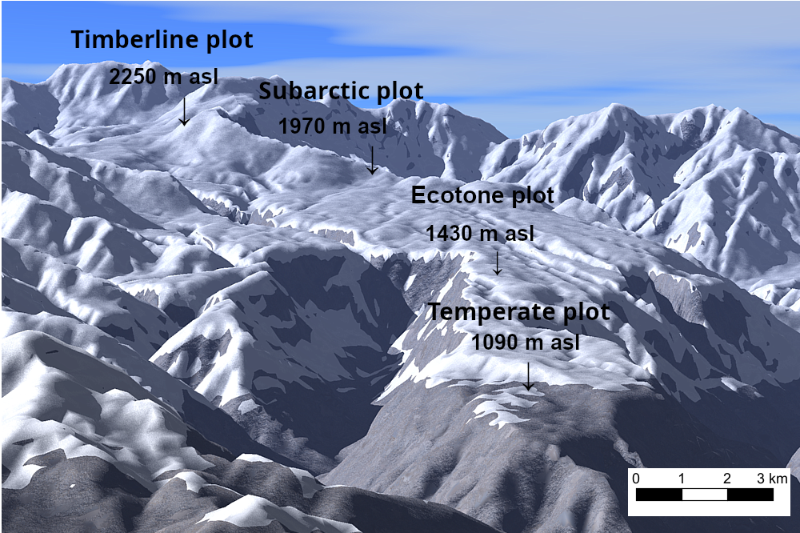

Fig. 1. Bird’s-eye view of each plot
Four plots were established on the Tateyama lava plateau in the Chubu-Sangaku National Park.
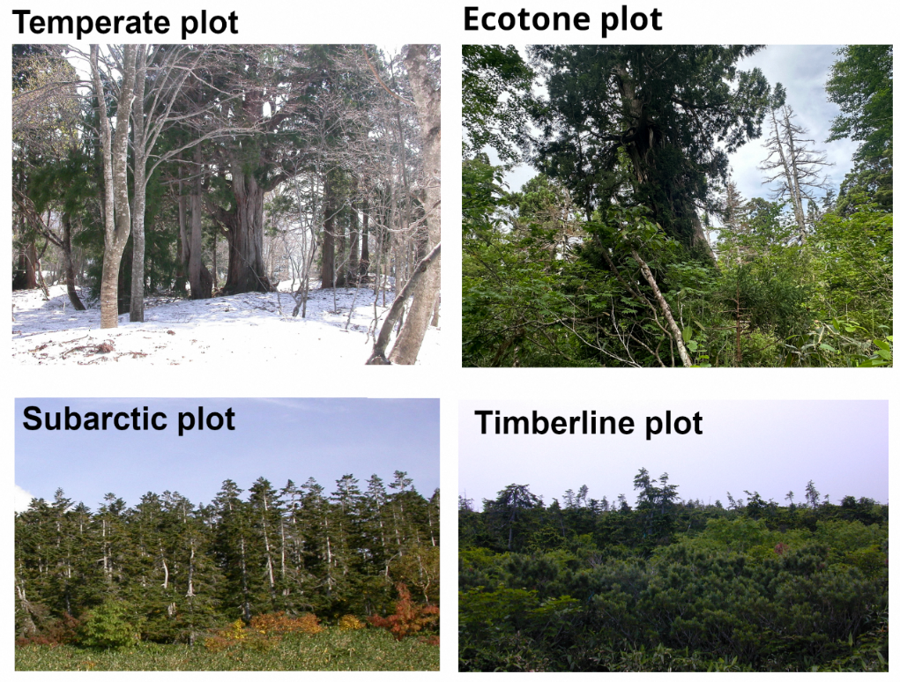

Fig. 2. Photographs of the forest type in each plot
The main tree species in the plots are as follows: Temperate plot: Cryptomeria japonica (Japanese cedar), and Fagus crenata; Ecotone plot: C. japonica, F. crenata, Pinus parviflora, and A. mariesii; Subarctic plot: A. mariesii; and Timberline plot: A. mariesii, Pinus pumila.

Based on the Mesh climatological normal for 2020 (Japan Meteorological Agency, 2022) and a temperature lapse rate of −0.55°C per 100 m (Ishida, 1991), the mean air temperatures in the Temperate, Ecotone, Subarctic, and Timberline plots are 8°C, 6.2°C, 2.8°C, and 1°C, respectively. The corresponding warmth indexes are 62.8°C·month, 51.6°C·month, 37.7°C·month, and 24.9°C·month; annual precipitation amounts are 2908, 2828, 2652, and 2628 mm; and the annual maximum snow depths are 335, 393, 517, and 583 cm, respectively (Aiura et al., 2018).

2.2. Field survey
The areas of the Temperate and Ecotone plots measured 10,000 m², while the area of the Subarctic plot measured 5,000 m². In these plots, we surveyed all tall tree species with a diameter at breast height of 10 cm or more. A plot of area measuring 625 m² was set up in the timberline region near the forest boundary, where we surveyed all A. mariesii trees with a height of 1.3 m or more (Table 1). Identification tags were attached to the surveyed trees at breast height, and we measured the diameter at breast height and vitality (Nakajima et al., 2011) during each survey. We also counted all the live and dead standing trees in all plots. If a standing tree fell, then further survey on that tree was discontinued. A total of 666, 745, 228, and 188 trees were surveyed at the Temperate, Ecotone, Subarctic, and Timberline plots, respectively. This corresponds to stem densities of 666, 745, 456, and 3008 stems ha⁻¹ at the Temperate, Ecotone, Subarctic, and Timberline plots, respectively. A total of seven forest composition surveys were conducted across all plots. The survey years for each plot are indicated in the footnotes to Table 1.
The annual maximum snow depths for each plot were measured using a Takahashi snow depth gauge (Takahashi, 1968). However, the snow depth could not be measured in the Timberline plot. We estimated the snow cover duration from periods when the ground was at 0°C using a ground thermometer (Ishida, 2006).

2.3. Estimation of changes in WI for each plot over time
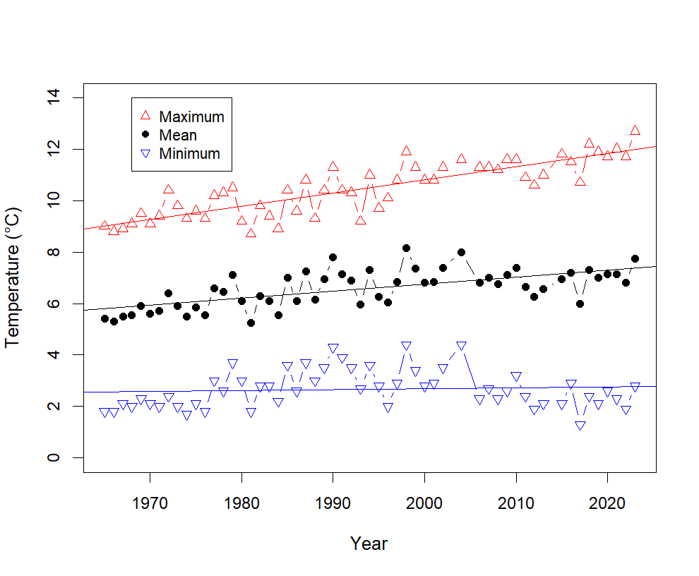

Fig. 3. Changes in temperature (daily maximum, daily minimum, and daily average) at the Kurobe Dam
Straight lines denote the regression equations (see Table 2).
From 1965 to 2023, the daily maximum and mean temperatures observed at the Kansai Electric Power Kurobe Dam (latitude 36.335943°, longitude 137.394358°, elevation 1368 m) correlated positively with the year, with the regression equations showing that these temperatures had increased by 0.5°C and 0.3°C, respectively, over the 10-year period (Fig. 3, Table 2). On the other hand, Wada et al. (2004) reported that the mean daily minimum temperature from 1965 to 2001 positively correlated with the year; however, no upward trend was detected in the mean daily minimum temperature. This finding might be attributed to a decrease in the daily minimum temperature since 2000; however, the meteorological cause is unknown.

Table 2. The results of regression analyses of yearly trends in daily temperature at the Kurobe Dam (1965–2023).
 | Intercept |  | Coefficient |  | Adjusted R squared | p-value
Daily maximum | -91.455 | *** | 0.051 | *** | 0.71 | < 2.2e-16 | ***
Daily mean | -47.932 | *** | 0.027 | *** | 0.41 | 8.142e-08 | ***
Daily minimum | -4.410 |  | 0.004 |  | -0.01 | 0.5368

We used the Kurobe Dam observations to estimate the changes in WI over time for each plot. The Kurobe Dam was located 7.8, 9.8, 15.2, and 16.8 km away from the Timberline, Subarctic, Ecotone, and Temperate plots, respectively.
We defined T_{ij} as the monthly mean temperature observed at Kurobe Dam in the year i and month j and δT_{ijk} as the temperature difference between each plot k and the Kurobe Dam, which was estimated based on the elevation difference between each plot ALT_{k} and Kurobe Dam (1368 m) with a temperature lapse rate of 0.55°C/100 m. The warmth index WI_{ik} was calculated for each plot in the year $y$ using the following formula:
$δT_{ijk}=-0.55/100×\left(ALT_{k}-1368\right)$ (1)
$ΔT_{ijk}=T_{ij}-5+δT_{ijk},$ (2)
$where, ΔT_{ijk}=0 if ΔT_{ijk}<0$ (3)
$WI_{ik}=ΣΔT_{ijk}$ (4)
Temperature records at Kurobe Dam were unavailable for 2003, 2004, 2014, and 2024. Missing values were estimated from Toyama Meteorological Observatory observations using the ratio of the two stations in the preceding year.

2.4. Estimation of death years of dead standing Abies mariesii trees
The times of death of dead standing A. mariesii trees in the Ecotone plot in 2000 were estimated using the mean time to fall model (Gärtner et al., 2023) as shown below:
$mtf=e^{2.40+0.04dbh-0.12mat}$ (5)
Here, mtf is the mean time to fall of dead standing trees, dbh is the diameter at the breast height of the trees, and mat is the mean annual temperature.
The year when dead standing trees fell, y_{fall ,} was determined as the median year y_{death} between the two survey years, y2 and y1, which are the year when the fall was first confirmed and the previous survey year, respectively.
$y_{fall}=y1+(y2-y1)/2$ (6)
$y_{death}=y_{fall}-mtf$ (7)

2.5. Statistical analysis
Long-term trends in WI and snow-related variables (snow cover duration and snow depth) were assessed using the Mann–Kendall trend test.
Demographic rates for population growth (G = ln(N1/N0)/t), mortality (M = ln(N0/Ns)/t), and ingrowth (I = ln(N1/Ns)/t) were calculated following Condit et al. (1999), where N0 is the number of trees at the first survey, N1 is the number of trees at the latest survey, Ns is the number of trees that survived throughout all survey periods, and t is the total number of years of the study period. Here, ingrowth refers to trees newly reaching the DBH ≥ 10 cm threshold (or height ≥ 1.3 m for the Timberline plot), not seedling establishment.
Differences in the proportion of dead standing A. mariesii trees among plots were assessed using Tukey's multiple comparison test. The normality of estimated death-year distributions was assessed using the Kolmogorov–Smirnov test.
To examine the relationship between climate warming and forest dynamics in the Ecotone plot, ANCOVA was used with WI as the covariate and species as the grouping factor to compare the slopes of WI versus basal area ratio among F. crenata, C. japonica, and A. mariesii (n = 7 survey periods). Differences in the rate of increase in cumulative A. mariesii mortality among the Ecotone, Subarctic, and Timberline plots were assessed using ANCOVA with survey year as the covariate and plot as the grouping factor (n = 7 per plot). Pairwise comparisons of slopes were conducted by refitting the model with each group as the reference level.
To examine the relationships between A. mariesii demographic rates and climate variables, Pearson's product-moment correlation was calculated between each of four climate variables — WI, mean daily maximum temperature (Tmax), and mean daily minimum temperature (Tmin) — and each of three demographic rates (G, M, and I) for each plot separately (n = 6 inter-survey intervals per plot) and for all plots combined (n = 18). As temperature-related variables were highly intercorrelated, multivariate analysis was not conducted. This constitutes an exploratory analysis, and no correction for multiple comparisons was applied.
All statistical analyses were performed in R (version 4.3; R Core Team, 2024).

3. Results

3.1. Changes in WI and snow conditions of each plot over time
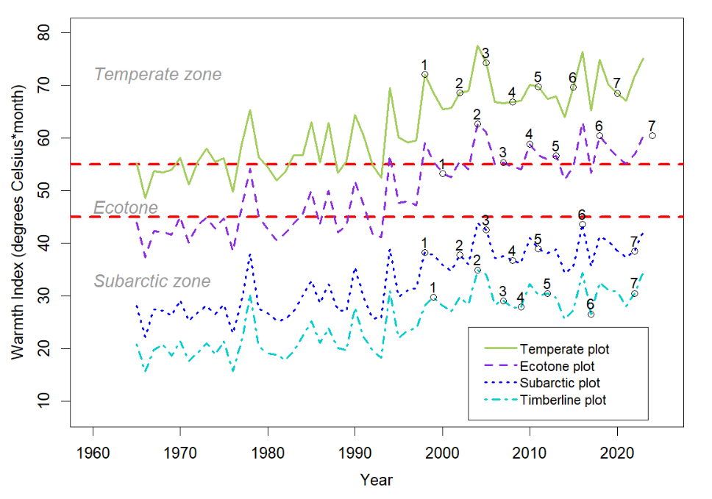

Fig. 4. Changes in WI for each plot over time
WI was estimated from observations at the Kurobe Dam. Numbered points indicate the survey periods (1–7) and WI value at each survey year for each plot, respectively. The dotted lines for warmth indexes 45 and 55°C·month are based on Kira (1948), which describes the ecotone between the temperate and subarctic zones.
The WI of each survey area (estimated from the observed air temperatures at the Kurobe Dam; Fig. 3) showed a clear rising trend over time (Fig. 4; Mann-Kendall test: all p < 0.001). The linear slopes were +3.67, +3.37, +2.81, and +2.52 °C·month per decade for the Temperate, Ecotone, Subarctic, and Timberline plots, respectively. The plots at higher-elevation showed smaller rates of increase. Since WI values were derived from Kurobe Dam temperature records using a fixed lapse rate, this increasing trend directly reflects the warming at the Dam. Nevertheless, for completeness, Kendall trend tests confirmed a significant increasing trend in WI for all plots (all p < 0.001). The Ecotone plot crossed the ecotone–temperate boundary (WI = 55 °C·month) for the first time in 1994. In the period 2013–2023, 72.7% of years exceeded WI = 55, firmly placing this plot within the temperate zone. By contrast, the Subarctic and Timberline plots remained entirely within the subarctic zone throughout the study period (maximum WI: 43.9 and 34.9 °C·month, respectively).
The annual maximum snow depths from 2004 to 2024, measured using the Takahashi snow depth meter (Takahashi, 1968), were in the ranges of 200–400, 250–450, and 400–550 cm in the Temperate, Ecotone, and Subarctic plots, respectively (Appendix S1).
The snow cover durations from 1999 to 2024, estimated using a ground thermometer (Ishida, 2006), were in the ranges of 120–170, 150–190, and 200–240 days/year in the Temperate, Ecotone, and both Subarctic and Timberline plots, respectively (Appendix S2). No statistically significant trend was detected in snow cover duration or snow depth at any plot during the observation period (Mann–Kendall test: all p > 0.05).

3.2. Forest composition at each plot
We identified a total of 26 tall tree species representing temperate, ecotone, and subarctic species across the four plots (Table 3). In the Temperate plot, the predominant species were C. japonica and F. crenata, while in the Subarctic and Timberline plots, the predominant species was A. mariesii. We observed a mixture of temperate, ecotone, and subarctic species in the Ecotone plot, including P. parviflora and Thuja standishii.

Table 3. Basal areas (BAs) of each tree species in each plot. The BA values represent means during periods 1 to 7.
Species | Temperate plot |  | Ecotone plot |  | Subarctic plot |  | Timberline plot
 | m²/ha | (%) | m²/ha | (%) | m²/ha | (%) | m²/ha | (%)
Temperate elements | 49.35 | (100.00) | 33.31 | (60.76) | 0.23 | (0.98) |  | (0.00)
Cryptomeria japonica | 32.13 | (65.10) | 30.78 | (56.16)
Fagus crenata | 7.82 | (15.84) | 1.30 | (2.38)
Magnolia obovata | 4.84 | (9.80)
Prunus grayana | 2.70 | (5.47) | 0.02 | (0.04)
Phellodendron amurense | 0.41 | (0.83)
Quercus crispula | 0.31 | (0.63) | 0.37 | (0.68)
Acer rufinerve | 0.25 | (0.51)
Acer japonicum | 0.23 | (0.47) | 0.11 | (0.20)
Aesculus turbinata | 0.23 | (0.46)
Acer amoenum | 0.16 | (0.33)
Betula maximowicziana | 0.08 | (0.16)
Acanthopanax  sciadophylloides | 0.07 | (0.14) | 0.03 | (0.05)
Acer mono | 0.06 | (0.12)
Cornus controversa | 0.03 | (0.06)
Sorbus americana | 0.03 | (0.05) | 0.19 | (0.35) | 0.23 | (0.98)
Tilia japonica | 0.01 | (0.02) | 0.01 | (0.03)
Kalopanax pictus | 0.01 | (0.02)
Magnolia salicifolia |  |  | 0.24 | (0.44)
Alnus hirsuta |  |  | 0.25 | (0.45)
Ecotone elements | 0.00 | (0.00) | 18.62 | (33.97) | 0.00 | (0.00) | 0.00 | (0.00)
Pinus parviflora |  |  | 13.31 | (24.29)
Thuja standishii |  |  | 4.86 | (8.86)
Betula corylifolia |  |  | 0.45 | (0.82)
Subarctic elements | 0.00 | (0.00) | 2.89 | (5.27) | 23.18 | (99.02) | 12.76 | (100.00)
Abies mariesii |  |  | 2.23 | (4.06) | 21.97 | (93.84) | 12.76 | (100.00)
Tsuga diversifolia |  |  | 0.39 | (0.72)
Betula ermanii |  |  | 0.11 | (0.19) | 1.21 | (5.15)
Acer tschonoskii |  |  | 0.16 | (0.29) | 0.01 | (0.02)
Total | 49.35 | (100.00) | 54.81 | (100.00) | 23.41 | (100.00) | 12.76 | (100.00)

Calculating the total basal area ratios according to species group in each plot showed that 100% of the species in the Temperate plot were temperate species; 60.76%, 33.97%, and 5.27% of the species in the Ecotone plot were temperate, ecotone, and subarctic species, respectively; and 99.02% of the species in the Subarctic and Timberline plots were subarctic species (Fig. 5).
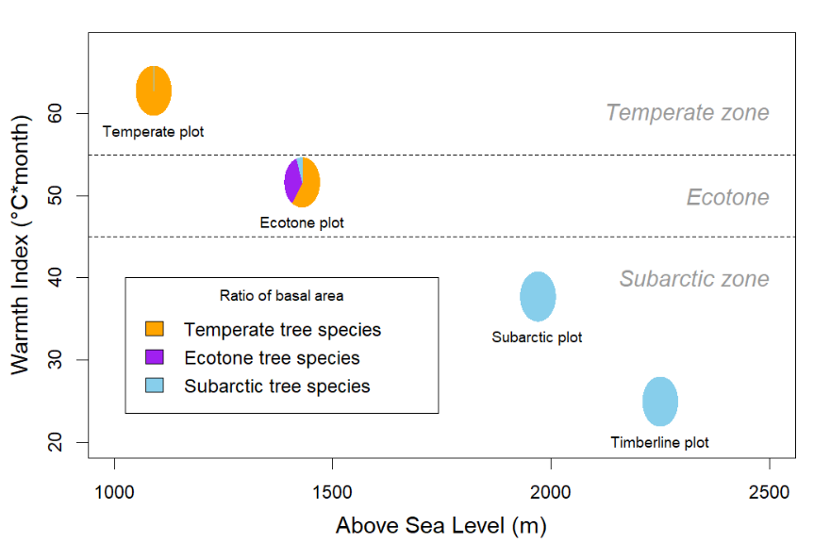

Fig. 5. Warmth index and proportion of tree species in each plot
WI was estimated based on the Mesh climatological normal for 2020 (Japan Meteorological Agency, 2022). The tree species are listed in Table 3.

3.3. Forest dynamics in each climate zone

Table 4. Demographic rates for population growth, mortality, and ingrowth (% per year) of the tree species grouped by elements in each plot.
 | Temperate plot |  |  |  | Ecotone plot |  |  |  | Subarctic plot |  |  |  | Timberline plot
Species | G* | M* | I* |  | G* | M* | I* |  | G* | M* | I* |  | G* | M* | I*
Temperate elements |  |  |  |  |  |  |  |  |  | 0.19 | 0.97 | 1.16 |  | 0.68 | 0.74 | 1.42
Cryptomeria japonica | -0.67 | 0.72 | 0.05 |  | 0.20 | 0.66 | 0.85
Fagus crenata | 1.23 | 0.58 | 1.80 |  | 0.49 | 1.32 | 1.81
Magnolia obovata | -0.06 | 0.54 | 0.47
Prunus grayana | -0.96 | 1.43 | 0.47
Phellodendron amurense | -2.76 | 2.76 | 0.00
Quercus crispula |  |  |  |  | 1.96 | 1.49 | 3.44
Acer rufinerve | -2.32 | 8.62 | 6.30
Acer japonicum | 3.15 | 0.28 | 3.43 |  | 7.29 | 0.00 | 7.29
Acer amoenum | 4.26 | 0.54 | 4.80
Magnolia salicifolia |  |  |  |  | 1.76 | 1.58 | 3.34
Ecotone elements |  |  |  |  | 0.64 | 0.60 | 1.24
Pinus parviflora |  |  |  |  | -0.40 | 0.55 | 0.14
Thuja standishii |  |  |  |  | 0.00 | 1.20 | 1.20
Betula corylifolia |  |  |  |  | 3.60 | 0.27 | 3.87
Subarctic elements |  |  |  |  |  |  |  |  |  |  |  |  |  | -2.01 | 2.42 | 0.42 |  | -0.33 | 0.77 | 0.44 |  | 0.85 | 0.69 | 1.55
Abies mariesii |  |  |  |  | -2.37 | 2.89 | 0.52 |  | -0.43 | 0.75 | 0.32 |  | 0.85 | 0.69 | 1.55
Betula ermanii |  |  |  |  |  |  |  |  | 1.33 | 1.20 | 2.53
 | 0.19 | 0.97 | 1.16 |  | 0.51 | 0.82 | 1.33 |  | -0.34 | 0.80 | 0.46 |  | 0.82 | 0.69 | 1.55
Only species with 10 or more recorded individuals are shown in this table. However, demographic rates for the total and for each element were
calculated based on all recorded species, including those not listed.
*)G, M, I （see section 2.5, Condit et al. 1999)

The demographic rates were calculated based on the number of trees (Condit et al., 1999) in each plot (Table 4). In the Temperate plot, F. crenata showed vigorous renewal with a high ingrowth rate (1.80%/yr). Acer amoenum and A. japonicum also showed high growth rates. In the Ecotone plot, temperate elements showed active growth and ingrowth (G: 0.68, I: 1.42%/yr). In contrast, subarctic elements (A. mariesii) showed negative growth (G: −2.37), high mortality (M: 2.89), and low ingrowth (I: 0.52%/yr), representing the most severe decline among of all the plots. Ecotone elements (Pinus parviflora) also showed negative growth (G: −0.40). In the Subarctic plot, A. mariesii showed mild negative growth (G: −0.43) and relatively low mortality (M: 0.75). Betula ermanii showed a relatively high ingrowth rate (I: 2.53%/yr). In the Timberline plot, composed solely of A. mariesii, the population showed positive growth (G: 0.85), low mortality (M: 0.69), and high ingrowth (I: 1.55%/yr)—the most favorable demographic performance among of all four plots.

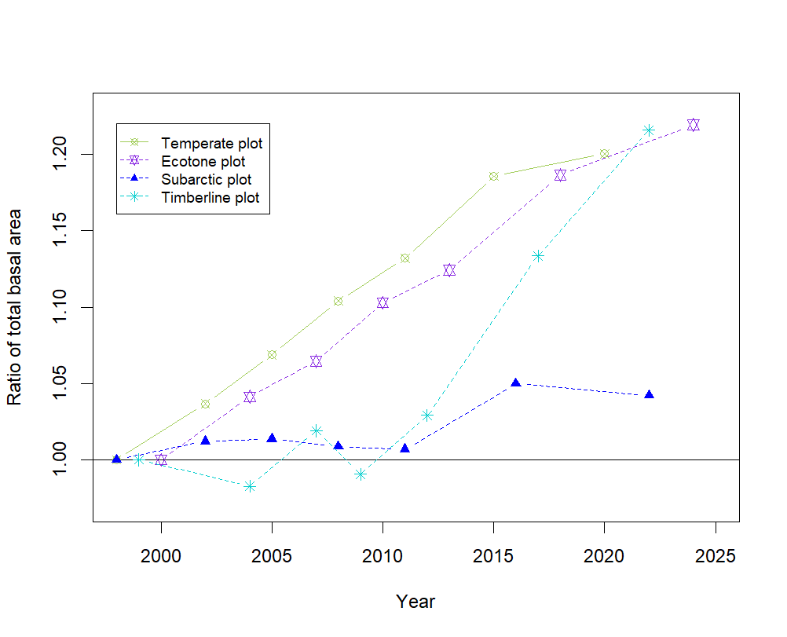

Fig. 6. Changes in the total basal area in each plot over time
The change in the ratio of the total basal area was calculated based on the value from the first survey in 2000.
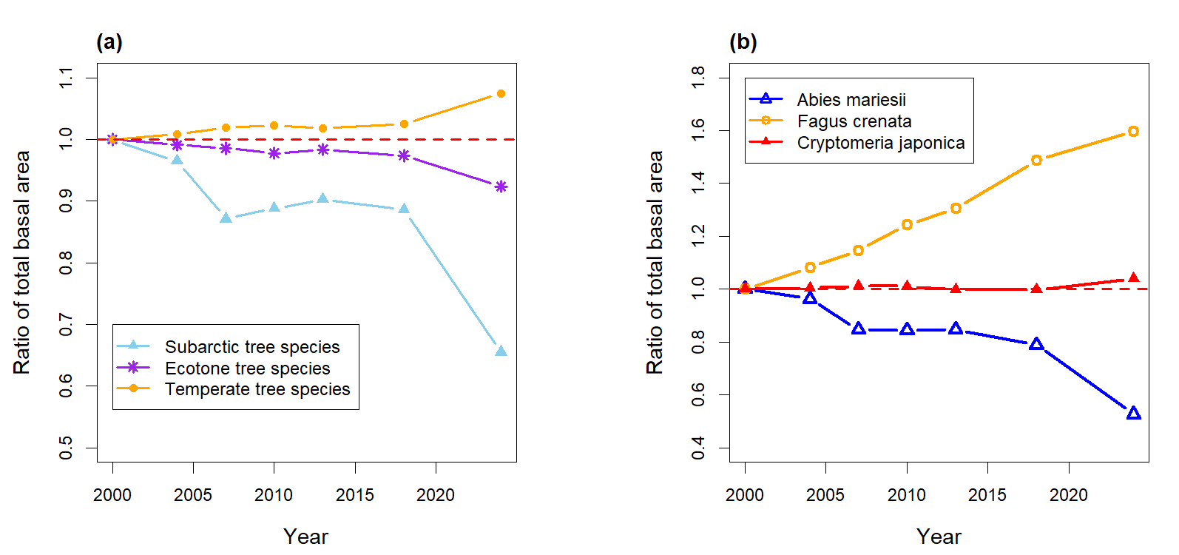
The total basal area at breast height at the beginning of the first period in the Temperate, Ecotone, and Timberline plots had increased by about 1.2-fold at the end of the seventh period (Fig. 6). In contrast, the rate of increase in the Subarctic plot was the lowest (1.03-fold). In the Timberline plot, large individuals died in the second and fourth periods, and the area decreased from the beginning of the period but showed steady growth from the fifth period onward, reaching the same growth rate as the Temperate and Ecotone plots.

Fig. 7. Changes in basal area in the Ecotone plot over time. (a) Ratio of total basal area by tree species group (temperate, ecotone, and subarctic elements). (b) Ratio of basal area of major tree species in the Ecotone plot(A. mariesii, F. crenata, and C. japonica). The ratio of the total basal area was based on the value from the first survey in 2000. Tree species are listed in Table 3."

In the Ecotone plot, by the seventh period, the basal areas at breast height of temperate, ecotone, and subarctic tree species gradually increased to 1.07-fold, gradually decreased to 0.92-fold, and significantly decreased to 0.66-fold, respectively (Fig. 7a). The degree of change in the basal areas of the species groups became more pronounced after 2018.
In the Ecotone plot, the ratios of the basal areas at breast height of F. crenata, C. japonica (both climax species in the temperate zone of the Tateyama region), and A. mariesii (climax species in the subarctic zone) increased to 1.6, remained nearly unchanged at 1.04, and decreased to 0.53, respectively (Fig. 7b).

Table 5 The results of Analysis of covariance (ANCOVA) for the relationship between the warmth index and basal area ratio in the Ecotone plot.
(a) By tree species group
Group | Slope (/WI) | Comparison | p
Temperate tree species | 0.004 | Temperate vs. Ecotone | 0.305
Ecotone tree species | −0.004 | Ecotone vs. Subarctic | 0.135
Subarctic tree species | −0.017 | Subarctic vs. Temperate | 0.019
(b) By species
Species | Slope (/WI) | Comparison | p
Fagus crenata | 0.034 | F. crenata vs. C. japonica | 0.092
Cryptomeria japonica | 0.002 | C. japonica vs. A. mariesii | 0.165
Abies mariesii | −0.024 | A. mariesii vs. F. crenata | 0.005
Slopes were estimated from ANCOVA with WI as covariate and species group (a) or species (b) as grouping factor (n = 7 survey periods).
p-values for comparisons are from pairwise slope tests with Bonferroni correction for three comparisons.

In the Ecotone plot, as WI increased, the basal area ratio of temperate tree species increased (slope +0.004), while that of subarctic tree species decreased (slope −0.017), showing contrasting trends; the difference in slopes was significant (p = 0.019, Table 5a). Ecotone tree species showed an intermediate response (slope −0.004, p = 0.135).
At the species level, F. crenata (slope +0.034) and A. mariesii (slope −0.024) showed contrasting responses to warming, and the difference in their slopes was significant (p = 0.005, Table 5b). C. japonica showed a neutral response (slope +0.002, p = 0.165).

3.4. Dynamics of the A. mariesii population
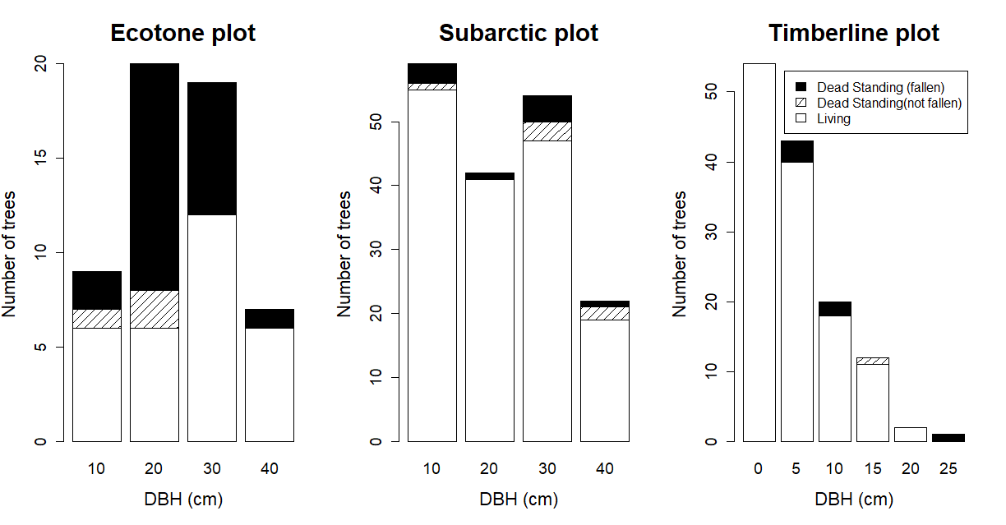

Fig. 8. Distributions of the diameter at breast height of A. mariesii during the first survey in each plot
The black solid and the diagonal lines indicate trees that had fallen and were still standing during the seventh survey, respectively. This distinction is necessary because the mean-time-to-fall model (Gärtner et al., 2023) used to estimate death years (Section 2.4) requires standing dead trees as input; Dead standing trees that had not fallen by the seventh survey cannot be assigned estimated death years using this approach, as the time elapsed since death is unknown.
In the Ecotone plot, 45.6% of A. mariesii trees were dead standing during the first period (basal area: 39%). This proportion was significantly higher than the corresponding proportions in the Subarctic (8.9%; basal area: 12.8 %) and Timberline (11.4%; basal area: 16.4%) plots (Tukey’s multiple comparison P ≤ 0.001, Fig. 8). In addition, various diameters of dead A. mariesii trees were observed in all plots, without any bias in size.
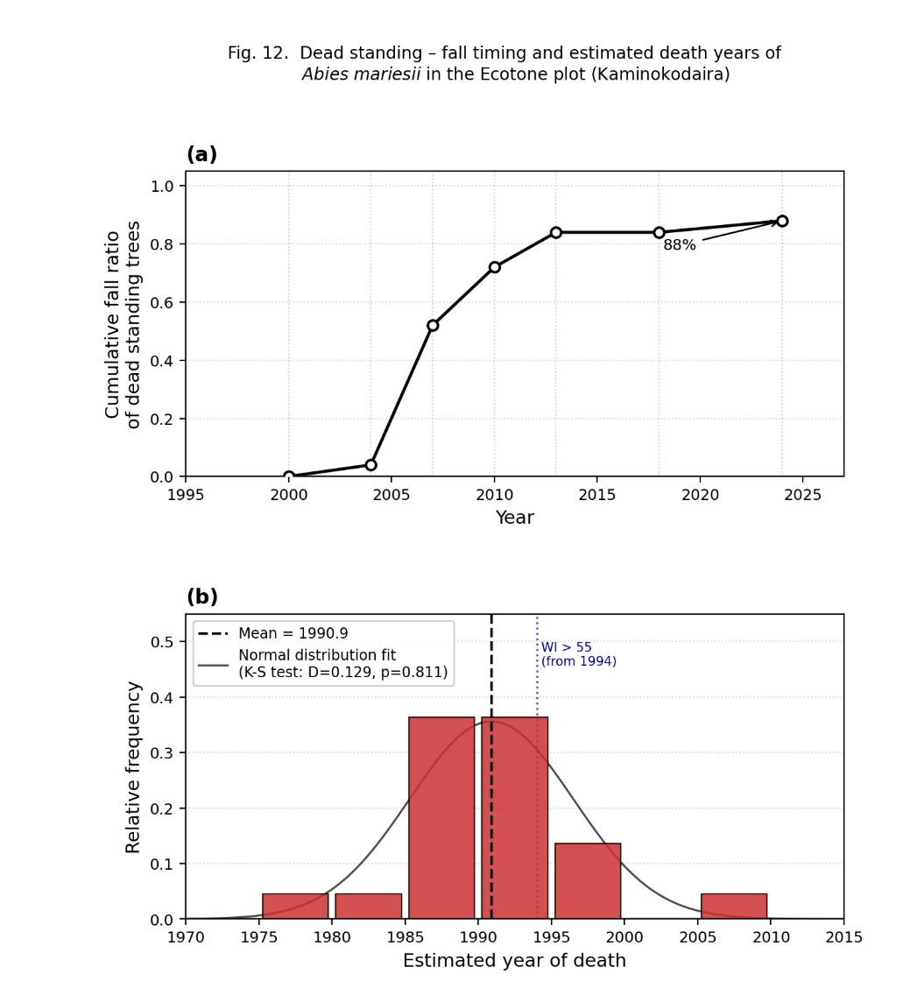

Fig. 9. Changes in the cumulative ratio of dead standing A. mariesii trees in the Ecotone plot in 2000 and the estimated frequency of death
In the Ecotone plot, 25 dead standing A. mariesii trees were observed in 2000. By 2024, 88% of them had fallen. The red histogram indicates the frequency of their death, estimated from their year of death (y_{death}, eq. (7)) using the mean time to fall model (Gärtner et al., 2023).
There were 25 dead standing A. mariesii trees in the Ecotone plot in 2000. Of these, 22 (88%) of the trees had fallen by 2024 (Fig. 9). The mean time for trees to fall was estimated to be 16.6 ± 4.4 years (mean ± s.d., min–max: 7.8–26.6 years) using the model (Gärtner et al., 2023). The dead standing A. mariesii trees exhibited a normal frequency distribution (Kolmogorov-Smirnov test: D = 0.129, p = 0.811) and were estimated to have died in 1990.9 ± 5.7 (mean ± s.d.). From 2000 to 2024, three A. mariesii trees with diameters at breast height of 12.1, 12.5, and 39.8 cm died while standing and then fell after 5, 6, and 20 years, respectively. The model (Gärtner et al.,2023) estimated the times between death and falling of the trees at 9, 9, and 26 years, respectively.
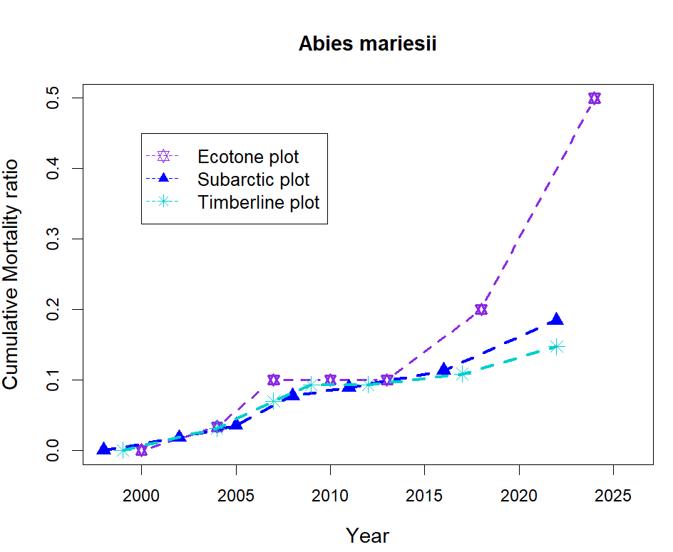

Fig. 10 Changes in cumulative mortality ratio of Abies mariesii in each survey plot over time
The cumulative mortality ratios of A. mariesii trees that had survived in period 1 from periods 1 to 7 in the Subarctic and Timberline plots were 18.5% and 15.2%, respectively (Tukey multiple comparisons, p = 0.059); however, in the Ecotone plot , the rate was significantly higher at 50% (Tukey multiple comparisons, both p < 0.001; Fig. 10). The increase in mortality was particularly noticeable after 2013. The annual mortality rate at the Ecotone plot was 2.89%/yr for the full observation period (2000–2024, Table 4), increasing markedly to 8.3%/yr during the recent period (2013–2024). By contrast, annual mortality rates at the Subarctic and Timberline plots remained low throughout the observation period (0.75%/yr and 0.69%/yr, respectively).

Table 6. Pearson correlation coefficients between climate variables and demographic rates of A. mariesii
This is an exploratory analysis and no correction for multiple comparisons has been performed.
Plot | Climate variables | Growth (G) | Mortality (M) |  | Ingrowth (I)
Ecotone | WI | -0.465 | 0.775 |  | 0.022
(n=6) | Tmax | -0.702 | 0.959 | ** | -0.193
 | Tmin | 0.09 | -0.47 |  | -0.349
Subarctic | WI | -0.084 | 0.304 |  | 0.076
(n=6) | Tmax | -0.192 | 0.035 |  | -0.263
 | Tmin | 0.057 | -0.348 |  | -0.145
Timberline | WI | -0.399 | -0.475 |  | -0.538
(n=6) | Tmax | -0.599 | -0.056 |  | -0.62
 | Tmin | 0.377 | 0.431 |  | 0.503
Pooled | WI | -0.372 | 0.507 | * | -0.082
(n=18) | Tmax | -0.421 | 0.596 | ** | -0.071
 | Tmin | -0.296 | 0.421 |  | -0.048
* p<0.05, ** p<0.01
WI: Warmth Index, Tmax: maximum temperature, Tmin: minimum temperature
Growth (G), Mortality (M), Ingrowth (I); see section 2.5 (Condit et al. 1999)
Among the correlations between A. mariesii demographic rates and interval-mean climate variables (Table 6), mortality rate (M) showed the strongest associations with climate. At the Ecotone plot, Tmax was strongly and positively correlated with (M) (r = 0.959, p = 0.003). In the pooled analysis across three plots (n = 18), both WI (r = 0.507, p = 0.032) and Tmax (r = 0.596, p = 0.009) were significantly and positively correlated with (M). No significant relationships were found between climate variables and either growth rate (G) or ingrowth rate (I) in any plot or in the pooled analysis.

4. Discussion

4.1. Warming trend around Mt. Tateyama
The average temperature at the Kurobe Dam in Mt. Tateyama increased by 0.27°C/decade from 1965 to 2023 (Fig. 3). In the Green Mountains of Vermont, USA, the annual temperature has increased by 1.1°C from 1964 to 2004 (Beckage et al., 2008), with a rate of temperature increase of 0.28°C/decade, which was almost equal to that of Mt. Tateyama. The rate of temperature increase in the Tateyama region since the 1960s was about approximately five times higher than that of the global rate of 0.05°C/decade since before the industrial revolution (IPCC, 2023). Pepin et al. (2022) also reported higher warming rates at higher elevations in some mountainous regions.
WI value (Kira, 1948), calculated using the Mesh climatological normal for 2020 (Japan Meteorological Agency, 2022), of the Ecotone plot placed it at the ecotone between the temperate and subarctic zones (Fig. 5). Assuming that the temperatures rose in the same way as the rise in temperature in the Kurobe Dam, WI at the Ecotone plot changed from 40 to 60°C·month from the 1960s to 2020s (Fig. 4). This warmth index range encompassed the ecotone as set by Kira (1948). These results indicated that WI for this period rose from a subarctic zone value to an ecotone value and finally reached a temperate zone value.

4.2. Forest dynamics
The forest population growth rate was negative only in the Subarctic plot, primarily due to the influence of A. mariesii, the dominant tree species in that zone (Table 4). The growth rate of A. mariesii was lowest in the Ecotone plot but increased with altitude. The remarkably low growth rate in the Ecotone plot might be attributed to reduced overall growth caused by high mortality and low ingrowth. However, in terms of the overall population, the growth rate in the Ecotone plot was second only to that of the Timberline plot. This may reflect the high growth rates of temperate and ecotone elements that overshadowed the decline of A. mariesii. The Timberline plot exhibited the highest ingrowth rate among all plots, indicating active regeneration at the upper forest limit. The contrasting demographic trends of A. mariesii — rapid decline at lower elevations and active regeneration at higher elevations — are consistent with a thermally driven upward redistribution of this species along the altitudinal gradient.
It has previously been reported that forest growth decreases in old-growth, overmature forests (Kira and Shidei, 1967; Smith and Long, 2001). However, we found that basal area at breast height increased in all plots (Fig. 6), which are pristine old-growth stands. As noted in previous studies (Ryan et al., 2004; Luyssaert et al., 2008; Noguchi et al., 2022), such stands can continue to accumulate biomass. Notably, in the Ecotone plot, located near the transition zone between the temperate and subarctic zones, the basal area of temperate tree species increased while that of subarctic A. mariesii decreased (Fig. 7a, b; Table 5).
At the beginning of the study (2000), both the number and basal area ratio of dead standing A. mariesii trees were significantly higher in the Ecotone plot than in the Subarctic and Timberline plots (Fig. 8). The model (Gärtner et al., 2023) of dead trees in the Ecotone plot indicated that the A. mariesii population deteriorated and died intensively in 1990 (Fig. 9). In addition, WI began to deviate from the ecotone range in the Ecotone plot. These results indicated that the ecotone areas are not in a state of forest decline but are rather rapidly replacing tree species following the death of A. mariesii; therefore, the forest growth is maintained.

4.3. Decline of A. mariesii trees in the ecotone
We observed a remarkably high mortality rate of A. mariesii in the Ecotone plot (Table 4, 6; Fig. 10). Although Mt. Tateyama is located within a national park designated as a natural environment conservation area, it is also a popular tourist destination and thus experiences anthropogenic disturbances. We acknowledge that other anthropogenic factors associated with high tourist traffic, such as nitrogen deposition from vehicle exhaust, may have contributed to the observed increases in basal area and tree growth across some plots (Kume et al., 2009). However, as discussed below, the species-specific pattern of decline in A. mariesii alongside vigorous growth in co-occurring temperate species is more consistent with a thermal stress explanation than a general site-level anthropogenic effect. For instance, F. crenata has declined along the roadsides at 1200 m asl, and this decline has been attributed to either vehicle exhaust (Kawano and Kato, 2000) or long-range air pollution (Kume et al., 2009). Kume et al. (2020) later observed an improvement in the area’s air quality and the recovery of F. crenata growth. In contrast, in our Ecotone plot, we observed vigorous growth of F. crenata (known to be sensitive to air pollution), while only A. mariesii population declined (Fig.7b). Therefore, air pollution alone is unlikely to be the primary driver of A. mariesii mortality, given the species-specific nature of the decline.
Insect outbreaks that are modulated by climate warming (Domingo et al., 2024) have also been suggested as a potential cause of A. mariesii mortality. The defoliator Epinotia piceae and the woodborer Polygraphus proximus are known pests of A. mariesii (Chiba, 2020). However, we found no evidence of insect activity (that is, feeding marks, frass, or boreholes) in this study, suggesting that A. mariesii mortality might not be attributed to insect damage.
Thus, the most plausible explanation for A. mariesii mortality is climate-associated stressors. Subalpine firs, such as A. mariesii, rely on a stable snow cover for protection against desiccation, frost, and early-season drought (Hu et al., 2010; Frei and Henry, 2022).
We found no clear trend in annual snow depth or snow cover duration during the monitoring period (Appendix S1, S2). However, an increase in winter runoff at the Kurobe Dam (Wada et al., 2004; Shinohara et al., 2009) implied earlier snowmelt and potentially reduced water availability later in the growing season, which is a critical period for A. mariesii.
In addition, climate warming might also reduce the frost hardiness of A. mariesii. A decrease in cold acclimation during autumn and spring, coupled with advanced budburst, increases the risk of frost injury (Larcher, 2003; Jönsson et al., 2004; Astigarraga et al., 2025). These stressors—suboptimal growth temperature, insufficient moisture, and late frost damage risk—likely acted in combination to trigger the increase in A. mariesii mortality that peaked in 1990.
A. mariesii is ecologically adapted to heavy snow environments through morphological and physiological traits (Shidei, 1956; Kaji, 1982; Sugita, 1992; Mori and Mizumachi, 2009). However, our findings suggested that it is now facing thermal conditions beyond its optimal range. Notably, snow cover conditions remained relatively stable during the study period; therefore, temperature, rather than snow-related factors, is the primary stressor for A. mariesii.

4.4. Forest zone shift
Under increasing warmth index conditions, both the increasing mortality of A. mariesii in the Ecotone plot and the reduced growth in Subarctic plot (which is thermally approaching the ecotone range) strongly suggest that climate warming has negatively affected the performance and persistence of A. mariesii, even in snow-rich areas. In contrast, temperate species, such as F. crenata, are expanding and growing vigorously in the areas where A. mariesii is declining. The vigorous growth of F. crenata in the Ecotone plot is consistent with its known thermal niche, which is strongly governed by WI (Matsui et al., 2009). The Ecotone plot now exceeds WI = 55 in most years, surpassing A. mariesii's lower thermal optimum, while Timberline plot (WI = 27–35 °C·month) remains well within the favorable subarctic range. The active ingrowth at Timberline plot (1.55%/yr) may reflect an upward range shift toward thermally suitable conditions, consistent with the hypothesis of climate-driven elevational redistribution rather than simple population collapse. Therefore, A. mariesii decline cannot be attributed to general site degradation but rather to species-specific sensitivity to warming. Although causal inference from observational data is inherently limited, the combination of a significant WI–mortality correlation, an elevation gradient in mortality rates, and the absence of any significant snow trend provides strong circumstantial evidence for a temperature-driven mechanism. Thus, the ongoing upward shift of the forest zone on Mt. Tateyama cannot be attributed to species migration alone; while the active ingrowth of A. mariesii at the Timberline plot may reflect an altitudinal range shift toward thermally more favorable conditions at higher elevations, the primary driver is a mismatch between the thermal adaptation of A. mariesii and the rapidly changing thermal conditions at its current lower distributional limits.

5. Conclusions
Long-term monitoring on Mt. Tateyama showed that climate warming is already causing an upward shift in the forest zones. While the snow cover conditions remained largely unchanged, WI increased significantly, especially in the Ecotone plot, where A. mariesii population declined, while temperate species such as F. crenata expanded. The growth of the forest stand in the Subarctic plot, which is thermally approaching the ecotone threshold, was low, suggesting that the thermal conditions in the region are suboptimal for A. mariesii growth. In contrast, the A. mariesii population in the Timberline plot grew at a high rate, along with its basal area. Overall, our results suggested that the conditions at the upper forest limit remain favorable for the growth and regeneration of A. mariesii. Moreover, these results indicated that climate warming, rather than changes in snow cover or anthropogenic disturbance, is the main driver of A. mariesii mortality. Although this species is ecologically adapted to heavy snow cover, it has not adapted to rapid temperature increases. Therefore, the forest zone shifts predicted for the future are already underway, driven by climate change that is reshaping the boundaries of the forest ecosystems in the mountains. These field-based findings are consistent with species distribution model projections, which predict a substantial upward contraction of suitable habitat for subalpine conifers under future warming scenarios in Japan (Tanaka et al., 2012; Tsuyama et al., 2015).

References
Aiura,H., Nakajima,H., Ishida, M. 2018. Estimate Average Annual Maximum Snow Depth with the Temperature and the Amount of Precipitation of the Mesh Normal Climatic Data in Toyama Prefecture, Japan. Journal of Japanese Forest Society 100: 174-177. (in Japanese)
Alexander, J. M., Diez J. M., and Levine J. M. 2015. Novel Competitors Shape Species’ Responses to Climate Change. Nature 525 (7570): 515–18. https://doi.org/10.1038/nature14952.
Astigarraga, J., Calatayud, J., Ruiz-Benito, P., Madrigal-González, J., Tijerı́n-Triviño, J., Zavala, M.A., Andivia, E., Herrero, A., 2025. Forest structural diversity modulates tree growth synchrony in response to climate change. Forest Ecology and Management 579, 122505.
Beckage, B., .Osborne B., Gavin B. G., Pucko C., Siccama T., and Perkins T. 2008. A Rapid Upward Shift of a Forest Ecotone During 40 Years of Warming in the Green Mountains of Vermont. Proceedings of the National Academy of Sciences 105 (11): 4197–4202.
Bonan, G.B., 2008. Forests and climate change: Forcings, feedbacks, and the climate benefits of forests. Science 320, 1444–1449.
Chiba, S., Kawatsu, S., Hayashida, M. 2020.Large-area Mapping of the Mass Mortality and Subsequent Regeneration of Abies mariesii Forests in the Zao Mountains in Northern Japan. J . Jpn. For. Soc. 102: 108–114
Condit, R., Ashton, P.S., Manokaran, N., LaFrankie, J.V., Hubbell, S.P., Foster, R.B., 1999. Dynamics of the forest communities at Pasoh and Barro Colorado: comparing two 50-ha plots. Philosophical Transactions of the Royal Society of London. Series B: Biological Sciences 354, 1739--1748.
Domingo, D., Vicente-Serrano, S.M., Gómez, C., Olano, J.M., Sangüesa-Barreda, G., 2024. Summer heat waves could counterbalance the increasing incidence of pine processionary due to warmer winters in Mediterranean pine forests. Forest Ecology and Management 555, 121695. https://doi.org/10.1016/j.foreco.2024.121695
Dobrowski, S.Z. (2011) A climatic basis for microrefugia: the influence of terrain on climate. Global Change Biology, 17, 1022–1035. https://doi.org/10.1111/j.1365-2486.2010.02263.x
Fang, J., Yoda, K., 1990. Climate and vegetation in China IV. Distribution of tree species along the thermal gradient. Ecological Research 5, 291–302.
Frei, Esther R., and Gregory H. R. Henry. 2022. Long-Term Effects of Snowmelt Timing and Climate Warming on Phenology, Growth, and Reproductive Effort of Arctic Tundra Plant Species. Arctic Science 8 (3): 700–721. https://doi.org/10.1139/as-2021-0028.
Gärtner, A., Jönsson, A.M., Metcalfe, D.B., Pugh, T.A.M., Tagesson, T., Ahlström, A., 2023. Temperature and tree size explain the mean time to fall of dead standing trees across large scales. Forests 14, 1017. https://doi.org/10.3390/f14051017
Harada, I., Matsumura, T., Hara, K., Kondoh, A., 2011. Spatial analysis of changes in Japanese forests during the process of modernization. Japan Association for Landscape Ecology 16 (1): 17–32
Hiura, Tsutom, Sato Go, and Hayato Iijima. 2019. Long-Term Forest Dynamics in Response to Climate Change in Northern Mixed Forests in Japan: A 38-Year Individual-Based Approach. Forest Ecology and Management 449: 117469. https://doi.org/https://doi.org/10.1016/j.foreco.2019.117469.
Hu, J., Moore, D.J.P., Burns, S.P., Monson, R.K., 2010. Longer growing seasons lead to less carbon sequestration by a subalpine forest. Global Change Biology 16, 771–783. https://doi.org/10.1111/j.1365-2486.2009.01967.x
Intergovernmental Panel On Climate Change (Ipcc), 2023. Climate Change 2021 - The Physical Science Basis: Working Group I Contribution to the Sixth Assessment Report of the Intergovernmental Panel on Climate Change, 1st ed. Cambridge University Press. https://doi.org/10.1017/9781009157896
Ishida, M., 2006. Altitudinal gradient of annual snow cover period in forested areas of Toyama Prefecture: Estimation from forest floor surface temperatures. Journal of the Japanese Society of Snow and Ice 68, 489–496. https://doi.org/10.5331/seppyo.68.489 (in Japanese)
Ishida, M., 1991. The properties of the presumed meteological data file (temperature precipitation snow depth) in Toyama prefecture. Journal of the Japanese Society of Snow and Ice 53, 45–51. https://doi.org/10.5331/seppyo.53.45 (in Japanese)
Japan Meteorological Agency, 2022. Mesh climatological normal 2020 (1991-2020).
Jönsson, A.M., Linderson, M.-L., Stjernquist, I., Schlyter, P., Bärring, L., 2004. Climate change and the effect of temperature backlashes causing frost damage in Picea abies. Global and planetary change 44, 195–207.
Kaji, M. 1982. Studies on the ecological geography of subalpine conifers. Distribution pattern of Abies mariesii in relation to the effect of climate in the postglacial warm period. Bulletin, Tokyo University Forests 72, 31-120. (in Japanese)
Kawano S., Kato T., 2000. Implications of long-term monitoring on the tree growth exposed to air pollution and an assessment of its effects. Japanese Journal of Ecology 50, 289–295. (in Japanese)
Kira, T., 1948. On the altitudinal arrangement of climatic zones in Japan. Kanchi-nogaku 2, 143–173. (in Japanese)
Kira, T., Shidei, T., 1967. Primary production and turnover of organic matter in different forest ecosystems of the western pacific. Japanese Journal of Ecology 17, 70–87. (in Japanese)
Kume, A., Numata, S., Watanabe, K., Honoki, H., Nakajima, H., Ishida, M., 2009. Influence of air pollution on the mountain forests along the tateyama-kurobe alpine route. Ecological Research 24. https://doi.org/10.1007/s11284-008-0557-2
Kume, A., Fujimoto, M., Mizoue, N., Honoki, H., Nakajima, H., & Ishida, M., 2020. Impact of reduced ozone concentration on the mountain forests of Mt. Tateyama, Japan. Environmental Pollution, 267(2), 115407. https://doi.org/10.1016/j.envpol.2020.115407
Larcher, W. 2003. Physiological plant ecology: ecophysiology and stress physiology of functional groups. Springer Science & Business Media.
Lenoir, J., Gégout, J.-C., Dupouey, J.-L., Bert, D., Svenning, J.-C., 2010a. Forest plant community changes during 1989-2007 in response to climate warming in the jura mountains (france and switzerland). Journal of Vegetation Science 21, 949–964.
Leonelli, G., Pelfini, M., Morra di Cella, U., Garavaglia, V., 2011. Climate warming and the recent treeline shift in the European Alps: The role of geomorphological factors in high-altitude sites. Ambio 40, 264–273.
Lutz, David A., Rebecca L. Powell, and Miles R. Silman. 2013. Four Decades of Andean Timberline Migration and Implications for Biodiversity Loss with Climate Change. Edited by Maura Geraldine Chapman. PLoS ONE 8 (9): e74496. https://doi.org/10.1371/journal.pone.0074496.
Luyssaert, S., Schulze, E.-D., Börner, A., Knohl, A., Hessenmöller, D., Law, B.E., Ciais, P., Grace, J., 2008. Old-growth forests as global carbon sinks. Nature 455, 213–215.
Mamantov, M.A., Gibson‐Reinemer, D.K., Linck, E.B., Sheldon, K.S., 2021. Climate‐driven range shifts of montane species vary with elevation. Global Ecol. Biogeogr. 30, 784–794. https://doi.org/10.1111/geb.13246
Matsui, T., Yagihashi, T., Nakaya, T., Tanaka, N., Taoda, H., 2009. Predicting the impact of climate change on potential habitats of fir (Abies) species in Japan and on the East Asian continent. Journal of Vegetation Science 20, 120–130.
Matsumoto, A., Fujii, S., Shibata, K., 1991. K-ar ages of lavas from tateyama volcano, toyama prefecture, central japan. Journal of Mineralogy, Petrology and Economic Geology 86, 278–282. (in Japanese)
Mori, S. A., Mizumachi E. 2009. Within-Crown Structural Variability of Dwarfed Mature Abies Mariesii in Snowy Subalpine Parkland in Central Japan. Journal of Forest Research 14(3): 155–66. doi:10.1007/s10310-009-0115-y.
Nakajima, H., Kume, A., Ishida, M., Ohmiya, T., Mizoue, N., 2011. Evaluation of estimates of crown condition in forest monitoring: Comparison between visual estimation and automated crown image analysis. Annals of Forest Science 68, 1333–1340. https://doi.org/10.1007/s13595-011-0132-9
Noguchi, Mahoko, Kazuhiko Hoshizaki, Michinari Matsushita, Daiki Sugiura, Tsutomu Yagihashi, Tomoyuki Saitoh, Tomohiro Itabashi, et al. 2022. Aboveground Biomass Increments over 26 Years (1993–2019) in an Old-Growth Cool-Temperate Forest in Northern Japan. Journal of Plant Research 135 (1): 69–79. https://doi.org/10.1007/s10265-021-01358-5.
Nogami M., 1994. Thermal Condition of the Forest Vegetation Zones and their Potential Distribution under Different Climates in Japan. Journal of Geography 103(7): 886-897 (in Japanese)
O’Sullivan, Kirsten S. W., Paloma Ruiz‐Benito, Jan‐Chang Chen, and Alistair S. Jump. 2021. Onward but Not Always Upward: Individualistic Elevational Shifts of Tree Species in Subtropical Montane Forests. Ecography 44 (1): 112–23. https://doi.org/10.1111/ecog.05334.
Shinohara, Y., Kumagai, T., Otsuki, K., Kume, A. and Wada, N. 2009.1313 Impact of climate change on runoff from a mid-latitude mountainous catchment in central Japan. Hydrol. Process., 23: 1418–1429. https://doi.org/10.1002/hyp.7264
Smith, F. W., & Long, J. N. 2001. Age-related decline in forest growth: An emergent property. Forest Ecology and Management, 144(1), 175–181. https://doi.org/10.1016/S0378-1127(00)00369-8
Pepin, N. C., E. Arnone, A. Gobiet, K. Haslinger, S. Kotlarski, C. Notarnicola, E. Palazzi, et al. 2022. Climate Changes and Their Elevational Patterns in the Mountains of the World. Reviews of Geophysics 60 (1): 1-40. https://doi.org/10.1029/2020RG000730.
R Core Team, 2024. R: A Language and Environment for Statistical Computing. R Foundation for Statistical Computing, Vienna, Austria.
Rumpf, Sabine B., Karl Hülber, Günther Klonner, Dietmar Moser, Martin Schütz, Johannes Wessely, Wolfgang Willner, Niklaus E. Zimmermann, and Stefan Dullinger. 2018. Range Dynamics of Mountain Plants Decrease with Elevation. Proceedings of the National Academy of Sciences 115 (8): 1848–53. https://doi.org/10.1073/pnas.1713936115.
Ryan, Michael G, Dan Binkley, James H Fownes, Christian P Giardina, and Randy S Senock. 2004. An Experimental Test of the Causes of Forest Growth Decline with Stand Age. Ecological Monographs 74 (3): 393–414.
Sakio, H., Masuzawa, T., 2012. The advancing timberline on Mt. Fuji: Natural recovery or climate change? Journal of plant research 125, 539–546.
Saxe, H., Cannell, M.G.R., Johnsen, Ø., Ryan, M.G., Vourlitis, G., 2001. Tree and forest functioning in response to global warming. New Phytologist 149, 369–399. https://doi.org/10.1046/j.1469-8137.2001.00057.x
Seki, T., Kajimoto, T., Sugita H., Daimaru H., Ikeda S., Okamoto,T. 2005. Mechanical Damage on Abies Mariesii Trees Buried below the Snowpack. Arctic, Antarctic, and Alpine Research 37(1): 34–40. doi:10.1657/1523-0430(2005)037[0034:MDOAMT]2.0.CO;2.
Shidei, T. 1956. The effect of some climatic factors on the existence of vertical forest zones in &Ocirc;u-district」. Journal of the Japanese Forestry Society 38(9): 356–58. doi:10.11519/jjfs1953.38.9_356. (in Japanese)
Sugita, H. 1992. Ecological geography of the range of the Abies mariesii forest in northeast Honshu, Japan, with special reference to the physiographic conditions. Ecological Research 7(2): 119–32. doi:10.1007/BF02348490.
Takahashi, K., 1968. On the snow scale for measuring maximum snow depth. Journal of the Japanese Society of Snow and Ice 30, 111–114. https://doi.org/10.5331/seppyo.30.111 (in Japanese)
Takahashi, K., Azuma, H., Yasue, K., 2003. Effects of climate on the radial growth of tree species in the upper and lower distribution limits of an altitudinal ecotone on Mount Norikura, central Japan. Ecological Research 18, 549–558.
Takahashi, K., Okuhara, I., Tokumitsu, Y., Yasue, K., 2011. Responses to climate by tree-ring widths and maximum latewood densities of two Abies species at upper and lower altitudinal distribution limits in central Japan. Trees - Structure and Function 25, 745–753. https://doi.org/10.1007/s00468-011-0552-z
Tanaka, N., Nakao, K., Tsuyama, I., Higa, M., Nakazono, E., Matsui, T., 2012. Predicting the impact of climate change on potential habitats of fir (Abies) species in Japan and on the East Asian continent. Procedia Environmental Sciences 13, 455–466. https://doi.org/10.1016/j.proenv.2012.01.039
Takyu, M., Kubota Y., Aiba S.,Seino T., Nishimura T. 2005. Pattern of Changes in Species Diversity, Structure and Dynamics of Forest Ecosystems Along Latitudinal Gradients in East Asia. Ecological Research 20, 287-296.
Toyama Prefecture, 2002. Report of Mt. Tateyama Vegetation Program (I). Toyama Prefectural Government. (in Japanese)
Toyama Prefecture, 2008. Report of Mt. Tateyama Vegetation Program (II). Toyama Prefectural Government. (in Japanese)
Toyama Prefecture, 2014. Report of Mt. Tateyama Vegetation Program (III). Toyama Prefectural Government. (in Japanese)
Toyama Prefecture, 2020. Report of Mt. Tateyama Vegetation Program (IV). Toyama Prefectural Government. (in Japanese)
Tsuyama, I., Higa, M., Nakao, K., Matsui, T., Horikawa, M., Tanaka, N., 2015. How will subalpine conifer distributions be affected by climate change? Impact assessment for spatial conservation planning. Regional Environmental Change 15, 393–404. https://doi.org/10.1007/s10113-014-0641-9
Wada, N., Kawada, K., Kawamura, R., Aoki, K., Kume, A., 2004. Increasing winter runoff in a middle-latitude mountain area of central japan. Journal of the Meteorological Society of Japan. Ser. II 82, 1589–1597.

Supporting Information to the paper
“The Impacts of Climate Warming on the Forest Vegetation Zone on Mt. Tateyama, Japan: Findings From Long-Term Forest Monitoring (1998–2024) and Meteorological Observation Data.” ( Journal of Vegetation Science)

Appendix S1: Changes in the maximum snow depth for each plot over time
The values represent the snow season from the previous autumn to the spring of the indicated year. Maximum snow depth measured at the Temperate, Ecotone, and Subarctic plots from 2004 to 2024. No statistically significant trend was detected in snow depth at any plot during the observation period (Mann–Kendall test: all p > 0.05). Data for Timberline plot are unavailable. Annual maximum snow depth was measured using a Takahashi snow depth gauge (Takahashi 1968).

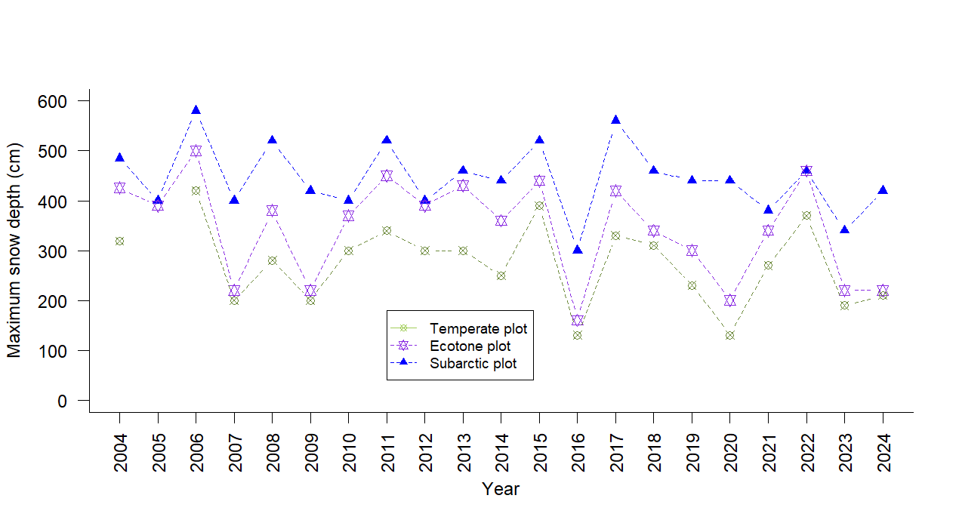

Appendix S2: Changes in the annual snow cover duration (days) for each plot over time
The values ​​represent the snow season from the previous autumn to the spring of the indicated year. Annual snow cover duration (days) estimated from ground surface temperature records at all four plots from 1999 to 2024. Values represent the snow season from the previous autumn to the spring of the indicated year. No statistically significant trend was detected in either variable during the observation period (Mann–Kendall test: all p > 0.05). Snow cover duration was estimated from periods when the ground surface temperature was at 0°C, recorded by a ground thermometer (Ishida 2006). Data are shown for years in which measurements were available at each plot.

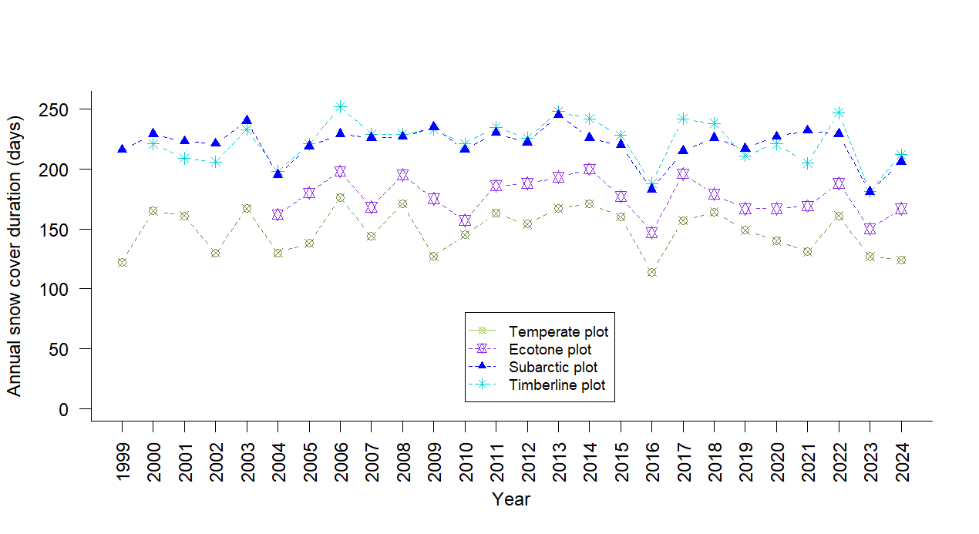

April **, 2026

Editor, Journal of Vegetation Science
Manuscript Revision — "The Impacts of Climate Warming on the Forest Vegetation Zone on Mt. Tateyama, Japan: Findings From Long-Term Forest Monitoring (1998–2024) and Meteorological Observation Data"
Manuscript ID: 5217335
Dear Dr. Gazol,
Thank you for the opportunity to revise our manuscript. We are grateful to both reviewers for their thorough and constructive comments, which have substantially strengthened the manuscript. The principal revisions are as follows:
(1) Figures 5 (annual maximum snow depth) and 6 (snow cover duration) have been moved to Supplementary Material (Appendix S1 and S2), as they provide supporting evidence for the absence of a snow trend rather than primary results.
(2) Figures 9 and 10 (basal area changes in the Ecotone plot) have been merged into a single two-panel figure, reducing the total number of figures to 10.
(3) A new subsection (Section 2.5, Statistical Analysis) has been added to the Methods, consolidating all statistical procedures previously described in the Results section.
(4) Table 5 (WI vs. the basal area ratio — ANCOVA) has been added to section 3.3. Forest dynamics in each climate zone
All changes in the revised manuscript are shown as tracked changes with inline comments indicating the reviewer concern being addressed. Point-by-point responses to the comments of Reviewer 1 and Reviewer 2, and Additional Revisions are provided in the accompanying letters. Other minor corrections were made during English proofreading.

Sincerely,
The authors

Response to Reviewer 1
We thank Reviewer 1 for the positive assessment of our long-term dataset and for the helpful suggestions for improving the manuscript.

Comment 1 (Keywords):
"I believe the long formulation of 'ecotone between temperate and subarctic' is not necessary, it can be break into two shorter keywords."
Response: （ver.2_L6）The keyword has been shortened to "temperate-subarctic ecotone" in the revised manuscript. This change is marked with a tracked change in the Keywords section.

Comment 2 (Introduction, L37–38):
"Regarding complex topography in mountainous areas, specific landforms (e.g. local depressions in karst terrain) can have important buffering effect, acting as refugia for cold-adapted species. I would suggest adding some of these aspects here."
Response: （ver.2_L37-40）We have added the following sentence to the Introduction (after the sentence on complex topography and elevational climatic gradients): "At the same time, specific topographic features such as local depressions, north-facing hollows, and valley bottoms can buffer against warming by maintaining cold air pooling and extended snow cover, potentially acting as microrefugia for cold-adapted species (Dobrowski, 2011)." This addition is marked in the revised manuscript. We have also added Dobrowski (2011) to the References.
“Dobrowski, S.Z. (2011) A climatic basis for microrefugia: the influence of terrain on climate. Global Change Biology, 17, 1022–1035. https://doi.org/10.1111/j.1365-2486.2010.02263.x”

Comment 3 (Introduction, last paragraph):
"In the last paragraph of the Introduction, I miss some clear formulation of study aims. It would be also beneficial to write some questions or even hypotheses. That would make reading more appealing."
Response: （ver.2_L88-92）We have replaced the final sentence with a clear statement of three testable hypotheses: “We specifically investigated the following questions: (1) How did WI increase in each study plot during the study period in response to regional warming? ; (2) What impact has regional warming had on the distribution range of A. mariesii at both its lower and upper elevation limits?; (3) How have interspecies relationships changed in temperate and subarctic ecotone zones on Mt. Tateyama, and what are the implications of these changes?” These changes are marked in the revised manuscript.

Comment 4 (Methods, Section 2.2):
"It should be explicitly stated the following: (1) the number of total surveys of forest composition at each plot, and (2) at which years surveys were performed (please provide exact years). Later, authors refer to periods from 1 to 7 but it is confusing."
Response: （ver.2_L142-143）We have added the following sentence to Section 2.2:
"Forest composition surveys were conducted a total of seven times across all plots. Survey years for each plot are listed in Table 1 (see footnote **)”
Footnote of Table 1
**) Survey years (periods 1–7): Temperate: 1998, 2002, 2005, 2008, 2011, 2015, 2020; Ecotone: 2000, 2004, 2007, 2010, 2013, 2018, 2024; Subarctic: 1998, 2002, 2005, 2008, 2011, 2016, 2022; Timberline: 1999, 2004, 2007, 2009, 2012, 2017, 2022.

Comment 5 (Results):
"This section is overloaded with too many figures. I would recommend moving some of the more detailed graphical outputs to Supplementary materials."
Response: （ver.2_ Appendix S1 and S2）In the revised manuscript, Figures 5 (annual maximum snow depth) and 6 (snow cover duration) have been moved to Supplementary Material (Appendix S1 and S2), as they provide supporting evidence rather than primary results. In addition, Figures 9 (changes in the total basal area by tree species group in the Ecotone plot) and 10 (changes in basal area of major tree species in the Ecotone plot) have been combined into a single two-panel figure. The total number of figures in the main text has thus decreased from 13 to 10. The main text now refers readers to the Supplementary Material where appropriate.

Comment 6 (Results, L268–269 and L280–281):
"This is the first time you have mentioned these statistical tests. All statistics used should be described in the Methods section and not in the Results section. This as well applies to equations (for instance L293)."
Response: （ver.2_L187-213）We have added a new subsection (“Section 2.5 Statistical Analysis") to the Methods section, which describes the use of Tukey's multiple comparison test (for comparing dead-tree proportions among plots), the Kolmogorov-Smirnov test (for testing normality of the estimated death-year distribution), and the demographic rate equations (Condit et al., 1999). References to these tests in the Results section now cite this Methods subsection. A comment marking this required addition is included in the revised manuscript.

Comment 7 (Discussion, L367–371):
"This part addresses A. mariesii and its decline, so it seems more reasonable to include it in the previous subchapter 4.3, no?"
Response: （ver.2_L442-446）The opening paragraph of Section 4.4 (beginning with "A. mariesii is ecologically adapted to heavy snow environments..."), which discusses the species' ecological adaptation and the role of temperature as the primary stressor, has been moved to the end of Section 4.3. This relocation is noted with a comment in the revised manuscript. The remaining content of Section 4.4 now focuses more coherently on the broader forest zone shift.

Comment 8 (Discussion, L379):
"I would generally agree. However, you showed that A. mariesii is recruiting at the timberline, so this might indicate its migration towards higher elevations where thermal conditions are more favorable for its growth?"
Response: We have newly examined the relationships between A. mariesii demographic rates and climate variables .
Methods; ver.2 L206-212 “To examine the relationships between A. mariesii demographic rates and climate variables,…. for multiple comparisons was applied.”,
Table and text; ver.2 L 345-362” Table 6. Pearson correlation coefficients between climat….. Among the correlations between A. mariesii demographic rates and interval-mean climate variables (Table 6), mortality rate (M) showed the strongest associations with climate….. in any plot or in the pooled analysis.” )

Comment 9 (Conclusions):
"Are there any simulations based on species distribution models available for the focal tree species Abies mariesii for this territory or Japan in general? It would be nice to support your main findings with model predictions."
Response: （ver.2_L485-488）We have added SDM references and a sentence to the Conclusions referring to species distribution model predictions for subalpine conifers in Japan under future warming scenarios.
“These field-based findings are consistent with species distribution model projections, which predict a substantial upward contraction of suitable habitat for subalpine conifers under future warming scenarios in Japan (Tanaka et al., 2012; Tsuyama et al., 2015).”

Furthermore, we have added a SDM reference for Fagus crenata in section of 4.4 Forest zone shift
（ver.2_L453-455）
“The vigorous growth of F. crenata in the Ecotone plot is consistent with its known thermal niche, which is strongly governed by WI (Matsui et al., 2009).”

and Reference.

Matsui, T., Yagihashi, T., Nakaya, T., Tanaka, N., Taoda, H., 2004. Climatic controls on distribution of Fagus crenata forests in Japan. Journal of Vegetation Science 15, 57–66. https://doi.org/10.1111/j.1654-1103.2004.tb02237.x

Tanaka, N., Nakao, K., Tsuyama, I., Higa, M., Nakazono, E., Matsui, T., 2012. Predicting the impact of climate change on potential habitats of fir (Abies) species in Japan and on the East Asian continent. Procedia Environmental Sciences 13, 455–466. https://doi.org/10.1016/j.proenv.2012.01.039

Tsuyama, I., Higa, M., Nakao, K., Matsui, T., Horikawa, M., Tanaka, N., 2015. How will subalpine conifer distributions be affected by climate change? Impact assessment for spatial conservation planning. Regional Environmental Change 15, 393–404. https://doi.org/10.1007/s10113-014-0641-9

-END for Response to Reviewer 1 -

Response to Reviewer 2

Main Comment 1 (Structure and figures):
"The manuscript is poorly structured and lacks a systematic approach to presenting findings. The manuscript included a total of 13 figures, yet many are overly simplistic or lack sufficient detail. Descriptions of methodology and results are scattered inconsistently throughout the text, which makes it difficult for the reader to follow the story or understand the evidence behind the authors' claims."
Response: In the revised manuscript, we have made the following reorganization:
(1) Figures 5 (annual maximum snow depth) and 6 (snow cover duration) have been moved to Supplementary Material (Appendix S1,2), as they provide supporting evidence for the absence of a snow trend rather than primary results.
(2) Figure 9 and 10 (basal area changes in Ecotone plot) have been merged into a single two-panel figure, reducing the total to 10 figures.
(3) A new subsection (Section 2.5, Statistical Analysis) has been added to the Methods, consolidating all statistical procedures that were previously scattered in the Results section.

Main Comment 2 (Statistical link between climate and forest dynamics):
"While the paper presents trends in temperature and snow conditions, it fails to bridge the gap between these climatic shifts and the field-surveyed forest dynamics. I expected a rigorous statistical analysis correlating tree mortality with specific climate drivers (e.g., heat accumulation, minimum temperatures, or snow duration), but such a crucial link is missing."
Response:
The following statistical analysis has been newly added:

Changes in WI for each plot over time (Mann-Kendall test) （ver.2_L 223-234）
“WI of each survey area (estimated from the air temperatures observed at the Kurobe Dam; Fig. 3) showed a clear rising trend over time (Fig. 4; Mann-Kendall test: all p < 0.001). The linear slopes were +3.67, +3.37, +2.81, and +2.52 °C·month per decade for the Temperate, Ecotone, Subarctic, and Timberline plots, respectively, with higher-elevation plots showing smaller rates of increase. Since WI values were derived from Kurobe Dam temperature records using a fixed lapse rate, the increasing trend in WI directly reflects the warming at Kurobe Dam. Nevertheless, for completeness, Kendall trend tests confirmed a significant increasing trend in WI for all plots (all p < 0.001). Ecotone plot crossed the ecotone–temperate boundary (WI = 55 °C·month) for the first time in 1994. In the period 2013–2023, 72.7% of years exceeded WI = 55, placing this plot firmly within the temperate zone. By contrast, Subarctic and Timberline plots remained entirely within the subarctic zone throughout the study period (maximum WI: 43.9 and 34.9 °C·month, respectively).”

Warmth index trend: （ver.2_L 223-234）
" WI of each survey area (estimated from the air temperatures observed at the Kurobe Dam; Fig. 3) showed a clear rising trend over time (Fig. 4; Mann-Kendall test: all p < 0.001). The linear slopes were +3.67, +3.37, +2.81, and +2.52 °C·month per decade for the Temperate, Ecotone, Subarctic, and Timberline plots, respectively, with higher-elevation plots showing smaller rates of increase. Since WI values were derived from Kurobe Dam temperature records using a fixed lapse rate, the increasing trend in WI directly reflects the warming at Kurobe Dam. Nevertheless, for completeness, Kendall trend tests confirmed a significant increasing trend in WI for all plots (all p < 0.001). Ecotone plot crossed the ecotone–temperate boundary (WI = 55 °C·month) for the first time in 1994. In the period 2013–2023, 72.7% of years exceeded WI = 55, placing this plot firmly within the temperate zone. By contrast, Subarctic and Timberline plots remained entirely within the subarctic zone throughout the study period (maximum WI: 43.9 and 34.9 °C·month, respectively).”

WI zone classification（ver.2_L230-234）
“Ecotone plot crossed the ecotone–temperate boundary (WI = 55 °C·month) for the first time in 1994. In the period 2013–2023, 72.7% of years exceeded WI = 55, placing this plot firmly within the temperate zone. By contrast, Subarctic and Timberline plots remained entirely within the subarctic zone throughout the study period (maximum WI: 43.9 and 34.9 °C·month, respectively).”

The cumulative mortality ratios of A. mariesii trees: （ver.2_L345-352）
“The cumulative mortality ratios of A. mariesii trees that had survived in period 1 from periods 1 to 7 in the Subarctic and Timberline plots were 18.5% and 15.2%, respectively (Tukey multiple comparisons, p = 0.059); however, in , the rate was significantly higher at 50% (Tukey multiple comparisons, both p < 0.001; Fig. 10). The increase in mortality was particularly noticeable after 2013. The annual mortality rate at the Ecotone plot was 2.89%/yr for the full observation period (2000–2024, Table 4), increasing markedly to 8.3%/yr during the recent period (2013–2024). By contrast, annual mortality rates at the Subarctic and Timberline plots remained low throughout the observation period (0.75%/yr and 0.69%/yr, respectively).”
These analyses have been added to a new Section “2.5 Statistical Analysis” in the Methods and to Section 3.1 and 3.3 of the Results. This interpretation has been incorporated into the Discussion (Section 4.4).

Main Comment 3 (Contrasting A. mariesii population trends):
"The observation of contrasting population trends for Abies mariesii—decline at lower elevations versus successful recruitment and growth at higher elevation—is perhaps the most significant finding of this study. This phenomenon likely relates to the species' thermal niche and climate adaptation, yet no further analysis was conducted to explore this."
Response:
The following has been added:

Table 5（ver.2_L 304-313）

“Table 5 Analysis of covariance (ANCOVA) results for the relationship between the warmth index and basal area ratio in the Ecotone plot.
(a) By tree species group
Group | Slope (/WI) | Comparison | p
Temperate tree species | 0.004 | Temperate vs. Ecotone | 0.305
Ecotone tree species | −0.004 | Ecotone vs. Subarctic | 0.135
Subarctic tree species | −0.017 | Subarctic vs. Temperate | 0.019
(b) By species
Species | Slope (/WI) | Comparison | p
Fagus crenata | 0.034 | F. crenata vs. C. japonica | 0.092
Cryptomeria japonica | 0.002 | C. japonica vs. A. mariesii | 0.165
Abies mariesii | −0.024 | A. mariesii vs. F. crenata | 0.005
Slopes were estimated from ANCOVA with WI as covariate and species group (a) or species (b) as grouping factor (n = 7 survey periods).
p-values for comparisons are from pairwise slope tests with Bonferroni correction for three comparisons.

In the Ecotone plot, as WI increased, the basal area ratio of temperate tree species increased (slope +0.004), while that of subarctic tree species decreased (slope −0.017), showing contrasting trends; the difference in slopes was significant (p = 0.019, Table 5a). Ecotone tree species showed an intermediate response (slope −0.004, p = 0.135).At the species level, F. crenata (slope +0.034) and A. mariesii (slope −0.024) showed contrasting responses to warming, and the difference in their slopes was significant (p = 0.005, Table 5b). C. japonica showed a neutral response (slope +0.002, p = 0.165).”

Table 6.（ver.2_L 354-363）

“Table 6. Pearson correlation coefficients between climate variables and demographic rates of A. mariesii
This is an exploratory analysis and no correction for multiple comparisons has been performed.
Plot | Climate variables | Growth (G) | Mortality (M) |  | Ingrowth (I)
Ecotone | WI | -0.465 | 0.775 |  | 0.022
(n=6) | Tmax | -0.702 | 0.959 | ** | -0.193
 | Tmin | 0.09 | -0.47 |  | -0.349
Subarctic | WI | -0.084 | 0.304 |  | 0.076
(n=6) | Tmax | -0.192 | 0.035 |  | -0.263
 | Tmin | 0.057 | -0.348 |  | -0.145
Timberline | WI | -0.399 | -0.475 |  | -0.538
(n=6) | Tmax | -0.599 | -0.056 |  | -0.62
 | Tmin | 0.377 | 0.431 |  | 0.503
Pooled | WI | -0.372 | 0.507 | * | -0.082
(n=18) | Tmax | -0.421 | 0.596 | ** | -0.071
 | Tmin | -0.296 | 0.421 |  | -0.048
* p<0.05, ** p<0.01
WI: Warmth Index, Tmax: maximun temperature, Tmin: minimun temperature
Growth (G), Mortality (M), Ingrowth (I); see section 2.5 (Condit et al. 1999)
Among the correlations between A. mariesii demographic rates and interval-mean climate variables (Table 6), mortality rate (M) showed the strongest associations with climate. At the Ecotone plot, Tmax was strongly and positively correlated with (M) (r = 0.959, p = 0.003). In the pooled analysis across three plots (n = 18), both WI (r = 0.507, p = 0.032) and Tmax (r = 0.596, p = 0.009) were significantly and positively correlated with (M). No significant relationships were found between climate variables and either growth rate (G) or ingrowth rate (I) in any plot or in the pooled analysis.”

Detail Comment 1 (L105 — forest density):
"Forest density should be provided instead of the number of trees, as it appears that plots in higher altitudes have a higher density."
Response: The high density at Timberline plot reflects the small-statured, densely packed nature of the A. mariesii–Pinus pumila scrub at the forest limit.
Stem densities have been added to Table 1 and the Methods text: 666, 745, 456, and 3,008 stems ha⁻¹ for the Temperate, Ecotone, Subarctic, and Timberline plots, respectively. （ver.1_L134-136）“A plot of area measuring 625 m² was set up in the timberline region near the forest boundary, where we surveyed all A. mariesii trees with a height of 1.3 m or more (Table 1).”
We added the following caption to Table 1. （ver.2_L108-109）
"***)In the Temperate, Ecotone, and Subarctic plots, the survey targeted tall tree species with a diameter of 10 cm or more, while in the Timberline plot, it targeted Abies mariesii trees with a height of 130 cm or more."

Detail Comment 2 (L224 — missing results description):
"Maybe I missed it, but is there any description of the results in this subsection?"
Response: （ver.2_L240-242）Section 3.1 originally presented the warmth index results adequately but lacked an explicit statement summarizing the snow condition results. We have added the following sentence: "No statistically significant trend was detected in either annual maximum snow depth or snow cover duration during the observation period (Mann-Kendall test: all p > 0.05), confirming that snow conditions remained largely stable while temperatures increased significantly." The detailed snow figures (original Fig.) have been moved to Appendix S1 and S2.

Detail Comment 3 (L225–226 — recruitment terminology):
"The recruitment is related to seedlings, but the authors did not investigate seedlings according to L129–132."
Response: （ver.2_L194-195）Throughout the revised manuscript, "recruitment" has been replaced with "ingrowth" to accurately reflect that ” Here, ingrowth refers to trees newly reaching the DBH ≥ 10 cm threshold (or height ≥ 1.3 m for the Timberline plot), not seedling establishment.”

Detail Comment 4 (L262 — fallen vs. standing dead):
"Why is it necessary to distinguish between fallen and standing dead trees?"
Response: （ver.2_L318-322）The distinction is necessary because the mean-time-to-fall (MTF) model (Gärtner et al. 2023) used to back-calculate estimated death years (Section 2.4) requires standing dead trees as input. “The black solid and the diagonal lines indicate trees that had fallen and were still standing during the seventh survey, respectively. This distinction is necessary because the mean-time-to-fall model (Gärtner et al., 2023) used to estimate death years (Section 2.4) requires standing dead trees as input; Dead standing trees that had not fallen by the seventh survey cannot be assigned estimated death years using this approach, as the time elapsed since death is unknown.” This clarification has been added to the Fig. 8 caption and legend.
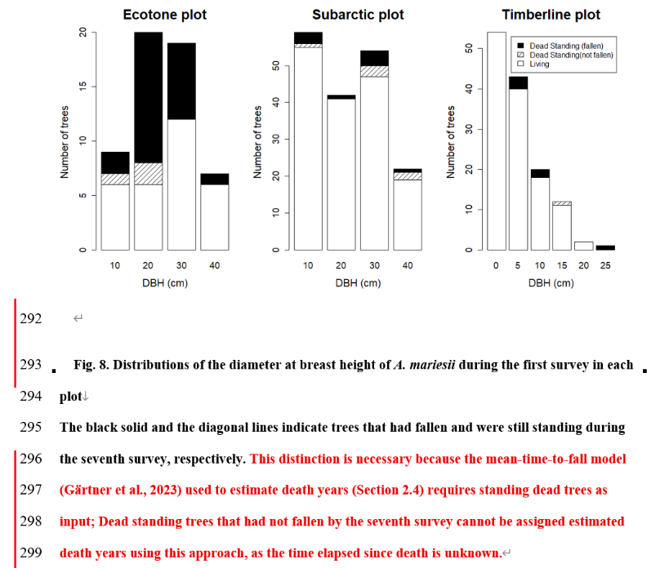

Detail Comment 5 (L272 — dual y-axes in Fig. 9):
"The two y-axes in this figure are easily confused."

Response: （ver.2_L329-333, Fig.9）Fig. 9 has been redesigned as a two-panel figure: the upper panel shows the cumulative proportion of dead standing trees that had fallen by each survey, and the lower panel shows the estimated frequency distribution of death years derived from the MTF model. Both panels share a common x-axis (year), making the temporal correspondence clear. Axis labels and colors have been made consistent.

Detail Comment 6 (L339–347 — human activity and nitrogen deposition):
"Since human activity is intense, it is difficult to rule out its impacts; for instance, nitrogen deposition from heavy vehicular traffic might contribute to increased tree growth."
Response: （ver.2_L412-417）The following caveat has been added to Section 4.3: "We acknowledge that other anthropogenic factors associated with high tourist traffic, such as nitrogen deposition from vehicle exhaust, may have contributed to the observed increases in basal area and tree growth across some plots (Kume et al. 2009). However, the species-specific pattern of decline in A. mariesii alongside vigorous growth of co-occurring temperate species is more consistent with a thermal stress explanation than with a general site-level anthropogenic effect, which would be expected to affect all co-occurring species similarly."

Detail Comment 7 (L353 — air pollution conclusion):
"Direct evidence is required, as it is difficult to exclude the influence of all human activities or disturbances."
Response: （ver.2_L422-424）We have softened the conclusion accordingly. The original sentence "air pollution is unlikely to be a major factor" has been revised to "air pollution alone is unlikely to be the primary driver of A. mariesii mortality, given the species-specific nature of the decline." We concur that complete exclusion of anthropogenic influences is not possible from observational data alone, and this has been stated explicitly as a limitation in the revised Discussion.

- End for Response to Reviewer 2 -

Additional Revisions

Keyword
The keyword "warming" which was duplicated in the title, has been changed to "Warmth Index" .

Abbreviation of Warmth Index
The abbreviation for Warmth Index was set to WI(Introduction ver_2.L55)。

R Core Team (2024) has been added to the References.
R Core Team, 2024. R: A Language and Environment for Statistical Computing. R Foundation for Statistical Computing, Vienna, Austria.
Other minor corrections were made during English proofreading.

久米さん

L.89-95
We specifically investigated the following questions: (1) How did the warmth index increase in each sutudy plot during the study period in response to regional warming? ; (2) What impact has regional warming had on the distribution range of A. mariesii at both its lower and upper elevation limits?; (3) How have interspecies relationships changed in temperate and subarctic ecotone zones on Mt. Tateyama, and what are the implications of these changes?
⇒ 採用させていただきました（ver.2_L88-92）

L. 112 upper left "Tree recorded" > "Number of tree recorded"
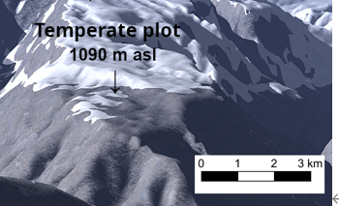
⇒ 修正しました（ver.2_L108 Table 1）
L. 115 Fig. 1 縮尺を加えた方が良い
⇒ スケールつけました

L. 161 Table 2. The results of regression analyses of yearly trends in daily temperature at the Kurobe Dam (1965–2023).
⇒ 修正しました（ver.2_L158）

L.210 indicate the survey year (1–7) and the warmth index at that year for each plot,
⇒ 修正しました（ver.2_L219-220）

L.230 Table 3. Basal areas (BAs) of each surveyed tree species in each plot.
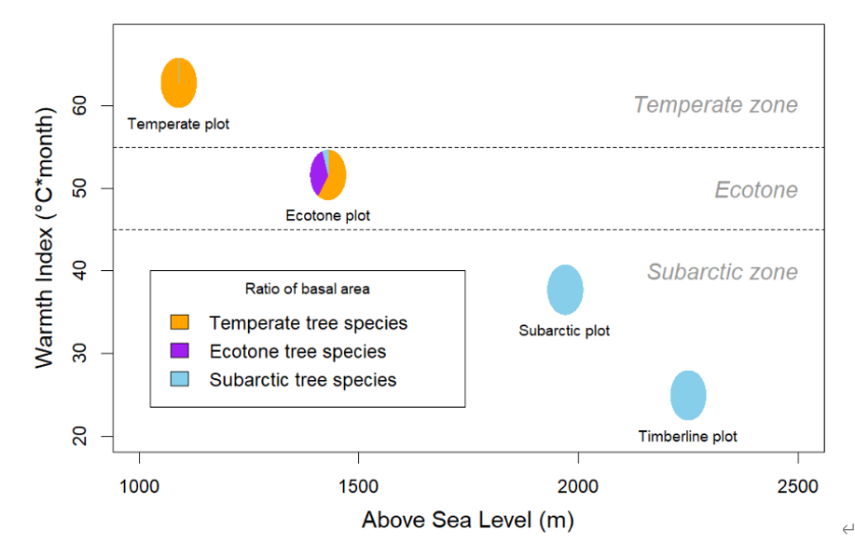
⇒ 修正しました（ver.2_L250）

L.238 Fig. 5 この図で、Temperate zone, Ecotone, Subarctic zoneの大きな色文字は、軸の方に移した方が良いと思います（四角枠内の説明と混乱しています）。
⇒ 修正しました。Fig.4も同じように修正しました。

L. 306 Fig. 10. Changes in cumulative mortality ratio of Abies mariesii in each survey plot over time
⇒ 修正しました（ver.2_L344）

以上，久米さんのコメントへの対応

中島さん

・Reviewer 2のMain comment 2とDetail comment 2関連： 統計解析の追加
回答書で解析して記述を追加したとされていますが（L805-806、L833-837）、結果に記述がないようです。なお、Detail comment 2関連は、Appendix 2には解析結果の記述が入っていますが（L627-628）、Appendix1には入っていません。
⇒ 修正しました（Appendix 2）
⇒ 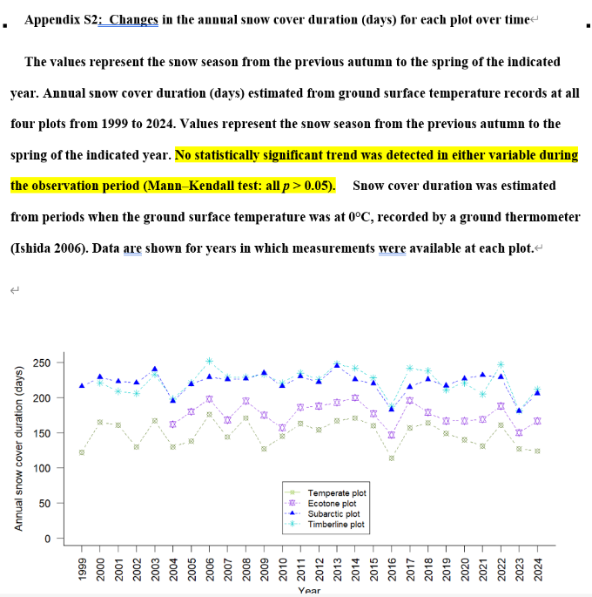

・Reviewer 1 のComment 6関連： 統計の記述
Reviewer1のコメント末尾にfor instance L293とありますが、これは改訂稿L312 の formula [exp (log(1 − mortality)) / duration)]は結果でなく方法に書くようにとの指摘と思われます。対応が必要です。また、数式中、mortalityの後ろに閉じカッコが2つありますが1つで良いと思われます。
⇒（ver.2_L190-195） Condit式に統一しました

・Reviewer 1 のComment 7関連： 4.4節冒頭の記述
回答書L725では初稿の4.4節冒頭を4.3節末尾に移動したとなっていますが、改訂稿本文に反映されていないようです。また、この移動は改訂稿にコメントを付けたとなっていますが（L728）、そのコメントも本文に見当たりません。
⇒ 修正しました（ver.2_L442-446）

・Reviewer 1 のComment 9関連： 結論への種分布モデル記述の追加
回答書L748のplaceholder commentはどれのことでしょうか
⇒ Comment 9 (Conclusions): “These field-based findings are consistent with species distribution model projections, which predict a substantial upward contraction of suitable habitat for subalpine conifers under future warming scenarios in Japan (Tanaka et al., 2012; Tsuyama et al., 2015).”
（ver.2_L485-488）

・Reviewer 2 のMain comment 2関連： 期間年死亡率算出
fallen by the end（L193）だと立枯れを含まないので、dead by the endが適切ではないでしょうか。
⇒ “Demographic rates for population growth (G = ln(N1/N0)/t), mortality (M = ln(N0/Ns)/t), and ingrowth (I = ln(N1/Ns)/t) were calculated following Condit et al. (1999)….” 年率計算はCondit式に統一しました （ver.2_L190-195）

・Reviewer 2 のMain comment 2関連： 期間WIと期間年死亡率の相関分析
3プロットの6期間のデータをプールしてn=18で解析されていますが（L194-195、L794）、この相関についてはプロットによって傾向が異なることも予想されます。単純に考えれば、上ノ小平ではWIが高くなるほど生育に不適となり死亡率も高くなる正の相関が想定されますが、上限に近い鏡石ではWIが高くなるほど生育に好適となり死亡率が低下する負の相関が想定されます。n=18で解析すると正の相関があるとのことなので、上ノ小平の影響が大きいのかもしれませんが、それぞれのプロットについてn=6で解析した方が解釈しやすいように思いました。
・Reviewer 2 のMain comment 2関連： 平均WIと平均死亡率？の関係
L795-796のWhen compared across plots using mean values, the relationship was perfect (Spearman r = 1.000, p < 0.001)ですが、それぞれのプロットについて6期間の平均値を得て、n=3で解析したということでしょうか。そうであれば、r=1だとしてもp=0.33となりp<0.001にはならないと思われます。

⇒ 温量指数と死亡率の区間平均との回帰分析は取りやめANCOVA に改めました。Reviewer comment 2 Response 参照下さい
方法 の記述 （Section 2.5 ver.2_L199-205）
結果 の追加 （Table.5 ver.2_L304-313）

・Reviewer 2 のMain comment 2関連： 年死亡率
L796-798のKaminokodaira plot showed by far the highest mean annual mortality rate (1.88%/yr), compared with 0.33%/yr at Matsuotoge and 0.28%/yr at Kagamiishi.ですが、算出方法が違うとしても、Table 4の年死亡率2.89%、0.75%、0.69%とかなり差があるのは何故でしょうか。
⇒ 年間死亡率の計算式はCondit式に統一しました。

・Reviewer 2 のDetail comment 1： 本数密度
L828-829で鏡石の本数密度が高い理由を説明していますが、測定下限が鏡石では樹高130cm、他は胸高直径10cmであることが主要因ではないでしょうか。この点は、本文に記述はありますが（L137-138）、Table1の脚注にも入れた方が親切かもしれません。
⇒ Table 1. caption 追加しました。（Table.1 ver.2_L108-109）
"***)In the Temperate, Ecotone, and Subarctic plots, the survey targeted tall tree species with a diameter of 10 cm or more, while in the Timberline plot, it targeted Abies mariesii trees with a height of 130 cm or more."

・Reviewer 2 のDetail comment 2： 結果の記述不足
回答書では最大積雪深と根雪期間の記述について対応したと述べていますが（L832-838）、commentでは初稿L224について指摘しているので、forest dynamicsについて結果に記述が不足しているとの指摘と考えられます。改訂稿考察4.2節のL332-340に対応する記述が結果にありません。改訂稿Table4の個体群動態パラメータ表（個体群成長率、死亡率、加入率）についての記述が結果 3.3節に必要です。
⇒ 追加しました（ver.2_L267-278）“The demographic rates were calculated based on the number of trees (Condit et al., 1999) in each plot (Table 4). ….rformance among the four plots.

・Reviewer 2 のDetail comment 3関連： recruitmentのingrowthへの置き換え
Reviwer2のMain Comment 3 は「successful recruitment and growth」ですが、回答書でのコメントのコピー（L812）では「successful ingrowth and growth」となっており、コメントまで用語が置換されてしまっています。
⇒ 修正しました。（ver.2_L920）

・Reviewer 2 のDetail comment 4 （オオシラビソ直径分布のカテゴリ区分の説明）
Fig.8説明文とL851ではFallen trees cannot be assigned estimated death years using this approachとされており、Fig.8の黒塗り潰し部（fallen）が死亡年を推定できないと読めます。しかし、死亡年を推定できないのはFig.8斜線部の最終調査時まで倒れていないものであって、調査開始時から終了までに倒れた黒塗りつぶし部は死亡年を推定できるのではないでしょうか。
⇒ （ver.2_L314-322）
ご指摘のとおりです。図のLegendとキャプション，査読者2コメント4の回答を改めました。

・出現樹種数

L225で24 tall tree specieとなっていますが、Table3には26種あります
⇒ 26 tall tree specie に修正しました。（ver.2_L245）

・樹種グループ別BA割合
Ecotone plotの3要素について本文は60.80%, 34.19%, 5.01%ですが（L235）、Table3では60.76%, 33.97%, 5.27%です。
⇒” 60.76%, 33.97%, and 5.27%” （ver.2_L255）

Subarctic plotのsubarctic elementsについて本文は100%ですが（L237）、Table3では99.02%です。
⇒ “99.02%” (ver.2_L257)

・調査区BA変化率
L260のAmong these plotsで始まる文でSubarctic plotについて述べていますが、前文はSubarctic plotを含まないのでAmongだと繋がりが悪いと思われます
⇒ “In contrast, the rate of increase in the Subarctic plot ….” (ver.2_L286)

・オオシラビソ枯死率
L307のfrom seasons 1 to 7ですが、他の部分ではseasonでなくperiodを使っているので合わせた方が良さそうです
⇒ 修正しました(ver.2_L345)

・森林帯シフトの考察
L397で上ノ小平のWI上昇と、松尾峠の成長低下を並列で述べていますが、WI上昇は全プロット共通なので、WI上昇に伴う上ノ小平の枯死増加と松尾峠の成長鈍化とした方が良いかもしれません
⇒ オリジナル “The increased warmth index in the Ecotone plot, coupled with the reduced growth in the Subarctic plot (which is thermally approaching the ecotone range), strongly suggested that climate warming has negatively affected both the performance and persistence of A. mariesii, even in snow-rich areas.”
修正文(ver.2_L449-452)
"Under increasing warmth index conditions, both the increasing mortality of A. mariesii in Ecotone plot and the reduced growth in Subarctic plot (which is thermally approaching the ecotone range) strongly suggest that climate warming has negatively affected the performance and persistence of A. mariesii, even in snow-rich areas."
・引用文献の改行漏れ

L593でTakyu et alの冒頭の改行が漏れています
⇒ 修正しました(ver.2_L654)

・引用文献漏れ
R Core Team 2024 （L202）⇒ 追加しました (ver.2_L617-618)
Tsuyama et al. 2015 （L427）⇒ 追加しました(ver.2_L665-668)

・回答書への参照行番号の記入
修正稿が確定した段階で最後に作業される予定かとは思いますが、回答書において、修正や追加した部分の行番号や図の明示があると編集者・査読者が確認しやすく心証が良いと思われます。
⇒ 恐縮です。改善しました。

以上，中島さんのコメントへの対応

