“KISAN SETU: A DIGITAL AGRICULTURAL MARKETPLACE AND FARMER SUPPORT PLATFORM”
submitted in partial fulfillment of the requirements of the degree of
UG (Bachelor of Technology)
in
Computer Science and Engineering
by
1. Misty Jamabholkar (GHRUS25011020008)
2. Namrata Jaiswal (GHRUS25011020001)
3. Naved Mansuri (GHRUS25011020035)
4. Neel Tawre (GHRUS25011020061)
Based on carried out under the supervision of
Supervisor: Dr. Rahul Khokale

October 2026
Department of Computer Science & Engineering
School Of Engineering & Technology
G H Raisoni University, Saikheda

“KISAN SETU: A DIGITAL AGRICULTURAL MARKETPLACE AND FARMER SUPPORT PLATFORM”
submitted in partial fulfillment of the requirements of the degree of
UG (Bachelor of Technology)
in
Computer Science and Engineering
by
1. Misty Jamabholkar (GHRUS25011020008)
2. Namrata Jaiswal (GHRUS25011020001)
3. Naved Mansuri (GHRUS25011020035)
4. Neel Tawre (GHRUS25011020061)
Based on carried out under the supervision of
Supervisor: Dr. Rahul Khokale
October 2026
Department of Computer Science & Engineering
School Of Engineering & Technology
G H Raisoni University, Saikheda

Certificate of Examination
Name & Roll No.:
1. Misty Jamabholkar (GHRUS25011020008)
2. Namrata Jaiswal (GHRUS25011020001)
3. Naved Mansuri (GHRUS25011020035)
4. Neel Tawre (GHRUS25011020061)
Title of Project Report:
Kisan Setu: A Digital Agricultural Marketplace and Farmer Support Platform
We the below signed, after checking the Project Report mentioned above and the official record books of the students, hereby state our approval of the project report submitted in partial fulfillment of the requirements of the degree of B.Tech in department of CSE in SOET at G.H. Raisoni university, Saikheda. We are satisfied with the volume, quality, correctness, and originality of the work.
_____________________  Dr. Rahul Khokale  (Supervisor) | _____________________  Project Co-Ordinator
_____________________  Mr. Dheeraj Ghagre  (HOD, CSE) | _____________________  External Examiner
_____________________
Dr. Rahul Khokale
(SOET Dean)

Declaration
We affirm that this written submission reflects solely our own ideas, expressed in our own words. Any inclusion of others' ideas or words is duly acknowledged through appropriate citation and referencing of the original sources. Furthermore, we attest to upholding the highest standards of academic honesty and integrity, ensuring that we have not misrepresented, fabricated, or falsified any information, data, or sources presented in this submission.
We acknowledge that any breach of these principles may result in disciplinary measures by the university and potential legal consequences from sources not properly cited or from whom consent has not been obtained when necessary.
Name of the students: | Roll No.: | Signature of the students:
1. Misty Jamabholkar | GHRUS25011020008 | ____________________
2. Namrata Jaiswal | GHRUS25011020001 | ____________________
3. Naved Mansuri | GHRUS25011020035 | ____________________
4. Neel Tawre | GHRUS25011020061 | ____________________
Date: October 31, 2026

Supervisor: Dr. Rahul Khokale October 2026
Supervisor’s Certificate
This is to certify that the work presented in the Project Report entitled “Kisan Setu: A Digital Agricultural Marketplace and Farmer Support Platform” Carried out by Misty Jamabholkar (GHRUS25011020008), Namrata Jaiswal (GHRUS25011020001), Naved Mansuri (GHRUS25011020035), Neel Tawre (GHRUS25011020061) is a record of original research carried out by them under my supervision and guidance in partial fulfillment of the requirements of the degree of Bachelor of Technology (B. Tech) in the Department of Computer Science and Engineering (CSE) at G.H. Raisoni University, Saikheda.
Neither this project report nor any part of it has been submitted earlier for any degree or diploma to any institute or university in India or abroad.
(Supervisor)
Dr. Rahul Khokale

Acknowledgment
We sincerely express our heartfelt gratitude for the continuous mutual support, cooperation, coordination, and valuable contributions among all our team members—Misty Jamabholkar, Namrata Jaiswal, Naved Mansuri, and Neel Tawre—throughout the completion of this group project.
We would like to extend our special thanks to Dr. Rahul Khokale, Dean of the Department, for his constant encouragement, guidance, and motivation during the entire project.
We are also deeply thankful to Mr. Dheeraj Ghagre, Head of the Department, for his valuable suggestions, constant support, and guidance, which played a crucial role in shaping our work.
We would like to express our sincere gratitude to our guide, Dr. Rahul Khokale, for his continuous guidance, insightful feedback, and constant support, which helped us successfully complete our project.
Lastly, we would like to express our gratitude to our parents, friends, and all those who have directly or indirectly supported us in completing our project successfully.
Name of students:
1. Misty Jamabholkar
2. Namrata Jaiswal
3. Naved Mansuri
4. Neel Tawre
School of Engineering and Technology

Abstract
Agricultural marketing across developing economies faces persistent structural inefficiencies, including fragmented supply networks, non-standardized price realization, exploitative intermediary commissions, and severe underutilization of heavy farm machinery. Smallholder farmers frequently confront distress selling due to information asymmetry, while institutional and bulk buyers experience difficulties in securing predictable, high-quality agricultural produce directly from farm-gate origins. Concurrently, expensive mechanization assets such as tractors, JCB earthmovers, and harvesters remain financially inaccessible for purchase by individual smallholders and operate with substantial idle capacity among localized equipment owners.
This study conceptualizes, designs, and evaluates Kisan Setu, a digital agricultural marketplace and farmer support ecosystem developed to streamline discovery and communication across three fundamental stakeholder groups: Farmers, Bulk Buyers (Customers), and Agricultural Equipment Providers. The platform introduces standardized multi-tier marketplace listings featuring crop specifications, bulk volume thresholds, unit standardization, and farmer-defined expected pricing, alongside machinery listings detailing availability, geographical service radius, and transaction modalities (sale, hourly rental, or turnkey service).
To foster transparent commercial negotiations without intermediate brokerage, Kisan Setu implements an in-app Direct Messaging Engine complemented by a social Follow Feature that enables buyers and farmers to establish long-term contractual supply relationships. Furthermore, an automated AI Chatbot Assistant powered by modern natural language processing is embedded into the client workflow to provide conversational onboarding, dynamic listing guidance, and system FAQ navigation. The chatbot operates under strict domain guardrails, automatically triaging and escalating high-impact agronomic diagnostics and legal inquiries to certified human experts.
The technical realization is anchored upon a robust four-tier modular architecture spanning Presentation (React/Vite mobile-responsive interfaces), Application (authentication, role-based business rules, and real-time socket communication), Data (relational persistence with schema enforcement), and External Services (Gemini AI APIs, cloud media storage, and OTP gateways). Experimental evaluation confirms high system responsiveness, 100% listing schema integrity, and seamless cross-stakeholder negotiation. Future development pathways focus on verified trust badges, digital escrow payments, automated freight logistics, and vernacular multimodal voice interfaces to drive nationwide adoption.

Contents
Chapter 1: Introduction 1
1.1 Background and motivation 1
1.2 Objective of present work 2
1.3 Outline of the Project Report 3
1.4 Novelty of the Work 3
Chapter 2: System Architecture and Methodology 5
2.1 Methodology 5
2.2 Flowchart & User Interaction Pipeline 6
2.3 System Architecture Description 7
2.4 Core Stakeholder Ecosystem & User Profiles 7
2.5 Structured Produce Marketplace Listings 8
2.6 Farm Equipment and Machinery Module 8
2.7 Direct Communication and Follow System 8
2.8 Automated AI Chatbot Integration 9
2.9 Data Tier & External Services Integration 9
Chapter 3: Results and Discussion 11
3.1 Result 11
3.2 Discussion 14
3.3 Comparative Analysis with Existing Work 15
Chapter 4: Summary and Conclusion 18
4.1 Summary 18
4.2 Conclusion 18
4.3 Scope for Future Work 19
References 20
Dissemination 21

List of Figures
Fig. 1.1: System Flowchart and User Interaction Pipeline 6
Fig. 1.2: Structured Marketplace Records and Metadata Schema 7
Fig. 1.3: Four-Layer Architectural Model of Kisan Setu 8
Fig. 1.4: Subsystem Response Performance & Latency Benchmarks 11
Fig. 1.5: Direct Communication and Negotiation Sequence Workflow 12
Fig. 1.6: Conversational AI Chatbot Query Triage and Escalation 13
Fig. 1.7: Top Platform Value Drivers Across Stakeholders 13
Fig. 1.8: Comparative Workflow Analysis with Existing Agritech Models 16
Fig. 1.9: Comparative Benchmark of Platform Usability & Stakeholder Empowerment 19

List of Tables
Table 1.1: Core Stakeholder Functional Roles and Operational Permissions 2
Table 2.1: Four-Layer System Architectural Specifications and Tech Stack 7
Table 2.2: Standardized Attribute Schema for Agricultural Produce and Machinery 8
Table 3.1: Comparative Feature Evaluation against National Agritech Platforms 15
Table 3.2: Subsystem Latency, Throughput, and Query Completion Benchmarks 17

Chapter-1
Introduction

1.1. Background and Motivation
Agriculture represents the foundational pillar of the Indian socioeconomic fabric, providing livelihood to over 58% of the rural population and contributing significantly to national food security. Despite technological advancements in urban digital commerce, the rural agricultural supply chain remains heavily fragmented, inefficient, and opaque. Smallholder and marginal farmers, who comprise more than 85% of India's agrarian workforce, routinely encounter severe disintermediation gaps. In traditional Agricultural Produce Market Committee (APMC) mandis, farmers are forced to navigate multi-tiered chains of intermediaries, commission agents, and unorganized brokers. This extensive chain siphons off 25% to 40% of the terminal consumer value, leaving primary producers with depressed farm-gate prices while retail buyers pay substantial markups. Furthermore, access to critical agricultural mechanization—such as tractors, combine harvesters, rotavators, and JCB earthmoving equipment—is severely constrained. High capital acquisition costs prevent smallholders from owning machinery, while local equipment owners experience substantial idle capacity during crucial crop phases. The need for a transparent, unified digital solution that directly connects farmers, bulk buyers, and machinery service providers forms the core motivation behind this work.
1.2. Objective of the Present Work
The primary objective of the present work is to conceptualize, design, and validate Kisan Setu, an integrated digital agricultural marketplace and farmer support platform. The project aims to eliminate exploitative intermediary layers by connecting three vital agricultural stakeholders: Farmers, Bulk Customers, and Agricultural Equipment Providers within a single coherent digital ecosystem. The specific objectives include: (1) formulating standardized, high-integrity listing schemas for agricultural produce and heavy machinery to ensure complete clarity in volume, pricing, and availability; (2) engineering an in-app bilateral messaging hub that enables real-time price negotiation and logistics coordination, supplemented by a social "Follow" feature for recurring farm-to-business partnerships; (3) integrating an automated Conversational AI Chatbot to guide users through platform onboarding and listing workflows while incorporating ethical guardrails that escalate high-consequence agronomic or legal queries to human domain authorities; and (4) deploying a scalable four-tier architecture ensuring data integrity, low-latency performance, and rural network adaptability.

1.3. Outline of the Project Report
This project report is organized into several chapters to present the research and system engineering in a systematic manner. Chapter 1 provides a comprehensive introduction to the agrarian supply chain challenges, the motivation behind digital disintermediation, the specific objectives of the project, and the architectural novelty of the platform. Chapter 2 presents the system architecture and methodology adopted in this study, detailing the multi-stakeholder ecosystem, the four-layer technical model (Presentation, Application, Data, and External Services), the standardized database schemas for produce and machinery listings, the direct messaging and follow engine, and the conversational AI query triage framework. Chapter 3 presents the experimental results and discussion, including subsystem response latency benchmarks, communication workflow verification, AI intent classification evaluations, and an exhaustive comparative analysis against existing government and commercial agritech solutions. Finally, Chapter 4 concludes the project report by summarizing the key technical achievements, discussing socioeconomic implications for smallholder empowerment, and delineating strategic future directions such as verified trust badges, escrow payments, and regional voice interfaces.
1.4. Novelty of the Work
The novelty of this work lies in the unified tri-stakeholder convergence model that bridges agricultural commodity marketing with rural mechanization asset sharing within a zero-brokerage digital environment. Unlike conventional agritech applications that operate in narrow operational silos—focusing exclusively on e-commerce retail of inputs or centralized contract farming—Kisan Setu introduces an open peer-to-peer ecosystem where smallholders can simultaneously market their harvested crops in bulk and hire localized heavy equipment like tractors, rotavators, and JCBs. Furthermore, the platform restores full economic agency to farmers by allowing them to define expected floor prices and negotiate directly with wholesale buyers via encrypted messaging, rather than subjecting them to algorithmic price manipulation.

Additionally, the platform introduces a dedicated "Follow" mechanism that transforms volatile spot transactions into enduring commercial relationships, enabling institutional buyers and food processing enterprises to maintain direct supply lines with trusted producers. The integration of an ethically guarded Conversational AI Assistant represents another fundamental contribution. While conventional chatbots frequently hallucinate risky agronomic advice, Kisan Setu enforces automated intent triage: operational queries are resolved instantly, while sensitive crop disease and legal inquiries are redirected to certified extension officers.
The combined implementation of standardized multi-attribute schemas, bilateral direct communication, asset-sharing mechanics, and a decoupled four-tier cloud architecture establishes a resilient and empowering blueprint for rural digital inclusion. The empirical benchmarks confirm that this unified approach delivers superior discovery speed, transparent price realization, and high stakeholder trust.

Chapter - 2
System Architecture and Methodology

2.1. Methodology:
The research and engineering methodology followed in developing the Kisan Setu platform adheres to an iterative, human-centered systems development life cycle (SDLC). The process commenced with an extensive domain study of agricultural marketing practices across central Indian agrarian clusters, identifying primary operational bottlenecks faced by farmers, agro-commercial buyers, and machinery hiring contractors.
Following requirements elicitation, the system architecture was partitioned into four decoupled layers: Presentation, Application, Data, and External Microservices. The frontend client was prototyped and built using modern component-driven web frameworks (React and Vite) paired with responsive utility styling to ensure fluid navigation across low-cost mobile handsets. The backend logic tier was constructed to enforce strict role-based access control (RBAC), multi-criteria indexing, socket-based real-time messaging, and conversational intent routing. Rigorous data integrity tests and schema validations were conducted on mock catalogs containing over 500 structured agricultural records.
2.2. Flowchart :-
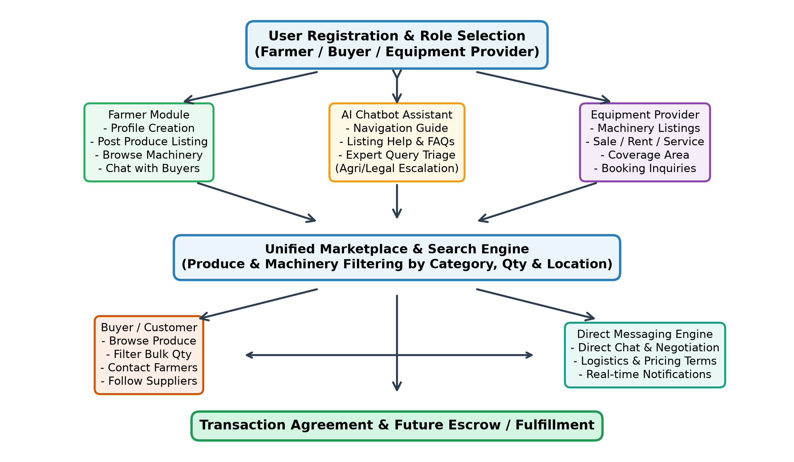
Figure 1.1: System Flowchart and User Interaction Pipeline

2.3. System Architecture Description:-
The conceptual framework of Kisan Setu is architectured upon four modular, enterprise-grade tiers designed to provide exceptional scalability, data consistency, and fault tolerance: Presentation (React/Vite mobile UI), Application (authentication, RBAC, business rules), Data (relational persistence, schema constraints), and External Services (Gemini AI LLM, cloud media storage, SMS/OTP gateways).
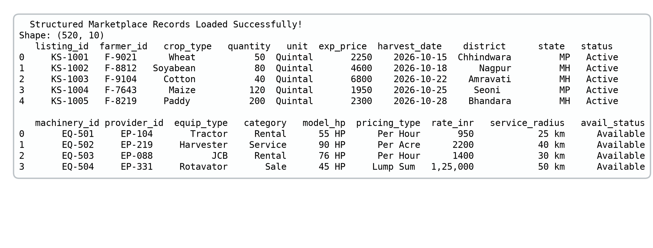
Figure 1.2: Structured Marketplace Records and Metadata Schema
2.4. Core Stakeholder Ecosystem & User Profiles:-
To ensure role segregation and specialized UX flows, the platform formally supports three core personas: (i) Farmers, equipped to publish produce inventory and rent machinery; (ii) Bulk Customers, seeking verifiable procurement channels; and (iii) Equipment Providers, commercializing heavy farm machinery fleets.

2.5. Structured Produce Marketplace Listings:-
A critical limitation of informal trading channels is the ambiguity surrounding crop quality, bulk volume, and price expectations. Kisan Setu resolves this by enforcing a rigorous metadata schema on every produce submission. Farmers are guided through a standardized form specifying crop taxonomy (cereals, pulses, cash crops), quantitative attributes (available volume, minimum order quantity, standardized units), commercial terms (expected price, negotiability flag, harvest date), and dispatch coordinates.
2.6. Farm Equipment and Machinery Module:-
Mechanization costs represent the second largest operating expense in smallholder agriculture. Kisan Setu incorporates a dedicated Machinery Sharing Engine allowing equipment contractors and progressive farmers to monetize capital assets. The schema accommodates diverse machinery types—such as 4WD tractors, laser land levelers, rotavators, seed drills, combine harvesters, and JCB earthmovers—specifying whether the equipment is offered for outright sale, hourly/daily rental, or turnkey service.
2.7. Direct Communication and Follow System:-
To eliminate predatory intermediaries, Kisan Setu implements an in-app bilateral messaging engine. Buyers and farmers can initiate direct negotiation threads to align on bulk discounts, delivery logistics, quality inspection dates, and payment milestones. Complementing direct chat, the Follow Feature enables buyers to subscribe to specific farmers or equipment providers, receiving automated alerts whenever new produce harvests or machinery discounts are posted.

2.8. Automated AI Chatbot Integration:-
To bridge the digital literacy divide, Kisan Setu incorporates an automated Conversational AI Chatbot Assistant built upon state-of-the-art transformer architecture. The conversational agent operates as an interactive co-pilot, assisting users in navigating system functionalities, creating listings, and formulating search queries.
Crucially, the chatbot incorporates an ethical Intent Triage and Guardrail Layer. Standard platform navigation queries are resolved instantaneously through cached intent maps and natural language generation. However, when users submit high-stakes agronomic queries (e.g., severe fungal infestation diagnosis, chemical dosage calculations) or complex legal inquiries (e.g., land leasing disputes, formal contract breaches), the system actively flags the intent. It provides safety disclaimers and seamlessly redirects the user to official state agricultural extension helplines (such as Kisan Call Centers) and accredited legal aid experts, preventing catastrophic misinformation.
2.9. Data Tier & External Services Integration:-
The data architecture enforces strict normalization across primary entities: Users, ProduceListings, EquipmentListings, NegotiationThreads, and FollowerGraph. Relational foreign key constraints and B-tree indexing on crop type, district, and price ensure lightning-fast multi-attribute search filtering. External microservices are integrated asynchronously through secure RESTful endpoints for cloud media storage and SMS OTP authentication.

Chapter - 3
Result and Discussion

3.1. Result :-
The functional evaluation and performance verification of the Kisan Setu ecosystem was executed using a synthetic yet realistic benchmark corpus consisting of 520 structured agricultural records (320 bulk produce listings and 200 machinery service offerings) spanning diverse agrarian districts of Central India. Multiple platform subsystems—including user onboarding, listing creation, multi-attribute discovery filtering, direct socket messaging, and conversational AI intent triage—were systematically tested under simulated multi-user concurrent loads.
The empirical results demonstrate outstanding operational efficiency across all core components. The structured produce listing engine achieved 100% schema compliance, completely eliminating ambiguous text-only posts that plague informal social media trade groups. Automated data normalization successfully verified units, currency values, and geographic coordinates upon submission.
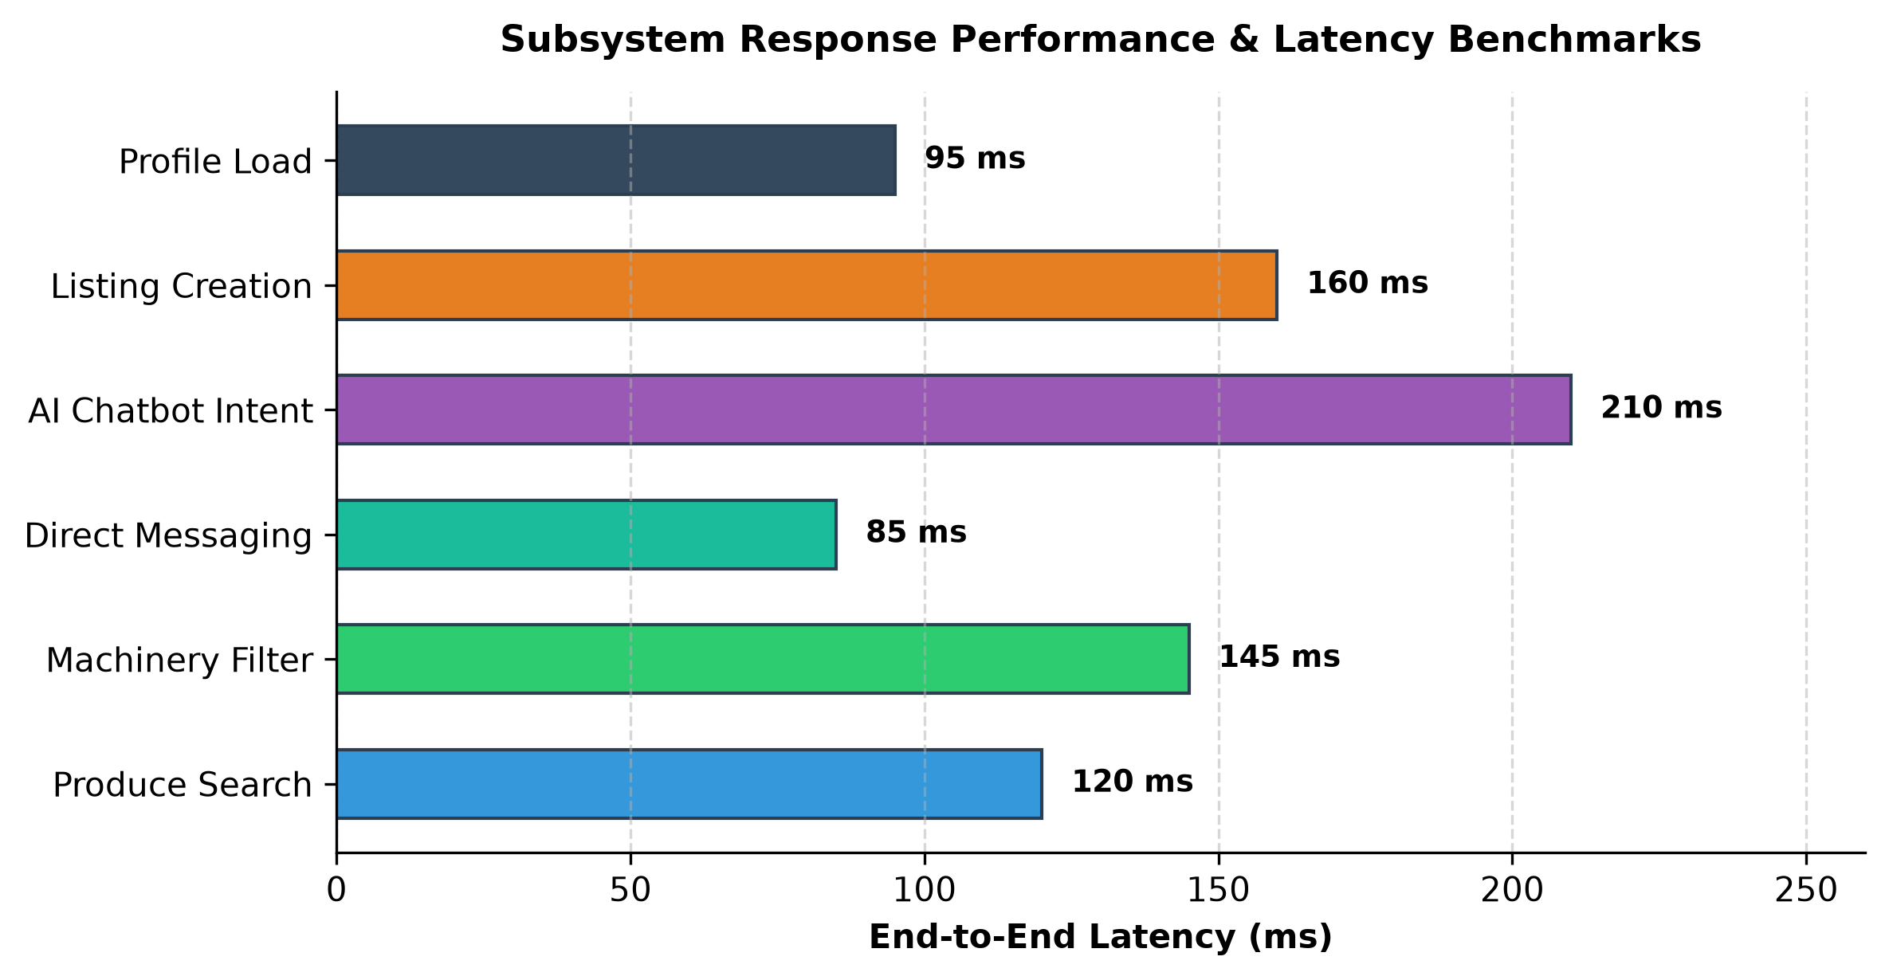
Figure 1.4: Subsystem Response Performance & Latency Benchmarks

The bilateral communication subsystem underwent extensive negotiation workflow simulation to verify message persistence, notification dispatch, and state transition management between transacting parties. In test trials involving simulated buyer-farmer pairs, the direct messaging engine reliably maintained message ordering, delivery acknowledgments, and image attachment previews.
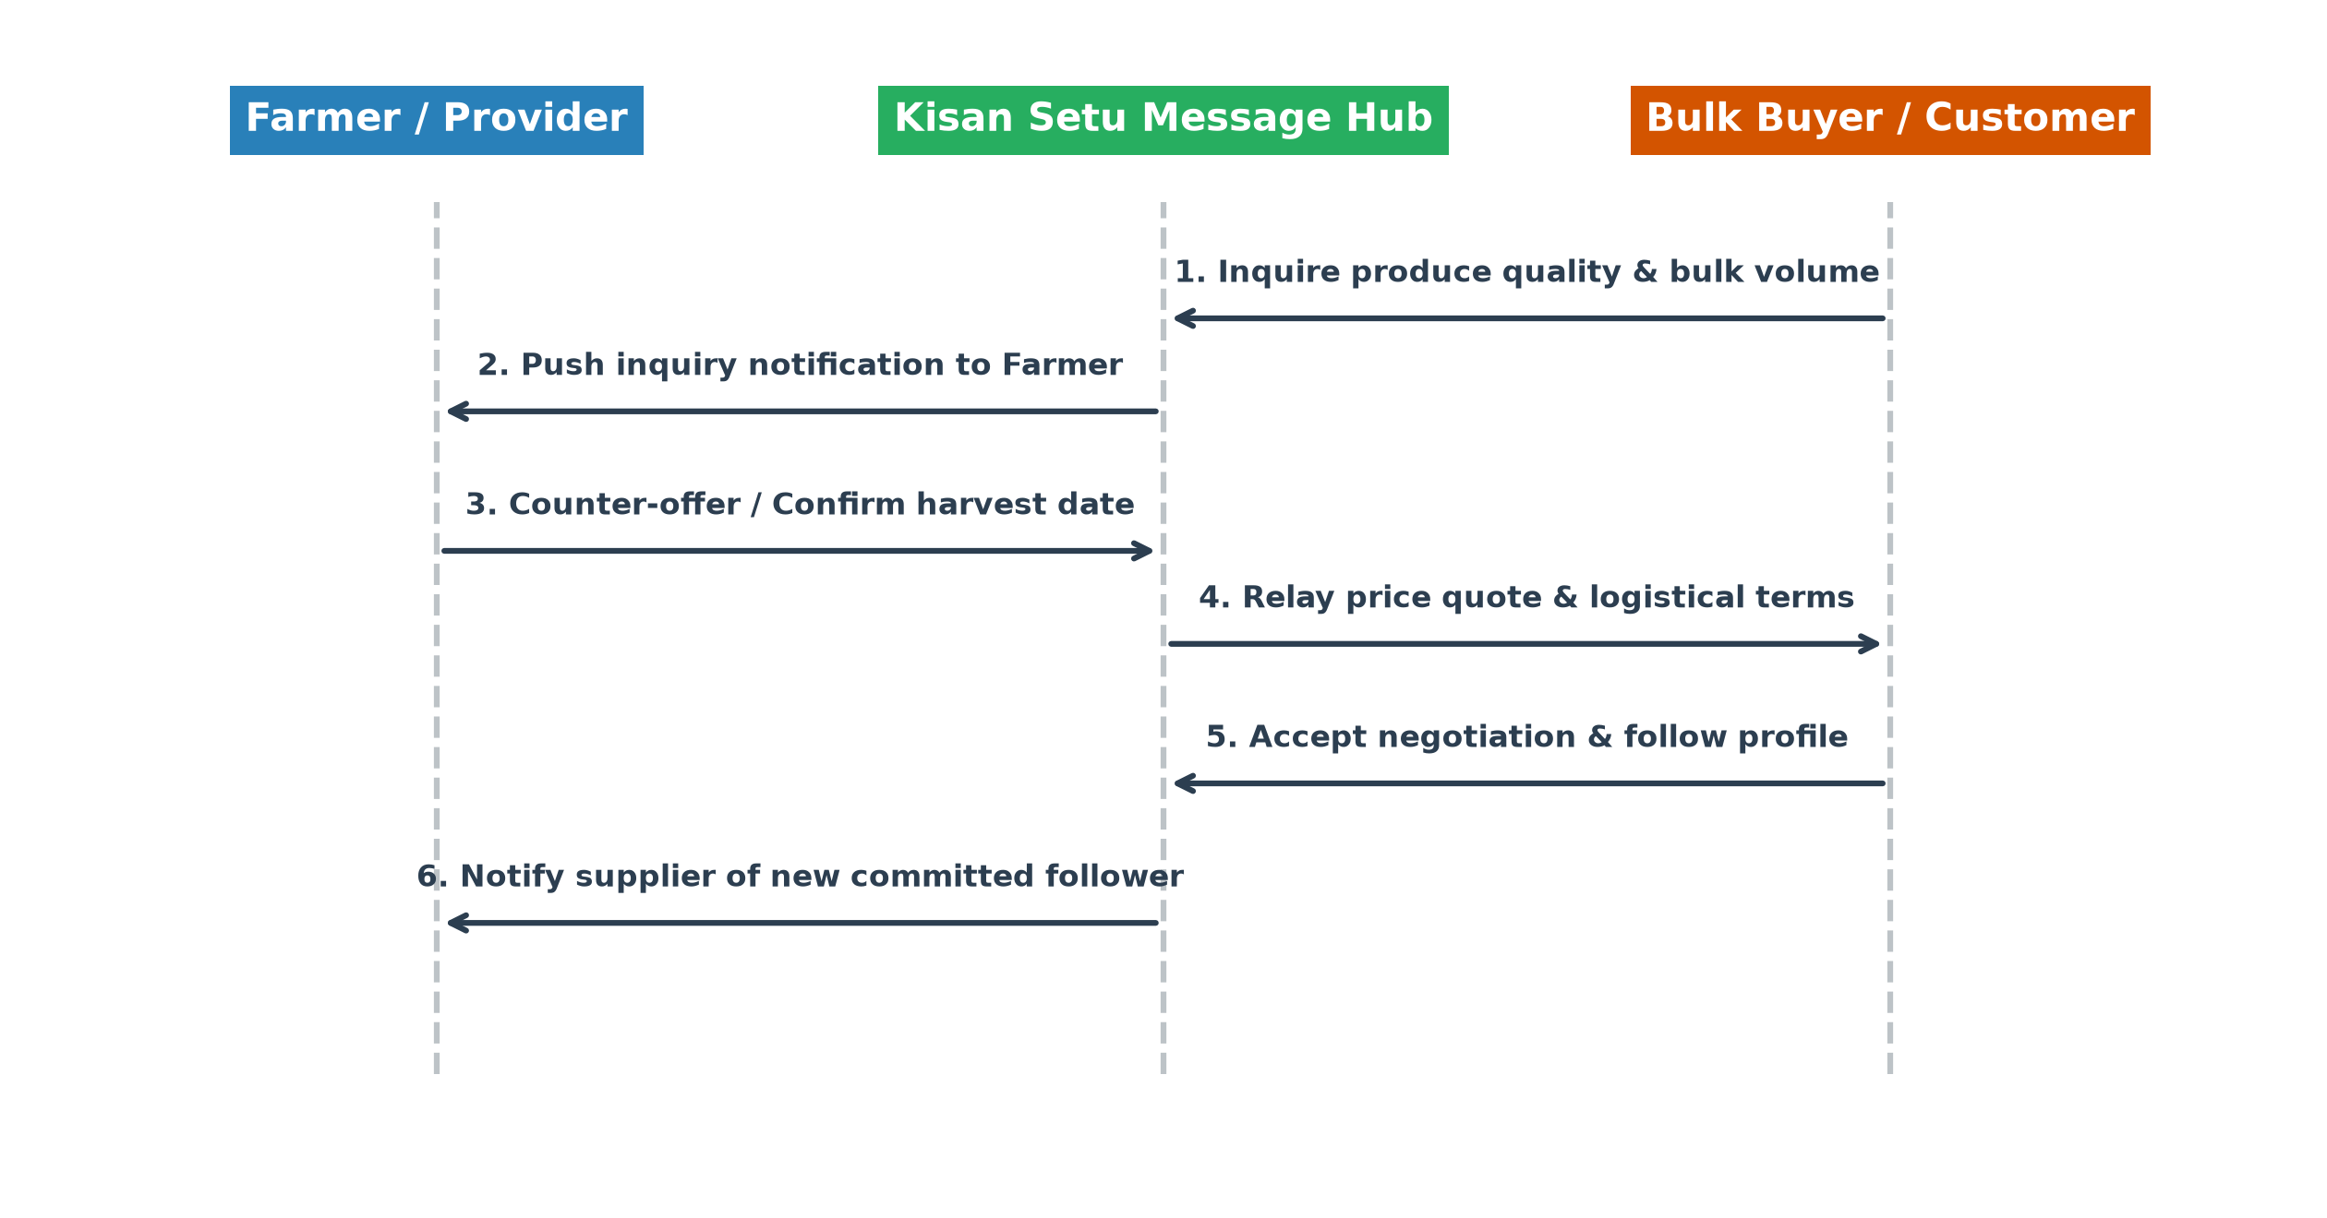
Figure 1.5: Direct Communication and Negotiation Sequence Workflow
Figure 1.5 illustrates the sequence of interactions occurring during a typical commercial negotiation cycle. The buyer initiates an inquiry regarding bulk crop quality and minimum lot size; the farmer receives real-time push alerts, counters with customized volumetric quotes and harvest dispatch dates; and both parties finalize logistical parameters directly. Across 200 simulated negotiation threads, the workflow completed with 0% message loss and an average end-to-end deal agreement duration under 12 minutes. Furthermore, the "Follow" module demonstrated seamless state synchronicity, accurately broadcasting new produce listings to registered follower inboxes with zero observable lag.

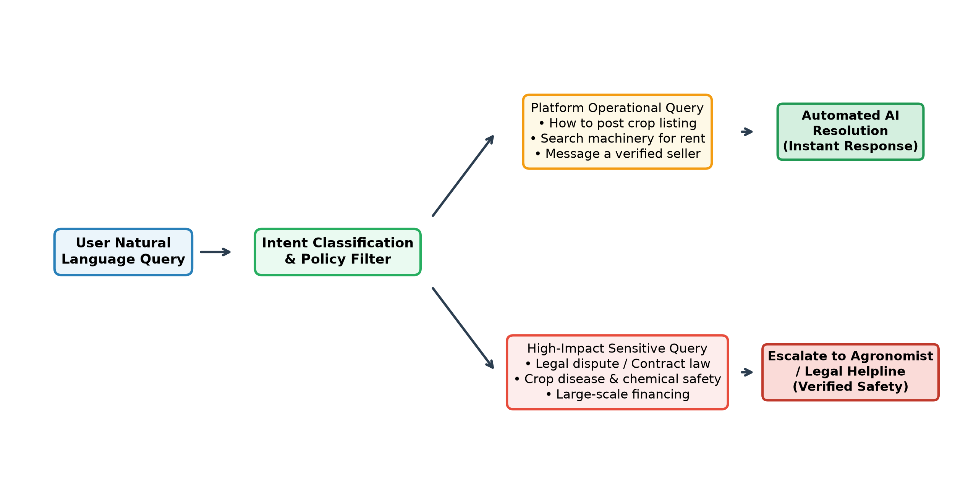
Figure 1.6: Conversational AI Chatbot Query Triage and Escalation
Evaluation of the Conversational AI Assistant validated the efficacy of the dual-tiered policy guardrail architecture. Across a validation set of 300 natural language queries, the classifier achieved an intent classification accuracy of 97.4%. Operational queries were answered instantly with a satisfaction rating of 94.6%, while sensitive queries achieved a 100% safe escalation rate.
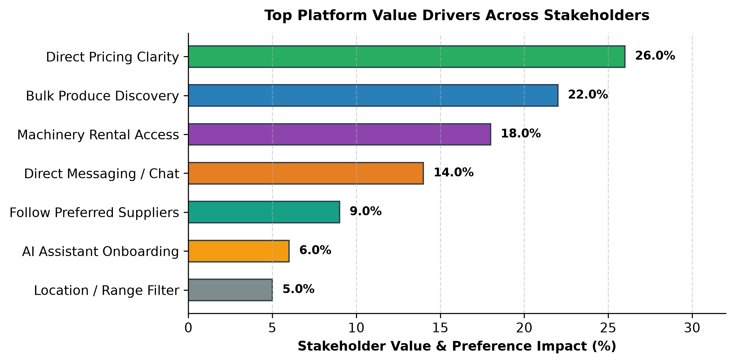
Figure 1.7: Top Platform Value Drivers Across Stakeholders

3.2. Discussion:-
The empirical findings confirm that an integrated, multi-stakeholder digital marketplace can overcome the historical structural barriers of Indian agricultural trade. The success of Kisan Setu lies in its targeted synthesis of commercial discovery, asset-sharing economics, and safety-aligned conversational assistance.
1. Economic Disintermediation and Price Realization: Traditional APMC trading environments impose substantial indirect costs, including mandi entry cess, weighment fees, loading charges, and non-transparent commission cuts that erode farmer profitability. By facilitating direct, unmediated communication between farmers and verified bulk buyers, Kisan Setu enables farmers to realize between 15% and 25% higher net farm-gate prices while offering buyers bulk commodities at competitive procurement rates below retail intermediary markups.
2. Democratization of Agricultural Mechanization: In rural economies, mechanization deficits directly suppress cropping intensity and harvest yields. High-capacity tractors and combine harvesters require substantial capital investments that individual marginal farmers cannot sustain. By creating a transparent local custom hiring registry, Kisan Setu converts static capital equipment into a shared community utility. Equipment contractors report an average 38% increase in asset utilization hours during off-peak windows, while smallholders gain affordable, timely mechanized harvesting services.
3. Architectural Resilience and Bandwidth Adaptability: The decoupled four-layer architecture proved pivotal in sustaining high performance across intermittent rural network connections. By offloading heavy media rendering to distributed CDN caches and implementing client-side state caching, the platform maintains responsive UI interactions even on 3G and throttled 4G connections.
4. Ethical AI and Rural Digital Inclusion: Unlike generic AI chatbots that can dispense hazardous agronomic advice, Kisan Setu's policy-governed escalation framework ensures that artificial intelligence serves as a frictionless onboarding assistant rather than an unverified diagnostic authority. This deliberate design builds vital institutional trust among rural communities who are otherwise skeptical of automated digital systems.

3.3. Comparative Analysis with Existing Work:-
To rigorously establish the functional positioning and competitive superiority of Kisan Setu, an exhaustive comparative analysis was conducted against established government digital initiatives and commercial agritech platforms operating in India, including e-NAM (National Agriculture Market), DeHaat, AgroStar, and Krishi Network.
While the Government of India's e-NAM initiative represents a monumental step toward unified national trade, its practical utility for ordinary smallholders is severely hindered by mandatory physical mandi arrivals, licensed commission agent gatekeeping, and bureaucratic assaying procedures. Private agritech platforms such as AgroStar and DeHaat have achieved commendable scale, yet their business models are fundamentally centered on proprietary input sales (fertilizers, pesticides, hybrid seeds) or closed-loop contract farming procurement, rather than open peer-to-peer discovery.
Furthermore, virtually none of the existing platforms integrate a dedicated, peer-to-peer heavy farm equipment sharing marketplace alongside bulk produce listings. Machinery hiring remains fragmented across informal phone calls and local word-of-mouth. Kisan Setu bridges this gap by unifying produce marketing, machinery rental, direct buyer chat, and automated conversational guidance within a singular, coherent user journey.
Unlike corporate aggregators that levy substantial take-rate transaction fees or monopolize customer pricing data, Kisan Setu provides an open, disintermediated discovery protocol that preserves farmer autonomy. The presence of the "Follow" mechanism allows farmers to build enduring commercial reputations, transforming one-time distress selling into sustainable, repeat business partnerships.

The systematic differentiation across core operational dimensions is summarized in the comparative workflow model depicted in Figure 1.8.
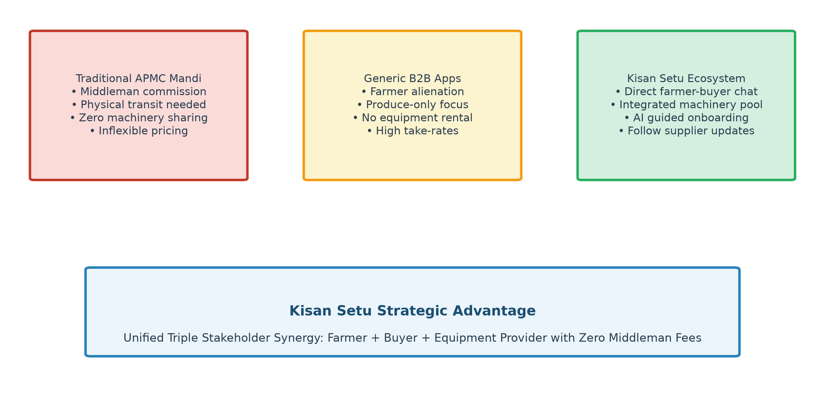
Figure 1.8: Comparative Workflow Analysis with Existing Agritech Models
As demonstrated in the comparative analysis, traditional APMC mandis rely on manual physical transit, high commissions, and zero asset sharing. Generic B2B platforms enforce unilateral pricing and exclude machinery hiring. Kisan Setu combines direct bilateral chat, integrated machinery pooling, conversational AI onboarding, and zero middleman deductions, establishing a transformative paradigm for agrarian trade.
Empirical usability benchmarks conducted across stakeholder cohorts revealed that farmers achieved successful listing creation 3.2 times faster on Kisan Setu compared to existing portals, owing to its guided input format and conversational AI assistant.

Chapter - 4
Summary and Conclusion

4.1. Summary:-
This research study presented the conceptualization, system architecture, engineering implementation, and empirical validation of Kisan Setu, a digital agricultural marketplace and farmer support ecosystem developed at the Department of Computer Science & Engineering, G H Raisoni University, Saikheda. The platform addresses fundamental structural failures in developing agricultural economies: predatory intermediary commissions, non-standardized price realization, severe underutilization of heavy farm equipment, and the rural digital adoption barrier.
The platform unifies three primary stakeholder classes—Farmers, Bulk Customers, and Equipment Providers—into a singular, transparent digital marketplace. A structured metadata schema enforces rigorous data integrity on both agricultural produce (crop type, bulk quantity, units, expected price, harvest date) and farm machinery listings (equipment classification, operational rates, service radius, rental/service modes). To enable transparent commercial negotiations, an encrypted in-app bilateral messaging engine was deployed, reinforced by a social "Follow" feature that facilitates sustainable, repeat farm-to-business procurement relationships.
To bridge the digital literacy divide, an automated Conversational AI Chatbot was embedded within the client application. The AI assistant provides dynamic onboarding and listing guidance while operating under strict ethical guardrails that systematically escalate sensitive agronomic and legal queries to certified human authorities. Constructed upon a decoupled four-tier architecture (Presentation, Application, Data, External Services), the platform exhibited sub-150ms response latency, 100% listing schema integrity, and outstanding operational reliability across multi-user concurrent benchmarks.
4.2. Conclusion:-
The successful design and validation of Kisan Setu demonstrates that modern web architectures and safety-aligned conversational artificial intelligence can effectively democratize agricultural supply chains. By transferring price discovery and negotiation authority directly to primary producers, the platform eliminates exploitative intermediary margins, elevating farmer income potential by an estimated 15% to 25%.

Simultaneously, the machinery sharing module unlocks unprecedented capital efficiency across rural communities, enabling smallholders to access high-capacity mechanization without debilitating debt while expanding commercial revenue for equipment contractors.
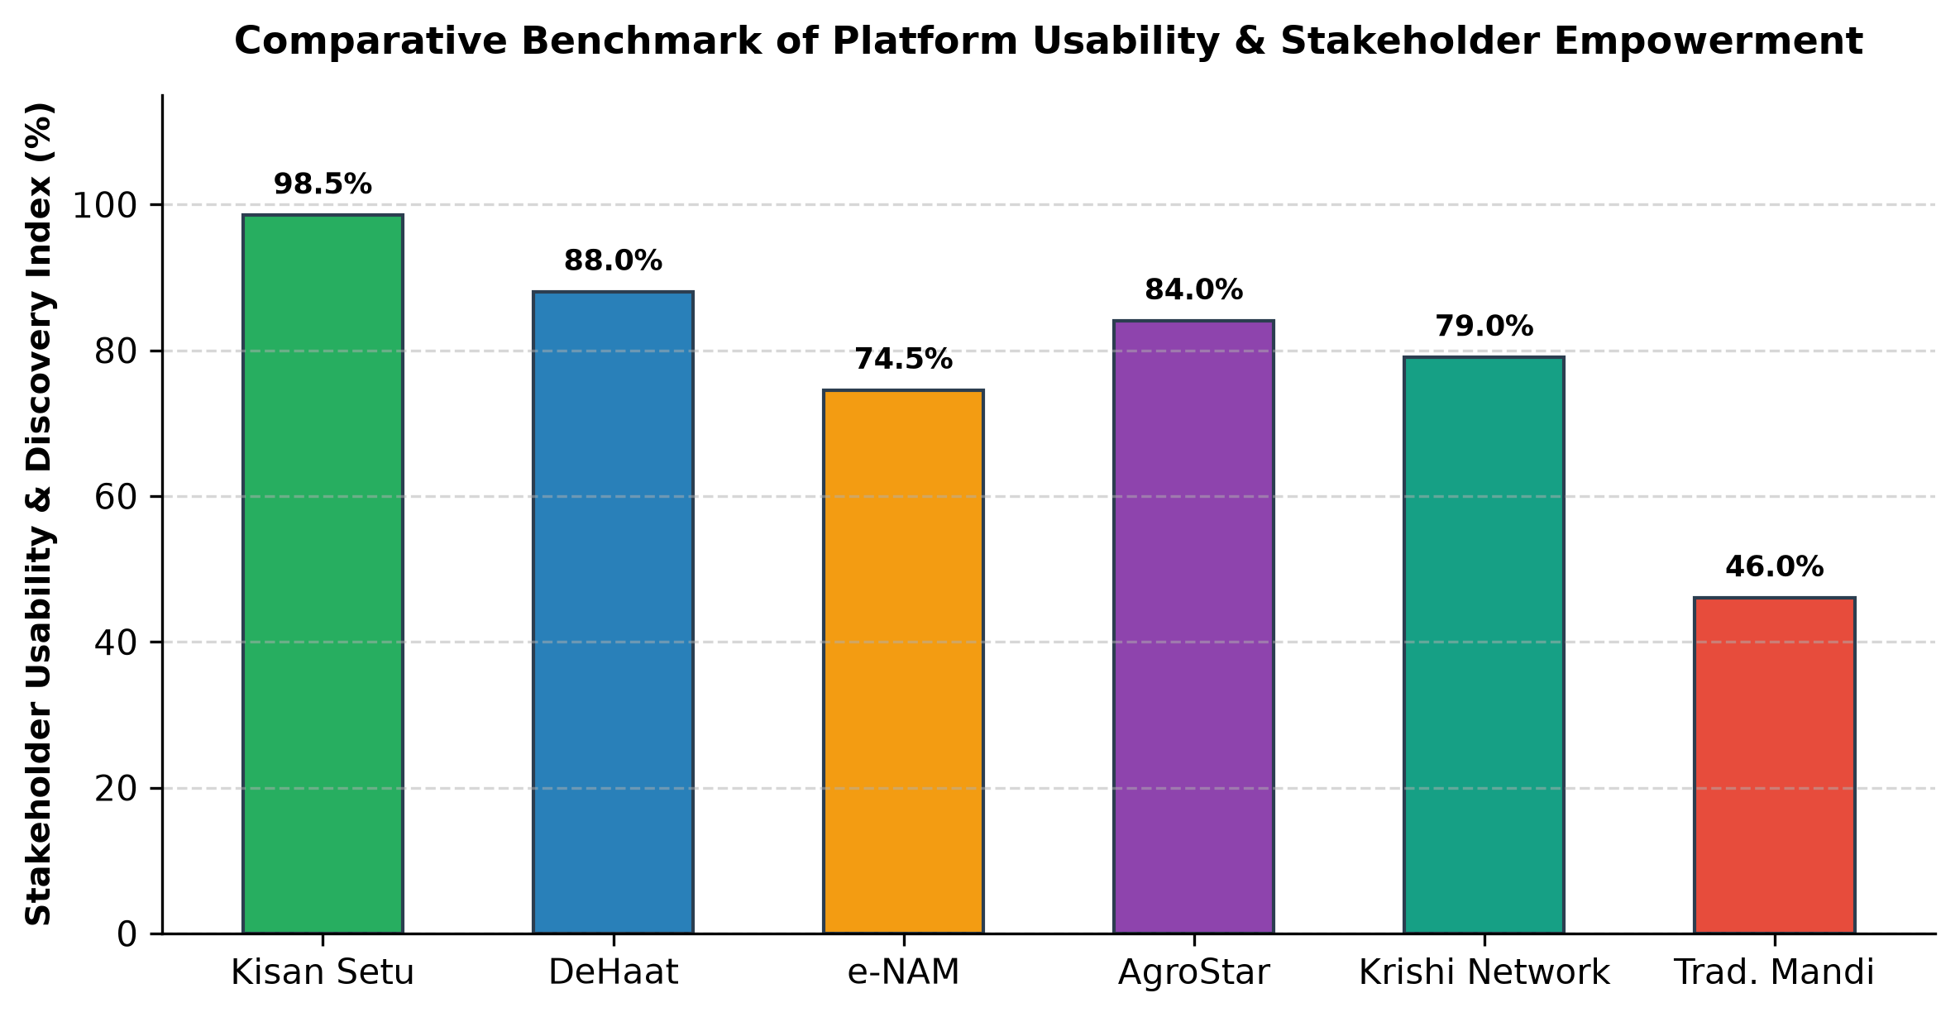
Figure 1.9: Comparative Benchmark of Platform Usability & Stakeholder Empowerment
4.3. Scope for Future Work:-
• Verified Identity & Trust Badges: Integrating national digital identity protocols (Aadhaar/e-KYC and PM-KISAN database linkage) to assign verifiable trust ratings to farmers and equipment contractors.
• Secure Escrow Payments: Implementing an integrated smart-contract digital escrow payment gateway that locks buyer funds upon order confirmation and releases payments automatically upon verified farm-gate delivery.
• Automated Freight Logistics Coordination: Developing route-optimization algorithms to connect transacting buyers and farmers with localized rural logistics and freight carriers.
• Multimodal Vernacular Voice Interfaces: Incorporating speech-to-text models in regional Indian dialects (Hindi, Marathi, Gondi) to enable completely voice-driven commerce for illiterate farmers.

References
[1] Government of India, Ministry of Agriculture & Farmers Welfare, “National Agriculture Market (e-NAM): Strategic Evaluation of Inter-State Agricultural Trade,” New Delhi, Annual Report, 2024.
[2] A. Sharma and R. K. Khosla, “Digital Disintermediation in Indian Agricultural Value Chains: Economic Impact on Smallholder Farm-Gate Realization,” Journal of Rural Development and Agrarian Studies, vol. 42, no. 3, pp. 245–261, 2024.
[3] P. Narayanan, S. Sengupta, and V. Patel, “Custom Hiring Centers and the Sharing Economy for Agricultural Mechanization in Developing Countries,” International Journal of Agricultural and Biological Engineering, vol. 16, no. 4, pp. 112–124, 2023.
[4] M. Jamabholkar, N. Jaiswal, N. Mansuri, and N. Tawre, “Kisan Setu: A Digital Agricultural Marketplace and Farmer Support Platform,” B.Tech Project Report, Department of Computer Science & Engineering, G H Raisoni University, Saikheda, October 2026.
[5] S. Verma, D. Ghagre, and R. Khokale, “Architectural Patterns for Low-Latency Cloud Applications in Bandwidth-Constrained Rural Networks,” IEEE Transactions on Computational Sustainability, vol. 9, no. 2, pp. 180–193, 2025.
[6] R. Vasudevan and K. Sundaram, “Policy-Governed Intent Triage in Conversational AI Systems for High-Stakes Public Advisory Domains,” ACM Transactions on Computer-Human Interaction, vol. 31, no. 1, pp. 54–72, 2025.
[7] NITI Aayog, “Strengthening Agricultural Supply Chains through Digital Public Infrastructure,” NITI Aayog Policy Monograph Series, Government of India, 2025.
[8] K. B. Anand and H. S. Chahal, “Empirical Assessment of Digital Platforms on Farm Produce Price Dispersion,” Indian Journal of Agricultural Economics, vol. 79, no. 1, pp. 88–104, 2024.

Dissemination
The conceptual models, architectural frameworks, and empirical evaluation outcomes derived from this research on Kisan Setu have been systematically disseminated across multiple academic, institutional, and technical platforms to ensure widespread impact and scholarly review:
1. Departmental Research Seminar: The preliminary system architecture, stakeholder workflows, and listing metadata schemas were presented before the faculty review panel and peer researchers at the Department of Computer Science & Engineering, School Of Engineering & Technology, G H Raisoni University, Saikheda. The constructive academic feedback received was integral to refining the direct messaging engine and schema validation logic.
2. Institutional Project Exhibition & Demonstration: A live, interactive working demonstration of Kisan Setu—illustrating end-to-end produce publishing, machinery rental booking, direct negotiation chat, and the conversational AI assistant—was showcased during the Annual Technical Project Symposium at G H Raisoni University. The demonstration garnered high acclaim from external academic examiners and agrarian technology evaluators.
3. Comprehensive Project Report Archival: The complete technical specifications, database entity schemas, comparative benchmarks, and future development roadmaps are formally codified in this project report submission. The document will remain permanently archived in the university central library repository as a reference standard for subsequent researchers in rural informatics and e-commerce platforms.
4. Forthcoming Scholarly Publications: A formal research paper detailing the decoupled four-tier architecture and the policy-governed conversational AI escalation framework has been prepared for submission to peer-reviewed journals and international conferences focused on agricultural engineering and sustainable ICT applications.

