Name: **Ishita Mehta**

Employee Code: **655162**

**DBMS Day2 Assignment**

**SQL DBMS Slowly Changing Dimensions (SCD)**

1. Creating the tables

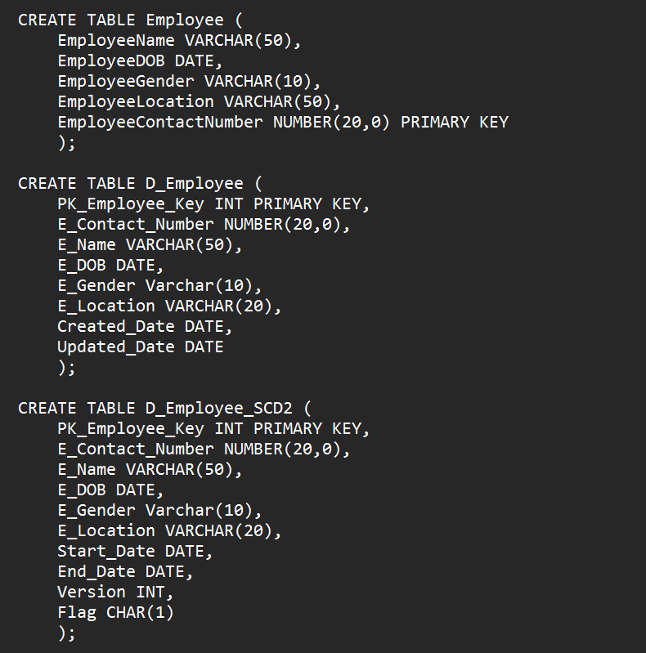

1. Inserting data into all 3 tables

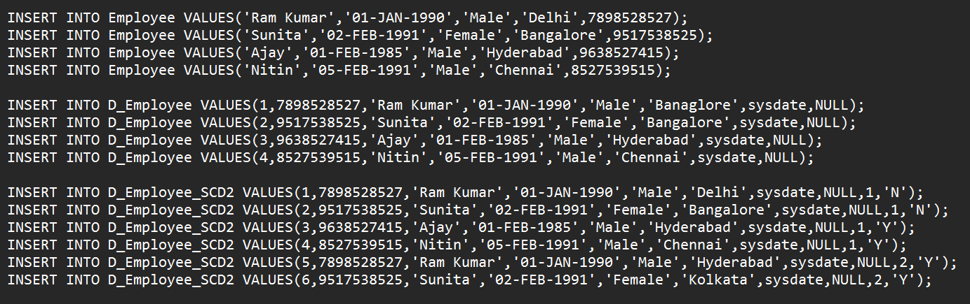

1. Display the data

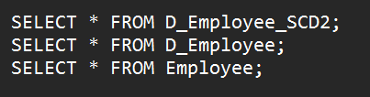

1. Update data in the tables

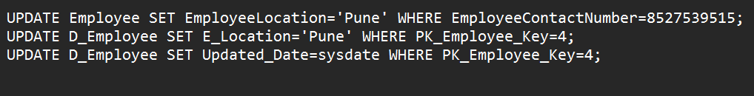

Create a VM :

