Name: **Ishita Mehta**

Employee Code: **655162**

**DAY 3**

**Azure SQL QUERIES**

Creating the SQL Server:

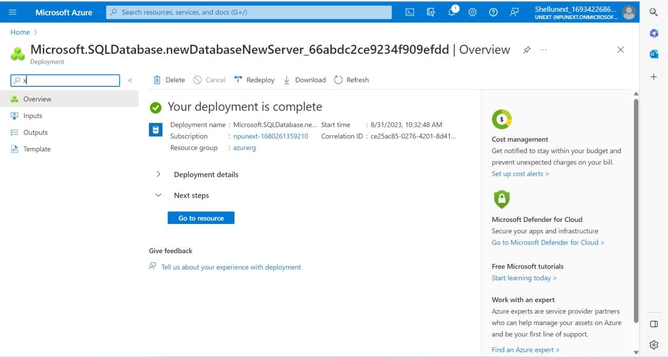

Creating SQL Database:

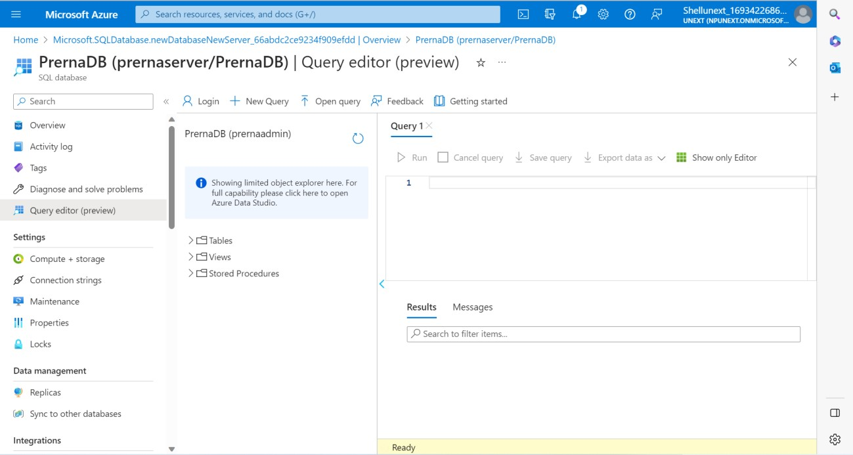

Queries:

CREATE TABLE Department(

DeptID VARCHAR(50) PRIMARY KEY,

DeptName VARCHAR(50),

DeptCode VARCHAR(50)

);

CREATE TABLE Employee(

EmpID VARCHAR(50) NOT NULL PRIMARY KEY,

EmpName VARCHAR(100),

EmailID VARCHAR(30),

DeptID VARCHAR(50) UNIQUE,

Designation VARCHAR(50),

FOREIGN KEY (DeptID)

REFERENCES Department(DeptID)

);

CREATE TABLE Students(

slno INTEGER,

ID INTEGER,

sname VARCHAR(100),

subject VARCHAR(100),

marks INTEGER);

INSERT INTO Students VALUES(1,5030, 'Ashley', 'DWH', 50);

INSERT INTO Students VALUES(2,5031, 'Priya', 'DWH', 61);

INSERT INTO Students VALUES(3,5032, 'Julia', 'DWH', 90);

INSERT INTO Students VALUES(4,5033, 'Don', 'DWH', 50);

INSERT INTO Students VALUES(5,5034, 'Bob', 'DWH', 65);

INSERT INTO Students VALUES(6,5030, 'Ashley', 'SQL', 75);

INSERT INTO Students VALUES(7,5031, 'Priya', 'SQL', 80);

INSERT INTO Students VALUES(8,5032, 'Julia', 'SQL', 40);

INSERT INTO Students VALUES(9,5033, 'Don', 'SQL', 88);

INSERT INTO Students VALUES(10,5034, 'Bob', 'SQL', 92);

INSERT INTO Students VALUES(11,5030, 'Ashley', 'Azure', 95);

INSERT INTO Students VALUES(12,5031, 'Priya', 'Azure', 95);

INSERT INTO Students VALUES(13,5032, 'Julia', 'Azure', 85);

INSERT INTO Students VALUES(14,5033, 'Don', 'Azure', 57);

INSERT INTO Students VALUES(15,5034, 'Bob', 'Azure', 44);

**--- Query 1 ---**

select s1.s_name, s1.s_subject, s1.s_marks from students s1 join (select s_subject, max(s_marks) as max_marks from students group by s_subject) s2 on (s1.s_subject = s2.s_subject and s1.s_marks = max_marks);

*--- OR ---*

with cte as (select dense_rank() over (partition by s_subject order by s_marks desc) xyz, s_subje ct, s_marks, s_name from students)

select * from cte where xyz = 1;

**--- Query 2 ---**

select * from students order by s_subject asc, s_marks desc;

**--- Query 3 ---**

select * from students where s_marks<50;

**--- Query 4 ---**

select * from students where s_subject = 'Azure' order by s_marks desc;

**--- Query 5 ---**

select s_name, sum(s_marks) from students group by s_name;

**--- Query 6 ---**

select s_name, sum(s_marks) from students group by s_name order by sum(s_marks);

**--- Query 7 ---**

select s_subject, sum(s_marks) from students group by s_subject order by sum(s_marks);

**--- Query 8 ---**

with cte as (select dense_rank() over (partition by s_subject order by s_marks desc) xyz, s_subje ct, s_marks, s_name from students)

select * from cte where xyz = 2;

**--- Query 9 ---**

select s1.s_name, s1.s_subject, s1.s_marks, s2.max_marks from students s1 join (select s_subject, max(s_marks) as max_marks from students group by s_subject) s2 on (s1.s_subject = s2.s_subject);

**--- Query 10 ---**

select *, (left(s_name,3) + right(id,2) + '@ta.com') as email from students;