Name: **Ishita Mehta**

Employee Code: **655162**

**Day 6 Azure Storage**

**Exercise 1:**

* Created Storage accounts, LRS, GRS, ZRS, GZRS, Containers.

* Edited and modified an uploaded file using Snapshots.

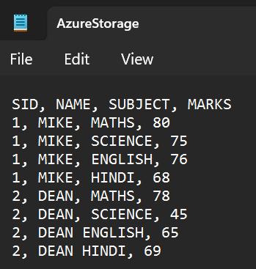

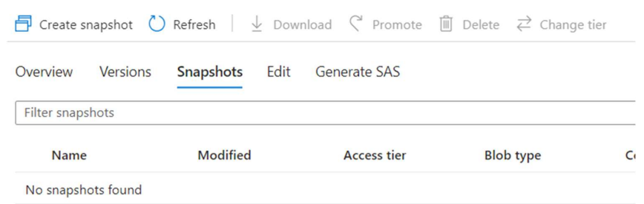

* Worked on File shares, queues, tables.

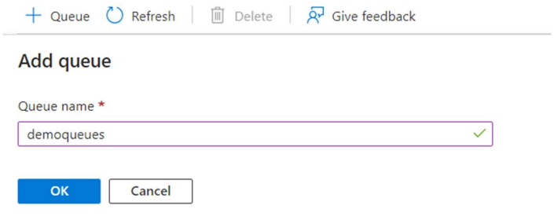

* Converted access level of a file from hot tier to cold tier and vice versa.
* Created a file with Archive tier as its access level.

**Exercise 2:**

* Creating a storage account. Select Access keys.

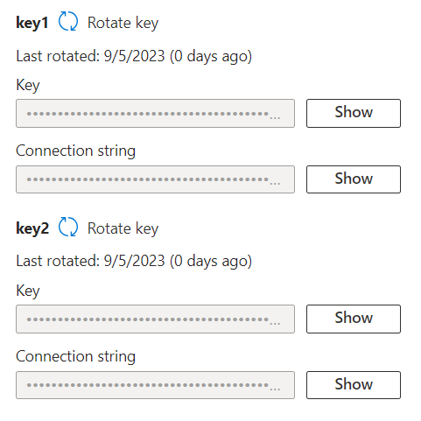

* Shared access signatures. Granting access to services and setting the expiration date.

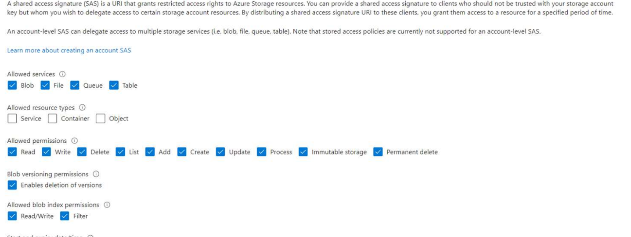

* Generating SAS and using the BLOB link to download file from file explorer.

**Exercise 3:**

* Create Azure Data Factory.

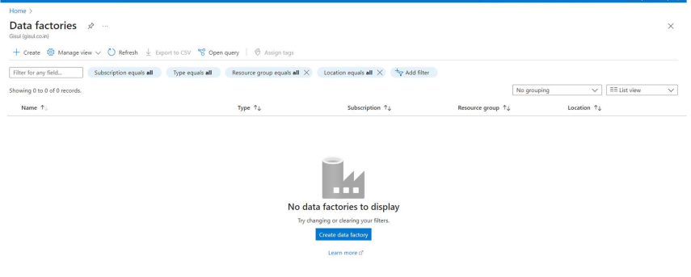

* Launch Data Factory Studio and create a pipeline.

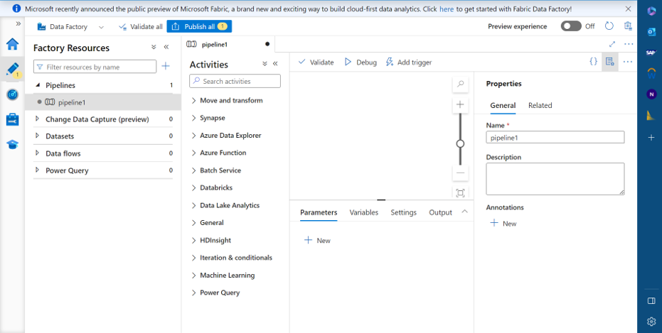

* Dataflow from previously uploaded data in storage.

