Name: **Ishita Mehta**

Employee Coode: **655162**

**Day 8 Azure Data Factory**

1. Create a pipeline in Azure Data Factory studio

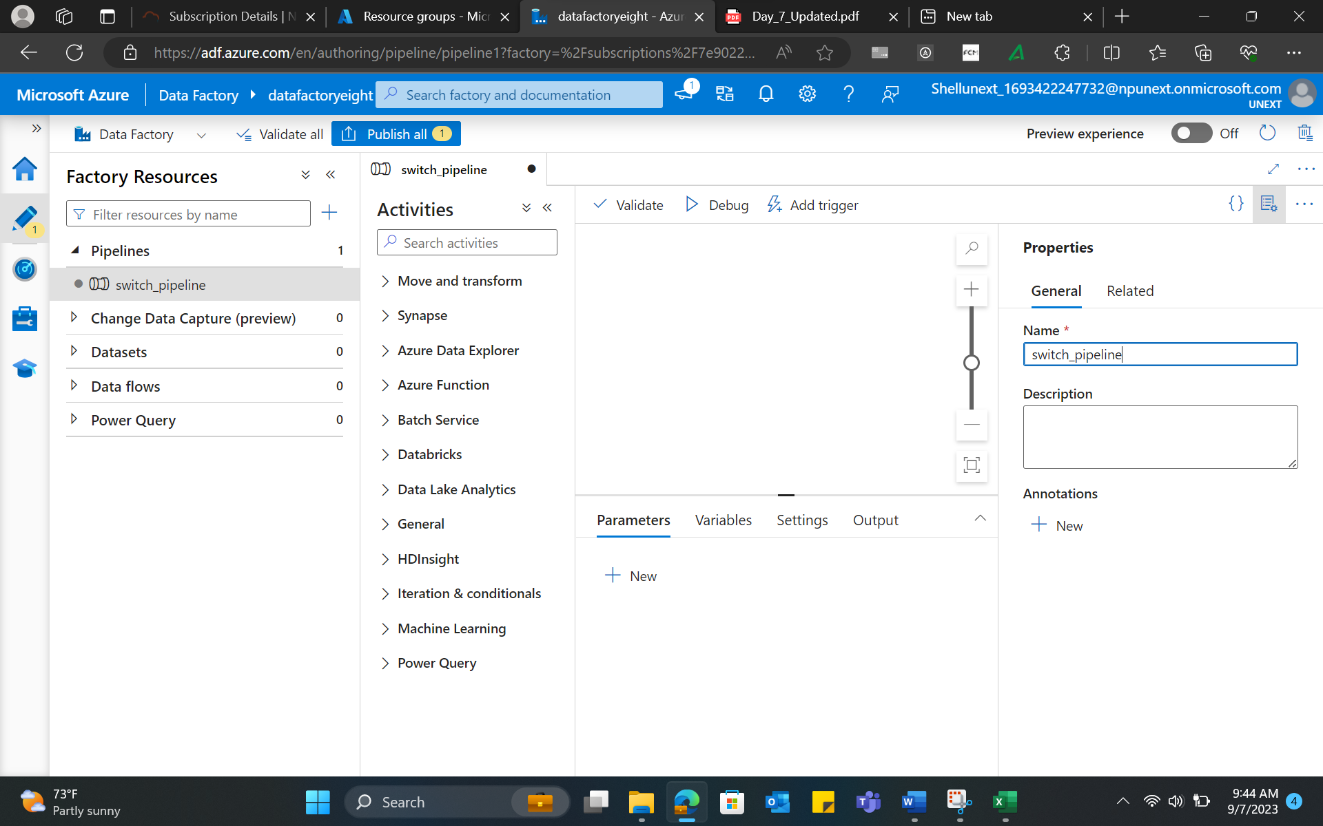

1. Create a new dataset and linked service.
2. Switch activity is implemented using Pipeline drag and drop.

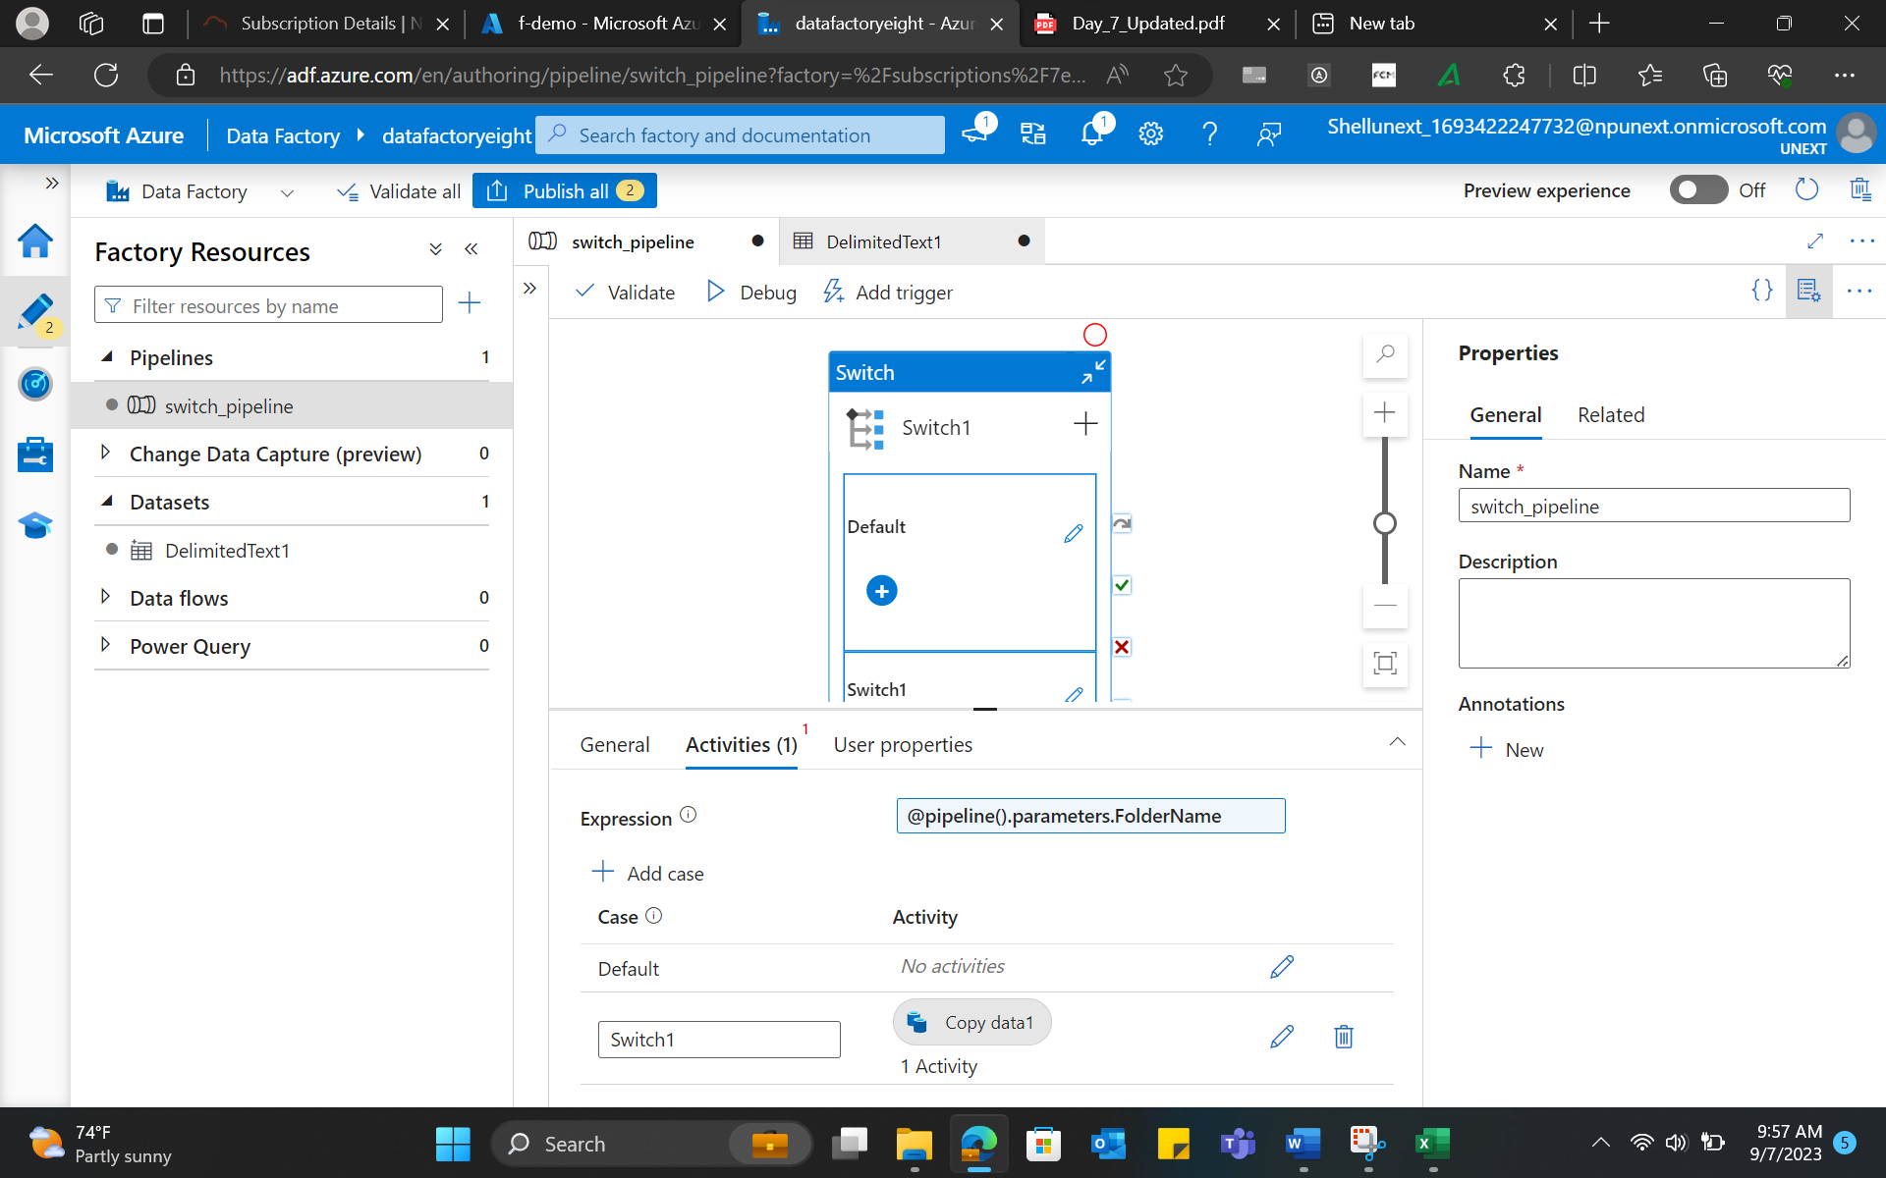

1. Click on Publish all, and a new trigger is generated.

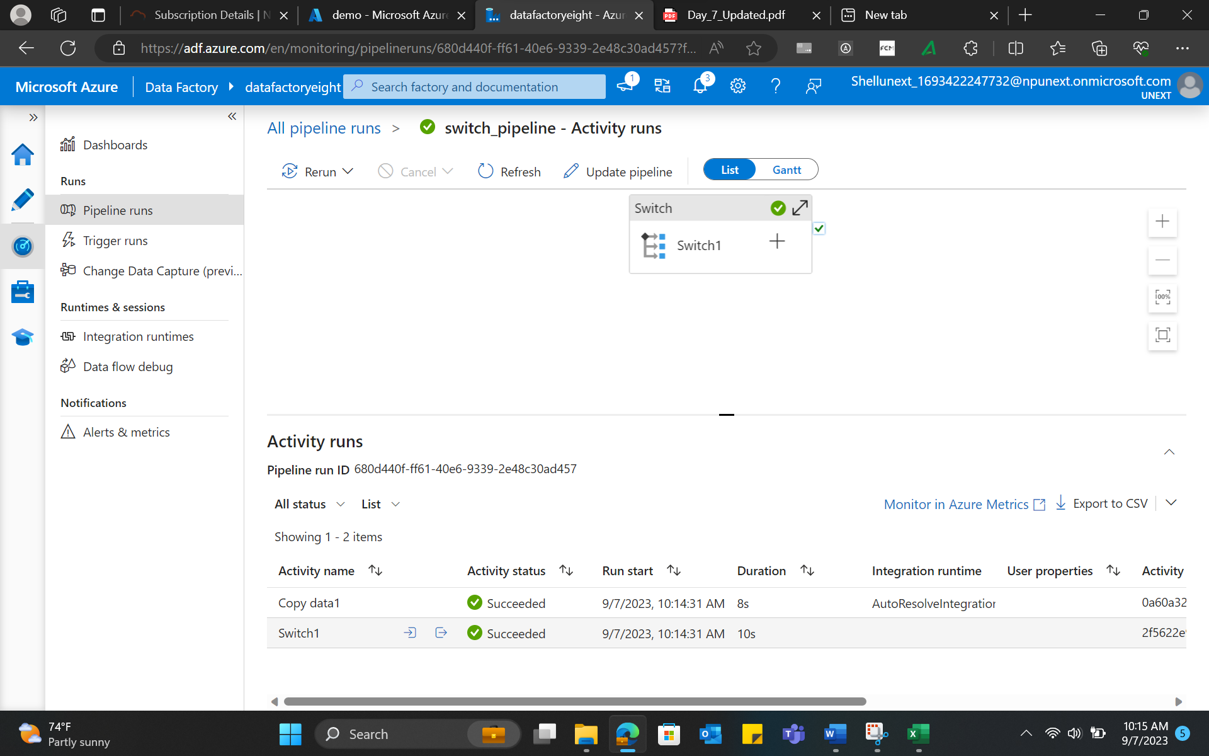

1. Similarly, Wait activity is implemented.

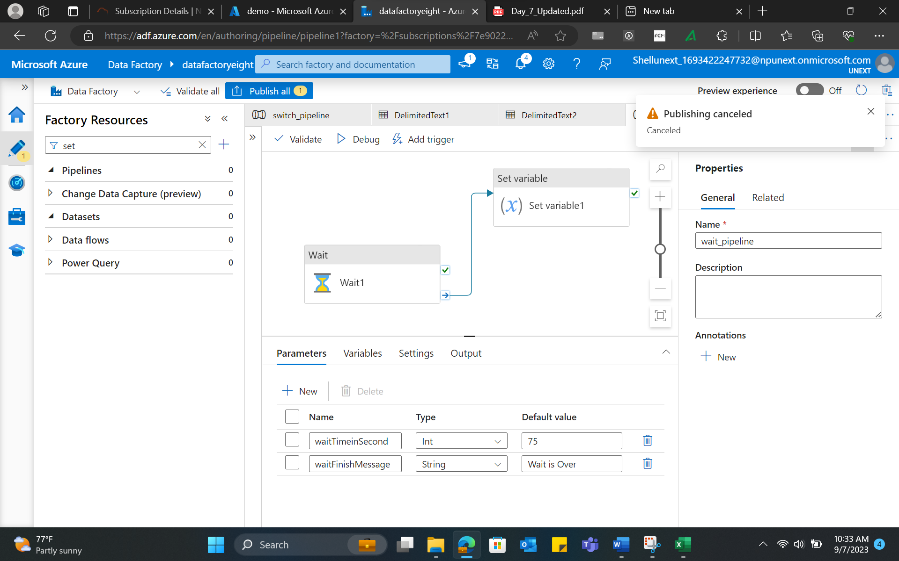

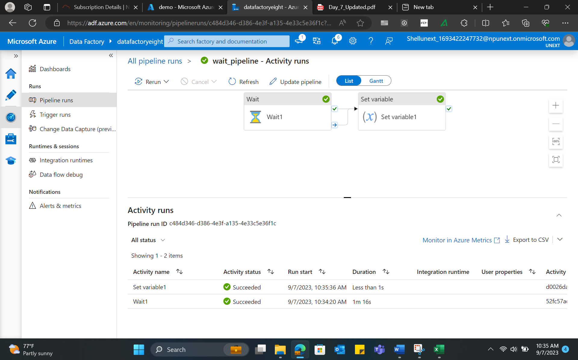

1. Using Data flows and conditional splits:

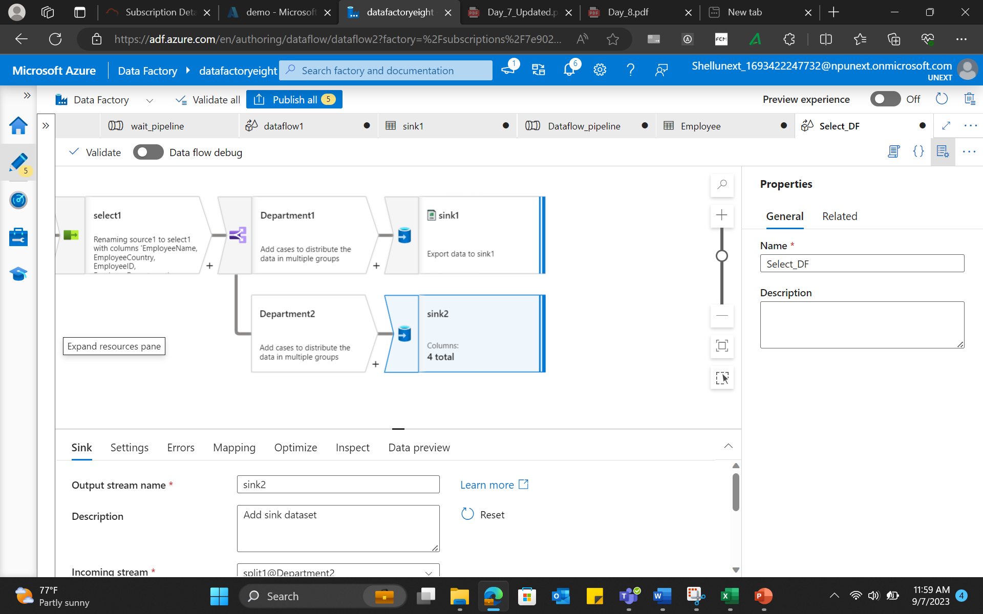

1. Implementing Union:

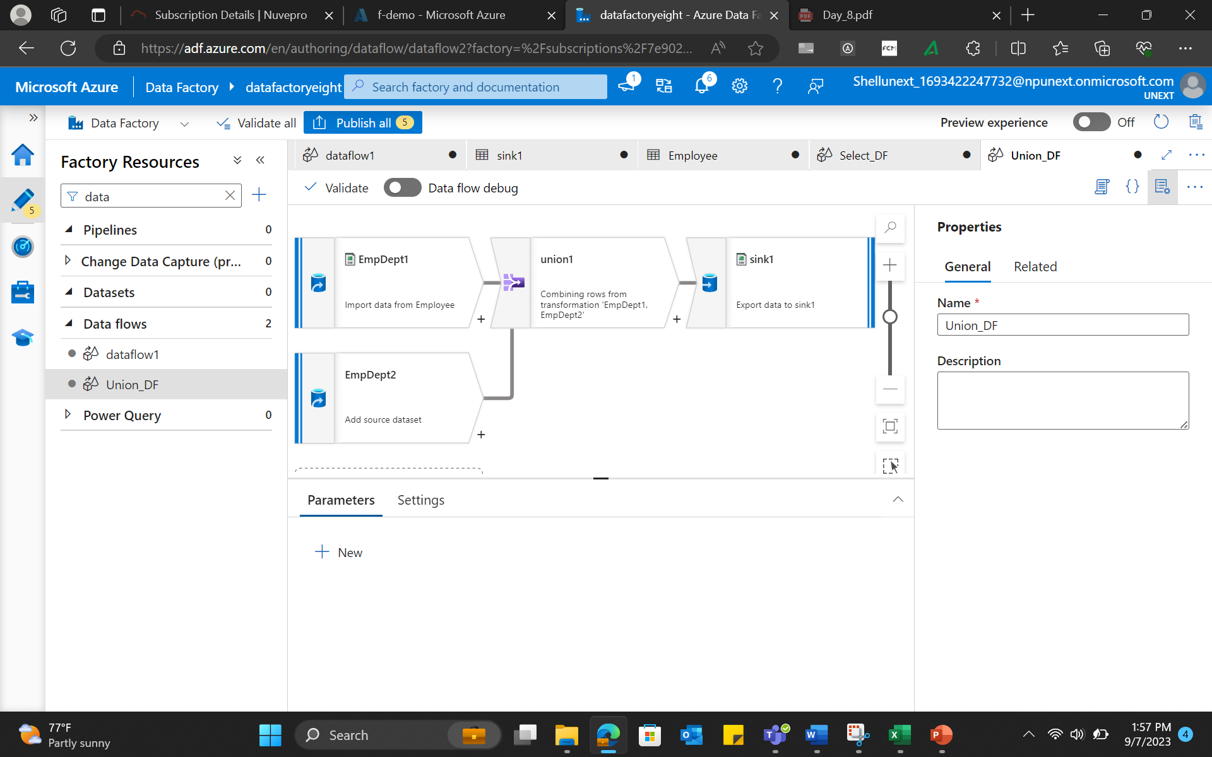

1. Sort transformation

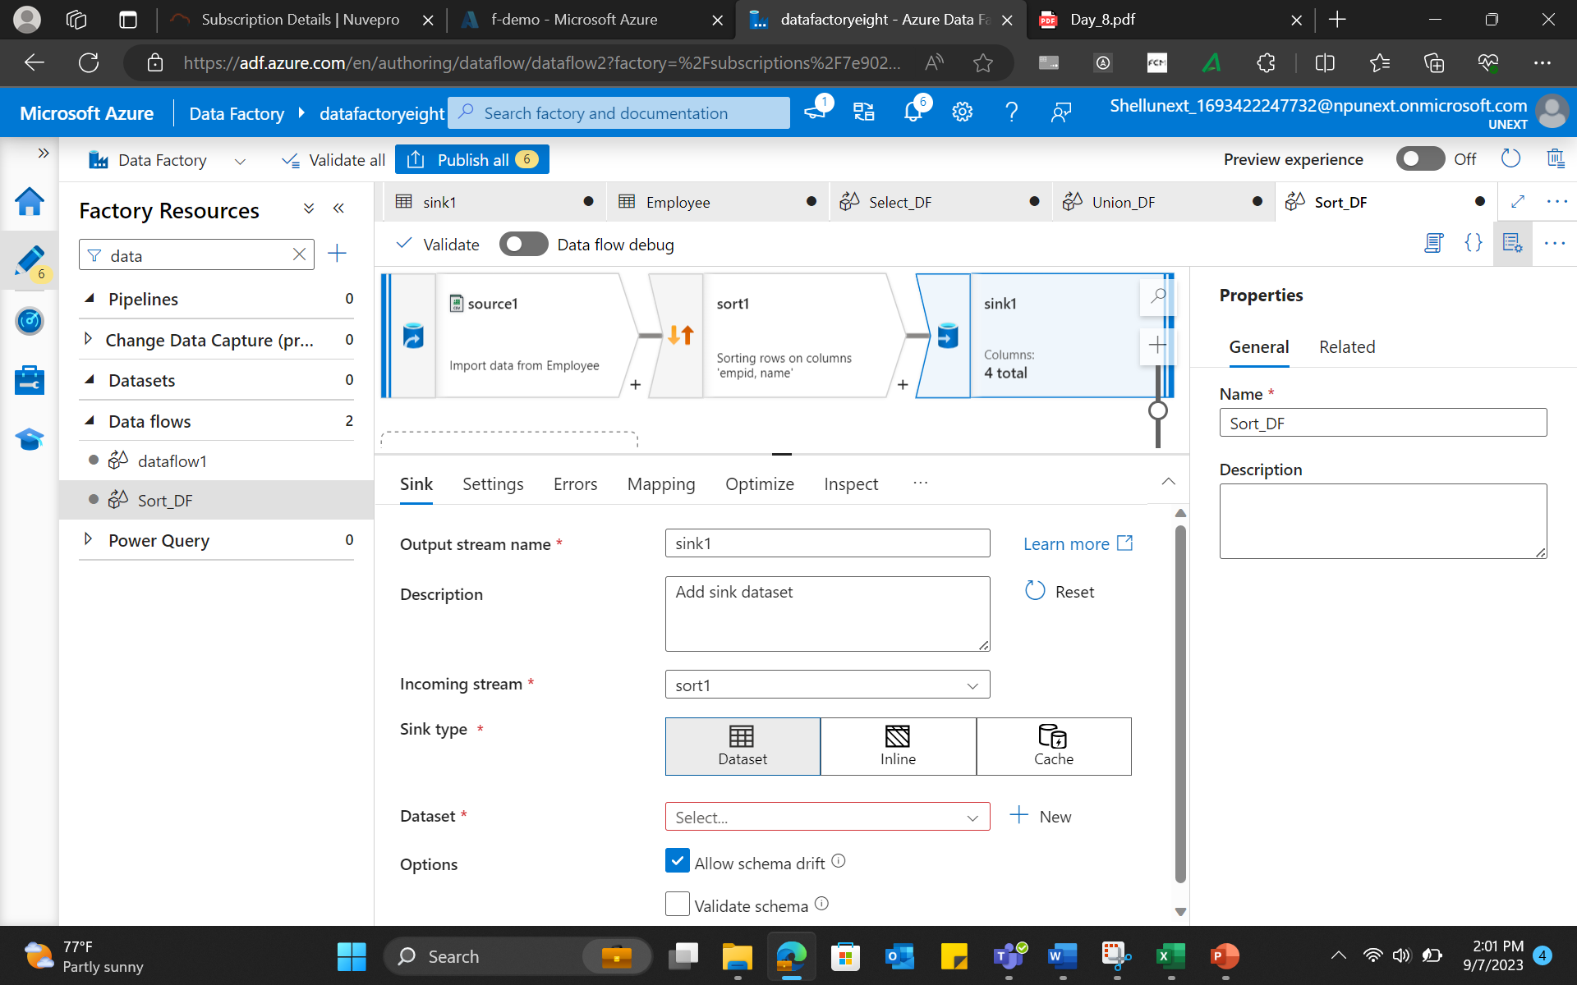

1. Surrogate key implementation:

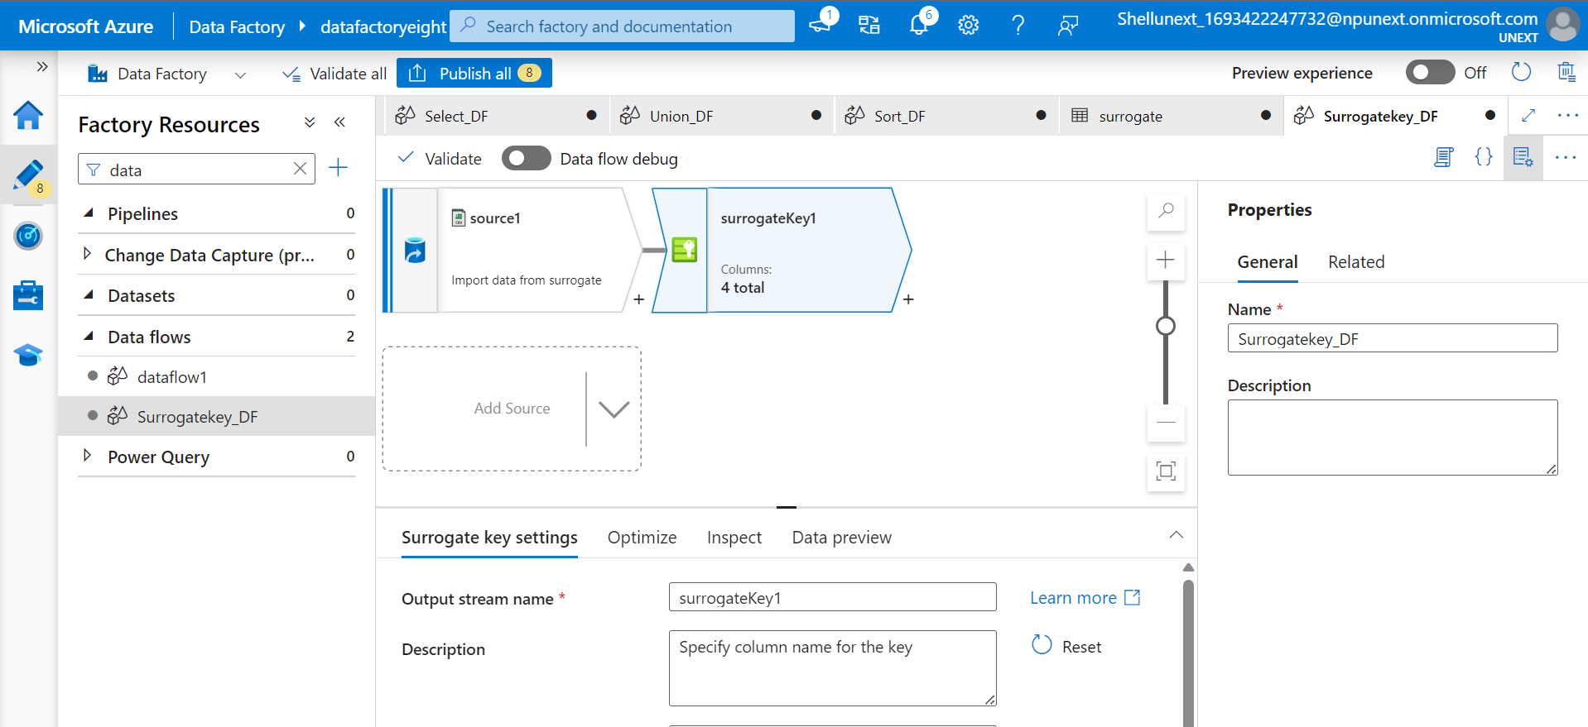

1. Filter transformation

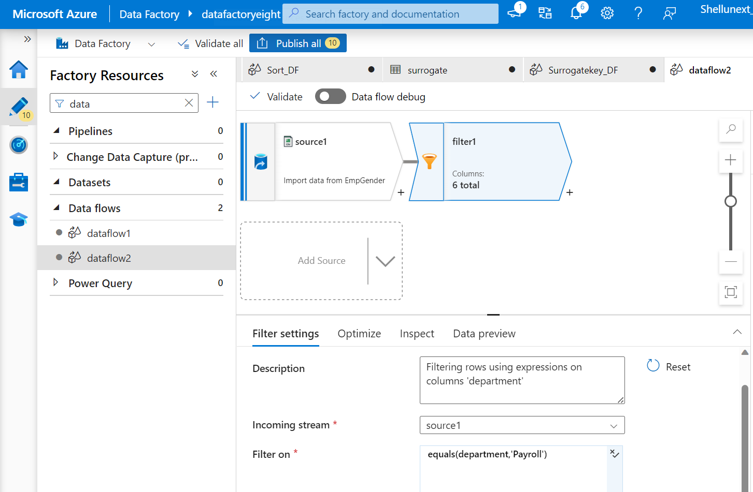

1. Aggregate transformation

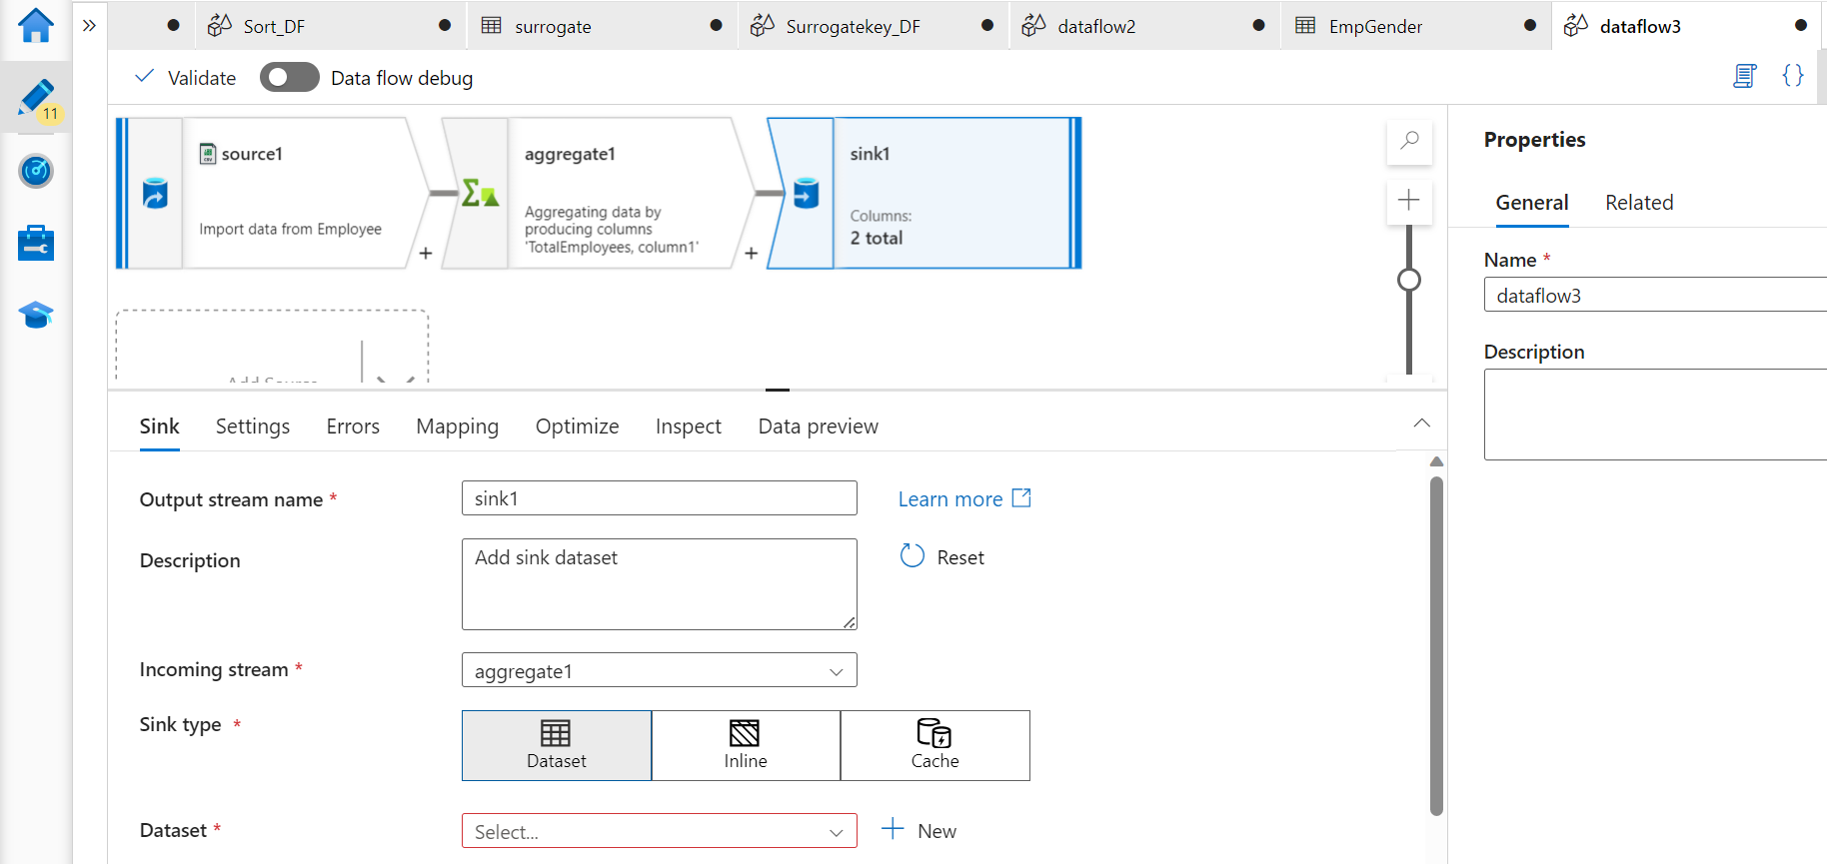

1. Implementing joins

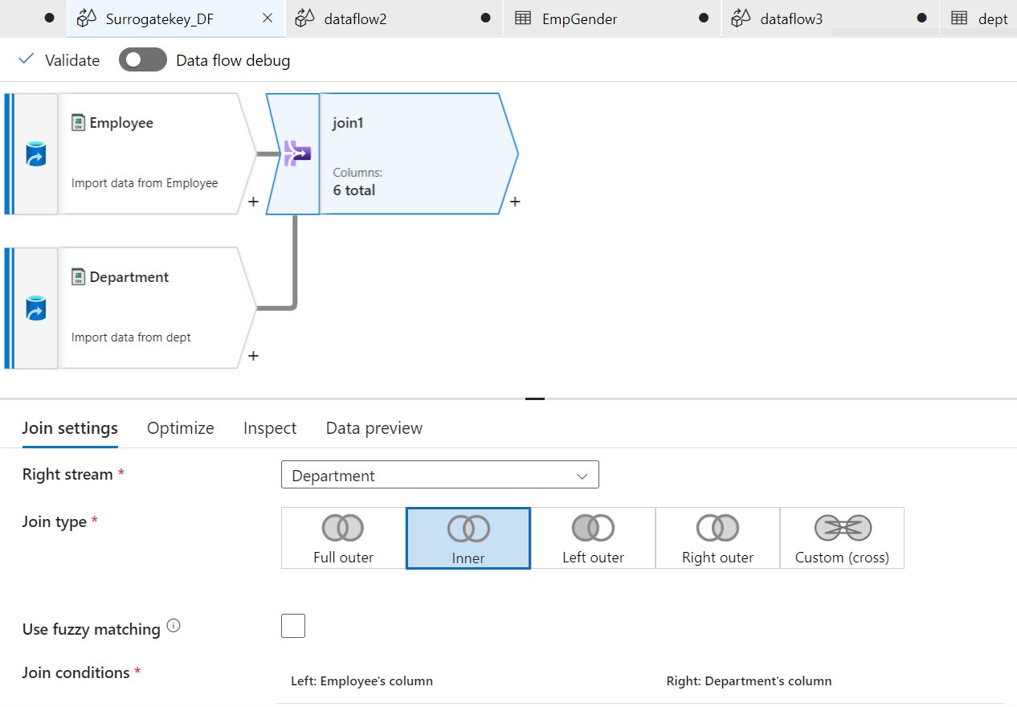

1. Implementing LookUp

