**ER-DIAGRAM CASE STUDY**

Name: **Ishita Mehta**

Employee Code: **655162**

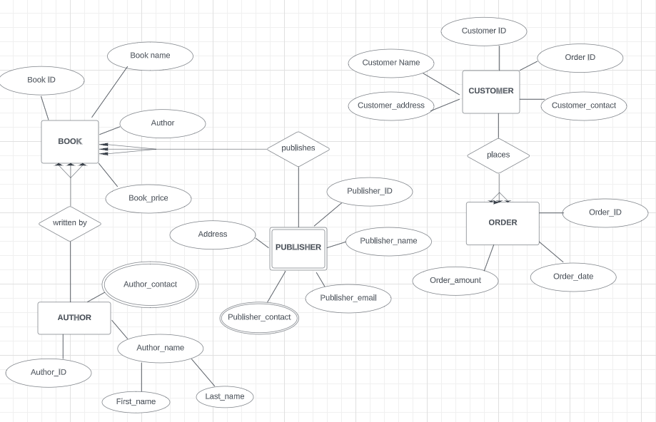

***NORMALIZATION:***

**1NF:** The tables ‘AUTHOR’ and ‘PUBLISHER’ comprise of multivalued attributes namely , ‘Publisher_contact’, ‘Author_contact’. Thus, redundancy is removed by creating a separate table.

|  |  |  |  |
| --- | --- | --- | --- |
| **Publisher_name** | **Address** | **Publisher_contact** | **Publisher_email** |
| Aakash Mehta | Sobha Palms | 8097978912, 9090909090 | [mehta@Gmail.com](mailto:mehta@Gmail.com), mm@gmail.com |
| Priya Mehta | Sobha Rose | 3490987899 | priya@gmail.com |

|  |  |  |  |
| --- | --- | --- | --- |
| **Publisher_name** | **Address** | **Publisher_contact** | **Publisher_email** |
| Aakash Mehta | Sobha Palms | 8097978912 | mehta@Gmail.com |
| Aakash Mehta | Sobha Palms | 9090909090 | mehta@Gmail.com |
| Priya Mehta | Sobha Rose | 3490987899 | priya@gmail.com |

Similarly in the author table,

|  |  |  |  |
| --- | --- | --- | --- |
| **Author_ID** | **Author_contact** | **First_name** | **Last_name** |
| A001 | 3490987899, 8097678908 | Ishita | Mehta |
| A002 | 9083672999 | Riya | Gupta |

|  |  |  |  |
| --- | --- | --- | --- |
| **Author_ID** | **Author_contact** | **First_name** | **Last_name** |
| A001 | 3490987899 | Ishita | Mehta |
| A001 | 8097678908 | Ishita | Mehta |
| A002 | 9083672999 | Riya | Gupta |

**2NF:**

In the BOOK table, all attributes are fully functional and dependent on the primary key only.

Similarly, the AUTHOR, PUBLISHER and ORDER tables also have all their attributes fully dependent on the primary key.

The CUSTOMER table has a super key (Customer ID + Order ID ), and all its attributes are fully dependent on the super key only.

Hence, the tables are in 2NF.

**3NF:**

In the above ER diagram, there is no indirect relationship between values in the same table that cause a functional dependency. The table is also in 2NF form. Thus, it satisfies the 3NF criteria too.