EXERCISE-9
ListofPlayers.jsx
import React from "react";

const PlayerList = () => {
const playerStats = [
{ name: "Virat", score: 85 },
{ name: "Rohit", score: 45 },
{ name: "Rahul", score: 73 },
{ name: "Shikhar", score: 66 },
{ name: "Pant", score: 88 },
{ name: "Jadeja", score: 55 },
{ name: "Ashwin", score: 78 },
{ name: "Shami", score: 64 },
{ name: "Bumrah", score: 90 },
{ name: "Kuldeep", score: 50 },
{ name: "Hardik", score: 70 },
];

// Identify players who scored less than 70
const underPerformers = playerStats.filter(player => player.score < 70);

return (
<div>
<h2>Complete Player List</h2>
{playerStats.map((player, idx) => (
<p key={idx}>
{player.name}: {player.score}
</p>
))}

<h2>Players Scoring Below 70</h2>
{underPerformers.map((player, idx) => (
<p key={idx}>
{player.name}: {player.score}
</p>
))}
</div>
);
};

export default PlayerList;

IndianPlayers.jsx
import React from "react";

const IndianPlayers = () => {
const players = [
"Virat",
"Rohit",
"Rahul",
"Shikhar",
"Pant",
"Jadeja",
"Ashwin",
"Shami",
"Bumrah",
"Kuldeep",
"Hardik",
];

// Destructure into odd and even players
const oddPlayers = players.filter((_, index) => index % 2 === 0);
const evenPlayers = players.filter((_, index) => index % 2 !== 0);

// Merge arrays
const T20Players = ["Virat", "Rohit", "Pant", "Hardik"];
const RanjiPlayers = ["Rahul", "Ashwin", "Shami"];

const mergedPlayers = [...T20Players, ...RanjiPlayers];

return (
<div>
<h2>Odd Team Players:</h2>
{oddPlayers.map((name, index) => (
<p key={index}>{name}</p>
))}

<h2>Even Team Players:</h2>
{evenPlayers.map((name, index) => (
<p key={index}>{name}</p>
))}

<h2>Merged Team (T20 + Ranji Trophy):</h2>
{mergedPlayers.map((name, index) => (
<p key={index}>{name}</p>
))}
</div>
);
};

export default IndianPlayers;

Output
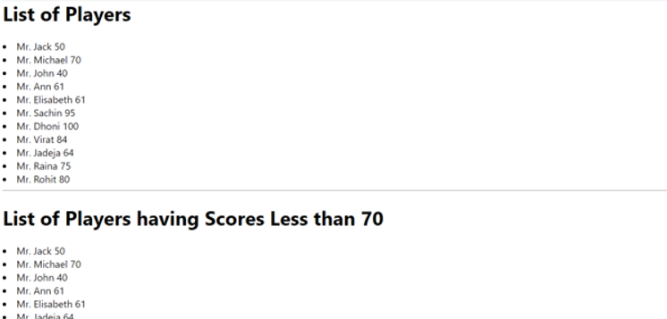

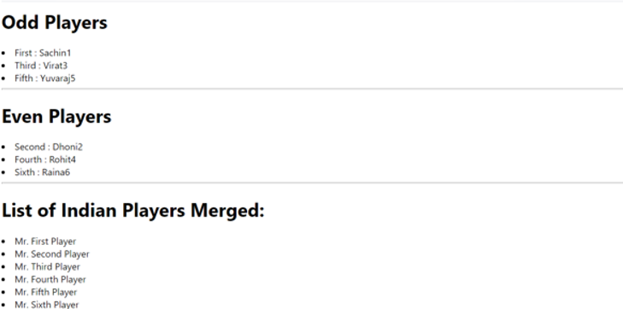

EXERCISE 10
OfficeList.jsx
import React from "react";
import "./OfficeList.css"; // For styling

const OfficeList = () => {
// Object list of office spaces
const offices = [
{
id: 1,
name: "Indiranagar Workspace",
rent: 45000,
address: "Indiranagar, Bangalore",
image: "https://via.placeholder.com/300x200?text=Indiranagar+Office",
},
{
id: 2,
name: "Koramangala Hub",
rent: 75000,
address: "Koramangala, Bangalore",
image: "https://via.placeholder.com/300x200?text=Koramangala+Office",
},
{
id: 3,
name: "Whitefield Tech Park",
rent: 62000,
address: "Whitefield, Bangalore",
image: "https://via.placeholder.com/300x200?text=Whitefield+Office",
},
{
id: 4,
name: "HSR Layout Office",
rent: 58000,
address: "HSR Layout, Bangalore",
image: "https://via.placeholder.com/300x200?text=HSR+Office",
},
];

return (
<div>
<h1>Office Space Rental Listings</h1>

{offices.map((office) => (
<div key={office.id} className="office-card">
<img src={office.image} alt={office.name} />
<h2>{office.name}</h2>
<p>Address: {office.address}</p>
<p className={office.rent < 60000 ? "rent-low" : "rent-high"}>
Rent: ₹{office.rent}
</p>
</div>
))}
</div>
);
};

export default OfficeList;

OfficeList.css
.office-card {
border: 1px solid #ccc;
padding: 16px;
margin: 16px auto;
width: 320px;
text-align: center;
border-radius: 8px;
box-shadow: 0 2px 4px rgba(0,0,0,0.1);
font-family: Arial, sans-serif;
background-color: #f9f9f9;
}

.office-card img {
width: 100%;
height: auto;
border-radius: 4px;
}

.rent-low {
color: red;
font-weight: bold;
}

.rent-high {
color: green;
font-weight: bold;
}

App.js

import React from "react";
import OfficeList from "./components/OfficeList";

function App() {
return (
<div className="App">
<OfficeList />
</div>
);
}

OUTPUT:
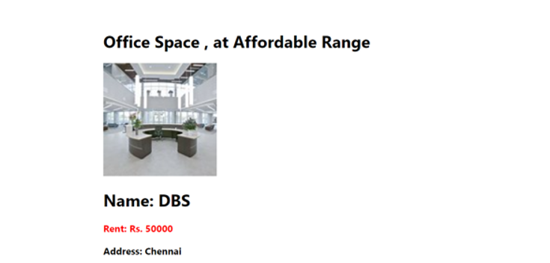

EXERCISE 11
Counter.jsx
import React, { useState } from "react";

const Counter = () => {
const [count, setCount] = useState(0);

const increment = () => {
setCount(count + 1);
sayHello();
};

const decrement = () => {
setCount(count - 1);
};

const sayHello = () => {
console.log("Hello! This is a static message.");
};

return (
<div>
<h2>Counter: {count}</h2>
<button onClick={increment}>Increment</button>
<button onClick={decrement}>Decrement</button>
</div>
);
};

export default Counter;

WelcomeButton.jsx
import React from "react";

const WelcomeButton = () => {
const sayMessage = (msg) => {
alert(msg);
};

return (
<div>
<button onClick={() => sayMessage("Welcome!")}>Say Welcome</button>
</div>
);
};

export default WelcomeButton;

ClickEvent.jsx
import React from "react";

const ClickEvent = () => {
const handleClick = (e) => {
console.log("I was clicked");
};

return (
<div>
<button onClick={handleClick}>OnPress</button>
</div>
);
};

export default ClickEvent;

CurrencyConvertor.jsx
import React, { useState } from "react";

const CurrencyConvertor = () => {
const [rupees, setRupees] = useState("");
const [euro, setEuro] = useState("");

const handleChange = (e) => {
setRupees(e.target.value);
};

const handleSubmit = () => {
const rate = 0.011; // Example conversion rate
const converted = parseFloat(rupees) * rate;
setEuro(converted.toFixed(2));
};

return (
<div>
<h2>Currency Convertor</h2>
<input
type="number"
placeholder="Enter amount in INR"
value={rupees}
onChange={handleChange}
/>
<button onClick={handleSubmit}>Convert</button>
{euro && <p>Euro: €{euro}</p>}
</div>
);
};

App.js
import React from "react";
import Counter from "./components/Counter";
import WelcomeButton from "./components/WelcomeButton";
import ClickEvent from "./components/ClickEvent";
import CurrencyConvertor from "./components/CurrencyConvertor";

function App() {
return (
<div className="App">
<h1>Event Examples App</h1>
<Counter />
<WelcomeButton />
<ClickEvent />
<CurrencyConvertor />
</div>
);
}

export default App;

Output
