**ASSIGNMENT – 10**

**Problem Statement:** Deploy project from GitHub to EC2 by creating new security group and user data.

**Procedure:**

1. Sign in to your AWS account.
2. Go to your EC2 dashboard
3. Scroll down and Click on Security Groups option on the left side nav bar under Network & Security option.

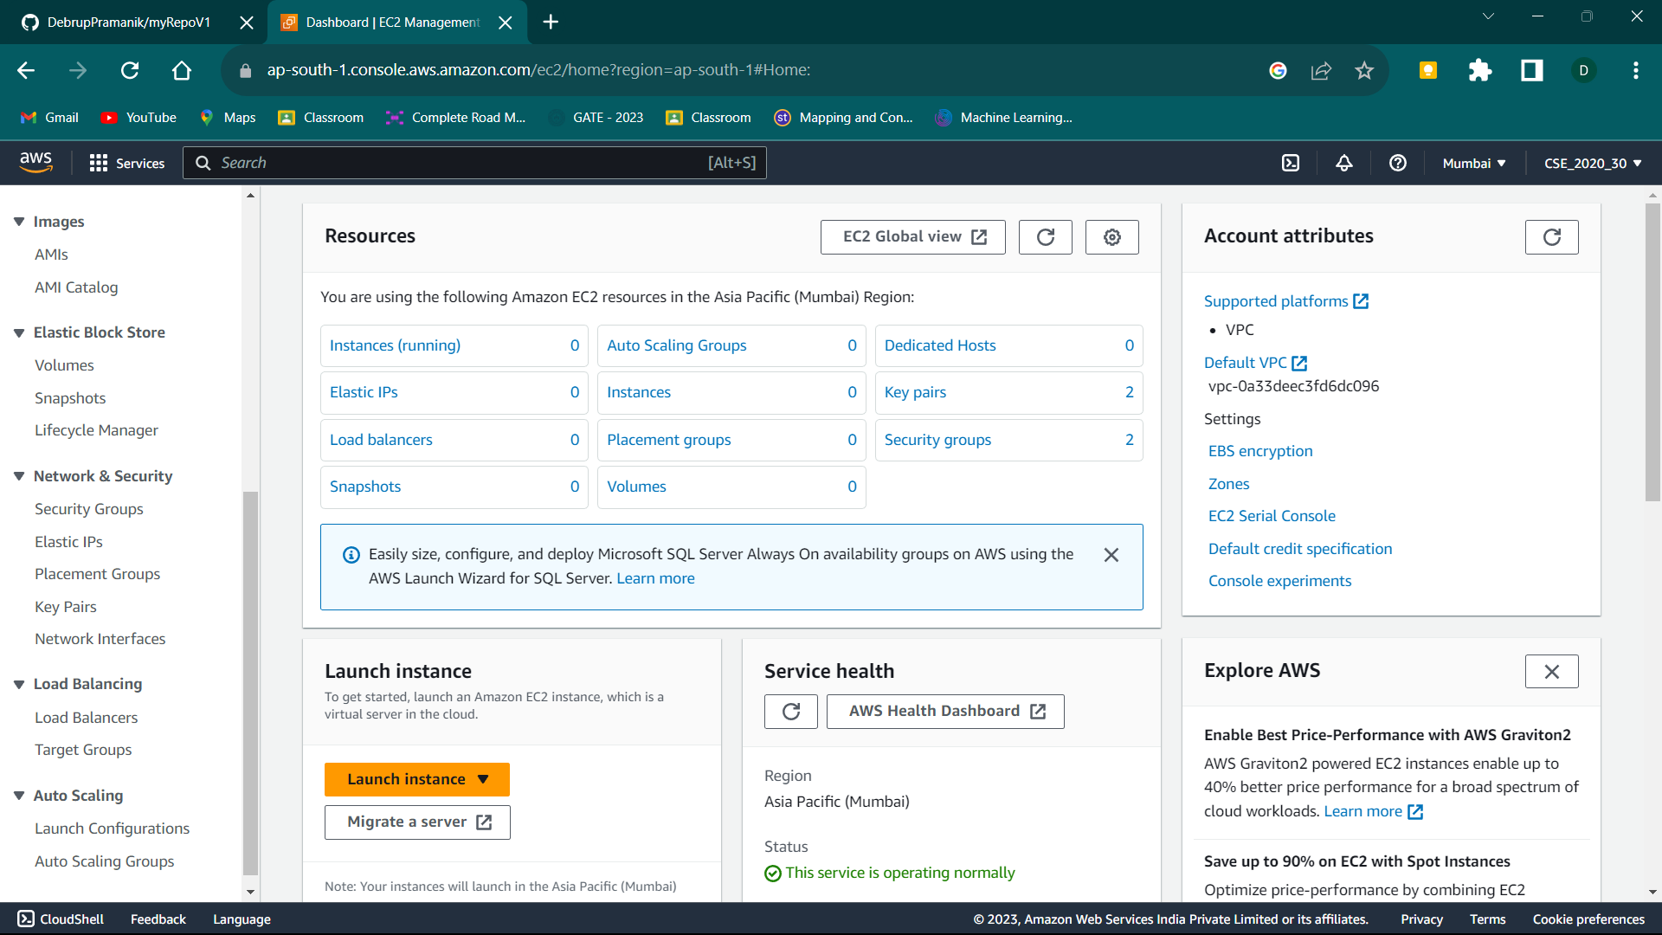

1. Select all the Security Groups other than the one named “default”.

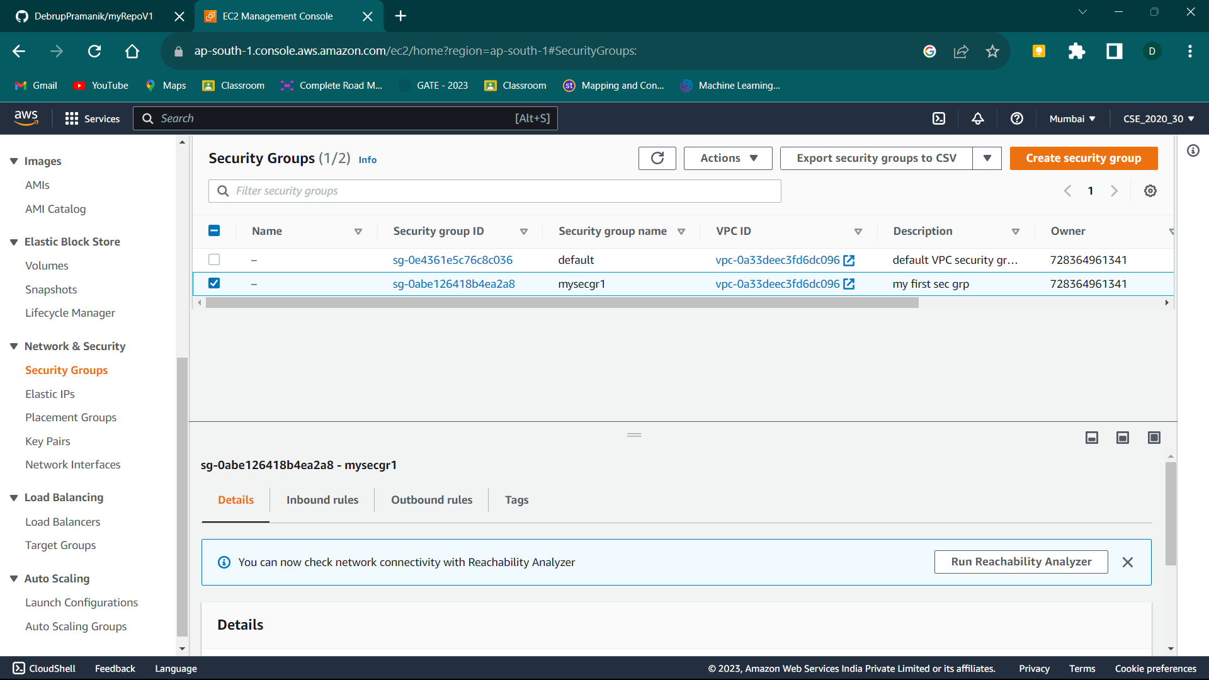

1. Then Click on the Actions button.

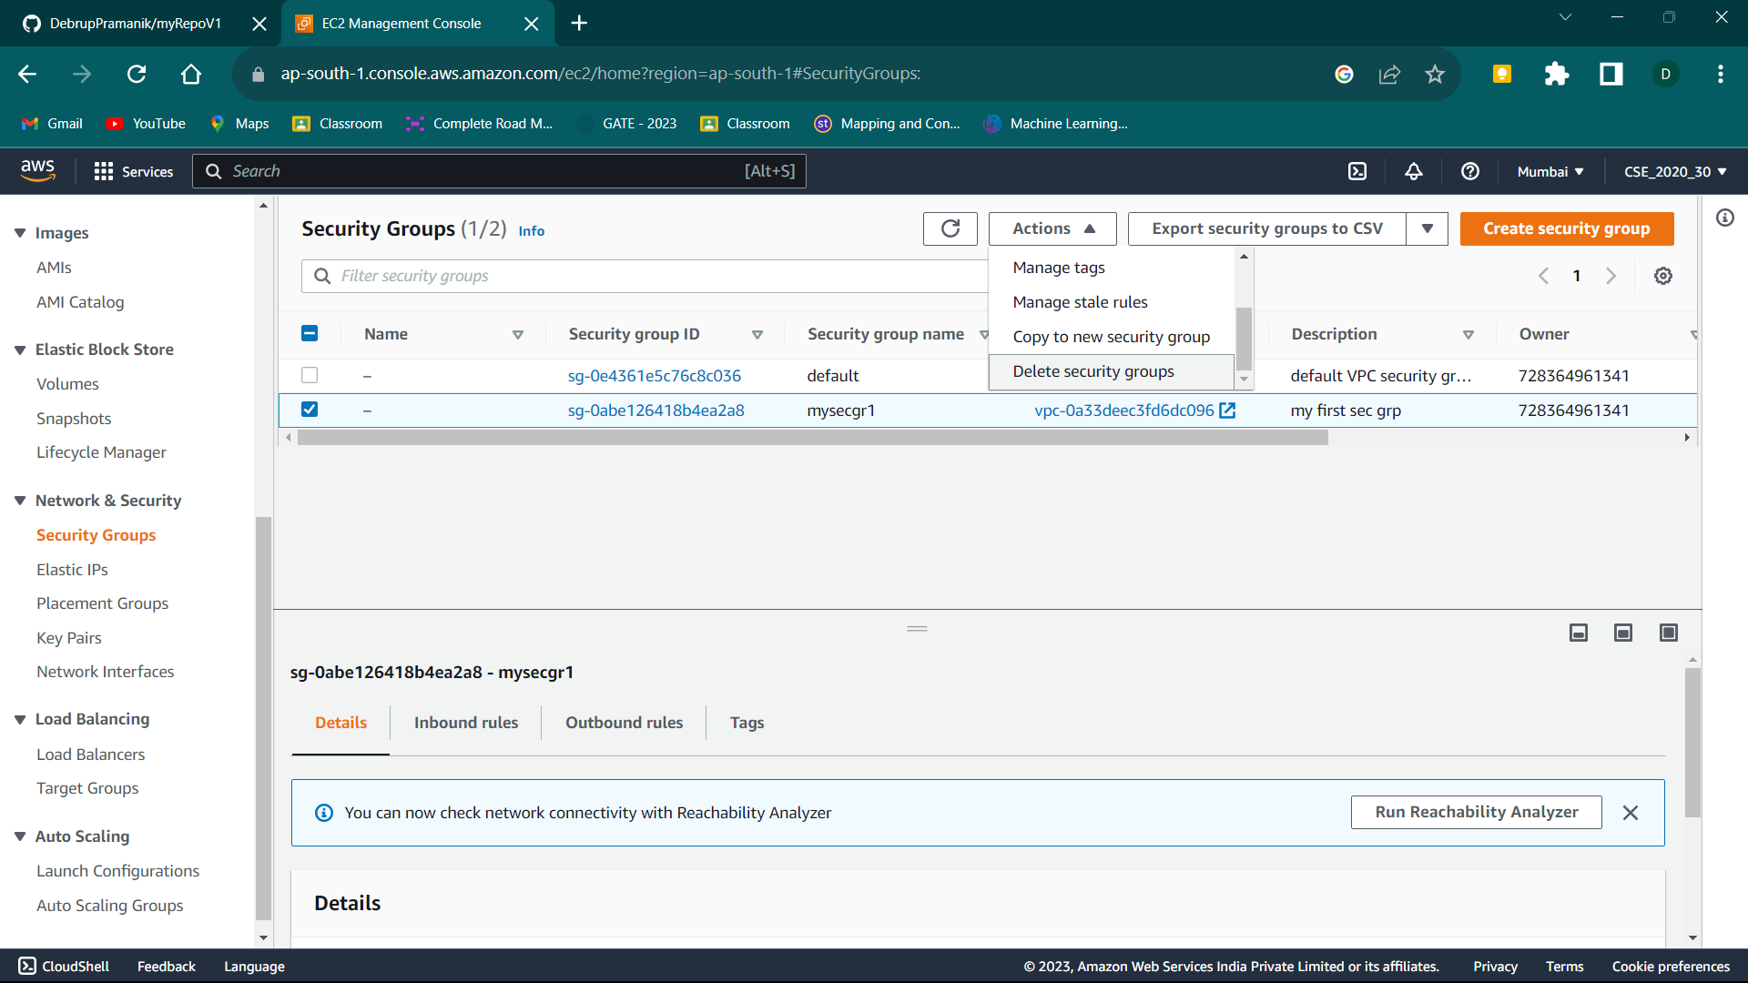

1. Scroll-Down the dropdown list until you find the “delete all security groups” option. Click on it.



1. Now only the “default” security group remains and we keep it that way.

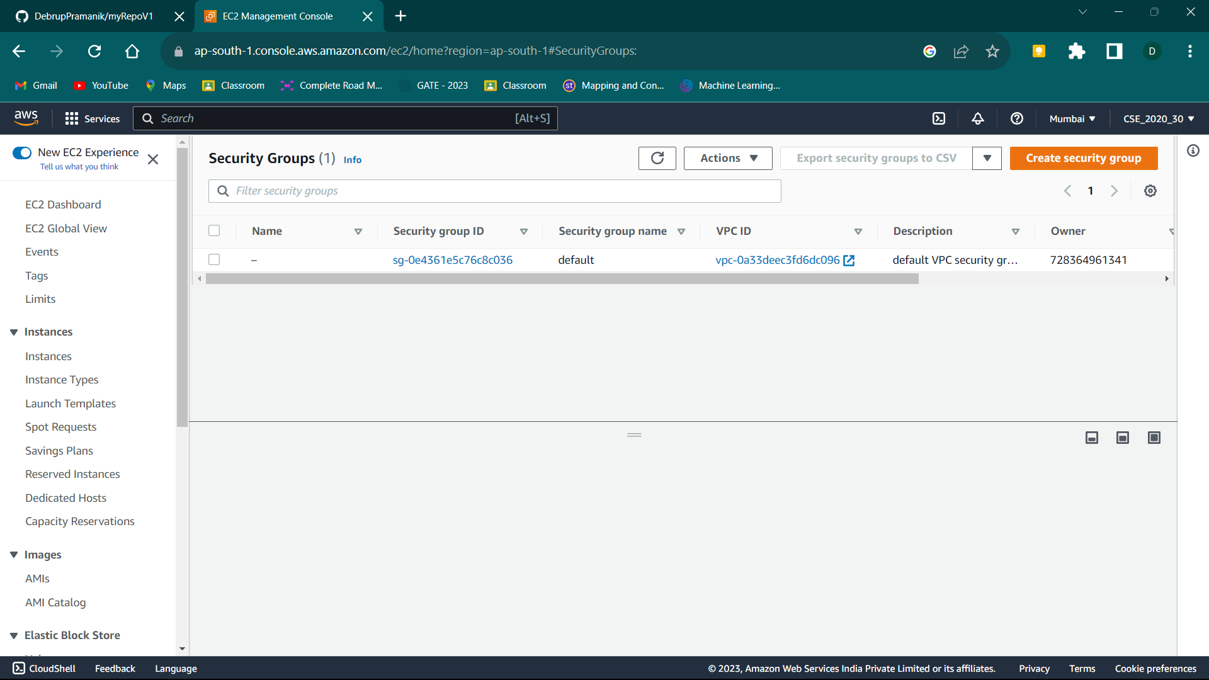

1. Now click on the “Create Security Group” button.

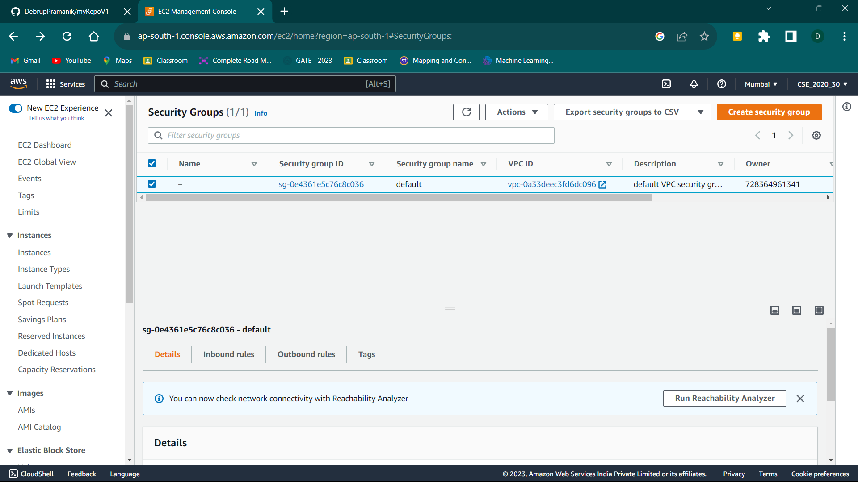

1. Now start by giving a name to the security group and giving its description (anything).

Let the VPC remain unchanged.

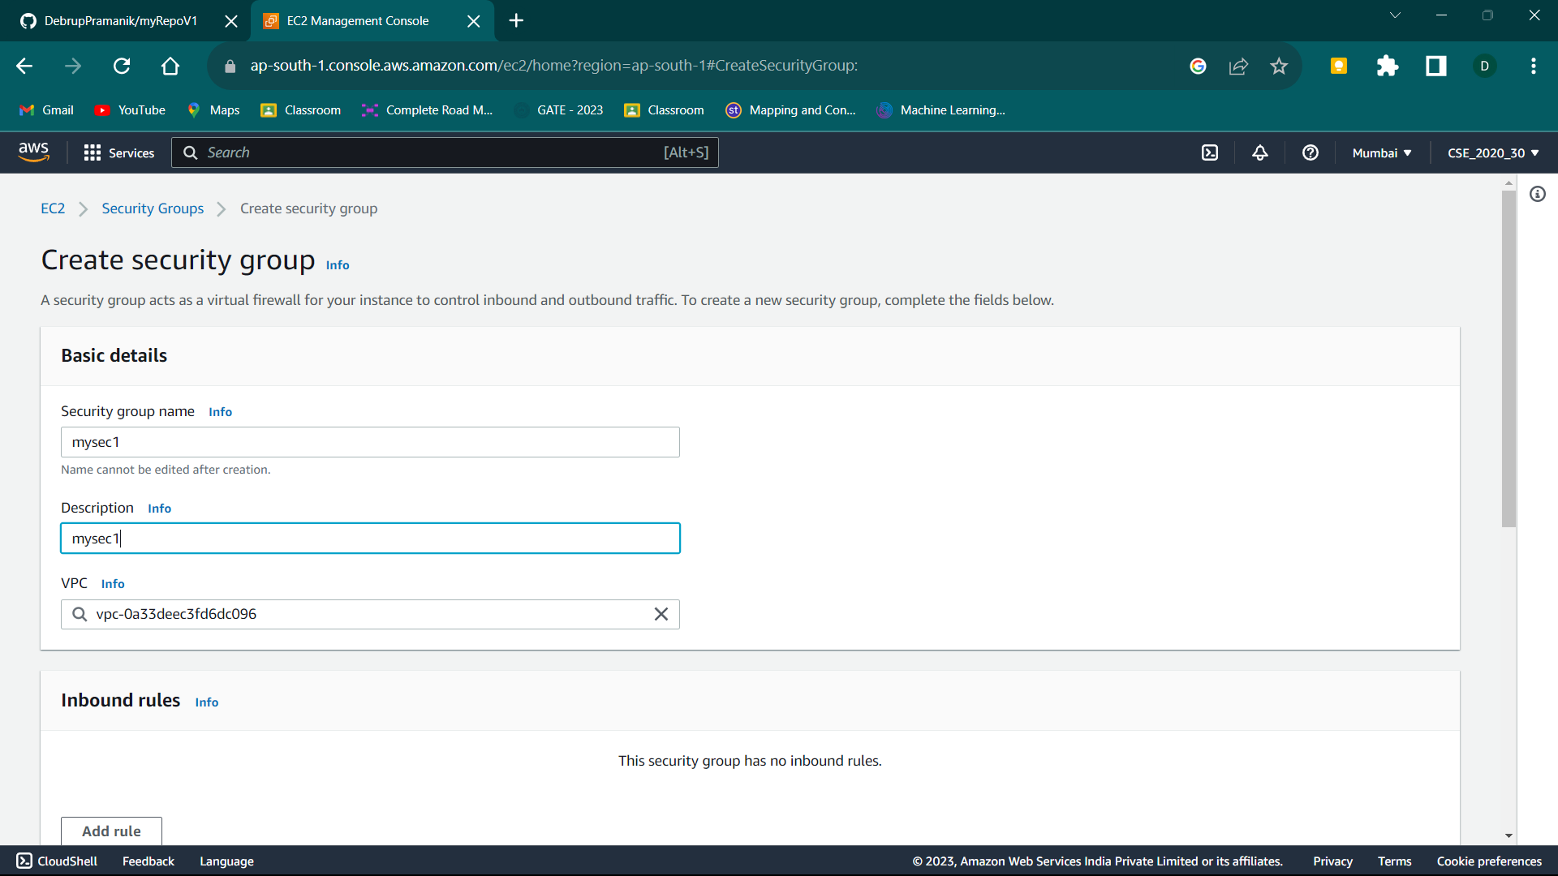

1. Next, we will add Inbound Rules. Start adding by clicking the Add rule button. These include:
2. SSH

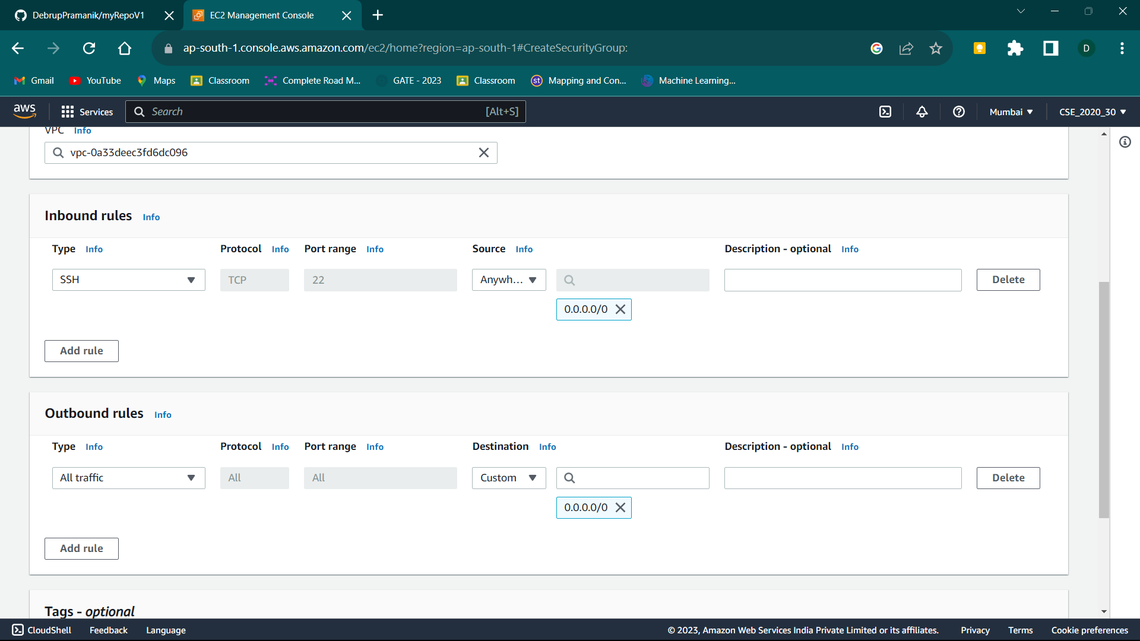

1. HTTP



1. HTTPS



1. Custom TCP



The last one with custom TCP has a specific port range that we require to connect to our project. It has been specified in our index.js file (refer Ass9).

Now the final Inbound Rules section should look like this.

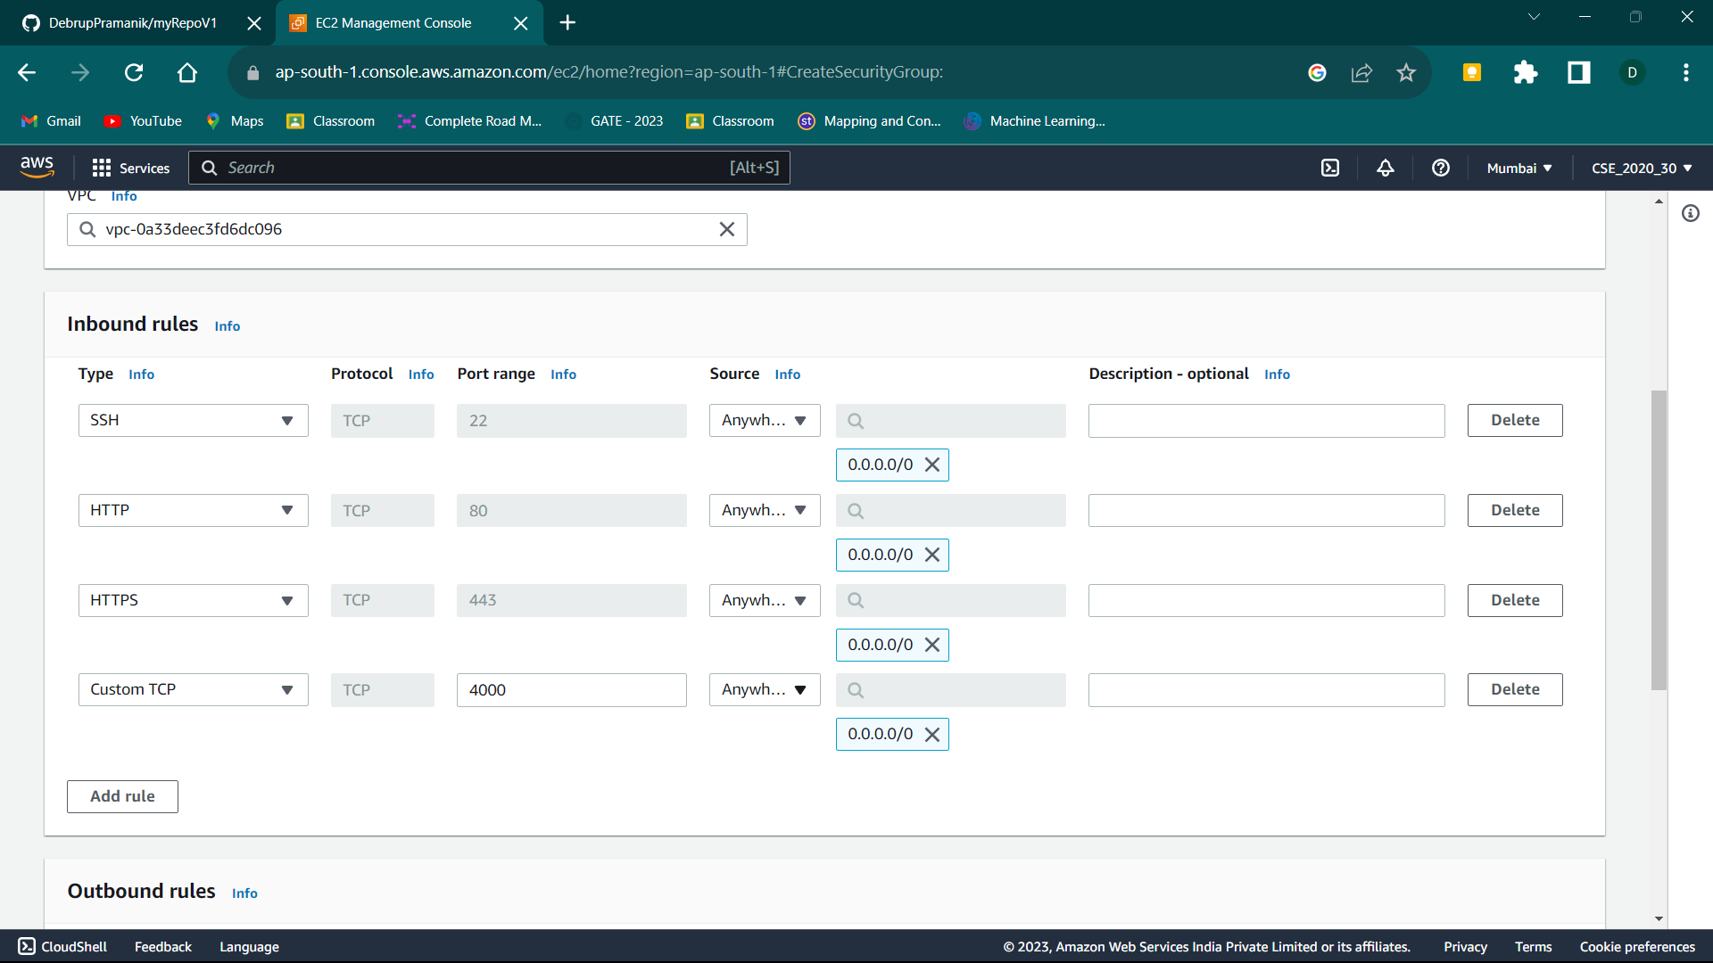

1. Next outbound rules and all other sections remain unchanged. Now Click on the create security group button.

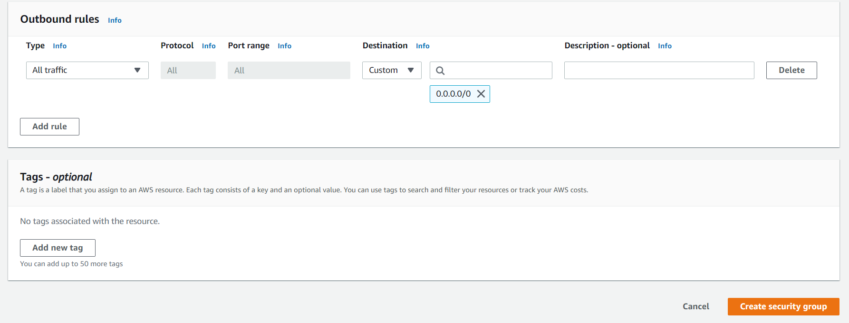

1. Now go back to the security groups list and click on the security group ID of the newly created Security Group.

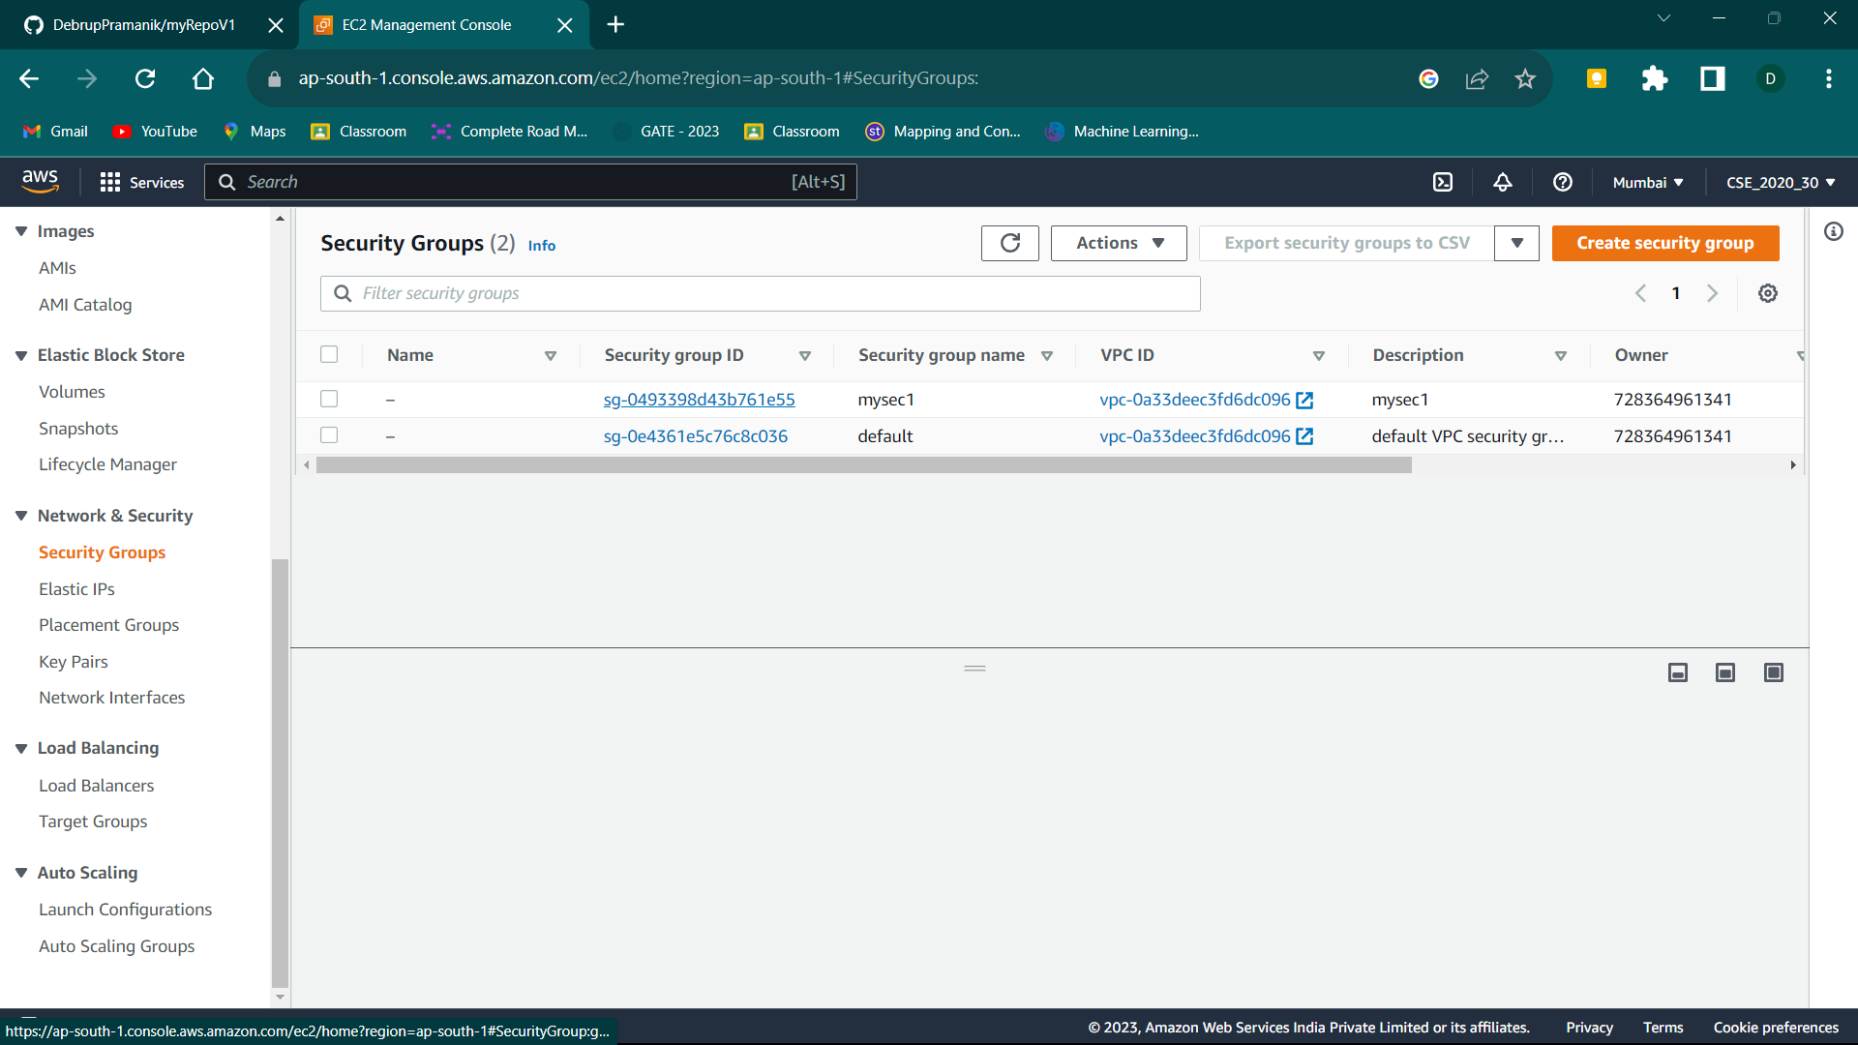

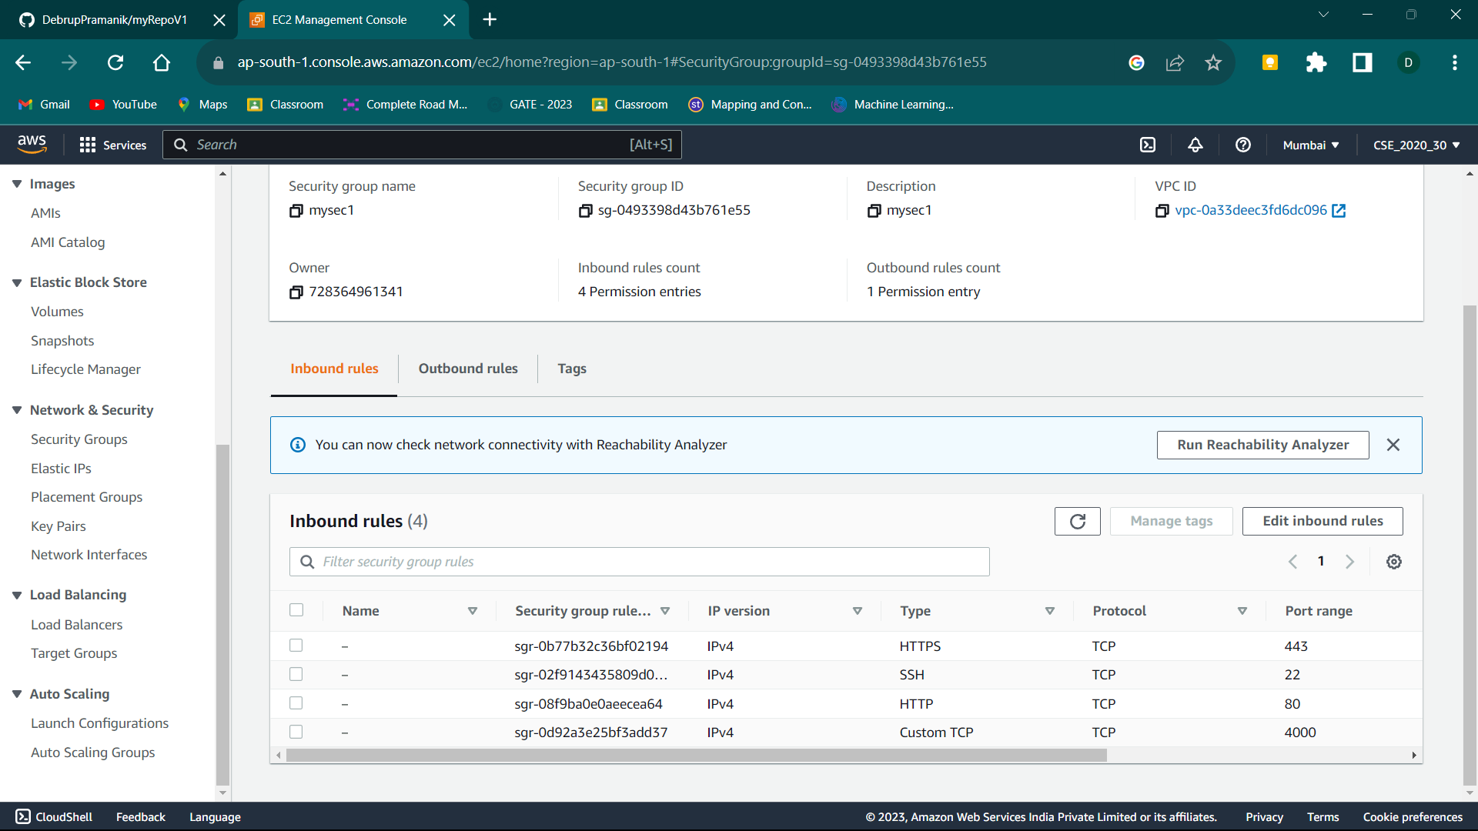

After clicking we can view the inbound rules that we added during its creation.

1. Now we go to the instances section from the left side nav bar.
2. Now we Create a new EC2 instance. Click on the Launch Instance button.

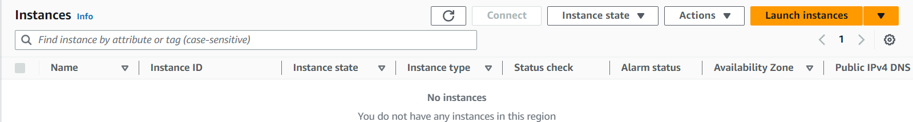

Now,

1. 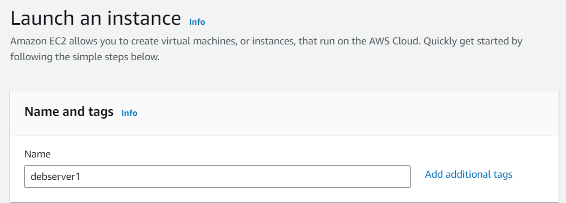Give the name, Select Ubuntu as OS, Select a keypair or generate a new one if none is available.

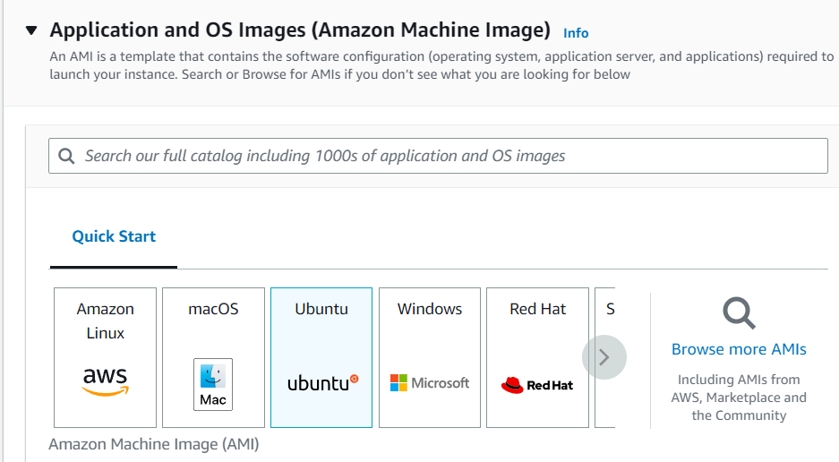

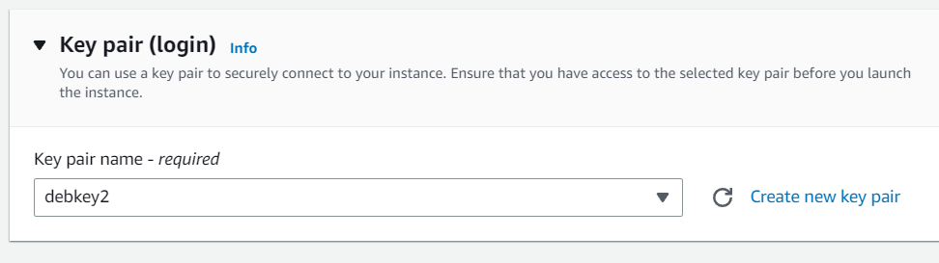

1. Then under Network settings select the Select Existing Security Group option.
2. Now under the security groups dropdown menu select the one we just created.

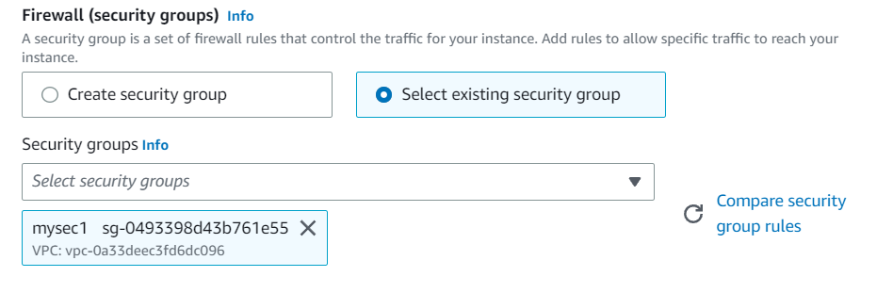

1. Now scroll down and click on the Advanced Details option.
2. Now again scroll-down to the newly appeared sub-sections until you find User Data section.
3. Write the following commands in the given box. Remember this user data is given to execute the given commands once the server starts. So essentially, we can provide all commands that we entered in our Assignment 9 previously and execute them without connecting to our server itself!! They will be executed sequentially.

* **#!/bin/bash**
* **apt-get update**
* **apt-get install -y nginx**
* **systemctl start nginx**
* **systemctl enable nginx**
* **apt-get install -y git**
* **curl -sL https://deb.nodesource.com/setup_18.x | sudo -E bash -**
* **apt-get install -y nodejs**

Now, here is a caveat. We have created a private repository in GitHub. So, whenever we run the git clone command it asks for our username and password. Hence this cannot be executed directly through our User Data instructions. We have to connect manually and enter all commands starting from the git clone command.

1. Now we click on the launch instance button.

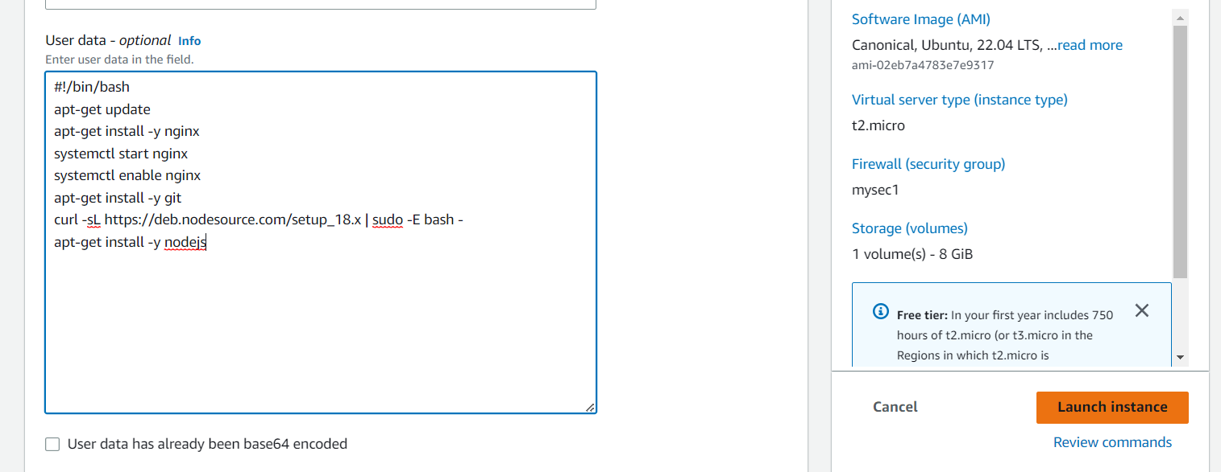

1. Now we Click on the ‘Instance Id’ link of our newly created server in our Instances list.

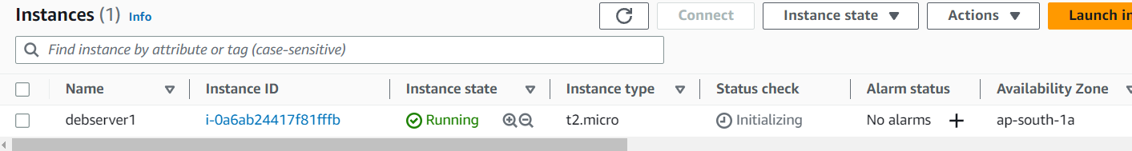

1. Now click on the connect button

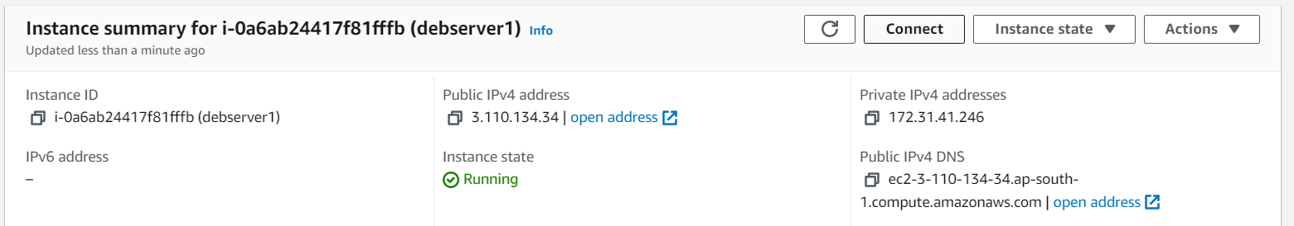

1. Again, click on the connect button

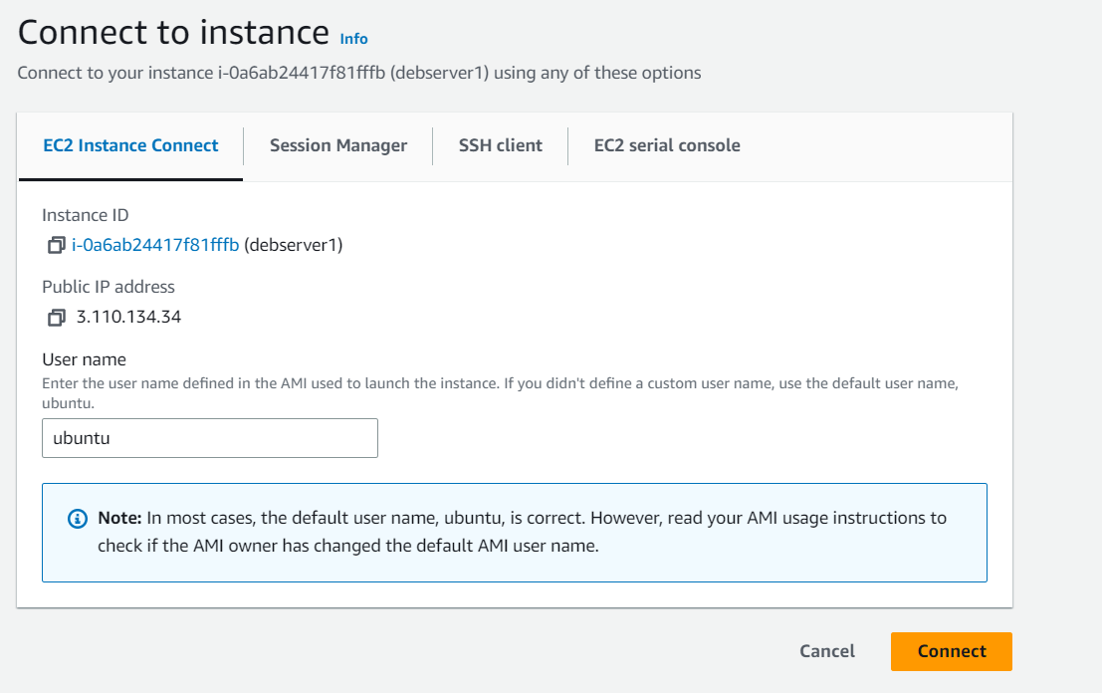

1. After this anew Tab will open with a Bash Terminal that is of our remote EC2 server!

Here we can type all our required commands that we used to type in a similar terminal by connecting to our remote server through our Bitvise SSH client software in our previous assignments.

1. Now copy and paste the Public IPv4 address of your EC2 instance in another browser.

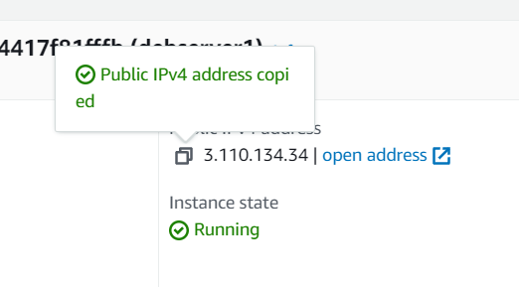

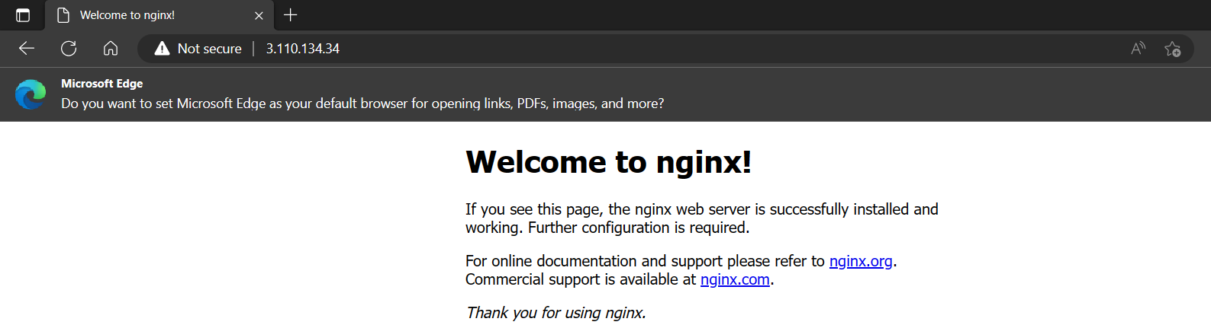

1. Now append the port no. 4000 (for our case) to the IP address in the browser with a “:” sign.



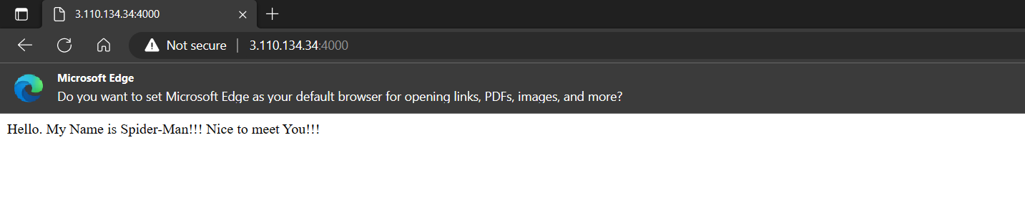

**We have successfully Deployed a project from GitHub to EC2 by creating a new Security group and User Data.**