
DEPARTMENT OF INFORMATION AND COMMUNICATION TECHNOLOGY, VEER NARMAND SOUTH GUJARAT UNIVERSITY, SURAT.
PROJECT TITLE
“ONLINE COSMETIC STORE ”
AS PARTIAL REQUIREMENT FOR THE DEGREE OF
MASTER OF SCIENCE IN INFORMATION AND COMMUNICATION TECHNOLOGY (MSC ICT)
2022-23
(SEMESTER – I)
GUIDED BY SUBMITED BY
PROF.DR.VEENA JOKHAKAR Ms. ISHIKA PAWAR
MR. SAGAR SEVAYKAR

Department of Information and Communication Technology M.Sc.(Information Technology) Programme

CERTIFICATE

This is to certify that MS.ISHIKA PAWAR & Mr SAGAR SEVAYKAR And Seat no.10038 & 10048 has Worked on a project entitled as “ONLINE COSMATIC STORE” as a partial fulfillment of requirement 1 st Semester - M.Sc. (Information and Communication Technology) [2 Year course], during the academic Year 2021-2022.

Date:- Head of the Department
Place:- Department of ICT
VNSGU

INDEX

CHAPTER NO | CHAPTER NAME | PAGE NO
1. | Project Profile | 1
2. | Environment Description | 3
2. | 2.1 Hardware & Software Requirements
3. | Project Management | 6
3. | 3.1 Project purpose
3. | 3.2 project scope
3. | 3.3 Project objective
3. | 3.4 Technology use
4. | Data Dictionary | 11
5. | Task Dependency | 18
6. | System Analysis | 19
6. | 6.1 ER Diagram
6. | 6.2.1 Use Case Diagram
6. | 6.2.2 Activity Diagram
6. | 6.2.3 Dfd Diagram
7. | Interface Design | 27
8. | Testing | 42
9. | Software Limitation | 47
10. | Reference | 49

No index entries found

VM

PROJECT PROFILE

PROJECT PROFILE

Project Title: | ONLINE COSMATIC STORE
Front-End | JSF, Prime Faces
Back-End | JAVA EE, MySQL 5.7.16
Development Tools | Net beans-13, MySQL 5.7.16
Internal Guide: | Prof. Dr.Veena Jokhakar
Time Duration: | 6 Months
Submitted By: | Ms. ISHIKA PAWAR & Mr Sagar Sevaykar
Submit To: | DEPARTMENT OF INFORMATION AND COMMUNICATION TECHNOLOGY

ENVIRONMENT DESCRIPTION

Hardware And Software Requirements:

- Hardware Requirement: -

RAM | 12.0 GB
Processor | 11th Gen Intel(R) Core (TM) i7-1165G7 @ 2.80GHz 1.69 GHz
Hard Disk | 40 GB
Input Device | Key board, Mouse
Output Device | Monitor Screen

- Software Requirement: -

- Server-side software: -

Operating System | Windows 7, Windows 8, Windows 10  Windows 11.
Server | Payara Server
Development(editor) | Integrated Development Environment (IDE) Net Beans 13  JDK (Java Development Kit) Web
Front-End | JSF, Prime Faces
Back-End | Java EE, MySQL 5.7.16
Language | Java Programming Language

- Client-Side Software:

Operating System | Any
Supported Browser | Google Chrome (Recommended), you can use any latest browser that supporting HTML/XHTML.

PROJECT MANAGEMENT

Project purpose

Project scope
Project objective
-
- Administrator managing a particular task of website for a particular time and manage all functionality of the website.
- Service Provider Provide their services which are approved by administrator.
- Without login Visitors can’t be a member of the website, but he/she can be visit website.
- Do inquiry about place provide by our website for user.
- Administrator handles registered provider, user and other related details regarding this site.
- Service provider can manage information details given by user.
- Users allowed for online retrieve information about place also they can.
- Administrator provides Email sending facility and Report facility.
- Service provider can also view, add, delete and update the product details.
- User can also able to give feedback of providing services.

The main objective and purpose of our website is to provide better and efficient way to communicate with service provider and user. And also increase business of service provider on the local plate-form.

TECHNOLOGY USE

Technology Used
- Java
- Why do I need Java?
- There are lots of application and websites that won’t work unless you have java installed, and more are created every day.
- java is fast, secure and reliable.
- From laptops to datacenters, game consoles to scientific super computers, cell phones to the internet, java is everywhere!

- Overview of EJB
- The introduction of the enterprise java Bens 3,0 specification is a giant step forwards and will go a long way towards luring developers back to EJBS,
- The goal of the specification is twofold
  - Make it easier for developers to develop EJB,
  - Standardize the persistence framework.
- EJB 3.0 brings us closer to the dream of treating enterprise bens like regular javabens.
- It decreases the number of programming artifacts for developers to provide, eliminates or minimizes callback methods required to be implemented, and reduces the complexity of the entity bean programming model and Q/R mapping model.
- With EJB 3.0,J2EE now seems accessible to a much wider audience. EJB 3.0 address the encapsulation of environmental dependencies and JNDI access through the use of annotations, dependency injection mechanism, and simple look-up mechanisms 78.

- Introduction to java 2 Enterprise Edition
- The Java EE stands for Java Enterprise Edition, which was earlier known as J2EE and is currently known as Jakarta EE. It is a set of specifications wrapping around Java SE (Standard Edition).
- The Java EE provides a platform for developers with enterprise features such as distributed computing and web services.
- Java EE applications are usually run-on reference run times such as micro servers or application servers. Examples of some contexts where Java EE is used are e-commerce, counting, banking information systems.

- The Enterprise Java Blue Prints for the J2EE platform describe the J2EE application model and best practices for using the J2EE platform. Building on the J2SE platform, the J2EE application model provides a simplified approach to developing highly scalable and highly available internet or intranet-based applications.

- Services need to be: -
  - Highly available, to meet the needs of today’s global business environment.
  - Secure, to protect the privacy of users and the integrity of enterprise data.
  - Reliable and scalable, to insure that business transaction are accurately and promptly processed.

  - The J2EE application model defines architecture for implementing services as muti-tier application that avoid their problems and deliver the scalability, accessibility and manageability that is needs.

- MYSQL database: -
The MYSQL pluggable storage engine architecture enables a database professional to select a specialized storage engine for a particular application need while a being completely shielded from the need to manage any specific application coding requirements. The MYSQL server architecture isolates the application programmer and DBA from all the low-level implementation details at the storage level, providing a consistent and easy application model and API. Thus, there are different capabilities across different storage engines; the application is shielded from these differences.



Features of MYSQL

Scalability and flexibility
- The MYSQL database server provides the ultimate in scalability, sporting the capacity to handle deeply embedded application with a footprint of only 1 MB to running massive data warehouse hokling terabytes of information.

High performance
- A unique storage engine architecture allows database professionals to configure the MYSQL database server specifically for particular application, with the end result being amazing performance result.

High availability
- MYSQL is a variety of high-availability options from high-speed master/slave replication configurations, to specialized cluster servers offering instant failover, to third party vendors

- offering unique high- availability solutions for the MYSQL database server.

Robust transactional support
- MYSQL offers one of the most powerful transactional database engines on the market. Features include complete ACID (atomic, consistent, isolated, durable) transaction capability, and multi-version transaction support where readers never block writers and vice-versa.

ER-DIAGRAM

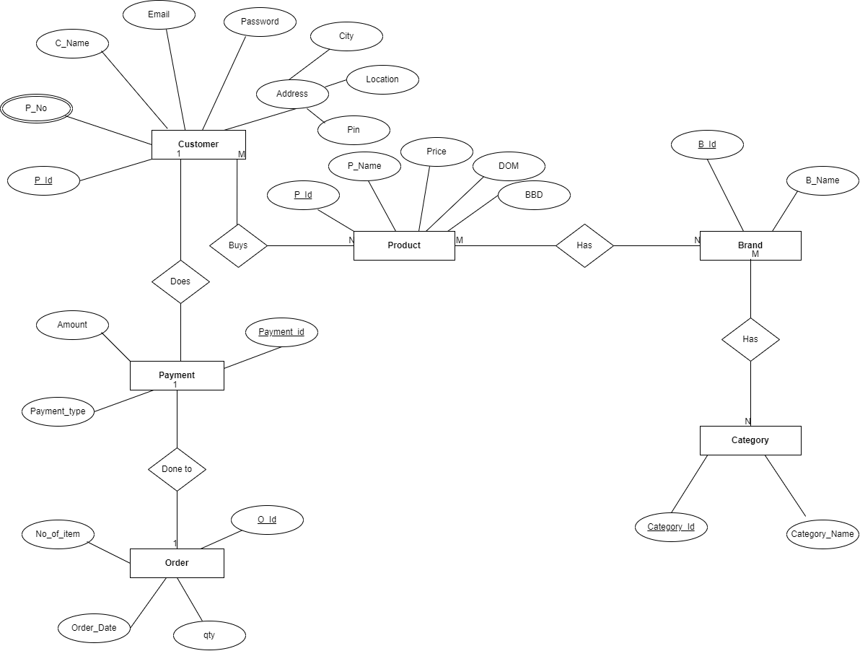

USECASE
DIAGRAM

- Use-case USER ADMIN
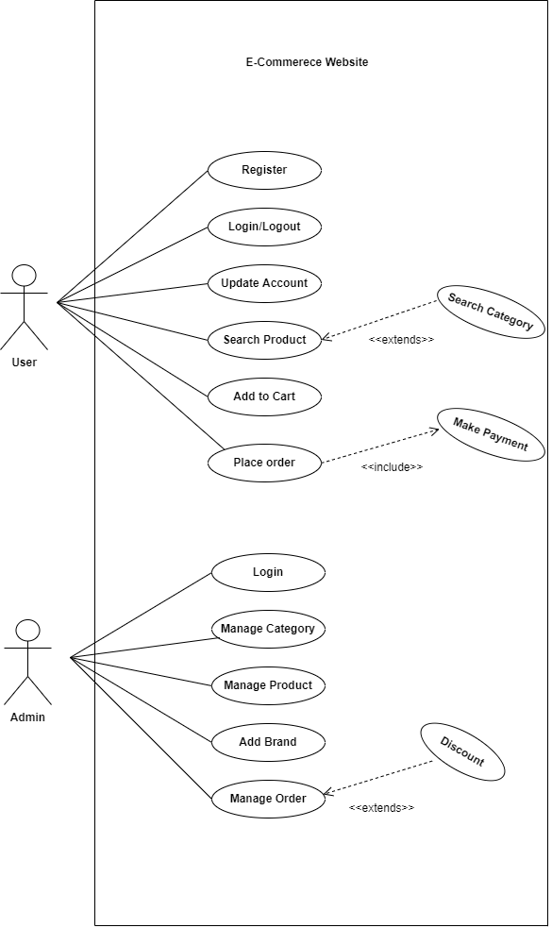

ACTIVITY
DIAGRAM

- Activity-diagram ADMIN

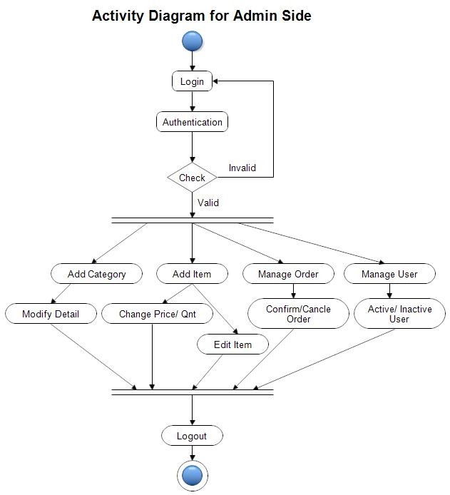

- Activity-diagram USER
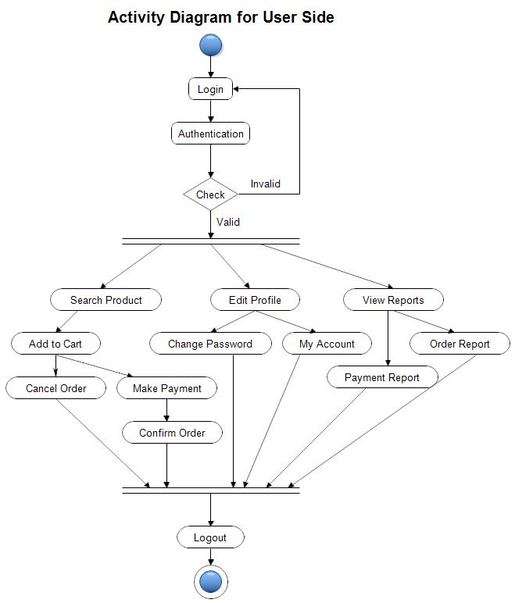

DFD
DIAGRAM

- 0st level DFD

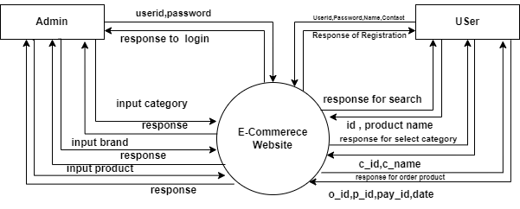

- 1st level for ADMIN
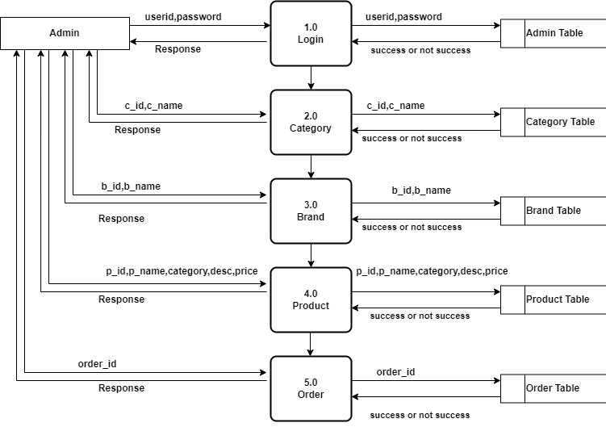

- 1st level for USER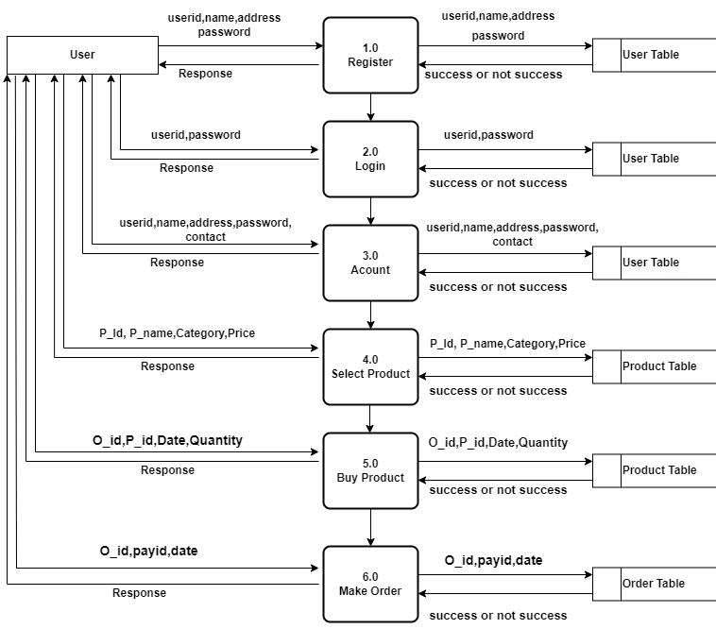

DATA
DICTIONARY

1.Table Users
Primary key : User_id
Field Name | Data Type | Field Size | Constraints
Uid | Int(AUTO_INCREMENT) | 10 | Primary key
Username | varchar |  | -
Email | Varchar |  | Unique key
Mobile_number | Varchar |  | -
Address | Text | - | -
City | V |  | -
State | Varchar |  | -
Pincode | Varchar |  | -
Password | Varchar |  | -
Confirm password | Varchar |  | -
Date | Datetime | - | -
Usertype | varchar | 30 | -

2.Table Category
Primary key : Category_id
Field Name | Data Type | Field Size | Constraints
Cid | Int(AUTO_INCREMENT) | 11 | Primary key
Category | Varchar |  | -

3.Table BRAND
Primary key : B_id
Field Name | Data Type | Field Size | Constraints
Bid | Int(AUTO_INCREMENT) | 11 | Primary key
Brand | Varchar |  | -

3.Table Item
Primary key : Item_id
Foreign key : Category _id
Field Name | Data Type | Field Size | Constraints
Pid | Int(AUTO_INCREMENT) | 10 | Primary key
Category | Varchar |  | -
Product_name | Varchar |  | -
Brand | Varchar |  | -
Mrp | Decimal | (10,0) | -
Selling_price | Decimal | (10,0) | -
Qty | Int | 10 | -
Images | Varchar |  | -
Title | Varchar |  | -
Description | longtext | - | -
Ingredients | longtext | - | -
Howto | text | - | -
Status | varchar |  | -

5.Table Order
Primary key : Order_id

Field Name | Data Type | Field Size | Constraints
Order_id | Int(AUTO_INCREMENT) | 11 | -
Pid | int | 11 | -
Pname | Varchar |  | -
Qty | Int | 11 | -
Price | Int | 11 | -
Total_price | Int | 11 | -
Date | Datetime | - | -
Status | Varchar |  | -

SCREENSHOTS

home page


product page
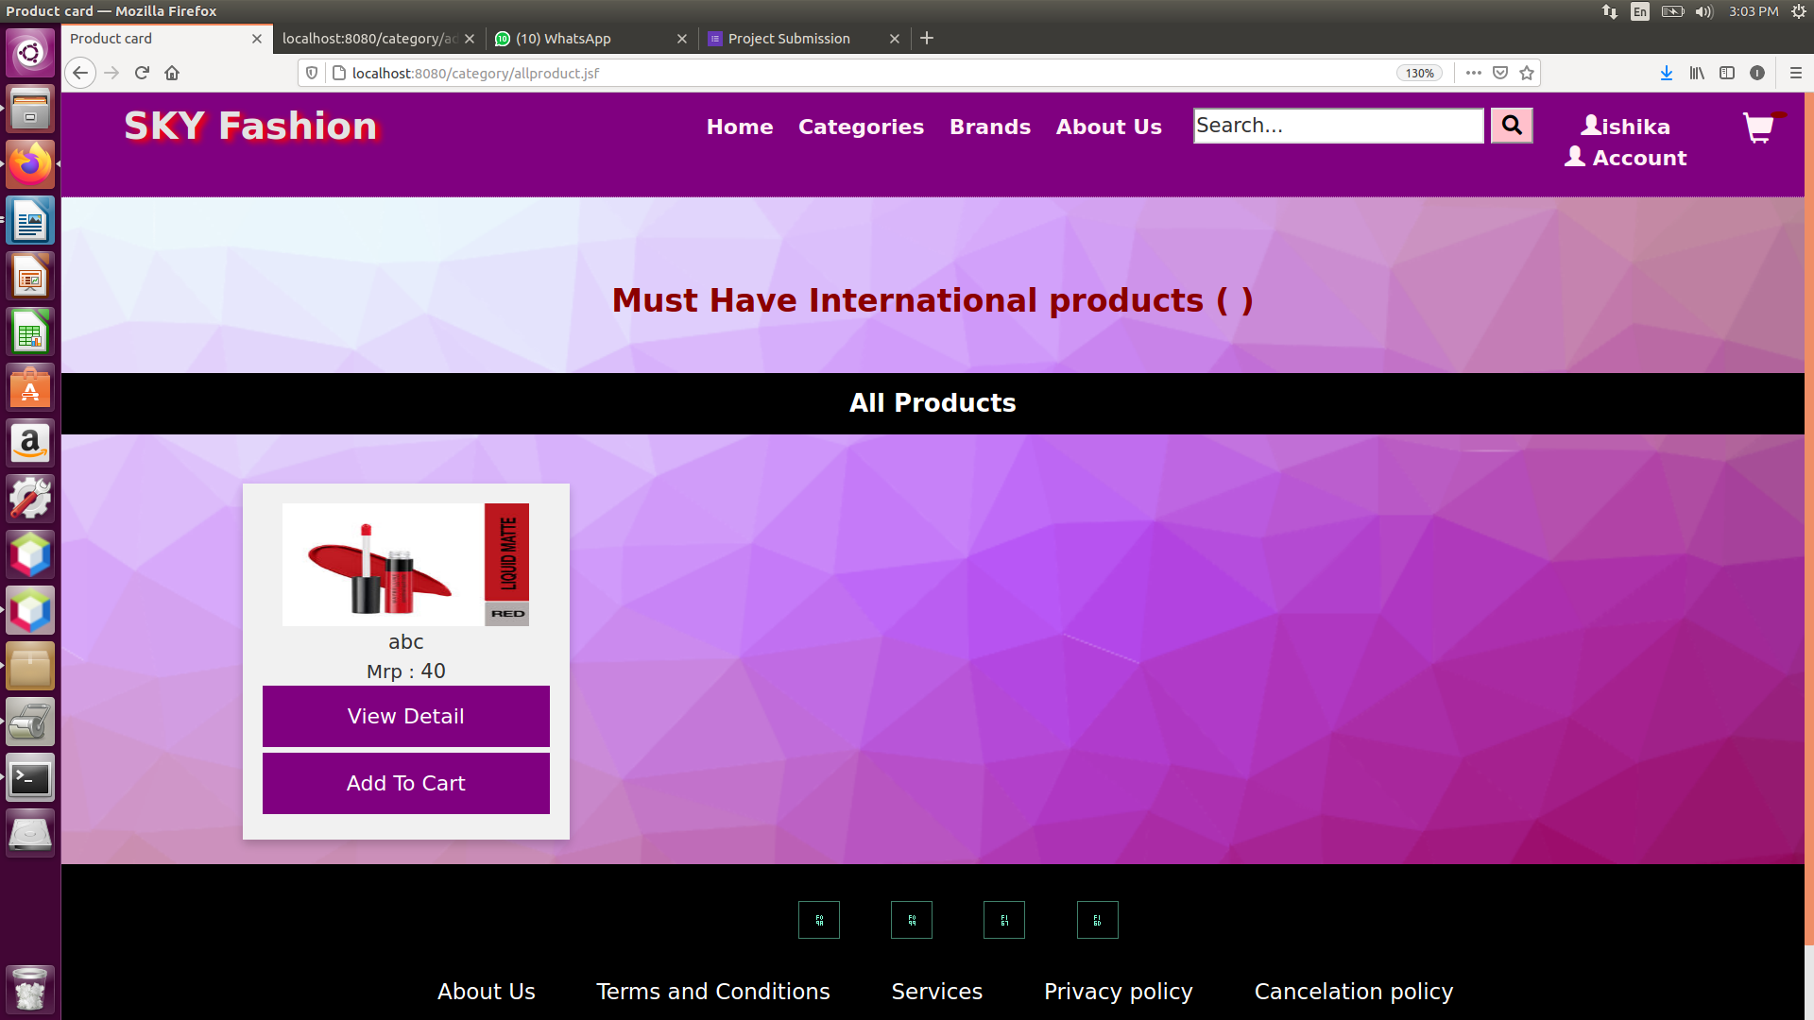

REFERENCE

admin
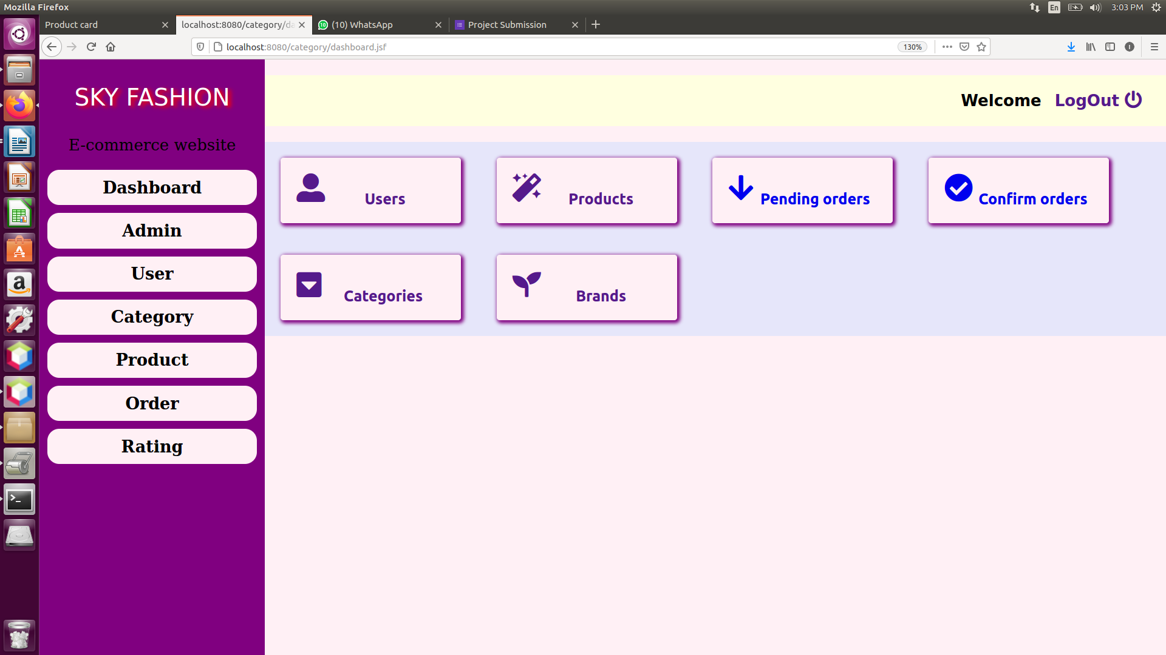

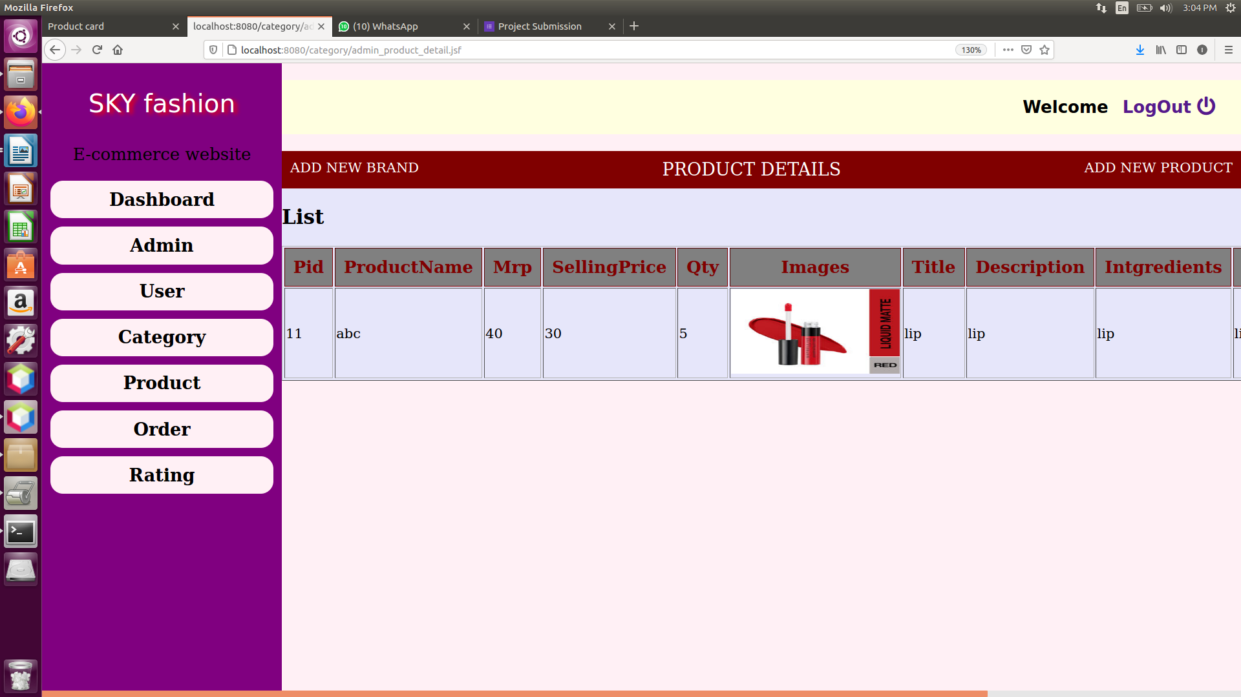

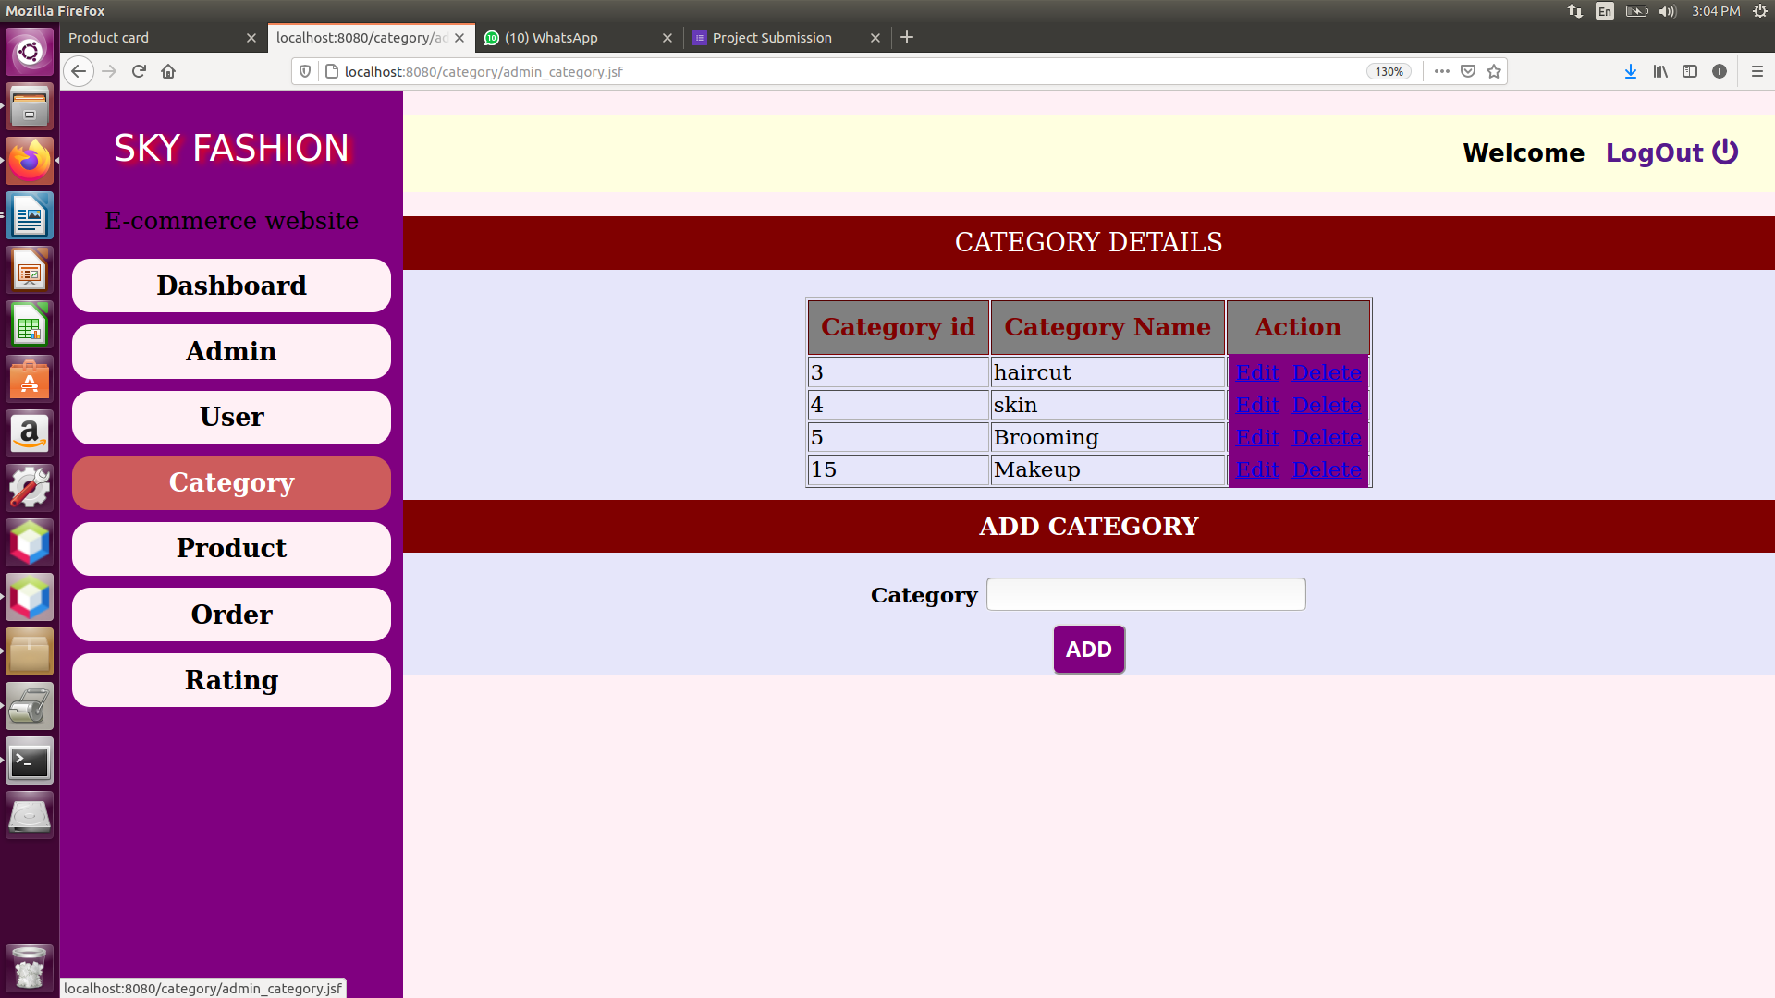

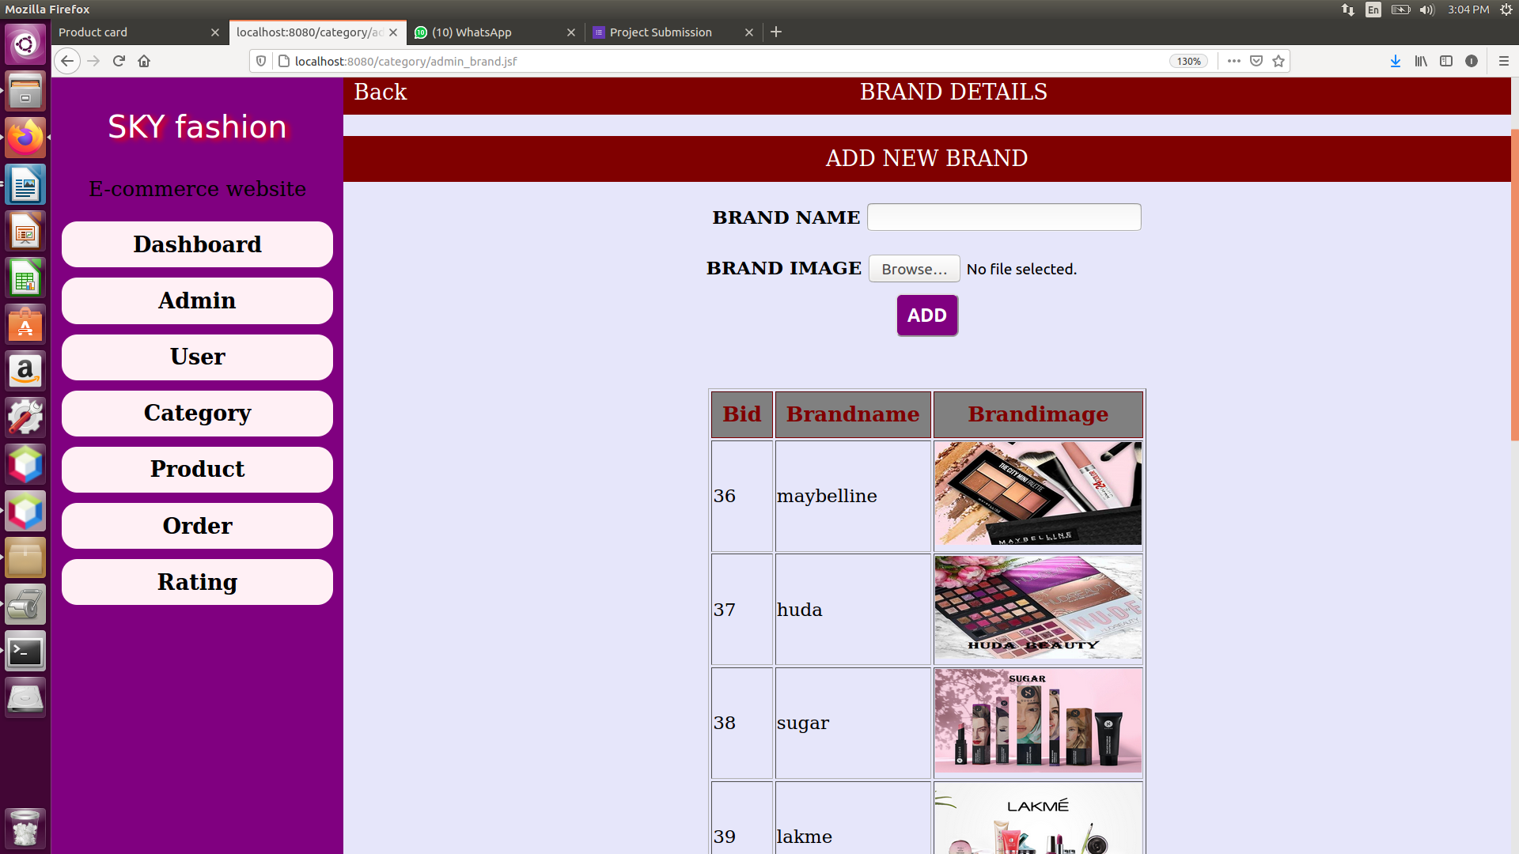

11.Reference
- https://www.tutorialspoint.com/php/index.html
- https://www.primefaces.org/showcase/index.xhtml
- https://youtu.be/rkxN-v6JOdw
- https://www.guru99.com/what-is-spiral-model
- https://www.olacabs.com/
- https://getbootstrap.com/
- https://www.justdial.com/

