PROJECT OF MYSQL

~ Building a Rule-Based Fraud Detection System in SQL
AIM : Data Analytics & Financial Security
1. Introduction
In the modern fintech landscape, detecting fraudulent activity in real-time is critical for protecting user assets. This article explores a rule-based approach to identifying suspicious transactions using SQL. We will define common "Red Flags"—such as high transaction amounts, rapid-fire spending, and geographical inconsistencies—and implement them through structured queries.

2. Database Schema and Environment Setup
The foundation of our analysis is the MONEY database. We utilize a TRANSACTIONS table that tracks user IDs, amounts, timestamps, locations, and merchants.
SQL Setup Code
The following script initializes our environment and populates it with sample data designed to trigger our fraud rules.
SQL
CREATE DATABASE MONEY;
USE MONEY;
-- Table creation and data insertion logic
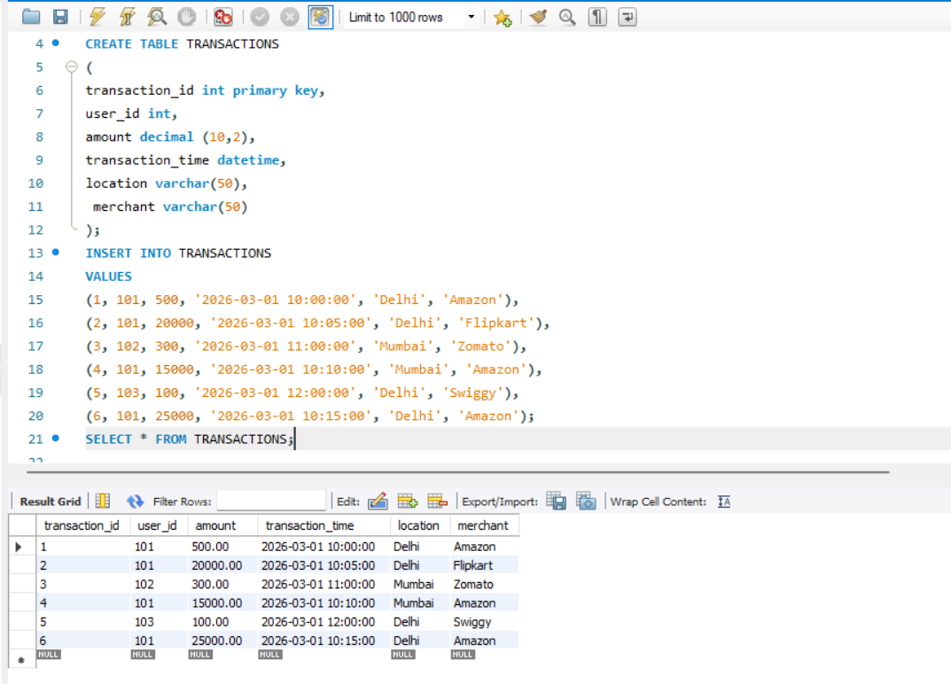
3. Defining the Fraud Detection Rules
Rule 1: High-Value Transaction Detection
Large transfers are often the first sign of a compromised account. We flag any transaction exceeding 10,000 units.
- Analysis: This is a simple threshold filter. In our dataset, User 101 triggered this multiple times with amounts of 20,000 and 25,000.
Rule 2: Velocity Checking (Time-Series Analysis)
Fraudsters often "drain" accounts by performing multiple transactions in a very short window.
- Query Logic: We group by USER_ID and filter for counts greater than 2 within a 15-minute window.
- Analysis: User 101 shows a high velocity of transactions between 10:00 AM and 10:15 AM.
Rule 3: Geographical Mismatch (Location Hopping)
If a user transacts in Delhi and Mumbai within the same hour, it suggests either a shared account or a stolen card (unless the user is a very fast traveler!).
- Analysis: Using COUNT(DISTINCT LOCATION), we identify users operating from multiple cities.
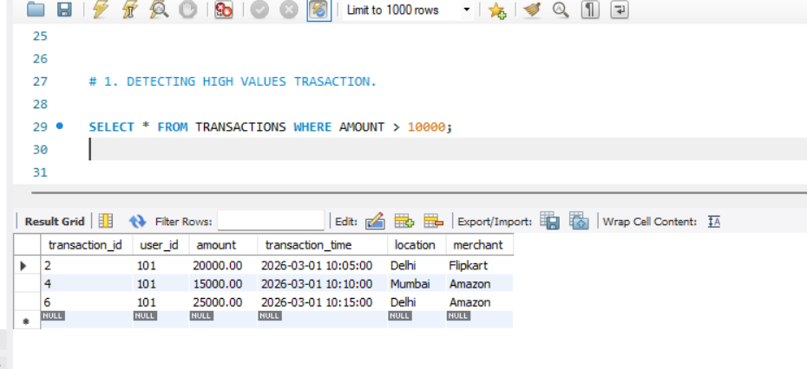
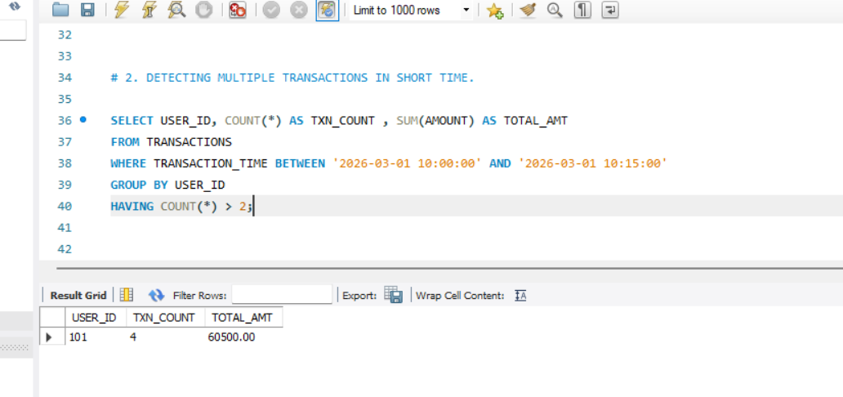

4. Advanced Analytics: The "Fraud Flag" Logic
To make the data actionable for a security team, we consolidate these rules into a single report using a CASE statement. This creates a labeled status for every transaction.
Comprehensive Fraud Analysis Query
SQL
SELECT *,
CASE
WHEN AMOUNT > 10000 THEN 'HIGH AMOUNT FRAUD'
WHEN USER_ID IN (...) THEN 'TOO MANY TRANSACTIONS'
WHEN USER_ID IN (...) THEN 'LOCATION MISMATCH'
ELSE 'NORMAL'
END AS FRAUD_STATUS
FROM TRANSACTIONS;

5. Analytical Summary & Findings
User ID | Detected Issue | Risk Level
101 | High Amount, Location Mismatch, High Frequency | Critical
102 | Single Location, Low Amount | Low/Normal
103 | Single Location, Low Amount | Low/Normal
Key Takeaways:
- User 101 Analysis: This user is the primary anomaly. They transacted in both Delhi and Mumbai within minutes, while also moving large sums of money. This behavior is a textbook example of a "High-Risk" profile.
- Scalability: While rule-based systems are effective for known patterns, they can be bypassed by "low and slow" fraud.
- Optimization: Using Window Functions (as seen in Query 4) allows the system to analyze patterns without losing the granularity of individual transaction rows.

6. Conclusion
By implementing these SQL rules, we can transform raw logs into a proactive security tool. This system allows financial institutions to flag or even block suspicious transactions before the funds are permanently cleared.
