ASSIGNMENT 2
Cloud Storage Implementation (Amazon S3)
Objective:
To set up a scalable object storage bucket and host a public resource.
Key Steps (Attach screenshots below each step):
- Bucket Creation:
Create a bucket named aws-ishuu-choudhary-01 in the "Europe (Stockholm)" region.
- Permissions Management:
Disable "Block All Public Access" to allow the bucket to be publicly accessible.
- Policy Generation:
Use the AWS Policy Generator to create a JSON bucket policy for granting access permissions.
- File Upload & Hosting:
Upload the ER Diagram image and access it using its public Object URL.

Step 1: General Configuration
Go to the Amazon S3 dashboard and click on the orange "Create bucket" button to create a storage bucket.
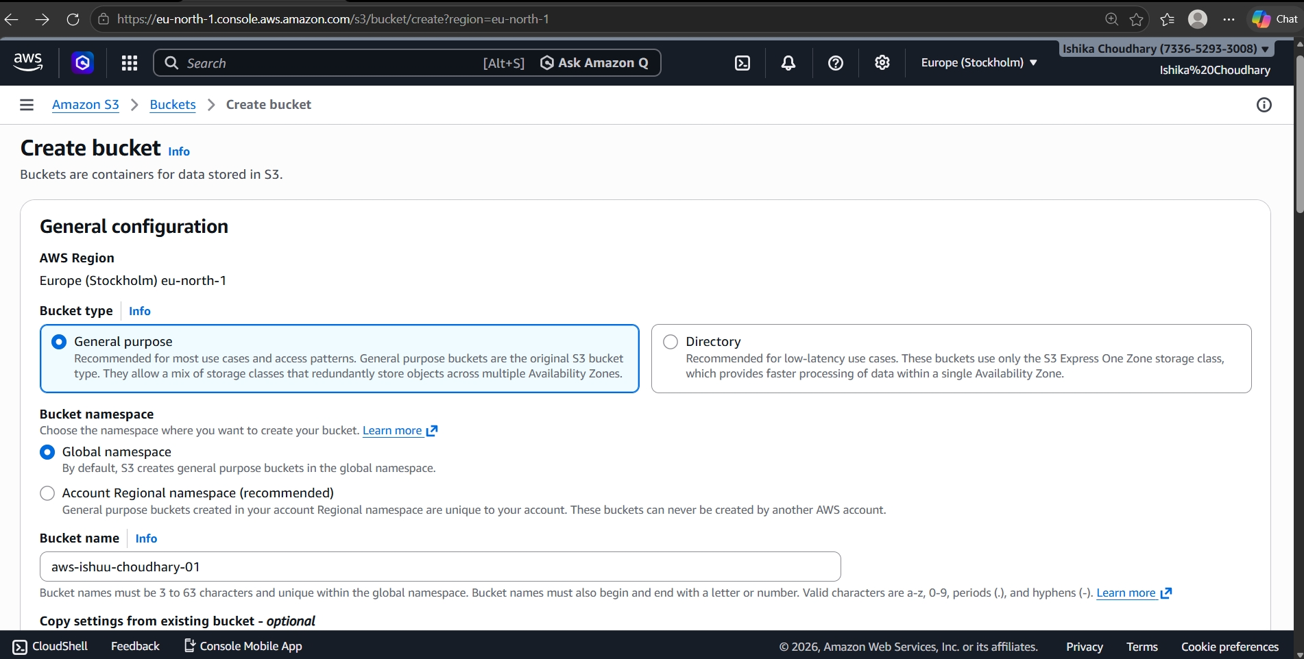

Step 2: Object Ownership

Enable ACLs option in object creation to give access to the object publicly.
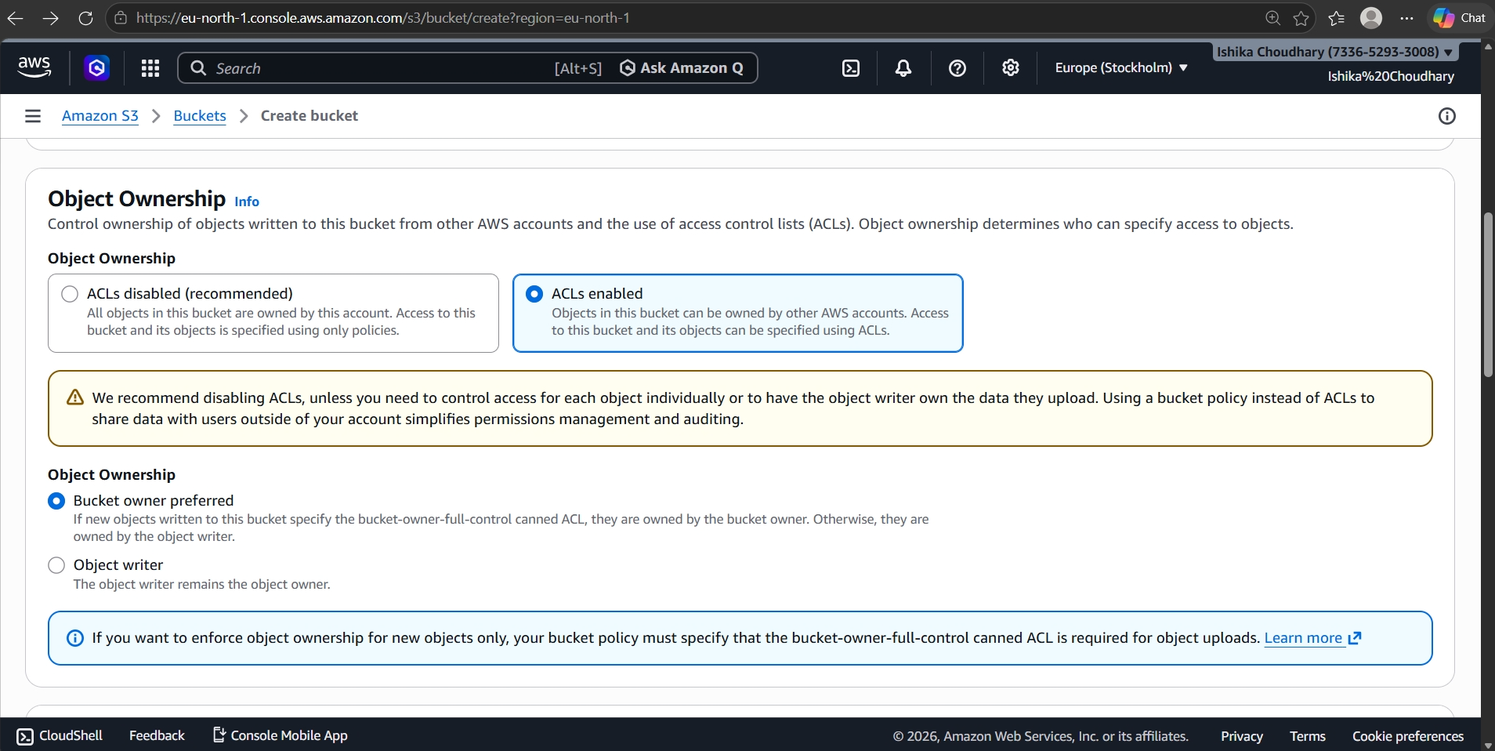

Step 2: Public Access Settings

The user unchecking "Block all public access." This choice is made to allow the bucket to be publicly accessible, and the user has checked the acknowledgment box to confirm they understand the security risks.
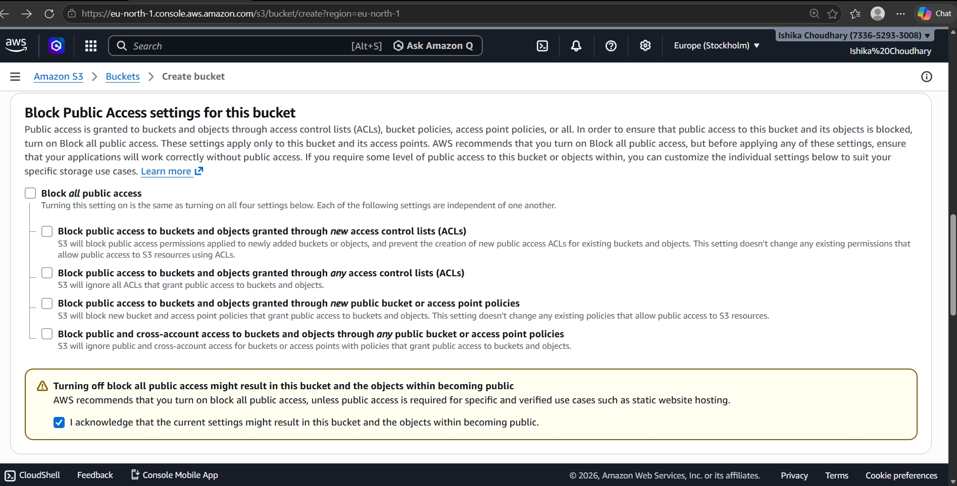

Step 3: Encryption Settings

The Default encryption settings. The user has selected "Server-side encryption with Amazon S3 managed keys (SSE-S3)" and has enabled the "Bucket Key" to reduce encryption costs.
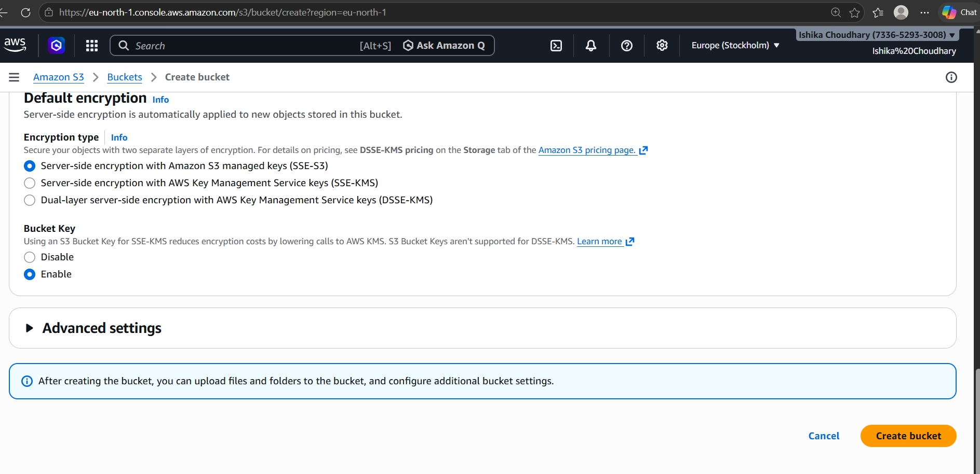

Step 4: Bucket Successfully Created

The green success banner stating "Successfully created bucket 'aws-s3-ranjeet'." It takes the user to the bucket's "Objects" tab, which is currently empty.
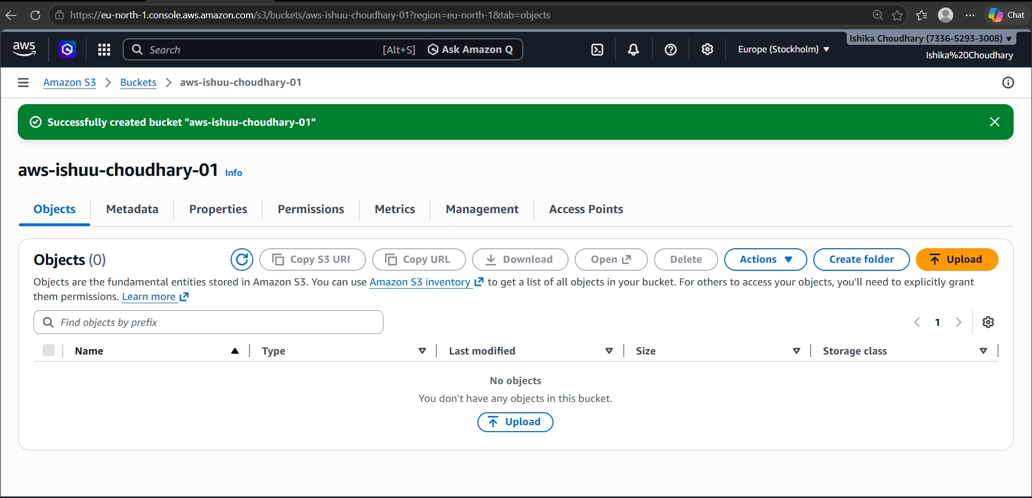

Step 5: Policy JSON Generation

The Policy JSON Document generated by the tool. It contains the code that grants public "Allow" permissions for the specific object practise.sql within your bucket.

Step 6: Editing Bucket Policy

In you have navigated back to the S3 Console under the "Permissions" tab. You are pasting the generated JSON code into the Bucket policy editor to apply the security rules.

Step 7: Policy Successfully Applied

A green success banner appears saying "Successfully edited bucket policy." This confirms that the permissions are now active and the file is ready to be accessed via its public link.
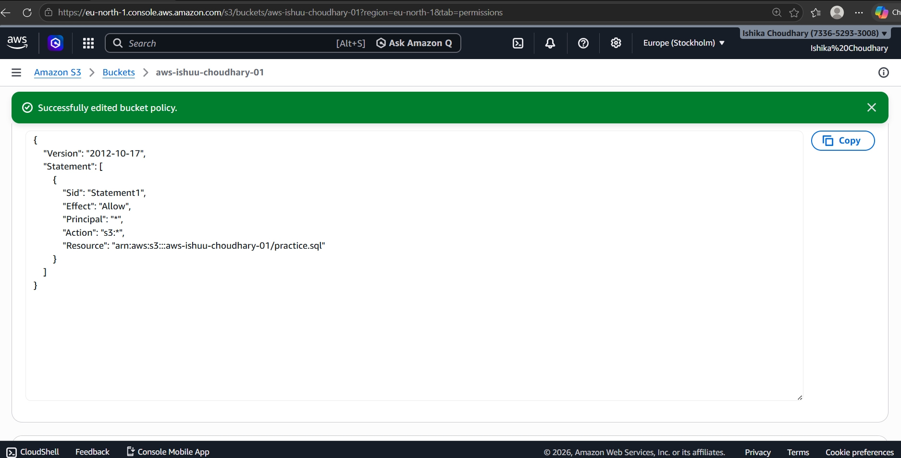

Step 8: Policy Successfully Applied

A green success banner appears saying "Successfully edited bucket policy." This confirms that the permissions are now active and the file is ready to be accessed via its public link.
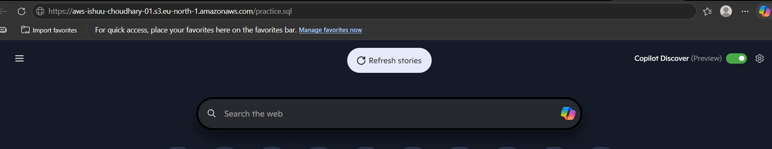

Step 9: Final Result

The final successfully loaded the file in the browser. It is a SQL Coding , it confirming your S3 hosting setup is working perfectly.

