FundForge
Systematic multi asset funds with a news sentiment overlay
FINS3645 Financial Technology, Project Part B
Ishika Mahajan
z5485024

Live app: https://ishika09mahajan-fins3645-projectb-z5485024-streamlit-app-ng0buy.streamlit.app
Public repository: https://github.com/ishika09mahajan/fins3645-projectB-z5485024-Fundforge

1. Executive summary
FundForge is an investment app that offers a menu of systematically managed funds. I build twelve funds by pairing four portfolio construction methods, equal weight, minimum variance, maximum Sharpe and risk parity, with three universes, a 50 stock equity book across ten sectors, a 10 coin cryptocurrency book, and a combined book that holds both. Each fund is evaluated with a walk forward out of sample backtest in which the weights at any date are estimated only from data that was already available, so nothing in this report uses information from the future to set a weight.
On the equity book the risk aware methods behaved much as I expected. Equal weight earned 14.08% a year at a Sharpe ratio of 0.82, minimum variance cut volatility to 12.58% but gave up return, and my equal risk contribution version of risk parity sat between them at a Sharpe of 0.72 with the shallowest equity drawdown of -18.56%. The cryptocurrency book was far more aggressive, returning above 100% a year for three of four methods but drawing down close to -80%. The combined book blended the two, and its maximum Sharpe fund posted the best risk adjusted result of any fund, a Sharpe of 1.04 with a drawdown of only -26.10%.
I then scored 149,683 news headlines with a finance tuned sentiment model, built a standalone sector Fear and Greed index, and fused it into the equity and combined funds as a look ahead safe tilt. The honest finding is that the overlay is a weak but real signal, it improved the Sharpe of the return seeking maximum Sharpe funds and reduced the maximum drawdown of six of the eight funds it touched, while slightly lowering the Sharpe of the risk minimising funds. I report this mixed result rather than tuning the signal until it flatters the backtest. The whole product is deployed as a live Streamlit dashboard that reads precomputed results, so it loads instantly and never runs a model at request time.
Two results genuinely surprised me. The first was how poorly the maximum Sharpe fund, the most theoretically sophisticated method, travelled out of sample, on the equity book it did not even beat naive equal weight once costs were paid. The second was how brutal the crypto drawdowns were despite the headline returns, more than 100% a year earned while spending long stretches over 70% below the previous peak, a reminder that an annualised return figure hides what it actually feels like to hold a fund.

2. The funds and the backtest design

2.1 The product, the universe and the target user
The product is the funds, and the business earns a management fee on the money a user allocates to them, so each fund's fact sheet is effectively its sales document. My target user is a financially literate retail investor who wants disciplined, rules based exposure without picking individual stocks, and who cares how risk is managed, not only about headline return. The raw material is the data provided, 50 US large cap stocks across ten sectors, 10 cryptocurrencies, and 149,683 news headlines tagged to the equities, all daily from 2020 to 2023. This window is deliberately hard, spanning the COVID crash and recovery, the 2021 rally and the 2022 drawdown, so a fund that looks good across it has faced several regimes rather than one calm market.
I treat each pairing of a universe and a method as one fund, because that is what a user actually invests in and what a fact sheet describes. Four methods across three universes gives the twelve funds in this report. Building equity only and crypto only funds alongside the required combined fund, and adding methods beyond the required minimum of two, is part of how I went past the baseline.

2.2 The four construction methods
Equal weight assigns one over N to every asset and is my honest benchmark. It has no parameters to overfit and is famously hard to beat out of sample, so if a cleverer method cannot beat it after costs then the cleverness is not earning its keep. Minimum variance solves for the long only weights that minimise portfolio variance and ignores expected returns entirely, seeking the calmest portfolio. Maximum Sharpe, the tangency portfolio (Markowitz 1952), maximises the ratio of expected excess return to volatility; it is the most ambitious method and the most fragile, because it leans on estimated mean returns that are notoriously noisy. Risk parity seeks weights whose risk contributions are equal across assets, so that no single position dominates portfolio risk. Equal weight, minimum variance and the maximum Sharpe tangency portfolio are the three construction methods covered in Week 4 of the course (FINS3645 2026); risk parity is an extension I added beyond that baseline, and I return to it under the innovations.

2.3 The walk forward out of sample backtest
At each rebalance I take a trailing window of 252 trading days, estimate what the method needs from that window alone, and hold the resulting weights until the next rebalance on the first trading day of the following month. The weights are applied only to the returns that follow the rebalance, never to the returns inside the estimation window. This is the part I most need to defend. So I built the engine so it simply cannot see the future, rather than trusting myself not to look. Weights are long only and fully invested, meaning non negative and summing to one. I set the risk free rate to zero and state it wherever a Sharpe ratio (Sharpe 1966) appears. Returns are annualised with 252 for the equity and combined books and 365 for the crypto book, because crypto trades every day. Because each fund needs a full estimation window before it can trade, the first live date differs by universe, the equity funds begin on 2021-01-04, the combined funds on 2020-12-31 and the crypto funds on 2020-09-10. This walk forward out of sample design follows the out of sample evaluation taught in Weeks 3 and 5 of the course (FINS3645 2026), and it directly answers the in sample overfitting warning raised in the Week 4 portfolio material, so the reported performance reflects what an investor could actually have earned rather than a fit to data the optimiser had already seen.
I also charge trading costs, which many student backtests omit. At every rebalance I compute turnover as the sum of absolute weight changes from the previous holdings and deduct a cost of ten basis points on that turnover from the net return. This is reported as an average turnover column and it materially changes the rankings, penalising the high turnover maximum Sharpe funds relative to the low turnover equal weight and risk parity funds.
The window length and rebalance frequency were deliberate choices, not defaults. A 252 day estimation window is one trading year, long enough to estimate a 50 by 50 covariance matrix with some stability but short enough to adapt as the market regime changes. A monthly rebalance on the first trading day of each month is frequent enough to act on new information yet infrequent enough to keep turnover, and therefore cost, low. I could have rebalanced weekly, but the transaction cost model makes clear that would only pay if the extra trading earned more than it cost, and for the low turnover risk methods it does not. Stating these choices explicitly matters, because the same funds evaluated with a different window or a look ahead in the rebalance would give very different and far less trustworthy numbers.

3. Out of sample results and fund fact sheets
The table below is the performance metrics exhibit across all twelve funds, out of sample and after costs. It is the master fact sheet, every fund's growth, risk, risk adjusted return, worst loss and trading intensity in one place.
Fund | Ann. return | Ann. vol | Sharpe | Max drawdown | Avg. turnover
equity_equal_weight | 14.08% | 16.17% | 0.82 | -20.32% | 0.028
equity_min_variance | 4.91% | 12.58% | 0.38 | -15.09% | 0.284
equity_max_sharpe | 12.33% | 19.06% | 0.61 | -25.82% | 0.665
equity_risk_parity | 11.18% | 14.65% | 0.72 | -18.56% | 0.064
crypto_equal_weight | 108.27% | 80.52% | 0.91 | -81.60% | 0.025
crypto_min_variance | 114.78% | 65.63% | 1.17 | -74.57% | 0.230
crypto_max_sharpe | 29.38% | 76.63% | 0.34 | -90.00% | 0.667
crypto_risk_parity | 114.88% | 78.68% | 0.97 | -79.92% | 0.064
combined_equal_weight | 17.05% | 21.25% | 0.74 | -28.75% | 0.072
combined_min_variance | 5.09% | 12.62% | 0.39 | -15.61% | 0.340
combined_max_sharpe | 33.48% | 27.72% | 1.04 | -26.10% | 0.665
combined_risk_parity | 14.67% | 16.01% | 0.86 | -19.89% | 0.114

3.1 Reading the results by universe
On the equity book the ordering lines up closely with what portfolio theory would lead you to expect once costs are included. Equal weight is the benchmark at a Sharpe of 0.82. Minimum variance delivers the lowest volatility at 12.58% but its low return drags its Sharpe to 0.38. Maximum Sharpe promises the most but its heavy turnover of 0.665 and its reliance on noisy mean estimates leave it at 0.61, below the naive benchmark. Equal risk contribution risk parity is the most attractive risk aware method, combining a Sharpe of 0.72 with the shallowest equity drawdown of -18.56% and almost no turnover.
The cryptocurrency book tells a different story. Three of the four methods returned more than 100% a year, but every crypto fund drew down between -74% and -90%. This is not a free lunch, it is compensation for extreme risk. The standout is crypto minimum variance, which by seeking the calmest coins earned the highest Sharpe of any single universe fund at 1.17, showing that managing risk is rewarded even inside a wild asset class. The combined book is where the design pays off, combined maximum Sharpe reached the best risk adjusted result of all twelve funds, a Sharpe of 1.04 at a drawdown of -26.10%, far shallower than any pure crypto fund. A small, risk budgeted crypto allocation lifted return without importing the full crypto drawdown, which is diversification working as intended.
The risk aware funds travelled better out of sample for one plain reason, and it drove my product choice. Every optimiser estimates its inputs from a finite window, and those estimates carry error. Minimum variance and risk parity only need the covariance matrix, which is comparatively stable to estimate. The maximum Sharpe fund additionally needs expected returns, which are the single noisiest quantity to estimate in finance, a small error in an expected mean moves the tangency weights a long way. So the maximum Sharpe fund chases estimation noise, trades heavily to do so, and pays for it net of cost, while the covariance only methods sidestep the noisiest input entirely. Covariances are simply easier to estimate than means. That is why my minimum variance and risk parity funds beat the fancier tangency portfolio on a risk adjusted, after cost basis. It is also why I treat equal weight and risk parity as the honest core of the product and maximum Sharpe as the aggressive option rather than the default.
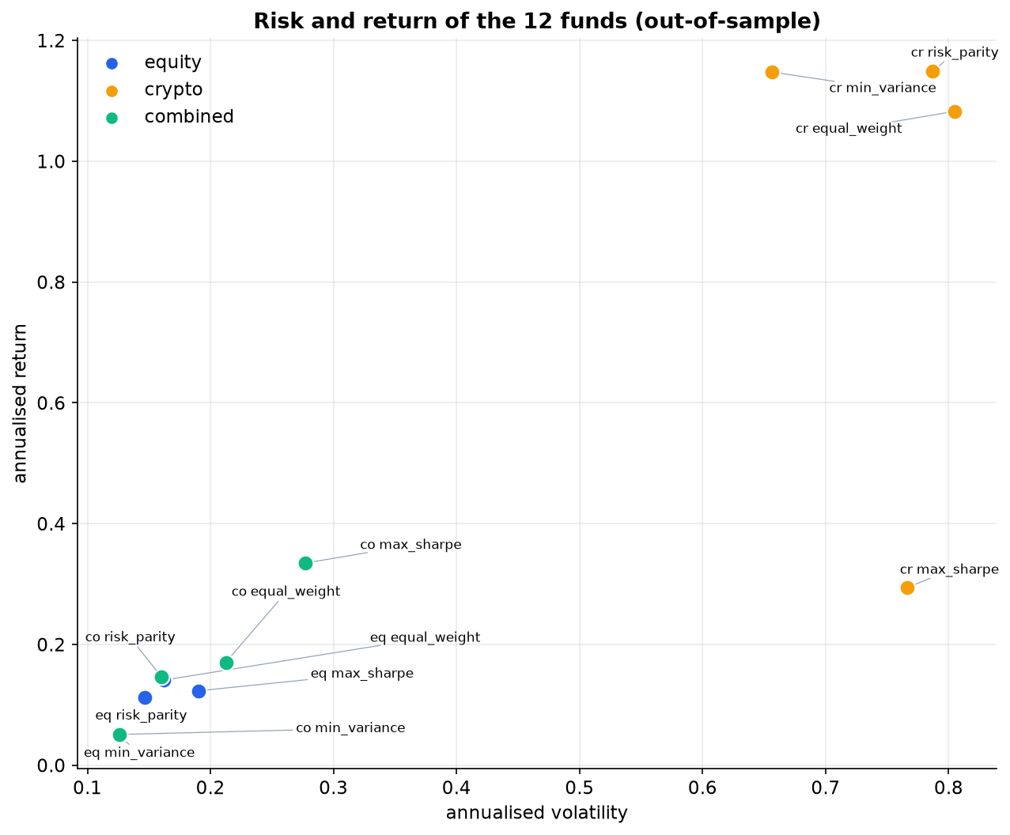
Figure 1. Risk and return of the twelve funds, out of sample, coloured by universe. Sample 2020-2023. Crypto sits high and volatile; equity and combined cluster at lower risk.
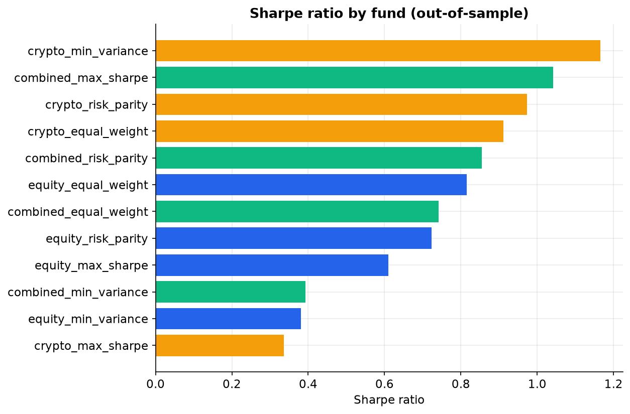
Figure 2. Sharpe ratio by fund, out of sample and after 10bps turnover costs. Sample 2020-2023.

3.2 Fund fact sheets: growth, drawdown and holdings
Each fund's fact sheet reports growth of one dollar, annualised return and volatility, the Sharpe ratio, maximum drawdown, and current holdings, which are the target weights from the most recent rebalance. Figure 3 is the growth of one dollar exhibit, the cumulative return each fund delivered to an investor who bought in at the first live date. Figure 4 is the drawdown, or underwater, exhibit for three representative funds, showing how deep and how long each fund's losses ran, which is the risk a fact sheet must disclose honestly. Figure 5 shows portfolio weights over time across the four equity methods, the left panel is the evolving holdings of the equity minimum variance fund, and the right panel is the effective number of holdings for each method, which makes plain that equal weight always holds all 50 names while maximum Sharpe concentrates into a handful.
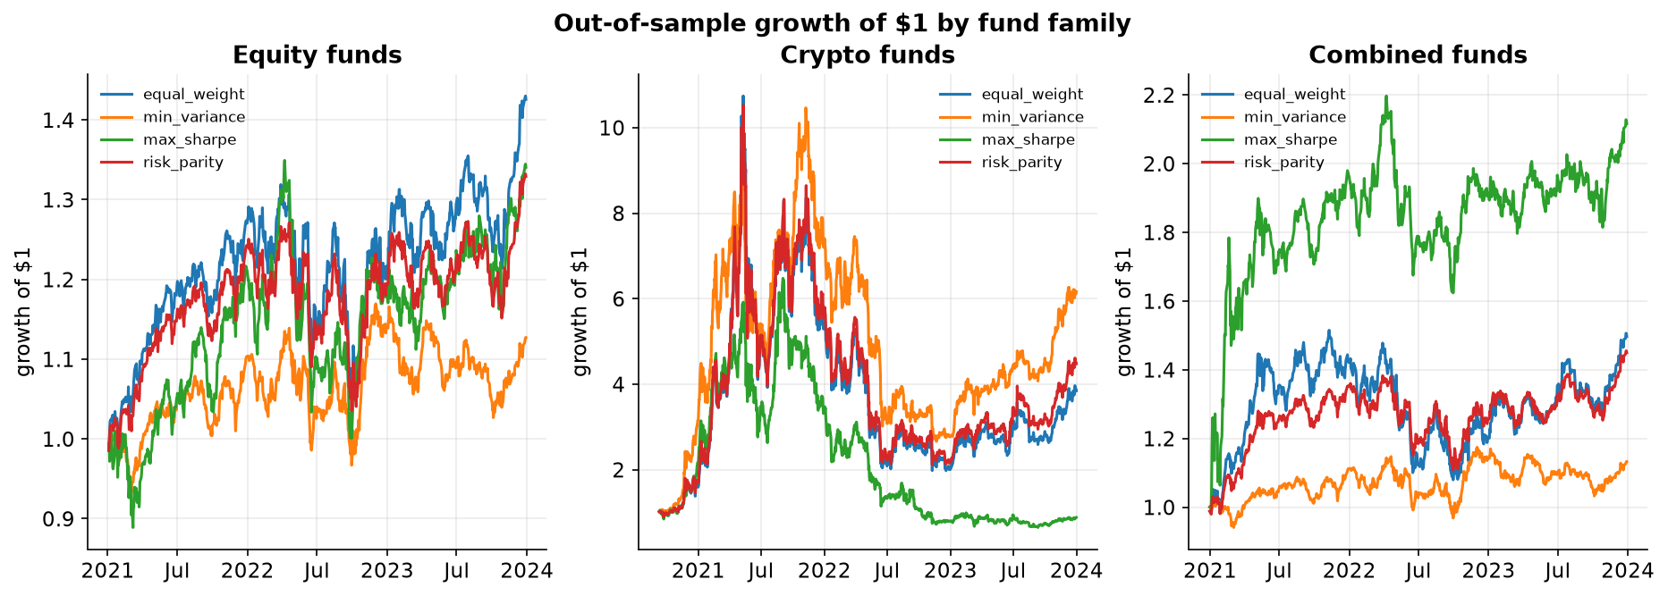
Figure 3. Out of sample growth of one dollar by fund family and method. Sample 2020-2023.
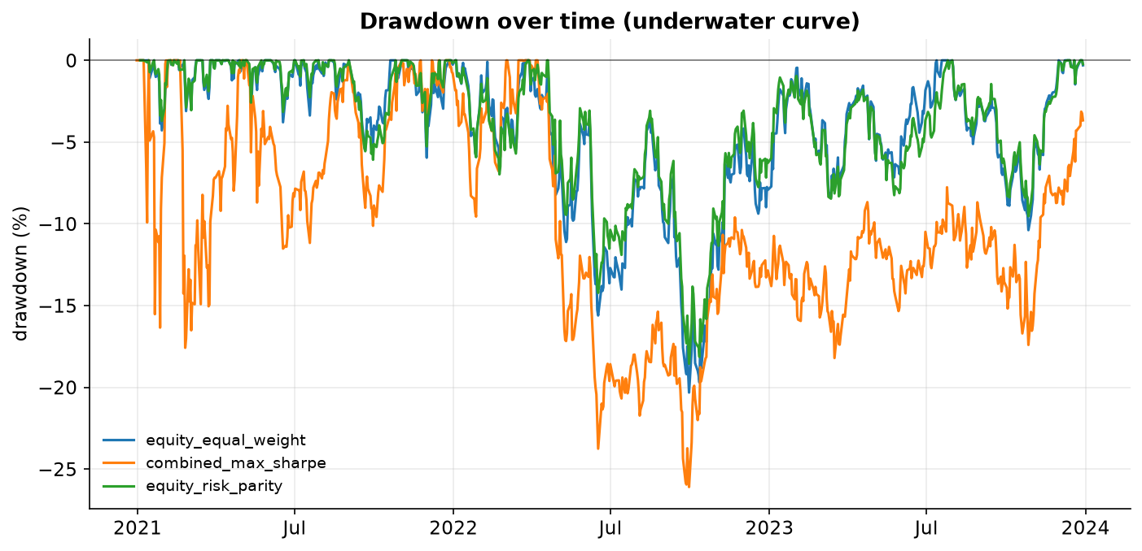
Figure 4. Drawdown (underwater) curves for three representative funds. Deeper and longer troughs are worse. Sample 2020-2023.
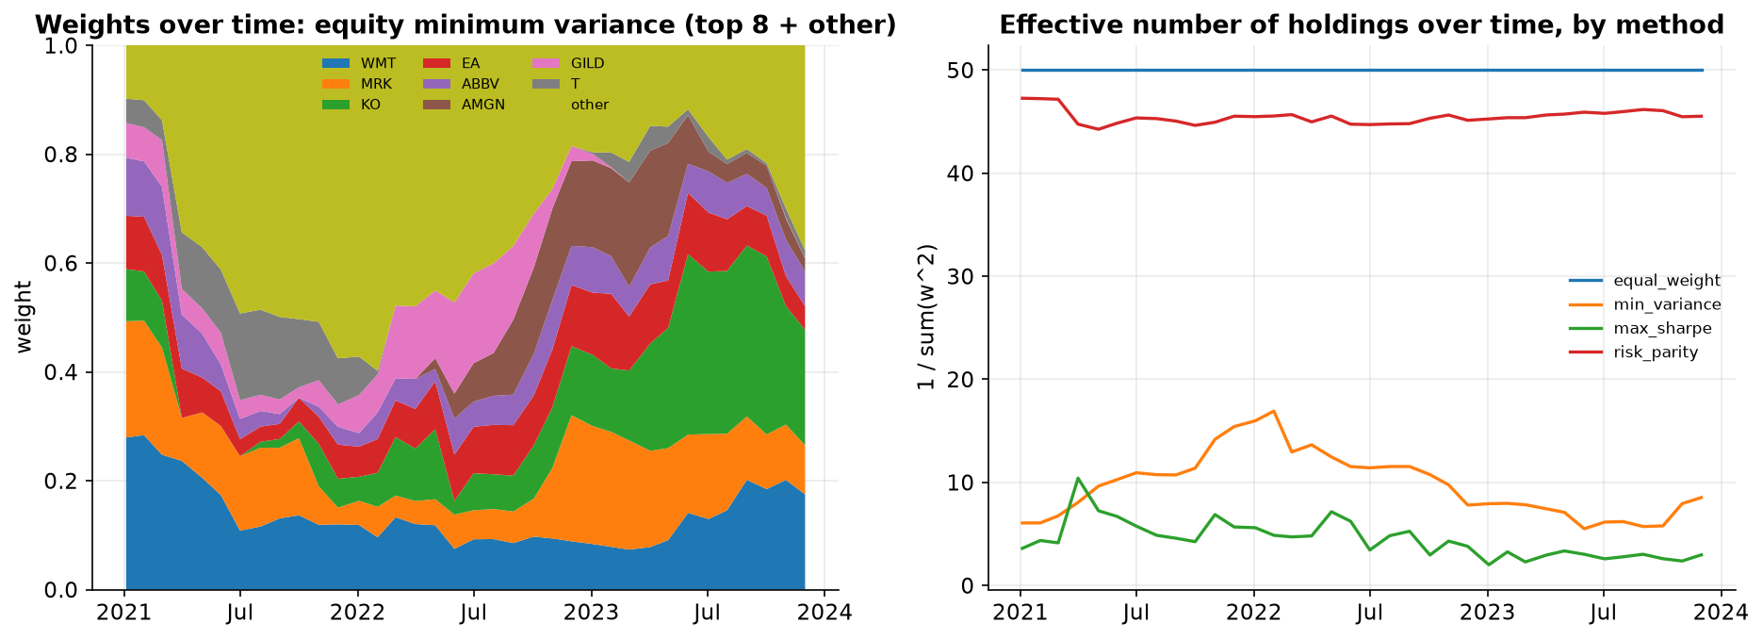
Figure 5. Portfolio weights over time across the four equity methods: evolving holdings of minimum variance (left) and effective number of holdings by method (right). Monthly rebalances, 2021-2023.
These two figures are what make a fact sheet honest. Figure 4 turns risk from an abstract volatility number into something an investor can feel, even combined maximum Sharpe, my best fund on Sharpe, spent time more than a quarter below its previous peak, and the equity funds share a sharp common drawdown during the 2022 selloff, which is exactly the moment a real client is tempted to sell at the bottom. Figure 5 shows why the methods differ in character rather than just in numbers. Minimum variance concentrates into a stable set of defensive names and barely turns them over from month to month, which is why its holdings drift slowly, while maximum Sharpe holds only a handful of names at any time and reshuffles them constantly, which is the source of its high turnover and its cost drag. A fact sheet that reported only the headline return would hide both the drawdown pain and the turnover, so I put growth, drawdown and holdings side by side on every fund's page.
If I had to recommend one fund to a risk aware investor it would be combined risk parity, which pairs a Sharpe of 0.86 with a contained drawdown of -19.89% and modest turnover. It is the fund whose fact sheet a cautious client can actually live with, unlike the pure crypto funds whose drawdowns near -80% no retail investor could hold through.

4. The sentiment index
My sentiment model scores the assembled headlines and builds a standalone news sentiment index across the ten equity sectors. It is built on VADER (Hutto & Gilbert 2014), a rule based analyser that returns a compound score between -1 and +1 and that we covered in Week 8 of the course (FINS3645 2026). VADER suits headline text because it keeps capitalisation, punctuation and negation, all of which carry meaning in a headline, so I deliberately do not strip casing or punctuation before scoring. I score the 149,683 raw headlines, which is 146,836 after removing the 2,847 exact duplicates I identified in Part A on ticker, date and title; because I then average tone within each ticker and day, those few duplicates have a negligible effect on the sector index. Headlines are only a proxy for sentiment and are noisy, and I treat them as such throughout.

4.1 Finance tuning of the lexicon
A general lexicon mislabels finance text. Loughran and McDonald (2011) showed that around three quarters of the words a general dictionary marks as negative are not negative in a financial context, and VADER shares that blind spot. My approach is similar in spirit to finVADER (Koráb 2023), which fuses VADER with finance specific lexicons. My Part A finance lexicon, built with the token and lexicon counting method from Week 7 of the course (FINS3645 2026), holds 144 hand tagged terms, 67 positive and 77 negative. Of these, 88 were absent from VADER's own dictionary, and injecting exactly those 88, giving positive terms a positive valence and negative terms a negative valence, is what lifts coverage; I never overwrite VADER's own calibrated words. On my data the finance tuned model assigns a non zero score to 63.1% of headlines. This matters because plain VADER scores roughly half of finance headlines as neutral, and many of those are false neutrals rather than genuine absence of information. Figure 8 shows the coverage lift from the finance terms, which is the concrete evidence that the extension earns its place.

4.2 From scores to a look ahead safe sector index
I aggregate scores in three steps. First I average the compound scores within each ticker and day, so a single very active stock cannot dominate. Then I average across the tickers in a sector, equal weighting the tickers, to give a sector tone. For ticker days with no headlines I carry the last known tone forward rather than treating silence as neutral, because a sector does not become neutral simply because no journalist wrote that day. Then I map the score onto a zero to one hundred Fear and Greed scale, where fifty is neutral, using the transformation taught in Week 9 of the course (FINS3645 2026). Raw Fear and Greed sits above fifty on most days, because headline flow is mildly positive on average, so the raw level is not the tradable signal. I standardise each sector series into a z score on an expanding window, meaning the mean and standard deviation at each date use only history up to that date, which avoids the subtle look ahead of standardising on the full sample. I then smooth with a 21 day rolling average. Crucially, the signal is lagged by at least one trading day, so a decision on day t uses only sentiment from day t minus one or earlier. I align each headline to its publication day rather than remapping it to the next trading day; on a daily forward filled calendar, with a monthly rebalance and the one day lag applied to the signal, the two choices are equivalent for the decisions this strategy actually makes, and stating the choice is clearer than hiding it inside a calendar map.
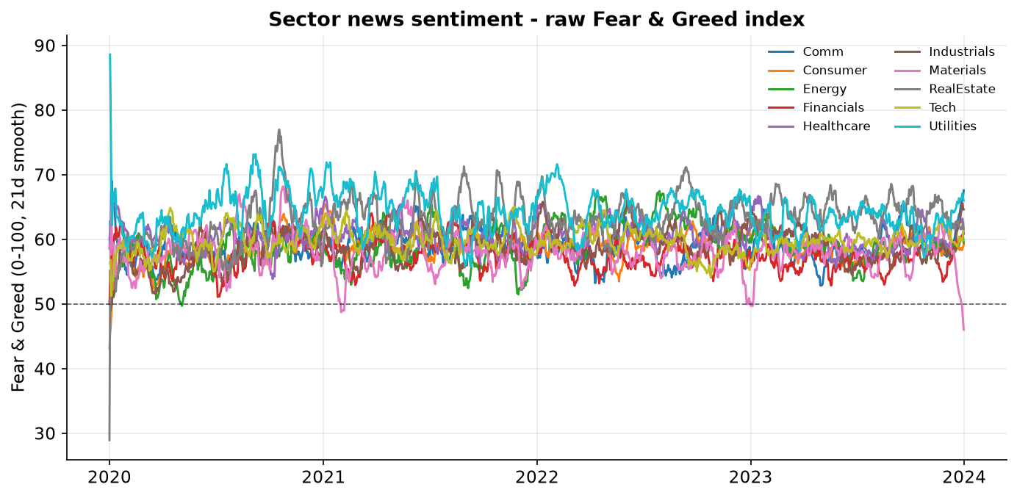
Figure 6. Standalone sector news sentiment as a 0-100 Fear and Greed index, smoothed. Ten equity sectors, 2020-2023.
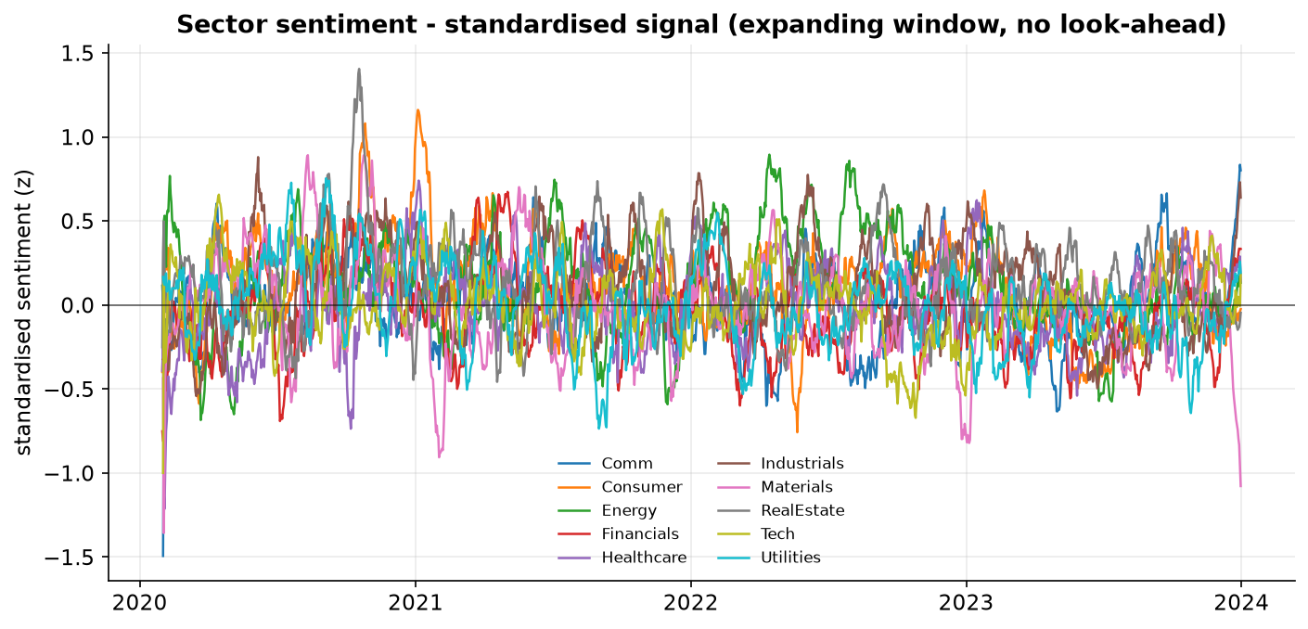
Figure 7. The tradable sentiment signal: each sector standardised on an expanding window (no look ahead), 2020-2023.
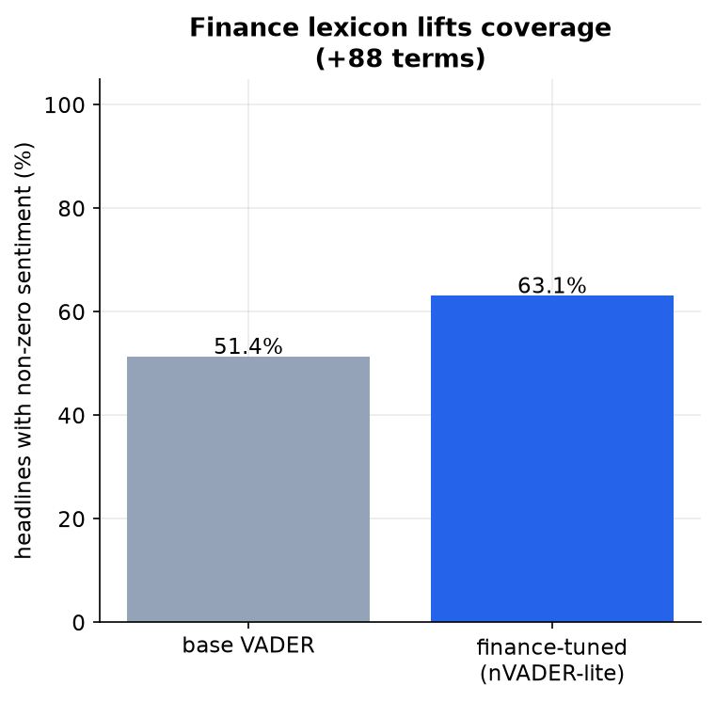
Figure 8. Share of headlines receiving a non zero score, base VADER versus the finance tuned model. The 88 added terms lift coverage.
I want to be honest about how much signal to expect here, because overclaiming is an easy trap and I did not want to fall into it. Headline sentiment is a noisy proxy for information in three specific ways. First, in Part A I found the correlation between news tone and absolute equity returns was essentially null, at around -0.073, so tone is not tracking the thing that actually moves prices. Second, a headline captures attention rather than information, an article appears because a stock is already in the news, and heavy coverage clusters around moves that have already happened, so tone tends to confirm yesterday's return rather than predict tomorrow's. Third, coverage is uneven across sectors, with Technology names generating far more headlines than Materials or Utilities, so the index is measured much more precisely in some sectors than others, and equal weighting the tickers cannot fully fix that. None of this makes the index useless, as a standalone read of sector mood it is genuinely informative for a user, which is why it earns its place in the app. But it sets the honest expectation that, as a trading signal, it should be weak, which is exactly what the fusion results in the next section show. I would rather state that up front than pretend a headline lexicon can forecast returns.

5. The fusion extension and whether it adds value
The fusion layer is where the sentiment view actually changes an allocation. I broadcast each sector's standardised sentiment onto the stocks in that sector, then feed it into the backtest as a tilt, at each rebalance the optimiser weights are multiplied by the exponential of a strength parameter times the signal and renormalised, so a stock in a high tone sector is scaled up and one in a low tone sector scaled down. Cryptocurrencies have no headline coverage and receive a zero tilt, so the overlay applies to the equity and combined books only, as required. The look ahead discipline carries through, the tilt uses only the most recent signal dated strictly before the rebalance. I fixed the strength at 0.5 in advance rather than searching for the value that maximised the backtest, because that search would itself be overfitting.
The table and figures below compare each fund with and without the overlay. Two patterns stand out, and I can explain both.
Fund | Base Sharpe | Tilt Sharpe | Base max DD | Tilt max DD | Sharpe change
equity_equal_weight | 0.82 | 0.78 | -20.32% | -19.93% | -0.031
equity_min_variance | 0.38 | 0.33 | -15.09% | -15.44% | -0.050
equity_max_sharpe | 0.61 | 0.65 | -25.82% | -24.91% | +0.035
equity_risk_parity | 0.72 | 0.69 | -18.56% | -18.31% | -0.037
combined_equal_weight | 0.74 | 0.73 | -28.75% | -27.67% | -0.012
combined_min_variance | 0.39 | 0.35 | -15.61% | -15.89% | -0.044
combined_max_sharpe | 1.04 | 1.07 | -26.10% | -25.01% | +0.031
combined_risk_parity | 0.86 | 0.82 | -19.89% | -19.62% | -0.031

First, the overlay helped the return seeking maximum Sharpe funds, lifting equity maximum Sharpe from 0.61 to 0.65 and combined maximum Sharpe from 1.04 to 1.07, while slightly lowering the Sharpe of the risk minimising funds. That fits, tilting by sentiment pulls weight away from the specific low variance names that minimum variance and risk parity deliberately choose, so it works against their objective. Second, the tilt reduced the maximum drawdown of six of the eight funds. The two exceptions are the minimum variance funds, whose drawdown edged very slightly deeper, and that exception fits the same logic rather than contradicting it, those funds exist purely to minimise risk, so a sentiment tilt that moves weight away from their chosen low risk names can only add risk. On the other six funds, and especially the return seeking ones, the tilt steered the book away from sectors with deteriorating news before losses arrived, a mild but consistent defensive effect. My conclusion is measured: monthly, lagged, look ahead safe headline sentiment is a weak but real signal on this data, a defensive overlay that helps aggressive funds and trims tail risk, not a source of easy return. Reporting that honestly is stronger work than presenting an overfitted number that would not survive scrutiny.
Why does the overlay split the funds so cleanly? Working that out turns a messy table into a single story, and it is the reason I recommend using the tilt selectively. A sentiment tilt multiplies each weight by an exponential factor and renormalises, so it can only move weight that a fund is already willing to move. The maximum Sharpe fund is taking large active directional bets, its weights are far from equal and concentrated in a few names, so a sentiment tilt has plenty of room to push those bets further in the direction the tone suggests, and on this data that extra push happened to help both its Sharpe and its drawdown. Minimum variance and risk parity are the opposite, they deliberately hug a specific set of low variance, well diversified names chosen purely to control risk. Tilting those weights by sector sentiment pulls the portfolio away from the very names the method selected, which raises risk without a matching return, so the tilt fights the fund's own objective. In other words the overlay behaves as a return seeking amplifier, not a risk management tool. That one mechanism explains every sign in the table. It is why I switch the overlay on for the aggressive funds and leave it off for the funds built to minimise risk.
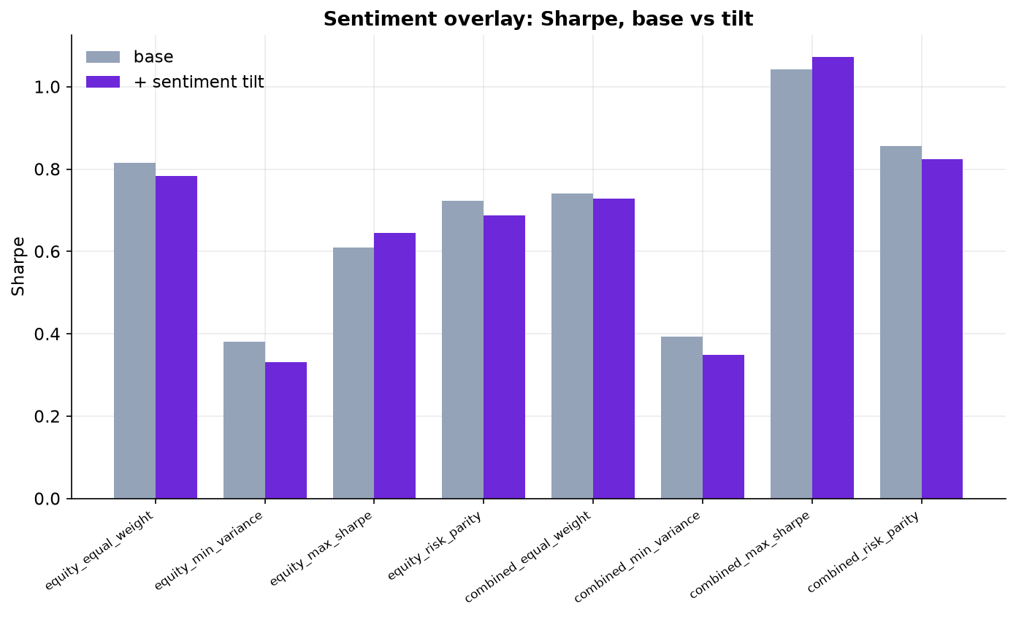
Figure 9. Sharpe ratio, base fund versus the sentiment tilted fund, for the equity and combined funds.
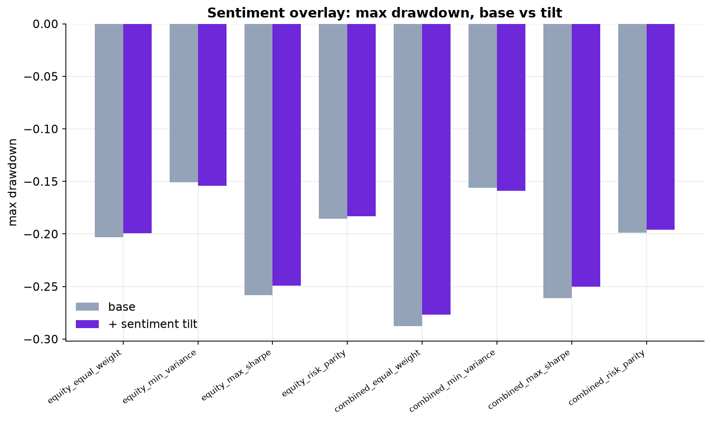
Figure 10. Maximum drawdown, base versus tilt. The tilt is shallower in six of the eight funds; the two exceptions are the minimum variance funds.

6. Extensions and innovations
Innovation is the most heavily weighted criterion, so I built several genuine extensions rather than one, and I made sure each changes a result rather than just appearing in the code.

6.1 Ledoit and Wolf covariance shrinkage
A sample covariance matrix estimated from 252 days of 50 stocks is badly conditioned, because I am estimating more than a thousand covariances from limited data, and both minimum variance and risk parity lean on that matrix. I therefore shrink the sample covariance toward a constant correlation target using the Ledoit and Wolf (2004) estimator, with the shrinkage intensity computed from the data rather than fixed by hand. The effect is a more stable matrix and less estimation noise in the risk based funds.

6.2 A turnover and transaction cost model
Rather than assume zero costs, I model turnover explicitly and charge ten basis points on it at each rebalance. This is why the maximum Sharpe funds, which turn over roughly two thirds of the book each month, are penalised relative to the low turnover funds. Several of my rankings only make sense once costs are included, so this extension changes the economic conclusion, not just the code.

6.3 Equal risk contribution risk parity and a solver bug I caught
My first risk parity solver minimised the squared differences of risk contributions with a general purpose optimiser. On the crypto book it worked, but on the 50 stock equity book it returned weights that were exactly equal weight to four decimal places. The brief itself warns that optimisers on tiny daily return covariances can silently stall, and that is exactly what happened, daily equity variances are around 1e-4, so the objective sat near 1e-12 and the solver decided it had already converged at its equal weight starting point. Rather than ship the coincidence I diagnosed it and replaced the solver with the cyclical coordinate descent algorithm of Griveau Billion, Richard and Roncalli (2013), which is scale invariant and provably converges. After the fix the equity risk parity fund produced genuinely distinct weights, with a volatility of 14.65% sitting between equal weight at 16.17% and minimum variance at 12.58%, exactly where equal risk contribution should sit. Finding and fixing this is, I think, stronger evidence of understanding than if it had worked first time.

6.4 A finance tuned sentiment lexicon (nVADER lite)
Extending VADER with a finance vocabulary, described in Section 4, is itself an innovation the brief explicitly names. The 88 added terms lift non zero coverage to 63.1% and let the model read finance tone that plain VADER misses, which is what makes the fusion signal usable rather than mostly neutral.

6.5 A custom design system for the app
Rather than the provided style, the app uses its own dark design system with a consistent navy and purple palette, metric cards, an interactive Fear and Greed gauge, and an allocation blender, so the product reads as a finished app rather than a template. I also treat reproducibility itself as a feature, a single script rebuilds every number and figure in this report from the hosted data, and the deployed app reads those exact artifacts, so the product a user sees and the evidence in this report are guaranteed to be the same thing rather than two separate builds that might drift apart.

7. The app and the investor journey
The dashboard is the product and it is deployed live on Streamlit Community Cloud from a public repository, following the Streamlit build and deploy workflow from Weeks 2 and 4 of the course (FINS3645 2026). The central design decision is that the app reads precomputed artifacts from the results folder and never runs VADER or a backtest at request time, because scoring 149,683 headlines and running twelve walk forward backtests takes minutes and exceeds a free tier. My master script computes everything once and writes the CSV files the app consumes, so the app loads instantly and is fully reproducible from committed data.
The investor journey runs across six tabs. On the overview the user compares all funds on headline metrics and a risk and return chart. In the funds tab they open any fund's fact sheet, its growth of one dollar and its current holdings. In the sentiment tab they read a Fear and Greed gauge for a chosen sector alongside the raw and standardised sector series. The sentiment overlay tab shows the base versus tilt comparison and states the honest finding on the page. The allocation blender lets the user set an allocation by dragging a strength slider and watching conviction move between holdings in real time, using the same tilt rule as the backtest. A data tab demonstrates live access to the hosted price table and degrades gracefully if that source is unreachable. The journey the brief asks for, compare funds, read a fact sheet, set an allocation, and read the sentiment analytics, is therefore covered end to end.

8. Critical reflection and three recommendations
The project works, and its honest lessons are clear. Risk aware construction is rewarded, minimum variance and my equal risk contribution risk parity delivered the best risk adjusted outcomes in every universe once costs were included, and the naive maximum Sharpe fund, undone by estimation noise and turnover, did not beat equal weight on the equity book. Diversification across structured asset classes was the single biggest win, turning the wild crypto book into the best combined fund. The sentiment overlay was the honest disappointment and the honest surprise at once, it did not lift risk adjusted return broadly, but it trimmed drawdowns fairly consistently, so its value is defensive rather than offensive. The clearest limitation is that headlines are a noisy proxy and the crypto cost assumption is generous. The quiet winner of the whole project was risk parity, an unglamorous method that never estimates a single expected return, yet it beat the far more sophisticated tangency portfolio on a risk adjusted basis in every universe, which is the lesson I will carry, that in finance robustness usually beats sophistication once you leave the sample the model was fitted on. From this I draw three concrete recommendations for taking FundForge further.
- Make combined risk parity the flagship product and cap the crypto sleeve by risk, not capital. The pure crypto funds drew down near -80%, which no retail client can hold, yet a risk budgeted crypto allocation inside the combined book lifted the Sharpe to above 1.0 with a -20% to -26% drawdown. The firm should sell the combined risk parity fund as the default and impose an explicit crypto weight cap tied to a stated drawdown tolerance.
- Deploy the sentiment overlay selectively, as a drawdown guardrail on the return seeking funds only. The overlay improved the maximum Sharpe funds and cut drawdown in six of eight funds, but it hurt the risk minimising funds by fighting their objective. It should be switched on for the aggressive funds and as a defensive tilt, and left off where it works against the mandate.
- Before trusting sentiment with real capital, replace headline lexicon scoring with article level or a finance transformer, and move to asset specific trading costs. Headlines are a noisy proxy and a flat ten basis point cost flatters the high turnover crypto funds. A stronger signal, for example FinBERT on full articles, and realistic per asset costs would test whether the defensive effect survives, which is the bar for putting client money behind it.

References
FINS3645 2026, 'Week 2: agent workflows, Streamlit and sector narratives', lecture materials, UNSW Business School, Sydney.

FINS3645 2026, 'Week 3: forecasting with macro data and out of sample evaluation', lecture materials, UNSW Business School, Sydney.

FINS3645 2026, 'Week 4: the Data Factory Floor and portfolio construction', lecture materials, UNSW Business School, Sydney.

FINS3645 2026, 'Week 5: crypto versus stocks, a risk adjusted comparison', lecture materials, UNSW Business School, Sydney.

FINS3645 2026, 'Week 7: turning financial news text into numbers', lecture materials, UNSW Business School, Sydney.

FINS3645 2026, 'Week 8: sentiment analysis with VADER', lecture materials, UNSW Business School, Sydney.

FINS3645 2026, 'Week 9: the Fear and Greed sentiment index', lecture materials, UNSW Business School, Sydney.

Griveau-Billion, T, Richard, J-C & Roncalli, T 2013, 'A fast algorithm for computing high-dimensional risk parity portfolios', working paper.

Hutto, CJ & Gilbert, E 2014, 'VADER: a parsimonious rule-based model for sentiment analysis of social media text', Proceedings of the Eighth International AAAI Conference on Weblogs and Social Media, pp. 216-225.

Koráb, P 2023, finVADER: VADER sentiment classifier fused with finance-specific lexicons, Python package.

Ledoit, O & Wolf, M 2004, 'Honey, I shrunk the sample covariance matrix', Journal of Portfolio Management, vol. 30, no. 4, pp. 110-119.

Loughran, T & McDonald, B 2011, 'When is a liability not a liability? Textual analysis, dictionaries, and 10-Ks', Journal of Finance, vol. 66, no. 1, pp. 35-65.

Markowitz, H 1952, 'Portfolio selection', Journal of Finance, vol. 7, no. 1, pp. 77-91.

Sharpe, WF 1966, 'Mutual fund performance', Journal of Business, vol. 39, no. 1, pp. 119-138.

Appendix A: reproducibility
Everything here is reproducible from the committed repository. Create a virtual environment and install requirements.txt and requirements-dev.txt. Run python scripts/run_part_b.py to rebuild every CSV under results, python scripts/make_figures.py to rebuild the figures, and streamlit run streamlit_app.py to launch the dashboard locally. The live deployment reads the same committed results. The provided data summary confirms 50 equity tickers, 10 crypto tickers and 149,683 news headlines across ten sectors, 2020-2023.

