//Write a program to demonstrate Autoboxing of all primitive datatypes

public class Main

{

public static void main(String[] args) {

int a=45;

boolean b=true;

float f=23.23F;

char c='A';

double d=34.444;

long l=123456;

short s=21;

byte bi=12;

Integer in=Integer.valueOf(a);

Boolean bo=Boolean.valueOf(b);

Float fl=Float.valueOf(f);

Character ch=Character.valueOf(c);

Double du=Double.valueOf(d);

Long lo=Long.valueOf(l);

Short sh=Short.valueOf(s);

Byte by=Byte.valueOf(bi);

System.out.println(a+" "+in);

System.out.println(b+" "+bo);

System.out.println(f+" "+fl);

System.out.println(c+" "+ch);

System.out.println(d+" "+du);

System.out.println(l+" "+lo);

System.out.println(s+" "+sh);

System.out.println(bi+" "+by);

}

}

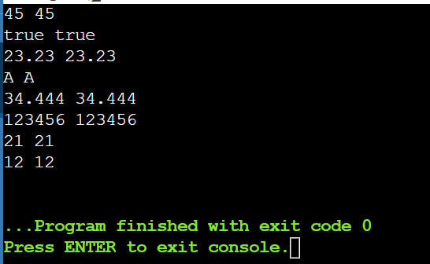

// Write a program to demonstrate Unboxing of Wrapper type Objects

public class Main

{

public static void main(String[] args) {

Integer a=new Integer(456);

Boolean b=new Boolean(false);

int in=a.intValue();

boolean bo=b.booleanValue();

System.out.println(a+" "+in);

System.out.println(b+" "+bo);

}

}

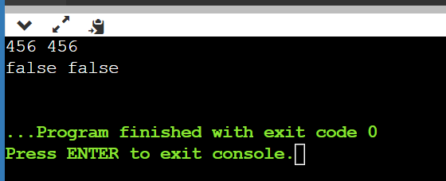

// Write a program to demonstrate toString() method. public class Student

{

int rollno;

String name;

String city;

Student(int rollno,String name,String city)

{

this.rollno=rollno;

this.name=name;

this.city=city;

}

public String toString()

{

return name+" "+rollno+" "+city;

}

public static void main(String args[])

{

Student s1=new Student(23,"Ishika","Indore");

Student s2=new Student(12,"Himanshi","mandav");

System.out.println(s1);

System.out.println(s2);

}

}

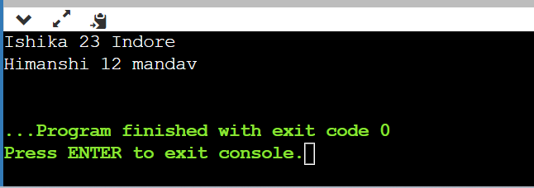

// Write a programto print Command line arguments as string.

public class CommandLineArguments {

public static void main(String[] args) {

if (args.length == 0) {

System.out.println("No command-line arguments provided.");

} else {

System.out.println("Command-line arguments:");

for (int i = 0; i < args.length; i++) {

System.out.println("Argument " + (i + 1) + ": " + args[i]);

}

}

}

}

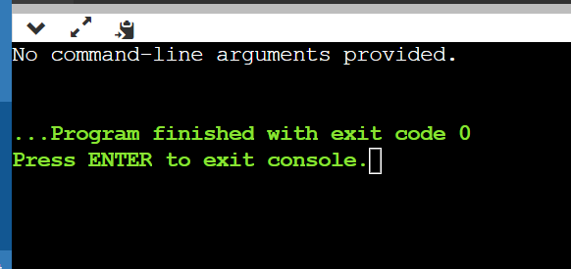

25. Write a program to print the area and perimeter of a triangle having sides of 3, 4 and 5 units by creating a class named 'Triangle' without any parameter in its constructor.

class Triangle{

int a,b,c;

public double getArea(){

double s = (a+b+c)/2.0;

return Math.pow((s\*(s-a)\*(s-b)\*(s-c)),.5);

}

public double getPerimeter(){

return (a+b+c)/2.0;

}

}

public class Ans{

public static void main(String[] args){

Triangle t = new Triangle();

t.a = 2;

t.b = 5;

t.c = 6;

System.out.println(t.getArea());

System.out.println(t.getPerimeter());

}

}

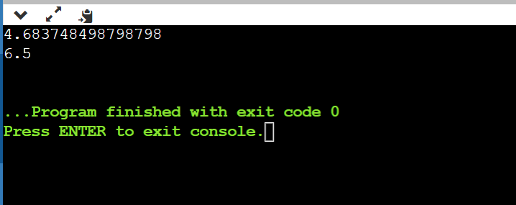

Write a program to print the area of two rectangles having sides (4,5) and (5,8) respectively by creating a class named 'Rectangle' with a method named 'Area' which returns the area and length and breadth passed as parameters to its constructor.

class Rectangle{

int length;

int breadth;

public Rectangle(int l, int b){

length = l;

breadth = b;

}

public int getArea(){

return length\*breadth;

}

public int getPerimeter(){

return 2\*(length+breadth);

}

}

public class Ans{

public static void main(String[] args){

Rectangle a = new Rectangle(4,5);

Rectangle b = new Rectangle(5,8);

System.out.println("Area : "+a.getArea()+" Perimeter is "+a.getPerimeter());

System.out.println("Area : "+b.getArea()+" Perimeter is" +b.getPerimeter());

}

}

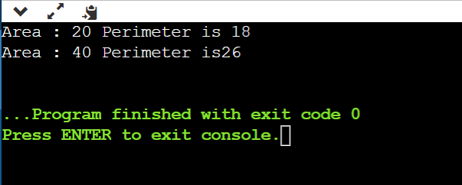

27. Print the sum, difference and product of two complex numbers by creating a class named 'Complex' with separate methods for each operation whose real and imaginary parts are entered by user.

import java.util.\*;

class Complex{

int real;

int imag;

public Complex(int r, int i){

real = r;

imag = i;

}

public static Complex add(Complex a, Complex b){

return new Complex((a.real+b.real),(a.imag+b.imag));

}

public static Complex diff(Complex a, Complex b){

return new Complex((a.real-b.real),(a.imag-b.imag));

}

public static Complex product(Complex a, Complex b){

return new Complex(((a.real\*b.real)-(a.imag\*b.imag)),((a.real\*b.imag)+(a.imag\*b.real)));

}

public void printComplex(){

if(real == 0 && imag!=0){

System.out.println(imag+"i");

}

else if(imag == 0 && real!=0){

System.out.println(real);

}

else{

System.out.println(real+"+"+imag+"i");

}

}

}

public class Ans{

public static void main(String[] args){

Complex c = new Complex(4,5);

Complex d = new Complex(9,4);

Complex e = Complex.add(c,d);

Complex f = Complex.diff(c,d);

Complex g = Complex.product(c,d);

e.printComplex();

f.printComplex();

g.printComplex();

}

}

