1) compare two string

class Main{

public static void main(String[] args){

String first = "java programming";

String second = "java programming";

String third = "programming";

boolean result1 = first.equals(second);

System.out.println("string first and second are equal:"+result1);

boolean result2 = first.equals(third);

System.out.println("string first and third are equal:"+result2);

}

}

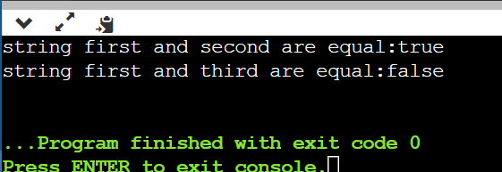

2) upper and lower case string

class Main{

public static void main(String[] args){

String s = "Hello World";

System.out.println(s.toUpperCase());

System.out.println(s.toLowerCase());

}

}

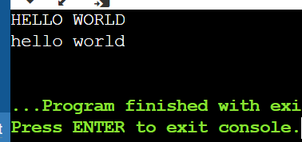

3)find e word in given spelling

class Main{

public static void main(String[] args){

String a = "Umbrella";

boolean per = false;

for(int i=0;i<a.length();i++){

if(a.charAt(i) == 'e'){

per=true;

break;

}

}

System.out.println(per);

}

}

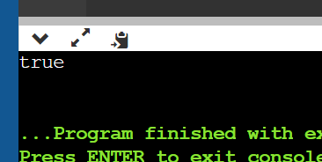

4)length of string

class Main{

public static void main(String[] args){

String a = "refrigerator";

System.out.println(a.length());

}

}

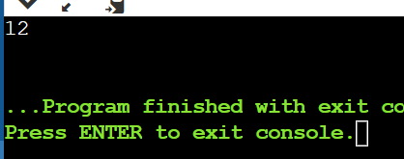

5)join two string

class Main{

public static void main(String[] args){

String first = "Java";

System.out.println("first string:"+first);

String second = "Program";

System.out.println("second string:"+second);

String joinedString = first.concat(second);

System.out.println("Joined string:"+joinedString);

}

}

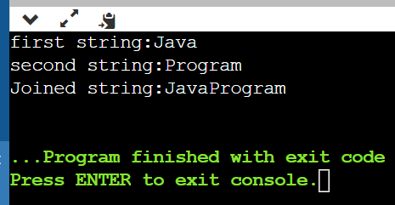

6)upper or lower case

import java.util.Scanner;

class Main{

public static void main(String[] args){

Scanner sc = new Scanner (System.in);

System.out.println("enter string:");

String s = sc.nextLine();

System.out.println("enter choose:");

int i=sc.nextInt();

switch(i){

case 0:

System.out.println("Lowercase:"+(s.toLowerCase()));

break;

case 1:

System.out.println("Uppercase:"+(s.toUpperCase()));

break;

}

}

}

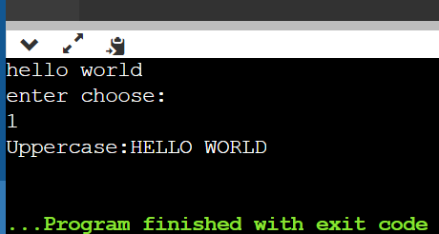

7)

import java.util.Scanner;

class Main{

public static void main(String[] args){

String s = "hello";

System.out.println(s.isEmpty());

}

}

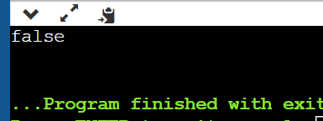

8)get length of string

import java.util.Scanner;

class Main{

public static void main(String[] args){

String greet = "Hello! World";

System.out.println("String:"+greet);

int length = greet.length();

System.out.println("Length:"+length);

}

}

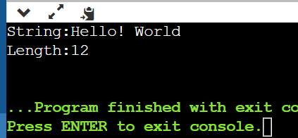

9)simple string

import java.util.Scanner;

class Main{

public static void main(String[] args){

String first = "java";

String second = "python";

String third = "javascript";

System.out.println(first);

System.out.println(second);

System.out.println(third);

}

}

