VIT BHOPAL UNIVERSITY
School of Computing Science & Engineering

THE OPEN-SOURCE AUDIT: AN ANALYSIS OF GIT

A Capstone Project for the OSS NGMC Course

Prepared by:
ISHIKA AGARWAL
Registration No.: 24BCE11099
Course: Open-Source Software (OSS) — NGMC
Date of Submission: 31 March 2026
Software Under Audit: Git
Slot:B22

TABLE OF CONTENTS

- Introduction
- Part A: Origin and philosophy
- Part B: Linux Footprint
- Part C: Foss Ecosystem
- Part D: Comparison
- Conclusion
- References

INTRODUCTION

The world today has an abundance of mainstream applications that have been developed in part through Open-Source Software (OSS). Most of the software tools that are being utilized by individuals to accomplish everyday tasks (e.g. an operating system and a variety of developer tools) were built using some type of an OSS technology.

Git is an OSS technology that allows a developer to keep track of the changes that have been made to his/her code over time, collaborate with other developers to assist in the development of a piece of code or project, and manage multiple versions of a project in order to increase development efficiencies.

Git is an open-source distributed version control system that is used worldwide to track code development on a global basis. Many of the high-quality (enterprise level) applications you may utilize in your everyday activities derive their source code from Git.

This report provides an overview of Git including its history, philosophy, licensing agreements, functionalities and operations on a Linux computer system, uses and developments within the Git ecosystem, and comparisons to proprietary applications.

PART A: ORIGIN AND PHILOSOPHY
- A1. PROBLEM GIT WAS CREATED TO SOLVE
An issue that Git was developed to address during its inception in 2005 by Linus Torvalds (who also created Linux) arose when the previous version control system known as Bit Keeper could no longer be utilized as a result of licensing issues associated with the system. Prior to this problem, a lot of developers and users were contributing to the Linux kernel which requires an enormous amount of code from many different resources. Without a proper version control system, it became very difficult to manage all of those changes efficiently.

Therefore, Linus set out to create a new version control system with the following requirements:

- Speed
- Ability to handle large projects
- Ability to support distributed development
- Being free/open-source

With these factors in mind, Git was born.

By providing each developer access to a complete copy of the source code, Git improved speed and dependability on working together.

FEATURES
- Distributed system
- Fast performance
- Open source and free to use
- Supports collaboration across teams

- A2. THE LICENSE-WHAT IT ACTUALLY SAYS
Git is licensed under the GPL v2 license. It provides the freedom to users to use, study, modify, and distribute the software. It also provides the freedom to modify the software and to share the modified version with the community. GPL is a copyleft license → sharing is a must
MIT is a permissive license → private use is permitted
One is related to openness, while the other is related to flexibility. It is not necessary that free software is free to use. Free software is related to freedom. Git is a free software because users can access and modify its source code.

- A3. ETHICS OF OPEN SOURCE
The open-source software encourages collaboration and innovation. However, it is essential for companies that use open-source software to give back to the community. It is ethical for organizations to support open-source software instead of exploiting it for personal gain.
PART B: LINUX FOOTPRINT
- Installation of Git on Linux System
Git can be installed using:
sudo apt install git
- Directory Structure and File Location
- /usr/bin/git → Git executable
- /etc/gitconfig → system-wide settings
- ~/.gitconfig → user settings
- .git/ → repository data

- User Roles and permission Management
Git works under the current user account. Permissions in Linux control who can read, write, or modify files. This ensures security in repositories.

- Working Mechanism of Git
Git stores snapshots of files instead of just changes. Each commit acts like a saved version. It uses hashing to ensure data integrity and allows branching for parallel development.

PART C: FOSS ECOSYSTEM

- Dependencies
Git depends on:
- C programming language
- Libraries like zlib, curl
- Tools built on Git
- GitHub
- GitLab
- Bitbucket
- Usage in Industry
Git is used in:
- Software Development
- Web development
- Data science
- Community
Git has a strong global community:
- Contributors worldwide
- Online Forums
- Documentation and tutorials

PART D: OPEN SOURCE VS PROPRIETARY
Dimension | Open Source | Proprietary Alternative
Cost | Free | Paid or subscription
Security (who can audit the code?) | Code is visible | Closed Code
Support and reliability | Community Support | Official support
Freedom to modify | Full Control | Limited Control
Community vs corporate control | Community driven | Company driven
Your overall verdic | Highly flexible, transparent, and cost-effective. Best for developers. | Less flexible, dependent on company, and costly

Conclusion
Git is a revolutionary tool for developers. It is an efficient tool for tracking changes and collaborating with other developers. The open-source nature of Git is also important for ensuring transparency and improvement.

The project helped in understanding the working of open-source software and its significance. Git is not just a tool but a part of software development.

Shell Script Tasks
Script 1 — System Identity Report (Unit 1 & 2)
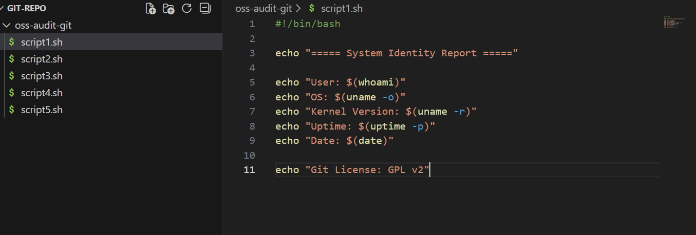
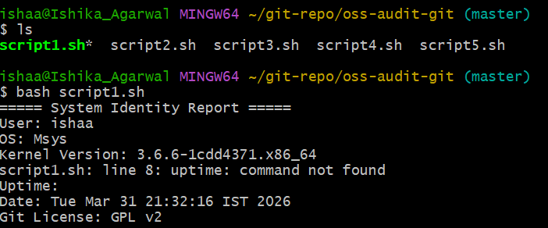
Script 2 — FOSS Package Inspector (Unit 2)
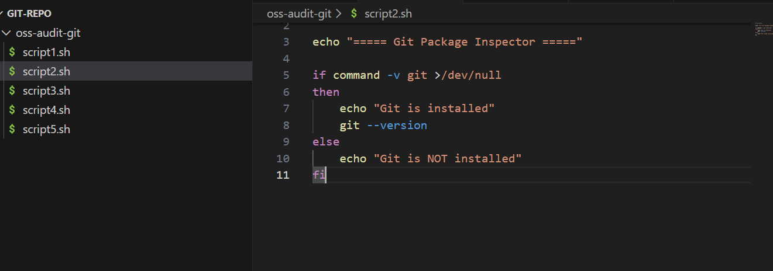
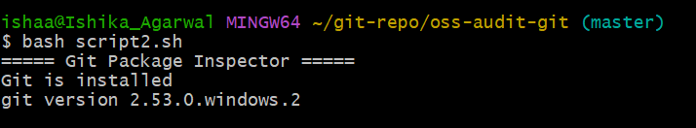
Script 3 — Disk and Permission Auditor (Unit 2)
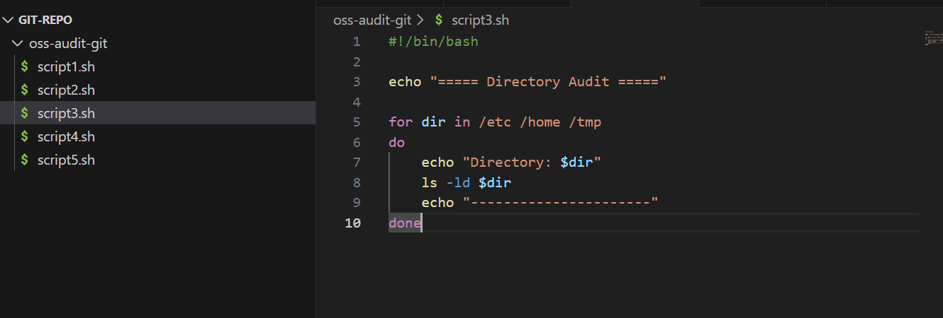
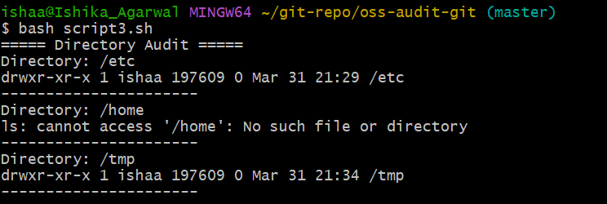

Script 4 — Log File Analyzer (Units 2 & 5)
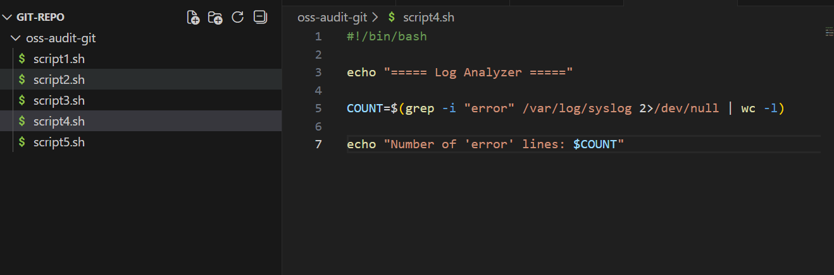
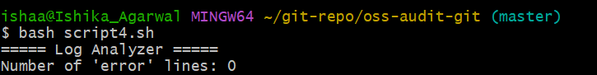

Script 5 — The Open Source Manifesto Generator (Unit 5)

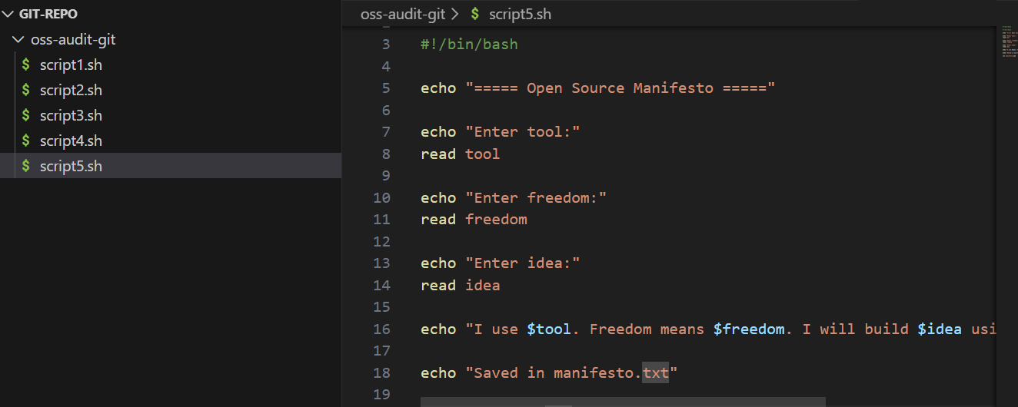

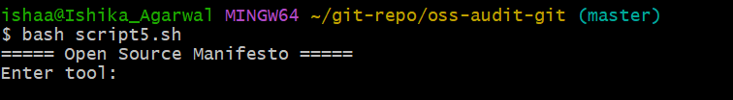

Conclusion
Git is found to be an effective and reliable open-source version control system. The system is effective in changing the way developers handle codes. The ability to track versions, collaborate, and maintain versions of the project is an indicator of the importance of the system in the current world. The fact that the system is open source, with the license being GPL, ensures that the system is transparent, secure, and constantly improved.
In comparison with other proprietary version control systems, the use of the Git system is advantageous due to the fact that the system is free, effective, and can be modified as desired. The system, although having some difficulties in terms of the knowledge required by new users, is found to be advantageous compared to the disadvantages. The analysis indicates that the system is highly recommended for use.
In addition, the system is advantageous in the sense that the user can contribute to the open-source community.

