Task 2: Mechanism Decision (drive, arm, gripper)

My decisions at a glance
Part | What I chose | Why, in one line | Key numbers
2a Drive | 4-wheel skid-steer, one 12 V gearmotor per wheel | Best score on ramp, speed breakers and stability; matches the 4 motors on my schematic | Dia 100 wheels, wheelbase 150, track 175, body 250 x 200
2b Arm | 3-link revolute arm with wrist (base yaw, shoulder, elbow, wrist) + gripper | Folds into the 300 x 300 box yet reaches 450 mm, and the wrist keeps the gripper level | L1 180, L2 170, L3 100, shoulder at 170 mm; 5 servos in total
2c Gripper | Parallel-jaw, rack and pinion, one MG90S servo | Centres every object shape on its own, tiny part count, servo is strong enough | Opening 7 to 76 mm, 19.6 N per jaw available

How I scored. For every part I listed the criteria the task asks for, gave each a weight (the weights add up to 100 %), scored each option from 1 (poor) to 5 (excellent), and calculated the weighted total = sum of (weight x score) / 100.

2a. Drive configuration
The arena asks a lot of the base: a 15 degree ramp, 40 mm speed breakers straight after a descent, a 250 mm-wide lane, and a heavy arm that pulls the centre of gravity forward. I compared four layouts.
Criterion | Weight % | 2-wheel diff + caster | 4-wheel skid-steer | Mecanum / omni | Tracks
Climb 15 deg ramp | 15 | 3 | 5 | 2 | 5
Cross 40 mm speed breakers | 15 | 2 | 4 | 1 | 5
Turn in 250 mm lane | 15 | 5 | 3 | 5 | 2
Stability with front-heavy arm | 15 | 2 | 5 | 4 | 5
Traction | 10 | 3 | 4 | 2 | 5
Cost | 10 | 5 | 4 | 2 | 2
Mechanical complexity | 10 | 5 | 4 | 2 | 2
Fits our driver / schematic (2 channels) | 10 | 5 | 4 | 1 | 4
Weighted total (max 5.00) | 100 | 3.60 | 4.15 | 2.50 | 3.85

Winner: 4-wheel skid-steer (4.15). All four wheels are driven, so the load is shared on the ramp and every wheel helps to push over a speed breaker, and the four contact points keep the robot stable when the arm leans forward.
Runner-up: tracks (3.85). They climb and cross steps very well, but they cost more, are harder to build and tension, and scrub heavily when turning in a 250 mm lane. Why the others lost: a caster on the 2-wheel layout gets stuck on a 40 mm step and gives only three contact points under a front-heavy arm; mecanum rollers are small, slip on a ramp and need four independent driver channels.

Layout and checks
- Layout (Sheet 1): wheel diameter 100 mm, width 25 mm; wheelbase 150 mm (axle to axle); track 175 mm (wheel centre to centre); chassis body 220 x 140 mm; overall 250 x 200 mm, so it fits in the 300 x 200 start box with 50 mm to spare in length. Underside of the chassis is 55 mm above the floor (rule: at least 50 mm).
- 40 mm step check: wheel radius R = 50 mm, step h = 40 mm. The wheel touches the step corner 49 mm ahead of the axle and 10 mm below it (a = sqrt(R^2 - (R-h)^2) = sqrt(2500 - 100) = 49 mm). Ratio h/D = 0.40, which is inside the usual limit of about 0.4 to 0.5 for a rubber tyre, so a 100 mm wheel clears the step; a 60 mm wheel would not.
- Torque to climb the step: I assume a 4.0 kg robot, so about 9.8 N per wheel. With rubber on a hard surface (friction mu = 0.8) a force balance at the corner gives N = W / (0.2 + 0.98 x mu), which is about 10.0 N, and the wheel torque needed is T = mu x N x R = 0.8 x 10.0 x 0.05 = 0.40 N.m = 4.1 kg.cm. The motor stall torque is 18 kg.cm, so I only need about a quarter of it.
- 15 degree ramp: force along the slope = m g (sin 15 + 0.03 cos 15) = 4.0 x 9.81 x 0.288 = 11.3 N. Torque per wheel = 11.3 x 0.05 / 4 = 0.14 N.m = 1.4 kg.cm, so each motor draws well under its typical 1 A (torque is roughly proportional to current).
- Speed: 100 rpm at 12 V. Through the L298N driver the motors see roughly 9 V, so about 75 rpm, which is pi x 0.1 m x 75/60 = 0.39 m/s. Crossing the 3 m arena takes about 8 s of driving, so time is not the problem.
- Tipping on the ramp: with the centre of gravity about 95 mm high and carried 25 mm forward by the arm, the robot would tip forward at atan(50 / 95) = 28 degrees, nearly double the 15 degree ramp (level and arm folded it is 40 degrees). Sideways, atan(87.5 / 95) = 43 degrees. The 400 mm bridge leaves 100 mm each side of my 200 mm width.
- Honest limitation (narrow lane): a skid-steer robot that spins on the spot sweeps a circle of about sqrt(250^2 + 200^2) = 320 mm, which is larger than the 250 mm lane. So in The Diagonals I will not spin; I will steer with arcs (left and right sides at different speeds), which needs about 25 mm of clearance each side. If testing shows this is too tight I would shorten the wheelbase before changing the layout.

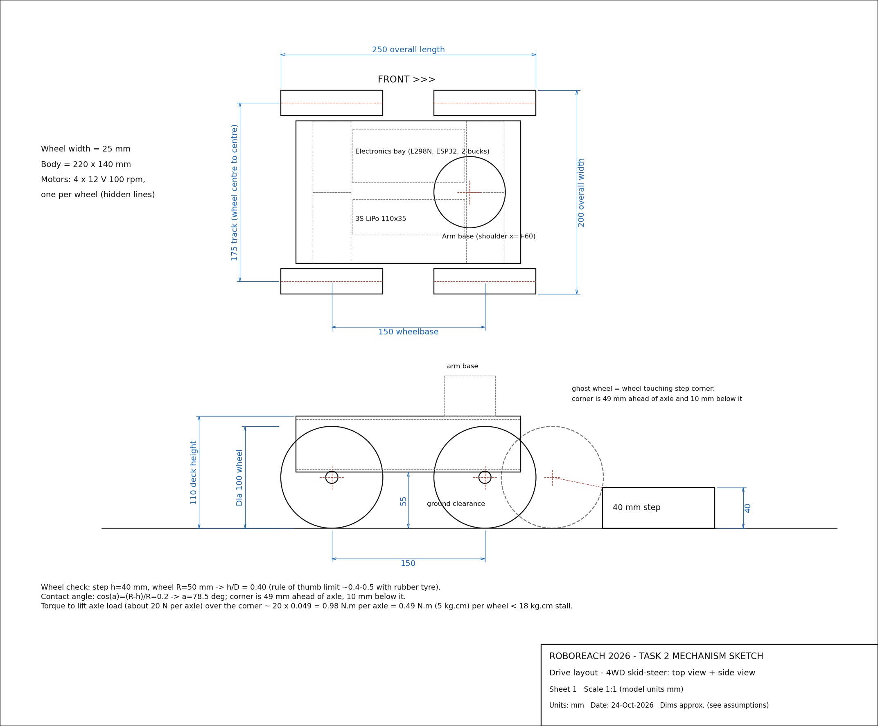

2b. Arm mechanism
The arm must reach an object whose centre is 450 mm above the ground, stay at least 50 mm off the floor, and fold into a 300 x 200 x 300 mm box. It also has to be precise enough for Buzzed (carry a loop along a wire) and Robonardo DaVinci (trace a logo with a marker).
Criterion | Weight % | 2-link revolute | 3-link + wrist | Linear lift + short arm | Telescopic arm
Reach-to-stowed ratio | 20 | 3 | 4 | 2 | 4
Number of actuators (fewer = better) | 10 | 5 | 4 | 3 | 3
Torque on base joint (lower = better) | 15 | 2 | 3 | 5 | 2
Stiffness / low backlash | 10 | 4 | 3 | 5 | 2
Precision for Buzzed & Robonardo | 20 | 2 | 4 | 3 | 2
Build complexity (simpler = better) | 10 | 5 | 4 | 2 | 1
Keeps gripper level / wrist control | 15 | 1 | 5 | 2 | 2
Weighted total (max 5.00) | 100 | 2.85 | 3.90 | 3.05 | 2.40

Winner: 3-link revolute arm with wrist (3.90). Base yaw, shoulder, elbow and wrist pitch plus the gripper servo makes five servos in total, which is exactly what my circuit powers. The wrist is what scores: it keeps the marker perpendicular to the board and the loop level, which a 2-link arm cannot do.
Runner-up: linear lift with a short arm (3.05). A lead-screw lift is stiff and puts almost no torque on a servo, but 450 mm of travel does not fit into a 300 mm start box unless it is a complex multi-stage scissor, and the short arm then has no wrist. Why the others lost: a 2-link arm has no way to keep the gripper level, and a telescopic arm sags, has backlash at full extension and is the hardest to build.

Geometry and checks
- Shoulder height hs = 170 mm: axle height 50 mm + chassis to the 110 mm deck + base servo and bracket (about 60 mm). Link lengths L1 = 180 mm (shoulder to elbow), L2 = 170 mm (elbow to wrist), L3 = 100 mm (wrist to the centre of the gripper jaws). Shoulder sits 60 mm ahead of the robot centre.
- Reach check (Sheet 2): z = hs + L1 sin(t1) + L2 sin(t1 + t2) + L3 sin(t1 + t2 + t3). I choose t1 = 55 degrees. Then L2 must supply 450 - 170 - 180 sin 55 = 132.6 mm, so sin(t1 + t2) = 0.780 and t1 + t2 = 51.2 degrees (t2 = -3.8 degrees). The wrist is set to t3 = -51.2 degrees so the gripper is horizontal, adding 0 to the height. Result: z = 170 + 147.4 + 132.6 + 0 = 450.0 mm.
- Horizontal reach: 310 mm from the shoulder, which puts the jaws about 245 mm beyond the front wheel edge, enough to reach the box and the raised platforms.
- Folded (Sheet 2): L1 points backwards along the deck, L2 folds back over it, and L3 folds back again (a Z-fold). The folded arm is about 250 mm tall and 250 mm long, inside the 300 x 300 envelope, and nothing hangs below the 55 mm chassis clearance. Reach-to-stowed ratio = total link length 450 mm / folded length about 250 mm = 1.8.
- Joint torques, working pose (assumed masses: link 30 g each, MG996R 55 g at elbow and wrist, gripper assembly 90 g, payload up to 50 g):
Joint | Servo | Torque needed | Servo stall @ 6 V | Share of stall
Shoulder (worst joint) | MG996R | 0.61 N.m = 6.2 kg.cm | 11 kg.cm | 57 %
Elbow | MG996R | 0.31 N.m = 3.2 kg.cm | 11 kg.cm | 29 %
Wrist | MG996R | 0.09 N.m = 1.0 kg.cm | 11 kg.cm | 9 %
Base yaw | MG996R | very small (low inertia, no weight lever) | 11 kg.cm | < 10 %

- The shoulder is the weak spot: at 57 % of stall it works, but with only a 1.8 safety factor. If the arm were stretched out straight and horizontal the shoulder would need 9.8 kg.cm (89 % of stall), so I will limit the shoulder in firmware and keep heavy movements close to the body. If trials show it is too hot, a torsion spring across the shoulder takes about half the load.
- Backlash and precision: metal-gear servos have about 1 degree of play, which is about 8 mm at the full 450 mm reach. For Buzzed and Robonardo I will work with the arm folded in closer and move the wrist in small slow steps, which cuts the error to a few millimetres. A ball-bearing digital servo at the shoulder and elbow is the upgrade if needed.

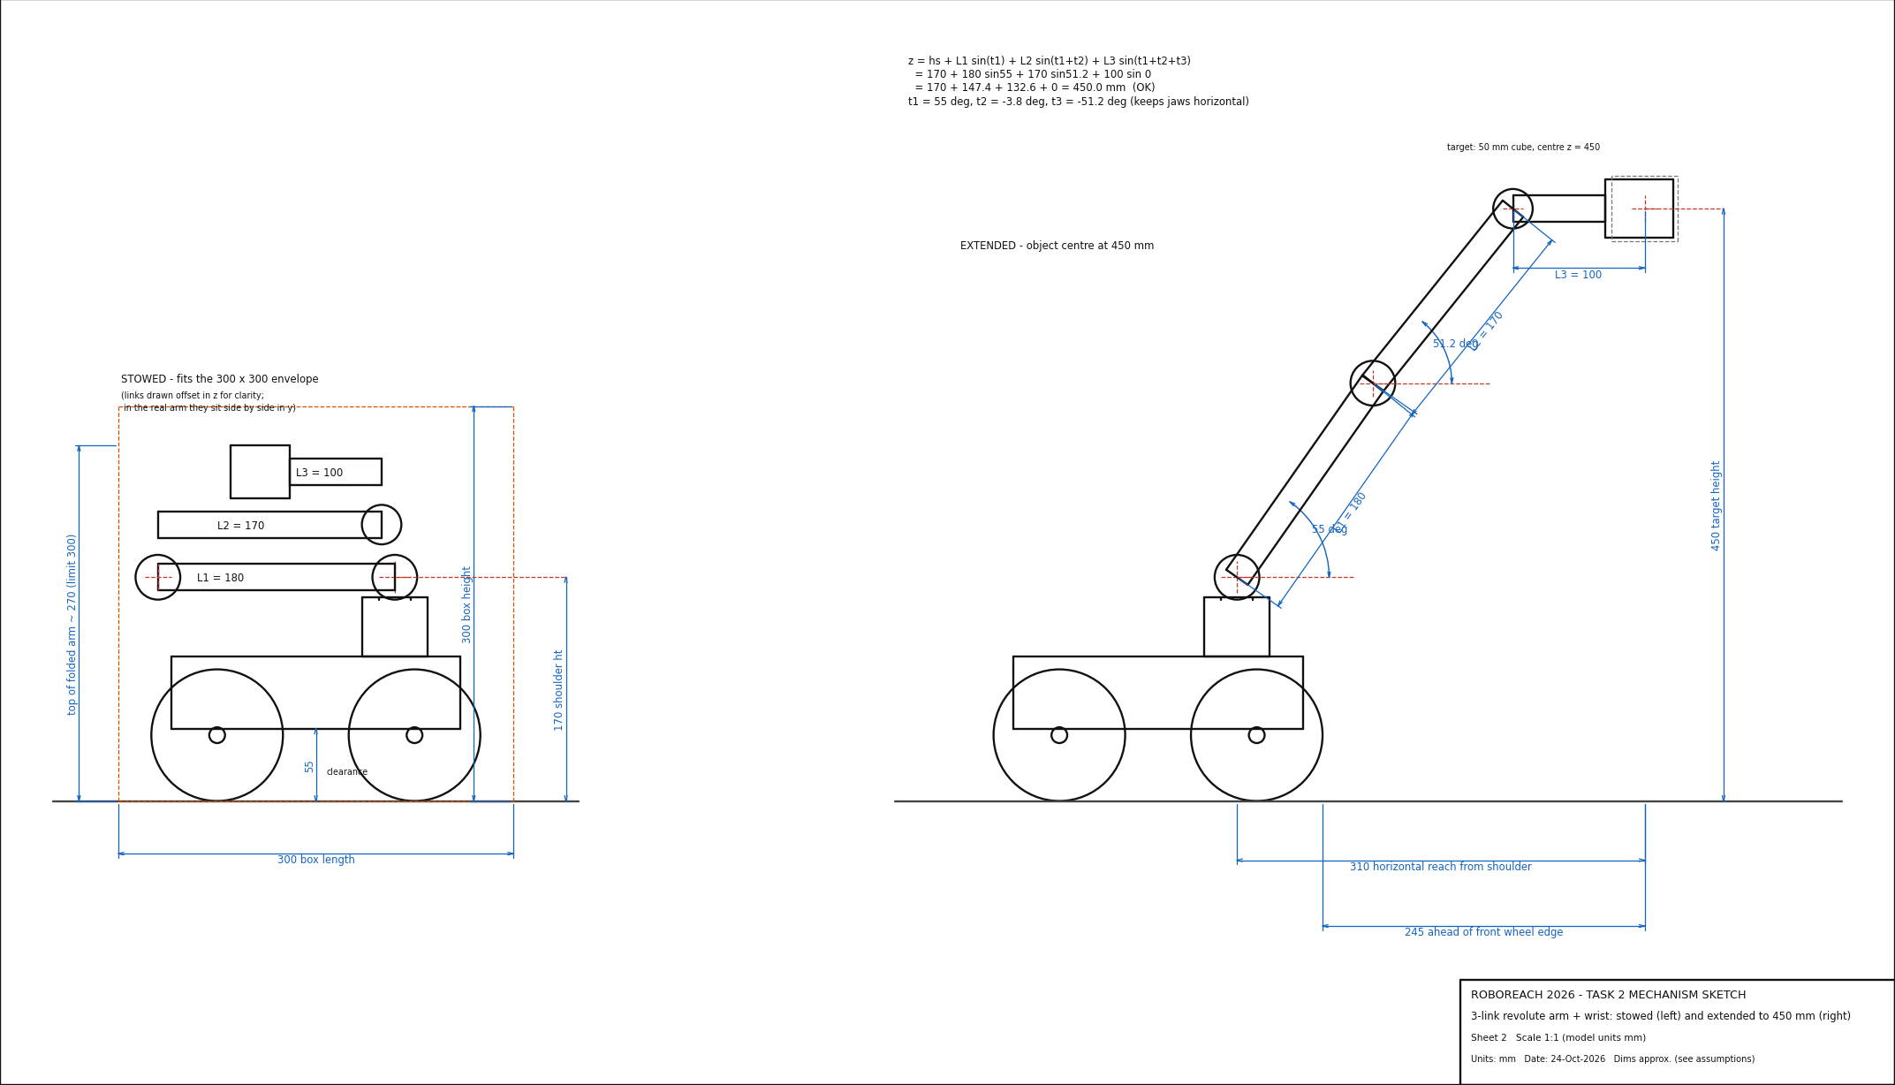
Sheet 2 - Arm stowed (inside the 300 x 300 box) and extended to the 450 mm target (file: sheet2_arm_stowed_extended.dxf).

2c. Gripper mechanism
The gripper must handle a 50 mm and 60 mm cube, a dia 60 x 80 mm cylinder, a cone (base dia 60, height 100), a marker and a loop with a handle, with no adhesives, magnets, hooks or suction.
Criterion | Weight % | Parallel jaw: rack & pinion | Parallel jaw: lead screw | Two-finger linkage | Adaptive fingers | Scoop / fork
Handles all objects (cubes, cylinder, cone, marker, loop) | 25 | 4 | 4 | 3 | 5 | 2
Self-centres a slightly misaligned object | 15 | 5 | 4 | 3 | 3 | 2
Works with a small servo (MG90S) | 15 | 4 | 3 | 3 | 3 | 5
Holds without slipping | 15 | 4 | 5 | 3 | 5 | 2
Light weight | 10 | 4 | 2 | 5 | 2 | 5
Easy to build / print | 10 | 4 | 2 | 4 | 2 | 5
Fine precision (marker, loop handle) | 10 | 4 | 5 | 3 | 2 | 1
Weighted total (max 5.00) | 100 | 4.15 | 3.70 | 3.30 | 3.50 | 2.95

Winner: parallel-jaw gripper with rack and pinion (4.15). One pinion on the servo horn drives two racks in opposite directions, so the jaws always close symmetrically around the middle. That centres the object automatically, which helps when I am a few millimetres off.
Runner-up: parallel jaw with a lead screw (3.70). It holds very firmly because a screw is self-locking and it is precise, but it needs a continuous-rotation motor or extra gearing, is slower and is heavier at the end of the arm. Why the others lost: the adaptive fingers are great on odd shapes but are complicated to print and soft in precision tasks; a linkage gripper changes force with opening; a scoop cannot hold the marker or the loop.

Design details
Object | How the gripper holds it
50 mm and 60 mm cubes | Flat silicone pads on both jaws; opening range 7 to 76 mm gives about 8 mm of play each side for the 60 mm cube
Dia 60 x 80 mm cylinder, cone | V-groove cut in each pad: touches in two lines per jaw and centres the round shape; cone is gripped near its middle where it is about 30 to 45 mm wide
Marker (about 15 mm) | Closes down to the 7 mm minimum gap, so the V-grooves pinch the barrel
Loop with handle | Jaws close on the handle (I assume at least 10 mm rod); the loop stays rigid because the handle is held between two pads

- Actuator: one MG90S micro servo (13 g, 2.2 kg.cm at 6 V), the gripper servo already on my circuit. The pinion is module 1 with 22 teeth (pitch diameter 22 mm, radius 11 mm).
- Stroke: each jaw moves pi x r = pi x 11 = 34.6 mm for the 180 degree servo sweep, so the total opening runs from about 7 mm (closed) to 76 mm (open), pad face to pad face.
- Force available: servo torque 2.2 kg.cm = 0.216 N.m, so force at the rack F = T / r = 0.216 / 0.011 = 19.6 N per jaw.
- Force needed: a 60 mm thermocol cube weighs only about 4 g (density about 20 kg/m3). I design for a heavy 50 g object and a safety factor of 2: 2 x mu x N >= 2 m g with mu = 0.4 (very conservative for silicone on thermocol) gives N >= 2 x 0.05 x 9.81 / (2 x 0.4) = 1.2 N per jaw. The servo can give about 16 times that, so I limit the closing angle in software and let the soft pad squeeze the thermocol gently rather than crush it.
- Anti-slip and no damage: 3 mm silicone (or EVA foam) pads 50 mm long on the inner faces; the large contact area keeps the pressure low on thermocol. The grip comes from friction on two faces plus the V-groove shape, never from the object being clamped hard.
- On link loss: the rules say the gripper stays where it was. My firmware stops updating the servo command but keeps sending the last pulse, so the jaws keep their position and the object is not dropped.

