MEGAMART SUPERMARKET CHAIN
PROJECT REPORT
Submitted by
Ishika Srivastava
Data Engineer - I

1. Executive Summary
The MegaMart Supermarket Chain project is an end-to-end data engineering and business intelligence solution developed to transform supermarket operational data into useful business insights. The project covers data generation, data-quality handling, analytical preparation in Databricks, and visualization in Power BI.
The business scenario represents five MegaMart stores operating across Hyderabad. The project focuses on sales performance, store comparison, inventory optimization, procurement decisions and supplier performance. The final reporting layer is divided into three Power BI pages so that management can view each business area independently.
The completed dashboard contains executive KPIs, store revenue analysis, market-share analysis, monthly sales trends, product/category performance, inventory turnover, supplier delivery metrics and procurement status.

Project at a Glance
Area | Implementation
Business | MegaMart five-store supermarket chain
Data period | 2024
Stores | 5
Products | 14
Core datasets | Stores, Products, Sales, Inventory, Suppliers, Purchase Orders
Engineering platform | Databricks
Visualization platform | Power BI
Dashboard pages | Retail Store Analysis; Sales Analysis; Inventory & Supply Chain

Overall Objective
The main objective is to demonstrate how raw operational data can be converted into validated, structured and decision-ready information through an integrated SQL/Python data-engineering workflow and a business dashboard.

2. Business Context, Objectives and Scope

2.1 Business Context
The project brief describes MegaMart as a five-store supermarket chain operating across Hyderabad. The business faces challenges related to inventory management, sales-performance variation, supplier visibility, fragmented information and the need for better customer and product analysis.
Store ID | Store Name | Location
1 | HITEC City Store | HITEC City
2 | Banjara Hills Store | Banjara Hills
3 | Ameerpet Store | Ameerpet
4 | Kukatpally Store | Kukatpally
5 | Dilsukhnagar Store | Dilsukhnagar

2.2 Project Objectives
- Build a structured representation of supermarket data.
- Load and validate source data and identify data-quality problems.
- Use SQL for joins, aggregation and analytical calculations.
- Use Python for data generation and ETL/data-quality processing.
- Prepare analytical datasets for reporting.
- Create an interactive dashboard that communicates business insights clearly.

2.3 Scope
The scope includes data integration and schema work, data loading and validation, sales-performance analysis, inventory optimization, store comparison and dashboard/report development. The project therefore combines technical data-engineering tasks with business-facing analytics.

3. Dataset and Data Quality

3.1 Dataset Structure
Dataset | Purpose | Representative Fields
Stores | Store master information | store_id, store_name, location, manager_name
Products | Product catalogue | product_id, product_name, category, unit_price
Sales Transactions | Sales activity | transaction_id, store_id, product_id, quantity_sold, total_amount, sale_date
Inventory | Stock information | inventory_id, store_id, product_id, quantity_on_hand
Suppliers | Supplier master | supplier_id, supplier_name, contact_person, phone
Purchase Orders | Procurement and delivery | po_id, supplier_id, order_date, delivery_date

3.2 Data Generation
The supplied Python generator creates the six core CSV datasets. It defines five stores, fourteen products and five suppliers and generates transaction, inventory and purchase-order records for the 2024 period.

3.3 Intentional Data-Quality Issues
- Duplicate sales transactions are introduced intentionally.
- A store manager value is missing.
- Product pricing includes invalid negative/zero values.
- Supplier phone numbers use inconsistent formats.
- Inventory contains out-of-stock situations.
- Purchase orders can have pending delivery dates.

3.4 Quality Handling
The appropriate engineering response is to detect duplicates before aggregation, validate required fields, check numeric ranges, standardize contact fields, distinguish pending deliveries from completed deliveries, and validate relationships between stores, products, sales, inventory and suppliers.

4. Databricks Data Engineering Workflow

4.1 End-to-End Workflow
- Generate or receive raw CSV data.
- Load source files into the Databricks environment.
- Inspect schemas and sample records.
- Validate missing values, duplicates and invalid values.
- Clean and standardize data where required.
- Join related datasets and create analytical summaries.
- Create KPI-oriented datasets for store, sales, inventory and supplier analysis.
- Connect the analytical data to Power BI.
- Build and validate the final dashboard.

4.2 Analytical Tables
Table / Dataset | Role in Dashboard
store_kpi_summary | Store revenue, transaction, product and market-share KPIs
supplier_scorecard | Supplier delivery and on-time performance
reorder_recommendations | Inventory procurement and reorder logic
Sales/Product summaries | Monthly, category and product sales analysis

4.3 Why Databricks?
Databricks provides a single environment for notebook-based data processing and analytics. In this project it acts as the engineering layer between raw operational data and the Power BI reporting layer, allowing the data to be prepared before visualization.

4.4 Engineering Outcome
The result is a set of business-ready datasets rather than a dashboard built directly on unprocessed raw files. This makes the reporting layer easier to understand and reduces the risk of incorrect aggregation.

5. Power BI Dashboard Architecture

5.1 Dashboard Structure
The Power BI report was deliberately divided into three pages. Each page has one primary business purpose and contains only the visuals required to answer that page's questions.
Page | Purpose | Main Visuals
Page 1 — Retail Store Analysis | Compare overall store performance | 4 KPI cards, Revenue by Store, Market Share, Store Performance Overview
Page 2 — Sales Analysis | Understand sales trends and product contribution | Monthly Revenue Trend, Category Revenue, Top 5 Products, Product Revenue Performance
Page 3 — Inventory & Supply Chain | Monitor stock risk and suppliers | 3 KPI cards, Inventory Turnover, Supplier Delivery Rate, Supplier Delivery Time, Procurement Status

5.2 Dashboard Design Principles
- KPI cards are placed at the top for rapid scanning.
- Charts are arranged in logical left/right groups.
- Horizontal bars are used for store and supplier comparisons.
- Trend information is given a wide visual area.
- Procurement composition is represented with a donut chart.
- Large detailed tables were replaced by more compact visuals where appropriate.

5.3 Interactivity
Store selection and standard Power BI visual interactions allow users to explore the report. Filters can be used to focus the analysis on selected stores or procurement states where applicable.

6. Dashboard Page 1 — Retail Store Analysis
The Retail Store Analysis page is the executive store-performance view. It starts with four headline KPIs and then provides comparative store visuals.

6.1 Layout
Position | Visual
Top row | Total Revenue | Total Transactions | Average Transaction Value | Unique Products Sold
Middle left | Revenue by Store
Middle right | Market Share by Store
Bottom | Store Performance Overview

6.2 KPI Results
KPI | Displayed Result
Total Revenue | 1.18M
Total Transactions | 1.992K
Average Transaction Value | 592.83
Unique Products Sold | 14

6.3 Interpretation
The Revenue by Store chart shows Banjara Hills Store at the top of the displayed ranking, followed closely by Ameerpet and Dilsukhnagar. HITEC City has the lowest displayed revenue among the five stores.
The Market Share donut indicates that revenue is relatively evenly distributed across the five stores. This is useful because it shows that MegaMart is not dependent on a single dominant location.
The Store Performance Overview adds another perspective by comparing transaction activity with revenue. This helps management identify stores that generate similar revenue through different levels of transaction activity.
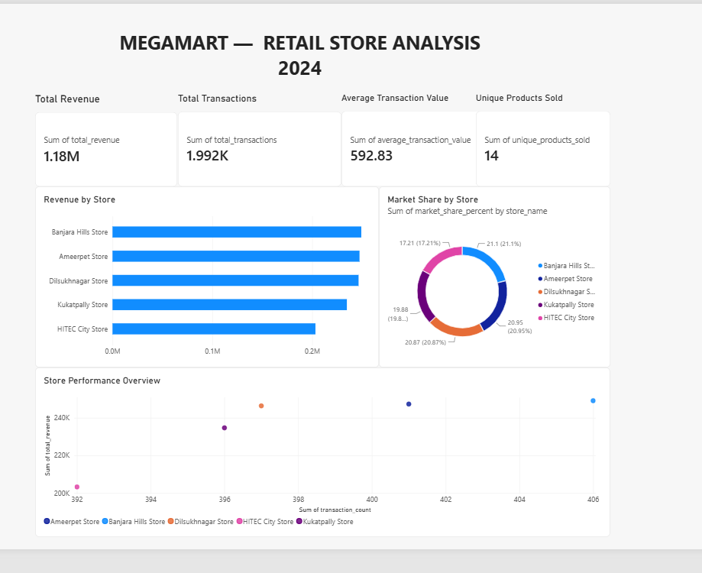
Figure 1 — Retail Store Analysis dashboard

7. Dashboard Page 2 — Sales Analysis
The Sales Analysis page focuses on the movement of revenue over time and the contribution of categories and individual products.

7.1 Layout
Position | Visual
Top | Monthly Revenue Trend — 2024
Middle left | Revenue by Product Category
Middle right | Top 5 Products by Quantity Sold
Bottom | Product Revenue Performance

7.2 Monthly Revenue Trend
The line chart displays all twelve months of 2024. The trend shows several periods of growth and decline, with a pronounced fall around September followed by recovery toward the end of the year.

7.3 Category and Product Analysis
The category chart shows Groceries as the largest displayed revenue contributor, followed by Cooking Oil and Dairy. This provides a high-level view of which product groups drive sales.
The Top 5 Products by Quantity Sold chart highlights high-volume products such as Chili Powder 100g, Basmati Rice 5kg, Biscuits Mix 200g, Lays Chips 40g and Soap 125g in the displayed result.

7.4 Business Value
Together, the trend, category and product visuals allow management to identify periods requiring investigation, categories requiring continued attention and high-volume products whose availability can influence customer satisfaction.
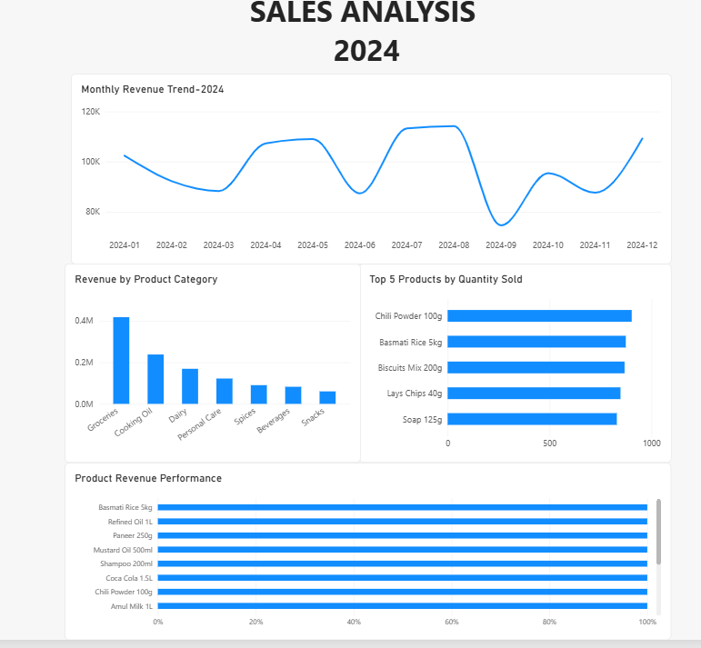
Figure 2 — Sales Analysis dashboard

8. Dashboard Page 3 — Inventory & Supply Chain
The Inventory & Supply Chain page is designed for procurement and inventory decisions. It combines stock-risk indicators with supplier performance and procurement status.

8.1 KPI Cards
KPI | Current Display
Out of Stock Products | 5
Low Stock Products | 1
Reorder Required | 6
The Reorder Required value is based on a distinct product count across the REORDER and URGENT REORDER recommendation states used in the dashboard.

8.2 Operational Visuals
- Inventory Turnover by Store — compares turnover across the five stores.
- Supplier On-Time Delivery Rate — compares supplier delivery reliability.
- Supplier Average Delivery Time — compares supplier delivery speed.
- Procurement Status — shows the share of products in NO ACTION, URGENT REORDER and REORDER states.

8.3 Business Interpretation
The inventory chart shows Dilsukhnagar with the highest displayed turnover, followed by HITEC City, Banjara Hills, Ameerpet and Kukatpally.
The procurement donut shows that most displayed product recommendations are NO ACTION, while smaller portions require urgent or normal reorder action. This gives procurement teams an immediate view of the overall workload.
Supplier visuals provide a second layer of decision support by helping management compare delivery reliability and delivery time before making supplier or replenishment decisions.
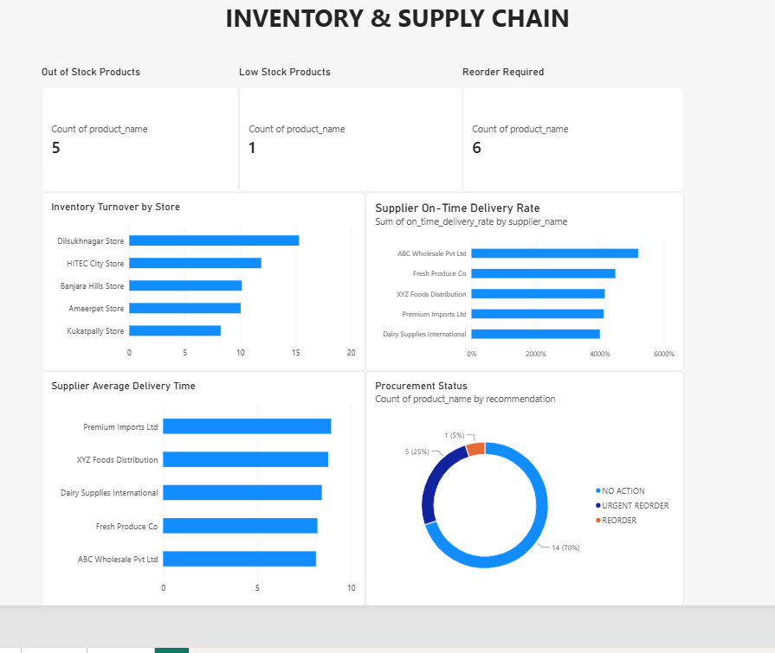
Figure 3 — Inventory & Supply Chain dashboard

9. Business Findings and Requirement Coverage

9.1 Key Business Findings
- Total displayed revenue is approximately 1.18M across the reporting period.
- Total displayed transactions are approximately 1.992K.
- Average transaction value is displayed as 592.83.
- The five stores have relatively close revenue levels, with Banjara Hills leading the displayed ranking.
- Market share is relatively balanced across the five stores.
- Revenue changes substantially by month, with a visible September decline and later recovery.
- Groceries is the strongest displayed revenue category.
- A small group of products accounts for the highest quantities sold.
- Dilsukhnagar has the highest displayed inventory-turnover value.
- The procurement view identifies products requiring no action, reorder and urgent reorder attention.

9.2 Requirement Coverage
Requirement | Status | Comment
Data integration & schema | Substantially addressed | Core entities and analytical datasets prepared
Data loading & validation | Substantially addressed | Intentional data-quality issues identified and handled
Sales performance analysis | Completed | Sales page contains trend, category and product analysis
Inventory optimization | Completed at dashboard level | Stock, turnover, supplier and procurement visuals included
Store performance dashboard | Substantially addressed | Retail page completed
Power BI dashboard | Completed | Three business-focused pages created
Technical documentation | Completed | Detailed report prepared
Year-over-Year Growth | Not demonstrated | Current source data is 2024-only

9.3 Final Technical Correction
The Supplier On-Time Delivery Rate visual should be checked before final submission because the current screenshot displays values on a percentage scale reaching several thousand percent. The measure/aggregation should be corrected so the visual represents a normal 0%–100% rate.

10. Conclusion, Deliverables and Final Checklist

10.1 Conclusion
The MegaMart project demonstrates a complete practical workflow from raw supermarket data to business intelligence reporting. Databricks provides the data-engineering and analytical preparation environment, while Power BI provides the management-facing visualization layer.
The final report is organized around three clear business questions: how the stores are performing, what is driving sales, and where inventory or supply-chain attention is required. This structure makes the dashboard easier to interpret than a single page containing every metric.
The project successfully demonstrates the major SQL/Python data-engineering and dashboard-development themes described in the capstone. The final quality pass should focus on the supplier percentage formatting and, if required by the evaluator, providing or documenting a prior-year dataset for YoY growth.

10.2 Final Deliverables
Deliverable | Status
Python data-generation script | Prepared
Raw/sample datasets | Generated
Databricks processing / analytical work | Completed during project
Analytical summary datasets | Used in Power BI
Power BI three-page dashboard | Completed
Detailed project report | Completed
Dashboard screenshots | Included in this report
Final validation | One formatting check + YoY requirement review

10.3 Final Submission Checklist
- Save/export the final Databricks notebooks and SQL scripts.
- Keep the generated CSV files or source-data location available if required.
- Correct the Supplier On-Time Delivery Rate percentage formatting.
- Confirm the Power BI report is saved/published after the final correction.
- Keep the three final dashboard screenshots.
- Confirm whether the evaluator requires an actual YoY metric; if yes, add prior-year data before submission.
- Submit this project report together with the technical artifacts requested by the capstone.

10.4 Final Statement
MegaMart now has a structured analytical reporting solution capable of supporting store-performance review, sales analysis, inventory monitoring and supply-chain decision-making. The project provides a strong end-to-end demonstration of data engineering combined with business intelligence.

