OCEANUS.COM

UNIVERSITY OF RWANDA

COMPUTER AND SOFTWARE ENGINEERING

WEB TECHNOLOGY

PROJECT NAME: OCEANUS.COM

PURPOSE: ECOMMERCE AND ONLINE MARKETING

REGISTRATION NUMBER: 222008650

NAME: ISHIMWE FRANK

OCEANUS.COM

Table of content

1.overview

2.Introduction

3.Problem specification

4.Objectives

   4.1. General objectives

   4.2. Specific purpose

5.Functionality

6.Design

   6.1. Flow chart

   6.2. ERD (Entity Relationship Diagram Model)

7.Implementation

8.References

**OVERVIEW**

This is the report for website which name called [oceanus.com](http://oceanus.com/" \t "_blank) which are intended for ecommerce and online marketing this report will show your different component of the website and describe it with more information about it. Different components of this website include the following:

-Header section

-Footer section

-User account

-User login

-Market Categories

The purpose of this report is provide you the information about this website and it explain for you how it works and show you some contents that include in it.

So, I think if you read this report of the website, I hope it give you more information and guide you when you use this website.

**1.Introduction**

Introduction:

Welcome to  [OCEANUS.COM](http://oceanus.com/" \t "_blank) our website for Ecommerce and Online Marketing that enable to sell and buy things online and making the advertising of them, a versatile platform that empowers users to engage in a world of digital commerce and marketing opportunities. Our website is designed to cater to the diverse needs of both buyers and sellers, providing a seamless online marketplace experience, and to provide chance for buyers who want to buy things online to get more choice due to more competition of many sellers on our website.

In an era where the digital landscape is reshaping the way we do business, our platform offers a gateway for individuals and businesses to thrive in the ecommerce and online marketing sector. Whether you're looking to buy, sell, or explore various markets, we've got you covered.

Our website boasts an intuitive page layout with a user-friendly header featuring our distinctive logo, quick access to account creation, and dedicated login options for buyers and sellers. Additionally, we offer robust search functionality, enabling users to effortlessly find their desired products or markets.

In the footer section, you'll discover a diverse array of markets to explore, each catering to different needs. From the Stock Market for financial enthusiasts to the Commodity Market for those interested in consumer goods, our platform provides a range of options. The Financial Market offers banking services, while the Special Market enables trade in commodities with specific ownership requirements. The Command Market allows buyers to specify product characteristics, and the Forex Market facilitates currency exchange.

This report delves into the website's layout, key features, and user experience, providing insights into how we facilitate digital commerce and online marketing. We invite you to explore our website further and learn about the exciting opportunities that await you in the world of ecommerce and online marketing.

**2.PROBLEM SPECIFICATION**

Problem the website wants to solve:

. today ecommerce platform have only one seller which limit the choice for buyer and reduce the competition among the seller which increase the price, and when buyer buy the products on it , sometime delivery time become long and sometimes it deliver the product to buyer after time and sometime deliver poor quality products which do not meet with the buyer need and because there no way for buyer to talk with the seller, the ignored by that problem and sometime the buyers want the emergency products and because  of the long delivery time, they do not that products on time which lead to problems sometime.

**3.OBJECTIVE OF MY WEBSITE**

**3.1. GENERAL OBJECTIVE OF MY WEBSITE**

The general objective is to facilitate online commerce and promote products or services effectively in the digital real world and it have more objectives which include the following objective:

**. Facilitating Transactions**: Providing a platform where businesses can showcase and sell their products or services to a global or broader audience.

. **Expanding Market Reach**: Breaking down geographical barriers and allowing businesses to reach customers beyond their physical locations.

. **Enhancing User Experience**: Creating user-friendly interfaces that make it easy for customers to find, explore, and purchase products or services.

. **Offering many secure Payment Options**: Providing secure and convenient payment methods to cater to customer preferences.

**. Ensuring Data Security**: Implementing robust security measures to protect customer data, transactions, and privacy.

. **Effective Online Marketing**: Supporting businesses in promoting their offerings through online marketing strategies, including SEO, social media, email marketing, and paid advertising.

. **Measuring and Analyzing Performance**: Providing tools and analytics to track user behavior, sales data, and marketing campaign effectiveness.

. **Improving Conversion Rates**: Optimizing the user journey, checkout process, and product presentation to increase the percentage of visitors who complete desired actions, such as making a purchase.

. **Building Customer Loyalty**: Encouraging repeat business through strategies like customer reviews, loyalty programs, and personalized recommendations.

. **Streamlining Operations**: Automating and streamlining various aspects of ecommerce operations, such as inventory management, order processing, and customer support, to improve efficiency and reduce costs.

. **Adapting to Mobile and Technology Trends**: Ensuring that the platform is mobile-responsive and staying updated with technological advancements to meet the changing needs of users.

**. Compliance with Regulations**: Adhering to legal and regulatory requirements related to online business operations, data protection, and consumer rights.

**. Stay Competitive**: Staying innovative and competitive in the dynamic ecommerce and online marketing landscape by continuously evolving and offering unique value to customers.

**3.2 THE SPECIFIC OBJECTIVE**

The primary objective of our website is to address the limitations and challenges present in traditional ecommerce platforms by establishing a user-friendly and effective online marketplace that connects buyers and sellers.

Our platform seeks to provide a seamless experience for ecommerce and online marketing, with a focus on reducing delivery times, enhancing communication between buyers and sellers, and fostering a sense of community among users.

**CHALLENGES AND ISSUES TO ADDRESS**

1.**Limited Seller Choice and Competition**

**Challenge**

Current ecommerce platforms featuring only one seller limit buyer choice and hinder healthy competition.

**Issue**

Reduced choice for buyers and potentially higher prices due to the lack of competition.

**2.Delivery Time and Quality Assurance**

**Challenge**

. Lengthy delivery times,

. inconsistent product quality,

. and missed delivery deadlines.

**Issue**:

 Frustration among buyers due to delayed or poor-quality products.

**3.Communication Gaps**

**Challenge**

 Absence of effective communication channels between buyers and sellers.

**Issue**

Limited ability for buyers to discuss orders, resolve issues, or inquire about products with sellers.

**4.Community Building**

**Challenge**

 Lack of a sense of community among users.

**Issue**

. Users are unable to share experiences,

. exchange product recommendations,

. or seek advice from fellow buyers or sellers.

**Solution Planned to apply for that problem**

To address these challenges and issues, our approach involves the following key strategies:

**1.Multiple Sellers and Enhanced Competition:**

**Solution**

On our platform:

. we will facilitate multiple sellers,

. promoting competition

. expanding buyer choice.

**2.Streamlined Delivery and Quality Control**

**Solution**

. We will implement measures to reduce delivery times and ensure consistent product quality.

. Monitoring and quality assurance processes will be put in place to meet delivery deadlines and maintain product standards.

**3.Effective Communication Channels**

**Solution**

. Our platform will feature chat rooms for direct communication between buyers and sellers, allowing them to discuss orders, resolve issues, and inquire about products in real time.

We will also create chat rooms for buyers to share experiences and recommendations and for sellers to interact with each other.

**4.Community Engagement**

**Solution**

 We will encourage community building by providing spaces for users to engage in discussions, share insights, and create a sense of belonging within our platform.

**4.FUNCTIONALITY**

My website has many features which enable it to accomplish it purpose and to the identified the problem, so here I am going to explain you the functions and the role of each feature.

1. **Landing Page and Header**

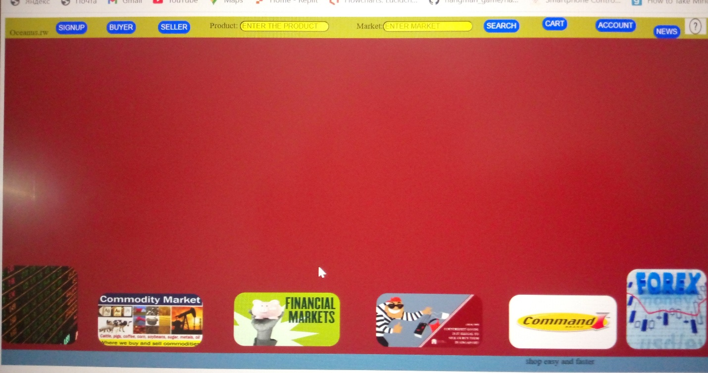

The landing page features a header that serves as the main navigation for the website.

The header includes the following features:

**Website Logo**: Clicking on the website logo redirects users to the website dashboard.

**SIGNUP** Button: Clicking this button leads to a page where users can enter the required information to create an account as either a seller or buyer.

**BUYER** Button: This button allows users to log in as a buyer.

**SELLER** Button: This button allows users to log in as a seller.

**SEARCH**Button: Users can use this button to perform quick product or market research.

**ACCOUNT** Button: Clicking on this button reveals user information, including account history, balance, transactions, and settings.

**Cart** Button: This button represents the shopping cart.

**Help**: This section provides assistance for problem-solving and offers other relevant information.

II. Footer:

The footer of the website includes different market categories, each providing access to specific sections of the platform:

**1.Stock Market**: Users can access a page with information on global stock markets, enabling them to trade financial assets worldwide.

**2.Commodity Market**: Access to various consumer products for trading.

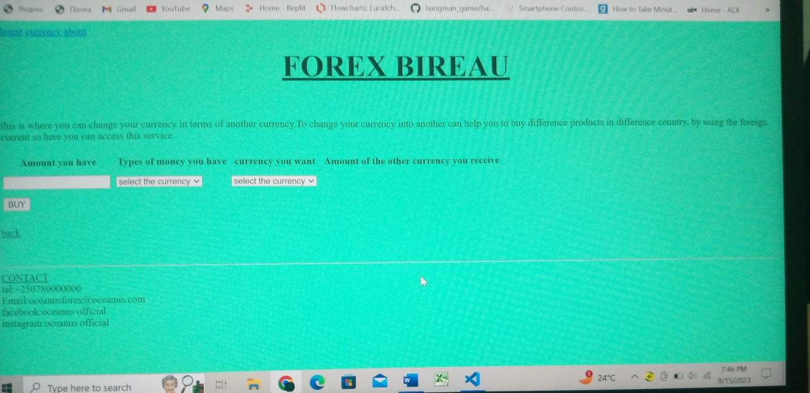

**3.Financial Market**: Access to different financial institutions and services.

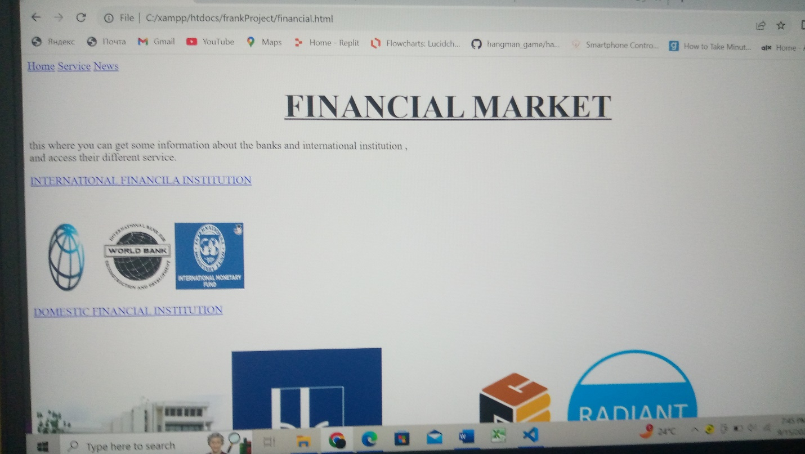

**4.Special Market**: A section for trading products that require legal documents.

**5.Command Market**: A space for buyers to specify key features of the products they want from sellers.

**6.Forex**: A section where users can exchange one currency for another.



III. USER ACCOUNTS:

The website allows users to create two primary account types: "seller" and "buyer."

**IV. SELLER Account**:

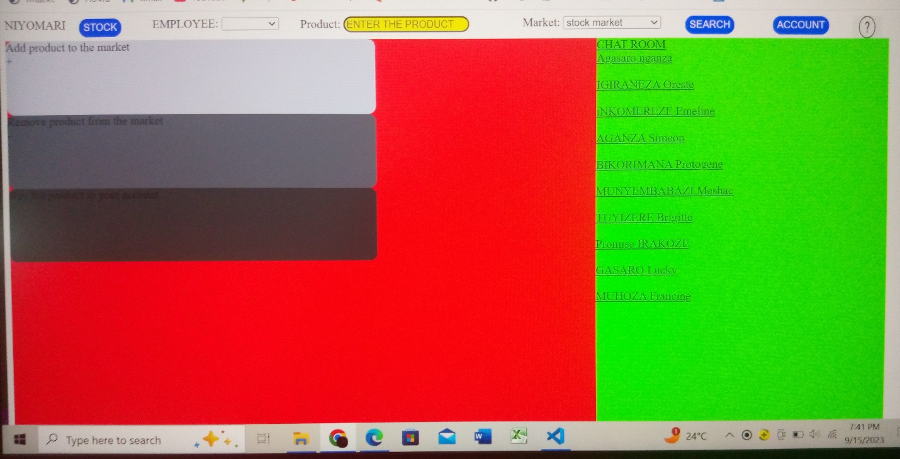

When logged in as a seller, users have access to the following features:

**1.Profile**: Displaying pictures and names of the seller.

**2.STOCK Button**: Leads to a page displaying all products in stock with detailed information organized in a table.

**3.List of Workers and Suppliers**: Lists the seller's employees and suppliers.

**4.ACCOUNT Button**: Provides a summary of transactions and account history.

**5.Chat Room**: Enables communication with customers and other sellers.

**6.Add Product Button**: Allows sellers to add new products to their stock.

**7.Remove Product Button**: Enables sellers to remove products from their stock.

**V. BUYER ACCOUNT**:

When logged in as a buyer, users have access to the following features:

**1.Profile**: Displaying the buyer's picture and full name.

**2.SEARCH Button**: Allows quick research of products or markets.

**3.ACCOUNT Button**: Provides access to user information, including account history, balance, transactions, and settings.

**4.Cart Button**: Represents the shopping cart.

**5.Help**: Offers assistance for problem-solving and additional information.

**6.Market Categories**: Provides access to different market sections including:

 . Stock Market

. Commodity Market,

. Financial Market,

. Special Market,

. Command Market

. Forex.

**VI. Footer Slogan**

The footer includes a dynamic phrase: "SHOP EASY AND FASTER," which serves as the website's slogan.

**6. DESIGN**

**ERD**

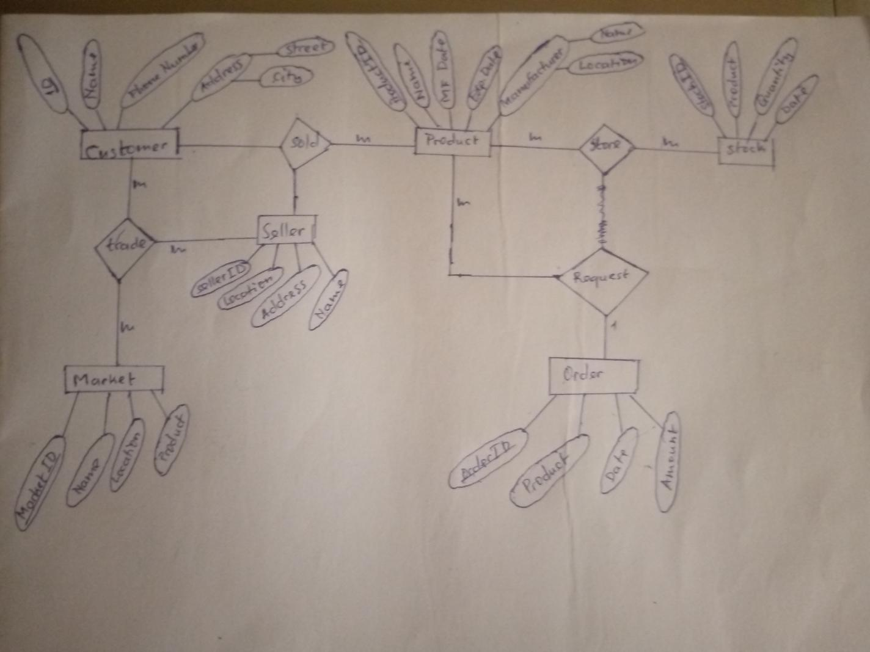

**7. IMPLEMENTATION**

In this section, we will delve into the implementation details of the Oceanus.com website, outlining how each of the identified features and functionalities was realized.

**7.1. Landing Page and Header Implementation**

The landing page serves as the gateway to the Oceanus.com platform. The header, a critical navigation element, was implemented to facilitate user interaction. The following components of the header were realized:

**. Website Logo**:

 Implemented as a clickable element that redirects users to the website dashboard.

**. SIGNUP Button**:

 Developed to lead users to a registration page, where they can create their accounts as sellers or buyers.

**. BUYER and SELLER Buttons**:

 Functionality was added to allow users to log in as either a buyer or seller.

**. SEARCH Button**:

 Developed to enable users to perform quick product or market research.

**. ACCOUNT Button**:

Implemented to reveal user information, including account history, balance, transactions, and settings.

**. Cart Button**:

Developed to represent the shopping cart feature.

**. Help**:

Added to provide users with assistance, problem-solving resources, and relevant information.

**7.2. Footer Implementation**

The footer of the website includes links to various market categories, providing users access to specific sections of the platform. Implementation details for each category are as follows:

**1. Stock Market**:

Users can access this section, which displays information on global stock markets, allowing them to trade financial assets worldwide.

**2. Commodity Market**:

Implemented to provide access to various consumer products for trading.

**3. Financial Market**:

Developed to grant users access to different financial institutions and services.

**4.Special Market**:

 Created as a section for trading products that require legal documents.

**5. Command Market**: Developed to allow buyers to specify key features of the products they want from sellers.

**6. Forex**: Implemented as a section where users can exchange one currency for another.

**7.3. User Accounts Implementation**

The Oceanus.com website enables users to create two primary account types: "seller" and "buyer." The implementation of these accounts includes the following:

**Seller Account**:

User profiles were created to display seller pictures and names.

A "**STOCK**" button was implemented to lead sellers to a page displaying all products in stock with detailed information organized in a table.

Lists of workers and suppliers were established for sellers.

An "**ACCOUNT**" button was developed to provide a summary of transactions and account history.

A **chat room** feature was integrated, enabling communication with customers and other sellers.

**ADD AND REMOVE THE PRODUCTS**

Functionality was added to allow sellers to add new products to their stock.

The ability to remove products from the seller's stock was also implemented.

**Buyer Account**:

Buyer profiles were created, displaying the buyer's picture and full name.

A "**SEARCH**" button was developed for quick research of products or markets.

An "**ACCOUNT**" button was implemented, providing access to user information, including account history, balance, transactions, and settings.

The shopping cart feature was realized through the "**Cart**" button.

A "**Help**" section was added, offering assistance for problem-solving and additional information.

**7.4. Footer Slogan Implementation**

Finally, the dynamic footer slogan, "SHOP EASY AND FASTER," was added to convey the website's mission and values, encouraging users to have a seamless and efficient shopping experience.

The implementation of these features and functionalities aligns with the overall objectives of Oceanus.com, aiming to provide a versatile ecommerce and online marketing platform that addresses the identified challenges in the market.

In the next section, we will delve into the references and sources used during the development and implementation of the website to ensure transparency and credibility in our project report.

**CONCLUSION**

In the ever-evolving landscape of digital commerce and online marketing, the development of Oceanus.com represents a significant milestone in the pursuit of providing a versatile and user-centric platform. Through this project, we have endeavored to address several key challenges and offer a dynamic solution that empowers users, fosters competition, and facilitates seamless online interactions.

From the outset, our goal was clear: to create a website that not only simplifies the process of buying and selling but also enhances the overall user experience. By facilitating multiple sellers and encouraging competition, we aimed to provide buyers with an extensive array of options, thereby reducing prices and expanding product choices.

We recognized that timely and reliable product delivery is paramount in online commerce. To this end, our platform incorporates measures to reduce delivery times and maintain consistent product quality, ensuring that buyers receive their orders promptly and in the expected condition. This commitment to customer satisfaction extends to our communication channels, where buyers can engage directly with sellers and fellow users through real-time chat rooms.

In our pursuit of excellence, we have strived to build a sense of community among our users. By offering dedicated market categories tailored to diverse needs and preferences, we have created a space where users can share their experiences, exchange product recommendations, and seek advice from one another. This sense of belonging within the *Oceanus.com* community is a testament to our commitment to enriching the user experience.

Our journey to create *Oceanus.com* has been marked by innovation, dedication, and collaboration. It is a reflection of our determination to remain competitive in the dynamic e-commerce and online marketing landscape. As we move forward, we remain committed to continuous improvement, user-focused enhancements, and staying at the forefront of technological advancements.

In closing, Oceanus.com is more than just a website; it is a digital marketplace designed to empower, connect, and inspire users in their journey through the world of online commerce and marketing.

**8. REFERENCE**

Website: -[www.w3schools.com](http://www.w3schools.com/" \t "_blank)

                -[www.Javatpoint.com](http://www.javatpoint.com/" \t "_blank)

                -[www.khanacademy.com](http://www.khanacademy.com/" \t "_blank)

                -[www.freecodecamp.com](http://www.freecodecamp.com/" \t "_blank)

For more information you visit our github through the following link