
Faculty of Computing and Information Sciences
FINAL PROJECT REPORT

Passport Appointment Booking System
Course: Database Programming
Student: Moïse ISHIMWE
Registration number: 31858/2025
Database Technology: Oracle Database 19c

Instructor: Eric MANIRAGUHA
Submission Date: 15 July 2026
Academic year: 2025-2026

Chapter 1 — Introduction
The Passport Appointment Booking System is an Oracle Database application designed to manage passport application processes efficiently.
The system provides a centralized platform for applicant registration, passport application processing, appointment scheduling, payment management, and application status tracking.
The project demonstrates database design, SQL implementation, PL/SQL programming, security management, auditing, and business rule enforcement using Oracle Database.
Chapter 2 — Problem Statement
Traditional passport application processes may involve long waiting times, manual record management, appointment conflicts, and difficulties tracking application progress.
A computerized database system is required to improve the efficiency of passport services by allowing applicants to submit applications, schedule appointments, and enabling officers to manage applications securely.
Chapter 3 — Project Objectives
To design and implement an Oracle database system for managing passport applications and appointment services.
Specific Objectives:
- Store applicant information securely.
- Manage passport application records.
- Schedule passport appointments.
- Track payments.
- Apply business rules using triggers.
- Implement security using Oracle roles.
- Maintain audit records.
Chapter 4 — System Users
User | Role
Applicant | Submits passport applications and books appointments
Officer | Reviews and processes applications
Administrator | Manages system security and database operations

Chapter 5 — Business Process Modeling
The Passport Appointment Booking System follows a structured workflow where applicants provide their information, submit passport applications, schedule appointments, and receive application status updates. Officers verify applications and process decisions through the system.
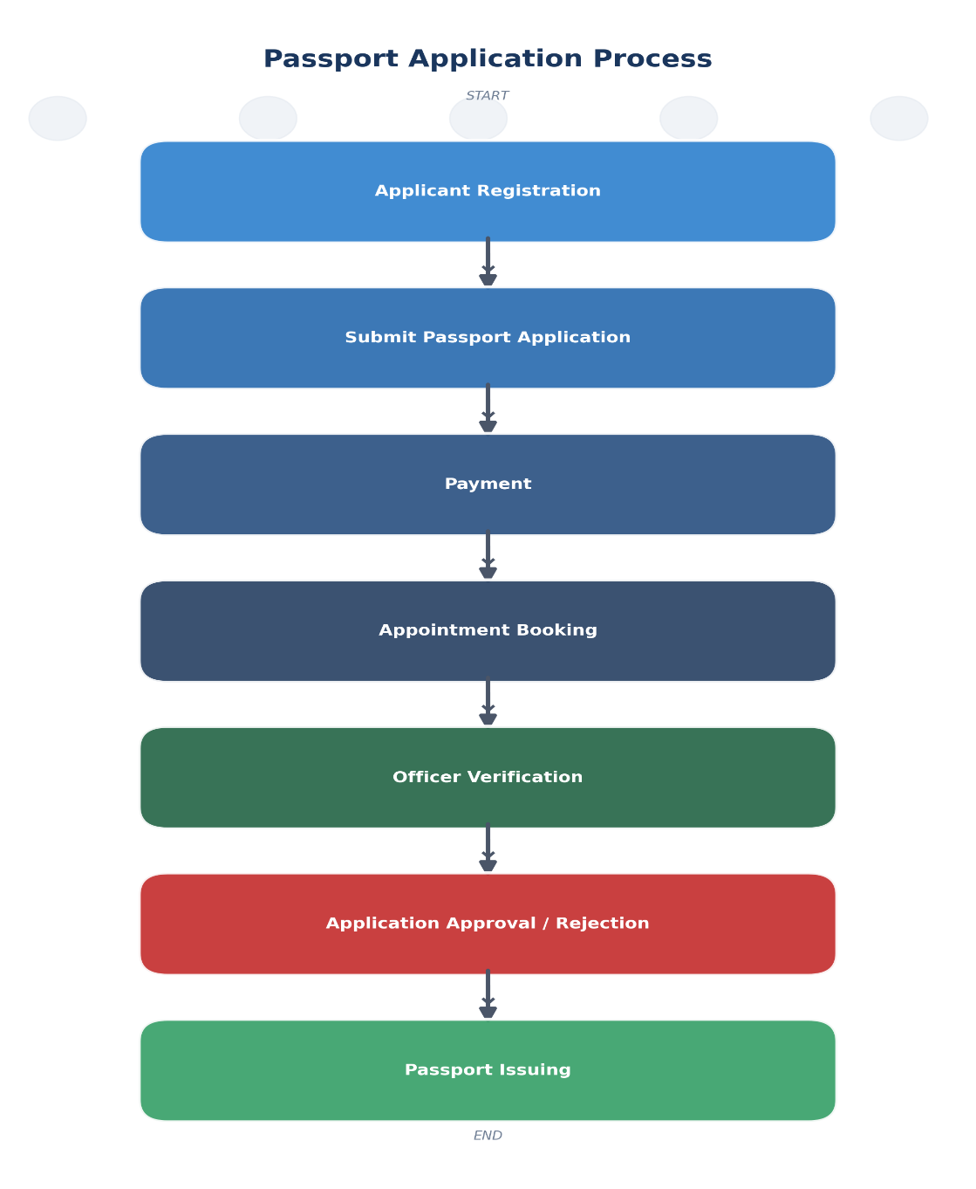
Chapter 6 — Database Design
6.1 Database Overview
The Passport Appointment Booking System database was designed using a relational database model in Oracle Database 19c. The database consists of multiple related entities that store applicant information, passport services, appointments, payments, user accounts, and audit activities.
The database design follows normalization principles up to Third Normal Form (3NF) to reduce data redundancy and improve data consistency.
6.2 Database Entities and Attributes
Entity 1: APPLICANT
Attribute | Description | Key
applicant_id | Unique identifier of applicant | Primary Key
national_id | Applicant national identification number | Unique
first_name | Applicant first name
last_name | Applicant last name
gender | Applicant gender
date_of_birth | Date of birth
phone | Contact number
email | Email address
address | Residential address
created_at | Record creation date

Entity 2: PASSPORT_TYPE
Attribute | Description | Key
passport_type_id | Passport type identifier | Primary Key
type_name | Type of passport
validity_years | Validity period
fee | Passport processing fee

Entity 3: PASSPORT_OFFICE
Attribute | Description | Key
office_id | Passport office identifier | Primary Key
office_name | Office name | Unique
location | Office location
phone | Office contact
email | Office email

Entity 4: OFFICER
Attribute | Description | Key
officer_id | Officer identifier | Primary Key
office_id | Assigned office | Foreign Key
first_name | Officer first name
last_name | Officer last name
position | Job position
phone | Contact
email | Email

Entity 5: PASSPORT_APPLICATION
Attribute | Description | Key
application_id | Application identifier | Primary Key
applicant_id | Applicant reference | Foreign Key
passport_type_id | Passport type reference | Foreign Key
officer_id | Officer reference | Foreign Key
application_date | Date submitted
status | Application status
passport_number | Issued passport number

Entity 6: APPOINTMENT_SLOT
Attribute | Description | Key
slot_id | Slot identifier | Primary Key
office_id | Office reference | Foreign Key
appointment_date | Appointment date
appointment_time | Appointment time
availability | Slot status

Entity 7: APPOINTMENT
Attribute | Description | Key
appointment_id | Appointment identifier | Primary Key
application_id | Application reference | Foreign Key
slot_id | Appointment slot reference | Foreign Key
appointment_status | Status

Entity 8: PAYMENT
Attribute | Description | Key
payment_id | Payment identifier | Primary Key
application_id | Application reference
amount | Payment amount | Foreign Key
payment_date | Date paid
payment_status | Payment status

Entity 9: USER_ACCOUNT
Attribute | Description | Key
user_id | User identifier | Primary Key
username | Login username | Unique
password | User password
role | User role

Entity 10: HOLIDAY
Attribute | Description | Key
holiday_id | Holiday identifier | Primary Key
holiday_date | Date of holiday
holiday_name | Holiday name

Entity 11: AUDIT_LOG
Attribute | Description | Key
audit_id | Audit identifier | Primary Key
username | User who performed action
action_type | INSERT/UPDATE/DELETE
table_name | Modified table
action_date | Date of action

6.3 Relationships Summary
Relationship | Description
Applicant → Passport Application | One applicant can have many applications
Passport Type → Passport Application | One passport type can be used in many applications
Passport Office → Officer | One office has many officers
Officer → Passport Application | One officer handles many applications
Application → Appointment | One application can have an appointment
Application → Payment | One application has payment records

Chapter 7 — ER Diagram
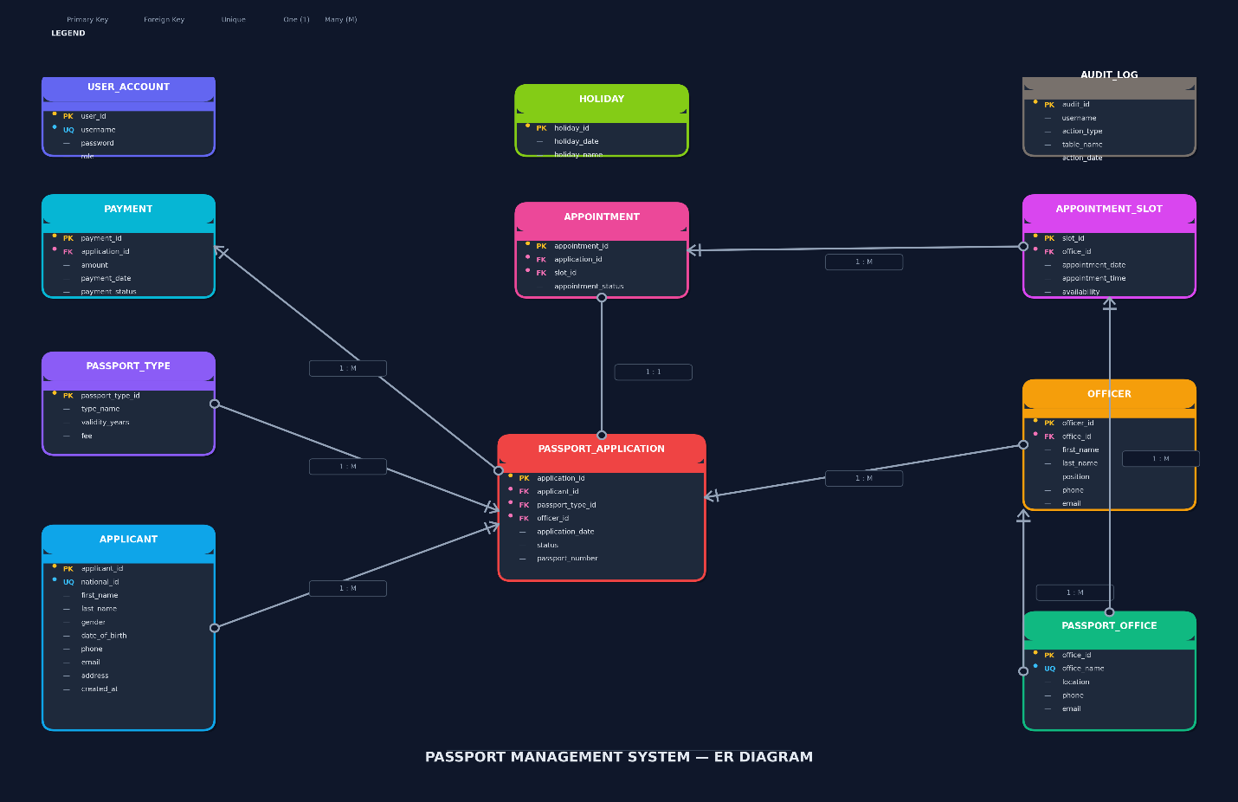
Chapter 8 — Database Implementation
The database was implemented using Oracle Database 19c.
The system contains tables, constraints, sequences, indexes, views, procedures, functions, packages, triggers, and audit mechanisms.
The system contains eleven main tables created according to the ERD design.
Table Name | Purpose
APPLICANT | Stores applicant information
PASSPORT_TYPE | Stores passport categories
PASSPORT_OFFICE | Stores office information
OFFICER | Stores officer details
PASSPORT_APPLICATION | Stores application records
APPOINTMENT_SLOT | Stores available appointment times
APPOINTMENT | Manages applicant appointments
PAYMENT | Stores payment transactions
USER_ACCOUNT | Manages system users
HOLIDAY | Stores public holidays
AUDIT_LOG | Stores system activities

Chapter 9 — SQL Operations and Data Manipulation
9.1 SQL Operations (DDL & DML)
SQL commands were used to create and manage database objects. Data Definition Language (DDL) was used for creating tables, constraints, sequences, views, and other database objects. Data Manipulation Language (DML) was used for inserting, updating, deleting, and retrieving data.
9.2 Data Insertion
Example:
INSERT INTO Applicant
(applicant_id, national_id, first_name, last_name, gender, date_of_birth, address)
VALUES
(1,'1234567890123456','Moise','Ishimwe', 'Male',DATE '2006-02-05','Kigali');
Sample data was inserted into the database to test system functionality.
9.3 Data Retrieval
Example:
SELECT * FROM Passport_Application;
SQL queries were created to retrieve application information from the database.
9.4 Join Query Example
Example:
SELECT a.first_name, a.last_name, p.status
FROM Applicant a
JOIN Passport_Application p
ON a.applicant_id = p.applicant_id;
This query combines applicant information with application status.
Chapter 10— PL/SQL Implementation
10.1 PL/SQL Programming
PL/SQL was used to implement application logic directly inside the Oracle Database. Procedures, functions, packages, cursors, and exception handling were developed to automate database operations.
10.2 Procedures
Example:
CREATE OR REPLACE PROCEDURE CREATE_APPLICATION...
The CREATE_APPLICATION procedure automates the creation of passport applications while maintaining data consistency.
10.3 Functions
Example:
GET_APPLICATION_STATUS
This function returns the current status of a passport application based on the application identifier.
10.4 Packages
Packages were created to group related procedures and functions, improving code organization and maintainability.
10.5 Exception Handling
Exception handling was implemented to manage errors during database operations and provide meaningful messages to users.
Example:
EXCEPTION
WHEN NO_DATA_FOUND THEN
DBMS_OUTPUT.PUT_LINE('Application not found');
Chapter 11 — Advanced Features
11.1 Database Triggers
Triggers were created to automatically execute actions when specific database events occur. They help enforce business rules and maintain data integrity.
Trigger 1: Prevent Duplicate Appointment Booking
A trigger was implemented to prevent an applicant from having conflicting appointments.
Example:
CREATE OR REPLACE TRIGGER trg_audit_applicant
AFTER INSERT OR UPDATE OR DELETE ON Applicant
FOR EACH ROW
BEGIN
...
END;
/
Trigger 2: Audit Data Changes
An audit trigger was implemented to record important database operations such as INSERT, UPDATE, and DELETE activities.
Example:
CREATE OR REPLACE TRIGGER trg_audit_applicant
AFTER INSERT OR UPDATE OR DELETE ON Applicant
FOR EACH ROW
BEGIN
...
END;
/
Trigger 3: Weekday and Holiday Restriction
A business rule was implemented to restrict INSERT, UPDATE, and DELETE operations during weekdays and public holidays. The system checks the current date against working days and the HOLIDAY reference table. Unauthorized operations are blocked using database triggers.
11.2 Audit System Implementation
Audit Logging, the audit system tracks important user activities in the database. This improves accountability and allows administrators to monitor changes.
11.3 Security Implementation
Security controls were implemented using Oracle users, roles, and privileges to restrict access according to user responsibilities.
Role | Responsibility
PASSPORT_ADMIN | Full database management privileges
PASSPORT_OFFICER | Manages passport applications
PASSPORT_VIEWER | Read-only access

12. Testing and Results
The system was tested to verify that database objects, PL/SQL programs, triggers, and security mechanisms operate correctly.
Test 1: Table Verification
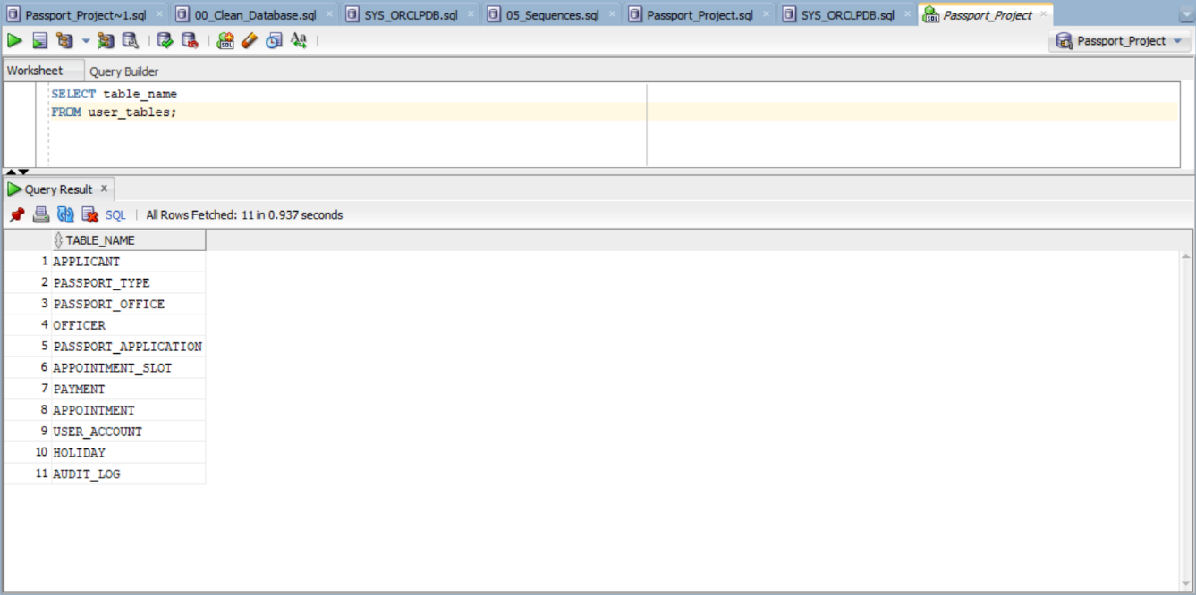

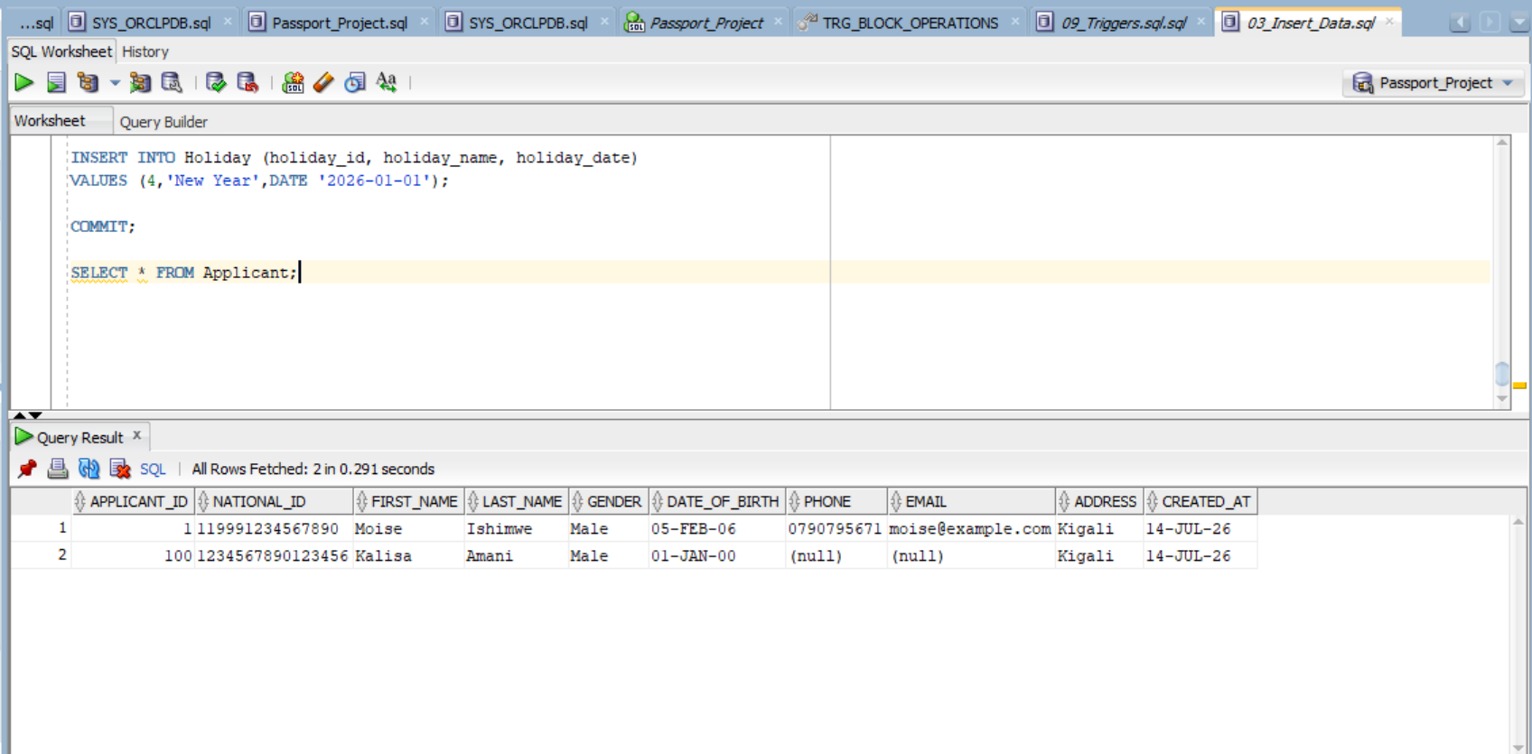
Test 2: Procedure Execution
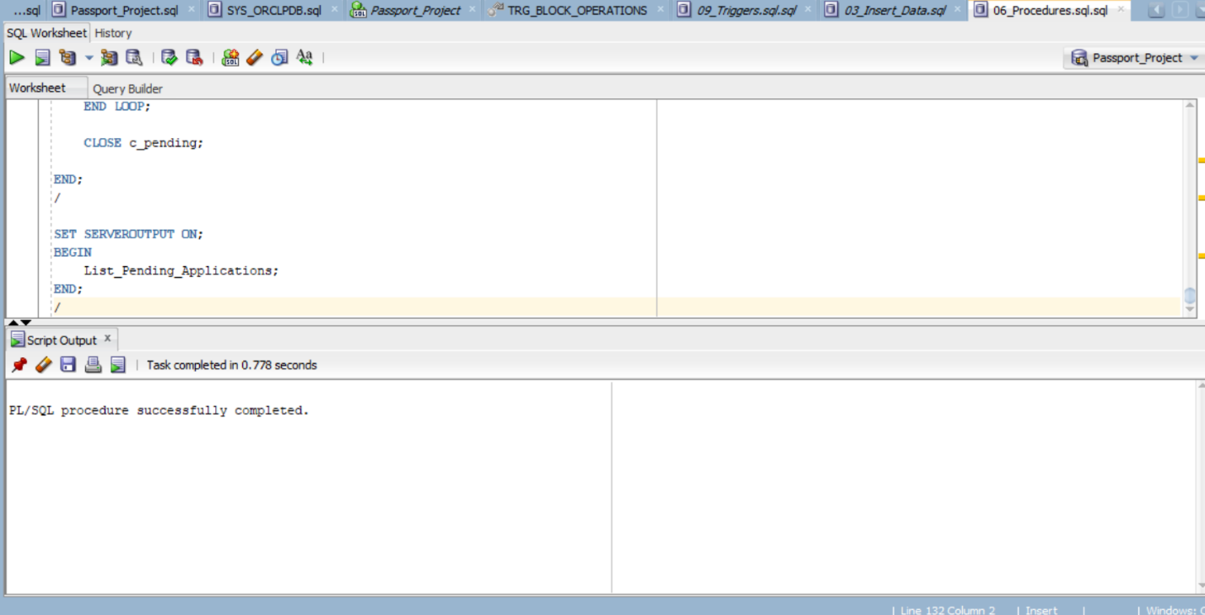
Test 3: Trigger Testing
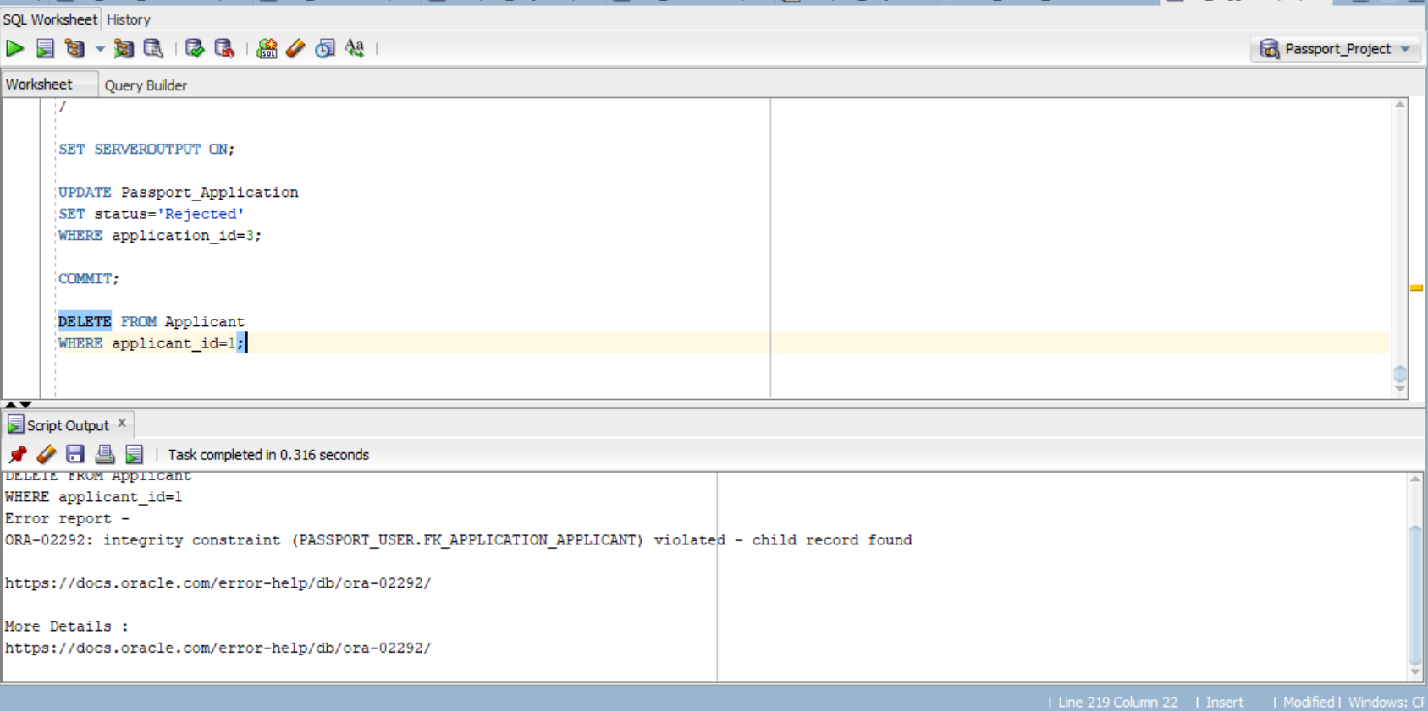
Test 4: Audit Verification
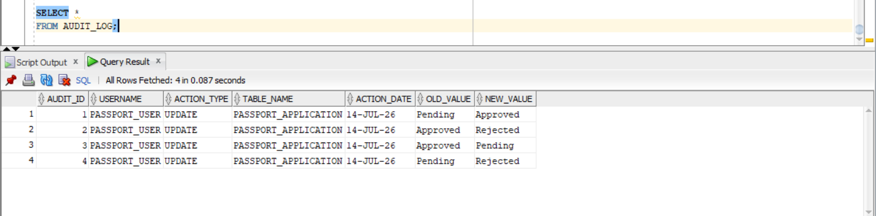

Chapter 13 — Innovation
14.1 Innovation: Passport Analytics Dashboard
To provide additional value beyond database implementation, a data visualization dashboard was proposed using Power BI. The dashboard provides graphical analysis of passport applications and supports decision-making.
Dashboard Features:
- Total number of passport applications
- Approved applications
- Pending applications
- Rejected applications
- Applications by passport office
- Payment statistics
- Monthly application trends
Benefits
The dashboard helps administrators understand application trends, monitor workload distribution, and make better operational decisions.
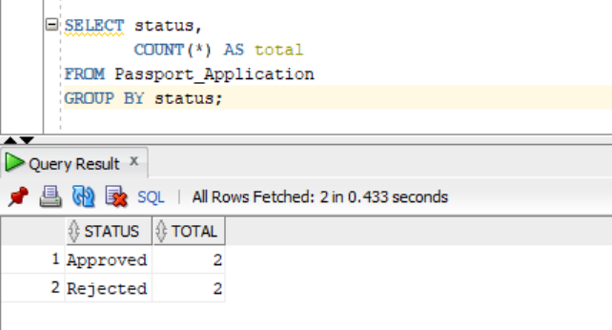
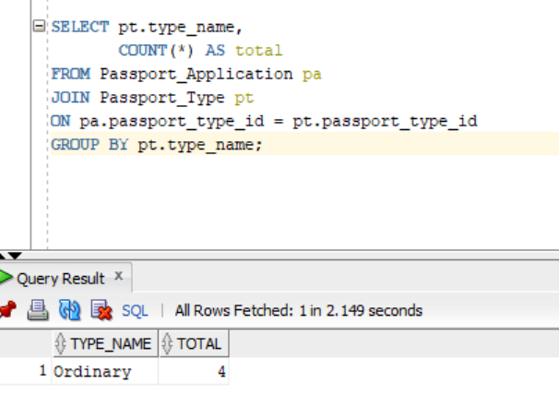
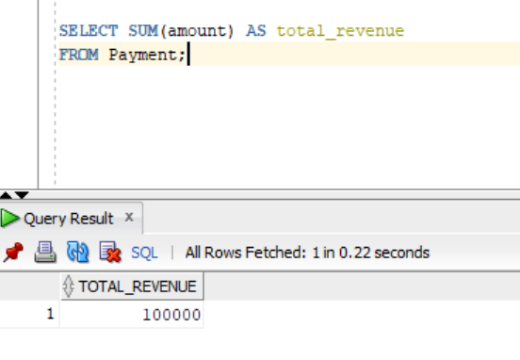
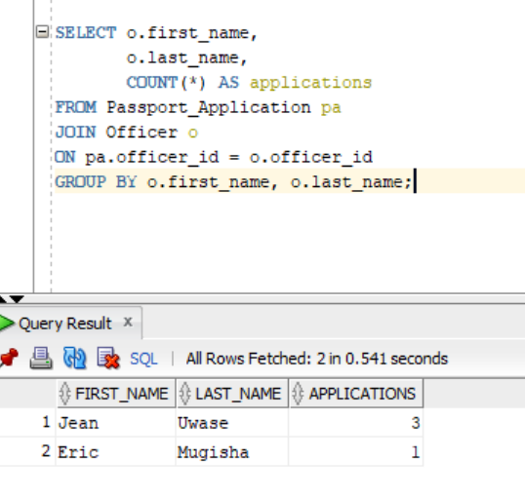
Chapter 14 — Conclusion
The Passport Appointment Booking System successfully demonstrates the application of Oracle Database technologies in solving a real-world problem.
The project implemented database design, SQL operations, PL/SQL programming, triggers, auditing, and security mechanisms.
Through this project, practical knowledge of relational database development and Oracle database management was demonstrated.

