A 3D Printed Wearable Exoskeleton for Hand Rehabilitation
I. Parekh and Dr I. Howard

School of Engineering, Computing and Mathematics, University of Plymouth, Plymouth, UK
ishita.parekh@postgrad.plymouth.ac.uk
ian.howard@plymouth.ac.uk
Abstract
Development of hand rehabilitation devices are increasing to assist patients following stroke or accidents. These devices are used to recover motor impairments to assist in the movement and rehabilitation of the hand and fingers. This paper describes the 3d design of the low-cost exoskeleton and implementation of the exoskeleton to perform the hand rehabilitation exercises. The mechanical design of the exoskeleton, kinematic analysis and finite element analysis, actuation of the exoskeleton using linear servo actuators and control mechanism using the hand muscle signals are described in the paper. The experimentation setup for testing the exoskeleton device and the results achieved are also discussed.
Keywords
Exoskeleton, EMG, Hand Rehabilitation, 3D Design, Finite Element Analysis, Linear Servo Actuator, MYO Armband.

Introduction
Motor impairments are caused when people suffer from serious accidents. Even after certain physiotherapy sessions patients still experience weakness in the limbs affected. These accidents largely hamper the daily life activities. Post-stroke motor impairments also affect the limbs of the patients. Stroke alone is the fourth leading cause of the death in the UK (State of Nation Stroke Statistics, Feb 2018). More than 100,000 strokes occur in the UK every year (one in every five minutes). According to the State of Nation Stroke Statistics, Stroke is also the second leading cause of the death worldwide causing around 6.2 million deaths every year. In the survey conducted by the Stroke Association, there are almost 1.2 million stroke survivors every year and more than three quarters of stroke survivors report limb weakness and difficulty to carry out daily activities. Flexion and extension of the fingers and thumb of the hand are also affected after stroke (Trombly, 1989).
Rehabilitation of the affected hand is important because it plays a vital role in daily life activities. Repetitive and task specific exercises are the main elements in rehabilitation of motor weakness. After accidents patients usually undergo physiotherapy sessions to recover motor functionalities of the limbs. But even after certain physiotherapy sessions the patients are not able to recover injured limb movements completely. Even post-stroke, a rehabilitation device would help to perform repetitive exercises to improve the motor functionalities of the limbs.
This project has following objectives: 3D designing an exoskeleton for the hand and analysing the kinematic model of the linkage structure to transmit the power. Performing finite element analysis of the designed links of the hand exoskeleton. Designing an easy to use actuator module for actuating the hand exoskeleton using linear servo actuators. Writing an interface code to connect the MYO armband (used for signal detection) and the actuator module to control the exoskeleton. The next section of the paper focuses on the state of the art of the previously developed exoskeleton devices for the hand rehabilitation. Section 3 of the paper discusses the methodology of designing and implementing the hand exoskeleton. Section 4 discusses the results obtained after testing the exoskeleton device. Section 5 discusses the results obtained and section 6 provides the conclusions and discusses the future work for the designed exoskeleton device.

Background literature
Many exoskeleton devices were developed previously for the hand (fingers and thumb) rehabilitation. When designing an exoskeleton for the hand following factors are considered: Controlling transmitted forces for safety reasons, Synchronising the design of the links with the hand (fingers for instance) and the force applied to the fingers to perform a given trajectory. Based on these factors the designed exoskeletons can be divided into three main groups: Rehabilitation hand exoskeletons, Haptic hand exoskeletons and Assistive hand exoskeletons. Figure 1 indicates the each of the previously mentioned devices for assisting patients when recovering from accidents or stroke.
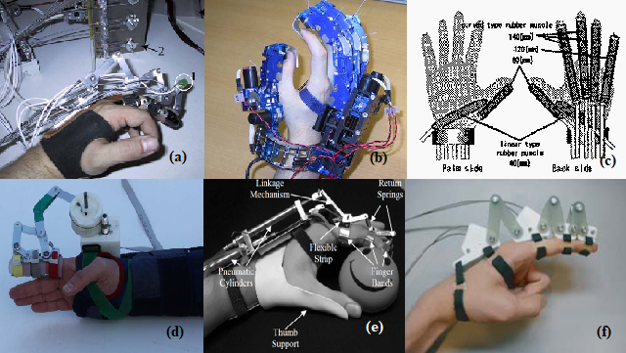
Figure 1 - Previously developed exoskeleton devices by the researchers
Figure 1a shows the rehabilitation exoskeleton device developed by the researchers Wege and Hommel, 2005. This device comes under the category of the rehabilitation hand exoskeletons. These researchers have shown that the exoskeleton designed for rehabilitation are more effective as compared to the manual rehabilitation therapies. Figure 1b shows the haptic device developed by the researchers Nakagawara, Kajimoto, Kawakami and Tachi, 2005. It is a multi-fingered master hand used to control a dexterous slave robot for tele-existence. Figure 1c indicates is an assistive device to aid patients in performing daily life activities (Noritsugu, Yamamoto, Sasaki and Takaiwa, 2004). It is a wearable hand assist device for grasping using pneumatic artificial rubber muscle. Figure 1d indicates another rehabilitation device developed by the Sabanci University researchers (Ertas, Hocaoglu, Barkana and Potaglu, 2009). It is 1 degree of freedom (DOF) rehabilitation exoskeleton device actuated by a single DC motor. The power was transmitted to the fingers with the help of mechanical linkages. Figure 1e shows the exoskeleton device that was designed and developed by the Pittsburgh University researchers (Di Cicco, Lucas and Matsuoka, 2004). It was designed to have 2 DOFs to get the flexion and extension of the fingers. It used two pneumatic actuators to actuate the exoskeleton. Figure 1f shows the rehabilitation exoskeleton developed by the University of Tokyo researchers (Yamaura, Matsushita, Kato and Yokoi, 2009).
The systems discussed above served the purpose of rehabilitating the hand recovering from accidents or stroke, but some developed devices had issues with the control mechanism while some devices had a problem with its complex and heavy mechanical structure. The next section explains the methodology used to design and implement the rehabilitation exoskeleton device for the patients recovering from the accidents or stroke.

Design and Implementation

Design
The exoskeleton was designed to have 1 DOF as the DIP (Distal Interphalangeal Joint), PIP (Proximal Interphalangeal Joint) and MCP (Metacarpophalangeal Joint) of the finger were coupled together with the help of mechanical linkages. The mechanical design of the exoskeleton could be divided into two groups: design of the finger exoskeleton and design of the exoskeleton for the dorsal part of the hand. The finger exoskeleton was designed to have 3 small exoskeletons covering the phalanges of the finger. Each of these small phalangeal skeletons were connected together using pivot joints to enable smooth movement of the fingers. The mechanical linkages were designed to transmit the power to the fingers. The linkage mechanism comprised of a four-bar linkage followed by a five-bar linkage. The kinematic model of the designed linkage mechanism is shown in figure 2.
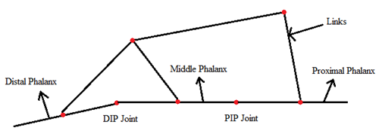
Figure 2 - Kinematic model of the designed linkage structure
Planar RRRR 4-bar linkage and planar 5-bar linkage were analysed to interpret the link lengths and position of the joints in the linkage structure. Finite element analysis of the linkages was also carried out to study how the links in the structure handle stresses. The designed exoskeleton is shown in the figure 3.
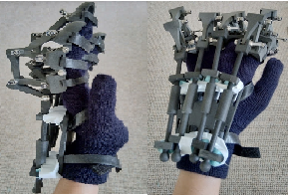
Figure 3 - Designed hand exoskeleton
To actuate this exoskeleton device, an actuator module was designed using continuous servo motors. A linear actuator was designed using rack and pinion mechanism with the help of servo motors. Four such actuator modules were used one for actuating each finger. A servo motor driver module PCA9685 was used to connect the four actuator modules to the Arduino UNO board to enable the precise and consistent working of all the actuator modules.
To control the trajectory of the exoskeleton MYO armband was used. MYO armband is a compact device comprised of eight medical grade stainless steel EMG sensors, a highly sensitive 9-axes IMU comprised of 3-axes gyroscope, 3-axes accelerometer, 3-axes magnetometer and a vibration motor (MYO armband website, 2013-2018). This device was used to capture the EMG signals used to flex or extend the fingers and use them to define certain poses like closed fist, stretched out fingers to decide the trajectory of the exoskeleton device.

Implementation
The implementation of the system could be divided into two parts: Hand pose detection using MYO armband and Controlling the trajectory of the exoskeleton. Initially the signal was acquired at 200Hz from the eight EMG sensors contained in the MYO. The acquired signals were amplified using OPAMP (Operational Amplifier) ST78589 to amplify the dominant components of the signals which lies in the range of 50-150Hz. The signals were interpreted using MYO connect application which uses a machine learning algorithm. It uses the muscle activation signals as a training data to learn different hand postures. The connection between MYO armband and the actuator module was established using Arduino UNO board. MYODuino application was used to interface the MYO armband with the Arduino board. Once the Arduino board is connected to the USB port of the PC or laptop, the MYODuino application is launched to select the port to which the Arduino is connected, and the connection is established. PCA9685 servo driver module (which uses PWM signals to control the servo motors) was used to interface the servo motors with the Arduino board, in order to avoid communication interference between the MYO armband and the servo motors. The exoskeleton must be worn on the affected hand and the MYO armband is supposed to be worn on the healthy hand of the patient. Once the connection is established between the MYO and the actuator, the healthy hand can be used to control the trajectory of the exoskeleton worn on the hand recovering from accident or stroke. The figure 4 shows the system and communication between the system components.
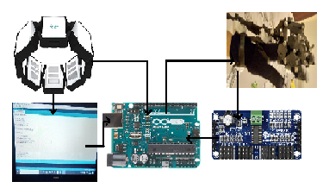
Figure 4 - Exoskeleton system

Testing and Results
Test results indicating the connection establishment between the MYO and Arduino UNO board are shown in figure 5. EMG graph indicating the close-open trajectory of the hand is also shown in figure 6. Acceleration and angular velocity data representing the close-open trajectory of the hand was also gathered at 50Hz from the 9-axes IMU contained within the MYO armband. The graphs indicating the acceleration and angular velocity of the trajectory are also indicated in the figures 7 and 8. Range of Motion (ROM) of the hand exoskeleton device was analysed by the tracker video analysis software and the graph indicating the range of motion of the fingers obtained with the designed hand exoskeleton is shown in figure 9.
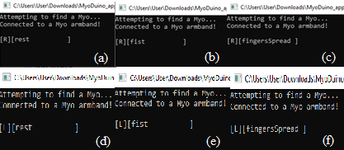
Figure 5 - Result indicating MYO connection with the Arduino

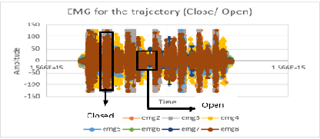
Figure 6 - EMG for the close-open trajectory
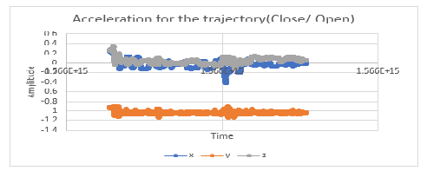
Figure 7 - Acceleration for the close-open trajectory
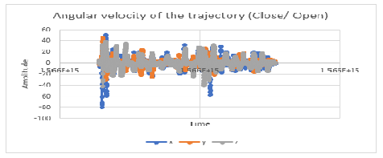
Figure 8 - Angular velocity for the close-open trajectory

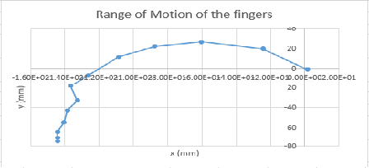
Figure 9 - Range of motion of the fingers

Discussion
It was observed that a decent range of motion was achieved from the designed 1 DOF exoskeleton for rehabilitation. With the designed exoskeleton the opening and closing of the hand was performed smoothly. The exoskeleton was designed to perform the rehabilitation exercise with and without the control of the EMG signals. Though with the exoskeleton device it is not possible to form a complete fist but the range of motion of the finger exoskeleton can be improved by adding more five-bar linkages in series with the designed linkage structure. The range of motion of the finger exoskeleton could also be improved by increasing the link lengths used in the four-bar and five-bar linkages. The results also indicate that the connection between the MYO armband, Arduino UNO and the actuator module was established successfully. Initially, the servo motors were connected to the Arduino UNO board and this led to interference in the communication between the MYO and the servo motors. To avoid that issue, servo driver module PCA9685 was used to connect the servo motors and the PCA9685 module was interfaced with the Arduino board by connecting the SDA, SCL, GND and VCC pins of both the boards together. The results also indicate that hand poses for both the hands were detected correctly based on the EMG signals when the fingers were flexed or extended. The results also show the EMG close-open trajectory. The acceleration and the angular velocity data for the trajectory were also gathered and the graphs in the figure 7 and 8 shows the respective data. The range of motion of the fingers is also indicated in figure 9, it was analysed by the tracker video analysis software by placing the origin at the tip of the finger.

Conclusion and future work
Thus, the exoskeleton device with 1 DOF was 3d designed successfully. The linkages designed to transmit the power to the phalanges of the finger were also designed successfully. The connection between the MYO armband, Arduino and the laptop was established successfully. The purpose for which the exoskeleton was designed was achieved with the prototype design of the exoskeleton.
But there are scopes for the future work in the designed rehabilitation exoskeleton device. Future work would include the 3d design of the exoskeleton for the thumb. Thumb has a complex structure as compared to the other fingers. It comprises of 5 DOFs. There are a quite few models designed for the thumb and the ones that are designed address only 3 or 4 DOFs. So, the future work would aim at 3d designing the exoskeleton structure for the thumb. The future work would also aim at improving the range of motion of the finger while using the exoskeleton.

References
Yamaura, H., Matsushita, K., Kato, R. and Yokoi, H. (2009) ‘Development of Hand Rehabilitation System for Paralysis Patient: Universal design using wire-driven mechanism’ in: 31st Annual International Conference of the IEEE EMBS, ISBN 978-1-4244-3296-7.

Nakagawara, S., Kajimoto, H., Kawakami, N. and Tachi, S. (2005) ‘An Encounter-Type Multi-Fingered Master Hand using Circuitous Joints’ in: Proceedings of the IEEE International Conference on Robotics and Automation, ISBN 0-7803-8914-X.

Noritsugu, T., Yamamoto, H., Sasaki, D. and Takaiwa, M. (2004) ‘Wearable Power Assist Device for Hand Grasping using Pneumatic Artificial Rubber Muscle’ in: 13th IEEE International Workshop on Robot and Human Interactive Communication, ISBN 0-7803-8570-5.

Wege, A. and Hommel, G. (2005) ‘Development and Control of a Hand Exoskeleton for Rehabilitation of Hand Injuries’ in: Proceedings of the IEEE/RSJ International Conference on Intelligent Robots and Systems, ISBN 0-7803-8912-3.

Ertas, I., Hocaoglu, E., Barkana, D. and Patoglu, V. (2009) ‘Finger Exoskeleton for Treatment of Tendon Injuries’ in: Proceedings of the IEEE 11th Conference on Rehabilitation Robotics ICORR: 194-201.

Di Cicco, M., Lucas, L. and Matsuoka, Y. (2004) ‘Comparison of Control Strategies for an EMG Controlled Orthotic Exoskeleton for the Hand’ in: Proceedings of the IEEE International Conference on Robotics and Automation: 1622-1627.

Stroke Association Website (2019) http://www.stroke.org.uk/ (Accessed multiple times during July-August 2019)

MYO Armband Website (2013-2018) http://www.myo.com/ (Accessed multiple times during January 2018-August 2019).

Trombly, A.C. (1989) ‘Occupational Therapy for Functional Dysfunction’ Lippincott Williams and Wilkins.

