1.) balancing parenthesis stack.cpp (output)

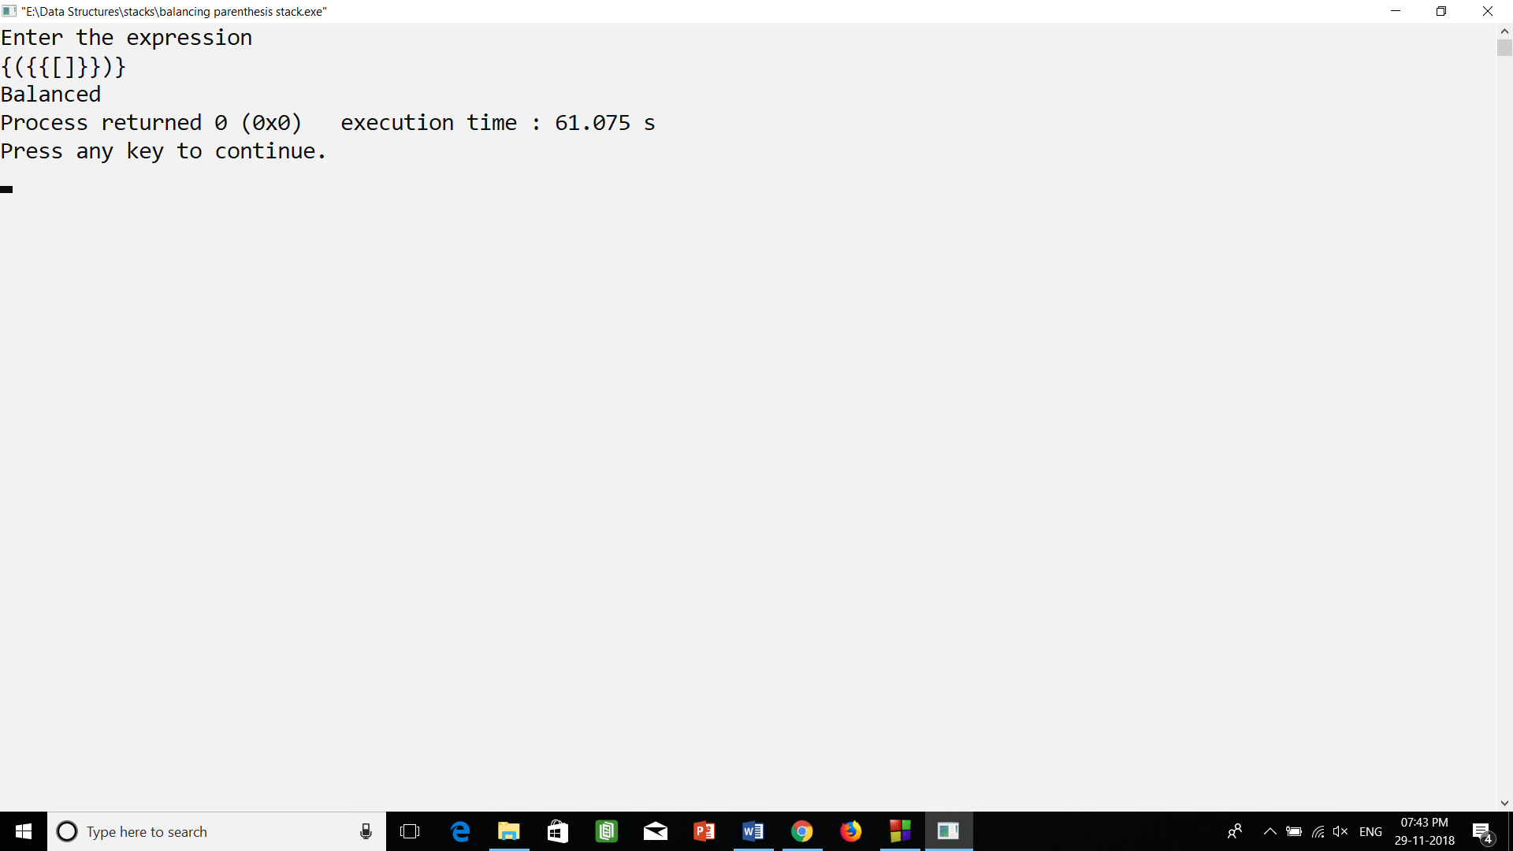

2.) balancing parenthesis.cpp (output)

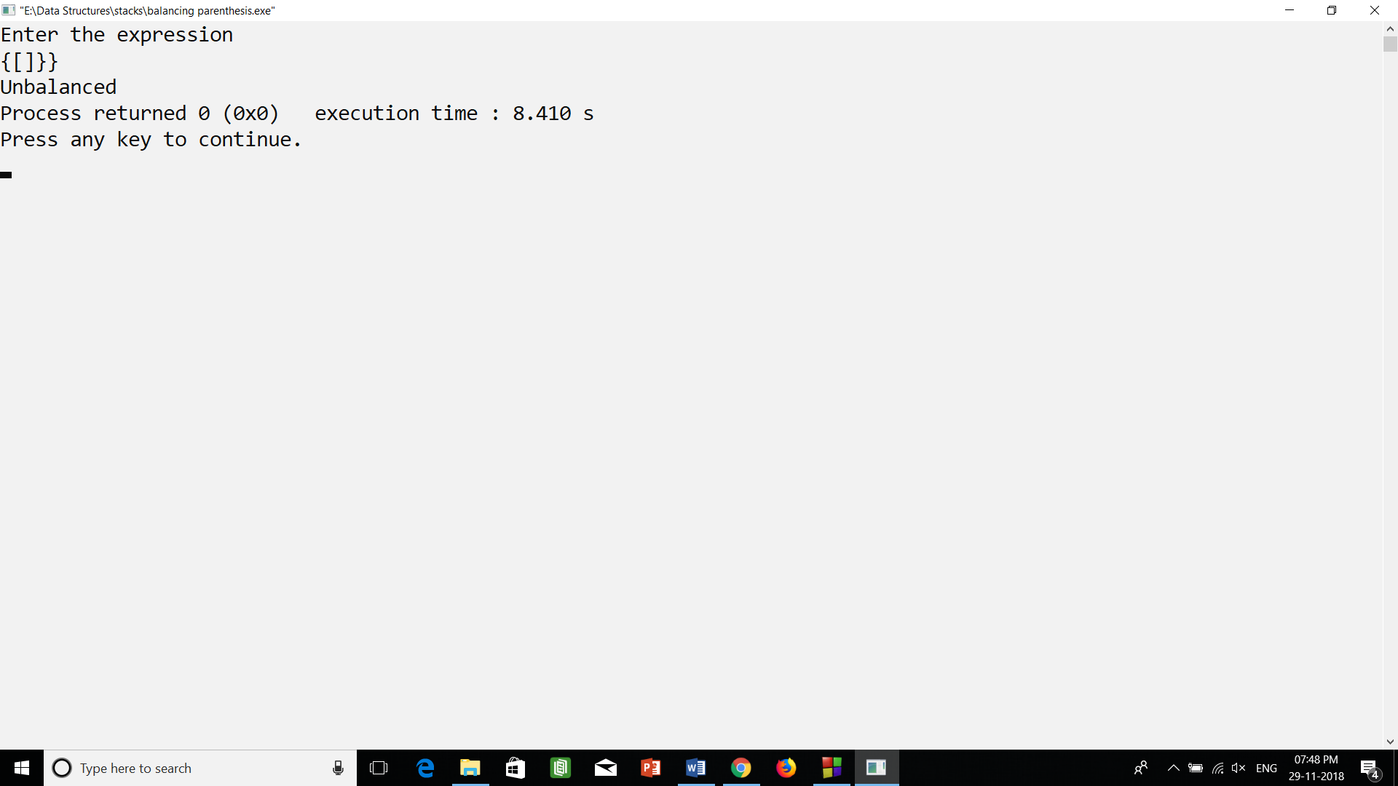

3.) evaluation of postfix (2 dig).cpp (output)

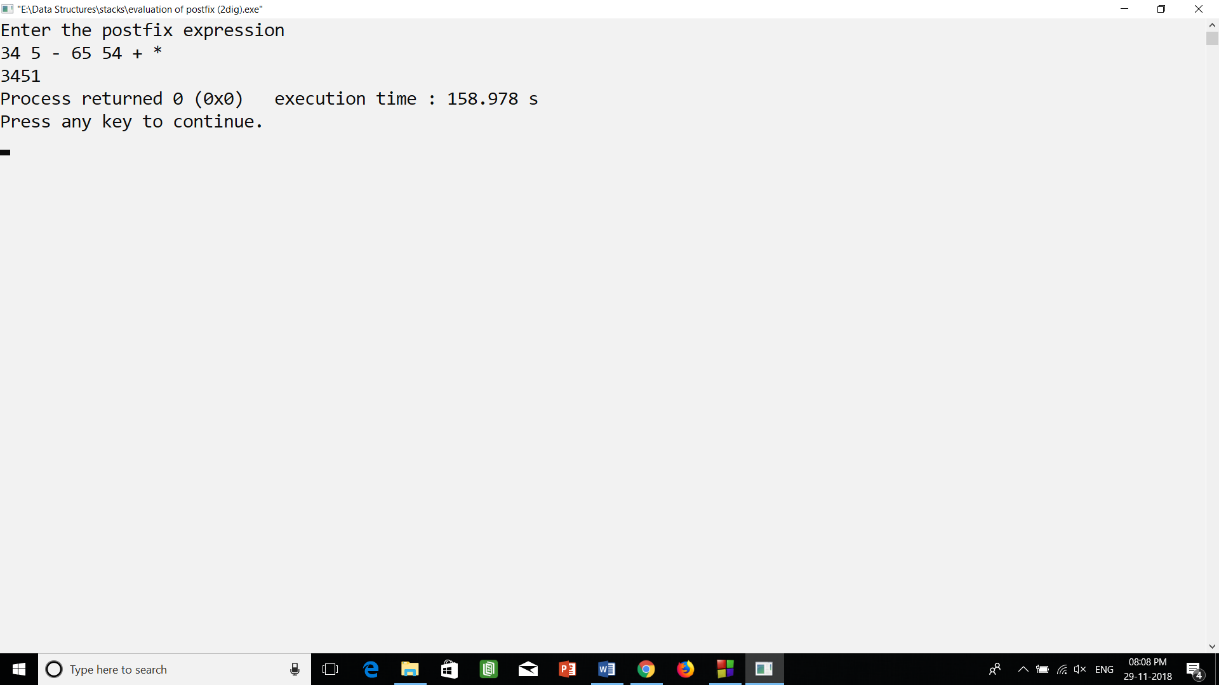

4.) evaluation of postfix.cpp (output)

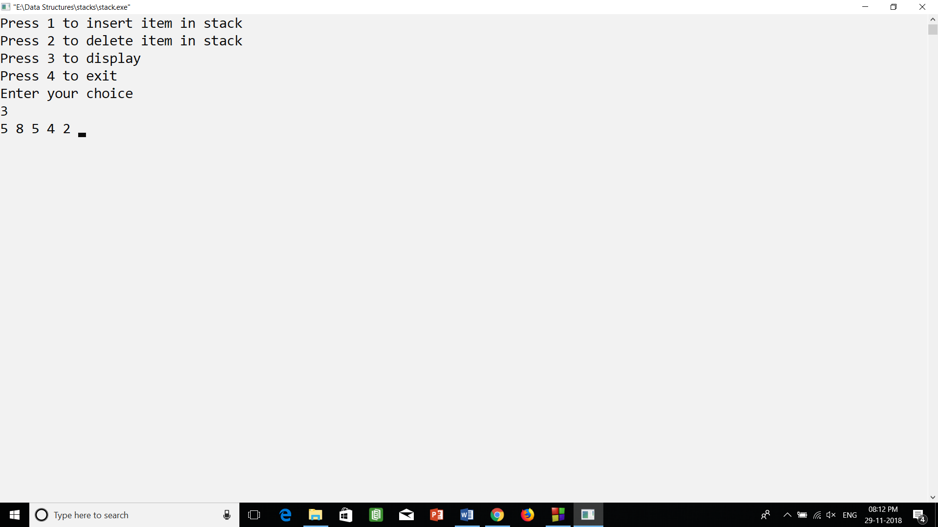

5.) infix to postfix.cpp (output)

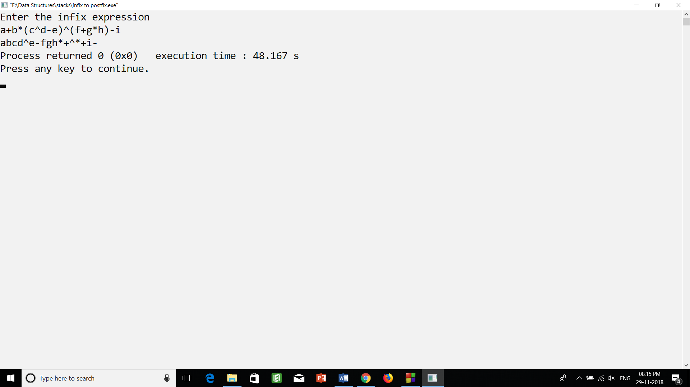

6.) stack using array.cpp (output)

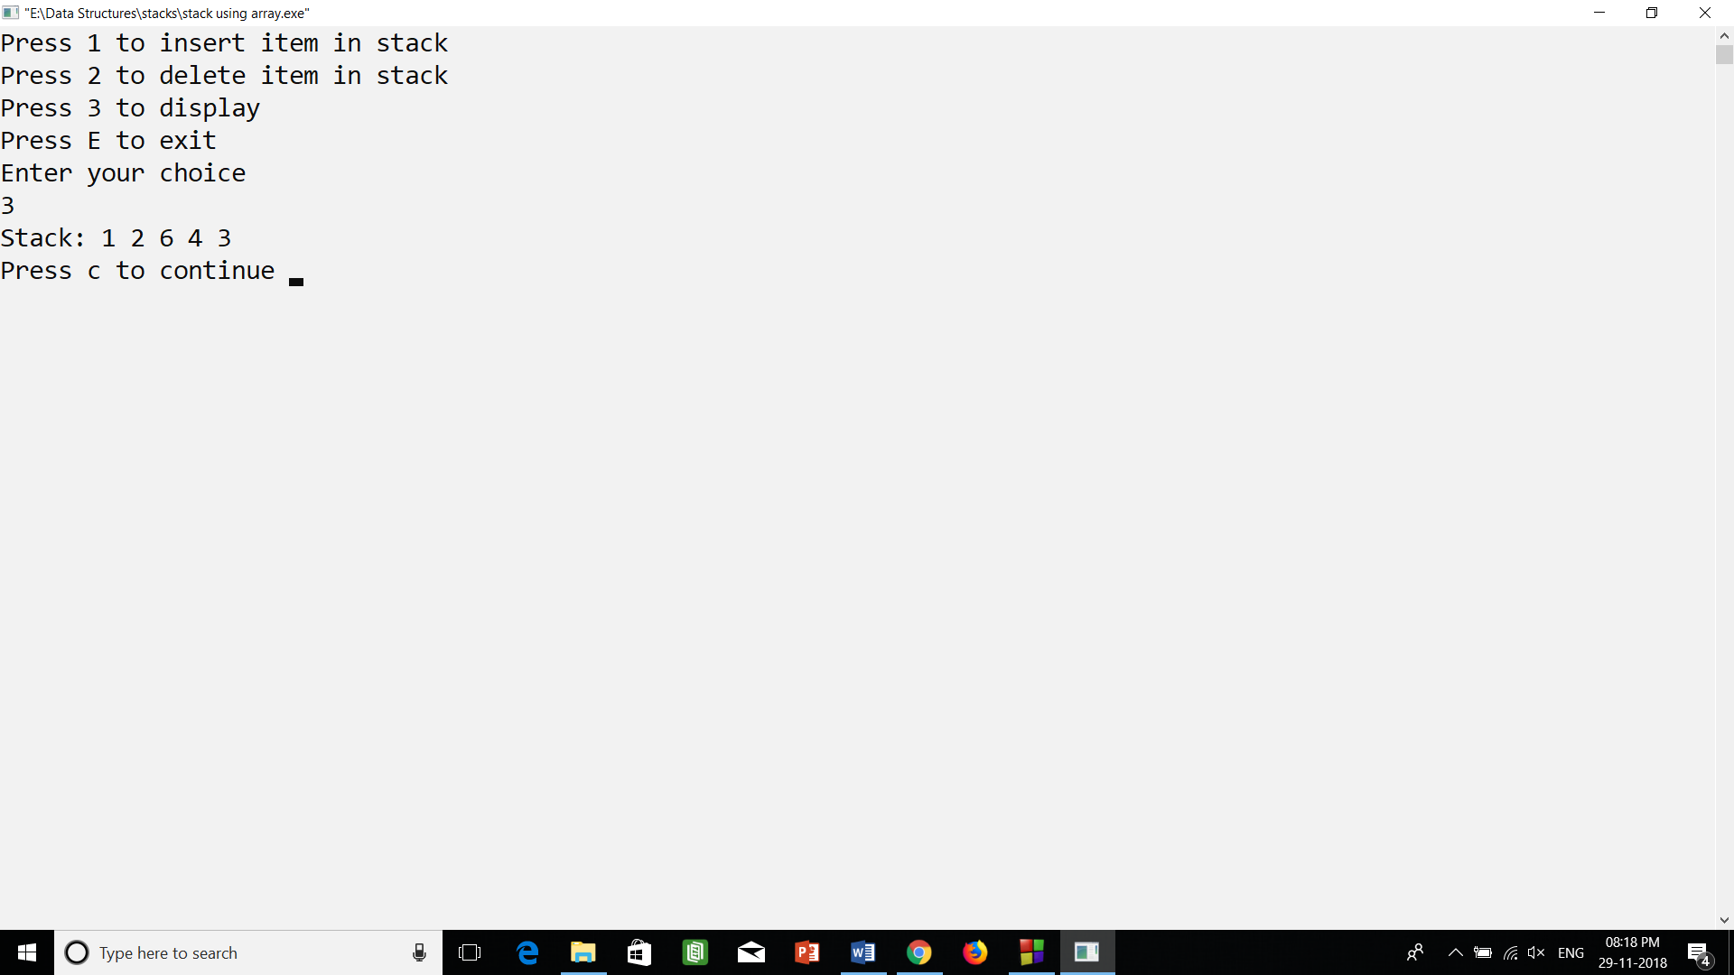

7.) stack using linked list.cpp (output)

