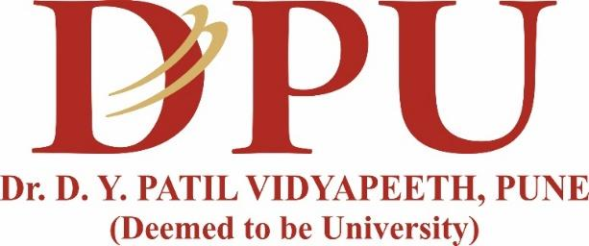

**DR. D. Y. PATIL SCHOOL OF SCIENCE AND TECHNOLOGY**

**TATHAWADE, PUNE**

**CERTIFICATE**

**This is to certify that the Mini- Project Report entitled**

**-“ Smart Recipe Recommender “-**

is a bonafide work carried out by Mr. Himanshu Chaudhari under the supervision of **Mrs. Mily Lal** and it is submitted towards the partial fulfillment of the requirement Fundamentals of Data Science(FDS).

Mrs. Mily Lal Prof. Manisha Bhende

**Project Guide Director I/C**

**ARTIFICIAL INTELLIGENCE & DATA SCIENCE**

**ACADEMIC YEAR 2024-2025**



**DR. D. Y. PATIL SCHOOL OF SCIENCE AND TECHNOLOGY**

**TATHAWADE, PUNE**

**CERTIFICATE**

**This is to certify that the Mini- Project Report entitled**

**-“ Smart Recipe Recommender “-**

is a bonafide work carried out by Ms. Ishwari Warhade under the supervision of **Mrs. Mily Lal** and it is submitted towards the partial fulfillment of the requirement Fundamentals of Data Science(FDS).

Mrs. Mily Lal Prof. Manisha Bhende

**Project Guide Director I/C**

**ARTIFICIAL INTELLIGENCE & DATA SCIENCE**

**ACADEMIC YEAR 2024-2025**