Lab Assignment-1

-- 1.

CREATE TABLE Student ( Rno number(10), SName varchar2(20), DOB date, gender varchar2(10), Sclass number(10), college varchar2(20), city varchar2(20), marks number(10))

-- 2.

INSERT INTO Student ( Rno, SName, DOB, gender, Sclass, college, city, marks)

VALUES ( 1, 'Sanya', DATE '2001-11-02', 'Female', 2, 'Tiet', 'Patiala', 70)

INSERT INTO Student ( Rno, SName, DOB, gender, Sclass, college, city, marks)

VALUES ( 2, 'Tanya', DATE '2001-01-12', 'Female', 4, 'AU', 'Amritsar', 80)

INSERT INTO Student ( Rno, SName, DOB, gender, Sclass, college, city, marks)

VALUES ( 3, 'Caddy', DATE '2002-12-22', 'Male', 7, 'DTU', 'Delhi', 90)

INSERT INTO Student ( Rno, SName, DOB, gender, Sclass, college, city, marks)

VALUES ( 4, 'Sanjay', DATE '2002-02-02', 'Male', 2, 'Tiet', 'Patiala', 70);

INSERT INTO Student ( Rno, SName, DOB, gender, Sclass, college, city, marks)

VALUES ( 5, 'Jay', DATE '2002-10-18', 'Male', 2, 'Tiet', 'Amritsar', 20);

-- 3.

SELECT \* FROM Student;

SELECT \* FROM Student ORDER BY Rno;

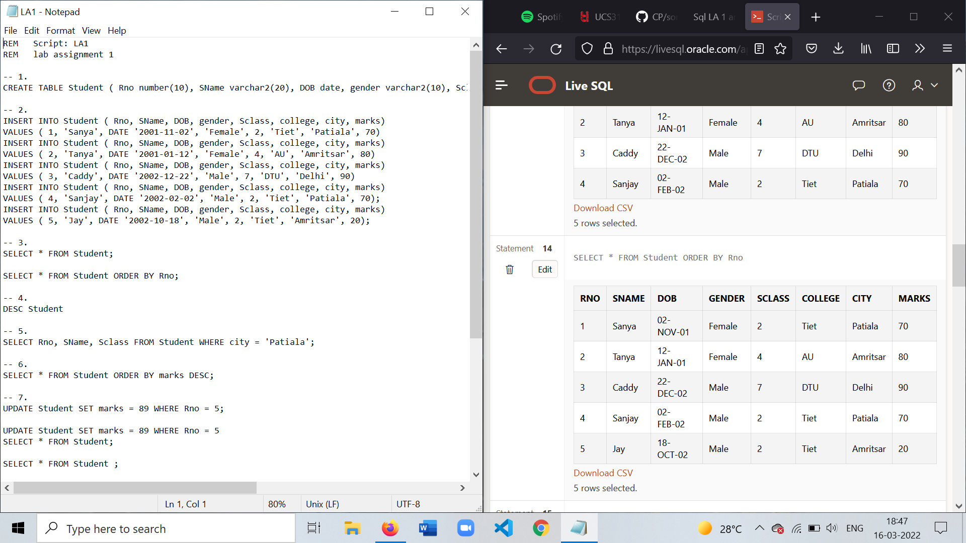

-- 4.

DESC Student

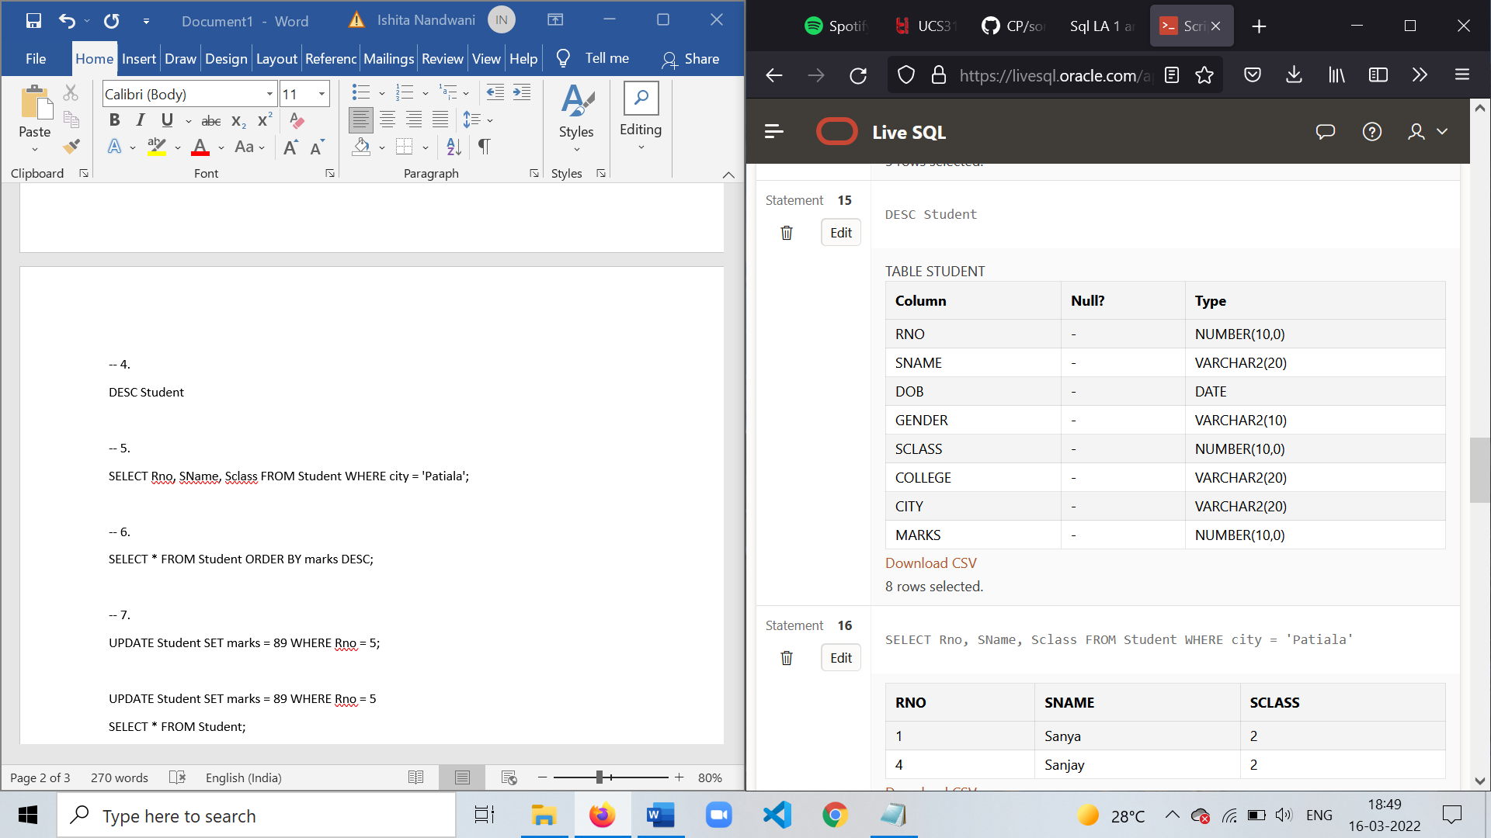

-- 5.

SELECT Rno, SName, Sclass FROM Student WHERE city = 'Patiala';

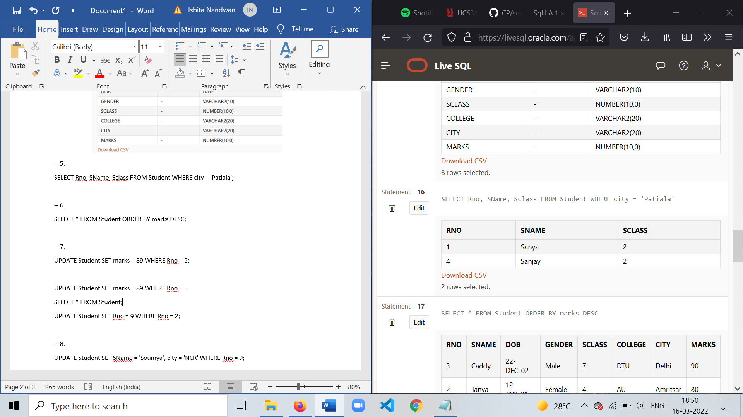

-- 6.

SELECT \* FROM Student ORDER BY marks DESC;

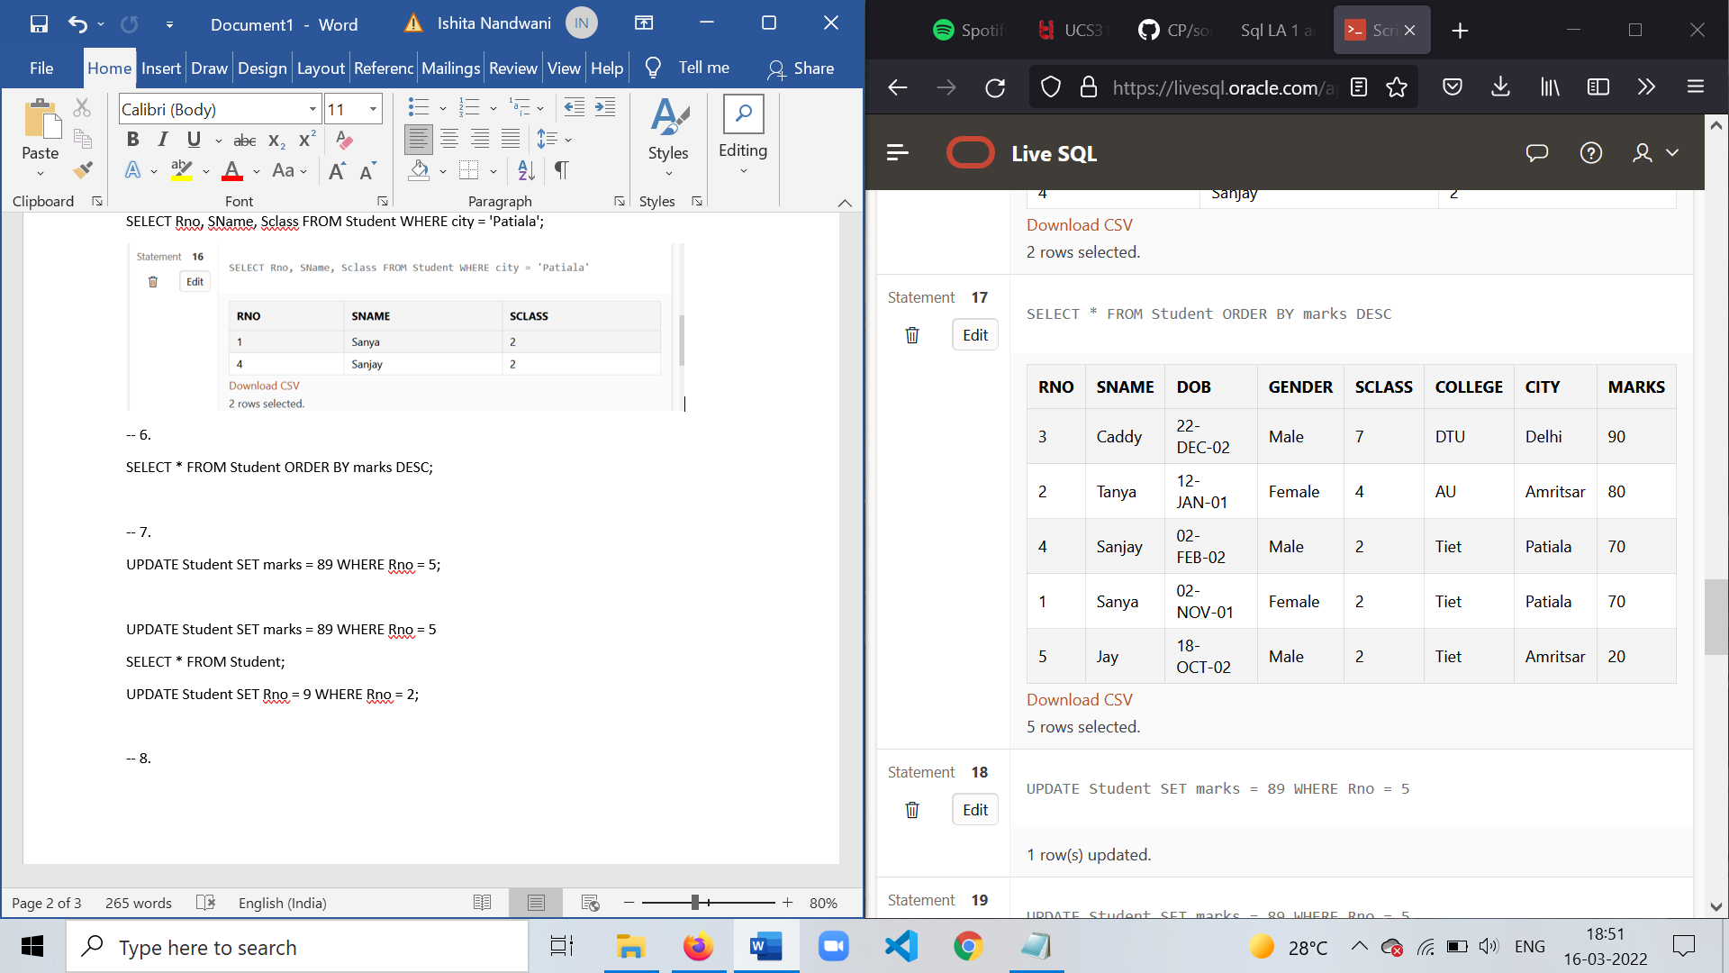

-- 7.

UPDATE Student SET marks = 89 WHERE Rno = 5;

UPDATE Student SET marks = 89 WHERE Rno = 5

SELECT \* FROM Student;

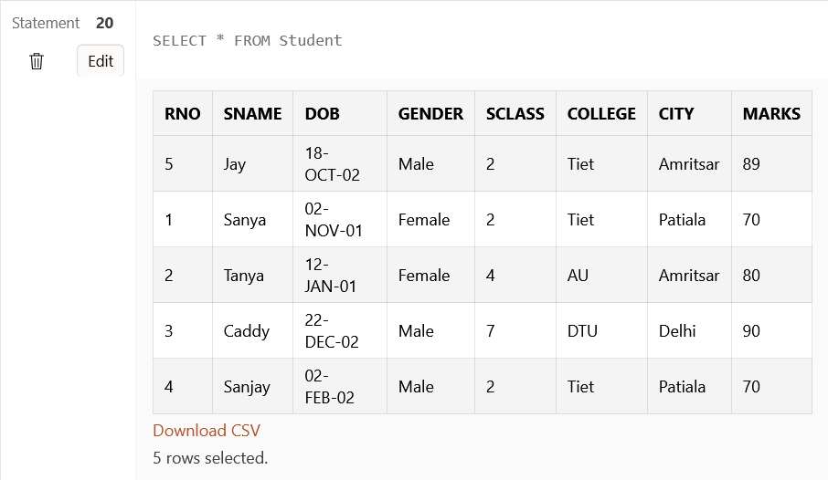

UPDATE Student SET Rno = 9 WHERE Rno = 2;

-- 8.

UPDATE Student SET SName = 'Soumya', city = 'NCR' WHERE Rno = 9;

SELECT \* FROM Student;

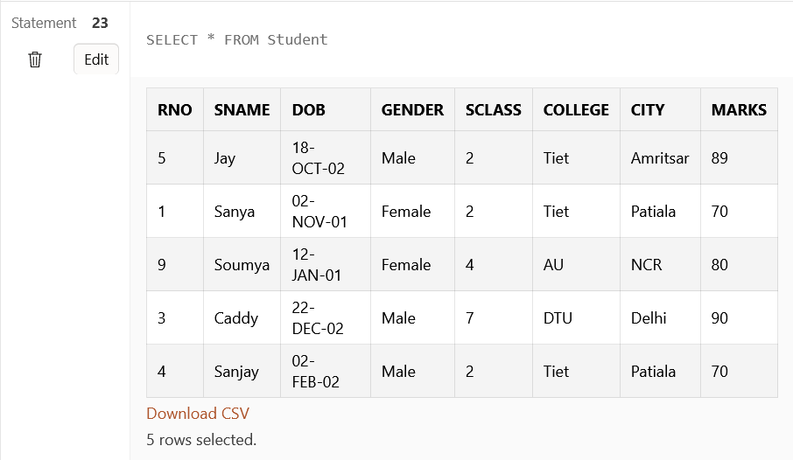

-- 9.

DELETE FROM Student WHERE city = 'Amritsar';

UPDATE Student SET marks = 20 WHERE marks = 80;

-- 10.

DELETE FROM Student WHERE marks < 30;

SELECT \* FROM Student;

