PART 1

# Part 1: Implement a function get_primes() that finds all prime numbers between

# a lower bound and a upper bound (inclusive).

# For example, if lower = 1, upper = 10, it returns [2, 3, 5, 7].

# TODO: implement get_primes() function

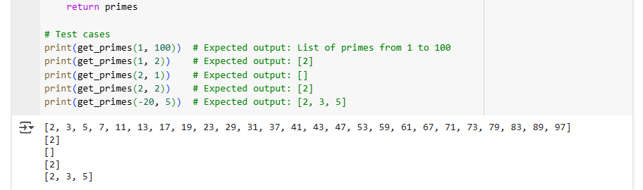

PART 2

# Part 2: Implement a function find_item_sorted_array() that finds

# if an given item is in a sorted array or not, by using binary search.

# For example, if array = [1, 2, 3] and item = 2, it returns 1.

# If array = [1, 2, 3] and item = 4, it returns -1.

# TODO: implement find_item_sorted_array() function

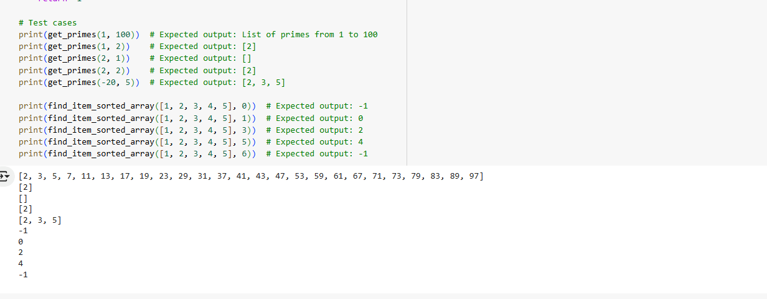

PART 3

# Part 3: ChatBot.

# TODO: obtain OPENAI API Key

# TODO: install missing modules

CHATBOT

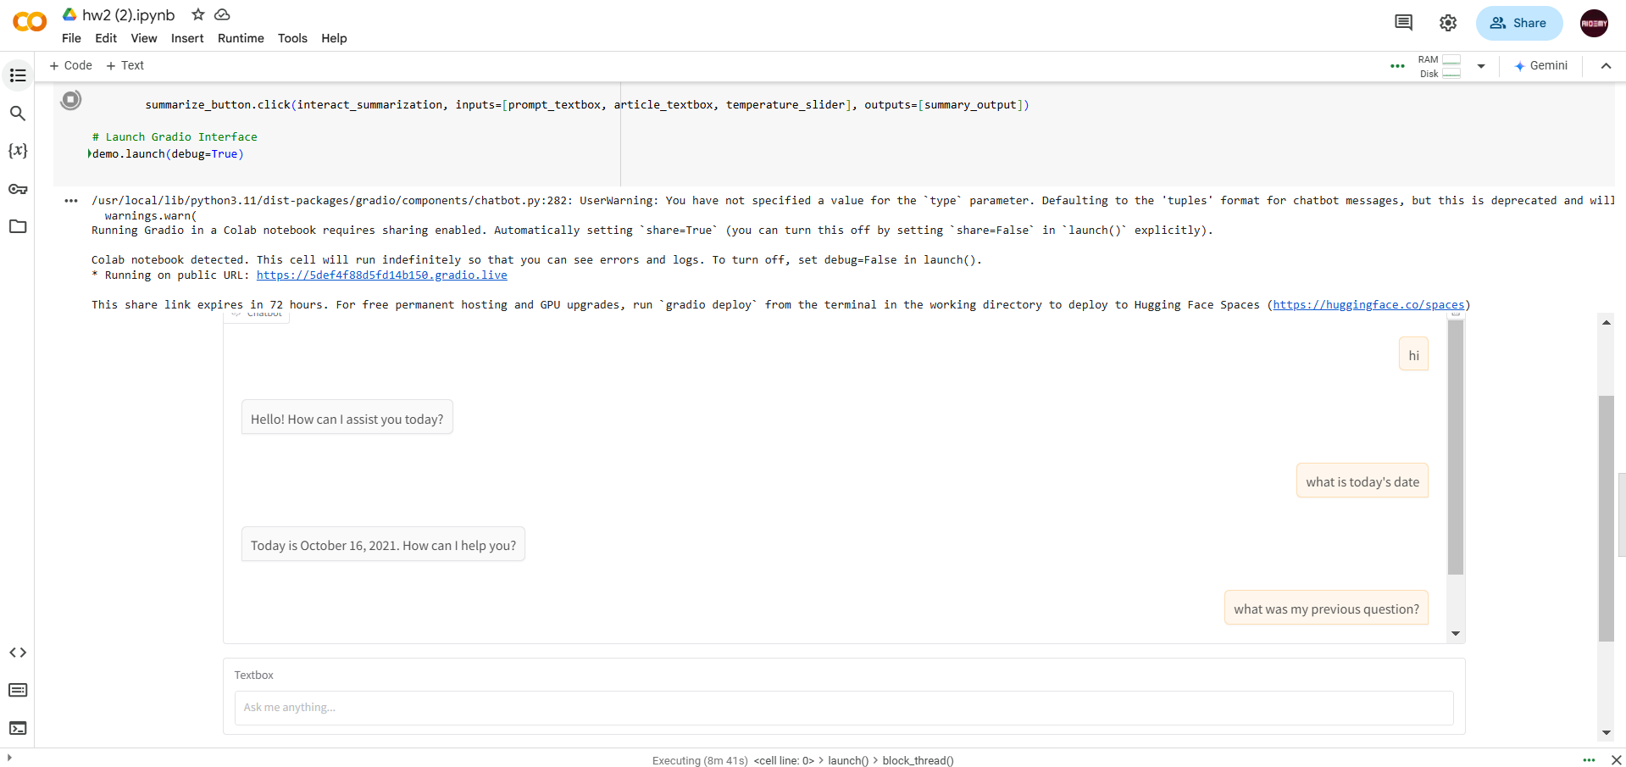

ARTICLE SUMMARIZATION

