FOCP ASSIGNMENT 1

MODULE 5
Ques 4
count divisors
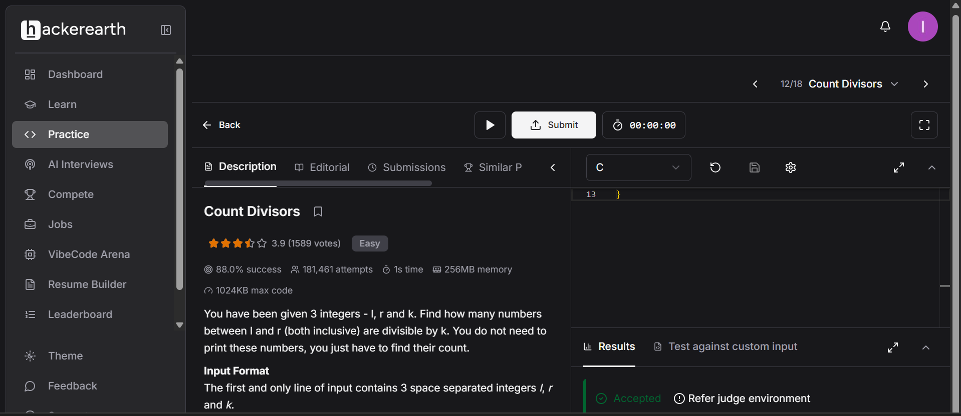
#include <stdio.h>

int main() {
int l, r, k;
scanf("%d %d %d", &l, &r, &k);

// Count multiples of k up to r, minus multiples of k before l
int count = (r / k) - ((l - 1) / k);

printf("%d\n", count);

return 0;
}

