FOCP ASSIGNMENT 1

MODULE 5
Ques 3
factorial

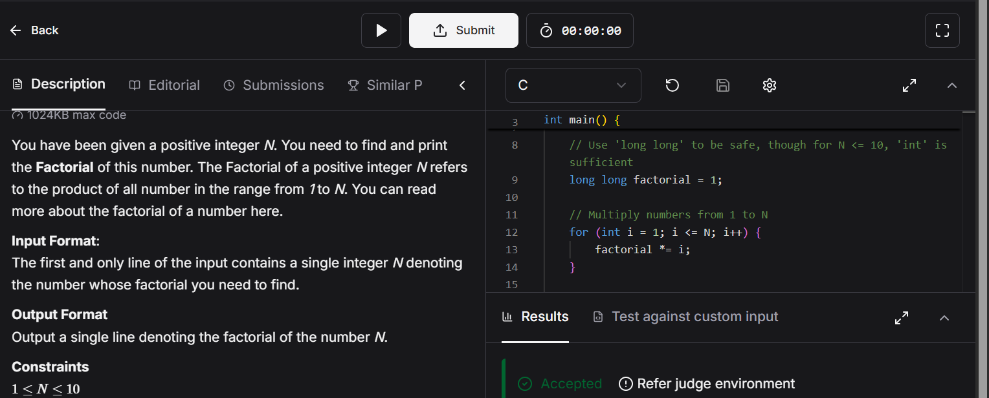

#include <stdio.h>

int main() {
int N;
// Read the integer N from standard input
scanf("%d", &N);

// Use 'long long' to be safe, though for N <= 10, 'int' is sufficient
long long factorial = 1;

// Multiply numbers from 1 to N
for (int i = 1; i <= N; i++) {
factorial *= i;
}

// Print the result
printf("%lld\n", factorial);
return 0;
}

