FOCP ASSIGNMENT 1

MODULE 2
Ques 4
roy and profile pic
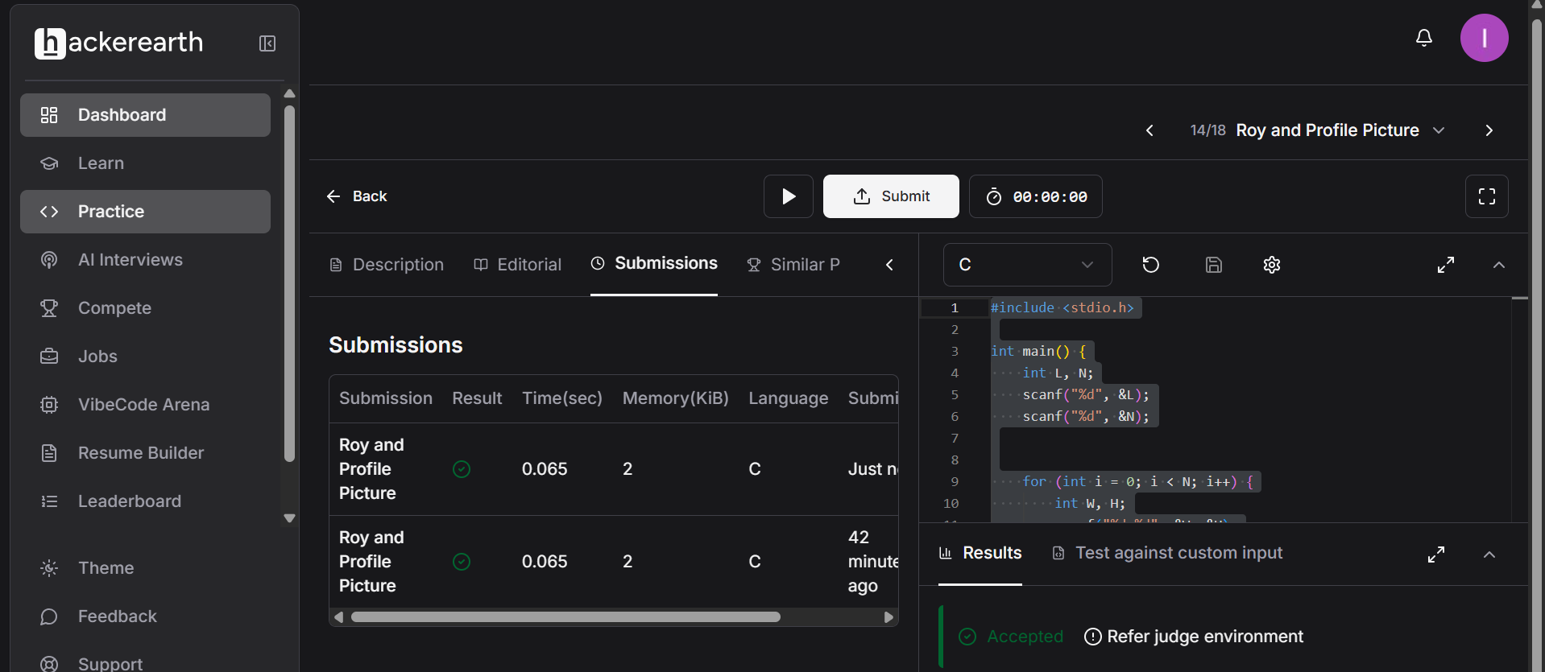

#include <stdio.h>

int main() {
int L, N;
scanf("%d", &L);
scanf("%d", &N);

for (int i = 0; i < N; i++) {
int W, H;
scanf("%d %d", &W, &H);

if (W < L || H < L) {
printf("UPLOAD ANOTHER\n");
}

else if (W == H) {
printf("ACCEPTED\n");
}

else {
printf("CROP IT\n");
}
}

return 0;
}

