FOCP ASSIGNMENT 1

MODULE 3
Ques 1
for loop in c
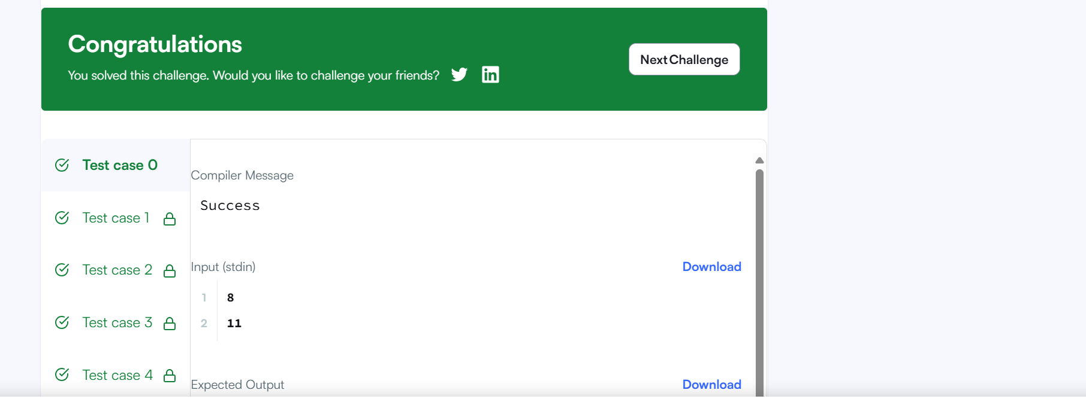

#include <stdio.h>
#include <string.h>
#include <math.h>
#include <stdlib.h>

int main()
{
int a, b;
scanf("%d\n%d", &a, &b);

const char *labels[] = {
"one", "two", "three", "four", "five",
"six", "seven", "eight", "nine", "even", "odd"
};

for (int i = a; i <= b; i++) {
if (i <= 9) {

printf("%s\n", labels[i - 1]);
} else {

int index = (i % 2 == 0) ? 9 : 10;
printf("%s\n", labels[index]);
}
}

return 0;
}

