FOCP ASSIGNMENT 1

MODULE 4
Ques 4
count digits that divide a num

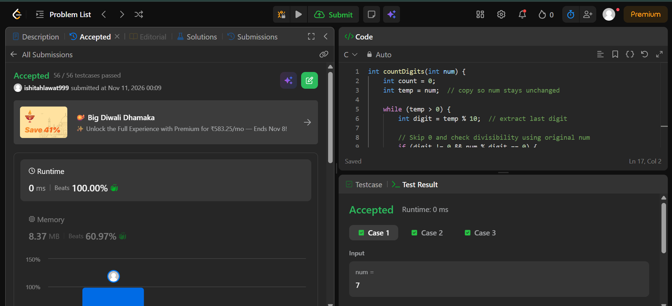

int countDigits(int num) {
int count = 0;
int temp = num; // copy so num stays unchanged

while (temp > 0) {
int digit = temp % 10; // extract last digit

// Skip 0 and check divisibility using original num
if (digit != 0 && num % digit == 0) {
count++;
}

temp /= 10; // remove last digit
}

return count;
}

