FOCP ASSIGNMENT 1

MODULE 3
Ques 2
number of steps

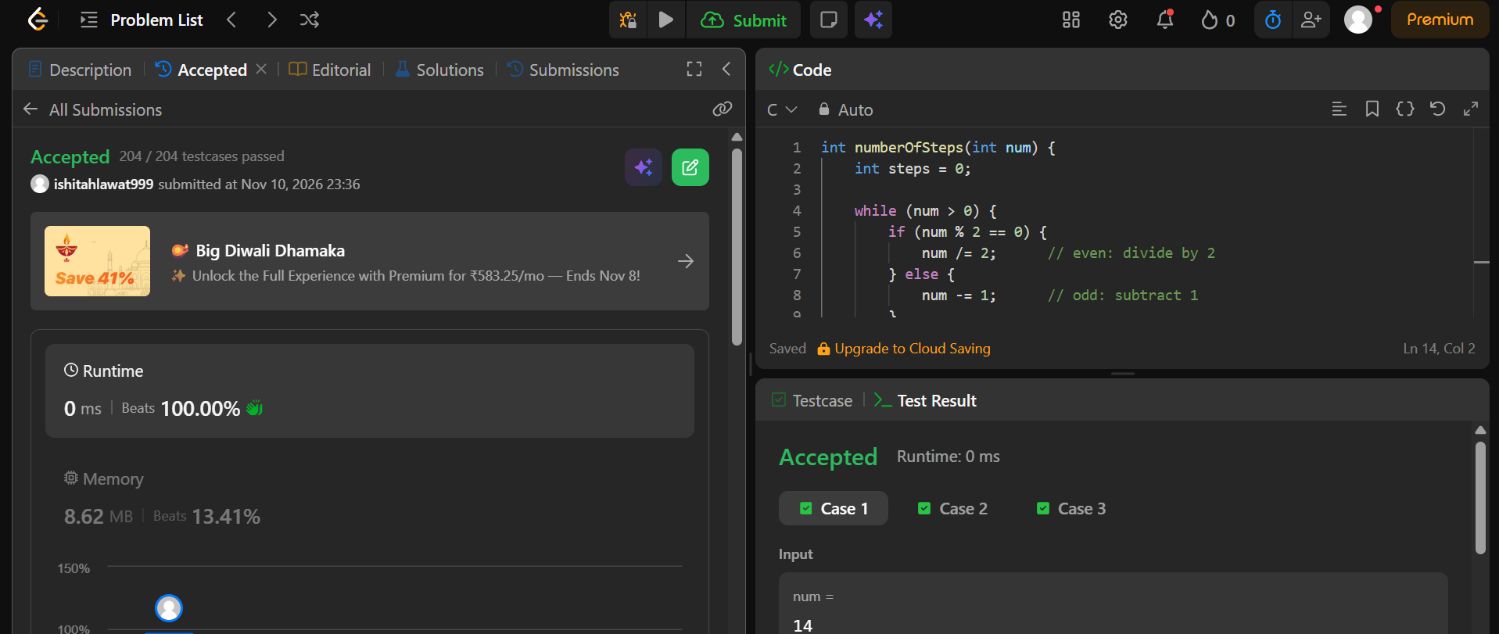
int numberOfSteps(int num) {
int steps = 0;

while (num > 0) {
if (num % 2 == 0) {
num /= 2; // even: divide by 2
} else {
num -= 1; // odd: subtract 1
}
steps++;
}

return steps;
}

