FOCP ASSIGNMENT 1

MODULE 4
Ques 5
palindrome number
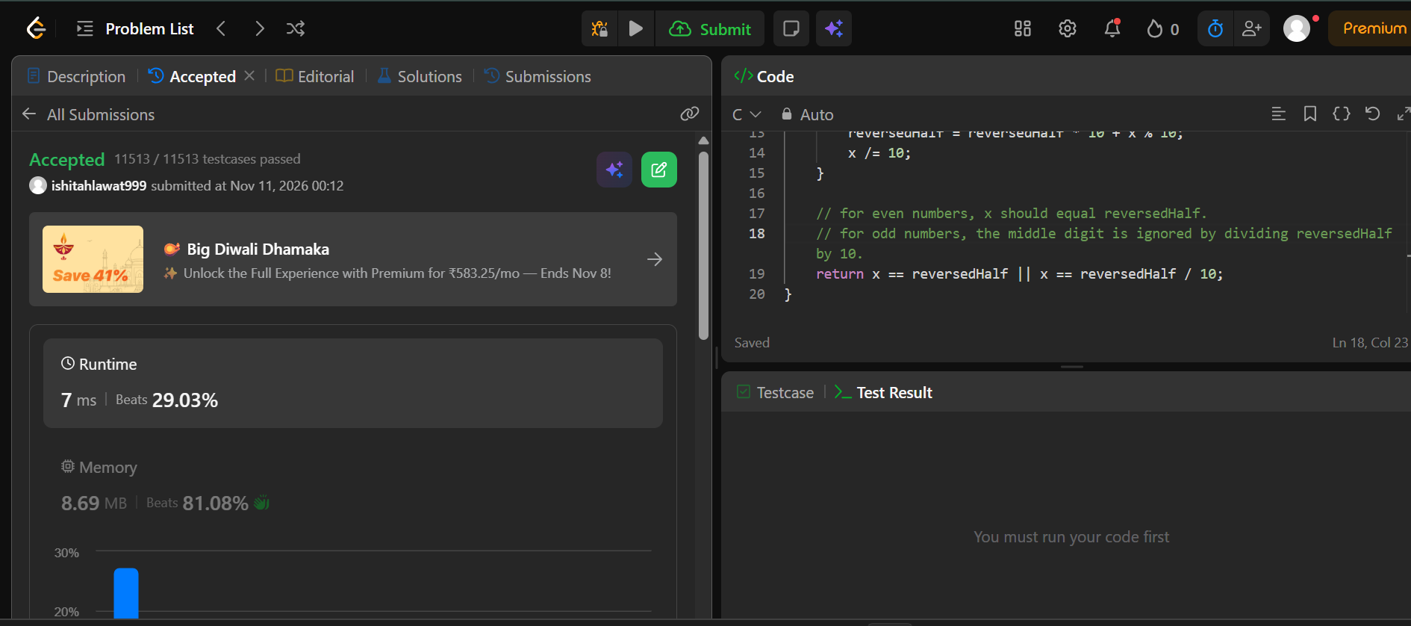

#include <stdbool.h>

bool isPalindrome(int x) {
// -ve nos are not palindromes
// number ending in 0 cant be a palindrome unless it is 0 itslef
if (x < 0 || (x % 10 == 0 && x != 0)) {
return false;
}

int reversedHalf = 0;
// reverse the second half of the number until it is no longer smaller than the first half
while (x > reversedHalf) {
reversedHalf = reversedHalf * 10 + x % 10;
x /= 10;
}

// for even numbers, x should equal reversedHalf.
// for odd numbers, the middle digit is ignored by dividing reversedHalf by 10.
return x == reversedHalf || x == reversedHalf / 10;
}

