FOCP ASSIGNMENT 1

MODULE 5
Ques 1
power of 2
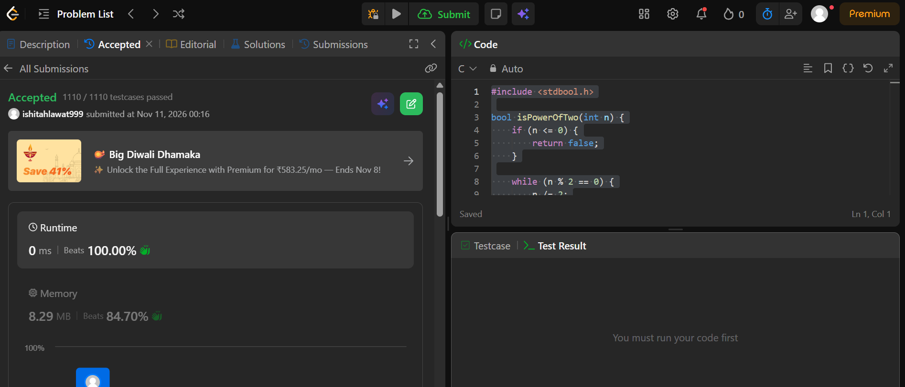

#include <stdbool.h>

bool isPowerOfTwo(int n) {
if (n <= 0) {
return false;
}

while (n % 2 == 0) {
n /= 2;
}

return n == 1;
}

