FOCP ASSIGNMENT 1

MODULE 4
Ques 6
reverse integer
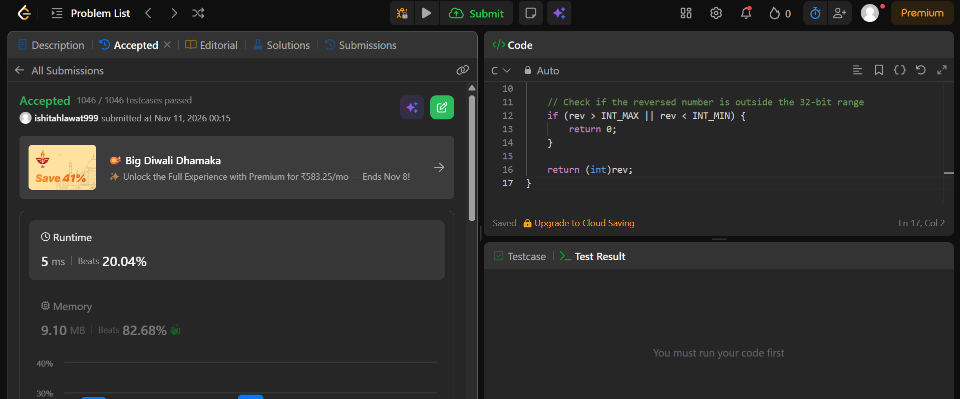
#include <limits.h>

int reverse(int x) {
long long rev = 0;

while (x != 0) {
rev = rev * 10 + x % 10;
x /= 10;
}

// Check if the reversed number is outside the 32-bit range
if (rev > INT_MAX || rev < INT_MIN) {
return 0;
}

return (int)rev;
}

