FOCP ASSIGNMENT 1

MODULE 1
Ques 5
total distance traveled

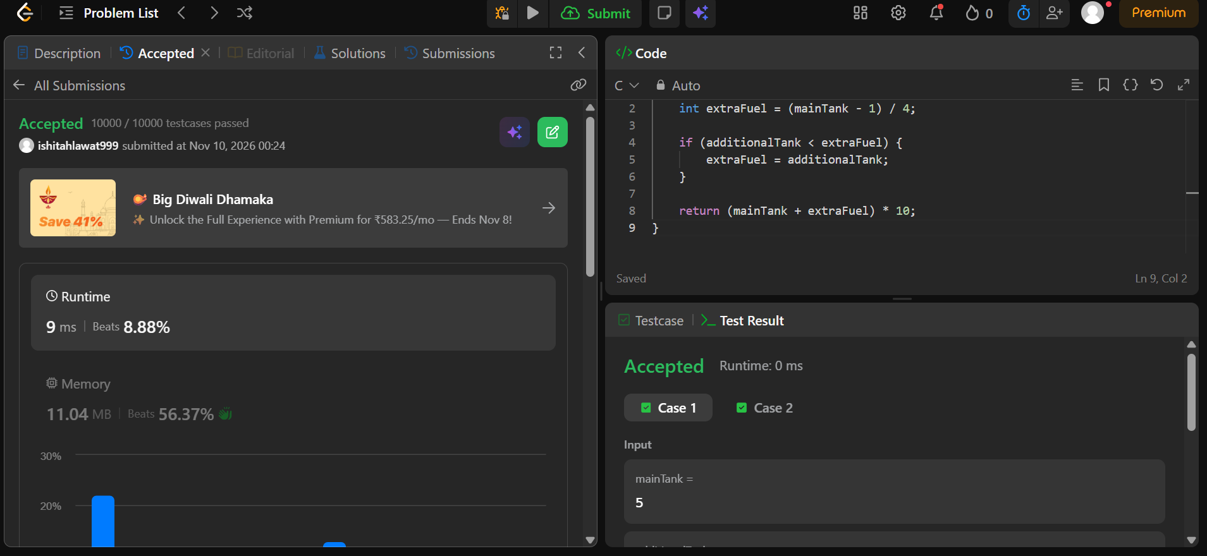

int distanceTraveled(int mainTank, int additionalTank) {
int extraFuel = (mainTank - 1) / 4;

if (additionalTank < extraFuel) {
extraFuel = additionalTank;
}

return (mainTank + extraFuel) * 10;
}

