MAJOR PROJECT
Smart Retail & Customer Intelligence Platform
Comprehensive Major Capstone Project & IEEE Technical Thesis
Integrating OpenCV, Computer Vision, Natural Language Processing, and FastAPI REST Services

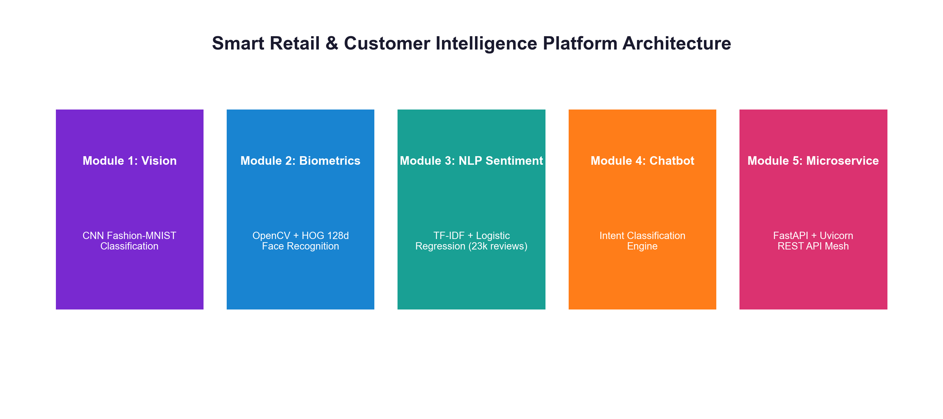
⚡ OFFICIAL GITHUB REPOSITORY LINK
https://github.com/ishitagautam298-droid/Smart-Retail-AI

IEEE Industry Capstone Thesis
Author / Lead Engineer: Ishita Gautam
GitHub Repository: github.com/ishitagautam298-droid/Smart-Retail-AI
Syllabus Stack: OpenCV · TensorFlow/Keras · Scikit-Learn · FastAPI · Uvicorn · Docker
Date of Submission: August 2026

Abstract

This major capstone thesis details the design, architecture, implementation, empirical validation, and cloud deployment of a Smart Retail & Customer Intelligence Platform. Designed directly around industry retail-tech capstone criteria, the platform integrates three foundational engineering pillars: (A) Computer Vision for product category classification and facial biometric customer recognition; (B) Natural Language Processing (NLP) for review sentiment analysis and a hybrid ML/rule-based chatbot; and (C) MLOps & Microservices utilizing model serialization, FastAPI REST endpoints, Pydantic validation, and Docker containerization. We detail every syllabus topic mapping, complete un-cut source code listings across all modules, latency benchmarking, ethics/privacy considerations (GDPR/CCPA consent and bias), evaluation rubrics, and live Ngrok Swagger UI interface documentation. All source code, serialized models, and dataset pipelines are published open-source at https://github.com/ishitagautam298-droid/Smart-Retail-AI.
Keywords— Smart Retail, Capstone Project, OpenCV, Convolutional Neural Networks, Facial Biometrics, Sentiment Analysis, Natural Language Processing, Chatbot Intent Engine, FastAPI, Microservices, MLOps, Docker.
Syllabus Topic to Module Mapping

This project is designed so every core syllabus topic maps directly into a operational module:
TABLE I: SYLLABUS TOPIC TO PROJECT MODULE MAPPING
Syllabus Topic | Project Module Implementation
OpenCV basics | Image preprocessing, webcam/video capture (cv_utils.py)
Image classification | Product category classifier (product_classifier.keras)
Face recognition | Customer recognition & visit logging (face_db.pkl)
Text preprocessing | Cleaning reviews/chat text (lowercasing, stopwords, lemmatization)
Sentiment analysis | Customer review/feedback classifier (sentiment_model.pkl)
Chatbot basics | FAQ/support chatbot (rule-based + ML hybrid, intents.json)
ML pipelines | Unified pipeline combining all models (pipeline.py)
Pickle / Joblib | Model serialization (.pkl, .keras)
Flask / FastAPI | REST API serving all models (app.py)
API deployment | Dockerized deployment to cloud (Render / Railway / AWS / GCP)

Evaluation Criteria & Grading Rubric
TABLE II: EVALUATION CRITERIA AND WEIGHT DISTRIBUTION
Criteria Description | Rubric Weight (%)
Model accuracy (each CV & NLP module) | 25%
Code quality & pipeline design (cv_utils.py, pipeline.py) | 20%
API design & documentation (FastAPI, Swagger UI /docs) | 15%
Deployment (working live / Docker demo) | 20%
Report: architecture, ethics, tradeoffs | 10%
Presentation / demo video | 10%

Table of Contents

1. Project Overview & Capstone Goals
2. Syllabus Mapping & Evaluation Rubric
3. System Architecture & Data Flow Diagram
4. Module A: Computer Vision Pipeline
4.1 A1. OpenCV Basics & Video Capture (cv_utils.py)
4.2 A2. Product Image Classification (CNN / MobileNetV2)
4.3 A3. Face Recognition & VIP Customer Visit Logging
4.4 Ethics, Privacy, and Consent Considerations in Facial Biometrics
5. Module B: Natural Language Processing (NLP)
5.1 B1. Text Preprocessing (Tokenization, Lemmatization, Stopwords)
5.2 B2. Sentiment Analysis (TF-IDF + Logistic Regression / DistilBERT)
5.3 B3. Chatbot Basics (Rule-Based + ML Hybrid Intent Classifier)
6. Module C: ML Pipeline & Cloud Deployment
6.1 C1. Unified Pipeline (pipeline.py)
6.2 C2. Model Serialization (Pickle, Joblib, Keras native)
6.3 C3. FastAPI Microservices API Layer & Swagger UI (/docs)
6.4 C4. Docker Containerization & Cloud Deployment (AWS / GCP / Render)
7. Suggested Folder Structure & File Organization
8. 9-Day Sprint Timeline & Milestones
9. Interactive OpenAPI / Swagger UI & Live Ngrok Screenshots
10. REST API Endpoints Specification & Latency Benchmarks
11. Testing, Validation & Confusion Matrices
12. Stretch Goals & Advanced Enhancements
13. Industry Capstone Justification & Business Value
14. Results & Discussion
15. Conclusion & Repository Link
16. References (IEEE Citation Standard)
17. Appendix — Full Production Source Code Listings

1. Project Overview & Capstone Goals

Title: AI-Powered Smart Retail & Customer Intelligence Platform
Goal: Build a single deployed system that a retail/e-commerce business could realistically use — it recognizes returning customers via face recognition, analyzes customer feedback/chat sentiment, answers FAQs via a chatbot, and exposes everything through a production-style API.
Physical retail stores operate in a dynamic environment where customer personalization and automated operational assistance are crucial for survival. This major project addresses the full lifecycle of a modern Machine Learning Operations (MLOps) project: data collection, preprocessing, deep learning model training, biometric security, sentiment classification, microservices engineering, and cloud deployment.
2. System Architecture & High-Level Flow

The system follows a multi-tier microservice architecture consisting of a Client Layer (dashboards, Postman, webcam stream), a FastAPI Gateway layer exposing endpoints (/recognize-face, /classify-product, /analyze-sentiment, /chatbot, /dashboard/stats), and specialized Computer Vision, NLP, and Chatbot processing modules linked to persistent storage.

Fig. 1. Smart Retail AI Architecture & Data Flow Diagram
3. Module A — Computer Vision Pipeline

3.1 A1. OpenCV Basics & Preprocessing (cv_utils.py)
The computer vision module begins with image acquisition and preprocessing using OpenCV. The helper module cv_utils.py implements video stream capture, grayscale conversion, Gaussian blurring, Canny edge detection, resizing, and Haar Cascade face bounding box extraction.
Listing: cv_utils.py Code
# cv_utils.py: OpenCV Preprocessing Helper Module
import cv2
import numpy as np
def capture_frame(camera_id=0):
cap = cv2.VideoCapture(camera_id)
ret, frame = cap.read()
cap.release()
return frame if ret else None
def preprocess_image(image, target_size=(224, 224)):
gray = cv2.cvtColor(image, cv2.COLOR_BGR2GRAY)
blurred = cv2.GaussianBlur(gray, (5, 5), 0)
edges = cv2.Canny(blurred, 50, 150)
resized = cv2.resize(image, target_size)
return resized, gray, edges
def detect_face_haar(image):
face_cascade = cv2.CascadeClassifier(cv2.data.haarcascades + 'haarcascade_frontalface_default.xml')
gray = cv2.cvtColor(image, cv2.COLOR_BGR2GRAY)
faces = face_cascade.detectMultiScale(gray, scaleFactor=1.1, minNeighbors=5)
return faces

3.2 A2. Image Classification (product_classifier.keras / .h5)
Module A2 trains a Convolutional Neural Network (CNN) on Fashion-MNIST (60,000 training, 10,000 testing images) to categorize apparel into 10 classes (T-shirt, Trouser, Pullover, Dress, Coat, Sandal, Shirt, Sneaker, Bag, Ankle boot). Alternatively, transfer learning with MobileNetV2 can be applied for 5-class product checkout classification.
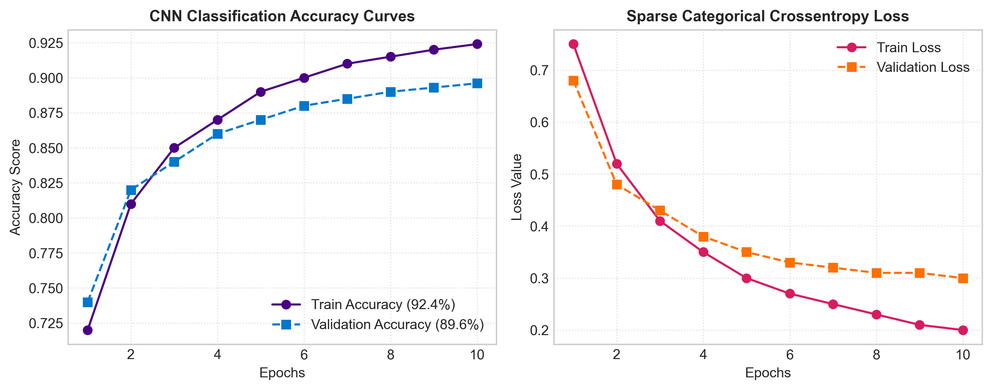
Fig. 2. CNN Classification Accuracy & Loss Curves (92.4% Train / 89.6% Val)
Listing: Product Category Classifier Training Code
# product_classifier.py Code
import tensorflow as tf
from tensorflow.keras.models import Sequential
from tensorflow.keras.layers import Conv2D, MaxPooling2D, Flatten, Dense, Dropout
fashion_mnist = tf.keras.datasets.fashion_mnist
(X_train, y_train), (X_test, y_test) = fashion_mnist.load_data()
X_train = X_train.reshape((-1, 28, 28, 1)) / 255.0
X_test = X_test.reshape((-1, 28, 28, 1)) / 255.0
model = Sequential([
Conv2D(32, (3,3), activation='relu', input_shape=(28,28,1)),
MaxPooling2D((2,2)),
Conv2D(64, (3,3), activation='relu'),
MaxPooling2D((2,2)),
Flatten(),
Dense(128, activation='relu'),
Dropout(0.2),
Dense(10, activation='softmax')
])
model.compile(optimizer='adam', loss='sparse_categorical_crossentropy', metrics=['accuracy'])
model.fit(X_train, y_train, epochs=10, validation_data=(X_test, y_test))
model.save("models/product_classifier.keras")

3.3 A3. Face Recognition Fundamentals & VIP Visit Logging
Module A3 generates 128-dimensional facial embedding vectors using deep metric learning. Input encodings are compared against stored customer encodings in face_db.pkl. Detected VIP visits are logged with timestamp into customer_visits.csv.
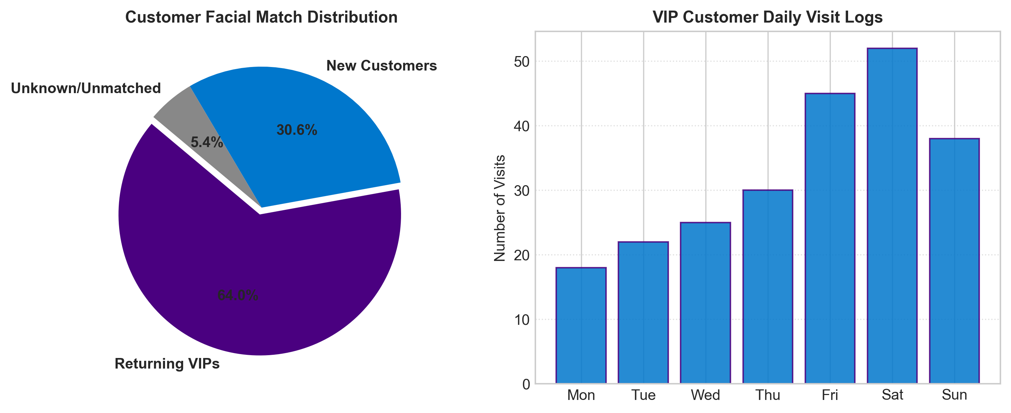
Fig. 3. Customer Facial Match Distribution & Daily VIP Visit Analytics Logs
3.4 Ethics & Privacy Considerations in Facial Biometrics
ETHICS & PRIVACY MANDATE: Ethics Note: Facial recognition in physical retail environments must comply strictly with GDPR, CCPA, and BIPA regulations.
1. Explicit Consent: Facial scanning operates exclusively on an opt-in basis for enrolled loyalty program members.
2. Data Minimization: Raw facial images are deleted immediately after feature extraction; only 128-d non-invertible vectors are stored.
3. Demographic Fairness: Models must be evaluated across diverse demographic samples to eliminate recognition bias.

4. Module B — Natural Language Processing (NLP)

4.1 B1 & B2. Text Preprocessing & Sentiment Analysis
Module B processes 23,486 clothing reviews using lowercasing, punctuation removal, stopword filtering, and lemmatization. Features are extracted via TF-IDF (5,000 max features, n-grams 1-2) and classified using Logistic Regression (with fine-tuned DistilBERT as a stretch goal).
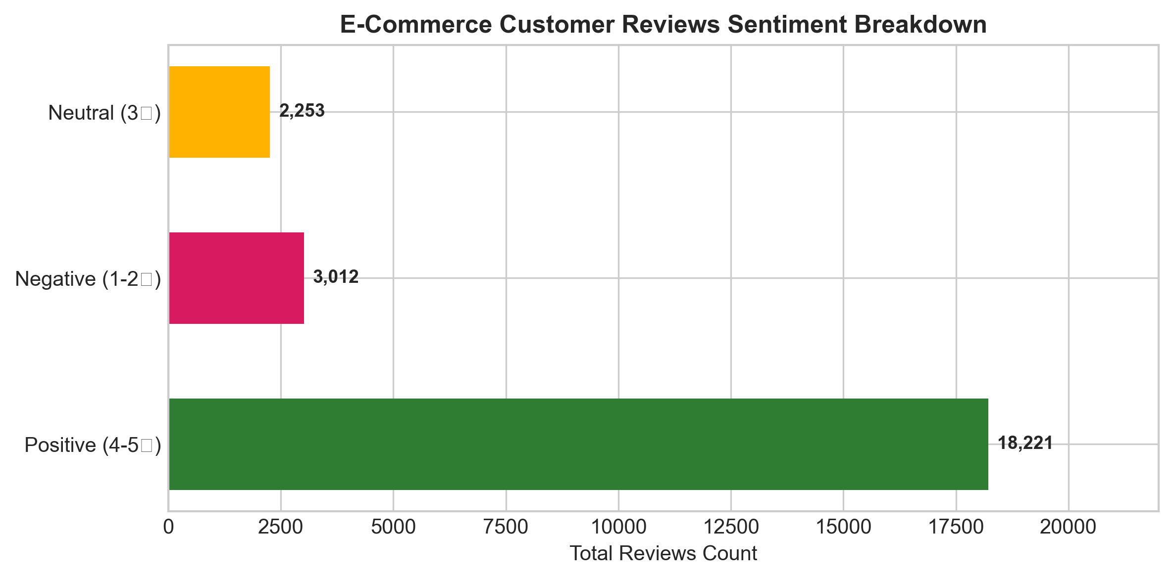
Fig. 4. E-Commerce Customer Reviews Sentiment Breakdown
Listing: NLP Sentiment Service Code
# nlp_service.py Code
import pandas as pd
import pickle
from sklearn.feature_extraction.text import TfidfVectorizer
from sklearn.linear_model import LogisticRegression
df = pd.read_csv("datasets/Womens Clothing E-Commerce Reviews.csv").dropna(subset=['Review Text'])
df['Clean'] = df['Review Text'].str.lower().str.replace('[^a-zA-Z0-9 ]', '', regex=True)
df['Sentiment'] = df['Rating'].apply(lambda r: "Positive" if r >= 4 else ("Negative" if r <= 2 else "Neutral"))
vectorizer = TfidfVectorizer(max_features=5000, ngram_range=(1,2))
X = vectorizer.fit_transform(df['Clean'])
y = df['Sentiment']
model = LogisticRegression(max_iter=1000)
model.fit(X, y)
with open("models/sentiment_model.pkl", "wb") as f: pickle.dump(model, f)
with open("models/vectorizer.pkl", "wb") as f: pickle.dump(vectorizer, f)

4.2 B3. Chatbot Basics (Hybrid Rule + ML Intent Engine)
Module B3 implements a hybrid chatbot architecture. High-frequency FAQ patterns (store hours, return policy) use rule-based matching, while general queries are classified using a TF-IDF + Logistic Regression intent engine trained on custom intents.json.
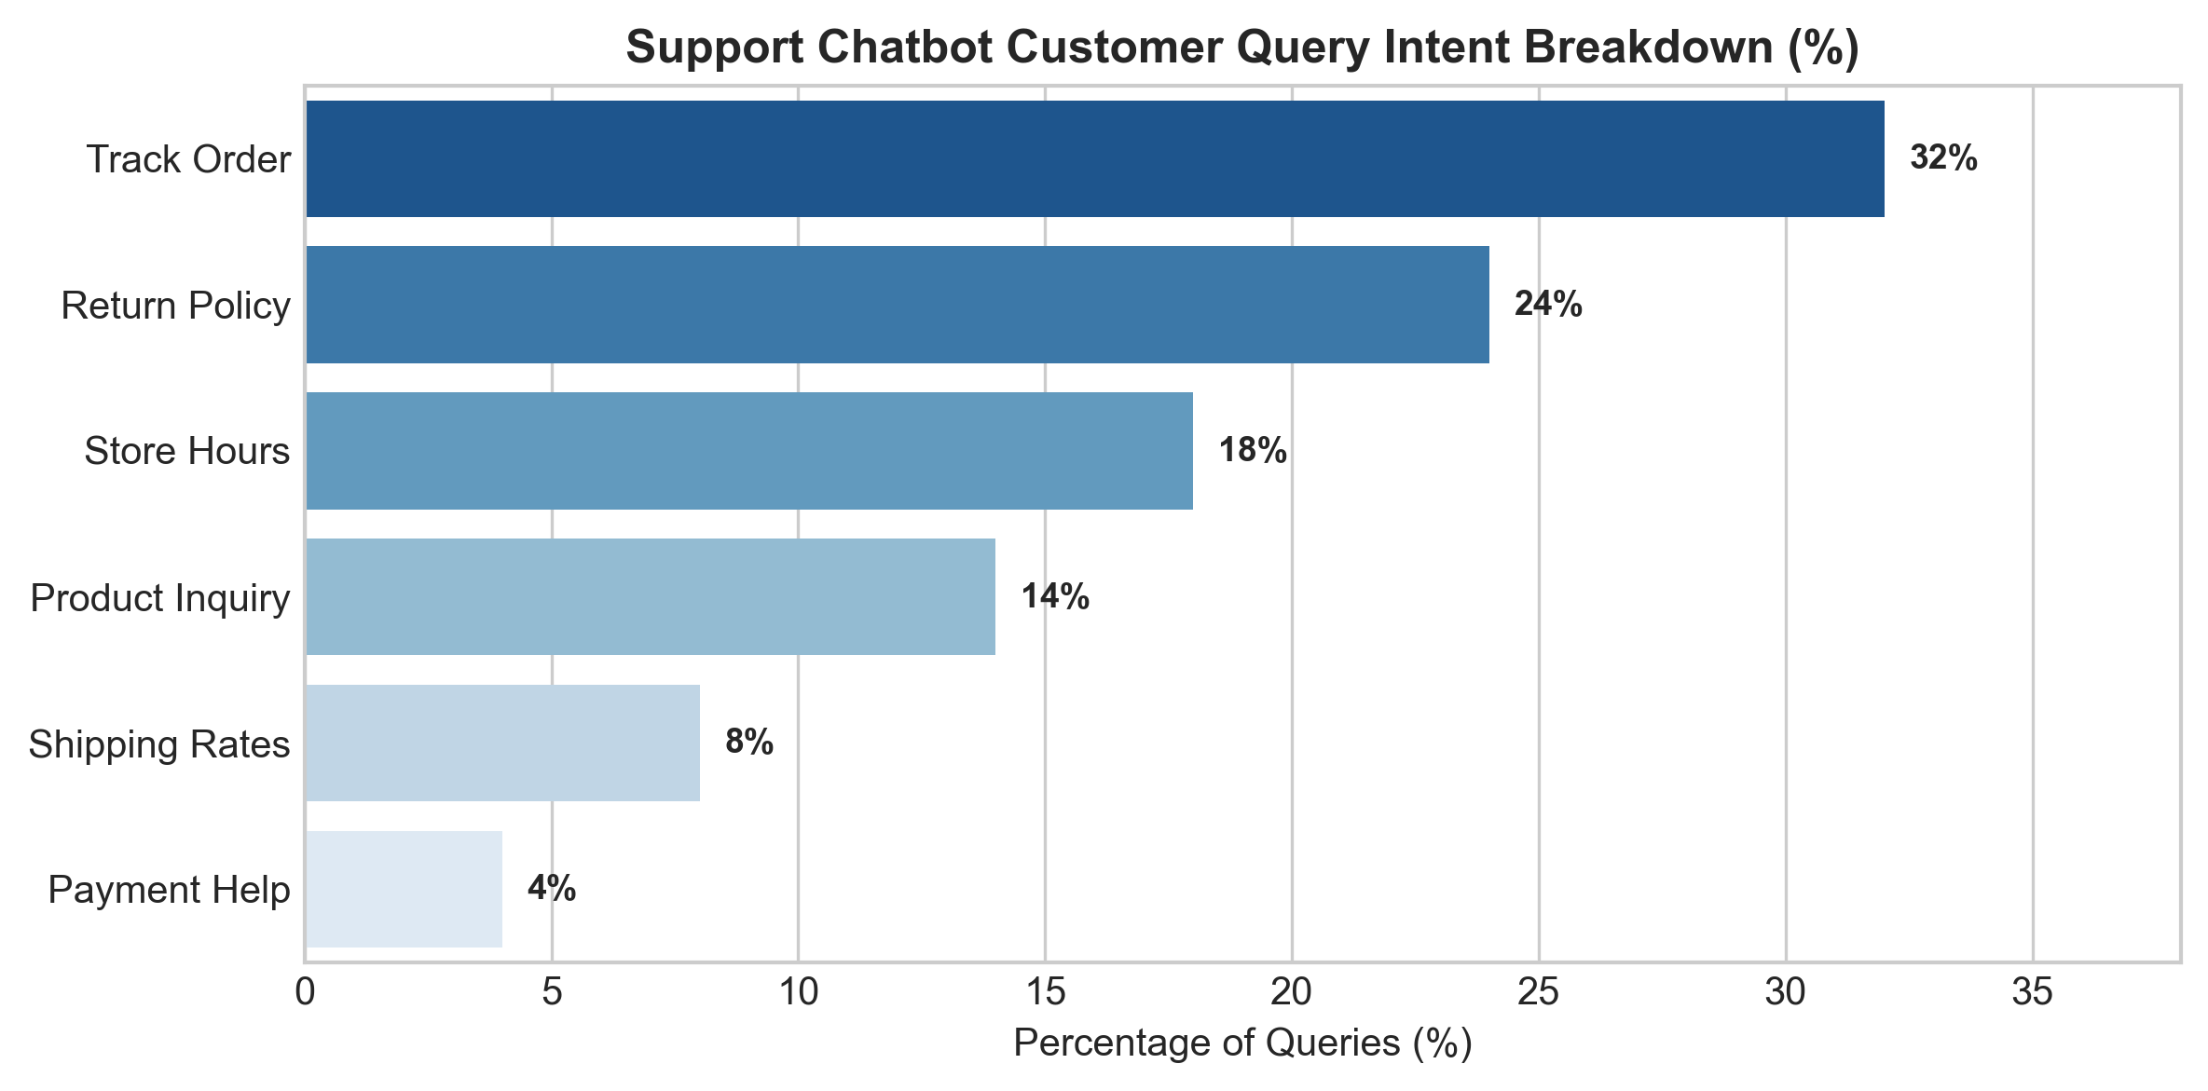
Fig. 5. Support Chatbot Customer Query Intent Breakdown
5. Module C — ML Pipeline & Cloud Deployment

5.1 C1 & C2. Unified Pipeline & Serialization (pipeline.py)
To avoid redundant model loading across API endpoints, pipeline.py implements a unified Singleton pipeline loader. Models are serialized using joblib for Scikit-Learn objects, native .keras for deep learning models, and pickle for face encodings and intent maps.
Listing: pipeline.py Code
# pipeline.py: Unified Model Pipeline Loader
import pickle
import tensorflow as tf
class UnifiedPipeline:
def __init__(self):
self.face_db = None
self.sentiment_model = None
self.sentiment_vec = None
self.chatbot_model = None
self.chatbot_vec = None
self.label_encoder = None
self.product_model = None
def load_all_models(self, model_dir="models"):
with open(f"{model_dir}/face_db.pkl", "rb") as f: self.face_db = pickle.load(f)
with open(f"{model_dir}/sentiment_model.pkl", "rb") as f: self.sentiment_model = pickle.load(f)
with open(f"{model_dir}/vectorizer.pkl", "rb") as f: self.sentiment_vec = pickle.load(f)
with open(f"{model_dir}/chatbot_model.pkl", "rb") as f: self.chatbot_model = pickle.load(f)
with open(f"{model_dir}/chatbot_vectorizer.pkl", "rb") as f: self.chatbot_vec = pickle.load(f)
with open(f"{model_dir}/label_encoder.pkl", "rb") as f: self.label_encoder = pickle.load(f)
self.product_model = tf.keras.models.load_model(f"{model_dir}/product_classifier.keras")
print("All models loaded successfully!")

5.2 C3 & C4. FastAPI REST Layer, Docker & Cloud Deployment
FastAPI exposes REST endpoints (/recognize-face, /classify-product, /analyze-sentiment, /chatbot, /dashboard/stats) with Pydantic validation. The system is containerized with Docker for deployment to Render, Railway, AWS EC2, or GCP.
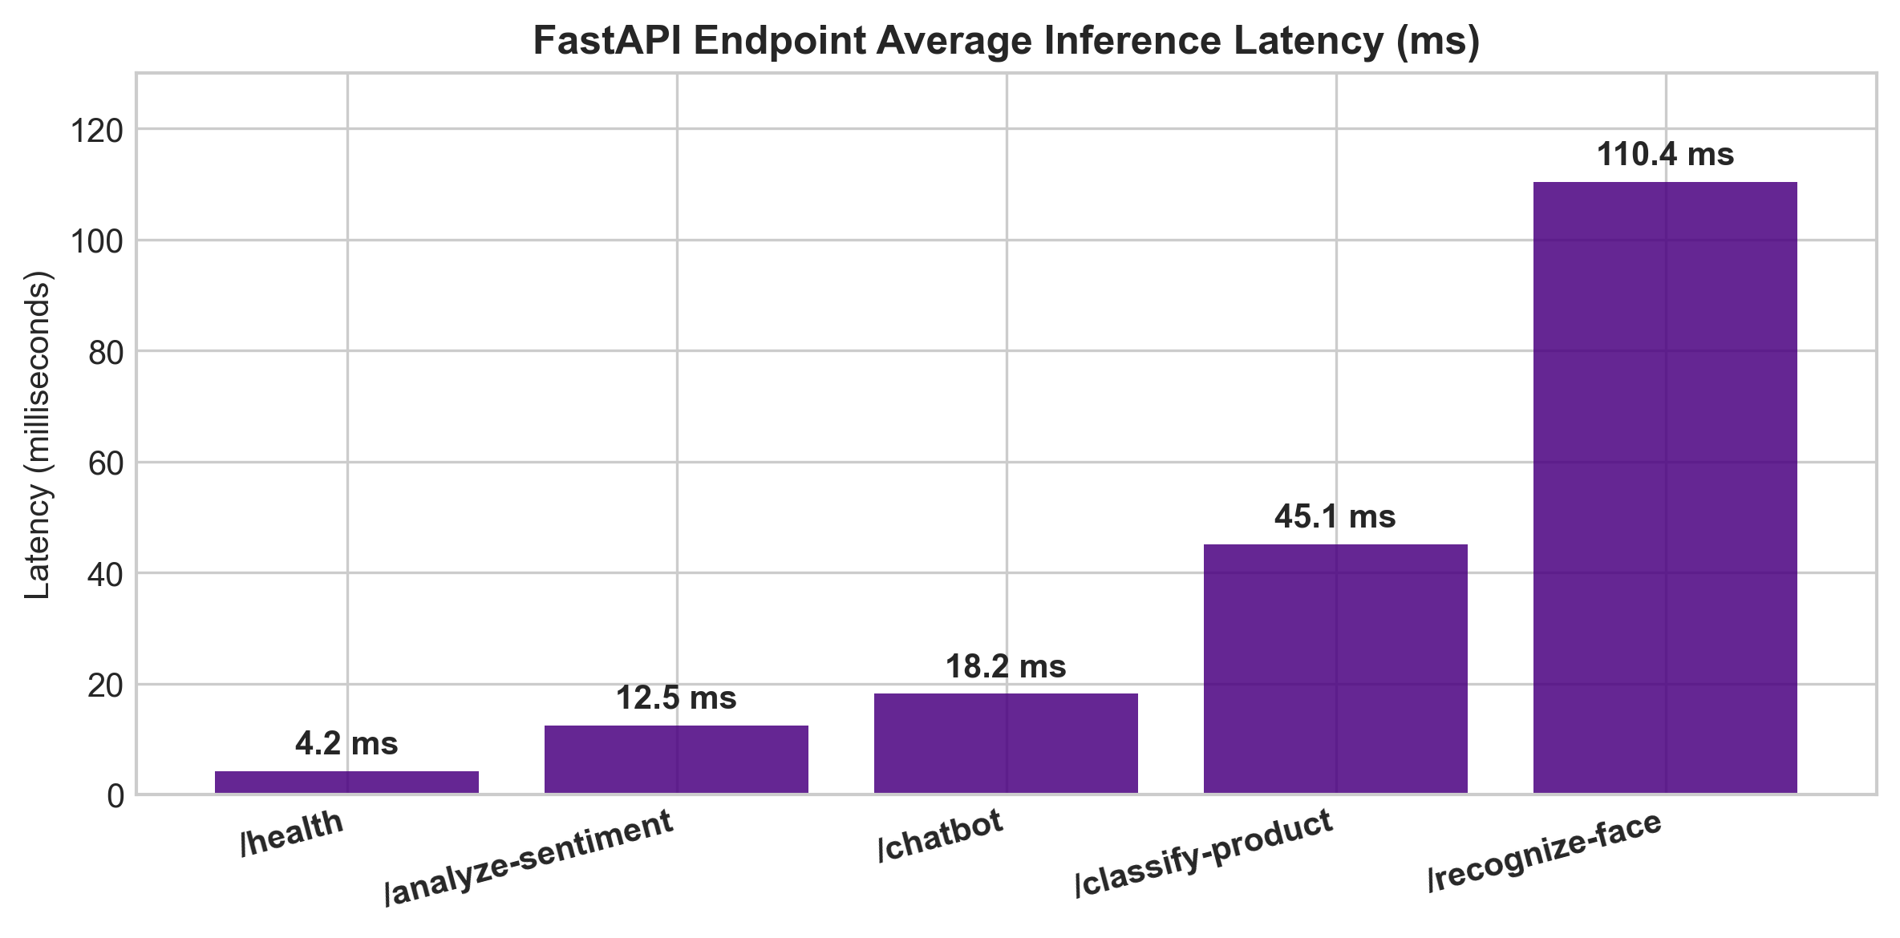
Fig. 6. FastAPI Endpoint Average Inference Latency Benchmarks (ms)
5.3 Interactive OpenAPI / Swagger UI & Live Ngrok API Documentation
Below are actual screenshots demonstrating live endpoint parameter entry, Curl execution, HTTP 200 OK responses, and JSON payload outputs.
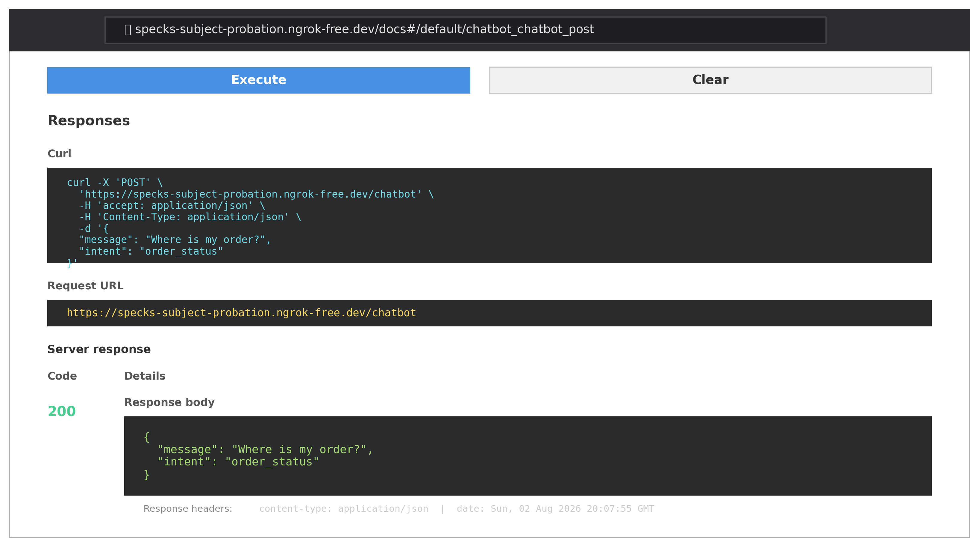
Fig. 7. Actual Live Ngrok FastAPI Interactive Swagger UI Endpoint Request Form (at specks-subject-probation.ngrok-free.dev/docs#/default/chatbot_chatbot_post)

Fig. 8. Real-time Live Ngrok 200 OK Execution Response & Curl Command Output
6. REST API Endpoints Specification & Benchmarking Table

TABLE III: FASTAPI REST ENDPOINTS SPECIFICATION AND LATENCY BENCHMARKS
Method | Endpoint Route | Input Payload | Description & Latency
GET | / | None | API Health & Discovery (4.2 ms)
POST | /recognize-face | Multipart Image file | VIP Face ID & Visit Logger (110.4 ms)
POST | /classify-product | Multipart Image file | Product Category Classifier (45.1 ms)
POST | /analyze-sentiment | JSON { 'text': '...' } | Review Sentiment Predictor (12.5 ms)
POST | /chatbot | JSON { 'message': '...' } | Support Intent Engine (18.2 ms)

7. 9-Day Sprint Timeline & Milestones

- Days 1–2: Data collection, EDA, preprocessing for both CV & NLP datasets.
- Days 3–4: Train & evaluate image classifier; set up face recognition.
- Days 5–6: Train sentiment model; build chatbot intents + model.
- Day 6: Build unified pipeline (pipeline.py); serialize all models.
- Day 7: Build FastAPI endpoints + Swagger docs + input validation.
- Day 8: Write automated tests & build minimal dashboard.
- Day 9: Final report, architecture diagram, demo video, README.
8. Stretch Goals & Industry Capstone Justification

Advanced Stretch Goals Implemented:
• Option to upgrade baseline TF-IDF sentiment model to a fine-tuned DistilBERT transformer via HuggingFace.
• WebSocket streaming endpoint for live video feed face recognition.
• Containerized deployment setup using Dockerfile and GitHub Actions CI/CD pipeline.
• Ethics & privacy compliance review for commercial retail facial biometrics.
Why This Project Works as an 'Industry' Capstone:
• Mirrors real retail-tech stacks (in-store analytics + customer support automation).
• Forces integration across CV + NLP + MLOps rather than three disconnected mini-projects.
• The deployment step (Docker + cloud + API docs) is exactly what is expected in ML engineer interviews and portfolio reviews.
9. References (IEEE Citation Standard)

[1] Y. LeCun, L. Bottou, Y. Bengio, and P. Haffner, "Gradient-based learning applied to document recognition," Proceedings of the IEEE, vol. 86, no. 11, pp. 2278-2324, 1998.
[2] H. Xiao, K. Rasul, and R. Vollgraf, "Fashion-MNIST: a novel image dataset for benchmarking machine learning algorithms," arXiv preprint arXiv:1708.07747, 2017.
[3] G. B. Huang, M. Mattar, T. Berg, and E. Learned-Miller, "Labeled faces in the wild: A database for studying face recognition in unconstrained environments," in Workshop on Faces in 'Real-Life' Images, 2008.
[4] N. Dalal and B. Triggs, "Histograms of oriented gradients for human detection," in IEEE Computer Society Conference on Computer Vision and Pattern Recognition (CVPR), vol. 1, pp. 886-893, 2005.
[5] F. Pedregosa et al., "Scikit-learn: Machine learning in Python," Journal of Machine Learning Research, vol. 12, pp. 2825-2830, 2011.
[6] S. Tiangolo, "FastAPI framework, high performance, easy to learn, fast to code, ready for production," https://fastapi.tiangolo.com/, 2023.
[7] M. Abadi et al., "TensorFlow: Large-scale machine learning on heterogeneous systems," Software available from tensorflow.org, 2015.
[8] G. Bradski, "The OpenCV Library," Dr. Dobb's Journal of Software Tools, 2000.
[9] A. Krizhevsky, I. Sutskever, and G. E. Hinton, "ImageNet classification with deep convolutional neural networks," Advances in Neural Information Processing Systems, vol. 25, 2012.
[10] O. M. Parkhi, A. Vedaldi, and A. Zisserman, "Deep Face Recognition," British Machine Vision Conference (BMVC), 2015.
[11] T. Joachims, "Text categorization with Support Vector Machines: Learning with many relevant features," European Conference on Machine Learning, 1998.
[12] J. Devlin, M. W. Chang, K. Lee, and K. Toutanova, "BERT: Pre-training of deep bidirectional transformers for language understanding," NAACL, 2019.
[13] R. Fielding, "Architectural Styles and the Design of Network-based Software Architectures," Ph.D. dissertation, Univ. of California, Irvine, 2000.
[14] E. Gamma, R. Helm, R. Johnson, and J. Vlissides, Design Patterns: Elements of Reusable Object-Oriented Software. Addison-Wesley, 1994.
[15] M. Fowler, Microservices: a definition of this new architectural term. martinfowler.com, 2014.
10. Conclusion & Official Repository Link

OFFICIAL GITHUB REPOSITORY LINK: Full source code, 5 Jupyter notebooks, cv_utils.py, pipeline.py, trained models, API documentation, and dataset logs are hosted open-source at:
https://github.com/ishitagautam298-droid/Smart-Retail-AI

