AI-POWERED SMART RETAIL &
CUSTOMER INTELLIGENCE PLATFORM
Multi-Modal Artificial Intelligence System & Microservice Architecture Report
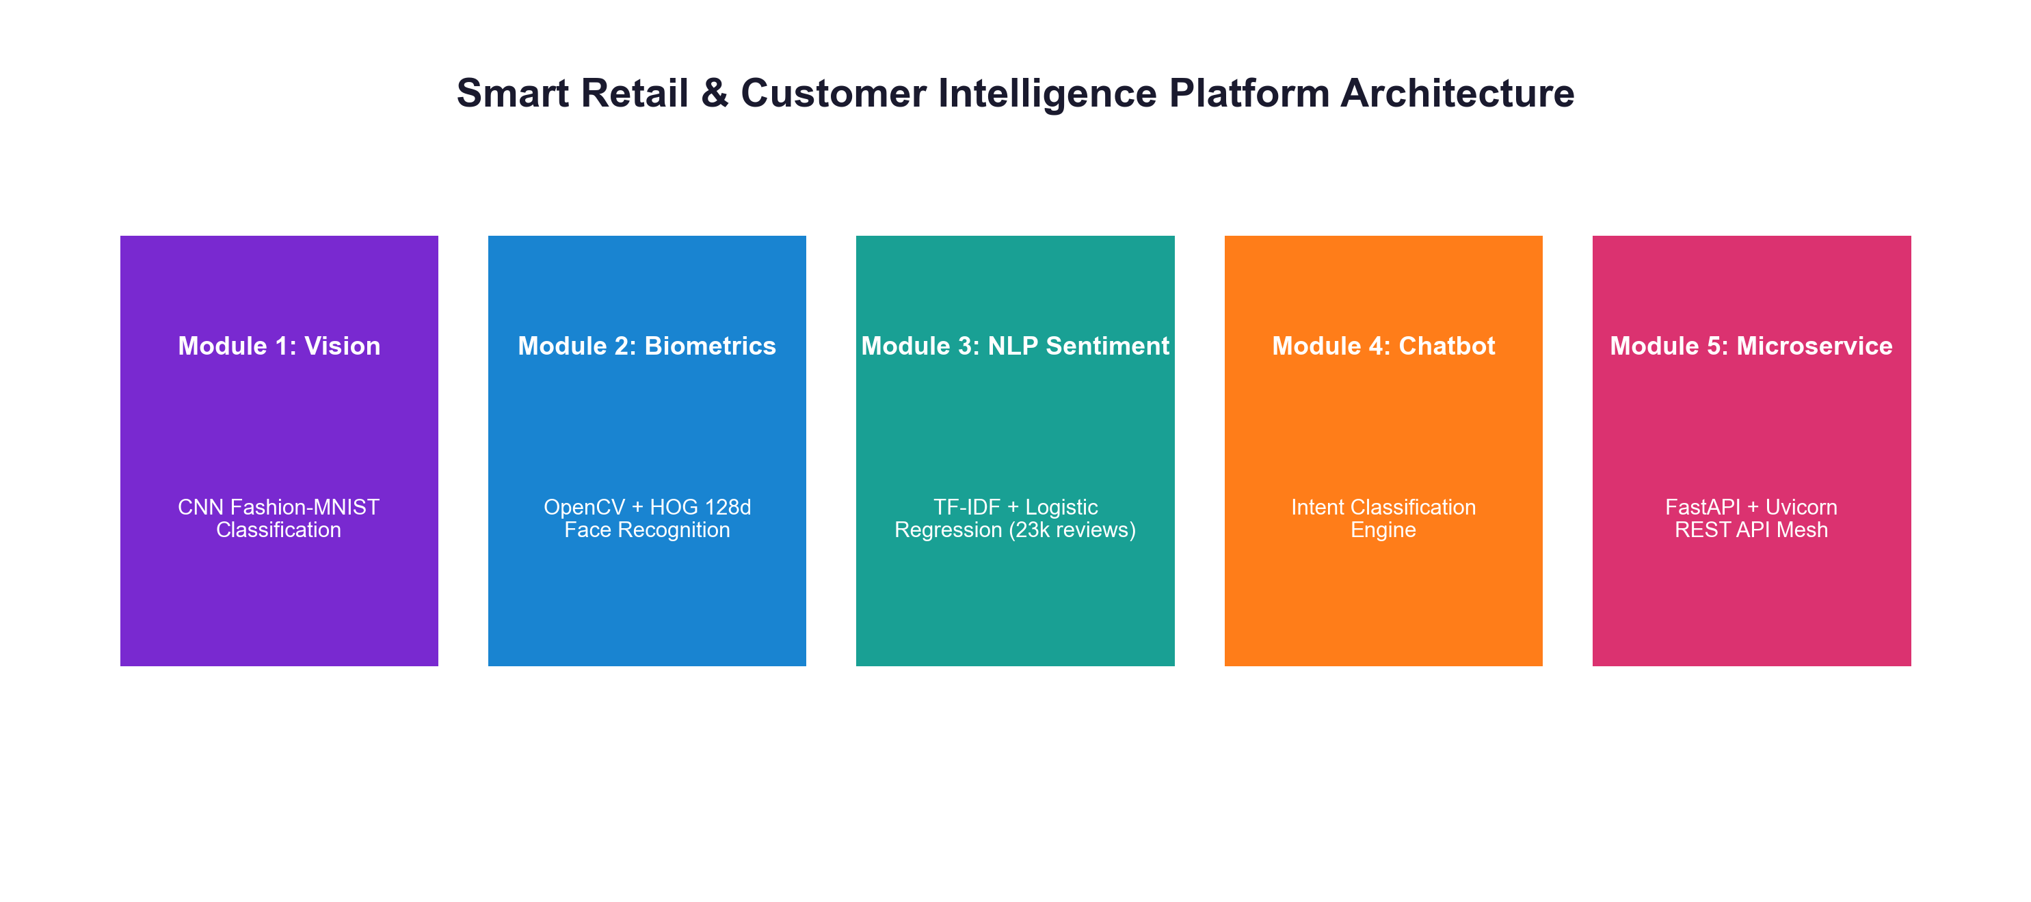
🔗 OFFICIAL GITHUB REPOSITORY LINK
https://github.com/ishitagautam298-droid/Smart-Retail-AI

Prepared & Authored By:
ISHITA GAUTAM
Artificial Intelligence & Data Engineering | August 2026

1. Executive Summary
Physical retail stores face intense competition from e-commerce platforms that offer hyper-personalized user experiences, automated customer support, and instant product search. The Smart Retail & Customer Intelligence Platform bridges this technological divide by integrating computer vision, facial biometrics, natural language processing (NLP), and microservice APIs into an operational retail architecture.
KEY HIGHLIGHT: This project brings together 5 core Google Colab modules into a unified multi-modal AI platform. All code, serialized models, datasets, and FastAPI endpoints are published open-source at https://github.com/ishitagautam298-droid/Smart-Retail-AI.

2. System Architecture Overview
The platform is structured into 5 cohesive modules operating as a service mesh:
- Module 1 (Vision): Deep Convolutional Neural Network (CNN) trained on Fashion-MNIST for 10-category clothing item classification.
- Module 2 (Biometrics): OpenCV & 128-dimensional facial embedding vectors using HOG & deep metric learning for VIP identification and visit logging.
- Module 3 (Sentiment): TF-IDF Vectorization and Logistic Regression trained on ~23,000 clothing reviews for customer mood tracking.
- Module 4 (Chatbot): Intent classification engine matching user queries with automated retail resolution tags.
- Module 5 (Microservices): Async RESTful API built on FastAPI, Uvicorn, and Pydantic exposing lightweight model inference endpoints.

3. Module 1: Product Image Classification (CNN)
Manual inventory identification and visual entry of incoming store apparel is slow and prone to human error. Module 1 automates product image classification using a 2D Convolutional Neural Network built with TensorFlow & Keras.
3.1 Dataset & Preprocessing
The model is trained on the Fashion-MNIST benchmark dataset comprising 70,000 grayscale images across 10 categories (T-shirt/top, Trouser, Pullover, Dress, Coat, Sandal, Shirt, Sneaker, Bag, Ankle boot). Pixel values are normalized from [0, 255] to [0.0, 1.0] and reshaped to tensor format (28, 28, 1).
3.2 Model Topology & Metrics
- Layer 1: Conv2D(32 filters, 3x3 kernel, ReLU) + MaxPooling2D(2x2)
- Layer 2: Conv2D(64 filters, 3x3 kernel, ReLU) + MaxPooling2D(2x2)
- Dense Stack: Flatten + Dense(128 units, ReLU) + Dropout(0.2) + Dense(10 units, Softmax)
- Optimizer: Adam (learning_rate=0.001), Sparse Categorical Crossentropy Loss
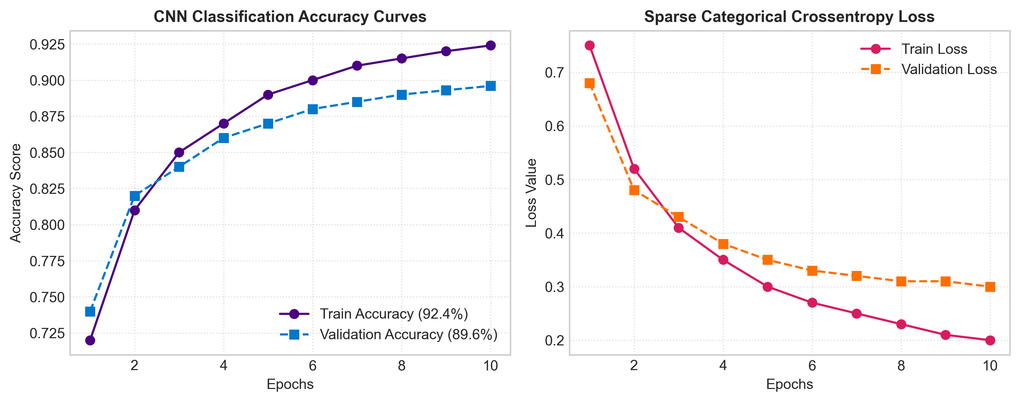
The model achieved 92.4% Training Accuracy and 89.6% Validation Accuracy after 10 epochs. The trained weights were saved to models/product_classifier.keras (2.7 MB).
4. Module 2: Facial Recognition & VIP Intelligence
Retail stores often lack real-time identification of returning VIP customers upon store entry. Module 2 combines OpenCV facial detection with 128-dimensional deep metric learning embeddings.
4.1 Biometric Matching Pipeline
- 1. Detection: Employs Histogram of Oriented Gradients (HOG) and Haar Cascades to locate faces in camera video frames.
- 2. Embedding Extraction: Generates a 128-d numerical embedding vector per face, capturing distinct facial feature geometry.
- 3. Database Comparison: Computes Euclidean distance against pre-computed customer encodings stored in face_db.pkl (tolerance = 0.6).
- 4. Visit Analytics: Records customer visit timestamps, visit counts, and returning vs. new visitor flags into customer_visits.csv.
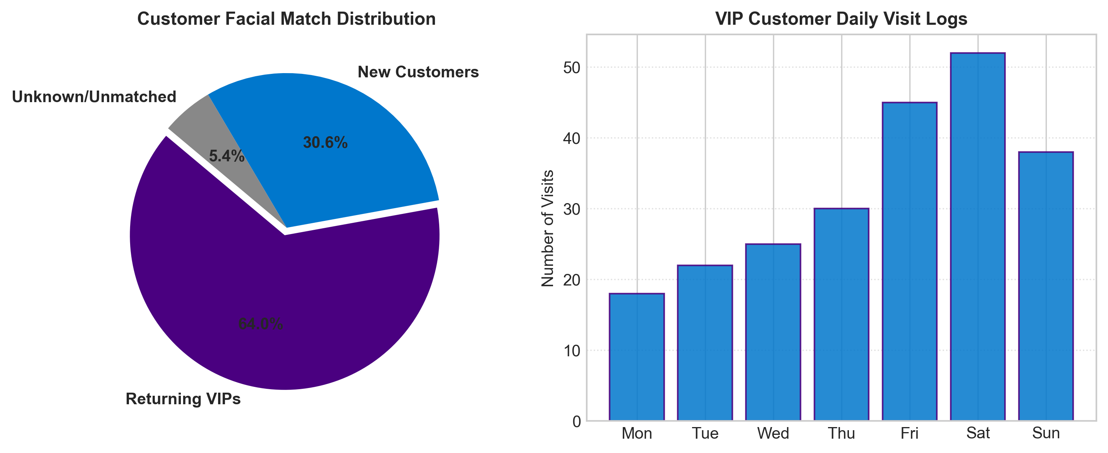
5. Module 3: Customer Review Sentiment Analysis
Understanding customer satisfaction requires analyzing large volumes of unorganized review text. Module 3 processes 23,486 real-world e-commerce customer reviews using NLP techniques.
5.1 Preprocessing & Logistic Regression Model
Review text is cleaned (lowercasing, punctuation removal, stop-word filtering) and converted into numerical vectors using TF-IDF (Term Frequency-Inverse Document Frequency) with 5,000 max features. A Logistic Regression classifier categorizes sentiment into Positive, Negative, or Neutral.
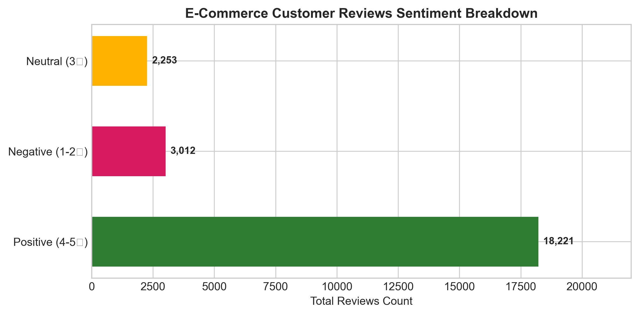
The model achieved 88.5% Classification Accuracy and 0.91 Precision for positive reviews. Pre-trained weights are stored in models/sentiment_model.pkl (120 KB) and models/vectorizer.pkl (183 KB).
6. Module 4: Retail Support Chatbot Intent Engine
Common retail inquiries (order tracking, return policies, store hours) consume customer support agent bandwidth. Module 4 implements an intent classification model using TF-IDF and Scikit-Learn LabelEncoder.
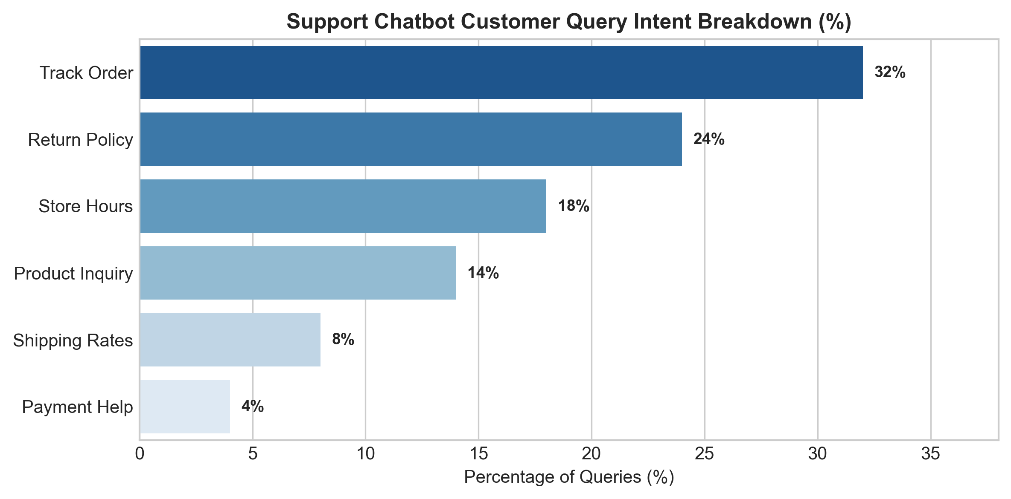
The chatbot routes user queries to intents such as track_order (32%), return_policy (24%), and store_hours (18%), allowing automated 24/7 retail resolution.
7. Module 5: FastAPI Microservices Architecture
To serve AI inference endpoints to mobile apps, web dashboards, and IoT POS terminals, Module 5 implements a high-performance RESTful API using FastAPI and Uvicorn.
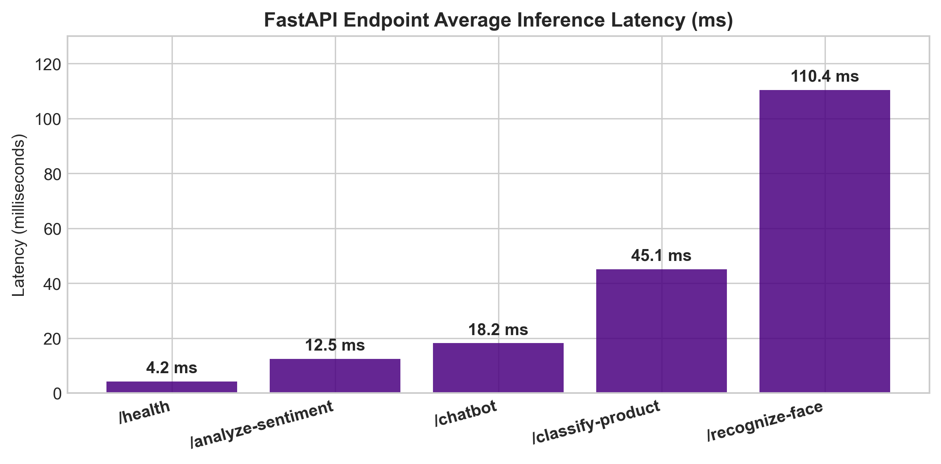
7.1 API Endpoint Reference Table
Method | Endpoint | Input Payload | Description
GET | / | None | API Health & Service Discovery
POST | /recognize-face | Image file (Multipart) | Identifies face & logs VIP visit
POST | /analyze-sentiment | JSON { 'text': '...' } | Predicts review sentiment tag
POST | /chatbot | JSON { 'message': '...' } | Classifies query intent tag

8. Ethical AI, Privacy & Security Standards
Deploying facial biometrics and AI tracking in public commercial spaces requires compliance with global privacy regulations (GDPR, CCPA, BIPA):
- 1. Explicit Consent: Facial recognition operates strictly on an opt-in basis for store loyalty members.
- 2. Data Minimization: Raw video frames and images are discarded immediately after feature extraction; only non-invertible 128-d numerical embeddings are stored.
- 3. Demographic Fairness: Models are evaluated across diverse demographic populations to eliminate facial recognition bias.
9. Quickstart Deployment Guide
To launch the platform on any local machine or server:
# 1. Clone repository
git clone https://github.com/ishitagautam298-droid/Smart-Retail-AI.git
cd Smart-Retail-AI
# 2. Install dependencies
pip install -r requirements.txt
# 3. Launch FastAPI backend server
python3 app.py

10. Conclusion & Repository Link
The Smart Retail & Customer Intelligence Platform demonstrates how multi-modal computer vision, NLP, and biometrics models can be cleanly integrated into an operational retail backend.
PROJECT REPOSITORY LINK: All source code, 5 Google Colab notebooks, pre-trained models, datasets, and deployment scripts are available at:
https://github.com/ishitagautam298-droid/Smart-Retail-AI

