**Team Name-The squad**

**Team Members-** Ishita Agarwal

Vishali Sharma

**To take data from user who wants ticket.**

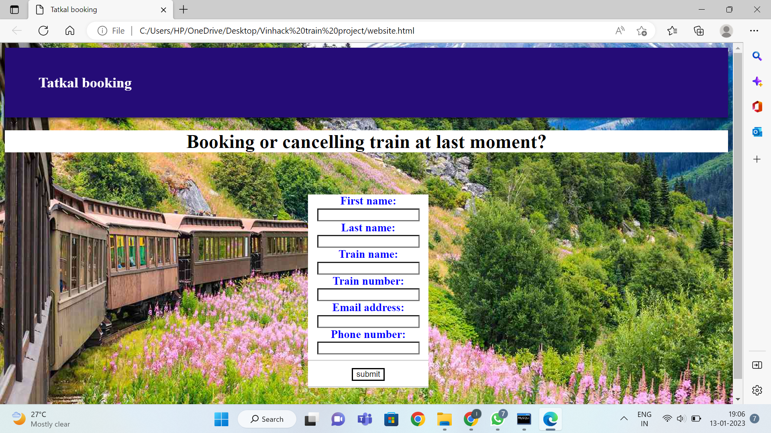

**Python is connected to mysql to take data**

**Data stored in mysql**

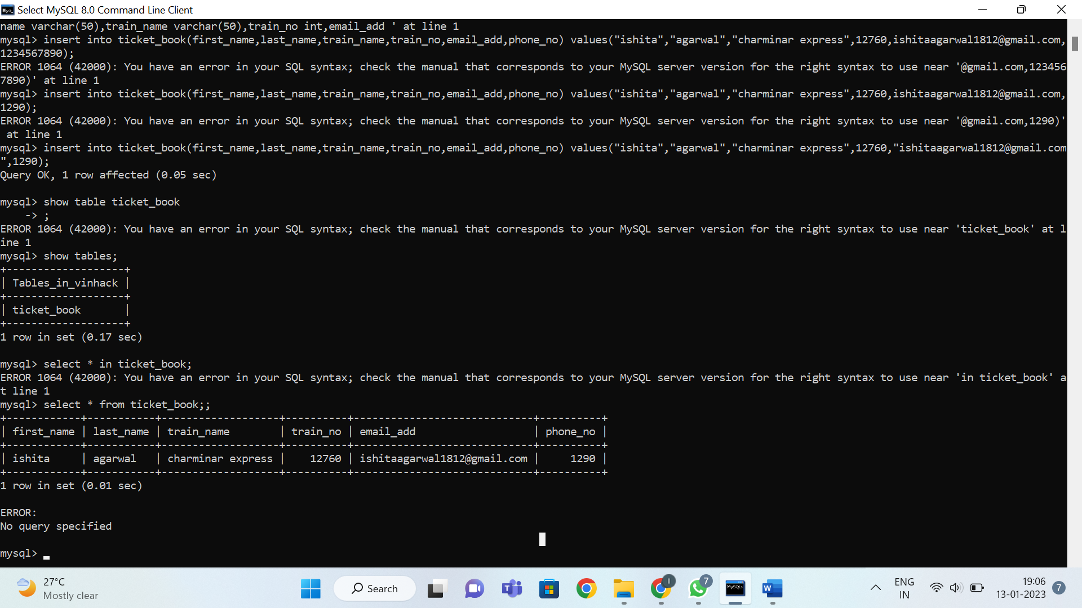

We will connect python with html and then data will be taken from form.

Another webpage for those who want to cancel ticket will be created which will show if anyone wants ticket of that train by searching from database.

Ticket will be cancelled of that person and given to that person who first filled form (those who want ticket)

**Website code-**

!DOCTYPE html>

<html lang="en">

<head>

  <!-- Required meta tags -->

  <meta charset="utf-8" />

  <meta name="viewport" content="width=device-width, initial-scale=1, shrink-to-fit=no" />

  <!-- style.css  -->

  <!--<link rel="stylesheet" href="Desktop//Vinhack_train//styles.css">-->

  <style>

    body{

    margin: 30;

    padding: 30;

  background-image: url("https://www.travelandleisure.com/thmb/EX0ouVFx5cEtirf3X9QPER8nTEk=/1500x0/filters:no_upscale():max_bytes(150000):strip_icc()/white-pass-yukon-route-6-TRAINTRIP0718-220e2c874df54fc88dd300d481b7632c.jpg");

  height: 100%;

/* Center and scale the image nicely */

background-position: center;

background-repeat: no-repeat;

background-size: cover;

background-blend-mode: lighten;

}

.form{

    width: 200px;

    margin-left: 6px;

    padding: 30px;

    top: 50%;

    left: 10%;

    text-align: center;

}

h2{

  color:rgb(255,255,255);

}

h1{

  color:rgb(0,0,0);

  background-color:rgb(255,255,255);

}

h3{

  color: rgb(0,0,255);

  background-color: rgb(255,255,255)

}

label{

  color: rgb(0,0,255);

}

nav{

  position: sticky;

  top: 0;

  left: 0;

  z-index: 1;

  display: flex;

  justify-content: space-between;

  align-items: center;

  background-color: rgb(37,12,119);

  padding: 1.5rem 3.5rem;

  box-shadow: 0 3px 5px rgba(0, 0, 0, 0.5);

}

input{

  background-color: rgb(255,255,255);

}

  </style>

  <!--favicon-->

  <link rel="apple-touch-icon" sizes="180x180" href="assets/images/apple-touch-icon.png">

  <link rel="icon" type="image/png" sizes="32x32" href="assets/images/favicon-32x32.png">

  <link rel="icon" type="image/png" sizes="16x16" href="assets/images/favicon-16x16.png">

  <link rel="manifest" href="assets/images/site.webmanifest">

  <link rel="mask-icon" href="assets/images/safari-pinned-tab.svg" color="#5bbad5">

  <meta name="msapplication-TileColor" content="#da532c">

  <meta name="theme-color" content="#ffffff">

  <title>

  Tatkal booking

  </title>

</head>

<body id="top">

   <!-- Start Top Nav -->

   <nav class="navbar navbar-expand-lg bg-dark navbar-light d-none d-lg-block" id="templatemo_nav_top">

    <div class="container text-light">

        <div class="w-100 d-flex justify-content-between">

          <b><h2>Tatkal booking </h2></b>

            <div>

                <a class="text-light" href="https://fb.com/" target="_blank" rel="sponsored"><i class="fab fa-facebook-f fa-sm fa-fw me-2"></i></a>

                <a class="text-light" href="https://www.instagram.com/" target="_blank"><i class="fab fa-instagram fa-sm fa-fw me-2"></i></a>

                <a class="text-light" href="https://twitter.com/" target="_blank"><i class="fab fa-twitter fa-sm fa-fw me-2"></i></a>

                <a class="text-light" href="https://www.linkedin.com/" target="_blank"><i class="fab fa-linkedin fa-sm fa-fw"></i></a>

            </div>

        </div>

    </div>

</nav>

<!-- Close Top Nav -->

<center><h1>Booking or cancelling train at last moment? </h1>

    <form class="form" name="sos" id="sos" action="index.html" method="POST">

        <h3>First name:

        <input type="text" id="name" name="fname"><br>

        Last name:

        <input type="text" id="name" name="lname"><br>

      Train name:

      <input type="text" id="name" name="name"><br>

      Train number:

      <input type="text" id="name" <br>

      Email address:

      <input type="text" id="name" name="email"><br>

      Phone number:

      <input type="text" id="name" name="number"><br>

      <hr>

        <input type="submit" value="submit">

      </form><hr>

    </h3>

    </center>

</body>

</html>