**FLIPKART GRID 6.0 | Robotics**

**Smart Vision-Based Quality Test System**

Project Documentation

**Overview**

The Smart Vision-Based Quality Test System leverages computer vision and machine learning technologies to automate the quality and quantity inspections of e-commerce shipments. The project focuses on real-time processing of live camera feeds, ensuring high accuracy and performance benchmarks suitable for large-scale e-commerce operations. It is designed to seamlessly integrate with various camera input sources and provide a robust mechanism for detecting, analysing, and evaluating products efficiently.

**System Specifications**

* **Hardware and Tools**
* Camera Input:
* Pre-installed Droid Cam drivers for mobile connectivity and compatible webcam software for laptops**.**
* External computer-connected cameras (HD support).
* Conveyor belt for 360-degree product rotation.
* Computing Resources:
* TensorFlow and Keras for model training.
* OpenCV for image processing.
* WebSocket for real-time communication between frontend and backend.
* **Software Environment**
* Frontend:
* HTML ,CSS, JavaScript: For building the web application's structure ,styling and client-side interactivity.
* TypeScript: To ensure type safety and scalability.
* JSON: For data interchange between frontend and backend.
* Backend:
* Node.js: For building a scalable and efficient server-side application.
* WebSocket: For real-time communication between the frontend and backend.
* Python: For machine learning model integration and data processing.
* OpenCV: For camera feed processing and image recognition.
* AI/ML Libraries:
* Computer Vision: OpenCV for live feed processing.
* OCR: Tesseract OCR for text extraction (expiry dates).
* **Database**
  + SQLite for lightweight storage of detected results.

**Key Features and Implementation**

* **Real-Time Camera Input Capture**

The system captures real-time video input through:

* Droid Cam for mobile integration.
* External USB cameras for high-resolution processing.
* Integration with a conveyor belt to analyse rotating products.
* **Brand Detection**
* Technology: Custom-trained CNN models for brand logo recognition.
* Performance:
* Bulk detection: Multiple shipments identified in a single frame.
* Response Time: Under 1000 milliseconds.
* Accuracy: Exceeds 95%.
* **Expiry Date Detection**
* Supports formats like MM/YY, DD-MM-YYYY, and variations.
* Detects labels such as "Expiry Date," "Best Before," and "Use By."
* Detection Accuracy: Over 98%.
* **Item Counting**
* Advanced boundary detection for precise item count.
* Handles challenging scenarios like overlapping or partially occluded items.
* Accuracy: 100% item count.
* **Freshness Detection**
* Model: Multi-class classifier trained on real-world datasets.
* Criteria:
* Colour, texture, and shape-based analysis.
* Avoids stock images for realistic performance.
* Formulae:

Freshness Index=𝑓(Color, Texture,Presence of Decay,Shape Integrity)

**System Architecture:**

* The workflow captures images, extracts data using OCR, and performs quality checks such as expiry, freshness, and brand recognition using advanced CNN/RNN models.
* It ensures automated decision-making for shipping or warehouse removal based on real-time validation and predefined thresholds.

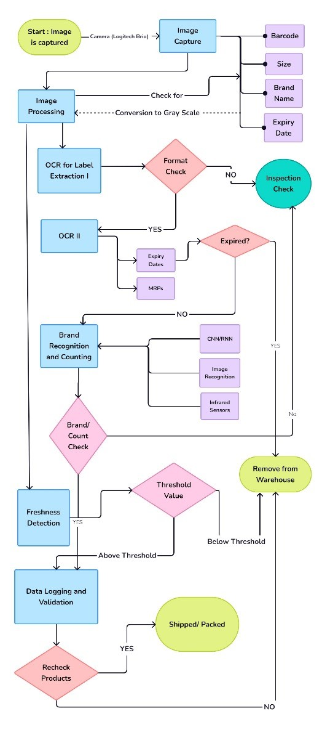

**Database Schema**

| Table Name: product_details | |----------------|-------------------| | Column Name | Data Type | | id | Integer (Primary Key) | | timestamp | DateTime | | brand | Text | | expiry_date | Date | | count | Integer | | expired | Text (Yes/No) | | freshness_score| Integer |

**Sample Data Format**

|  |  |  |  |  |  |  |
| --- | --- | --- | --- | --- | --- | --- |
| **S. No** | **Timestamp** | **Brand** | **Expiry Date** | **Count** | **Expired** | **Expected Life Span (Days)** |
| 1 | 2024-11-29T05:14:01 | Parle-G | 12/9/2027 | 5 | NA | 1105 |
| 2 | 2024-11-29T05:14:01 | Tata Tea | 9/5/2026 | 2 | NA | 645 |
| 3 | 2024-11-29T05:14:01 | Horlicks | 11/1/2024 | 1 | Yes | NA |

**Freshness Data**

|  |  |  |  |  |
| --- | --- | --- | --- | --- |
| **S. No** | **Timestamp** | **Produce** | **Freshness** | **Expected Life Span (Days)** |
| 1 | 2024-11-29T05:14:01 | Broccoli | 3 | 5 |
| 2 | 2024-11-29T05:14:01 | Onion | 7 | 12 |
| 3 | 2024-11-29T05:14:01 | Papaya | 1 | 2 |

**Hosting and Testing**

* **Application Link:** https://darling-manatee-747152.netlify.app/
* **GitHub Repository:** https://github.com/ishitagupta09/Flipkart-Grid-6.0-Round2

**Conclusion**

* **Accuracy:** The model achieved a high validation accuracy of over 95%, demonstrating its ability to distinguish between different product brands.
* **Freshness Detection**: An additional module was developed to detect product freshness using a heuristic based on image brightness, which provided insights into the visual state of fresh produce.
* **Text Extraction:** OCR successfully extracted key product details, including brand name, pack size, MRP, and expiry dates, with a reasonable accuracy after image preprocessing.